Introduction and motivation
The goal of the project is to explore the Graph Neural Network architectures’ capabilities in detecting patterns and outliers in systems engineering models. Systems Engineering (in particular Model Based Systems Engineering) is a fairly young discipline focusing on managing complexity in engineering projects. A typical systems engineering model, breaks down a product architecture into System Requirements, System Functions and Logical and Physical Components. Each one of those “domains” is decomposed through tiers representing decreasing levels of abstraction. The critical aspect of Systems Engineering is traceability consisting in the allocation of requirements at different levels of the architecture and ensuring that those requirements are met. A requirement that is missed can in some cases lead to catastrophic accidents leading to the loss of human life. For that reason, robust identification of gaps in traceability can indeed be a matter of life and death.
A classic example of a missed requirement leading to a catastrophic accident is the missed allocation of fatigue load stress testing on the De Havilland Comet fuselage leading to multiple accidents in the 50s and killing dozens of people. (Withey, 2019)

Technical background
Given that aerospace data is often proprietary, we had to resort to synthetic data. The first portion of the project consists in the generation of three sets of graphs where the outlier detection grows in complexity:
- Direct satisfaction of allocated requirement – an outlier in this case is any allocate or satisfy relationship that does not coexist with a complementary relationship going the opposite way.
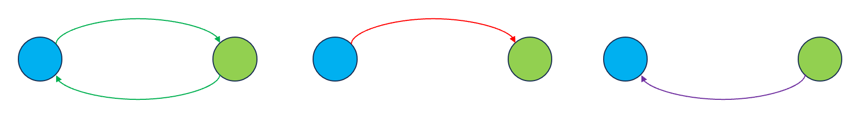
- Decomposition of the allocation target – an outlier in this case is any allocate that does not coexist with a set of decompose and satisfy link whose chain completes the loop or a satisfy link that does not participate in such a loop.
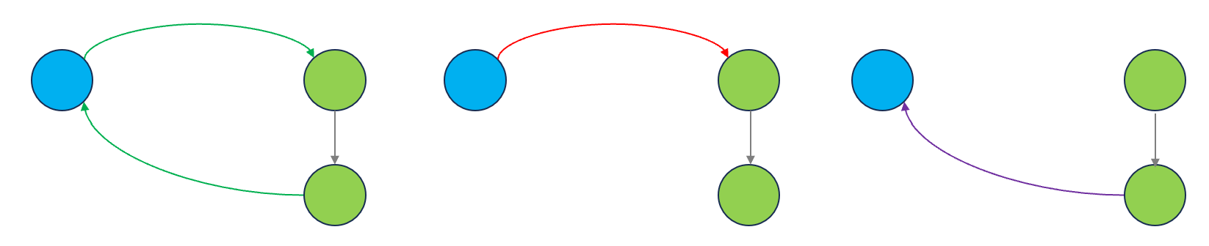
- Satisfying the sum of decomposed requirements – an outlier in this case is any allocate relationship where the set of decomposed requirements is not fully satisfied or a satisfy relationship that is redundant.
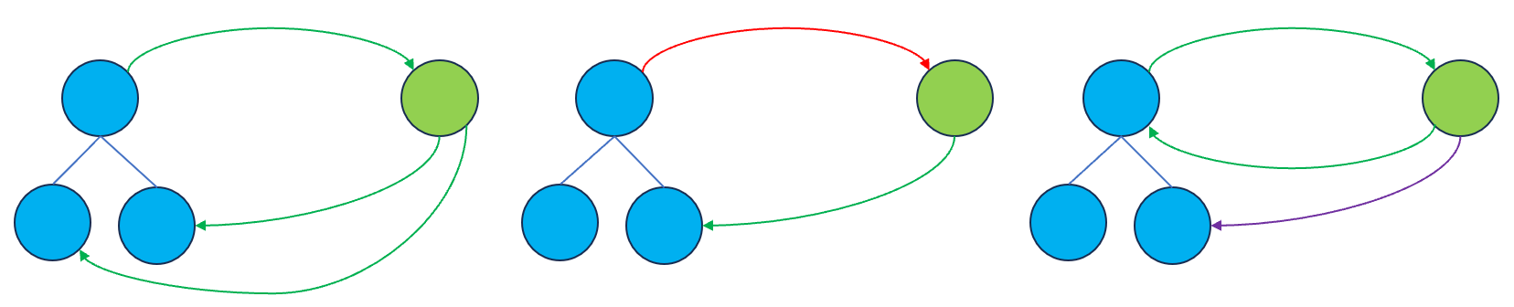
Our project will explore the impact of the presence of those outliers on the performance of different GNN architectures and also compare their performance to non-GNN based classifier NN methods.

Bibliography
Withey, P. (2019, 01 24). The Real Story of the Comet Disaster. Retrieved from University of Birmingham: https://www.fzt.haw-hamburg.de/pers/Scholz/dglr/hh/text_2019_01_24_Comet.pdf

