DS-6331 Time Series Project- Covid-19 Death Rate and the Influence of Vaccine and other variables

Tai Chowdhury and Simerpreet Reddy

4/09/2021

### Objective:

Analyze Covid-19 Death Rate(per day) and the influence of other factors- New cases per day, Vaccination Rates, number of hospitalizations and number of ICU patients per day. We will perform the following taks: 1) Performing Univariate analysis on ‘New Deaths per million’. 2) Build ARIMA model. 3) Build the following models: We will first build models using only ‘New Deaths per million’ and ‘New Vaccinations per million’ and then will analyze all other variables as well. We will also analyse lagged variables. Models to be built: i)Multivariate analysis ii) VAR models iii) MLP models iv) ensemble models using any of the above 2 models

### Data Set:

1. All Covid: Data Set with all data and related variables since the beginning of the pandemic.
2. Post Vaccine: Daily data since the first vaccine got administered in the US(12/21/20) through 03/26/2021 (96 observations). This is the data set we are bulding the models on.

### Data Set description:

96 observations with the following attributes: Date, New Cases per million, New Deaths per million, New ICU patients per million, New Hospitalizations per million, New Vaccinations per million

### Source:

Coronavirus (COVID-19) Vaccinations - Statistics and Research - Our World in Data. It is updated daily and includes data on confirmed cases, deaths, hospitalizations, testing, and vaccinations as well as other variables of potential interest.

#Include necessary libraries  
library(nnfor)  
library(forecast)  
library(vars)  
library(tswge)  
  
All_Covid <- read.csv(file.choose(), header=TRUE)  
nrow(All_Covid)

## [1] 429

Post_Vaccine <- read.csv(file.choose(), header=TRUE)  
nrow(Post_Vaccine)

## [1] 96

str(Post_Vaccine)

## 'data.frame': 96 obs. of 7 variables:  
## $ date : Factor w/ 96 levels "1/1/2021","1/10/2021",..: 32 33 34 35 36 37 38 39 40 41 ...  
## $ location : Factor w/ 1 level "United States": 1 1 1 1 1 1 1 1 1 1 ...  
## $ new_cases_per_million : num 602 598 694 587 295 ...  
## $ new_deaths_per_million : num 5.85 10.25 10.33 8.79 4.23 ...  
## $ icu_patients_per_million : num 79.9 80.8 81.4 80.7 80.3 ...  
## $ hosp_patients_per_million : num 346 355 356 351 342 ...  
## $ new_vaccinations_smoothed_per_million: int 173 381 450 571 644 692 632 646 705 763 ...

#Rolling Window Function def.n  
Rolling_Window_ASE = function(series, trainingSize, horizon, s, d, phis, thetas)  
{  
# trainingSize = 70  
# horizon = 12  
ASEHolder = numeric()  
# s = 10  
# d = 0  
# phis = phis  
# thetas = thetas  
for( i in 1:(length(series)-(trainingSize + horizon) + 1))  
{  
 forecasts = fore.aruma.wge(series[i:(i+(trainingSize-1))],phi = phis, theta = thetas, s = s, d = d,n.ahead = horizon)  
 ASE = mean((series[(trainingSize+i):(trainingSize+ i + (horizon) - 1)] - forecasts$f)^2)  
 ASEHolder[i] = ASE  
}  
ASEHolder  
hist(ASEHolder)  
WindowedASE = mean(ASEHolder)  
print(horizon)  
print(trainingSize)  
print("The Summary Statistics for the Rolling Window ASE Are:")  
print(summary(ASEHolder))  
print(paste("The Rolling Window ASE is: ",WindowedASE))  
return(WindowedASE)  
}

### EDA

#Plotting time series for all variables since the beginning of the pandemic  
plotts.wge(All_Covid$new_cases_per_million)

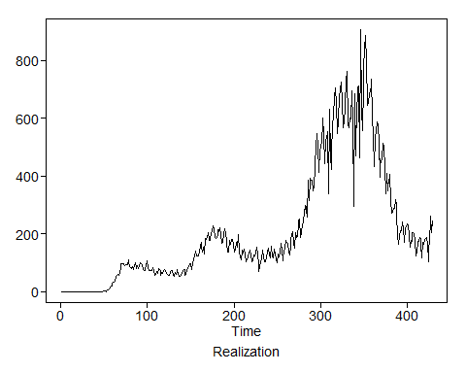

plotts.wge(All_Covid$icu_patients_per_million)

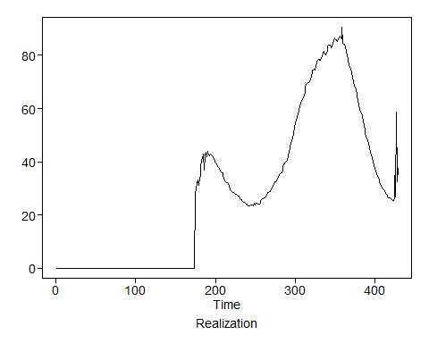

plotts.wge(All_Covid$hosp_patients_per_million)

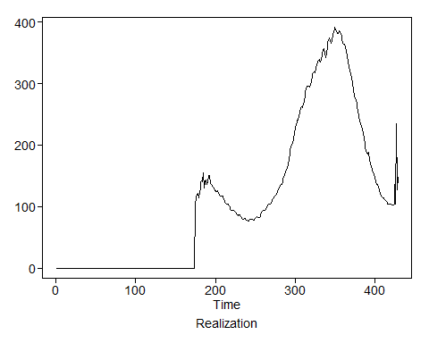

plotts.wge(All_Covid$new_vaccinations_smoothed_per_million)

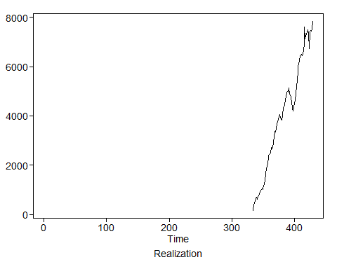

plotts.wge(All_Covid$new_deaths_per_million)

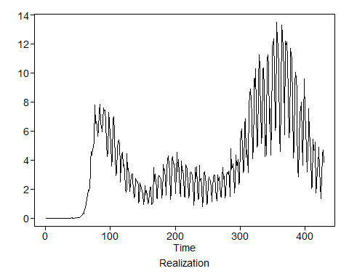

# Plotting time series for all variables Post Vaccine  
plotts.wge(Post_Vaccine$new_cases_per_million)

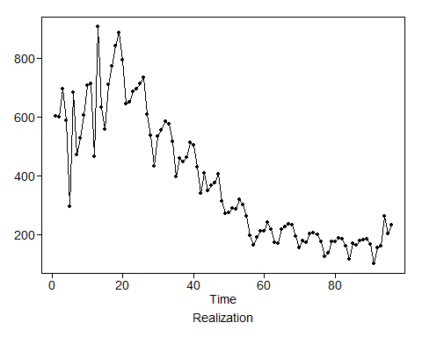

plotts.wge(Post_Vaccine$icu_patients_per_million)

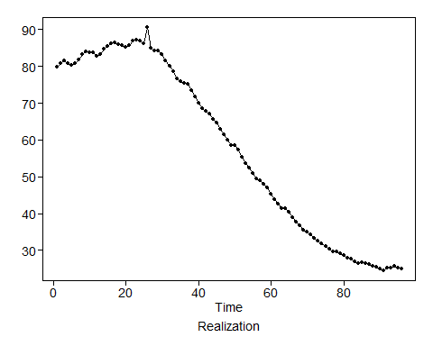

plotts.wge(Post_Vaccine$hosp_patients_per_million)

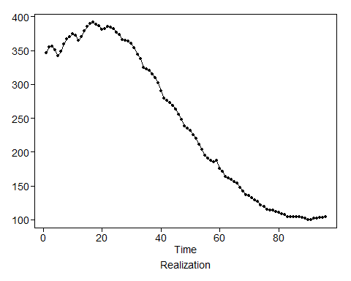

plotts.wge(Post_Vaccine$new_vaccinations_smoothed_per_million)

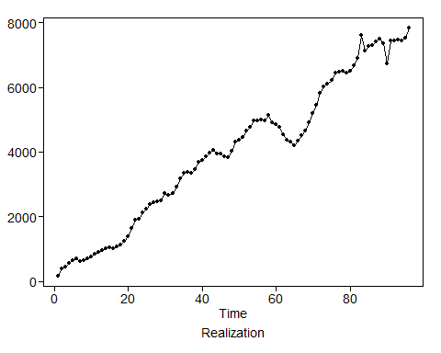

plotts.sample.wge(Post_Vaccine$new_deaths_per_million)

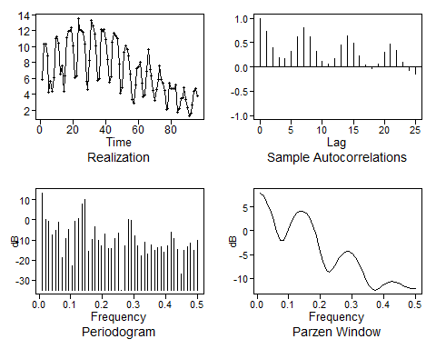

## $autplt  
## [1] 1.00000000 0.73924679 0.39319861 0.19136535 0.16605707  
## [6] 0.31555373 0.61873853 0.80447891 0.62269036 0.31663455  
## [11] 0.11686075 0.05243779 0.17584745 0.45067084 0.63267417  
## [16] 0.48665593 0.22107219 0.03480056 -0.04182223 0.05443786  
## [21] 0.30371212 0.46345231 0.33586596 0.09769245 -0.06443383  
## [26] -0.14549428  
##   
## $freq  
## [1] 0.01041667 0.02083333 0.03125000 0.04166667 0.05208333 0.06250000  
## [7] 0.07291667 0.08333333 0.09375000 0.10416667 0.11458333 0.12500000  
## [13] 0.13541667 0.14583333 0.15625000 0.16666667 0.17708333 0.18750000  
## [19] 0.19791667 0.20833333 0.21875000 0.22916667 0.23958333 0.25000000  
## [25] 0.26041667 0.27083333 0.28125000 0.29166667 0.30208333 0.31250000  
## [31] 0.32291667 0.33333333 0.34375000 0.35416667 0.36458333 0.37500000  
## [37] 0.38541667 0.39583333 0.40625000 0.41666667 0.42708333 0.43750000  
## [43] 0.44791667 0.45833333 0.46875000 0.47916667 0.48958333 0.50000000  
##   
## $db  
## [1] 13.38358616 -0.04328896 -0.75174151 -7.39894318 -5.36827217  
## [6] -1.37811985 -18.65942222 -9.16593121 -4.81889180 -22.75305069  
## [11] -0.77211585 0.54572886 7.95571565 9.93941684 -15.56200379  
## [16] -9.72457754 -3.38560102 -10.07724696 -12.72833848 -7.01784205  
## [21] -14.08874582 -14.14874488 -9.46702448 -6.70844920 -34.85089971  
## [26] -12.74161900 0.28877836 -0.24148581 -8.06338124 -12.89052420  
## [31] -18.01705539 -10.88015895 -17.18122820 -12.52831066 -14.98346501  
## [36] -13.80789350 -13.39160766 -15.87723676 -12.76930129 -5.93323504  
## [41] -9.12450411 -14.86457983 -26.89294306 -15.26595997 -13.47613264  
## [46] -11.75981173 -15.29994077 -10.07454685  
##   
## $dbz  
## [1] 7.9788031 7.2672461 6.0743600 4.3973430 2.2678901  
## [6] -0.1151091 -1.9929271 -2.0984330 -0.6209184 1.1639919  
## [11] 2.6360468 3.6397567 4.1442404 4.1419169 3.6253326  
## [16] 2.5826368 1.0007549 -1.1173108 -3.6908808 -6.3778929  
## [21] -8.3117954 -8.6721389 -7.8674247 -6.7118290 -5.6323643  
## [26] -4.8234984 -4.3885502 -4.3801163 -4.8170740 -5.6923301  
## [31] -6.9669555 -8.5427426 -10.2087892 -11.6078159 -12.3780204  
## [36] -12.4590336 -12.1037429 -11.5984253 -11.1315678 -10.8111772  
## [41] -10.6914415 -10.7802035 -11.0384540 -11.3843171 -11.7155324  
## [46] -11.9537425 -12.0792430 -12.1155303

### ARIMA Model 1 (with seasonal component, s = 7)

#ARIMA Models as this data is assumed non-stationary  
# Step 1 Check if data is white noise  
plotts.sample.wge(Post_Vaccine$new_deaths_per_million)



## $autplt  
## [1] 1.00000000 0.73924679 0.39319861 0.19136535 0.16605707  
## [6] 0.31555373 0.61873853 0.80447891 0.62269036 0.31663455  
## [11] 0.11686075 0.05243779 0.17584745 0.45067084 0.63267417  
## [16] 0.48665593 0.22107219 0.03480056 -0.04182223 0.05443786  
## [21] 0.30371212 0.46345231 0.33586596 0.09769245 -0.06443383  
## [26] -0.14549428  
##   
## $freq  
## [1] 0.01041667 0.02083333 0.03125000 0.04166667 0.05208333 0.06250000  
## [7] 0.07291667 0.08333333 0.09375000 0.10416667 0.11458333 0.12500000  
## [13] 0.13541667 0.14583333 0.15625000 0.16666667 0.17708333 0.18750000  
## [19] 0.19791667 0.20833333 0.21875000 0.22916667 0.23958333 0.25000000  
## [25] 0.26041667 0.27083333 0.28125000 0.29166667 0.30208333 0.31250000  
## [31] 0.32291667 0.33333333 0.34375000 0.35416667 0.36458333 0.37500000  
## [37] 0.38541667 0.39583333 0.40625000 0.41666667 0.42708333 0.43750000  
## [43] 0.44791667 0.45833333 0.46875000 0.47916667 0.48958333 0.50000000  
##   
## $db  
## [1] 13.38358616 -0.04328896 -0.75174151 -7.39894318 -5.36827217  
## [6] -1.37811985 -18.65942222 -9.16593121 -4.81889180 -22.75305069  
## [11] -0.77211585 0.54572886 7.95571565 9.93941684 -15.56200379  
## [16] -9.72457754 -3.38560102 -10.07724696 -12.72833848 -7.01784205  
## [21] -14.08874582 -14.14874488 -9.46702448 -6.70844920 -34.85089971  
## [26] -12.74161900 0.28877836 -0.24148581 -8.06338124 -12.89052420  
## [31] -18.01705539 -10.88015895 -17.18122820 -12.52831066 -14.98346501  
## [36] -13.80789350 -13.39160766 -15.87723676 -12.76930129 -5.93323504  
## [41] -9.12450411 -14.86457983 -26.89294306 -15.26595997 -13.47613264  
## [46] -11.75981173 -15.29994077 -10.07454685  
##   
## $dbz  
## [1] 7.9788031 7.2672461 6.0743600 4.3973430 2.2678901  
## [6] -0.1151091 -1.9929271 -2.0984330 -0.6209184 1.1639919  
## [11] 2.6360468 3.6397567 4.1442404 4.1419169 3.6253326  
## [16] 2.5826368 1.0007549 -1.1173108 -3.6908808 -6.3778929  
## [21] -8.3117954 -8.6721389 -7.8674247 -6.7118290 -5.6323643  
## [26] -4.8234984 -4.3885502 -4.3801163 -4.8170740 -5.6923301  
## [31] -6.9669555 -8.5427426 -10.2087892 -11.6078159 -12.3780204  
## [36] -12.4590336 -12.1037429 -11.5984253 -11.1315678 -10.8111772  
## [41] -10.6914415 -10.7802035 -11.0384540 -11.3843171 -11.7155324  
## [46] -11.9537425 -12.0792430 -12.1155303

acf(Post_Vaccine$new_deaths_per_million)   
parzen.wge(Post_Vaccine$new_deaths_per_million)

## $freq  
## [1] 0.01041667 0.02083333 0.03125000 0.04166667 0.05208333 0.06250000  
## [7] 0.07291667 0.08333333 0.09375000 0.10416667 0.11458333 0.12500000  
## [13] 0.13541667 0.14583333 0.15625000 0.16666667 0.17708333 0.18750000  
## [19] 0.19791667 0.20833333 0.21875000 0.22916667 0.23958333 0.25000000  
## [25] 0.26041667 0.27083333 0.28125000 0.29166667 0.30208333 0.31250000  
## [31] 0.32291667 0.33333333 0.34375000 0.35416667 0.36458333 0.37500000  
## [37] 0.38541667 0.39583333 0.40625000 0.41666667 0.42708333 0.43750000  
## [43] 0.44791667 0.45833333 0.46875000 0.47916667 0.48958333 0.50000000  
##   
## $pzgram  
## [1] 7.9788031 7.2672461 6.0743600 4.3973430 2.2678901  
## [6] -0.1151091 -1.9929271 -2.0984330 -0.6209184 1.1639919  
## [11] 2.6360468 3.6397567 4.1442404 4.1419169 3.6253326  
## [16] 2.5826368 1.0007549 -1.1173108 -3.6908808 -6.3778929  
## [21] -8.3117954 -8.6721389 -7.8674247 -6.7118290 -5.6323643  
## [26] -4.8234984 -4.3885502 -4.3801163 -4.8170740 -5.6923301  
## [31] -6.9669555 -8.5427426 -10.2087892 -11.6078159 -12.3780204  
## [36] -12.4590336 -12.1037429 -11.5984253 -11.1315678 -10.8111772  
## [41] -10.6914415 -10.7802035 -11.0384540 -11.3843171 -11.7155324  
## [46] -11.9537425 -12.0792430 -12.1155303

# This data set is not white noise, Autocorrelation are correlated. Damped sinusoidal indicating seasonality.  
  
#Bulding Models  
#ARIMA Model 1 Only Seasonality   
  
#Take out the s=7 (1-B^7) term from the model  
pv_s7 <- artrans.wge(Post_Vaccine$new_deaths_per_million,phi.tr = c(rep(0,6),1)) #Looks statinary

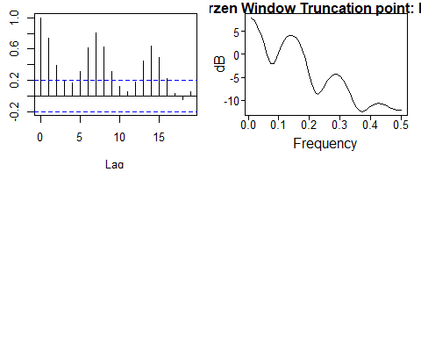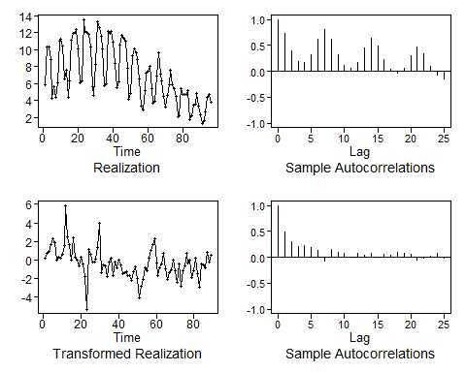

#Plot the timeseries without the seasonal component  
plotts.sample.wge(pv_s7)

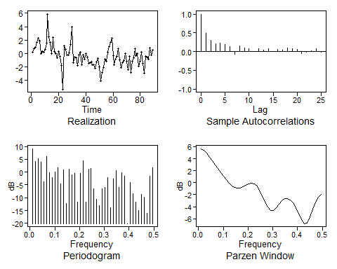

## $autplt  
## [1] 1.000000000 0.492180488 0.299766772 0.213089243 0.229396186  
## [6] 0.183677332 0.141909332 -0.067354143 0.147042664 0.091131712  
## [11] 0.081067140 0.011537174 0.078199694 0.047485936 0.075193179  
## [16] 0.006739226 0.055923563 0.032423785 0.100260130 0.071144592  
## [21] 0.059250540 -0.056189562 -0.016383601 0.017998032 0.080795779  
## [26] -0.019187692  
##   
## $freq  
## [1] 0.01123596 0.02247191 0.03370787 0.04494382 0.05617978 0.06741573  
## [7] 0.07865169 0.08988764 0.10112360 0.11235955 0.12359551 0.13483146  
## [13] 0.14606742 0.15730337 0.16853933 0.17977528 0.19101124 0.20224719  
## [19] 0.21348315 0.22471910 0.23595506 0.24719101 0.25842697 0.26966292  
## [25] 0.28089888 0.29213483 0.30337079 0.31460674 0.32584270 0.33707865  
## [31] 0.34831461 0.35955056 0.37078652 0.38202247 0.39325843 0.40449438  
## [37] 0.41573034 0.42696629 0.43820225 0.44943820 0.46067416 0.47191011  
## [43] 0.48314607 0.49438202  
##   
## $db  
## [1] 9.16405197 4.07488662 5.37430756 3.96627628 -3.85152335  
## [6] 6.19637279 -0.13694563 -2.21294200 0.05704151 1.68546786  
## [11] -4.53904475 0.96760308 -12.22322189 1.10724572 -1.14304363  
## [16] -0.44439686 -11.75326374 -0.58249618 4.34938832 -11.66188244  
## [21] 1.09207923 1.34202972 -6.56859978 -10.56045389 -12.94669805  
## [26] -6.45976335 -6.04322323 -2.25645380 -13.80650261 -2.60128366  
## [31] 0.57694076 -6.01416586 -0.34343245 -1.55988204 -20.09144758  
## [36] -3.94552598 -8.40304597 -11.77125917 -14.88780164 -8.68176633  
## [41] -9.82368199 -16.16512670 -1.54036469 1.65378534  
##   
## $dbz  
## [1] 5.67582676 5.36873305 4.89287908 4.29804713 3.64187226  
## [6] 2.97429944 2.32347514 1.69417607 1.08141145 0.48923046  
## [11] -0.05733847 -0.51246906 -0.82169108 -0.94386270 -0.87603907  
## [16] -0.66624378 -0.40246773 -0.18576173 -0.10648527 -0.23305597  
## [21] -0.60924722 -1.25112607 -2.13402073 -3.15998188 -4.11233134  
## [26] -4.67768251 -4.65985654 -4.18731419 -3.56438998 -3.02980270  
## [31] -2.70606390 -2.64369362 -2.86026276 -3.35815200 -4.12431621  
## [36] -5.10511538 -6.13343801 -6.82365751 -6.69662320 -5.73289342  
## [41] -4.43283409 -3.25053835 -2.40281570 -1.96756367

#Overfitting  
est.ar.wge(Post_Vaccine$new_deaths_per_million, p=10, type='burg')

##   
## Coefficients of Original polynomial:   
## 0.5536 -0.0193 0.0857 -0.0049 -0.0853 0.2286 0.5595 -0.1781 -0.1493 -0.0437   
##   
## Factor Roots Abs Recip System Freq   
## 1-1.2402B+0.9784B^2 0.6338+-0.7877i 0.9892 0.1422  
## 1-0.9788B 1.0217 0.9788 0.0000  
## 1+0.4129B+0.9012B^2 -0.2291+-1.0282i 0.9493 0.2849  
## 1+1.4865B+0.6800B^2 -1.0930+-0.5253i 0.8246 0.4287  
## 1-0.7062B 1.4161 0.7062 0.0000  
## 1+0.4722B+0.1054B^2 -2.2401+-2.1143i 0.3246 0.3796  
##   
##

## $phi  
## [1] 0.553589364 -0.019316268 0.085735201 -0.004904562 -0.085261659  
## [6] 0.228646043 0.559491742 -0.178106108 -0.149342180 -0.043678239  
##   
## $res  
## [1] -0.38095255 1.27335697 -0.24728887 0.76000753 -1.77349638  
## [6] 1.63853732 -0.81103872 0.04805977 1.41958216 0.05784013  
## [11] 1.73449922 -0.06842955 1.74204304 -1.76003728 0.06261579  
## [16] 0.88054517 0.02248746 1.96681789 3.67320919 0.63766902  
## [21] -0.80325048 -1.09238408 3.13700420 -1.25158741 0.02176969  
## [26] -0.45087442 0.75250787 -0.71883394 -2.15462603 -2.23615266  
## [31] 3.09208879 0.62409106 -0.14823268 0.17647564 -0.40724456  
## [36] 1.42482035 3.33549621 -2.44949107 -0.12957686 -0.69072969  
## [41] -0.69496304 0.33385322 -0.05183209 -0.01171220 -0.01472176  
## [46] -0.23107782 0.60435853 -0.46737714 -1.28157399 -0.68339391  
## [51] 0.39101605 -0.88225262 -0.78416953 -0.80903892 -0.05143122  
## [56] -0.33335934 -1.57569241 -2.04379326 -0.71187965 -0.48344840  
## [61] 0.65961699 -0.61054584 0.61908603 0.76929206 1.31790215  
## [66] 1.61734261 -2.07262104 -1.11191683 -0.68789290 -0.01779155  
## [71] 0.93743785 -1.30113059 -0.74879773 -1.13695101 0.09418679  
## [76] 0.42199793 -1.45174988 -1.42245830 0.49450707 -1.99699263  
## [81] -0.02449981 -0.06989499 1.28828350 -1.15273942 -0.17404870  
## [86] -1.31088245 -0.77159348 0.89529843 -1.90516378 -1.43581293  
## [91] -0.01879617 -0.09983680 -0.25856235 0.67511943 -0.22147557  
## [96] -0.01569065  
##   
## $avar  
## [1] 1.491563  
##   
## $aic  
## [1] 0.6289909  
##   
## $aicc  
## [1] 1.688981  
##   
## $bic  
## [1] 0.9228225

#aic with defaults  
aic.wge(pv_s7) #=p=4, q=1

## $type  
## [1] "aic"  
##   
## $value  
## [1] 0.6759946  
##   
## $p  
## [1] 4  
##   
## $q  
## [1] 1  
##   
## $phi  
## [1] -0.42786774 0.43299184 0.04853331 0.17183275  
##   
## $theta  
## [1] -0.9471465  
##   
## $vara  
## [1] 1.718004

arma_s7_1 <- est.arma.wge(pv_s7, p=4, q=1)

##   
## Coefficients of Original polynomial:   
## -0.4279 0.4330 0.0485 0.1718   
##   
## Factor Roots Abs Recip System Freq   
## 1+0.9915B -1.0086 0.9915 0.5000  
## 1-0.7219B 1.3853 0.7219 0.0000  
## 1+0.1582B+0.2401B^2 -0.3296+-2.0141i 0.4900 0.2758  
##   
##

#residuals  
plotts.sample.wge(arma_s7_1$res,arlimits = T) #Residuals not white noise

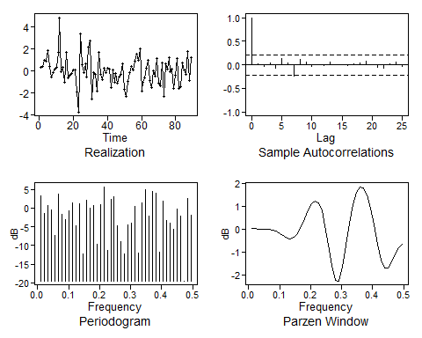

## $autplt  
## [1] 1.0000000000 0.0133111056 -0.0377762716 0.0360261071 -0.0750652450  
## [6] 0.1296215473 0.0497015005 -0.2483066169 0.1217109200 0.0610226774  
## [11] -0.0337191131 0.0016071293 -0.0238589853 0.0646591851 -0.0016082686  
## [16] 0.0002678429 -0.0237093208 0.0219909167 0.0372003324 0.0857732595  
## [21] 0.0019404344 -0.0518530464 -0.0721966394 0.0313406865 0.0566506492  
## [26] -0.0380707823  
##   
## $freq  
## [1] 0.01123596 0.02247191 0.03370787 0.04494382 0.05617978 0.06741573  
## [7] 0.07865169 0.08988764 0.10112360 0.11235955 0.12359551 0.13483146  
## [13] 0.14606742 0.15730337 0.16853933 0.17977528 0.19101124 0.20224719  
## [19] 0.21348315 0.22471910 0.23595506 0.24719101 0.25842697 0.26966292  
## [25] 0.28089888 0.29213483 0.30337079 0.31460674 0.32584270 0.33707865  
## [31] 0.34831461 0.35955056 0.37078652 0.38202247 0.39325843 0.40449438  
## [37] 0.41573034 0.42696629 0.43820225 0.44943820 0.46067416 0.47191011  
## [43] 0.48314607 0.49438202  
##   
## $db  
## [1] 3.16511473 -1.52117846 0.64692449 -0.42240332 -7.43896959  
## [6] 3.73127425 -1.71255287 -3.13335850 -0.74676501 1.41282669  
## [11] -4.74213806 1.20451364 -12.30440175 1.99070209 -0.01414299  
## [16] 0.65654244 -9.72270621 0.89312591 5.69470180 -11.41954841  
## [21] 2.44309035 2.94764754 -4.69994213 -9.08761188 -12.26381132  
## [26] -4.50006621 -4.15229073 0.41484313 -12.00120718 1.31805897  
## [31] 4.85348391 -2.22004364 4.53074670 3.89109318 -11.89694144  
## [36] 1.74051351 -3.25965569 -3.99805437 -5.73697207 -0.33334461  
## [41] -2.11257995 -19.51413473 2.56746569 -1.87102100  
##   
## $dbz  
## [1] 0.04499331 0.02173661 -0.00177432 -0.01443642 -0.01619729  
## [6] -0.01945961 -0.04199865 -0.09648074 -0.18266454 -0.28492406  
## [11] -0.37425178 -0.41296073 -0.36216059 -0.19424906 0.09049337  
## [16] 0.45291842 0.82062094 1.10754632 1.23390852 1.13775273  
## [21] 0.78053106 0.15570159 -0.68676039 -1.58783571 -2.23124357  
## [26] -2.26562309 -1.64757544 -0.68923500 0.27677939 1.06459762  
## [31] 1.59757356 1.84930699 1.81389587 1.49817318 0.92799066  
## [36] 0.16662946 -0.65873078 -1.35000360 -1.71125386 -1.69171536  
## [41] -1.42196858 -1.08681671 -0.81576820 -0.67009418

#Check bic  
aic5.wge(pv_s7, p=0:13, q=0:3, type="bic") #BIC picks ARMA(1,0) model. Looking at the data, this does not look appropriate.

## ---------WORKING... PLEASE WAIT...   
##   
##   
## Error in aic calculation at 1 3   
## Error in aic calculation at 2 3   
## Error in aic calculation at 4 3   
## Error in aic calculation at 10 2   
## Five Smallest Values of bic

## p q bic  
## 5 1 0 0.7485879  
## 6 1 1 0.7902914  
## 9 2 0 0.7929518  
## 3 0 2 0.8172374  
## 2 0 1 0.8214123

#arma_s7_d1 <- est.arma.wge(pv_s7_d1, p=7, q=3)  
for_aruma2_s7 = fore.aruma.wge(Post_Vaccine$new_deaths_per_million,s=7, phi = arma_s7_1$phi,n.ahead = 10, lastn = T)

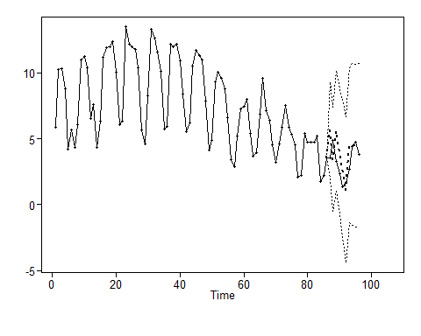

plot(as.numeric(Post_Vaccine$new_deaths_per_million), type = "l", xlim = c(1,96), main = "Last 10 Day forecast with p=7, q=3 and s=7")  
lines(seq(87,96,1),for_aruma2_s7$f, col = "red")

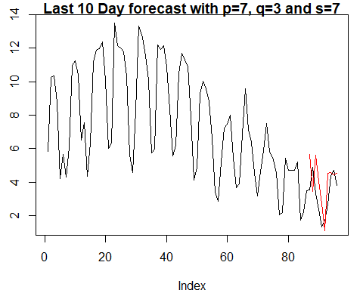

#ASE  
arma_s7_ase = mean((for_aruma2_s7$f - Post_Vaccine$new_deaths_per_million[(96-10+1):96])^2)  
arma_s7_ase

## [1] 2.076175

#Rolling_Window_ASE  
Rolling_Window_ASE(Post_Vaccine$new_deaths_per_million, trainingSize = 70, horizon = 10, d = 0, phis = arma_s7_1$phi,  
 s= 7, thetas = arma_s7_1$theta)

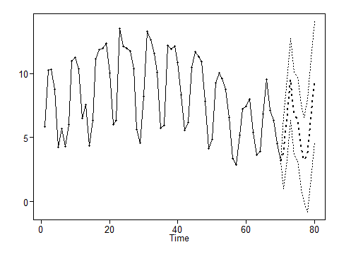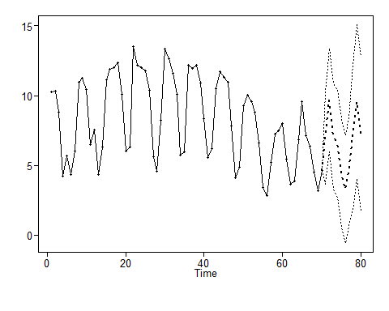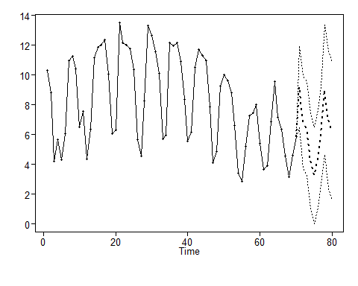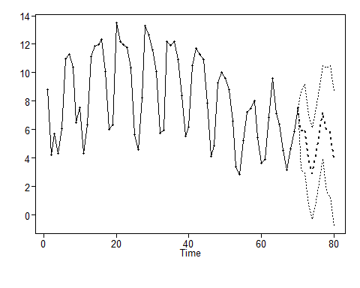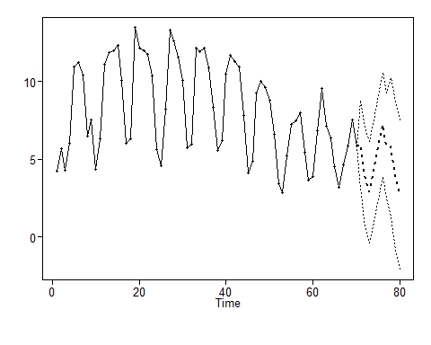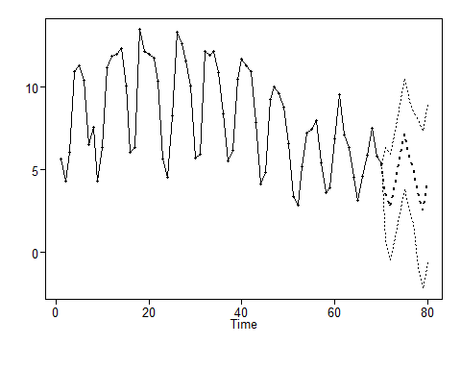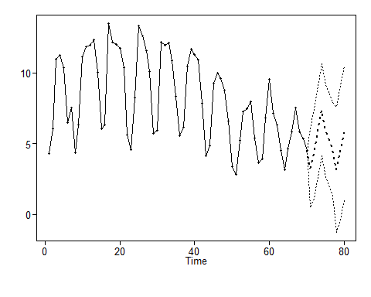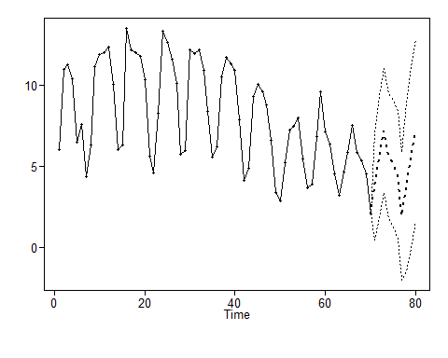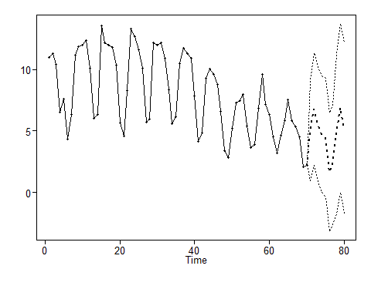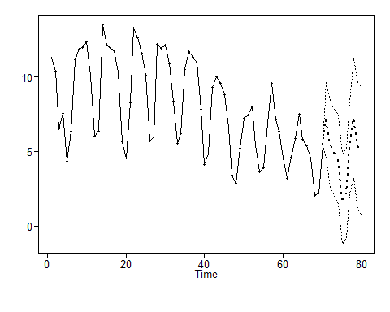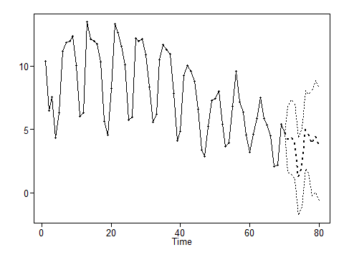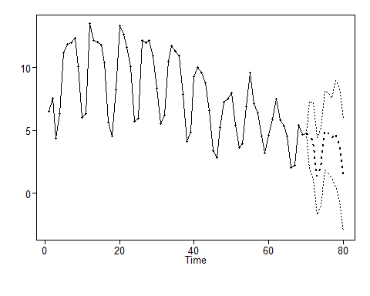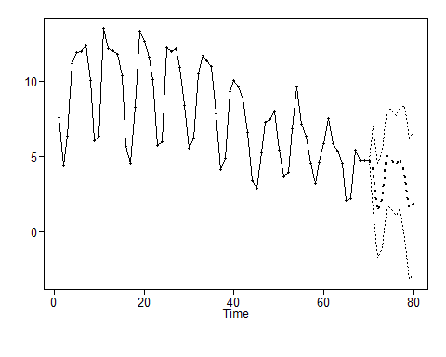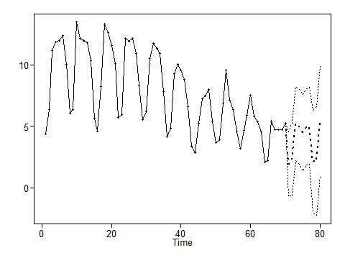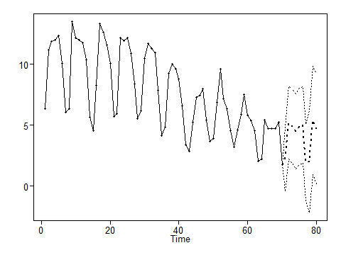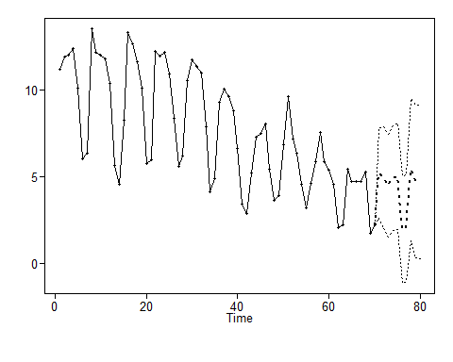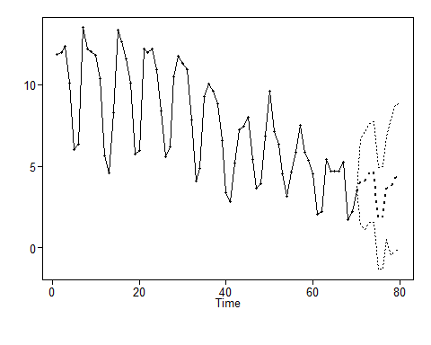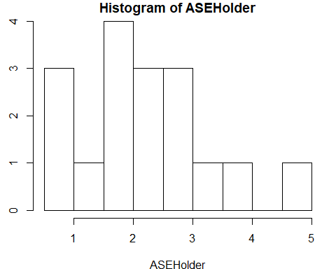

## [1] 10  
## [1] 70  
## [1] "The Summary Statistics for the Rolling Window ASE Are:"  
## Min. 1st Qu. Median Mean 3rd Qu. Max.   
## 0.9702 1.6788 2.2482 2.2539 2.7086 4.8301   
## [1] "The Rolling Window ASE is: 2.2538629137224"

## [1] 2.253863

#Forecasting  
#Next 10  
for_aruma2_s7_f10 = fore.aruma.wge(Post_Vaccine$new_deaths_per_million,s=7, phi = arma_s7_1$phi,n.ahead = 10)

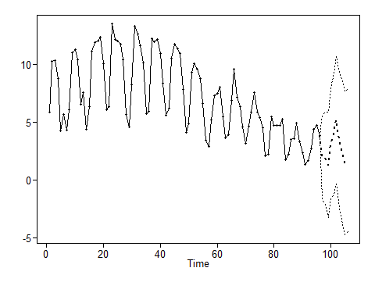

plot(as.numeric(Post_Vaccine$new_deaths_per_million), type = "l", xlim = c(1,101), main = "Next 10 Day forecast with p=7, q=3 and s=7")  
lines(seq(97,106,1),for_aruma2_s7_f10$f, col = "red")

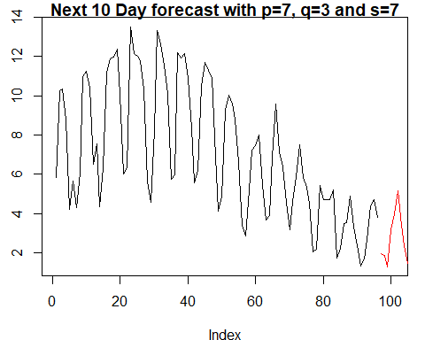

#Next 40  
for_aruma2_s7_f40 = fore.aruma.wge(Post_Vaccine$new_deaths_per_million,s=7, phi = arma_s7_1$phi,n.ahead = 40)

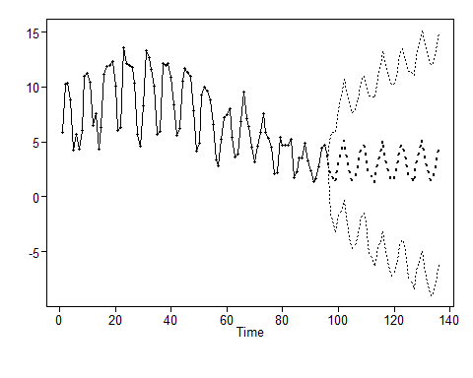

plot(as.numeric(Post_Vaccine$new_deaths_per_million), type = "l", xlim = c(1,136), main = "Next 40 Day forecast with with p=7, q=3 and s=7")  
lines(seq(96,135,1),for_aruma2_s7_f40$f, col = "red")

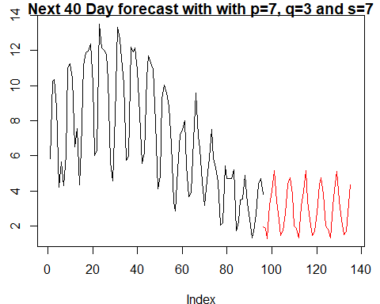

#Next 180  
for_aruma2_s7_f180 = fore.aruma.wge(Post_Vaccine$new_deaths_per_million,s=7, phi = arma_s7_1$phi,n.ahead = 180)

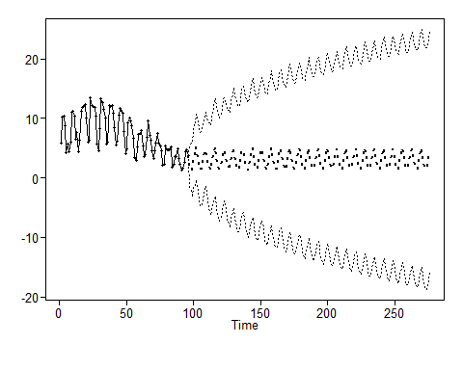

plot(as.numeric(Post_Vaccine$new_deaths_per_million), type = "l", xlim = c(1,276), main = "Next 180 Day forecast with p=7, q=3 and s=7")  
lines(seq(97,276,1),for_aruma2_s7_f180$f, col = "red")

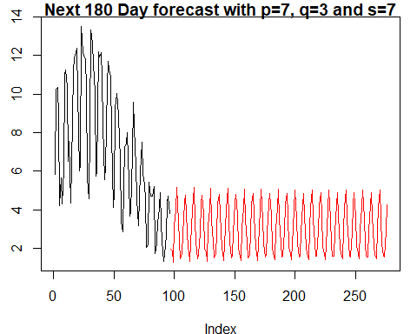

#Next 380  
for_aruma2_s7_f380 = fore.aruma.wge(Post_Vaccine$new_deaths_per_million,s=7, phi = arma_s7_1$phi,n.ahead = 380)

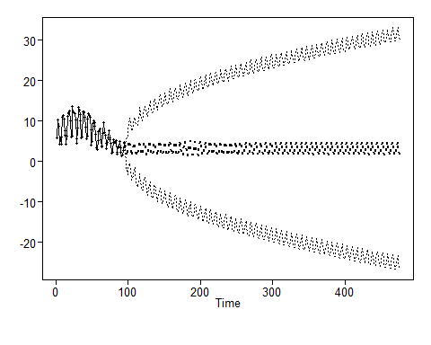

plot(as.numeric(Post_Vaccine$new_deaths_per_million), type = "l", xlim = c(1,476), main = "Next 10 Day forecast with p=7, q=3 and s=7")  
lines(seq(97,476,1),for_aruma2_s7_f380$f, col = "red")

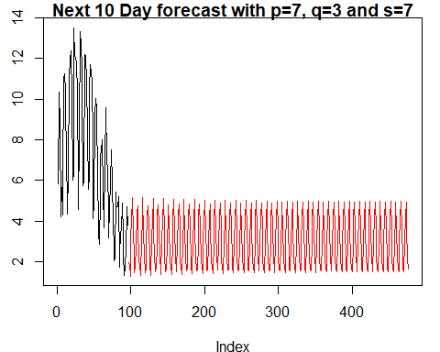

### ARMA MODEL 2 - (with (1-B) component)

# overfitting to check non stationary portion of the data  
est.ar.wge(Post_Vaccine$new_deaths_per_million, p=8, type='burg') #has one 1-0.9868B

##   
## Coefficients of Original polynomial:   
## 0.6105 -0.1117 0.0222 -0.0007 -0.0816 0.2254 0.5762 -0.2837   
##   
## Factor Roots Abs Recip System Freq   
## 1-0.9868B 1.0133 0.9868 0.0000  
## 1-1.2341B+0.9673B^2 0.6379+-0.7917i 0.9835 0.1421  
## 1+0.4502B+0.9015B^2 -0.2497+-1.0232i 0.9495 0.2881  
## 1+1.5912B+0.7652B^2 -1.0398+-0.4752i 0.8747 0.4318  
## 1-0.4309B 2.3205 0.4309 0.0000  
##   
##

## $phi  
## [1] 0.6105124076 -0.1117396292 0.0222221729 -0.0007395317 -0.0815648629  
## [6] 0.2254343105 0.5762355978 -0.2837410524  
##   
## $res  
## [1] -0.395967551 1.412382837 -0.262528353 0.642458488 -1.769929618  
## [6] 1.486845251 -0.920722449 0.133877695 1.467078233 0.168383118  
## [11] 1.692432954 -0.009618396 1.652627698 -1.415288592 0.268812894  
## [16] 1.004441629 0.174783230 1.882634588 3.676864986 0.322574139  
## [21] -0.174359237 -0.768964700 3.488453151 -1.190383726 0.139261616  
## [26] -0.298916532 0.802287438 -0.876023197 -2.264964790 -2.201857114  
## [31] 3.440926848 -0.247540763 -0.387604666 0.313236396 -0.393871247  
## [36] 1.219944926 3.233965987 -2.484785325 0.501737648 -0.657136371  
## [41] -0.832051410 0.320646089 -0.397447960 -0.171959374 0.293088150  
## [46] -0.505689198 0.545988447 -0.606554288 -1.365936926 -0.726750912  
## [51] 0.294926337 -0.921699580 -0.920083197 -0.976694497 -0.178883129  
## [56] -0.645250289 -1.874015679 -2.045693216 -0.580525947 -0.873063802  
## [61] 0.265574157 -0.918324125 0.459088551 0.540648571 1.228638870  
## [66] 1.716508445 -1.939398452 -0.796768668 -0.422414205 -0.226119625  
## [71] 0.766816503 -1.418711372 -0.583548431 -0.971105108 -0.198890363  
## [76] 0.283228350 -1.647584629 -1.442203539 0.613180527 -2.257846760  
## [81] 0.028389017 -0.345533947 1.090004103 -1.289275466 -0.170318214  
## [86] -1.261766943 -0.533543898 0.729455680 -2.082129334 -1.393772694  
## [91] 0.123863314 -0.542962997 -0.343373755 0.726750325 -0.379203270  
## [96] 0.134596076  
##   
## $avar  
## [1] 1.538098  
##   
## $aic  
## [1] 0.6180465  
##   
## $aicc  
## [1] 1.665841  
##   
## $bic  
## [1] 0.8584541

# 1st difference  
pv_dif1 <- artrans.wge(Post_Vaccine$new_deaths_per_million, phi.tr=1)#dif data does not look like white noise.

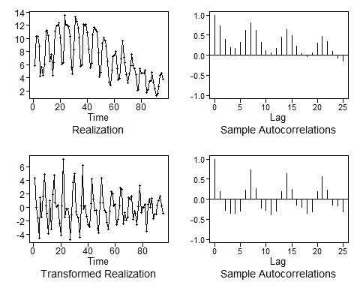

plotts.sample.wge(pv_dif1, arlimits = T)

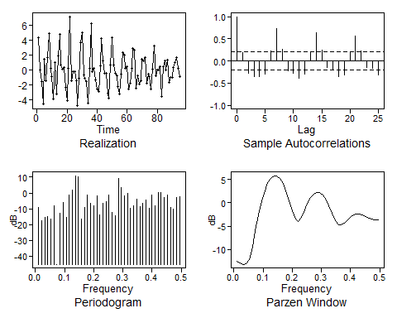

## $autplt  
## [1] 1.0000000 0.1829721 -0.2849749 -0.3608558 -0.3599959 -0.3005161  
## [7] 0.2334081 0.7310677 0.2649303 -0.2164156 -0.2681506 -0.3857824  
## [13] -0.2979713 0.1962294 0.6450992 0.2456240 -0.1543115 -0.2107155  
## [19] -0.3587187 -0.3068705 0.1814334 0.5695782 0.2365243 -0.1421584  
## [25] -0.1699776 -0.3195886  
##   
## $freq  
## [1] 0.01052632 0.02105263 0.03157895 0.04210526 0.05263158 0.06315789  
## [7] 0.07368421 0.08421053 0.09473684 0.10526316 0.11578947 0.12631579  
## [13] 0.13684211 0.14736842 0.15789474 0.16842105 0.17894737 0.18947368  
## [19] 0.20000000 0.21052632 0.22105263 0.23157895 0.24210526 0.25263158  
## [25] 0.26315789 0.27368421 0.28421053 0.29473684 0.30526316 0.31578947  
## [31] 0.32631579 0.33684211 0.34736842 0.35789474 0.36842105 0.37894737  
## [37] 0.38947368 0.40000000 0.41052632 0.42105263 0.43157895 0.44210526  
## [43] 0.45263158 0.46315789 0.47368421 0.48421053 0.49473684  
##   
## $db  
## [1] -9.1447854 -17.5152409 -15.2217035 -14.9483634 -16.3616096  
## [6] -7.9817964 -45.0710116 -13.0450700 -6.1762515 -15.6690427  
## [11] -1.3854730 1.6535434 10.8920771 10.2193492 -16.4890836  
## [16] -9.4007269 -1.2487324 -6.7457546 -8.3066540 -1.7381442  
## [21] -13.7238194 -6.7195505 -5.6034071 -1.4702385 -12.2003715  
## [26] -14.1900449 8.9418766 3.1645957 -1.9220632 -0.4066820  
## [31] -9.5157392 -7.9162448 -4.0282890 -8.4591908 -6.3743177  
## [36] -4.3450179 -9.4047613 -1.5259365 -8.2762607 0.4892745  
## [41] 0.4036087 -2.9976560 -1.4914511 -8.9984662 -10.3793638  
## [46] -2.9386257 -2.5320579  
##   
## $dbz  
## [1] -12.4451922 -12.8227637 -13.1370990 -13.0916798 -12.1167990  
## [6] -9.5301209 -5.9587015 -2.5061310 0.3773855 2.6192123  
## [11] 4.2460509 5.2962917 5.7991779 5.7716621 5.2202531  
## [16] 4.1464253 2.5608484 0.5253171 -1.7255003 -3.5449330  
## [21] -4.0139922 -3.0898128 -1.5882803 -0.1054644 1.0983031  
## [26] 1.9119495 2.2865782 2.2034478 1.6620878 0.6820996  
## [31] -0.6762250 -2.2593908 -3.7425763 -4.6649628 -4.7856215  
## [36] -4.3306474 -3.6751986 -3.0656378 -2.6239360 -2.4039716  
## [41] -2.4140284 -2.6181534 -2.9358211 -3.2582865 -3.4930791  
## [46] -3.6120759 -3.6501624

dif1_aic <- aic.wge(pv_dif1) #p=5, q=2  
arima_1_diff1 <- est.arma.wge(pv_dif1, p=5, q=2)

##   
## Coefficients of Original polynomial:   
## 0.2025 -0.6998 -0.2596 -0.3568 -0.5102   
##   
## Factor Roots Abs Recip System Freq   
## 1-1.2498B+0.9790B^2 0.6383+-0.7836i 0.9895 0.1412  
## 1+0.3766B+0.7771B^2 -0.2423+-1.1082i 0.8815 0.2843  
## 1+0.6706B -1.4911 0.6706 0.5000  
##   
##

#Examine model residuals  
plotts.sample.wge(arima_1_diff1$res, arlimits = T) #Not white noise, model needs improvement

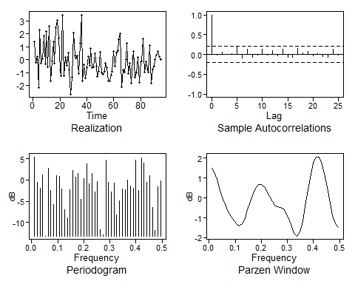

## $autplt  
## [1] 1.000000000 -0.016366806 0.054503248 0.002332935 0.025854277  
## [6] 0.211628198 -0.084437349 0.128636457 -0.074199295 -0.016021224  
## [11] 0.142565771 -0.023295876 0.095217566 -0.037238769 0.135927595  
## [16] -0.077909711 -0.069864550 0.144421426 0.049922851 0.077595812  
## [21] -0.025247490 0.021675670 -0.056095901 -0.078544644 0.131544968  
## [26] -0.006282457  
##   
## $freq  
## [1] 0.01052632 0.02105263 0.03157895 0.04210526 0.05263158 0.06315789  
## [7] 0.07368421 0.08421053 0.09473684 0.10526316 0.11578947 0.12631579  
## [13] 0.13684211 0.14736842 0.15789474 0.16842105 0.17894737 0.18947368  
## [19] 0.20000000 0.21052632 0.22105263 0.23157895 0.24210526 0.25263158  
## [25] 0.26315789 0.27368421 0.28421053 0.29473684 0.30526316 0.31578947  
## [31] 0.32631579 0.33684211 0.34736842 0.35789474 0.36842105 0.37894737  
## [37] 0.38947368 0.40000000 0.41052632 0.42105263 0.43157895 0.44210526  
## [43] 0.45263158 0.46315789 0.47368421 0.48421053 0.49473684  
##   
## $db  
## [1] 5.40611344 -0.49803418 -1.99280291 1.24806517 -13.16482918  
## [6] 2.73873122 -2.50766171 -5.75026381 0.98753922 0.76260924  
## [11] -2.03933164 -7.05586782 -8.80392032 -2.22635319 2.15348220  
## [16] 0.71192840 1.61447550 -4.50276392 0.39830853 3.70851584  
## [21] -0.85886176 1.51362400 -2.79414454 -0.45141704 -11.65743526  
## [26] -12.90335034 4.70365429 -0.53994101 -2.87455108 -0.76125682  
## [31] -8.16728522 -4.95700989 -2.14838280 -2.28333603 -0.09824085  
## [36] -1.36737049 -1.90344899 4.60318677 -2.37414887 5.11286181  
## [41] 4.02378696 -0.52134385 1.05860385 -6.49212578 -11.77147755  
## [46] -1.60313804 -0.15740303  
##   
## $dbz  
## [1] 1.49396923 1.22061557 0.82056493 0.36867844 -0.05692298  
## [6] -0.40760236 -0.68388135 -0.91896019 -1.13685527 -1.31783882  
## [11] -1.39651923 -1.30237900 -1.01979945 -0.60932980 -0.16881942  
## [16] 0.21709169 0.49768339 0.65109649 0.67265326 0.56889674  
## [21] 0.36085787 0.09215278 -0.17062685 -0.36057095 -0.45304991  
## [26] -0.49067354 -0.55886590 -0.73353367 -1.03926746 -1.42785331  
## [31] -1.77527779 -1.91350576 -1.71381094 -1.17196461 -0.40539628  
## [36] 0.42356923 1.17080225 1.73104415 2.03652701 2.05185713  
## [41] 1.77295286 1.23311007 0.51508516 -0.24360069 -0.88215138  
## [46] -1.29468920 -1.47906613

#forecast using diff-1  
#Last 10  
for_aruma1_diff1 = fore.aruma.wge(Post_Vaccine$new_deaths_per_million,d=1, phi = arima_1_diff1$phi,n.ahead = 10, lastn = T)

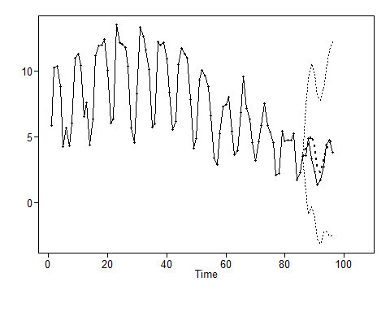

plot(as.numeric(Post_Vaccine$new_deaths_per_million), type = "l", xlim = c(1,96), main = "Last 10 Day forecast with p=5, q=2, s=0 and d=1")  
lines(seq(87,96,1),for_aruma1_diff1$f, col = "red")

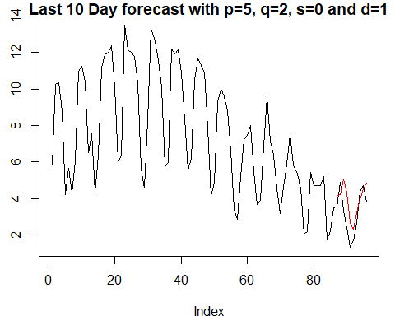

#Forecast future 10  
for_aruma1_diff_f10 = fore.aruma.wge(Post_Vaccine$new_deaths_per_million,d=1, phi = arima_1_diff1$phi,n.ahead = 10)

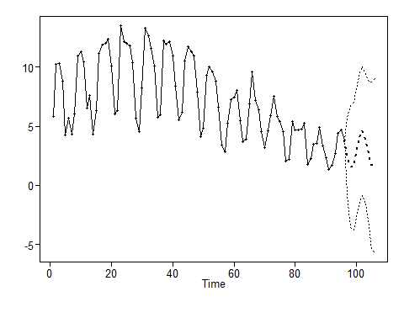

plot(as.numeric(Post_Vaccine$new_deaths_per_million), type = "l", xlim = c(1,106), main = "Next 10 Day forecast with p=5, q=2, s=0 and d=1")  
lines(seq(97,106,1),for_aruma1_diff_f10$f, col = "red")

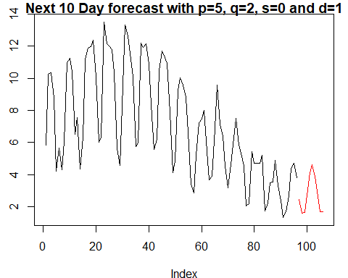

#Forecast future 40  
for_aruma1_diff_f40 = fore.aruma.wge(Post_Vaccine$new_deaths_per_million,d=1, phi = arima_1_diff1$phi,n.ahead = 40)

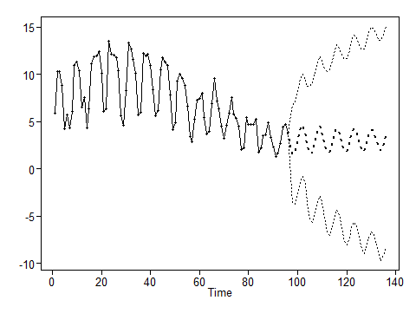

plot(as.numeric(Post_Vaccine$new_deaths_per_million), type = "l", xlim = c(1,136), main = "Next 40 Day forecast with p=5, q=2, s=0 and d=1")  
lines(seq(96,135,1),for_aruma1_diff_f40$f, col = "red")

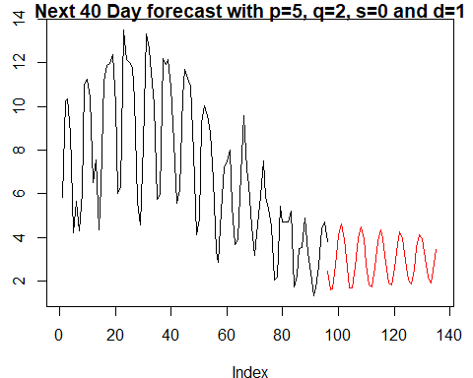

#Forecast future 180  
for_aruma1_diff_f180 = fore.aruma.wge(Post_Vaccine$new_deaths_per_million,d=1, phi = arima_1_diff1$phi,n.ahead = 180)

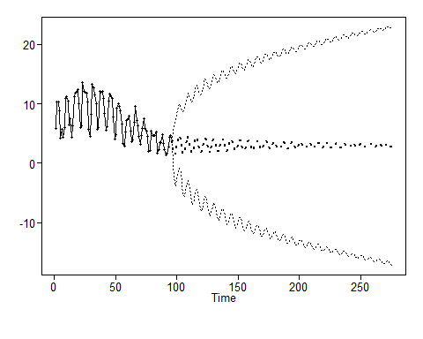

#Forecast future 380  
for_aruma1_diff_f380 = fore.aruma.wge(Post_Vaccine$new_deaths_per_million,d=1, phi = arima_1_diff1$phi,n.ahead = 380)

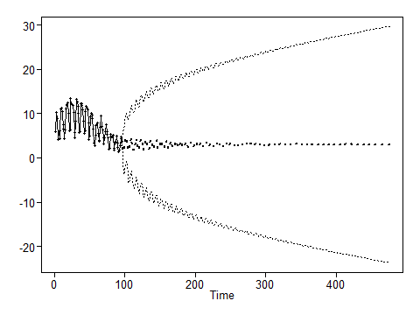

plot(as.numeric(Post_Vaccine$new_deaths_per_million), type = "l", xlim = c(1,476), main = "Next 380 Day forecast with p=5, q=2, s=0 and d=1")  
lines(seq(97,476,1),for_aruma1_diff_f380$f, col = "red")

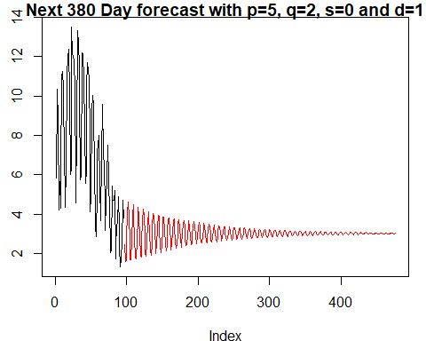

#ASE  
arima1_diff1_ase = mean((for_aruma1_diff1$f - Post_Vaccine$new_deaths_per_million[(96-10+1):96])^2)  
arima1_diff1_ase

## [1] 1.159396

Rolling_Window_ASE(Post_Vaccine$new_deaths_per_million, trainingSize = 70, horizon = 10, d = 1, phis = arima_1_diff1$phi,  
 s= 0, thetas = arima_1_diff1$theta)

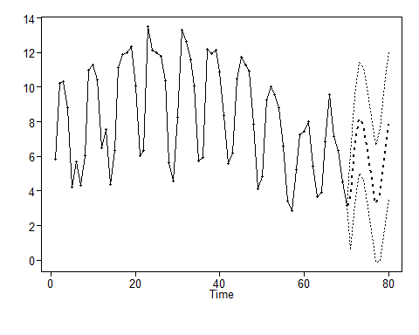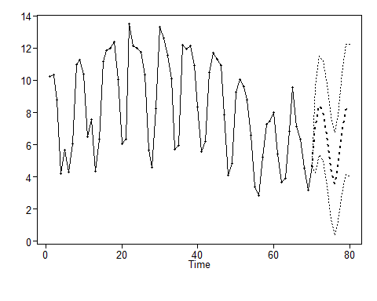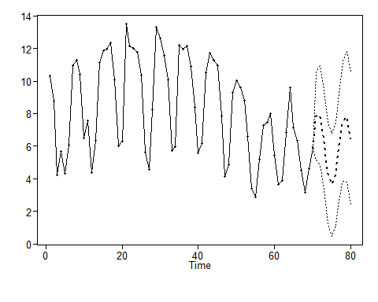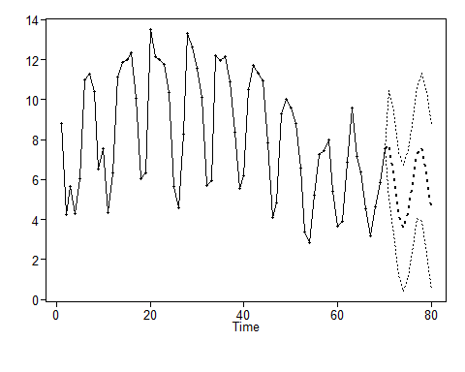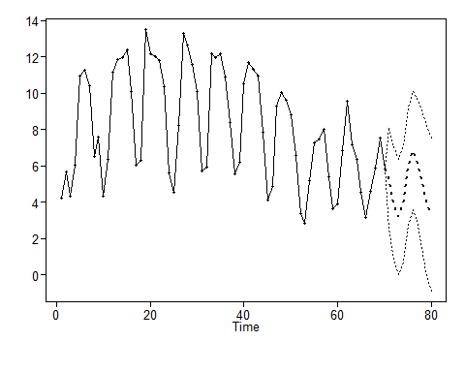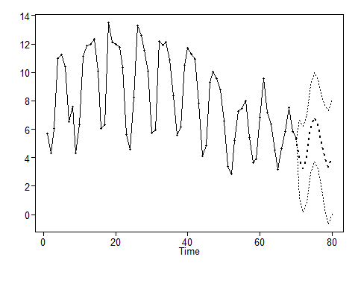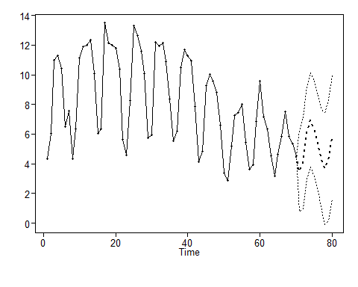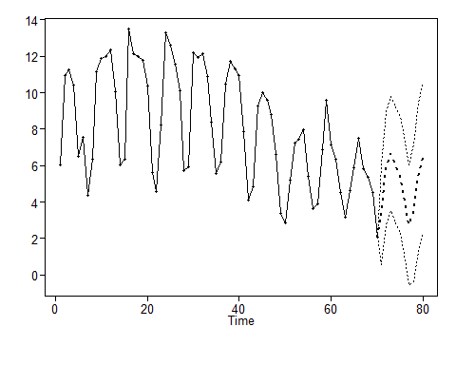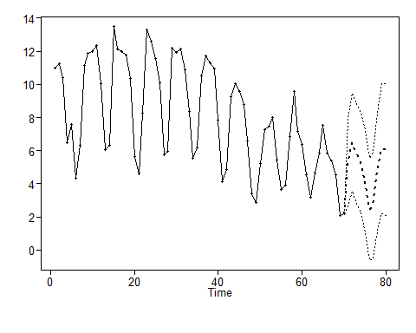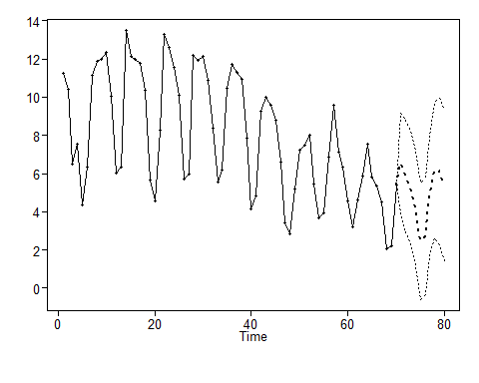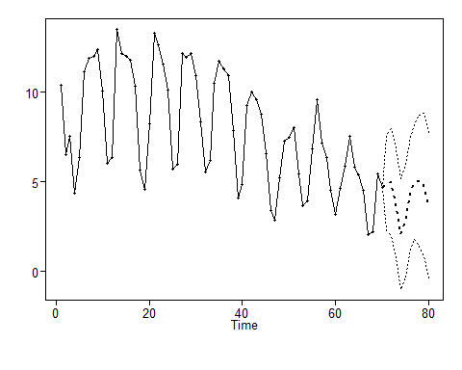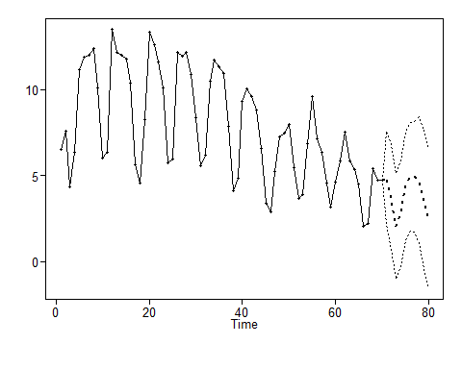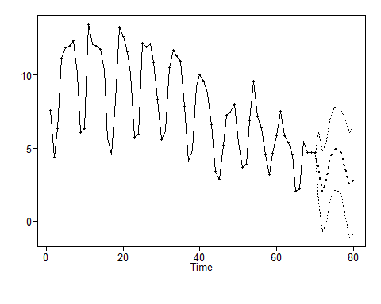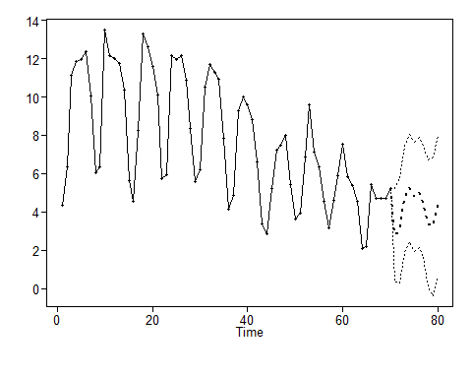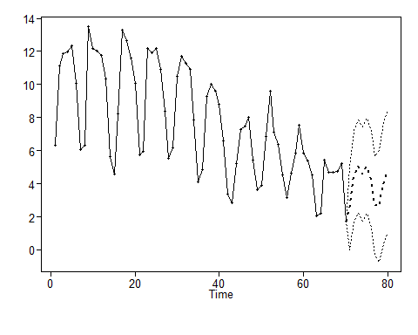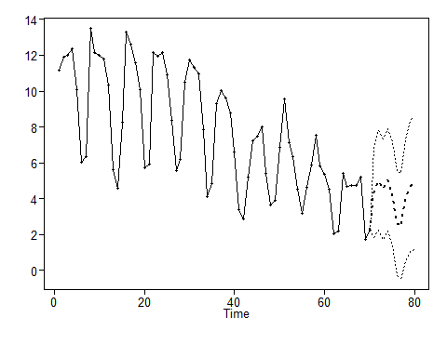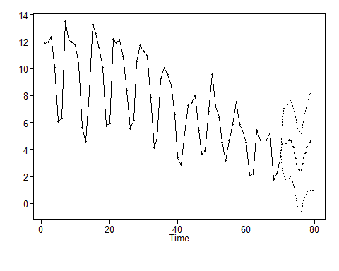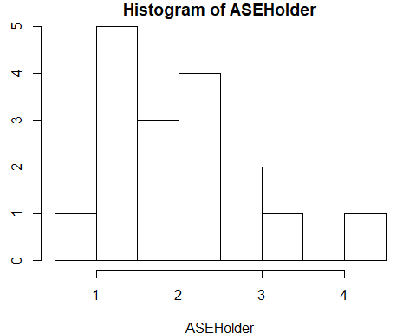

## [1] 10  
## [1] 70  
## [1] "The Summary Statistics for the Rolling Window ASE Are:"  
## Min. 1st Qu. Median Mean 3rd Qu. Max.   
## 0.9537 1.3391 1.9846 2.0191 2.3092 4.2075   
## [1] "The Rolling Window ASE is: 2.01912770779326"

## [1] 2.019128

### ARIMA - (with both seasonal(s = 7) and trend(1-B) components)

#Seasonality plus 1-B  
plotts.sample.wge(pv_dif1)

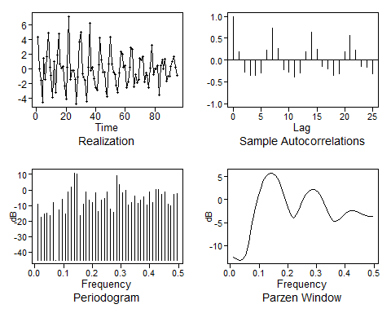

## $autplt  
## [1] 1.0000000 0.1829721 -0.2849749 -0.3608558 -0.3599959 -0.3005161  
## [7] 0.2334081 0.7310677 0.2649303 -0.2164156 -0.2681506 -0.3857824  
## [13] -0.2979713 0.1962294 0.6450992 0.2456240 -0.1543115 -0.2107155  
## [19] -0.3587187 -0.3068705 0.1814334 0.5695782 0.2365243 -0.1421584  
## [25] -0.1699776 -0.3195886  
##   
## $freq  
## [1] 0.01052632 0.02105263 0.03157895 0.04210526 0.05263158 0.06315789  
## [7] 0.07368421 0.08421053 0.09473684 0.10526316 0.11578947 0.12631579  
## [13] 0.13684211 0.14736842 0.15789474 0.16842105 0.17894737 0.18947368  
## [19] 0.20000000 0.21052632 0.22105263 0.23157895 0.24210526 0.25263158  
## [25] 0.26315789 0.27368421 0.28421053 0.29473684 0.30526316 0.31578947  
## [31] 0.32631579 0.33684211 0.34736842 0.35789474 0.36842105 0.37894737  
## [37] 0.38947368 0.40000000 0.41052632 0.42105263 0.43157895 0.44210526  
## [43] 0.45263158 0.46315789 0.47368421 0.48421053 0.49473684  
##   
## $db  
## [1] -9.1447854 -17.5152409 -15.2217035 -14.9483634 -16.3616096  
## [6] -7.9817964 -45.0710116 -13.0450700 -6.1762515 -15.6690427  
## [11] -1.3854730 1.6535434 10.8920771 10.2193492 -16.4890836  
## [16] -9.4007269 -1.2487324 -6.7457546 -8.3066540 -1.7381442  
## [21] -13.7238194 -6.7195505 -5.6034071 -1.4702385 -12.2003715  
## [26] -14.1900449 8.9418766 3.1645957 -1.9220632 -0.4066820  
## [31] -9.5157392 -7.9162448 -4.0282890 -8.4591908 -6.3743177  
## [36] -4.3450179 -9.4047613 -1.5259365 -8.2762607 0.4892745  
## [41] 0.4036087 -2.9976560 -1.4914511 -8.9984662 -10.3793638  
## [46] -2.9386257 -2.5320579  
##   
## $dbz  
## [1] -12.4451922 -12.8227637 -13.1370990 -13.0916798 -12.1167990  
## [6] -9.5301209 -5.9587015 -2.5061310 0.3773855 2.6192123  
## [11] 4.2460509 5.2962917 5.7991779 5.7716621 5.2202531  
## [16] 4.1464253 2.5608484 0.5253171 -1.7255003 -3.5449330  
## [21] -4.0139922 -3.0898128 -1.5882803 -0.1054644 1.0983031  
## [26] 1.9119495 2.2865782 2.2034478 1.6620878 0.6820996  
## [31] -0.6762250 -2.2593908 -3.7425763 -4.6649628 -4.7856215  
## [36] -4.3306474 -3.6751986 -3.0656378 -2.6239360 -2.4039716  
## [41] -2.4140284 -2.6181534 -2.9358211 -3.2582865 -3.4930791  
## [46] -3.6120759 -3.6501624

pv_s7_d1 <- artrans.wge(pv_dif1,phi.tr = c(rep(0,6),1)) #Looks statinary

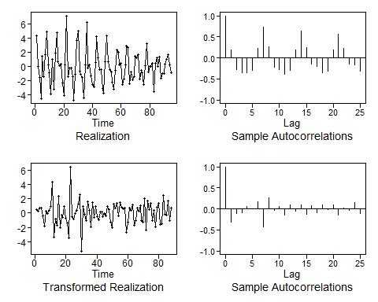

plotts.sample.wge(pv_s7_d1)

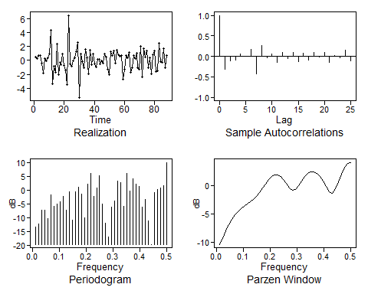

## $autplt  
## [1] 1.000000000 -0.310489297 -0.108797691 -0.097201773 0.058890926  
## [6] -0.003543395 0.178997215 -0.424863312 0.261685568 -0.041392776  
## [11] 0.059461184 -0.151476480 0.105238964 -0.059635158 0.103862480  
## [16] -0.119913933 0.082902182 -0.098411931 0.104543127 -0.023775132  
## [21] 0.099846159 -0.146811040 0.014406847 -0.039855995 0.158195165  
## [26] -0.114622681  
##   
## $freq  
## [1] 0.01136364 0.02272727 0.03409091 0.04545455 0.05681818 0.06818182  
## [7] 0.07954545 0.09090909 0.10227273 0.11363636 0.12500000 0.13636364  
## [13] 0.14772727 0.15909091 0.17045455 0.18181818 0.19318182 0.20454545  
## [19] 0.21590909 0.22727273 0.23863636 0.25000000 0.26136364 0.27272727  
## [25] 0.28409091 0.29545455 0.30681818 0.31818182 0.32954545 0.34090909  
## [31] 0.35227273 0.36363636 0.37500000 0.38636364 0.39772727 0.40909091  
## [37] 0.42045455 0.43181818 0.44318182 0.45454545 0.46590909 0.47727273  
## [43] 0.48863636 0.50000000  
##   
## $db  
## [1] -13.3604568 -12.2220301 -7.4012596 -7.2847222 -10.4496042  
## [6] -1.7456939 -5.9337457 -5.0909825 -4.1490614 -2.2346615  
## [11] -7.2088406 -0.6040349 -11.0293421 -0.5624124 0.9898893  
## [16] -1.3787451 -10.1832260 2.1951342 5.9785213 -2.2660619  
## [21] 0.9335691 5.1498756 -5.1276850 -12.0322733 -17.0711550  
## [26] -6.2845356 -3.8616592 3.3654951 2.7925788 -6.0014150  
## [31] 6.1073378 -0.3369475 4.2486121 2.2993108 1.3249688  
## [36] -6.2279128 -3.4789517 -11.0473726 -19.7086141 -0.9642477  
## [41] 0.1445992 0.7589488 1.5658848 10.0682368  
##   
## $dbz  
## [1] -10.40935994 -9.32761767 -8.07608475 -6.92408967 -5.96208710  
## [6] -5.19509494 -4.59385150 -4.11545638 -3.71217855 -3.33591517  
## [11] -2.93984038 -2.47939218 -1.91866082 -1.24620501 -0.49130192  
## [16] 0.27659188 0.96805325 1.49769540 1.79833578 1.82548337  
## [21] 1.56004216 1.01881612 0.28320967 -0.45299537 -0.87735351  
## [26] -0.73664301 -0.09406032 0.75022898 1.52951710 2.10029961  
## [31] 2.40321242 2.41845112 2.14261281 1.58209921 0.76411634  
## [36] -0.21638297 -1.08870944 -1.34844939 -0.65772975 0.65740598  
## [41] 2.02938041 3.12138550 3.80286978 4.03293524

#Overfitting  
est.ar.wge(Post_Vaccine$new_deaths_per_million, p=8, type='burg')

##   
## Coefficients of Original polynomial:   
## 0.6105 -0.1117 0.0222 -0.0007 -0.0816 0.2254 0.5762 -0.2837   
##   
## Factor Roots Abs Recip System Freq   
## 1-0.9868B 1.0133 0.9868 0.0000  
## 1-1.2341B+0.9673B^2 0.6379+-0.7917i 0.9835 0.1421  
## 1+0.4502B+0.9015B^2 -0.2497+-1.0232i 0.9495 0.2881  
## 1+1.5912B+0.7652B^2 -1.0398+-0.4752i 0.8747 0.4318  
## 1-0.4309B 2.3205 0.4309 0.0000  
##   
##

## $phi  
## [1] 0.6105124076 -0.1117396292 0.0222221729 -0.0007395317 -0.0815648629  
## [6] 0.2254343105 0.5762355978 -0.2837410524  
##   
## $res  
## [1] -0.395967551 1.412382837 -0.262528353 0.642458488 -1.769929618  
## [6] 1.486845251 -0.920722449 0.133877695 1.467078233 0.168383118  
## [11] 1.692432954 -0.009618396 1.652627698 -1.415288592 0.268812894  
## [16] 1.004441629 0.174783230 1.882634588 3.676864986 0.322574139  
## [21] -0.174359237 -0.768964700 3.488453151 -1.190383726 0.139261616  
## [26] -0.298916532 0.802287438 -0.876023197 -2.264964790 -2.201857114  
## [31] 3.440926848 -0.247540763 -0.387604666 0.313236396 -0.393871247  
## [36] 1.219944926 3.233965987 -2.484785325 0.501737648 -0.657136371  
## [41] -0.832051410 0.320646089 -0.397447960 -0.171959374 0.293088150  
## [46] -0.505689198 0.545988447 -0.606554288 -1.365936926 -0.726750912  
## [51] 0.294926337 -0.921699580 -0.920083197 -0.976694497 -0.178883129  
## [56] -0.645250289 -1.874015679 -2.045693216 -0.580525947 -0.873063802  
## [61] 0.265574157 -0.918324125 0.459088551 0.540648571 1.228638870  
## [66] 1.716508445 -1.939398452 -0.796768668 -0.422414205 -0.226119625  
## [71] 0.766816503 -1.418711372 -0.583548431 -0.971105108 -0.198890363  
## [76] 0.283228350 -1.647584629 -1.442203539 0.613180527 -2.257846760  
## [81] 0.028389017 -0.345533947 1.090004103 -1.289275466 -0.170318214  
## [86] -1.261766943 -0.533543898 0.729455680 -2.082129334 -1.393772694  
## [91] 0.123863314 -0.542962997 -0.343373755 0.726750325 -0.379203270  
## [96] 0.134596076  
##   
## $avar  
## [1] 1.538098  
##   
## $aic  
## [1] 0.6180465  
##   
## $aicc  
## [1] 1.665841  
##   
## $bic  
## [1] 0.8584541

#aic with defaults  
aic.wge(pv_s7_d1) #=p=0 q=2

## $type  
## [1] "aic"  
##   
## $value  
## [1] 0.7419945  
##   
## $p  
## [1] 0  
##   
## $q  
## [1] 2  
##   
## $phi  
## [1] 0  
##   
## $theta  
## [1] 0.5978693 0.2840983  
##   
## $vara  
## [1] 1.961702

#Check bic  
aic5.wge(pv_s7_d1, p=0:13, q=0:3, type="bic") #BIC picks MA(2) model. Looking at the data, this does not look appropriate.

## ---------WORKING... PLEASE WAIT...   
##   
##   
## Error in aic calculation at 3 2   
## Error in aic calculation at 3 3   
## Five Smallest Values of bic

## p q bic  
## 3 0 2 0.8264491  
## 2 0 1 0.8410476  
## 4 0 3 0.8789084  
## 6 1 1 0.8793909  
## 29 7 0 0.9121151

#aic with bigger p and q range  
aic.wge(pv_s7_d1, p=0:13, q=0:3) #=p=7 q=0

## $type  
## [1] "aic"  
##   
## $value  
## [1] 0.6869027  
##   
## $p  
## [1] 7  
##   
## $q  
## [1] 0  
##   
## $phi  
## [1] -0.40091849 -0.37704006 -0.32101509 -0.22790505 -0.17732419 -0.03340181  
## [7] -0.38601519  
##   
## $theta  
## [1] 0  
##   
## $vara  
## [1] 1.657126

arima_s7_d1 <- est.ar.wge(pv_s7_d1, p=7, type='burg')

##   
## Coefficients of Original polynomial:   
## -0.4043 -0.3805 -0.3330 -0.2273 -0.1792 -0.0318 -0.3981   
##   
## Factor Roots Abs Recip System Freq   
## 1+0.9256B -1.0804 0.9256 0.5000  
## 1+1.1234B+0.8137B^2 -0.6903+-0.8674i 0.9021 0.3570  
## 1-0.3342B+0.7895B^2 0.2116+-1.1054i 0.8885 0.2199  
## 1-1.3105B+0.6694B^2 0.9788+-0.7319i 0.8182 0.1022  
##   
##

#residuals  
plotts.sample.wge(arima_s7_d1$res, arlimits = T) #Much better model residuals

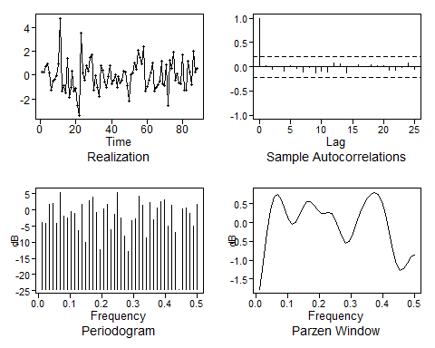

## $autplt  
## [1] 1.000000000 0.019981407 -0.044545692 0.007099925 -0.083089823  
## [6] 0.023080402 -0.027706775 -0.109170850 -0.018925376 -0.126356402  
## [11] -0.092552967 -0.114069069 0.082793873 0.062516232 -0.124033594  
## [16] 0.008950829 0.041389898 0.007846784 0.038008294 0.030155077  
## [21] 0.027149544 -0.062078547 -0.073221877 -0.012868532 0.081410078  
## [26] -0.046902137  
##   
## $freq  
## [1] 0.01136364 0.02272727 0.03409091 0.04545455 0.05681818 0.06818182  
## [7] 0.07954545 0.09090909 0.10227273 0.11363636 0.12500000 0.13636364  
## [13] 0.14772727 0.15909091 0.17045455 0.18181818 0.19318182 0.20454545  
## [19] 0.21590909 0.22727273 0.23863636 0.25000000 0.26136364 0.27272727  
## [25] 0.28409091 0.29545455 0.30681818 0.31818182 0.32954545 0.34090909  
## [31] 0.35227273 0.36363636 0.37500000 0.38636364 0.39772727 0.40909091  
## [37] 0.42045455 0.43181818 0.44318182 0.45454545 0.46590909 0.47727273  
## [43] 0.48863636 0.50000000  
##   
## $db  
## [1] -3.9515446 -4.2113149 1.6461729 1.9041508 -4.1162478  
## [6] 5.3562119 -1.9262027 -2.5646471 -0.5698288 -1.0870752  
## [11] -6.4815411 1.8317864 -10.1318551 2.9763482 4.0479796  
## [16] -0.8112941 -12.2578872 0.3713146 1.6279814 -6.2174057  
## [21] -1.3637767 5.4815943 -2.5610656 -7.9519876 -12.8394052  
## [26] -3.4424914 -2.6091713 4.2250037 1.4172525 -8.7457783  
## [31] 2.2450812 -2.9041104 0.6079985 2.6193152 3.2860079  
## [36] -4.8926547 1.5509569 -6.9836817 -24.5516785 0.2680124  
## [41] 0.6193338 -1.0847123 -4.9570825 1.6174128  
##   
## $dbz  
## [1] -1.772213069 -1.056868847 -0.278226542 0.328301022 0.669868529  
## [6] 0.742143947 0.596192940 0.328688985 0.070812262 -0.052615868  
## [11] 0.009380827 0.202567318 0.414060526 0.545282004 0.553450055  
## [16] 0.459072068 0.330792819 0.245775260 0.235163742 0.258006205  
## [21] 0.233569870 0.101463605 -0.133996286 -0.391235396 -0.543798021  
## [26] -0.503069101 -0.287685712 0.004070721 0.278920572 0.495272553  
## [31] 0.653487118 0.761116457 0.805073115 0.749266078 0.555232274  
## [36] 0.210021686 -0.250655220 -0.732578349 -1.104849684 -1.268001564  
## [41] -1.224346646 -1.070402317 -0.923816720 -0.865810634

#Forecast last 10  
for_aruma2_s7d1 = fore.aruma.wge(Post_Vaccine$new_deaths_per_million,d=1,s=7, phi = arima_s7_d1$phi,n.ahead = 10, lastn = T)

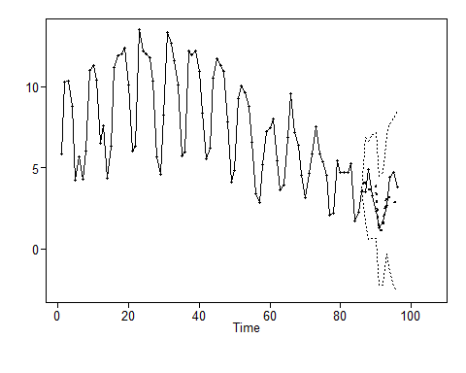

plot(as.numeric(Post_Vaccine$new_deaths_per_million), type = "l", xlim = c(1,96), main = "Last 10 Day forecast with p=7, q=0, s=7 and d=1")  
lines(seq(87,96,1),for_aruma2_s7d1$f, col = "red")

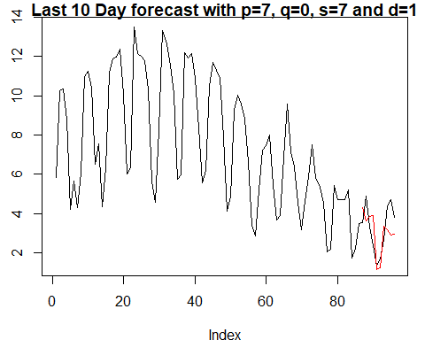

#Forecast last 16  
for_aruma2_s7d1_16 = fore.aruma.wge(Post_Vaccine$new_deaths_per_million,d=1,s=7, phi = arima_s7_d1$phi,n.ahead = 16, lastn = T)

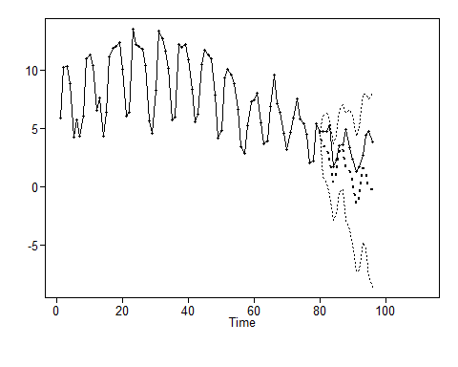

plot(as.numeric(Post_Vaccine$new_deaths_per_million), type = "l", xlim = c(1,96), main = "Last 16 Day forecast with p=7, q=0, s=7 and d=1")  
lines(seq(81,96,1),for_aruma2_s7d1_16$f, col = "red")

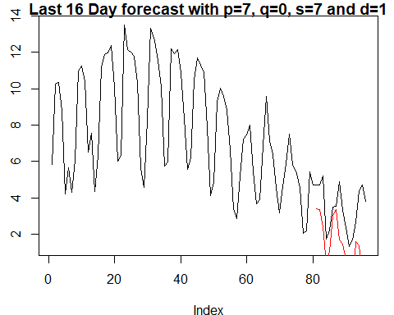

#ASE  
arma_s7_d1_ase = mean((for_aruma2_s7d1_16$f - Post_Vaccine$new_deaths_per_million[(96-16+1):96])^2)  
arma_s7_d1_ase

## [1] 6.068007

#Rolling_Window_ASE  
Rolling_Window_ASE(Post_Vaccine$new_deaths_per_million, trainingSize = 70, horizon = 10, d = 1, phis = arima_s7_d1$phi,  
 s= 7, theta = 0)

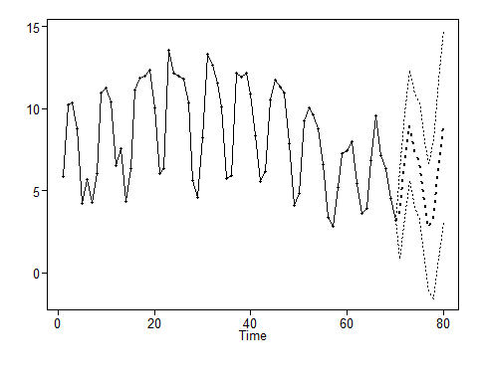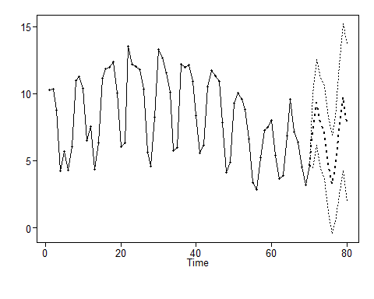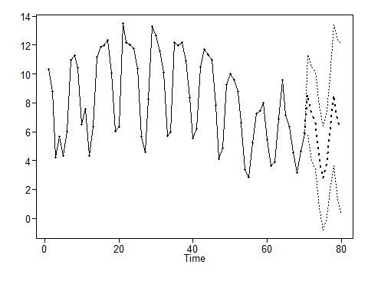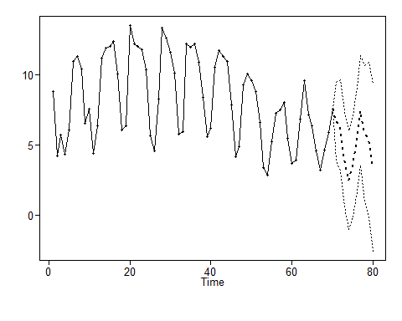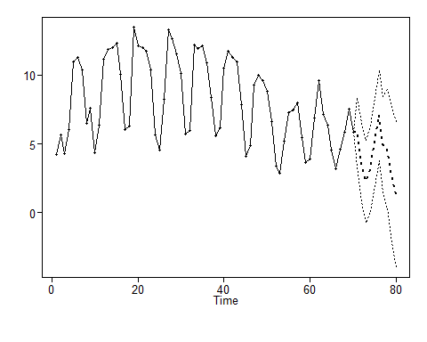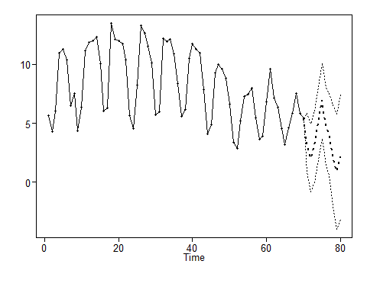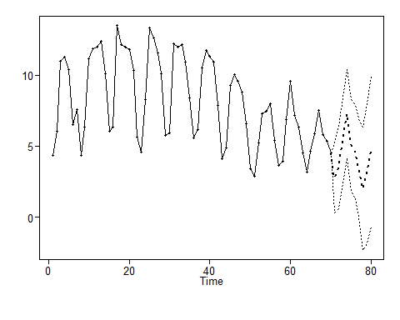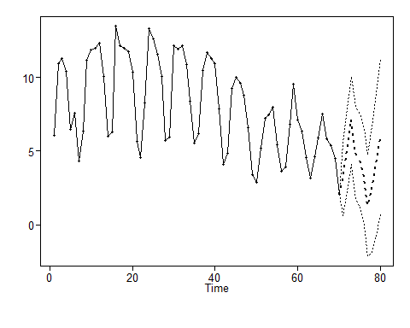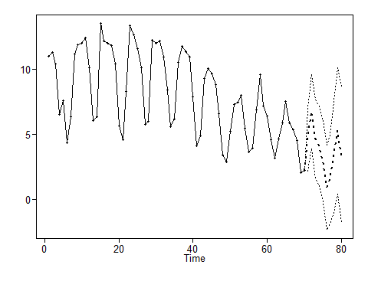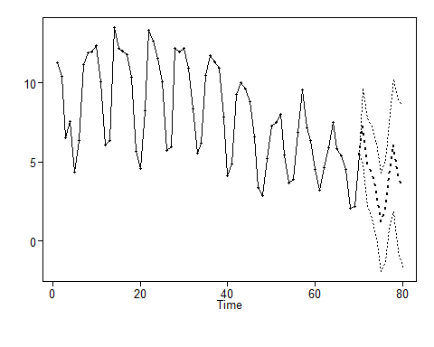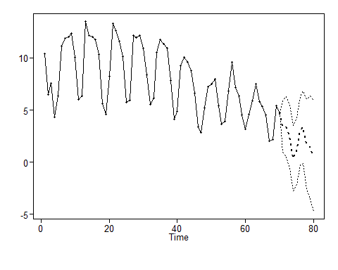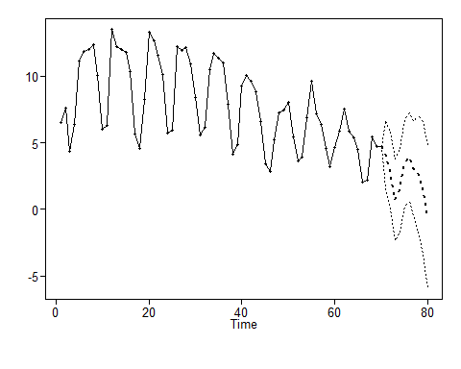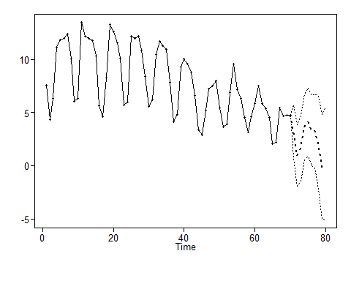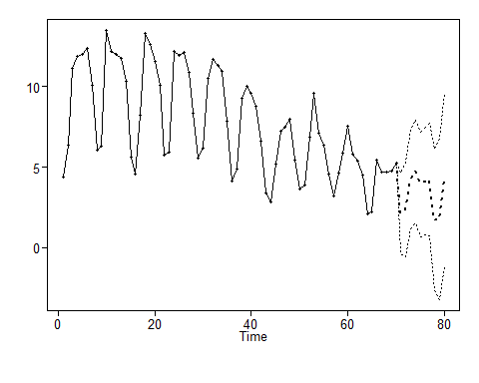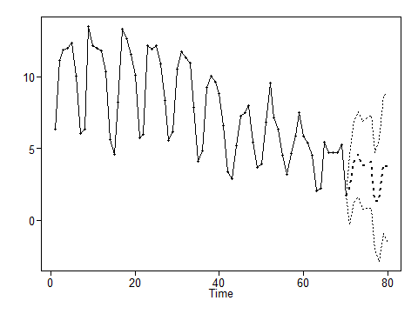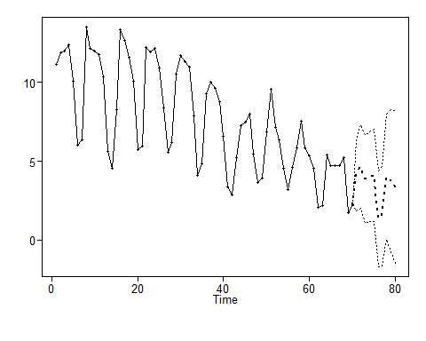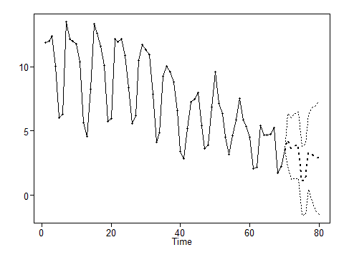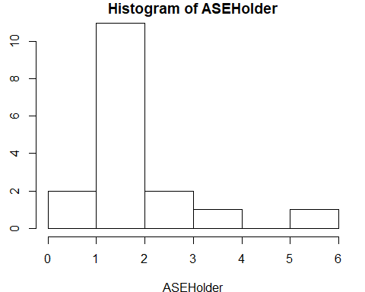

## [1] 10  
## [1] 70  
## [1] "The Summary Statistics for the Rolling Window ASE Are:"  
## Min. 1st Qu. Median Mean 3rd Qu. Max.   
## 0.805 1.201 1.616 1.924 1.877 5.670   
## [1] "The Rolling Window ASE is: 1.92382631816256"

## [1] 1.923826

#Future forecasts  
for_aruma2_s7d1_f14 = fore.aruma.wge(Post_Vaccine$new_deaths_per_million,d=1, s=7, phi = arima_s7_d1$phi,n.ahead = 14)

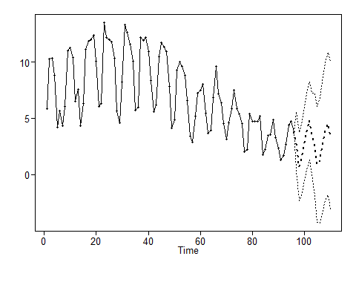

plot(as.numeric(Post_Vaccine$new_deaths_per_million), type = "l", xlim = c(1,110), main = "Next 14 Day forecast with p=7, q=0, s=7 and d=1")  
lines(seq(97,110,1),for_aruma2_s7d1_f14$f, col = "red")

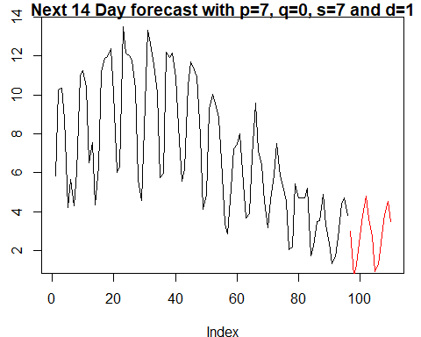

for_aruma2_s7d1_f40 = fore.aruma.wge(Post_Vaccine$new_deaths_per_million,d=1,s=7, phi = arima_s7_d1$phi,n.ahead = 40)

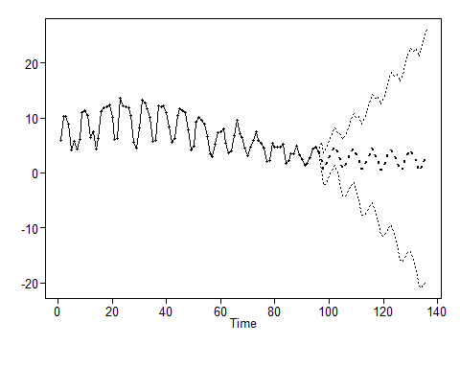

plot(as.numeric(Post_Vaccine$new_deaths_per_million), type = "l", xlim = c(1,136), main = "Next 40 Day forecast with p=7, q=0, s=7 and d=1")  
lines(seq(96,135,1),for_aruma2_s7d1_f40$f, col = "red")

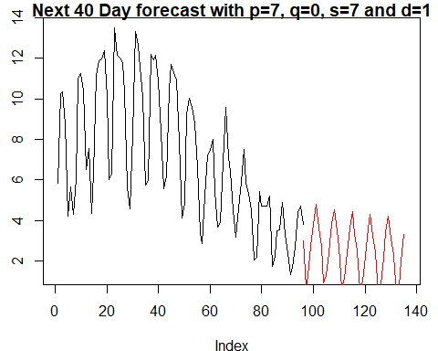

for_aruma2_s7d1_f180 = fore.aruma.wge(Post_Vaccine$new_deaths_per_million,d=1,s=7, phi = arima_s7_d1$phi,n.ahead = 180)

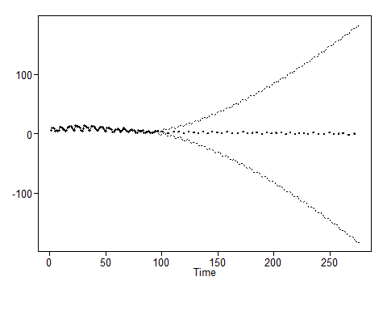

plot(as.numeric(Post_Vaccine$new_deaths_per_million), type = "l", xlim = c(1,276), main = "Next 180 Day forecast with p=7, q=0, s=7 and d=1")  
lines(seq(97,276,1),for_aruma2_s7d1_f180$f, col = "red")

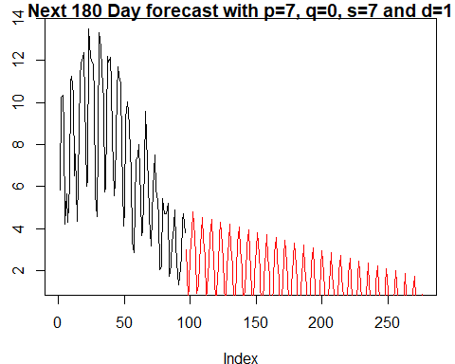

for_aruma2_s7d1_f380 = fore.aruma.wge(Post_Vaccine$new_deaths_per_million,d=1,s=7, phi = arima_s7_d1$phi,n.ahead = 380)

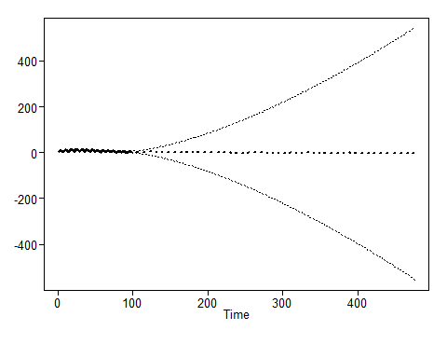

plot(as.numeric(Post_Vaccine$new_deaths_per_million), type = "l", xlim = c(1,476), main = "Next 380 Day forecast with p=7, q=0, s=7 and d=1")  
lines(seq(97,476,1),for_aruma2_s7d1_f380$f, col = "red")

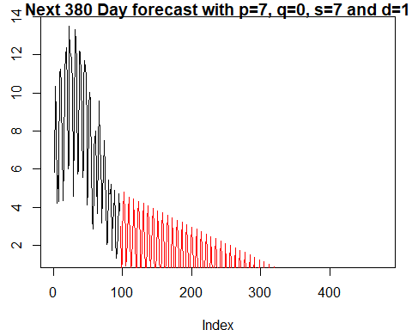

### Multivariate - model with only vaccine variable

# Considering Only new_vaccinations_smoothed_per_million  
PVsmall = Post_Vaccine[1:80,]  
mv_fit0 <- lm( new_deaths_per_million~ new_vaccinations_smoothed_per_million ,data = PVsmall)  
aic.wge(mv_fit0$residuals, p=0:8,q=0) #AIC picks 8,0 ; aic =0.8019881

## $type  
## [1] "aic"  
##   
## $value  
## [1] 0.6664726  
##   
## $p  
## [1] 8  
##   
## $q  
## [1] 0  
##   
## $phi  
## [1] 0.59563682 -0.12304724 0.04186753 -0.03825942 -0.06340488 0.18244759  
## [7] 0.60000280 -0.28433640  
##   
## $theta  
## [1] 0  
##   
## $vara  
## [1] 1.554995

fit0 = arima(PVsmall$new_deaths_per_million, order=c(8,0,0), xreg = PVsmall[,c(7)] )  
fit0 #AIC 295.99; Only new_vaccinations_smoothed_per_million looks significant

##   
## Call:  
## arima(x = PVsmall$new_deaths_per_million, order = c(8, 0, 0), xreg = PVsmall[,   
## c(7)])  
##   
## Coefficients:  
## ar1 ar2 ar3 ar4 ar5 ar6 ar7 ar8  
## 0.5969 -0.1228 0.0419 -0.0381 -0.0633 0.1824 0.6005 -0.2859  
## s.e. 0.1102 0.1081 0.1071 0.1115 0.1122 0.1132 0.1114 0.1137  
## intercept PVsmall[, c(7)]  
## 9.0735 -7e-04  
## s.e. 1.6740 3e-04  
##   
## sigma^2 estimated as 1.662: log likelihood = -136.99, aic = 295.99

acf(fit0$residuals) #appear to be white noise

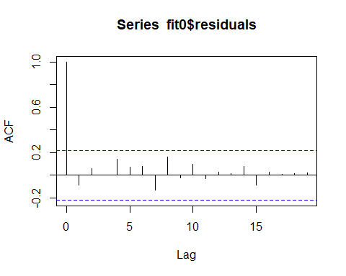

#ljung test for white noise of residuals  
ltest = ljung.wge(fit0$residuals) #null hypothesis = white noise, alternate- not white noise. pval = 0.975. Here we FTR null hypothesis, so this is white noise

## Obs -0.08933317 0.05728943 -0.0001381661 0.1447606 0.07306859 0.07705902 -0.1333722 0.1628458 -0.02067391 0.09979599 -0.0281532 0.02821667 0.01406468 0.07994413 -0.08846367 0.02845776 0.008774531 0.01521167 0.01981078 0.04623145 0.03766596 -0.09266563 -0.02844871 0.1111617

ltest

## $test  
## [1] "Ljung-Box test"  
##   
## $K  
## [1] 24  
##   
## $chi.square  
## [1] 13.38595  
##   
## $df  
## [1] 24  
##   
## $pval  
## [1] 0.9593268

preds_mv0 = predict(fit0, newxreg = (Post_Vaccine$new_vaccinations_smoothed_per_million[81:96] ))  
ASE_mv0 = mean((Post_Vaccine$new_deaths_per_million[81:96] - preds_mv0$pred)^2)  
ASE_mv0 #1.896324

## [1] 1.896324

plot(as.numeric(Post_Vaccine$new_deaths_per_million), type = "l", xlim = c(1,96), ylab = "new_deaths_per_million", main = "Multivariate -Last 10 day forecast with Only new_vaccinations")  
lines(seq(81,96,1),preds_mv0$pred, col = "red") # Even thought the ASE is low, plot doesn't capture the trend very well.

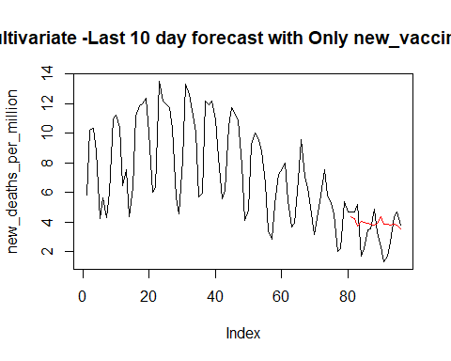

phi = aic.wge(mv_fit0$residuals)  
m1_resids_0 = fore.arma.wge(mv_fit0$residuals, phi = phi$phi, n.ahead = 14)

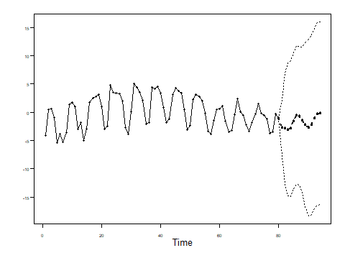

#Predicting future forecasts - 14  
Pred_nc_10_m1 = fore.aruma.wge(Post_Vaccine$new_cases_per_million, n.ahead = 14)

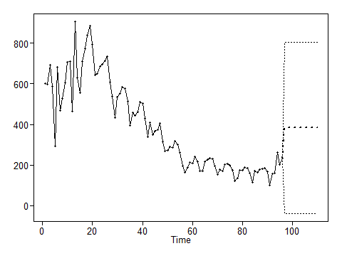

Pred_nv_10_m1 = fore.aruma.wge(Post_Vaccine$new_vaccinations_smoothed_per_million, n.ahead = 14)

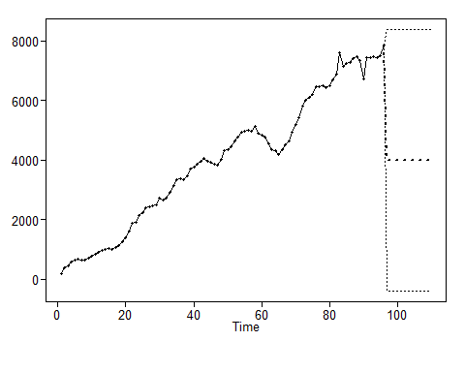

Pred_hs_10_m1 = fore.aruma.wge(Post_Vaccine$hosp_patients_per_million, n.ahead = 14)

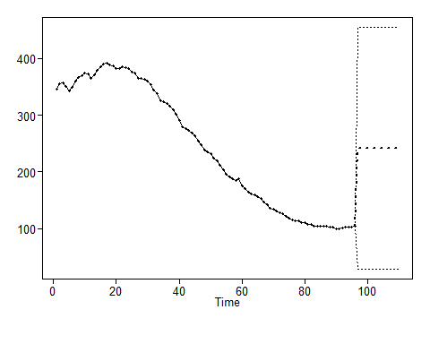

Pred_ic_10_m1 = fore.aruma.wge(Post_Vaccine$icu_patients_per_million, n.ahead = 14)

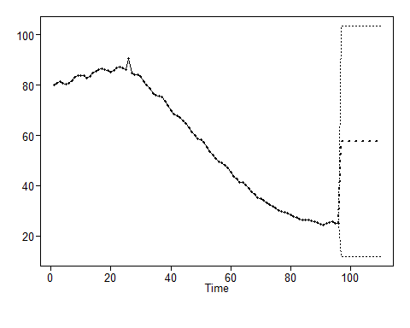

next10_m1 = data.frame(new_cases_per_million=Pred_nc_10_m1$f, new_vaccinations_smoothed_per_million=Pred_nv_10_m1$f,hosp_patients_per_million=Pred_hs_10_m1$f,icu_patients_per_million=Pred_ic_10_m1$f)  
#get predictions  
preds_m1_10 = predict(mv_fit0, newdata = next10_m1)  
Preds_m1_10_final = preds_m1_10 + m1_resids_0$f  
plot(as.numeric(Post_Vaccine$new_deaths_per_million), type = "l", xlim = c(1,110), ylab = "new_deaths_per_million", main = "Multivariate - Next 14 day forecast with Only new_vaccinations")  
lines(seq(97,110,1),Preds_m1_10_final, col = "red")

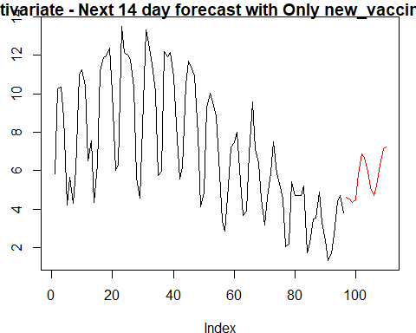

#Predicting future forecasts - 40  
m1_resids_40 = fore.arma.wge(mv_fit0$residuals, phi = phi$phi, n.ahead = 40)

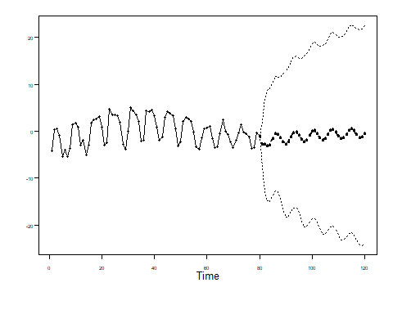

Pred_nc_40_m1 = fore.aruma.wge(Post_Vaccine$new_cases_per_million, n.ahead = 40)

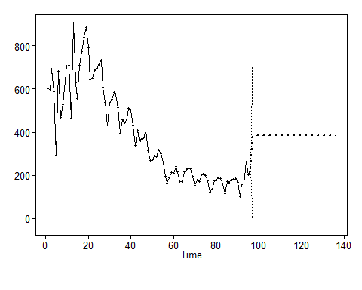

Pred_nv_40_m1 = fore.aruma.wge(Post_Vaccine$new_vaccinations_smoothed_per_million, n.ahead = 40)

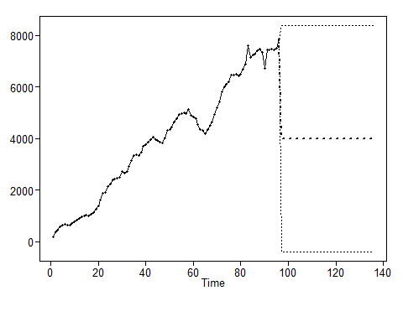

Pred_hs_40_m1 = fore.aruma.wge(Post_Vaccine$hosp_patients_per_million, n.ahead = 40)

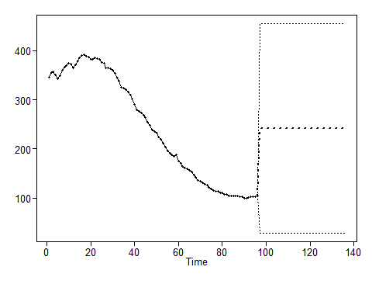

Pred_ic_40_m1 = fore.aruma.wge(Post_Vaccine$icu_patients_per_million, n.ahead = 40)

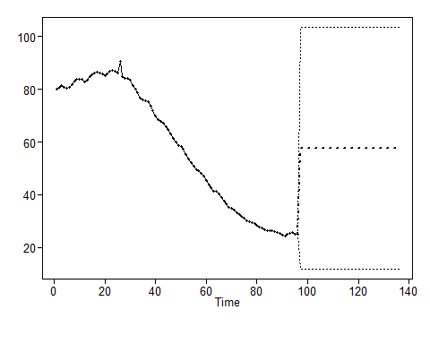

next40_m1 = data.frame(new_cases_per_million=Pred_nc_40_m1$f, new_vaccinations_smoothed_per_million=Pred_nv_40_m1$f,hosp_patients_per_million=Pred_hs_40_m1$f,icu_patients_per_million=Pred_ic_40_m1$f)  
#get predictions  
preds_m1_40 = predict(mv_fit0, newdata = next40_m1)  
Preds_m1_40_final = preds_m1_40 + m1_resids_0$f  
plot(as.numeric(Post_Vaccine$new_deaths_per_million), type = "l", xlim = c(1,136), ylab = "new_deaths_per_million", main = "Multivariate - Next 40 day forecast with Only new_vaccinations")  
lines(seq(97,136,1),Preds_m1_40_final, col = "red")

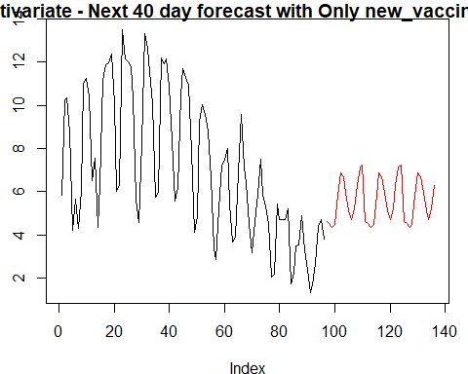

### Multivariate - model with all explanatory variables

#Multivariate - Model 1 - No trend and no lags  
#PVsmall = Post_Vaccine[1:80,]  
mv_fit1 <- lm( new_deaths_per_million~ new_cases_per_million+ icu_patients_per_million+hosp_patients_per_million+new_vaccinations_smoothed_per_million ,data = PVsmall)  
aic.wge(mv_fit1$residuals, p=0:8,q=0) #AIC picks 7,0 ; aic =0.8019881

## $type  
## [1] "aic"  
##   
## $value  
## [1] 0.8019881  
##   
## $p  
## [1] 7  
##   
## $q  
## [1] 0  
##   
## $phi  
## [1] 0.229948469 -0.036463718 -0.170439101 -0.006486376 -0.079572531  
## [6] 0.087570618 0.489722948  
##   
## $theta  
## [1] 0  
##   
## $vara  
## [1] 1.825745

fit1 = arima(PVsmall$new_deaths_per_million, order=c(7,0,0), xreg = PVsmall[,c(3,5,6,7)] )  
fit1 #AIC 281.45; Only new_cases_per_million looks significant

##   
## Call:  
## arima(x = PVsmall$new_deaths_per_million, order = c(7, 0, 0), xreg = PVsmall[,   
## c(3, 5, 6, 7)])  
##   
## Coefficients:  
## ar1 ar2 ar3 ar4 ar5 ar6 ar7 intercept  
## 0.4278 -0.1509 -0.0288 0.0719 -0.1452 0.2669 0.4721 1.8616  
## s.e. 0.1051 0.1161 0.1189 0.1162 0.1119 0.1099 0.1022 2.7545  
## new_cases_per_million icu_patients_per_million  
## 0.0080 0.1453  
## s.e. 0.0018 0.1258  
## hosp_patients_per_million new_vaccinations_smoothed_per_million  
## -0.0274 -1e-04  
## s.e. 0.0292 3e-04  
##   
## sigma^2 estimated as 1.329: log likelihood = -127.72, aic = 281.45

acf(fit1$residuals) #appear to be white noise

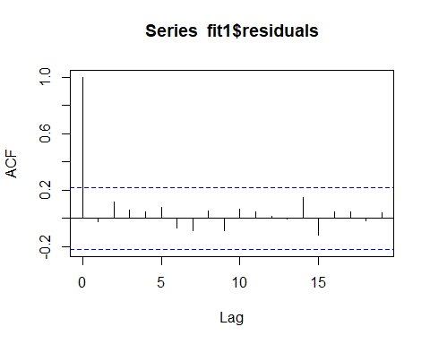

#ljung test for white noise of residuals  
ltest = ljung.wge(fit1$residuals) #null hypothesis = white noise, alternate- not white noise. pval = 0.975. Here we FTR null hypothesis, so this is white noise

## Obs -0.0225653 0.1170221 0.06159769 0.04841578 0.08116654 -0.06688804 -0.08781792 0.05318628 -0.08540389 0.06803597 0.04596115 0.01316819 -0.004960854 0.1465708 -0.1169755 0.04841578 0.04412049 -0.01465749 0.04264349 -0.05848696 0.04144058 -0.09182495 -0.07552927 0.08273832

ltest

## $test  
## [1] "Ljung-Box test"  
##   
## $K  
## [1] 24  
##   
## $chi.square  
## [1] 12.12541  
##   
## $df  
## [1] 24  
##   
## $pval  
## [1] 0.978458

#Forecast model 1  
preds_mv1 = predict(fit1, newxreg = cbind(Post_Vaccine$new_cases_per_million[81:96], Post_Vaccine$icu_patients_per_million[81:96],Post_Vaccine$hosp_patients_per_million[81:96],Post_Vaccine$new_vaccinations_smoothed_per_million[81:96]))  
ASE_mv1 = mean((Post_Vaccine$new_deaths_per_million[81:96] - preds_mv1$pred)^2)  
ASE_mv1 #2.59

## [1] 2.573935

#Multivariate - No trend and no lags with only new_cases_per_million  
mv_fit1_2 <- lm( new_deaths_per_million~ new_cases_per_million ,data = PVsmall)  
aic.wge(mv_fit1_2$residuals, p=0:8,q=0) #AIC picks 7,0 ; aic =0.471746

## $type  
## [1] "aic"  
##   
## $value  
## [1] 0.471746  
##   
## $p  
## [1] 7  
##   
## $q  
## [1] 0  
##   
## $phi  
## [1] 0.44078828 -0.17531875 0.01392374 0.02483295 -0.10761464 0.25213304  
## [7] 0.46623873  
##   
## $theta  
## [1] 0  
##   
## $vara  
## [1] 1.312254

fit1_2 = arima(PVsmall$new_deaths_per_million, order=c(7,0,0), xreg = PVsmall[,c(3)] )  
fit1_2 #AIC 281.45; Only new_cases_per_million looks significant

##   
## Call:  
## arima(x = PVsmall$new_deaths_per_million, order = c(7, 0, 0), xreg = PVsmall[,   
## c(3)])  
##   
## Coefficients:  
## ar1 ar2 ar3 ar4 ar5 ar6 ar7 intercept  
## 0.4524 -0.1862 0.0192 0.0254 -0.1162 0.2612 0.4571 3.3906  
## s.e. 0.1035 0.1132 0.1135 0.1144 0.1134 0.1113 0.1015 1.2187  
## PVsmall[, c(3)]  
## 0.0081  
## s.e. 0.0014  
##   
## sigma^2 estimated as 1.365: log likelihood = -128.71, aic = 277.43

acf(fit1_2$residuals) #appear to be white noise

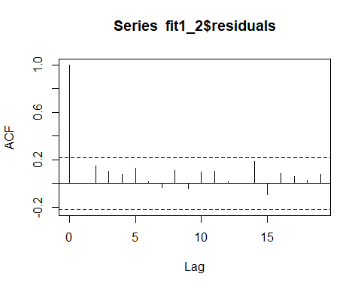

#ljung test for white noise of residuals  
ltest = ljung.wge(fit1_2$residuals) #null hypothesis = white noise, alternate- not white noise. pval = 0.975. Here we FTR null hypothesis, so this is white noise

## Obs 0.0003100592 0.1499663 0.1034955 0.07902539 0.1275278 0.01686719 -0.03732423 0.1109621 -0.04114831 0.09704431 0.1055418 0.016953 0.0003275814 0.184288 -0.09100432 0.08281432 0.06161375 0.02780213 0.07697265 -0.03159458 0.05110265 -0.07440334 -0.07181274 0.07211165

ltest

## $test  
## [1] "Ljung-Box test"  
##   
## $K  
## [1] 24  
##   
## $chi.square  
## [1] 16.42048  
##   
## $df  
## [1] 24  
##   
## $pval  
## [1] 0.8723045

#Forecast model 1_2  
preds_mv1_2 = predict(fit1_2, newxreg = cbind(Post_Vaccine$new_cases_per_million[81:96] ))  
ASE_mv1_2 = mean((Post_Vaccine$new_deaths_per_million[81:96] - preds_mv1_2$pred)^2)  
ASE_mv1_2 #3.736719

## [1] 3.736719

#Model 1 - No trend and no lags has the best ASE so far.  
  
  
#Multivariate - Model 2 - Trend but no lags  
t = seq(1:96)  
mv_fit2 <- lm( new_deaths_per_million~ t[1:80]+new_cases_per_million+ icu_patients_per_million+hosp_patients_per_million+new_vaccinations_smoothed_per_million ,data = PVsmall)  
aic.wge(mv_fit2$residuals, p=0:8,q=0) #AIC picks 7,0, aic = 0.6252096

## $type  
## [1] "aic"  
##   
## $value  
## [1] 0.6252096  
##   
## $p  
## [1] 7  
##   
## $q  
## [1] 0  
##   
## $phi  
## [1] 0.170524799 -0.044142741 -0.190096497 -0.008118636 -0.109335267  
## [6] 0.075185106 0.527296313  
##   
## $theta  
## [1] 0  
##   
## $vara  
## [1] 1.529911

fit2 = arima(PVsmall$new_deaths_per_million, order=c(7,0,0), xreg = cbind(t[1:80],PVsmall[,c(3,5,6,7)]) )  
fit2 #AIC aic = 274.31; time, hosp_patients_per_million looks insignificant,

##   
## Call:  
## arima(x = PVsmall$new_deaths_per_million, order = c(7, 0, 0), xreg = cbind(t[1:80],   
## PVsmall[, c(3, 5, 6, 7)]))  
##   
## Coefficients:  
## ar1 ar2 ar3 ar4 ar5 ar6 ar7 intercept  
## 0.3321 -0.1440 -0.1179 0.0659 -0.2102 0.2152 0.4698 -7.3622  
## s.e. 0.1137 0.1106 0.1278 0.1090 0.1180 0.1127 0.1110 3.6489  
## t[1:80] new_cases_per_million icu_patients_per_million  
## 0.1466 0.0075 0.3596  
## s.e. 0.0422 0.0018 0.1615  
## hosp_patients_per_million new_vaccinations_smoothed_per_million  
## -0.0538 -8e-04  
## s.e. 0.0326 4e-04  
##   
## sigma^2 estimated as 1.197: log likelihood = -123.16, aic = 274.31

acf(fit2$residuals) #appear to be white noise

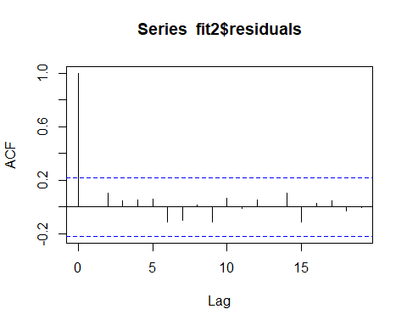

#ljung test for white noise of residuals  
ltest2 = ljung.wge(fit2$residuals) #null hypothesis = white noise, alternate- not white noise. pval = 0.975. Here we FTR null hypothesis, so this is white noise

## Obs 0.004095523 0.100914 0.04429023 0.05263636 0.05838233 -0.1117387 -0.09824692 0.01441274 -0.1121791 0.06319369 -0.01318881 0.05060121 0.002351999 0.103157 -0.1144501 0.0260979 0.04860438 -0.03123468 -0.004483388 -0.09553879 0.0130966 -0.1264479 -0.1618971 -0.003617753

ltest2

## $test  
## [1] "Ljung-Box test"  
##   
## $K  
## [1] 24  
##   
## $chi.square  
## [1] 14.0008  
##   
## $df  
## [1] 24  
##   
## $pval  
## [1] 0.9466322

#Forecast model 2  
preds_mv2 = predict(fit2, newxreg = cbind(t[81:96], Post_Vaccine$new_cases_per_million[81:96], Post_Vaccine$icu_patients_per_million[81:96],Post_Vaccine$hosp_patients_per_million[81:96],Post_Vaccine$new_vaccinations_smoothed_per_million[81:96]))  
ASE_mv2 = mean((Post_Vaccine$new_deaths_per_million[81:96] - preds_mv2$pred)^2)  
ASE_mv2 #5.407704

## [1] 5.271115

#Take hosp_patients_per_million out  
mv_fit2_1 <- lm( new_deaths_per_million~ t[1:80]+new_cases_per_million+ icu_patients_per_million +new_vaccinations_smoothed_per_million ,data = PVsmall)  
aic.wge(mv_fit2_1$residuals, p=0:8,q=0) #AIC picks 7,0, aic = 0.6189045

## $type  
## [1] "aic"  
##   
## $value  
## [1] 0.6189045  
##   
## $p  
## [1] 7  
##   
## $q  
## [1] 0  
##   
## $phi  
## [1] 0.39867963 -0.13735621 -0.03605856 0.02013120 -0.10836136 0.21409378  
## [7] 0.45756199  
##   
## $theta  
## [1] 0  
##   
## $vara  
## [1] 1.520295

fit2_1 = arima(PVsmall$new_deaths_per_million, order=c(7,0,0), xreg = cbind(t[1:80],PVsmall[,c(3,5,7)]) )  
fit2_1 #AIC aic = 274.31; time, new_vaccinations_smoothed_per_million looks insignificant

##   
## Call:  
## arima(x = PVsmall$new_deaths_per_million, order = c(7, 0, 0), xreg = cbind(t[1:80],   
## PVsmall[, c(3, 5, 7)]))  
##   
## Coefficients:  
## ar1 ar2 ar3 ar4 ar5 ar6 ar7 intercept  
## 0.4028 -0.1789 -0.0162 0.0318 -0.1562 0.2458 0.4735 -5.5820  
## s.e. 0.1004 0.1079 0.1096 0.1103 0.1102 0.1072 0.0997 3.6068  
## t[1:80] new_cases_per_million icu_patients_per_million  
## 0.1274 0.0064 0.1128  
## s.e. 0.0453 0.0016 0.0427  
## new_vaccinations_smoothed_per_million  
## -6e-04  
## s.e. 4e-04  
##   
## sigma^2 estimated as 1.238: log likelihood = -124.7, aic = 275.4

#Forecast model 2_1  
preds_mv2_1 = predict(fit2_1, newxreg = cbind(t[81:96], Post_Vaccine$new_cases_per_million[81:96], Post_Vaccine$icu_patients_per_million[81:96],Post_Vaccine$new_vaccinations_smoothed_per_million[81:96] ))  
ASE_mv2_1 = mean((Post_Vaccine$new_deaths_per_million[81:96] - preds_mv2_1$pred)^2)  
ASE_mv2_1 #6.364181

## [1] 6.315825

#Take new_vaccinations_smoothed_per_million out  
mv_fit2_2 <- lm( new_deaths_per_million~ t[1:80]+new_cases_per_million+ icu_patients_per_million ,data = PVsmall)  
aic.wge(mv_fit2_2$residuals, p=0:8,q=0) #AIC picks 7,0, aic = 0.5544063

## $type  
## [1] "aic"  
##   
## $value  
## [1] 0.5544063  
##   
## $p  
## [1] 7  
##   
## $q  
## [1] 0  
##   
## $phi  
## [1] 0.39279569 -0.13942168 -0.03341932 0.02502220 -0.11431402 0.21775082  
## [7] 0.47087041  
##   
## $theta  
## [1] 0  
##   
## $vara  
## [1] 1.425334

fit2_2 = arima(PVsmall$new_deaths_per_million, order=c(7,0,0), xreg = cbind(t[1:80],PVsmall[,c(3,5)]))  
fit2_2 #AIC aic = 275.97; time, AIC increased a little bit

##   
## Call:  
## arima(x = PVsmall$new_deaths_per_million, order = c(7, 0, 0), xreg = cbind(t[1:80],   
## PVsmall[, c(3, 5)]))  
##   
## Coefficients:  
## ar1 ar2 ar3 ar4 ar5 ar6 ar7 intercept  
## 0.4102 -0.1847 -0.0235 0.0327 -0.1625 0.2481 0.4553 -5.4533  
## s.e. 0.1014 0.1100 0.1111 0.1116 0.1122 0.1084 0.1020 3.6641  
## t[1:80] new_cases_per_million icu_patients_per_million  
## 0.0794 0.0068 0.1072  
## s.e. 0.0342 0.0016 0.0430  
##   
## sigma^2 estimated as 1.283: log likelihood = -125.98, aic = 275.97

acf(fit2_2$residuals) #appear to be white noise

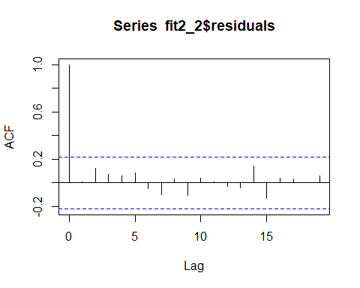

#ljung test for white noise of residuals  
ltest2_2 = ljung.wge(fit2_2$residuals) #null hypothesis = white noise, alternate- not white noise. pval = 0.975. Here we FTR null hypothesis, so this is white noise

## Obs 0.007809401 0.1246527 0.06976255 0.05935119 0.08727446 -0.04774794 -0.1018511 0.03612639 -0.1029307 0.03813898 0.01007962 -0.03007361 -0.04276539 0.1407171 -0.1332761 0.04274424 0.03431625 0.00186642 0.05645683 -0.05586972 0.03362173 -0.1008829 -0.10878 0.04155017

ltest2_2

## $test  
## [1] "Ljung-Box test"  
##   
## $K  
## [1] 24  
##   
## $chi.square  
## [1] 12.93714  
##   
## $df  
## [1] 24  
##   
## $pval  
## [1] 0.9671452

#Forecast model 2_1  
preds_mv2_2 = predict(fit2_2, newxreg = cbind(t[81:96], Post_Vaccine$new_cases_per_million[81:96], Post_Vaccine$icu_patients_per_million[81:96]))  
ASE_mv2_2 = mean((Post_Vaccine$new_deaths_per_million[81:96] - preds_mv2_2$pred)^2)  
ASE_mv2_2 #6.53061 No improvememnt

## [1] 6.477088

#Model 1 - No trend and no lags has the best ASE so far.  
#Multivariate - Model 2 - Trend and lags  
#Lagged variables - all  
ccf(Post_Vaccine$new_cases_per_million,Post_Vaccine$new_deaths_per_million) #7

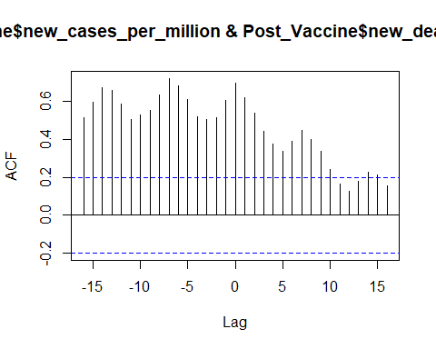

ccf(Post_Vaccine$icu_patients_per_million,Post_Vaccine$new_deaths_per_million) #1

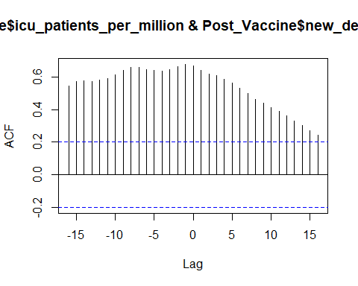

ccf(Post_Vaccine$hosp_patients_per_million,Post_Vaccine$new_deaths_per_million) #1

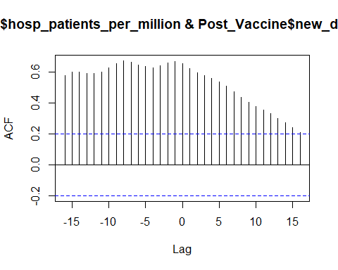

ccf(Post_Vaccine$new_vaccinations_smoothed_per_million,Post_Vaccine$new_deaths_per_million) #8

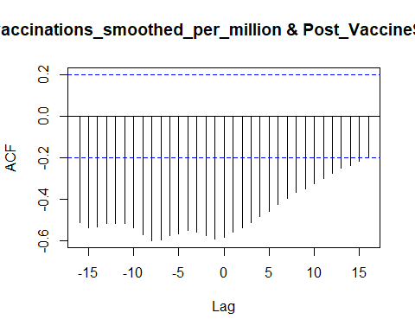

Post_Vaccine$new_cases_per_million_7 <- dplyr::lag(Post_Vaccine$new_cases_per_million,7)  
Post_Vaccine$icu_patients_per_million_1 <- dplyr::lag(Post_Vaccine$icu_patients_per_million,1)  
Post_Vaccine$hosp_patients_per_million_1 <- dplyr::lag(Post_Vaccine$hosp_patients_per_million,1)  
Post_Vaccine$new_vaccinations_smoothed_per_million_8 <- dplyr::lag(Post_Vaccine$new_vaccinations_smoothed_per_million,8)  
PVsmall = Post_Vaccine[1:80,]  
mv_fit3 <- lm( new_deaths_per_million~ t[1:80]+new_cases_per_million_7+ icu_patients_per_million_1+hosp_patients_per_million_1+new_vaccinations_smoothed_per_million_8 ,data = PVsmall)  
aic.wge(mv_fit3$residuals, p=0:8,q=0) #AIC picks 8,0, aic = 0.8735

## $type  
## [1] "aic"  
##   
## $value  
## [1] 1.022664  
##   
## $p  
## [1] 7  
##   
## $q  
## [1] 0  
##   
## $phi  
## [1] 0.35216207 -0.22011773 -0.10286256 -0.01584649 -0.13393431 0.07807821  
## [7] 0.36792006  
##   
## $theta  
## [1] 0  
##   
## $vara  
## [1] 2.226523

fit3 = arima(PVsmall$new_deaths_per_million, order=c(8,0,0), xreg = cbind(PVsmall[,c(8,9,10,11)]) )  
fit3 #AIC aic = 263.57; time, icu_patients_per_million_1 and hosp_patients_per_million_1 looks sig,

##   
## Call:  
## arima(x = PVsmall$new_deaths_per_million, order = c(8, 0, 0), xreg = cbind(PVsmall[,   
## c(8, 9, 10, 11)]))  
##   
## Coefficients:  
## ar1 ar2 ar3 ar4 ar5 ar6 ar7 ar8  
## 0.4851 -0.3189 0.0056 -0.182 -0.1394 0.1128 0.3720 -0.1546  
## s.e. 0.1288 0.1281 0.1419 0.165 0.1552 0.1488 0.1366 0.1411  
## intercept new_cases_per_million_7 icu_patients_per_million_1  
## -2.6125 0.0027 0.1264  
## s.e. 2.8790 0.0019 0.1417  
## hosp_patients_per_million_1 new_vaccinations_smoothed_per_million_8  
## -0.0025 6e-04  
## s.e. 0.0343 5e-04  
##   
## sigma^2 estimated as 1.529: log likelihood = -119.22, aic = 266.44

acf(fit3$residuals[9:80]) # does not appear to be white noise

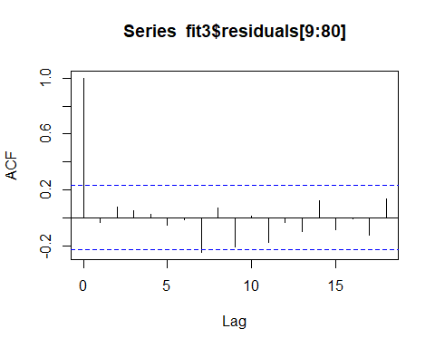

ltest3 = ljung.wge(fit3$residuals)

## Obs -0.03322311 0.07742046 0.05274098 0.022839 -0.05545107 -0.01306201 -0.2477912 0.07068801 -0.2125809 0.01236821 -0.1756755 -0.03174781 -0.1018219 0.1229846 -0.08584995 -0.007642846 -0.1225899 0.1357601 -0.07492321 0.05195774 0.006702245 -0.05569772 -0.1121167 0.1215022

ltest3 #FTR.There is not enough evidence to suggest that the residuals are serailly correlated. null hypothesis = white noise, alternate- not white noise. pval = 0.975. Here we FTR null hypothesis, so this is white noise

## $test  
## [1] "Ljung-Box test"  
##   
## $K  
## [1] 24  
##   
## $chi.square  
## [1] 25.56972  
##   
## $df  
## [1] 24  
##   
## $pval  
## [1] 0.3753519

#Lagged variables - icu_patients_per_million_1 and hosp_patients_per_million_1 - Best aic so far with white noise residuals.  
mv_fit3_1 <- lm( new_deaths_per_million~ t[1:80]+new_cases_per_million+ icu_patients_per_million_1+hosp_patients_per_million_1+new_vaccinations_smoothed_per_million ,data = PVsmall)  
aic.wge(mv_fit3_1$residuals, p=0:8,q=0) #AIC picks 7,0, aic = 0.5299

## $type  
## [1] "aic"  
##   
## $value  
## [1] 0.5668668  
##   
## $p  
## [1] 7  
##   
## $q  
## [1] 0  
##   
## $phi  
## [1] 0.26447143 -0.15486846 0.02252074 -0.19753293 -0.01938498 0.10438991  
## [7] 0.48000247  
##   
## $theta  
## [1] 0  
##   
## $vara  
## [1] 1.439557

fit3_1 = arima(PVsmall$new_deaths_per_million, order=c(7,0,0), xreg = cbind(t[1:80],PVsmall[,c(3,9,10,7)]) )  
fit3_1 #AIC= time, icu_patients_per_million_1 and hosp_patients_per_million_1 looks sig,

##   
## Call:  
## arima(x = PVsmall$new_deaths_per_million, order = c(7, 0, 0), xreg = cbind(t[1:80],   
## PVsmall[, c(3, 9, 10, 7)]))  
##   
## Coefficients:  
## ar1 ar2 ar3 ar4 ar5 ar6 ar7 intercept  
## 0.3869 -0.2750 0.0835 -0.2183 -0.0425 0.1394 0.4185 -8.2722  
## s.e. 0.1080 0.1217 0.1174 0.1471 0.1175 0.1203 0.1156 2.9848  
## t[1:80] new_cases_per_million icu_patients_per_million_1  
## 0.1486 0.0076 0.4062  
## s.e. 0.0386 0.0017 0.1486  
## hosp_patients_per_million_1 new_vaccinations_smoothed_per_million  
## -0.0621 -8e-04  
## s.e. 0.0312 4e-04  
##   
## sigma^2 estimated as 1.156: log likelihood = -119.99, aic = 267.98

acf(fit3_1$residuals[8:80]) # appears to be white noise

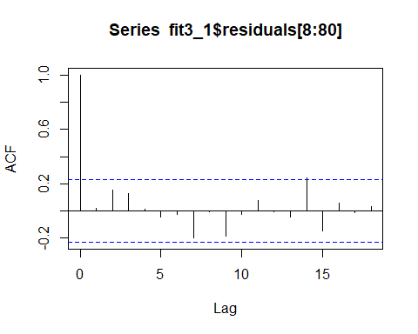

ltest3_1 = ljung.wge(fit3_1$residuals) #FTR. There is not enough evidence to suggest that the residuals are serailly correlated. null hypothesis = white noise, alternate- not white noise. pval = 0.5670672 Here we FTR null hypothesis, so this is white noise

## Obs 0.04050703 0.155121 0.1127794 -0.008856396 -0.04319614 -0.04597227 -0.1619064 -0.01852375 -0.1749616 -0.04760524 0.05436933 -0.03846552 -0.07485584 0.2106473 -0.1425802 0.05778509 0.007091063 0.03233046 -0.0101994 -0.04799799 -0.01637473 -0.05474732 -0.1851901 -0.07755122

#Forecast model 2_1  
preds_mv3_1 = predict(fit3_1, newxreg = cbind(t[81:96], Post_Vaccine$new_cases_per_million[81:96], Post_Vaccine$icu_patients_per_million_1[81:96], Post_Vaccine$hosp_patients_per_million_1[81:96] , Post_Vaccine$new_vaccinations_smoothed_per_million[81:96]))  
ASE_mv3_1 = mean((Post_Vaccine$new_deaths_per_million[81:96] - preds_mv3_1$pred)^2)  
ASE_mv3_1 #4.948167

## [1] 4.948167

#As Model 1 (no trend, no lag) has the best ASE. We will forecast future values using this model.  
m1_fit = lm(new_deaths_per_million~new_cases_per_million+new_vaccinations_smoothed_per_million+hosp_patients_per_million+icu_patients_per_million, data = Post_Vaccine)  
phi = aic.wge(m1_fit$residuals)  
m1_resids_14 = fore.arma.wge(m1_fit$residuals, phi = phi$phi, n.ahead = 14)

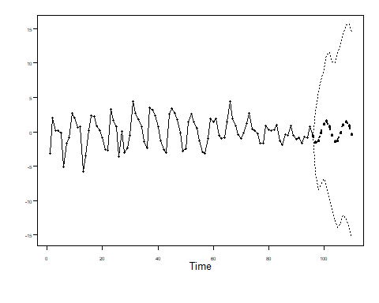

#Predicting future forecasts - 14  
Pred_nc_10_m1 = fore.aruma.wge(Post_Vaccine$new_cases_per_million, n.ahead = 14)



Pred_nv_10_m1 = fore.aruma.wge(Post_Vaccine$new_vaccinations_smoothed_per_million, n.ahead = 14)



Pred_hs_10_m1 = fore.aruma.wge(Post_Vaccine$hosp_patients_per_million, n.ahead = 14)



Pred_ic_10_m1 = fore.aruma.wge(Post_Vaccine$icu_patients_per_million, n.ahead = 14)



next10_m1 = data.frame(new_cases_per_million=Pred_nc_10_m1$f, new_vaccinations_smoothed_per_million=Pred_nv_10_m1$f,hosp_patients_per_million=Pred_hs_10_m1$f,icu_patients_per_million=Pred_ic_10_m1$f)  
  
#get predictions  
preds_m1_10 = predict(m1_fit, newdata = next10_m1)  
Preds_m1_10_final = preds_m1_10 + m1_resids_14$f  
plot(as.numeric(Post_Vaccine$new_deaths_per_million), type = "l", xlim = c(1,110), ylab = "new_deaths_per_million", main = "Next 14 day new_deaths_per_million Forecast")  
lines(seq(97,110,1),Preds_m1_10_final, col = "red")

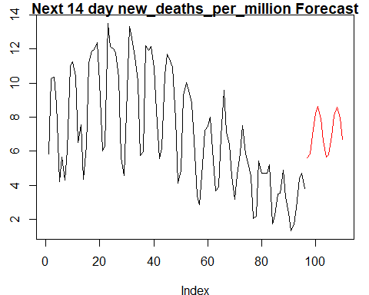

#Predicting future forecasts - 40  
m1_resids_40 = fore.arma.wge(m1_fit$residuals, phi = phi$phi, n.ahead = 40)

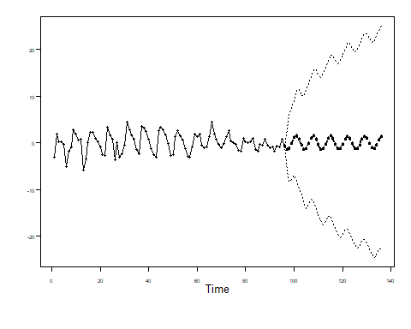

Pred_nc_40_m1 = fore.aruma.wge(Post_Vaccine$new_cases_per_million, n.ahead = 40)



Pred_nv_40_m1 = fore.aruma.wge(Post_Vaccine$new_vaccinations_smoothed_per_million, n.ahead = 40)



Pred_hs_40_m1 = fore.aruma.wge(Post_Vaccine$hosp_patients_per_million, n.ahead = 40)



Pred_ic_40_m1 = fore.aruma.wge(Post_Vaccine$icu_patients_per_million, n.ahead = 40)



next40_m1 = data.frame(new_cases_per_million=Pred_nc_40_m1$f, new_vaccinations_smoothed_per_million=Pred_nv_40_m1$f,hosp_patients_per_million=Pred_hs_40_m1$f,icu_patients_per_million=Pred_ic_40_m1$f)  
  
#get predictions  
preds_m1_40 = predict(m1_fit, newdata = next40_m1)  
Preds_m1_40_final = preds_m1_40 + m1_resids_40$f  
plot(as.numeric(Post_Vaccine$new_deaths_per_million), type = "l", xlim = c(1,136), ylab = "new_deaths_per_million", main = "Next 40 day new_deaths_per_million Forecast")  
lines(seq(97,136,1),Preds_m1_40_final, col = "red")

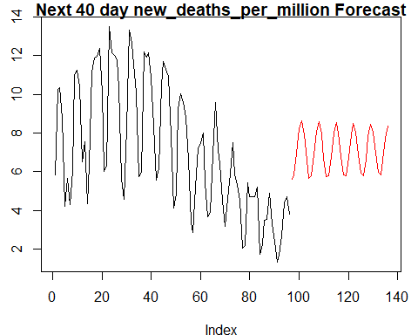

### VAR MODEL 1 with no lagged variables

PVsmall = Post_Vaccine[1:80,]  
VAR_PV = VAR(cbind(PVsmall$new_deaths_per_million,PVsmall$new_cases_per_million,PVsmall$icu_patients_per_million,PVsmall$hosp_patients_per_million,PVsmall$new_vaccinations_smoothed_per_million),lag.max = 8, type = "both")  
pred = predict(VAR_PV,n.ahead = 16)  
plot(Post_Vaccine$new_deaths_per_million, type = "l")  
lines(seq(81,96,1),pred$fcst$y1[,1],col = "red")

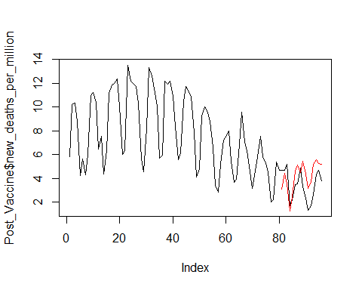

ASE = mean((Post_Vaccine$new_deaths_per_million[81:96] - pred$fcst$y1[1:16])^2)  
ASE

## [1] 2.237209

pred_14 = predict(VAR_PV,n.ahead = 30)  
plot(as.numeric(Post_Vaccine$new_deaths_per_million), type = "l", xlim = c(1,110),ylab = "new_deaths_per_million", main = "VAR MODEL 1 - Next 14 day new_deaths_per_million Forecast")  
lines(seq(97,110),tail(pred_14$fcst$y1[,1],14), col = "red")

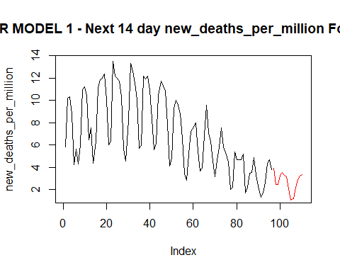

pred_40 = predict(VAR_PV,n.ahead = 56)  
plot(as.numeric(Post_Vaccine$new_deaths_per_million), type = "l", xlim = c(1,136), ylab = "new_deaths_per_million", main = "VAR MODEL 1 - Next 40 day new_deaths_per_million Forecast")  
lines(seq(97,136,1),tail(pred_40$fcst$y1[,1],40), col = "red")

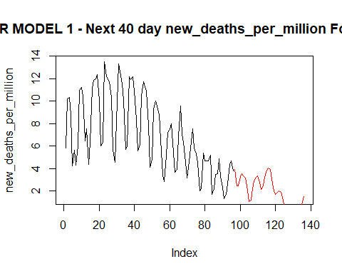

### VAR MODEL 2 - with lagged variables (Hospital and ICU)

#####lagged icu_1, hosp_1######  
VAR_PV = VAR(cbind(PVsmall$new_deaths_per_million[2:80],PVsmall$new_cases_per_million[2:80],PVsmall$icu_patients_per_million_1[2:80],PVsmall$hosp_patients_per_million_1[2:80],PVsmall$new_vaccinations_smoothed_per_million[2:80]),lag.max = 8, type = "both")  
pred = predict(VAR_PV,n.ahead = 16)  
plot(Post_Vaccine$new_deaths_per_million, type = "l")  
lines(seq(81,96,1),pred$fcst$y1[,1],col = "red")

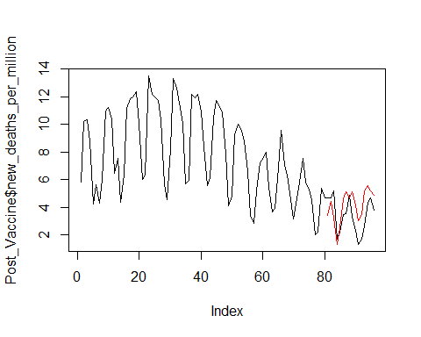

ASE = mean((Post_Vaccine$new_deaths_per_million[81:96] - pred$fcst$y1[1:16])^2)  
ASE

## [1] 1.985431

pred_14 = predict(VAR_PV,n.ahead = 30)  
plot(as.numeric(Post_Vaccine$new_deaths_per_million), type = "l", xlim = c(1,110),ylab = "new_deaths_per_million", main = "VAR MODEL 2 - Next 14 day new_deaths_per_million Forecast")  
lines(seq(97,110,1),tail(pred_14$fcst$y1[,1],14), col = "red")

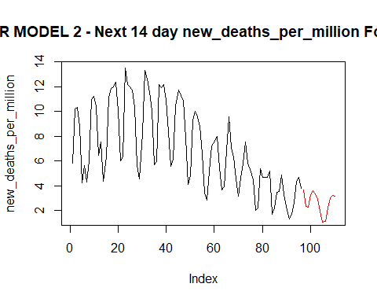

pred_40 = predict(VAR_PV,n.ahead = 56)  
plot(as.numeric(Post_Vaccine$new_deaths_per_million), type = "l", xlim = c(1,136),ylab = "new_deaths_per_million", main = "VAR MODEL 2 - Next 14 day new_deaths_per_million Forecast")  
lines(seq(97,136,1),tail(pred_40$fcst$y1[,1],40), col = "red")

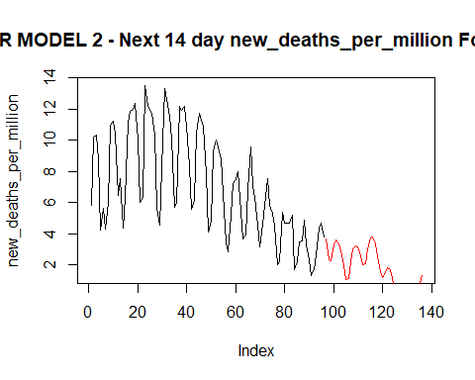

#Model entire data for future forecasting  
VAR_PV_full = VAR(cbind(Post_Vaccine$new_deaths_per_million[2:96],Post_Vaccine$new_cases_per_million[2:96],Post_Vaccine$icu_patients_per_million_1[2:96],Post_Vaccine$hosp_patients_per_million_1[2:96],Post_Vaccine$new_vaccinations_smoothed_per_million[2:96]),lag.max = 8, type = "both")  
pred_14 = predict(VAR_PV_full,n.ahead = 30)  
plot(as.numeric(Post_Vaccine$new_deaths_per_million), type = "l", xlim = c(1,110),ylab = "new_deaths_per_million", main = "VAR MODEL 2 - Next 14 day new_deaths_per_million Forecast")  
lines(seq(97,110,1),tail(pred_14$fcst$y1[,1],14), col = "red")

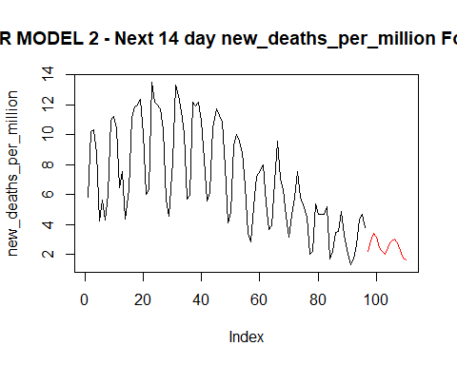

pred_40 = predict(VAR_PV_full,n.ahead = 56)   
plot(as.numeric(Post_Vaccine$new_deaths_per_million), type = "l", xlim = c(1,136),ylab = "new_deaths_per_million", main = "VAR MODEL 2 - Next 40 day new_deaths_per_million Forecast")  
lines(seq(97,136,1),tail(pred_40$fcst$y1[,1],40), col = "red")

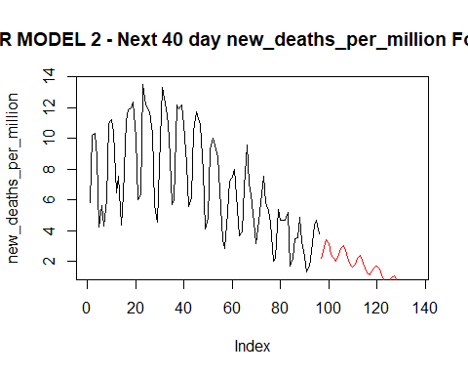

## We will proceed with Model 2 - with lagged variables ##

### MLP With Vaccine Variable Only

#Build the model  
Vacc_Train = Post_Vaccine[1:80,]  
Vacc_Test = Post_Vaccine[81:96,]  
Vacc_xreg = data.frame(Vaccine = ts(Vacc_Train$new_vaccinations_smoothed_per_million))  
set.seed(2)  
Vacc_fit.mlp1 = mlp(ts(Vacc_Train$new_deaths_per_million) ,reps = 50,comb = "median", xreg = Vacc_xreg )   
Vacc_fit.mlp1 #mse 1.168

## MLP fit with 5 hidden nodes and 50 repetitions.  
## Univariate lags: (1,2)  
## 1 regressor included.  
## - Regressor 1 lags: (2)  
## Forecast combined using the median operator.  
## MSE: 1.1966.

plot(Vacc_fit.mlp1)

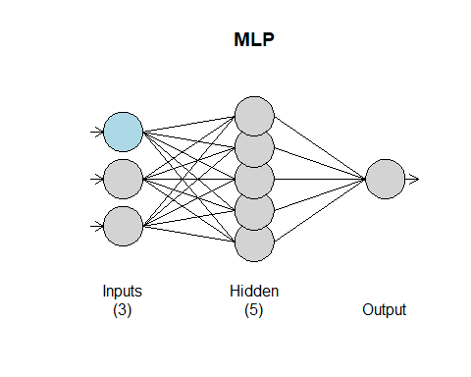

fore_vacc_df_exp = data.frame(Vaccine = ts(Post_Vaccine$new_vaccinations_smoothed_per_million))  
Vacc_fore.mlp1 = forecast(Vacc_fit.mlp1, h = 16, xreg = fore_vacc_df_exp)   
MLP1_ASE = mean((Vacc_Test$new_deaths_per_million- Vacc_fore.mlp1$mean)^2)  
MLP1_ASE

## [1] 3.108692

plot(Vacc_fore.mlp1)

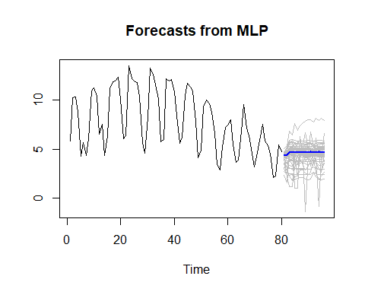

#New Vacc - 14 day forecast on this explanatory variable  
fit.mlp.NV = mlp(ts(Post_Vaccine$new_vaccinations_smoothed_per_million),reps = 50,comb = "median")  
fore.mlp2.14.NV = forecast(fit.mlp.NV, h = 14)  
plot(fore.mlp2.14.NV)

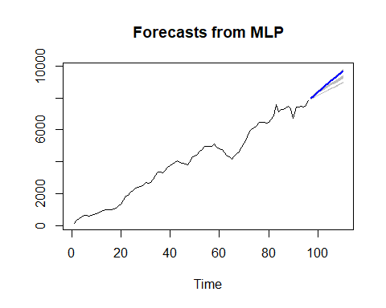

PV_DF_fore = data.frame(new_vaccinations_smoothed_per_million =ts(c(Post_Vaccine$new_vaccinations_smoothed_per_million,fore.mlp2.14.NV$mean)))  
fit.mlp = mlp(ts(Post_Vaccine$new_deaths_per_million),reps = 50,comb = "median",xreg = PV_DF_fore)  
fore.mlp = forecast(fit.mlp, h = 14, xreg = PV_DF_fore)  
plot(fore.mlp)

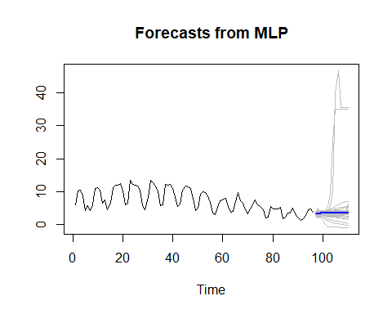

#New Vacc - 40 day forecast on this explanatory variable  
fit.mlp.NV = mlp(ts(Post_Vaccine$new_vaccinations_smoothed_per_million),reps = 50,comb = "median")  
fore.mlp2.40.NV = forecast(fit.mlp.NV, h = 40)  
plot(fore.mlp2.40.NV)

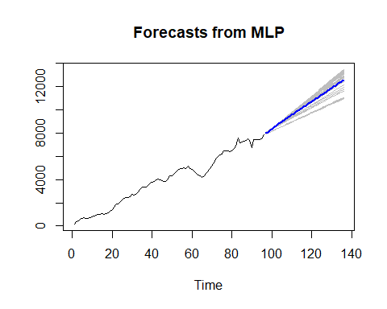

PV_DF_fore = data.frame(new_vaccinations_smoothed_per_million =ts(c(Post_Vaccine$new_vaccinations_smoothed_per_million,fore.mlp2.40.NV$mean)))  
fore.vacc_40 = forecast(fit.mlp, h = 40, xreg = PV_DF_fore)  
plot(fore.vacc_40)

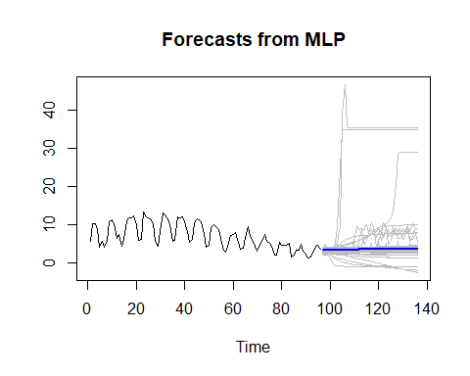

### MLP With all explanatory variables

VC_train = Post_Vaccine[1:80,]  
VC_test = Post_Vaccine[81:96,]  
all_exp_xreg = data.frame(Vaccine = ts(t = ts(seq(1:80)),VC_train$new_vaccinations_smoothed_per_million), NewCase = ts(VC_train$new_cases_per_million), Hosp = ts(VC_train$hosp_patients_per_million), ICU = ts(VC_train$icu_patients_per_million))  
set.seed(2)  
allexp_fit_mlp2 = mlp(ts(VC_train$new_deaths_per_million), reps = 50, comb = "median", xreg = all_exp_xreg )  
plot(allexp_fit_mlp2)

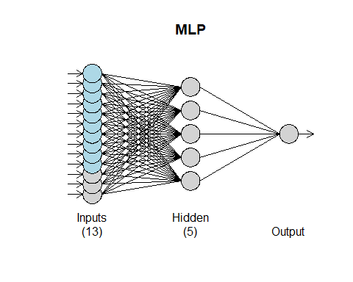

fore_all_exp_df = data.frame(Vaccine = ts(Post_Vaccine$new_vaccinations_smoothed_per_million), NewCase = ts(Post_Vaccine$new_cases_per_million), Hosp = ts(Post_Vaccine$hosp_patients_per_million), ICU = ts(Post_Vaccine$icu_patients_per_million))  
allexp_fore.m2 = forecast(allexp_fit_mlp2, h = 16, xreg = fore_all_exp_df)   
MLP2_ASE = mean((VC_test$new_deaths_per_million- allexp_fore.m2$mean)^2)  
MLP2_ASE #1.43

## [1] 1.427807

#Forecast - fitting on last 16 days  
plot(seq(1,96,1), Post_Vaccine$new_deaths_per_million, type = "l",xlim = c(0,96), ylab = "Death Rate Per Million", main = "forecast plot for last 6 days")  
lines(seq(81,96), allexp_fore.m2$mean, type = "l", col = "red")

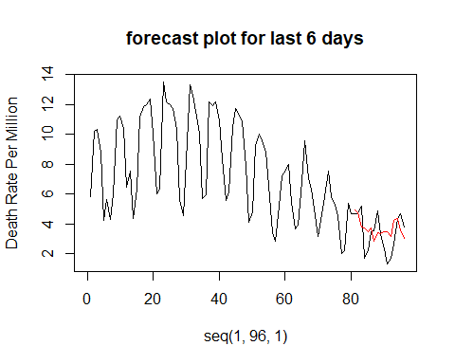

### Forecast on future short term (14 days) and long term (40 days) ###  
#New Case Forecast  
fit.mlp.NC = mlp(ts(Post_Vaccine$new_cases_per_million),reps = 50,comb = "median")  
fore.mlp2.14.NC = forecast(fit.mlp.NC, h = 14)  
fore.mlp2.40.NC = forecast(fit.mlp.NC, h = 40)  
plot(fore.mlp2.14.NC) #for short term

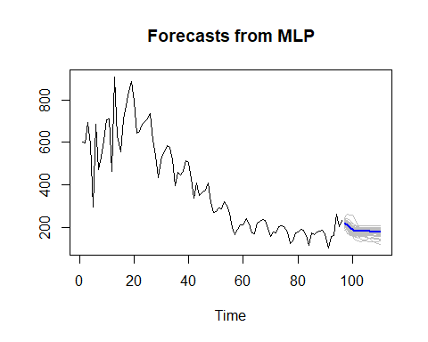

plot(fore.mlp2.40.NC) #for long term

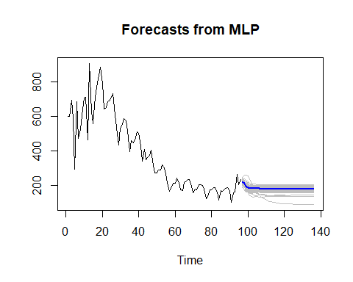

#New Vacc  
fit.mlp.NV = mlp(ts(Post_Vaccine$new_vaccinations_smoothed_per_million),reps = 50,comb = "median")  
fore.mlp2.14.NV = forecast(fit.mlp.NV, h = 14)  
fore.mlp2.40.NV = forecast(fit.mlp.NV, h = 40)  
plot(fore.mlp2.14.NV) #for short term

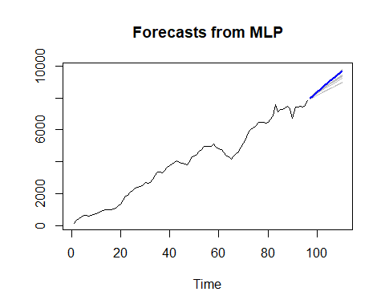

plot(fore.mlp2.40.NV) #for long term

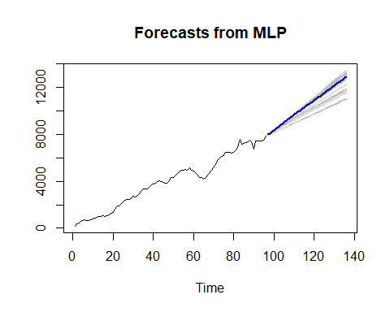

#New Hos  
fit.mlp.HS = mlp(ts(Post_Vaccine$hosp_patients_per_million),reps = 50,comb = "median")  
fore.mlp2.14.HS = forecast(fit.mlp.HS, h = 14)  
fore.mlp2.40.HS = forecast(fit.mlp.HS, h = 40)  
plot(fore.mlp2.14.HS) #for short term

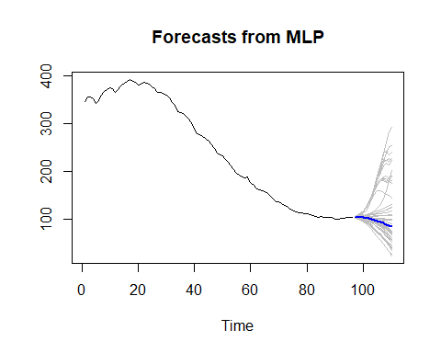

plot(fore.mlp2.40.HS) #for long term

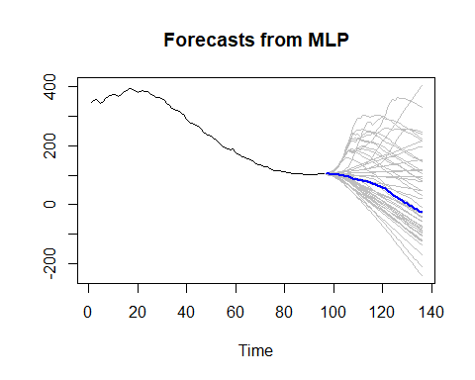

#New ICU  
fit.mlp.IC = mlp(ts(Post_Vaccine$icu_patients_per_million),reps = 50,comb = "median")  
fore.mlp2.14.IC = forecast(fit.mlp.HS, h = 14)  
fore.mlp2.40.IC = forecast(fit.mlp.HS, h = 40)  
plot(fore.mlp2.14.IC) #for short term



plot(fore.mlp2.40.IC) #for long term



#Forecast 14 days  
PV_DF_fore1 = data.frame(t = ts(seq(1:110)),new_cases_per_million = ts(c(Post_Vaccine$new_cases_per_million,fore.mlp2.14.NC$mean)), icu_patients_per_million = ts(c(Post_Vaccine$icu_patients_per_million,fore.mlp2.14.IC$mean)),  
 hosp_patients_per_million = ts(c(Post_Vaccine$hosp_patients_per_million,fore.mlp2.14.HS$mean)), new_vaccinations_smoothed_per_million =ts(c(Post_Vaccine$new_vaccinations_smoothed_per_million,fore.mlp2.14.NV$mean)))  
fit.mlp2_14 = mlp(ts(Post_Vaccine$new_deaths_per_million),reps = 50,comb = "median",xreg = PV_DF_fore1)  
fore.mlp2_14 = forecast(fit.mlp2_14, h = 14, xreg = PV_DF_fore1)  
plot(fore.mlp2_14)

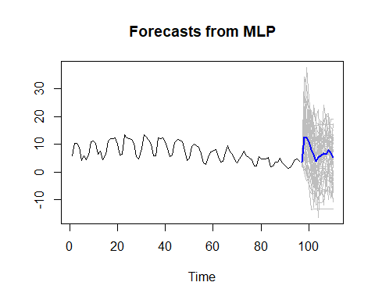

#Forecast 40 days  
PV_DF_fore = data.frame(t = ts(seq(1:136)),new_cases_per_million = ts(c(Post_Vaccine$new_cases_per_million,fore.mlp2.40.NC$mean)), icu_patients_per_million = ts(c(Post_Vaccine$icu_patients_per_million,fore.mlp2.40.IC$mean)),  
 hosp_patients_per_million = ts(c(Post_Vaccine$hosp_patients_per_million,fore.mlp2.40.HS$mean)), new_vaccinations_smoothed_per_million =ts(c(Post_Vaccine$new_vaccinations_smoothed_per_million,fore.mlp2.40.NV$mean)))  
fit.mlp2_40 = mlp(ts(Post_Vaccine$new_deaths_per_million),reps = 50,comb = "median",xreg = PV_DF_fore)  
fore.mlp2_40 = forecast(fit.mlp2_40, h = 40, xreg = PV_DF_fore)  
plot(fore.mlp2_40)

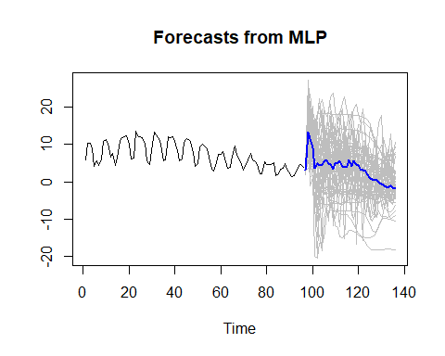

### Ensemble Model with NN (all variables) Model and VAR 2

#preds_mv0$pred : multivariate with only vaccine  
#allexp_fore.m2$mean: mlp with all variables  
ensemble = (preds_mv0$pred + allexp_fore.m2$mean)/2  
  
#Plot  
plot(seq(1,96,1), Post_Vaccine$new_deaths_per_million, type = "l",xlim = c(0,96), ylab = "Death Rate Per Million", main = "Ensemble Model with NN and Multivariate models")  
lines(seq(81,96,1), ensemble, type = "l", col = "green")

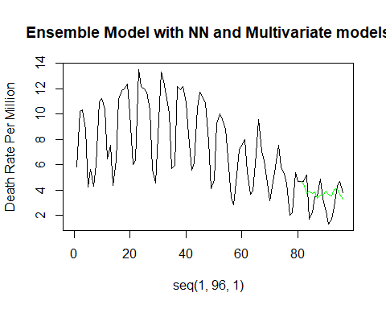

ASE_en = mean((Post_Vaccine$new_deaths_per_million[81:96] - ensemble)^2)  
ASE_en #1.590614

## [1] 1.590614

#for_aruma2_s7d1_16: Univariate 16 last n  
#allexp_fore.m2$mean: mlp with all variables  
  
#Univariate Model 3 and MLP with all variables  
ensemble2 = (for_aruma2_s7d1_16$f + allexp_fore.m2$mean)/2  
  
#Plot  
plot(seq(1,96,1), Post_Vaccine$new_deaths_per_million, type = "l",xlim = c(0,96), ylab = "Death Rate Per Million", main = "Ensemble Model with NN (All Var) and ARIMA models")  
lines(seq(81,96,1), ensemble2, type = "l", col = "green")

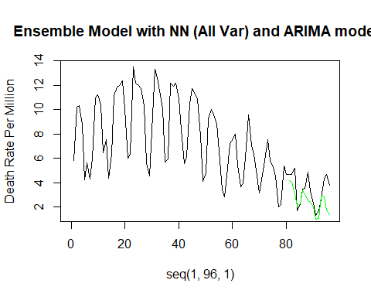

ASE_en2 = mean((Post_Vaccine$new_deaths_per_million[81:96] - ensemble2)^2)  
ASE_en2 #1.836393

## [1] 1.836393