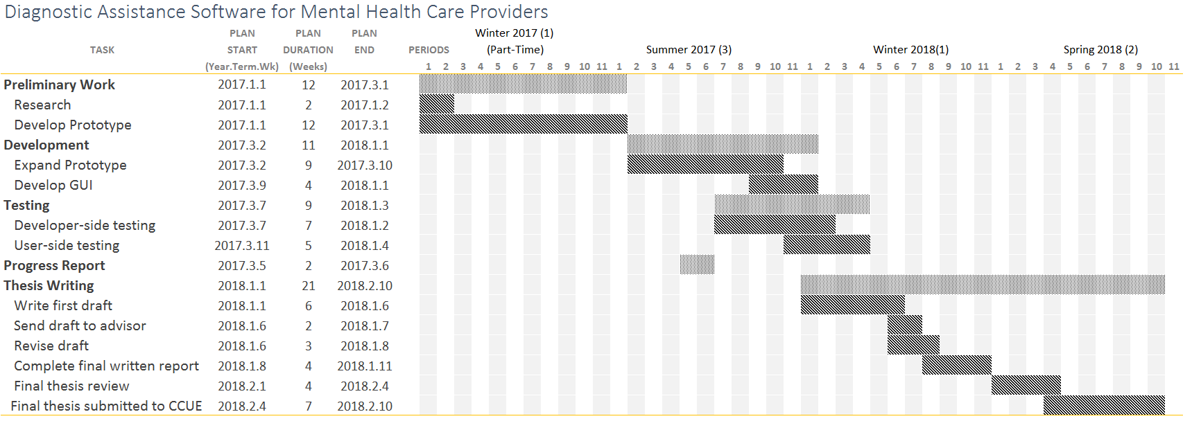

Figure 1. Gantt Chart for Proposed Thesis.