1. Login Prompt
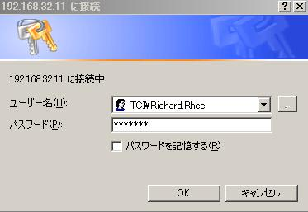
URL: http://tcijapp/Purchase/

2. Main Menu
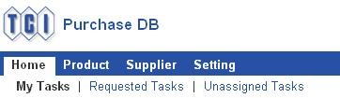
Click “Unassigned Tasks”.

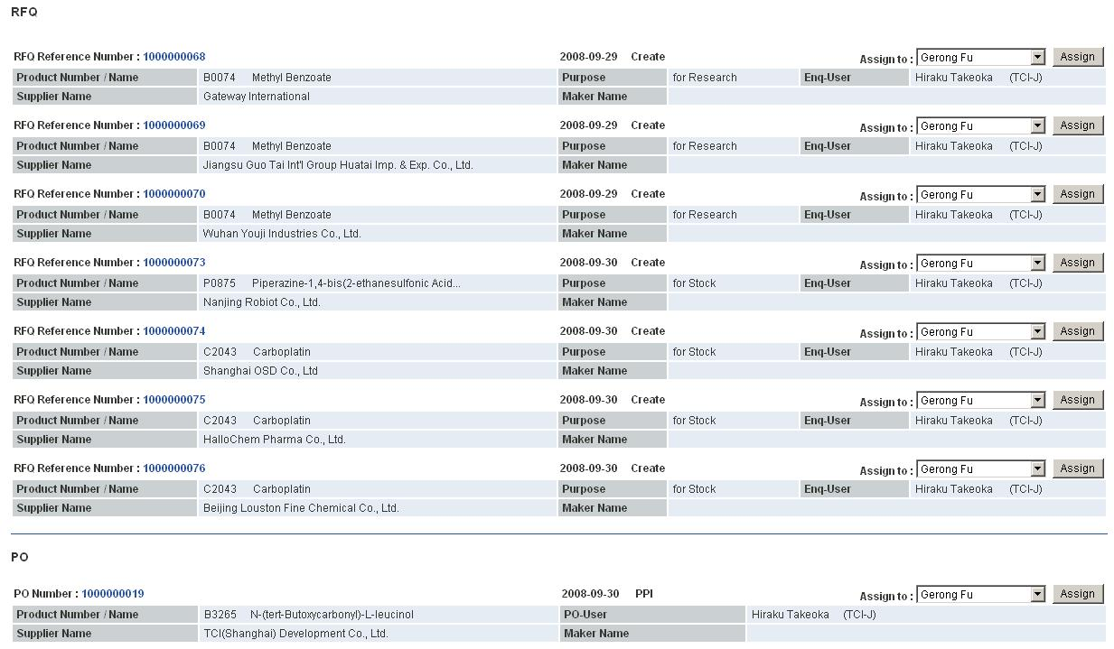
Unassigned RFQ

Unassigned PO

Assign PO to a person.

When PO is assigned to a person, it is moved to his/her “My Tasks”.
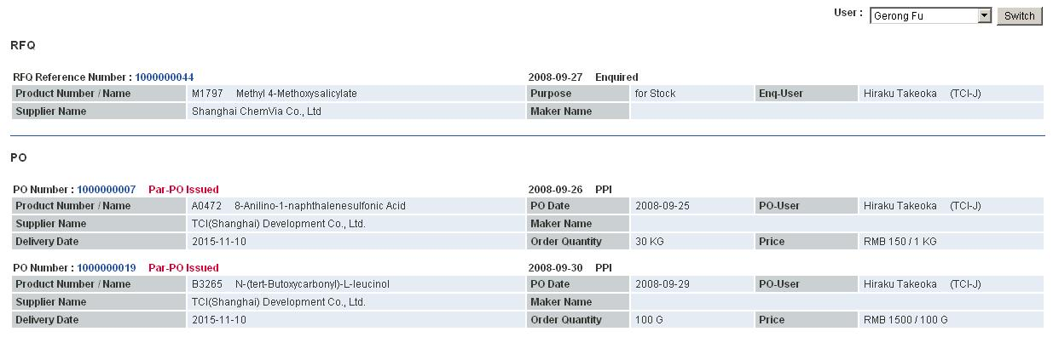
Status of PO

Click this link to view the details.

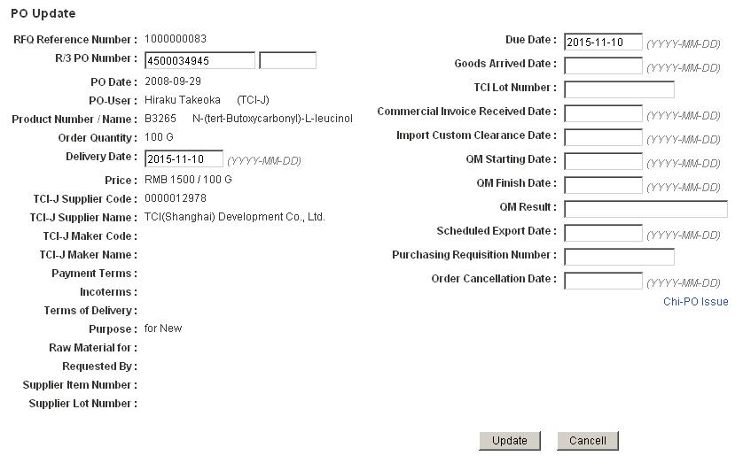

Click this link to issue Chi-PO.

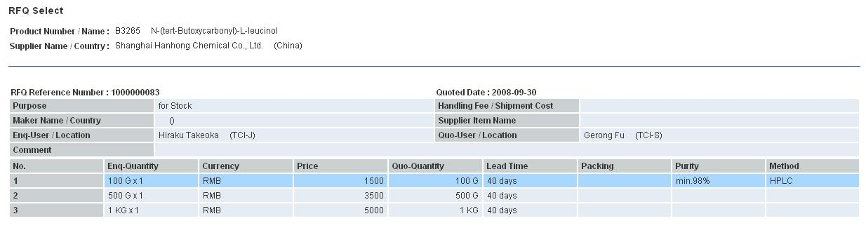

Click a chosen rank.

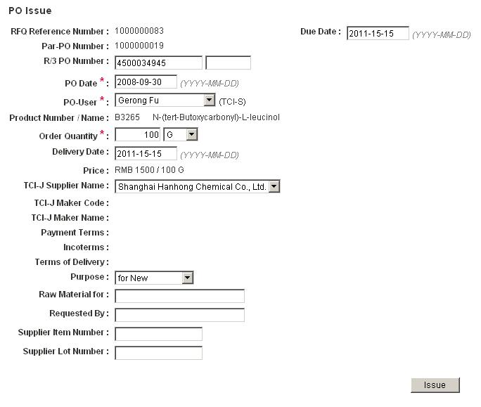
After entering data, click “Issue” button.

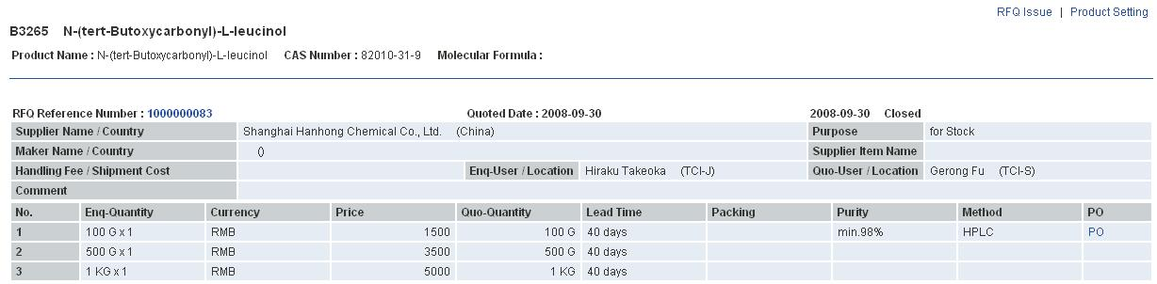
List of RFQ

Click this link to view the PO list.

Both Par-PO and Chi-PO are shown.
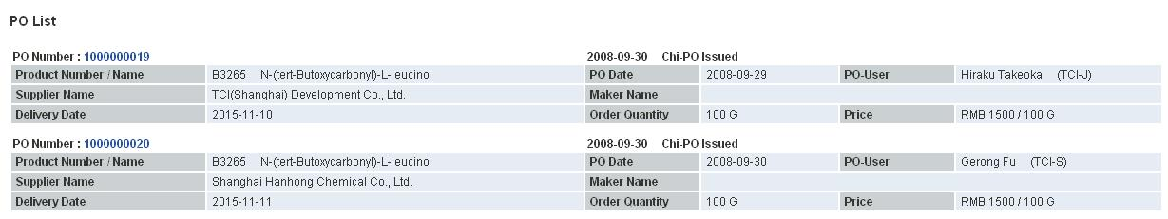

Click the link to view the details.

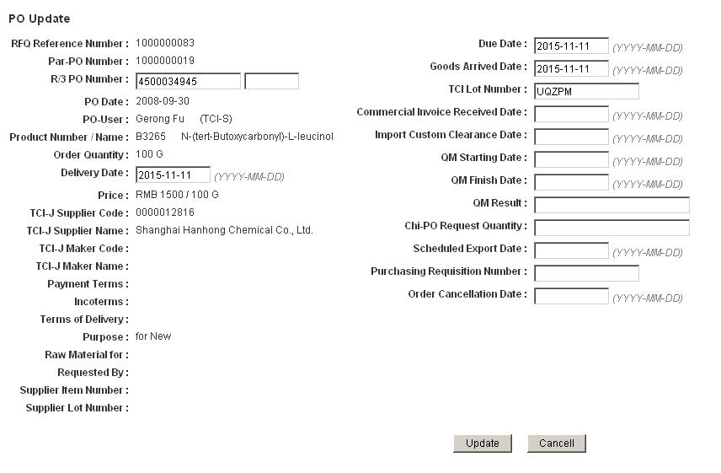

When the goods arrive, enter “Goods Arrived Date” and “TCI Lot Number”, and click “Update” button.
7 Correspondence – Receiving Messages
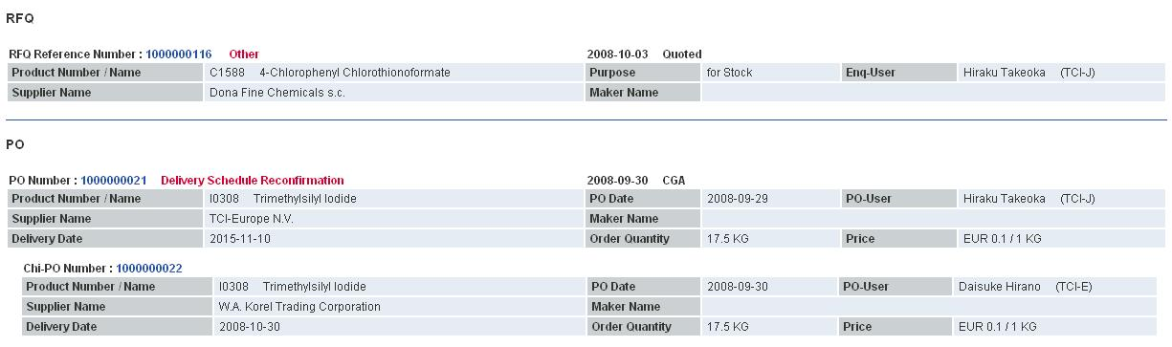
These red bold letters mean that a new message exists.

Click the link to view the details.

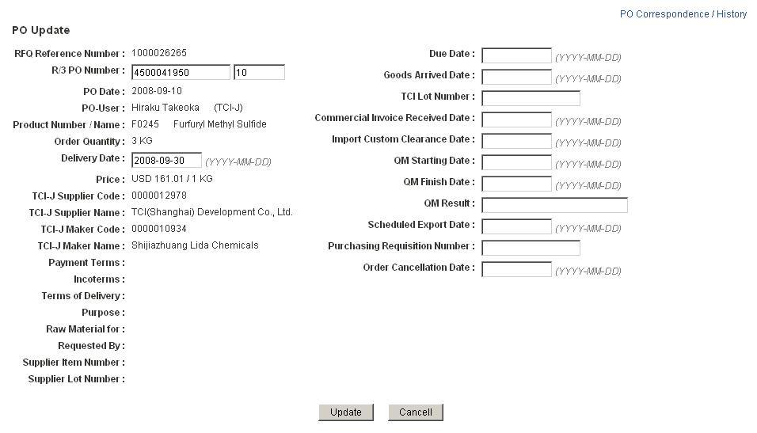

Click “PO Correspondence / History” to view the message.

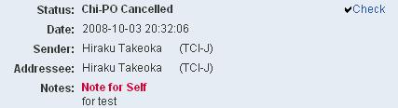
Click “Check”.
The message will continue to appear at your “My Tasks” until you click “Check”.

8 Correspondence – Writing messages

Click “PO Correspondence / History” to write a message.

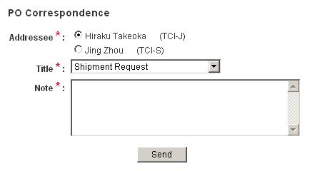
Remember to select Addressee.

After writing a message, click “Send” button.

