1. Login Prompt
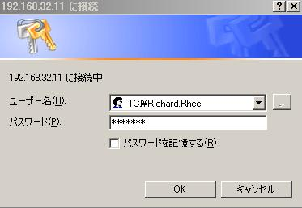
URL: http://tcijapp/Purchase/

2. Main Menu
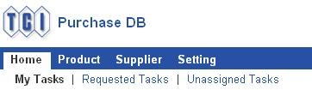
Click “Unassigned Tasks”.

3. Unassigned Tasks
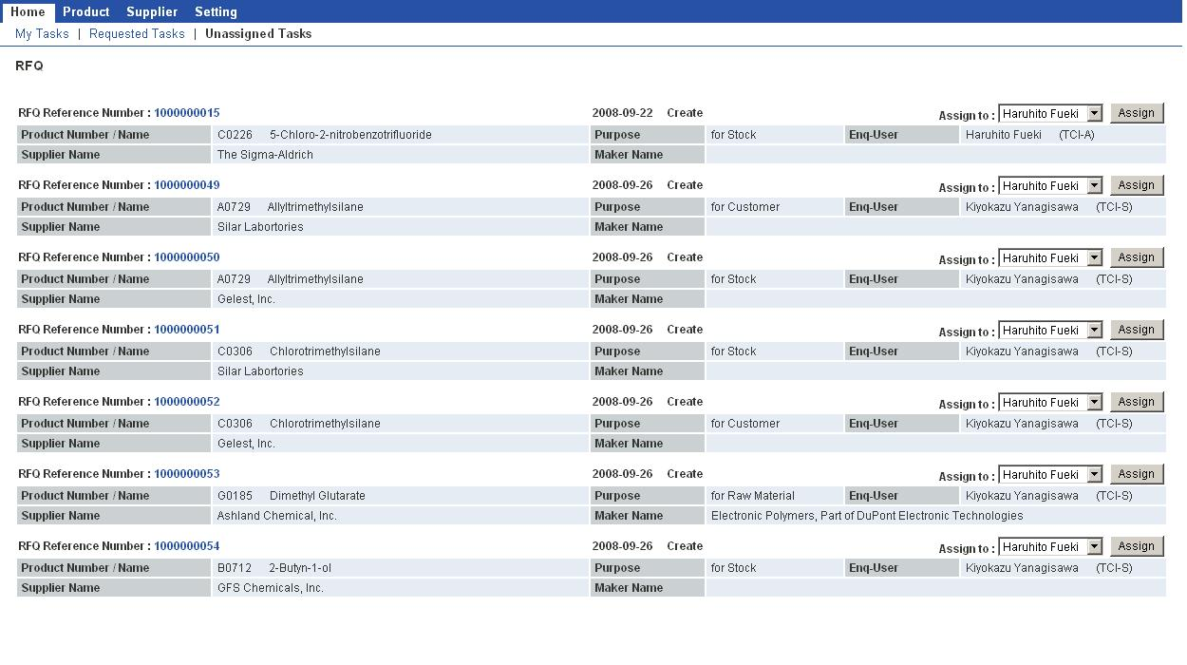
Status of RFQ
Choose a person from the pull-down menu, and click “Assign”.
The item is moved to “My Tasks”, with its status changed from “Create” to “Assigned”.
4. My Tasks

Click “My Tasks”.

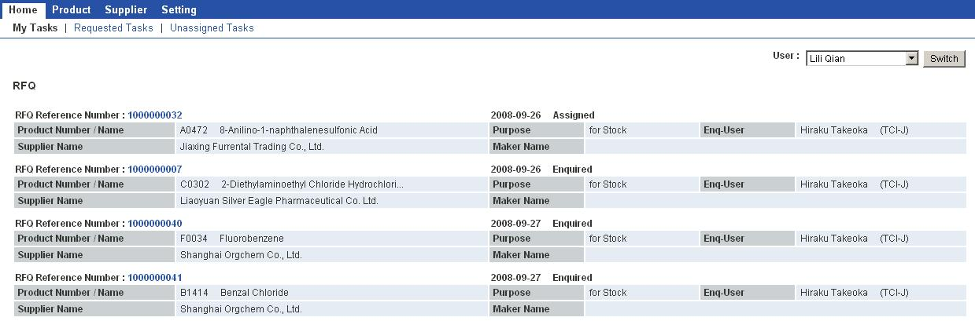

Choose a person to view his/her tasks.

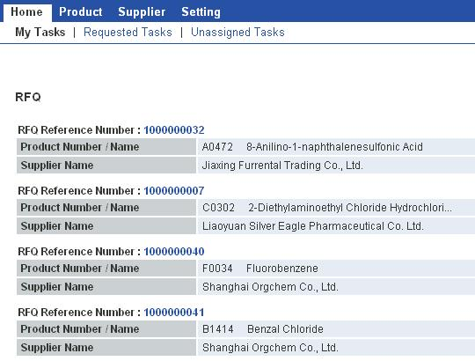

Click a link to view details.

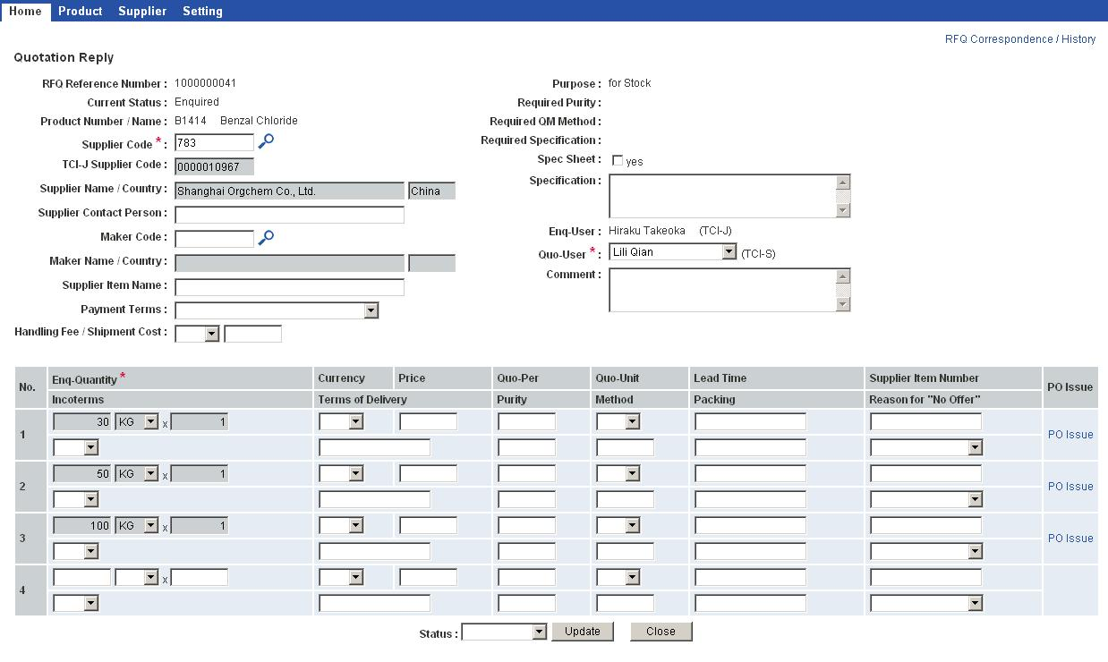

Change the status from “Assigned” to “Enquired” after asking a supplier.

Choose “Enquired” from the pull-down menu.
Remember to click “Update” button, or the data will not be saved.

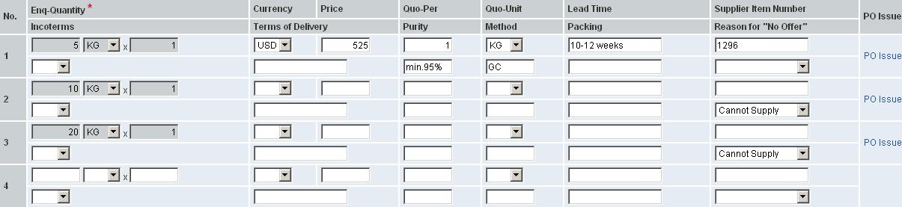
Change the status from “Enquired” to “Quoted” after inputting an answer.
If the answer is not incomplete, choose “Partly-quoted” instead of “Quoted”.

If the supplier doesn’t quote a price, choose a reason from the pull-down menu.

5 Modifying Data

Click “Product”.

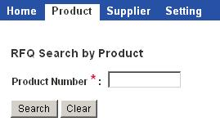
Enter a Product Number or CAS Number, and click “Search” button.

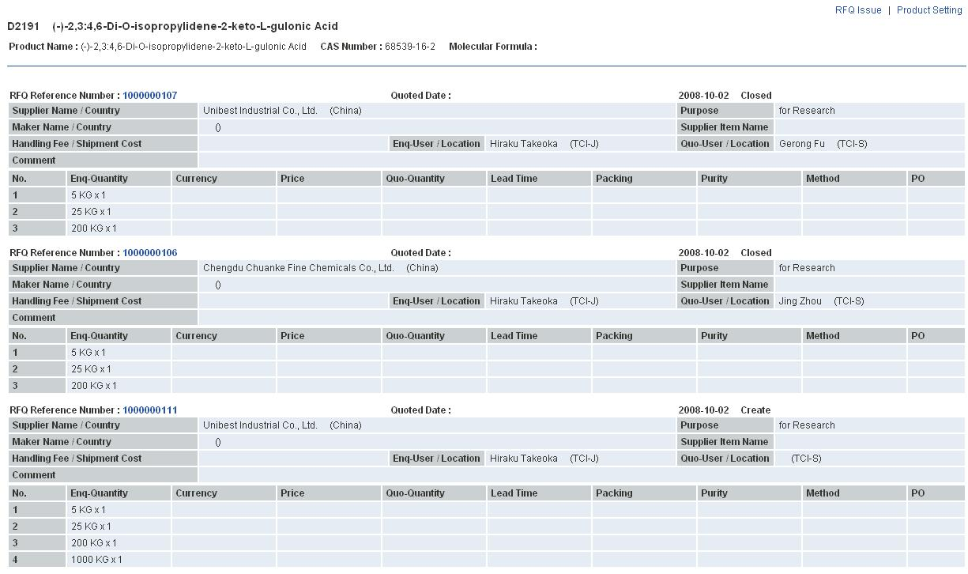
A list of quotations is shown for the product.

Click this link to view the details.

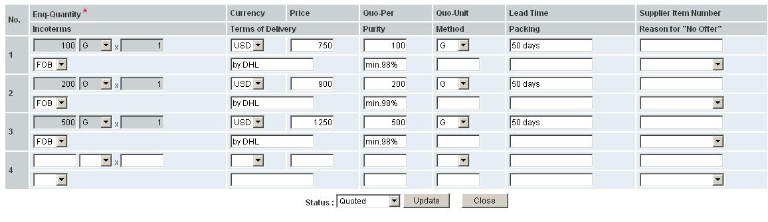
You can modify the data, but remember to push “Update” button in order to save the change.

6 JFYI

Click “Product”.

Enter a Product Number or a CAS Number, and click “Search” button.

Click “RFQ Issue”.

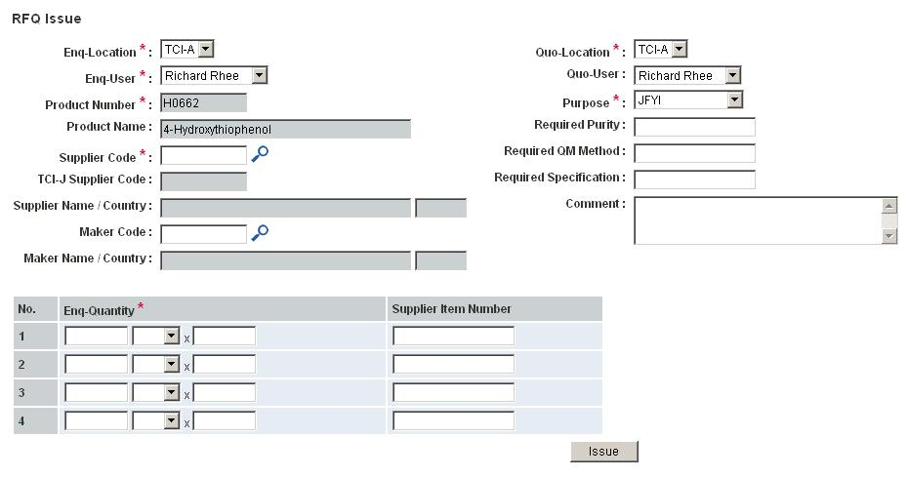
Select your own location as Quo-Location.
Select yourself as Quo-User.
Select “JFYI” as Purpose.

Click the magnifying glass icon.

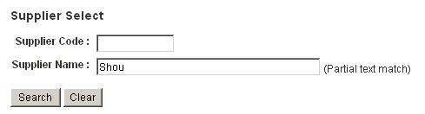

Enter a part of the supplier’s name, and click “Search” button.

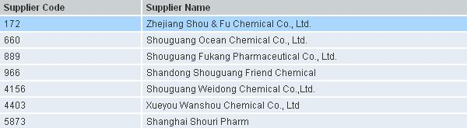
The search result is shown. Click a supplier.

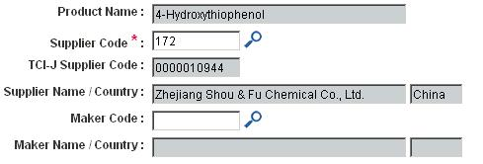

If Maker name is also required, click the other magnifying glass icon likewise.

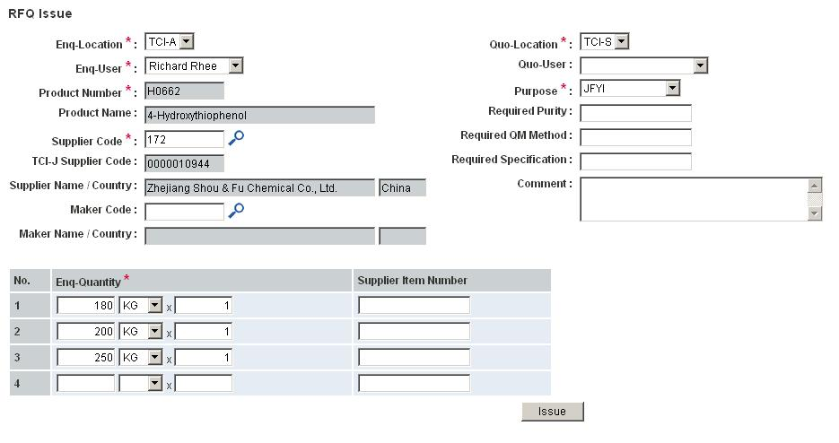
Factor is also required.
Enter quantities.

After entering the data, click “Issue” button.

Enter prices, lead time, and other data.
Change the status to “Quoted”, and click “Update” button.
Click “Close” button.
7 Correspondence – Receiving Messages
When a message arrives, it appears at “My Tasks”.
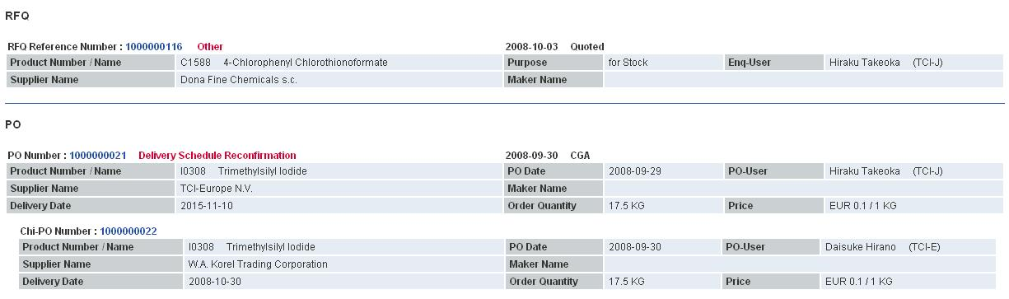
These red bold letters mean that a new message exists.

Click the link to view the details.

Click “RFQ Correspondence / History” to view the message.

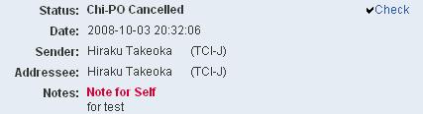
Click “Check”.

8 Correspondence – Writing Messages

Click “RFQ Correspondence / History” to write a message.

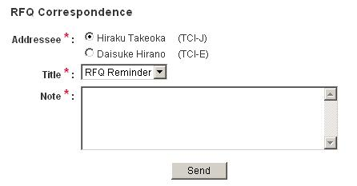
Remember to select Addressee.

After writing a message, click “Send” button.

