**Project: TrailFlix**

Team: Caliware

|  |  |  |
| --- | --- | --- |
| Timothy Cioffi-Dinkel | Anthony Farina | Joanna Hang |
| timothycioffi@csu.fullerton.edu | afarina@csu.fullerton.edu | johang@fullerton.edu |
| https://lh5.googleusercontent.com/PSroDgY8ZOUkmCV05kKayV-boTdpJSN4FXzGMZ1w6lwE5Br5w20a5pWMewmiTxHAznLEpv6jhuOyAIByZrQkCyPaceyEEcTEmPBQpFilW6976BlGvS6ZX0VZf9cAObv8=s1600 |  | sig.jpg |

|  |  |
| --- | --- |
| Lourdes Lopez | David Sullivan |
| lourdeslopez@csu.fullerton.edu | dsullivan@fullerton.edu |
| Untitled.png | https://lh5.googleusercontent.com/3FGNbflMbPEB_7oxSHs8FcMMr_Lp5KykcuOeEjncWoizP2v-jn12POyZmVra2fZCxjqKTL1FQzXUmPlmarUW9EyxEf-ii570A3UFlycFawZP6PRs9L7I6VX2bGtZIwEE8Ws=s1600 |

Submission Date: 12/07/2015

CPSC 541: Systems and Software Standards and Requirements

Dr. Christopher Ryu

# Revision History

|  |  |  |
| --- | --- | --- |
| **Date** | **Description** | **Author** |
| 9/15/15 | Created document outline | Joanna Hang |
| 9/29/15 | Business Requirements | Entire team |
| 9/30/15 | Requirements Specifications Outline | Timothy Cioffi-Dinkel |
| 10/1/15 | Scope and Limitations | David Sullivan |
| 10/1/15 | Business Requirements | Joanna Hang |
| 10/1/15 | Business Requirements | Lourdes Lopez |
| 10/2/15 | Requirements Specifications Outline | Timothy Cioffi-Dinkel |
| 10/2/15 | Functional Requirements | Anthony Farina |
| 10/3/15 | Business Requirements | Lourdes Lopez |
| 10/4/15 | Functional Requirements | Anthony Farina |
| 10/4/15 | Business Requirements | Entire team |
| 10/4/15 | Requirements Specifications Outline | Timothy Cioffi-Dinkel |
| 10/4/15 | Scope and Limitations | Entire team |
| 10/30/15 | Functional Requirements | Anthony Farina |
| 10/30/15 | Data Requirements | Anthony Farina |
| 11/3/15 | Data Requirements | Lourdes Lopez |
| 11/3/15 | Functional Requirements | Joanna Hang |
| 11/24/15 | Functional Requirements | Anthony Farina |
| 12/2/15 | Functional Requirements | Joanna Hang |
| 12/6/15 | Functional Requirements | David Sullivan |
| 12/6/15 | External Interface Requirements | Anthony Farina/Timothy Cioffi-Dinkel |
| 12/6/15 | Quality Attributes | Timothy Cioffi-Dinkel |
| 12/6/15 | Internationalization and Localization Requirements | Timothy Cioffi-Dinkel |

Contents

Revision History 2

**Vision and Scope Outline** 6

1. Business Requirements 6

1.1. Background 6

1.2. Business Opportunity 6

1.3. Business Objectives 7

1.4. Success Metrics 7

1.5. Vision Statement 7

1.6. Business Risks 7

1.7. Business Assumptions and Dependencies 8

2. Scope and Limitations 8

2.1. Major Features 8

2.2. Scope of Initial Release 9

2.3. Scope of subsequent releases 10

2.4. Limitations and exclusions 10

3. Business Context 11

*3.1.* Stakeholder Profiles 11

3.2. Project Priorities 12

3.3. Deployment Considerations 13

**Requirements Specifications Outline** 14

1. Introduction 14

1.1. Purpose 14

1.2. Document and Conventions 14

1.3. Project Scope 14

1.4. References 14

2. Overall Description 14

2.1. Product Perspective 14

2.2. User Classes and Characteristics 15

2.3. Operating Environment 16

2.4. Design and Implementation Constraints 16

2.5. Assumptions and Dependencies 16

3. System Features 17

3.1. User Registration 17

3.2. Uploading Videos 20

3.3. Searching Videos 24

3.4. Playing Videos 27

3.5. Sharing Videos 30

3.6. Adding Videos to “Favorites” List 31

3.7. Counting Number of Unique Views (Unique Users) 32

3.8. Adding Advertisement Videos 33

3.9. Analyze Videos to Match the Uploaded Videos to Advertisement Video 34

3.10. Paying Users for Views 35

3.11. Display/Add Local Events 38

3.12. Mobile Application 40

4. Data Requirements 42

4.1. Logical Data model 42

4.2. Data dictionary 42

4.3. Reports 46

4.4. Data acquisition, integrity, retention and disposal 49

5. External Interface Requirements 49

5.1. User interface 49

5.2. Software interfaces 50

5.3. Hardware interfaces 51

5.4. Communications interfaces 51

6. Quality Attributes 51

6.1. Usability 51

6.2. Performance 52

6.3. Security 52

6.4. Safety 52

7. Internationalization and Localization Requirements 52

Appendix A: Glossary 53

Appendix B: Analysis models 55

Appendix C: UI Sketch 58

# **Vision and Scope Outline**

## Business Requirements

### Background

Sharing videos is becoming more popular for outdoor enthusiasts now that everyone has full video capabilities through their smart phones and inexpensive high quality mobile cameras such as GoPro. Currently, there is no centralized place to search, share, and upload videos for outdoor enthusiasts while also looking for information on trails, tips for trips, and localized events. There are mobile apps for trails such as AllTrails, and there are video-sharing applications like YouTube and Vimeo. However, these video-sharing applications lack the integration of location services that could bring together a single user experience. We believe that our product will merge these two features into one seamless experience.

### Business Opportunity

Outdoor enthusiasts seek a system that provides video-sharing capabilities integrated with a geographical information system (GIS) to not only allow users to upload and share videos, but also to provide information on outdoor activities, trails, trip suggestions, and events nearby. Currently, there are generic video-sharing applications such as YouTube and Vimeo. YouTube only contains simple metadata for the location of the user where they uploaded the video. Vimeo is targeted towards users who wish to upload HD videos. For mobile devices, the AllTrails application provides a list of suggested trails, but does not contain any networking or video features. SnapChat and Instagram only allow short recordings that are 10 to 15 seconds long and can be uploaded with a general location tag. Current trends allow consumers to upload HD videos with inexpensive equipment and mobile devices. Consumers also are engaged in social networks. This presents as a business opportunity in our market as we can offer a single user experience of video-sharing capabilities in addition to offering more information on the location of trails, the difficulty of trails, and events nearby. These videos will provide outdoor enthusiasts a visual idea of what to expect when they visit these locations. The system will be both a web and mobile application. The user will be able to use the app the record videos while recording the location of his/her trail. The user will capture the locations of the videos as the videos are being recorded and can be saved offline for later upload after their adventure when they have internet access available.

### Business Objectives

BO-1 Generate revenue - Achieve positive cash flow within 6 months

BO-2 Capture a market share in video-sharing applications of 20% within 6 months

BO-3 Maximize ROI - Achieve 35% return on investment within 6 months

### Success Metrics

SM-1 Obtain $200,000 in advertisement

SM-2 Obtain 100,000 registered users

SM-3 Obtain 50,000 total videos uploaded

SM-4 Obtain 400,000 total views

### Vision Statement

For outdoor enthusiasts **who** need to share videos of their adventures, **the** TrailFlix, is a video-sharing website **that** will provide a platform to upload, search, play, and share videos. The video-sharing website will host videos from users, **unlike** YouTube**, our product** will be integrated with geographical information system, promote events in your area, and recommend local businesses in the area.

### Business Risks

RI-1: **Too few users** - When the application goes into production, consumers may not use the application, resulting in wasted time and resources. (Probability = 60%; Impact = 100%)

RI-2: **Copyright infringement** - Users may infringe copyrights if copyright-protected work was posted without proper authorization. (Probability = 80%; Impact = 10%)

RI-3: **Missed opportunity** - There is no similar application that exists today that is widely used for the target industry. Risk of not developing the application is missed opportunity. (Probability = 90%; Impact = 100%)

RI-4: **Organizational reputation** - System may damage organizational reputation if the implementation of our system is successful and has adverse effects on the geographical locations of these videos. i.e. national parks may become overburdened with crowd control and risk damage to the natural environment. (Probability = 10%; Impact = 80%)

RI-5: **Costly investment -** The infrastructure required to store videos in addition to developing the application, maintaining the application, and marketing is expensive. The profit needs to exceed these costs. (Probability = 20%; Impact = 90%)

### Business Assumptions and Dependencies

AS-1 Mobile phones will continue to be popular.

AS-2 Mobile apps will be able to accurately record locations.

DE-1 Mobile apps are dependent on GPS connection.

DE-2 Application is dependent on the reliability of hosting service.

## Scope and Limitations

### Major Features

FE-1: User registration page

FE-2: Uploading videos with personal comments

FE-3: Searching videos

FE-4: Playing videos

FE-5 Sharing Videos

FE-6: Adding videos to my favorites

FE-7: Counting number of views by unique users

FE-8: Adding advertisement (Ad) videos

FE-9: Analyzing videos to match the uploaded videos and Ad videos

FE-10: Paying Users for Views

FE-11: Display/Add localized events

FE-12: Smartphone app to provide GPS based location through smartphone for offline video location and upload video capability.

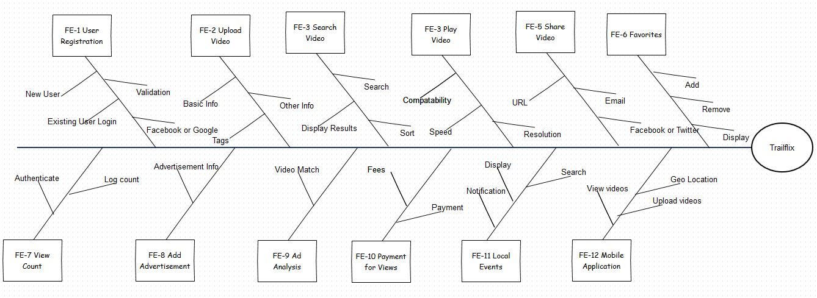

LI-1: English language is only available for the website and mobile app for this applications typical users.

LI-2: Due to the cost of storage, we will need to determine a size limit to the videos that can be uploaded to make it cost effective.

LI-3: Our application will not have an API for outside developers to be able read data or access from their application.

LI-4: We will not include a video editing capability. Users can use their own device or software to edit videos.

### Scope of Initial Release

FE-1: User Registration

FE-2: Uploading videos with personal comments

FE-3: Searching videos

FE-4: Playing videos

FE-5: Sharing videos

FE-6: Adding videos to my favorites

FE-7: Counting number of views by unique users

FE-12: Smartphone App - create a partially implemented App for iOS and Android. The authentication and video upload will be done by launching the website inside the mobile app in the “web viewer” control until the app is fully developed in future releases. On the web site, the user will select the location from a Google Map link in lieu of having the GPS location.

### Scope of subsequent releases

#### Release 2:

FE-8: Adding advertisement (Ad) videos

FE-9: Analyzing videos to match the uploaded videos and Ad videos  
FE-10: Paying Users for Views

FE-11: Display localized events - Not implemented

FE-12: iOS Version fully implemented. App will track the GPS location using location services and upload the video with native code

#### Release 3:

FE-12: Android Version fully implemented. App will track the GPS location using location services and upload the video with native code

FE-11: Display localized events

### Limitations and exclusions

English language is only available for the website and mobile apps: LI-1

In Release 1, we will only support video playback natively on the iOS and Android App. Native app features such as authentication, video upload, and GPS, will be deferred to future release. It will instead be uploaded by using the website. The users will manually selecting the location from Google maps.

In Release 2, the Android version will not yet have the native video upload and GPS feature

## Business Context

### Stakeholder Profiles

|  |  |  |  |  |
| --- | --- | --- | --- | --- |
| **Stakeholder** | **Major value** | **Attitudes** | **Major Interests** | **Constraints** |
| Direct User | Users will have a centralized location content and information on their outdoor adventures | Strong enthusiasm for major features | User-friendly application, strong interest in ease of use for major features, reliability of system | Promoting application is needed in order to make potential users aware of the application |
| Ad Customers and local businesses | Customers will be able to purchase ads that will reach their target audience with ease | Increased enthusiasm as the user base increases. Concern if user base decreases | Ability to promote their product, increase ad visibility, increase users | Success of renewed ad contracts may be dependent of number of user profiles |
| Event organizations | Event organizers or participants will be able to promote their events to target audience | Strong enthusiasm as the user base increases | Promote event, increase event visibility, increase users | None identified |
| Beta Testers | Beta testers will be able to use the latest version of the app before released | Strong commitment | New features | Beta testers may need to travel in order to test successfully |
| Venture Capitalist | Venture capitalist will receive a return on investment upon achieving a profitable product | Strong concern for success of application | Return on investment | None identified |
| Management Team | Profit | Strong commitment and enthusiasm | Maximize profit with ad sales, increase ad visibility, increase users, ease of use for purchasing ad space | Policy and procedure for ad sales needs to be in place |
| Project Team, including Development Manager, Product Owner, Architect, Developer, QA and Tester | Improved knowledge and skills | Strong commitment and enthusiasm | Development of a quality product, UI Design and technical architecture | None identified |

### Project Priorities

|  |  |  |  |
| --- | --- | --- | --- |
| **Dimension** | **Constraint** | **Driver** | **Degree of Freedom** |
| Features |  | Certain features can be deferred to a later release |  |
| Quality | 75% of user acceptance tests must pass; all security tests must pass |  |  |
| Schedule |  |  | Release should be aimed for one year with overrun of up to half a year |
| Cost | Cannot exceed budget |  |  |
| Staff |  | Team size is full-time project manager, full-time BA, 5 developers, 2 testers, and additional developer and half-time tester available if necessary |  |

### Deployment Considerations

First release will include both web and mobile applications. Mobile versions will need to be developed for iOS and Android. Infrastructure must be in place before release. Testing must be conducted prior to deployment.

# **Requirements Specifications Outline**

## Introduction

### Purpose

The product being described in this document is called TrailFlix, a geo-displaying video-sharing website used by outdoor enthusiasts looking to share both their experience with nature as well as giving others the opportunity to explore themselves. This document will be used as the display of our product ideas and visions to be shared with those actively developing the site. Project managers will utilize our vision of the website, as provided in this document, to formulate a process, time-framing, possible interferences and budgeting for which the development and marketing of the product can be started. With this process created, the developers and testers can utilize the desires for the product from the systems featured, data requirements, and quality attributes sections of this document to produce the website. From there, marketing can use the product created, with all of the features described here, to formulate the correct course of action for having users enticed into contributing to the web site and also visit the web site. Unless specified otherwise, the versioning documented here for TrailFlix is 1.0.

### Document and Conventions

No special typographical conventions are used in the SRS.

### Project Scope

The scoping of this product has been detailed in a previous section. Please refer to the Vision and Scope documented earlier in the SRS.

### References

## Overall Description

### Product Perspective

TrailFlix was invented out of the desire for a centralized website for the adventurers who wish to share their experiences in nature with other enthusiasts. Due to the limited quantity of places for the community to gather and share outside of websites such as Vimeo and YouTube, which is flooded with other traffic thus pushing out communities that desire specified websites, we believe there is a strong market for this product due to this limited production, with also a growing number of an outdoor community that longs to escape their urban environments.

This website is not a new idea but rather taking the idea of an existing product, YouTube or Vimeo, which are massive, centralized video sharing services, and attempting to create a specialized area for a specific group of people to come and share. Though, to deter individuals from using more developed websites we are proposing the use of mobile devices and small camera devices to allow a very personal experience with the individual who is taking a natural journey. Such as the concept of television utilizing Twitter to create community interaction with events occurring on T.V. TrailFlix will allow a similar communal involvement with modern day explorers, with the user seeing the exact pathing and video of the explorer in his cruise through nature.

### User Classes and Characteristics

|  |  |
| --- | --- |
| **User Class** | **Description** |
| Outdoorsman | TrailFlix allows for the possibility for a large user base, due to the extensive amount of outdoor activities that users can flood the website with. Not only can someone track their trail and take a video of the hike, this website can extend out to all of the outdoor community including: rock climbers who want to show the trail to their wall as well as their ascend; mountain bikers who wish to show their grand descend; water explorers such as river rafters, canoers and kayakers, sailors, surfers all wishing to show the route they took on this planet's seas and rivers; skiers and snowboarders during the cold seasons; all with high definition video evidence. |

### Operating Environment

OE-1: TrailFlix should be functioning on all versions of Windows and OSX which are supported by their developing companies.

OE-2: TrailFlix should be functioning on the most recent versions of Chrome, Firefox, Safari, Internet Explorer. Other browsers may be supported but we cannot guarantee.

OE-3: TrailFlix should be supported on the most recent version of Android, iOS, and Windows Phone, as well as their respective built in browsers. Other, third-party browsers cannot be guaranteed supported.

OE-4: TrailFlix will use Apache for its server and MySQL for storage.

### Design and Implementation Constraints

CO-1: TrailFlix will use the current MySQL database engine.

CO-2: All HTML will conform to the HTML 5.0 standard.

CO-3: TrailFlix will conform to W3C Standards as well as IETF internet standards

CO-4: TrailFlix must be compatible with PayPal for advertisement compensation.

### Assumptions and Dependencies

AS-1: GPS capabilities work as intended in remote areas.

DE-1: Application is dependent on the reliability of hosting service.

DE-2: Application is dependent on the operating system and internet browser it was developed for. Updates to these would require updates to the application.

## System Features

### User Registration

#### Description

Users will be allowed to register for the TrailFlix system. This will provide them with more features such as being allowed to upload videos, be compensated for video views, adding videos to a favorite’s list, and more. Users will be able to register using Facebook, Google, or using the native registration system. Note that user registration is not mandatory. Priority = High.

#### Functional Requirements

|  |  |
| --- | --- |
| ***Registration.Register*** | *Creating a new user account* |
| ***Registration.Native.Username*** | *The system shall provide a field for the user to enter a username.* |
| ***Registration.Native.Password*** | *The system shall provide a field for the user to enter a password.* |
| ***Registration.Native.Password.Confirm*** | *The system shall provide a second field for the user to confirm the password.* |
| ***Registration.Native.Email*** | *The system shall provide a field for the user to enter an e-mail address.* |
| ***Registration.Native.Validate*** | *When the user click the “Submit” button, the system shall validate that all fields.* |
| ***Registration.Native.Validate.Username*** | *The system shall validate the username.*  *The username shall not currently be in use.*  *The username shall have a minimum character length of 6 and maximum character length of 30.*  *The username shall not have contain special characters other than letters, numbers, periods, and underscores.* |
| ***Registration.Native.Validate.Password*** | *The system shall validate if the password field and confirm password field are identical.*  *The username shall not currently be in use.*  *The username shall have a minimum character length of 8 and maximum character length of 30.*  *The password shall contain a lowercase letter, an uppercase letter, a number.*  *The password shall not contain any special characters other than the following: ! @ $ % & * ( ) , . - _ +* |
| ***Registration.Native.Validate.Email*** | *The system shall validate the email address. The email address shall be a valid email address. The email address must not be in use.* |
| ***Registration.Facebook*** | *The system shall allow the user to register via Facebook. See https://developers.facebook.com/docs/facebook-login* |
| ***Registration.Google*** | *The system shall allow the user to register via Google. See https://developers.google.com/identity* |

### Uploading Videos

#### Description

The TrailFlix system will allow registered users to upload videos. They will be allowed to name the video and add a description to the video. The user will also be able to tag the video with certain identifiers so people can search for their video easier. The videos must comply with the terms of service and Caliware has the authority to remove any video. Priority = High.

#### Functional Requirements

|  |  |
| --- | --- |
| ***Video.Upload*** | *Uploading a video* |
| ***.RegisteredUser*** | *The system shall confirm that the user is a registered user and is logged in.* |
| ***.No*** | *If system detects that the user is not logged in then the system shall prompt the user to register.* |
| ***.BasicInfo*** | *The system shall prompt the user to enter the following fields for the uploaded video: Title, Description, Tags, Privacy.* |
| ***.BasicInfo.Title*** | *The system shall provide a field for the user to enter a Title for the video.* |
| ***.BasicInfo.Description*** | *The screen shall provide a field where the user can enter a description for the video. The system shall validate that the user has entered a description.* |
| ***.BasicInfo.Tags*** | *The system shall allow the user to enter tags for the video.* |
| ***.BasicInfo.Tags.Suggestions*** | *The system shall provide the user will suggestions for tags that have already been used.* |
| ***.BasicInfo.Privacy*** | *The system shall allow the user to restrict viewers from viewing the video with the following options: Private, Public, Unlisted.*  *If the user selects Private, the system shall restrict everyone except the user to view the video.*  *If the user selects Public, the system shall allow everyone to view the video.*  *If the user selects Unlisted, the system shall remove the video from search results but allow anyone with the URL to view the video.* |
| ***.OtherInfo*** | *The system shall prompt the user to edit other information regarding the video.* |
| ***.OtherInfo.OutdoorSportsCategory*** | *The system shall prompt the user to identify the video’s category: hiking, cycling, camping, dirt biking, skiing, snowboarding, etc.* |
| ***.OtherInfo.Location*** | *The system shall prompt the user for the location in which the video was recorded.* |
| ***.OtherInfo.Location.Description*** | *The system shall prompt the user for the location’s description in which the video was recorded.* |
| ***.OtherInfo.Location.Latitude*** | *The system shall prompt the user for the location’s latitude in which the video was recorded.* |
| ***.OtherInfo.Location.Longitude*** | *The system shall prompt the user for the location’s longitude in which the video was recorded.* |
| ***.OtherInfo.Trail*** | *The system shall prompt the user to check if the video uploaded is a recording of a trail. If the checkmark is selected, the system shall prompt the user for a name of the trail.* |
| ***.OtherInfo.RecordingDate*** | *The system shall prompt the user to enter the recording date of the video.* |
| ***.Duration*** | *When the user clicks on “Upload”, the system shall record the video’s length.* |
| ***.Duration.Limit*** | *If the video exceeds the size limit the system shall notify the user. The system shall prompt the user to either cancel or upload a different video.* |
| ***.UploadDate*** | *When the user clicks on “Upload”, the system shall record the video’s uploaded date.* |

### Searching Videos

#### Description

Users will be allowed to search for specific videos by using keywords. An algorithm to search video keywords and textual data will be used to produce search results of many videos that are related to the keyword. Priority = High.

#### Functional Requirements

|  |  |
| --- | --- |
| ***Search.Search*** | *The system shall search videos and return results based on user input.* |
| ***Search.SearchBar*** | *The system shall allow the user to be able to enter a text phrase into the search bar. When the user presses enter while the cursor is in the search bar, the system shall search for relevant videos, users, locations, or events. The search bar shall be visible to the user on all screens.* |
| ***Search.SearchBar.Results*** | *The system shall match the user’s input against the database video records of title, description, categories, and tags.* |
| ***Search.FilterResults*** | *The system shall filter search results by upload date, duration, and sort by. The system shall then search for videos based off the specified filter results.* |
| ***Search.FilterResults.UploadDate*** | *When the user selects to filter the search results by upload date, the system shall provide the user an option of filtering date added by videos uploaded within the last hour, today, this week, this month, or this year.* |
| ***Search.FilterResults.Duration*** | *When the user selects to filter the search results by duration, the system shall provide the option to an option of filtering duration by short videos under 5 minutes or long videos over 20 minutes.* |
| ***Search.FilterResults.NoResults*** | *The system shall notify the user if the search term returns no results.* |
| ***Search.FilterResults.SortBy*** | *The system shall allow the user to select the field to sort by. Options for sort by will be relevance, upload date, view count, and rating.* |
| ***Search.FilterResults.SortBy.Relevance*** | *The system shall sort search results by relevance. The system shall check the user’s inputted text against the system’s database tags. The system shall display the search results with the most matched tags.* |
| ***Search.FilterResults.SortBy.UploadDate*** | *The system shall sort search results by upload date. The system shall sort results by the most recent upload date to least recent upload date.* |
| ***Search.FilterResults.SortBy.ViewCount*** | *The system shall sort search results by view count by videos with the most view counts to the least view counts.* |
| ***Search.FilterResults.SortBy.Rating*** | *The system shall sort search results by rating from the highest rating to the lowest rating.* |

### Playing Videos

#### Description

The user can play videos, determine the aspect ratio of the web player, and even the resolution of the video. Priority = High*.*

#### Functional Requirements

|  |  |
| --- | --- |
| ***PlayerCompatibility*** | ***Check player compatibility*** |
| ***.CompatibleBrowser*** | *The system shall check if the user’s browser if compatible with the video player. The browser must be either Google Chrome, Firefox, Internet Explorer, Safari or Opera.* |
| ***.NoCompatibleBrowser*** | *The system shall notify the user if the browser is not compatible* |
| ***.CompatibleFlash*** | *The user shall check if the user has installed Adobe Flash Player.* |
| ***.NoCompatibleFlash*** | *The system shall notify the user if the Adobe Flash Player is not installed.* |

|  |  |
| --- | --- |
| ***LoadVideo*** | ***Load a Video*** |
| ***.Load*** | *After the user selects a video to play, the system shall prebuffer the video halfway of the video’s length. The system shall increase the buffer by 25% as the video plays.* |
| ***.Load.DisplayAdvertisement*** | *The system shall display an advertisement before playing video.* |

|  |  |
| --- | --- |
| ***PlayVideo*** | ***Play a video*** |
| ***.Resolution.User*** | *The user shall be able to select which available resolutions they want to watch the video in. When the user selects a resolution, the system shall pause the video, change the resolution, and then play the video at the pause point.* |
| ***.Resolution.System*** | *The system shall change the resolution based on the connection speed of the user.* |
| ***.Size*** | *The system shall be able to change the aspect ratio of the video.* |
| ***.Pause*** | *The system shall let the user pause the video at any point.* |
| ***.Forward*** | *The system shall let the user forward the video* |
| ***.Speed*** | *The system shall allow the user to adjust the video’s speed setting from 0.25x, .5x, normal, 1.25x, 1.5x, or 2x. These speed settings shall adjust the framerate of the video with this multiplier.* |

### Sharing Videos

#### Description

Users can share videos in a multitude of ways such as sharing directly to all the major social networks or email. Priority = Low.

#### Functional Requirements

|  |  |
| --- | --- |
| ***Share.*** | *The system shall provide a button where the user can share the video to Facebook, Twitter, Email, URL, and at a specific time.* |
| ***Share.Facebook*** | *The system shall provide a button where the user can share the video directly to Facebook. See https://developers.facebook.com/docs/plugins/share-button* |
| ***Share.Twitter*** | *The system shall provide a button where the user can share the video directly to Twitter. See https://dev.twitter.com/web/tweet-button* |
| ***Share.Email*** | *The system shall provide a button where the user can share the video via email. The default email application will open with the video title being the subject and the video link being in the body of the email.* |
| ***Share.URL*** | *The system shall copy the URL to the user’s clipboard.* |
| ***Share.SpecificTime*** | *The system shall copy a URL that will load the video at the specified time in the video.* |

### Adding Videos to “Favorites” List

#### Description

A registered user can add videos to a “Favorites” list so they have easy access to view there most liked videos. Priority = Low.

#### Functional Requirements

|  |  |
| --- | --- |
| ***Favorites.*** | *The system shall provide the user to add, remove, display favorited videos.* |
| ***Favorites.Add*** | *The system shall provide the user to add videos to a “Favorites” list* |
| ***Favorites.Remove*** | *The system shall provide the user to remove videos from the “Favorites” list* |
| ***Favorites.Display*** | *The system shall display the user a list of favorites upon user request.* |
| ***Favorites.Display.noResults*** | *The system shall notify the user if the favorites list is empty.* |

### Counting Number of Unique Views (Unique Users)

#### Description

The TrailFlix system must be able to count the number of unique views (unique users based on IP address) for a video. This will directly correlate with the amount of money being paid out to the video owner so authenticating the views is imperative. Priority = High.

#### Functional Requirements

|  |  |
| --- | --- |
| ***ViewCount*** | *The system shall record the number of views per video.* |
| ***.Unique*** | *The system shall count the amount of unique views that have occurred on every video by tracking the user’s IP address.* |
| ***.Authentication*** | *The system shall authenticate a unique view. The system shall determine if the user was a person or a bot.* |

### Adding Advertisement Videos

#### Description

Advertisement partners will be allowed to advertise on uploaded videos. Priority = High.

#### Functional Requirements

|  |  |
| --- | --- |
| ***Advertisement.Add*** | *The system shall allow the user to add an advertisement video.* |
| ***.AdInfo*** | *The system shall prompt the user to enter the following fields for the uploaded video: Title, Description, and Tags.* |
| ***.AdInfo.Title*** | *The system shall provide a field for the user to enter a Title for the video.* |
| ***.AdInfo.Description*** | *The screen shall provide a field where the user can enter a description for the video. The system shall validate that the user has entered a description.* |
| ***.AdInfo.Tags*** | *The system shall allow the user to enter tags for the video.* |
| ***Advertisement.Approval*** | *The system shall flag the video for Caliware approval process.* |

### Analyze Videos to Match the Uploaded Videos to Advertisement Video

#### Description

In order to maximize the impact of advertisements, there will be an analysis of videos to match advertisements with videos. The algorithm will take several data points into account. Priority = Medium.

#### Functional Requirements

|  |  |
| --- | --- |
| ***AnalyzeVideo.*** | *The system shall analyze videos based on various data points.* |
| ***.Location*** | *The system shall analyze videos based on location.* |
| ***.Views*** | *The system shall analyze videos based on amount of views.* |
| ***.VideoTags*** | *The system shall analyze videos based on the video tags.* |
| ***Advertisement.Length*** | *The system shall select a video that is 10% the length of the video. The system shall not display advertisements on videos less than a minute.* |

### Paying Users for Views

#### Description

To increase the user base and quality of videos, registered user will have the ability to receive compensation for their uploaded videos. The amount of compensation will be directly related to the amount of unique views a video has. Priority = Medium.

#### Functional Requirements

|  |  |
| --- | --- |
| ***Compensation.*** | *The system shall update balance for users based on the amount of views that the user has garnered on their video.* |
| ***Compensation.User*** | *The system shall verify if the user is qualified to receive compensation if the user has over 200,000 unique views on videos.* |
| ***Compensation.User.OptIn.Email*** | *The system shall email users with video counts over 200,000 asking to opt into compensation for views.* |
| ***Compensation.User.OptIn.No*** | *The system shall record that the user does not want compensation for views.* |
| ***Compensation.User.OptIn.Yes*** | *The system shall prompt the user to confirm to the agreement.* |
| ***Compensation.PayPal*** | *Upon approval, the system shall pay users via PayPal.* |
| ***Compensation.Paypal.AddAccount*** | *The system shall add the PayPal account by prompting the user to log into the PayPal account.* |
| ***Compensation.PayPal.Verify*** | *The system shall verify the PayPal account by sending an email to the user and by depositing a small amount to the PayPal account between $0.01 - $1.00.* |
| ***Compensation.PayPal.VerifyDeposit*** | *The system shall verify the deposit amount when the user enters the amount deposited into the user’s PayPal account.* |
| ***Compensation.ViewPendingDistributionBalance*** | *The system shall display the user’s pending distribution balance for that month per video.* |
| ***.Currency.USDollars*** | *The system shall be able to compensate using US Dollars if the user has selected that option* |
| ***.Currency.Euros*** | *The system shall be able to compensate using Euros if the user has selected that option.* |
| ***.Currency.Pounds*** | *The system shall be able to compensate using Pounds if the user has selected that option.* |

### Display/Add Local Events

#### Description

Registered users and advertising partners will be allowed to add local events (hiking trips, get-togethers, etc.) so other like-minded users can join. There will be a dedicated section for local events and local events will be advertised on video pages if they are related to the video (relationship decided by multiple data points). Priority = Low.

#### Functional Requirements

|  |  |
| --- | --- |
| ***Events.*** | *The system shall allow users and advertisements to create “events”.* |
| ***.Private*** | *The customer shall be able to set the event as private* |
| ***.Location*** | *The system shall require the customer to set a location for the event* |
| ***Event.Favorite*** | *The system shall allow users to mark an event as a favorite.* |
| ***.Date*** | *The system shall require the customer to set a date for the event* |
| ***.Date.Past*** | *The system shall remove the event from “Active” to “Past” if the date is past the event date* |
| ***.Date.Notification*** | *The system shall notify users via email when an event is 5 days away based on events marked as their favorites.* |
| ***.Description*** | *The system shall require the user to set a description for the event* |
| ***.Advertisers*** | *The system shall require advertisers to compensate “TrailFlix” for advertising sponsored event* |
| ***.Notification.Location*** | *The system shall display local events to users based on their location* |
| ***.Notificiation.ViewedVideos*** | *The system shall display event to users based on their video history* |
| ***Events.Search*** | *The system shall allow the user to search by location for upcoming events.* |
| ***Events.Search.NoResults*** | *The system shall indicate that no results matched any events.* |

### Mobile Application

#### Description

A companion mobile application will be developed so users can use the system when they are on the go. The mobile application is especially good for uploading since geolocation will automatically be recorded when taking videos. Priority = Medium.

#### Functional Requirements

|  |  |
| --- | --- |
| ***Mobile.*** | *The customer shall be able to use a “TrailFix” mobile application* |
| ***.ViewVideos*** | *The user shall be able to view all videos via the mobile application* |
| ***.UploadVideos*** | *The user shall be able to upload videos via the mobile application* |
| ***.Register*** | *The user shall be able to register an account via the mobile application* |
| ***.RecordVideo*** | *The user shall be able to record video via the mobile application* |
| ***.RecordVideo.Geolocation*** | *The system shall record geolocation throughout video recording if the user has given permission to do so.* |

## Data Requirements

### Logical Data model

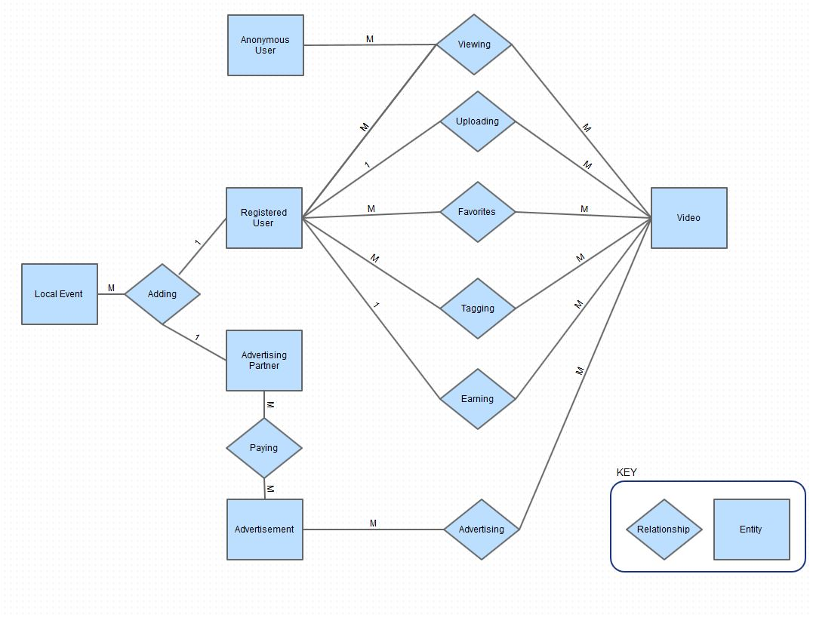

### Data dictionary

|  |  |  |  |  |
| --- | --- | --- | --- | --- |
| **Data Element** | **Description** | **Composition or data type** | **Length** | **Values** |
| Registered User | a user who has a registered account | User ID  +User Name  +User Authentication  +Account Status  +Account Creation Date |  |  |
| Account Status | the status of an account | string | 20 | active, canceled, hold |
| Video | an uploaded video | Video ID  +Registered User ID  +Geo Location  +Length  +Upload Date |  |  |
| Geo Location | the geographical location that a video was taken |  |  |  |
| Video View | a video view | View ID  +Video ID  +User  +View Date |  |  |
| Tag | a video tag | Tag ID  +Video  +User |  |  |
| Favorite | a video marked as a favorite | Favorite ID  +Video  +User |  |  |
| Advertising Partner | a company who is an advertising partner | Company ID  +Company Name  +Authorized User  +Account  +Account Status  +Account Creation Date |  |  |
| Advertisement | a promotional ad | Advertisement ID  +Advertising Partner  +Video |  |  |
| Event | an event | Event ID  +Event Location  +Event Start Date  +Event End Date  +(User)  +(Advertising Partner) |  |  |
| Account | an account used for tracking transactions | Account ID  +Advertising Partner |  |  |
| Statement |  | Statement ID  +Advertising Partner  +Advertisement  +Charge |  |  |
| Transaction |  | Transaction ID  +Transaction Status  +Amount  +Transaction Type |  |  |
| Transaction Type | type of transaction | String | 50 | payment, credit |

### Reports

* + 1. Advertiser's Statistics Report

|  |  |
| --- | --- |
| **Report ID** | **ADV-REPORT-1** |
| Report Title | {Company Name} {Month, Year} Statistics |
| Report Purpose | To allow the company to see the effectiveness of their advertisements which will allow them to increase their efforts, change their direction, etc. |
| Priority | High |
| Report Users | Advertisers |
| Data Sources |  |
| Frequency | Monthly |
| Distribution | On advertiser's profile and emailed directly to their advertisers email. |
| Format | PDF |
| Header | see Report Title |
| Body | Advertiser’s information  Statistics Total Table:   * Advertisement Identification number * Date started * Number of views * Number of clicks * Cost per advertisement   Individual Advertisement Breakdown:   * Trend Graphs throughout month including   + Views per day   + Clicks per day   Geographical heat map |
| Footer | TrailFlix copyright  Page number |
| Security | The advertiser’s profile is password protected |

* + 1. Executive Dashboard

|  |  |
| --- | --- |
| **Report ID** | **Exec-REPORT-1** |
| Report Title | Daily Executive Dashboard |
| Report Purpose | To give Caliware executives an insight on success metrics. |
| Priority | High |
| Report Users | Caliware Executives |
| Data Sources | Production Data |
| Frequency | Daily |
| Distribution | Emailed directly to executives email. |
| Format | PDF |
| Header | see Report Title |
| Body | Advertiser’s information  Summarized YTD Data:   * Total dollars received from advertisements per month. * Total number of registered users per month. * Number of new users per month. * Total videos uploaded per month. * Total videos viewed per month.   Geographical heat map   * All registered users. * New users current month * Video location for all videos |
| Footer | TrailFlix copyright  Page number |
| Security | The PDF is password protected |

### Data acquisition, integrity, retention and disposal

DI-1: Data for videos will be acquired by user’s uploading them.

DI-2: Data for advertisements will be acquired by companies wishing to have advertisements placed.

DI-3: Data for events will be acquired by those who are hosting the events and desire the event to be displayed by location.

DI-4: Data for location will be acquired by the user of the video desiring their video to have a location attached to it.

DI-5: Videos will be retained for up to 2 years from last view date.

DI-6: User account information will be retained for up to 2 years from last login date.

DI-7: Event data will be retained for up to 2 days from event date.

## External Interface Requirements

### User interface

*Note: Sample of the UI is displayed under Appendix C at the bottom of this document.*

UI-1: The TrailFlix screens shall always display the search bar.

UI-2: The TrailFlix system shall display location information, related/local events, video player, and ads in at least one screen.

UI-3: Keyboard hotkeys for controlling video shall be supported.

UI-4: Non-video embedded advertisements shall not be intrusive (e.g., Popups, Automatically Playing Sounds, etc.).

### Software interfaces

SI-1: Advertisement System

SI-1.1: The website will pull an advertiser’s video from the database, randomly by location, and display the video before the desired video.

SI-2: Video System

SI-2.1: Videos that were uploaded and placed into the database will be pushed forward bases on searching keywords.

SI-2.2: Views on the video will be pushed to the database alongside the video.

SI-3: User System

SI-3.1: The user will have a portal for which you can upload videos to, which will place the video into a database, being selected from keywords in the search function.

SI-3.2: The user’s portal will have a section to link PayPal account information for deposit of revenue from views, which will be stored in the user database.

SI-3.3: User will have basic information stored in the user database: Name, email, address, security questions.

SI-3.4:

SI-4: Geo-Location system

SI-4.1: Location of the video will be logged when the uploading user turns on the feature.

SI-4.2: The location is sent to with the video to the database for which that video exists.

SI-4.2: The location will be displayed with the video using Google’s mapping system.

SI-4.3: The location of the video will match with events in the area and display the events in the box that is indicated as events.

### Hardware interfaces

No hardware interfaces are required.

### Communications interfaces

CI-1: An email shall be sent to the user upon creation of an account. This email will welcome the new user and provide basic contact and troubleshooting information.

CI-2: An email will be sent to the user upon request for password change or username finding. This will then prompt the user to return to the website and enter security features to determine user’s identity.

CI-3: Email communication will be sent to the user regarding new videos from other users for which the emailed user has shared.

## Quality Attributes

### Usability

USE-1: TrailFlix shall allow for easy searching for activity the user wishes to watch.

USE-2: TrailFlix shall be easy to learn, mimicking the video player of other similar web-pages, to reduce user confusion and solidifying familiarity.

USE-3: TrailFlix shall be heavily tested using a proven testing system such as Selenium to ensure little to no errors.

USE-4: TrailFlix shall be able to be accessed from mobile devices as well as a home computing unit.

### Performance

PER-1: TrailFlix shall be able to host 1,000,000 amount of users during peak times of 6PM - 11PM, daily. This will increase as the size of the company increases.

PER-2: TrailFlix shall be able to provide 90% of videos in HD during peak times.

PER-3: TrailFlix shall pull up videos and mapping system within a 4-7 second window during peak times.

### Security

SEC-1: TrailFlix shall authenticate user profiles to secure revenue from advertisement.

SEC-2: TrailFlix shall authenticate currency information for advertisement placement within the web-page.

SEC-3: TrailFlix shall authenticate actual users to defend against botting to drive views.

### Safety

Safety requirements are not necessary for this application as there is no possibility for physical harm from this web-page.

## Internationalization and Localization Requirements

ILR-1: Trailflix shall allow advertising revenue to be available currencies around the world.

ILR-2: TrailFlix shall be available in English in the first release. Future releases will contain other various languages.

# Appendix A: Glossary

**Advertising Partner** A company that desires a video of an advertisement for their company will pay Caliware for their advertisement to be placed at the beginning of a video. Once payment is acquired, the company will become a partner for which their video will be selected randomly to be placed on a video.

**Favorites** A registered user can add videos to a list labeled “favorites” which will be added by a button located by the video when viewing. This list then will be displayed for the user under their account for future video retrieval.

**Geo Location** TrailFix will allow an uploading user to track their location and pathing for where they are traveling.

**Geographical Information System** The uploading user’s location is displayed beside the video using Google’s mapping system.

**HD Video** Videos that are uploaded have the option to be uploaded in HD, requiring more bandwidth for the uploading user, and will then be able to be displayed in HD by selection. The standard will be non-HD standard definition.

**Local Events** A user can request for a local event to be displayed next to a video that was recorded near the upcoming event.

**Registered User Tag** A person who has created an account using their information and provided with the power to upload content. This person is then considered a registered user by the system and provided with the registered user status, or “tag.”

# Appendix B: Analysis models

FE-2 Uploading Videos

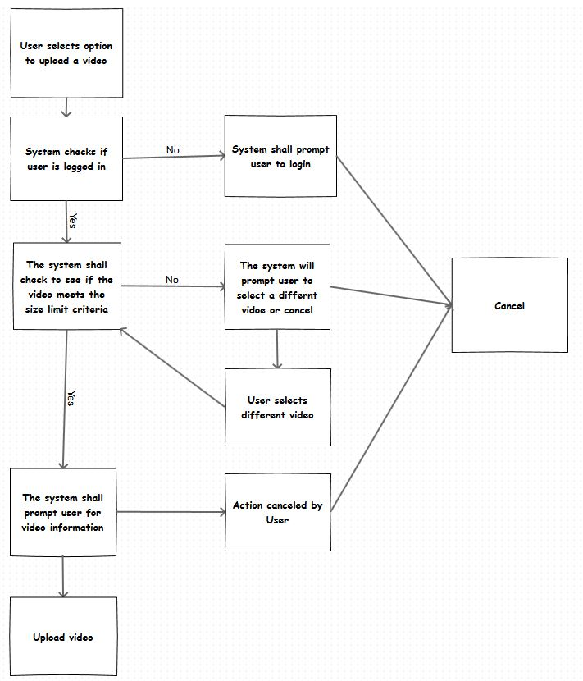

FE-4 Play Video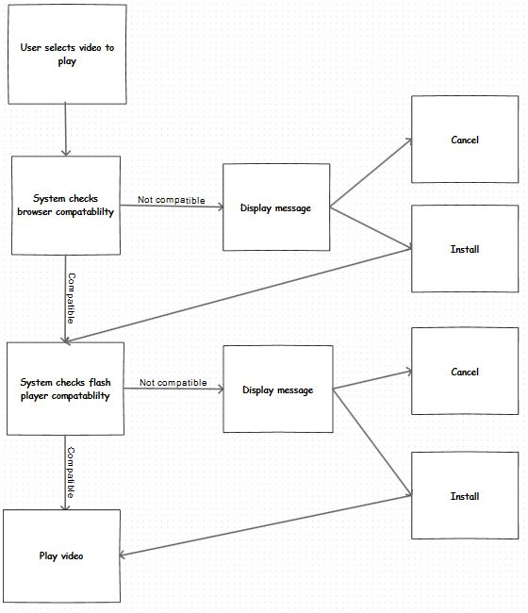

FE-10 Paying Users for Views

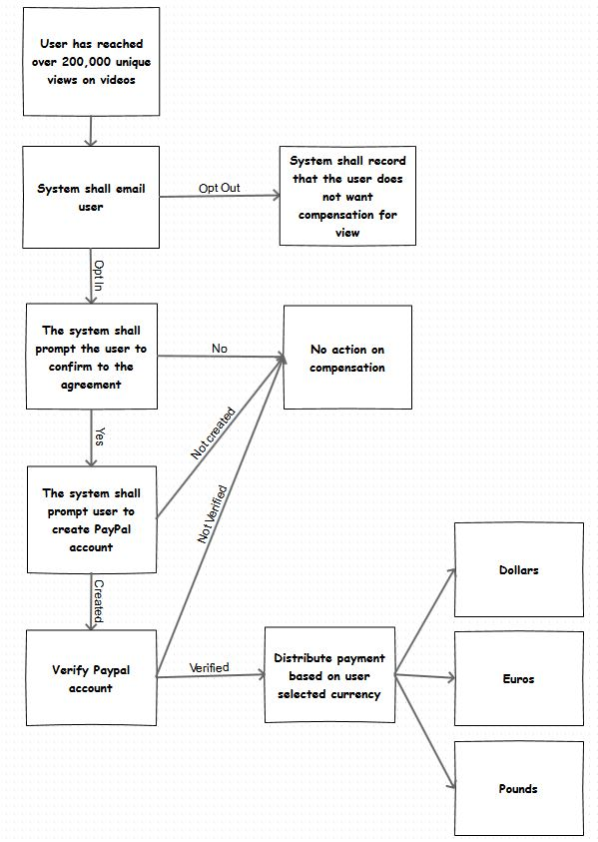

# Appendix C: UI Sketch

This sketch details a simple mockup sketch of the main video page. This sketch is just for thought and does not need to be copied or developed.

