目录

一、门店日报凭证操作 1

1.获取日凭证： 1

2.获取月凭证 1

3.导入至银祥 2

4.取消导入 2

二、导入K3数据库 2

1.zhuok导入函数 2

2.导入操作 2

三、相关表、视图 2

1.凭证细表记录数 2

2.凭证辅助项目视图 3

3.凭证会计科目视图 4

4.凭证主表视图 4

5.凭证细表视图 5

6.导入日志表 5

## 一、门店日报凭证操作

1.获取日凭证：

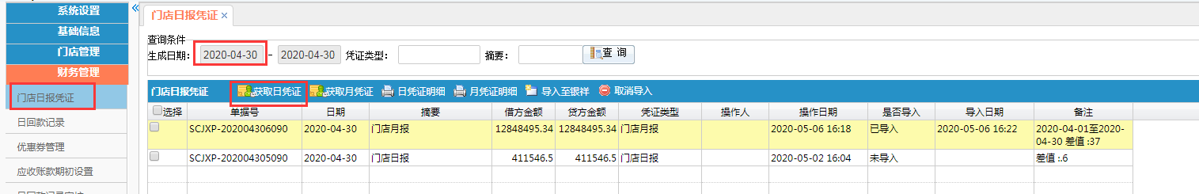

根据选择的开始日期生成日凭证相关数据

2.获取月凭证

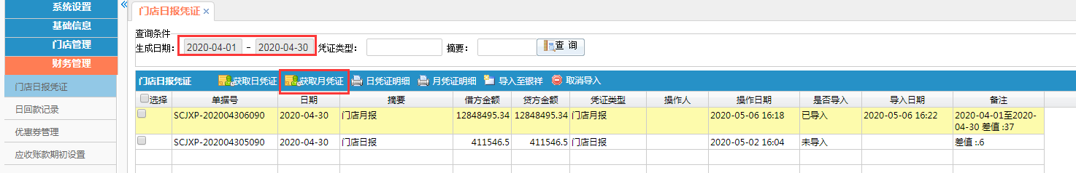

根据选择开始日期、结束日期获取期间的汇总数据；备注中列示出来具体的期间日期

3.导入至银祥

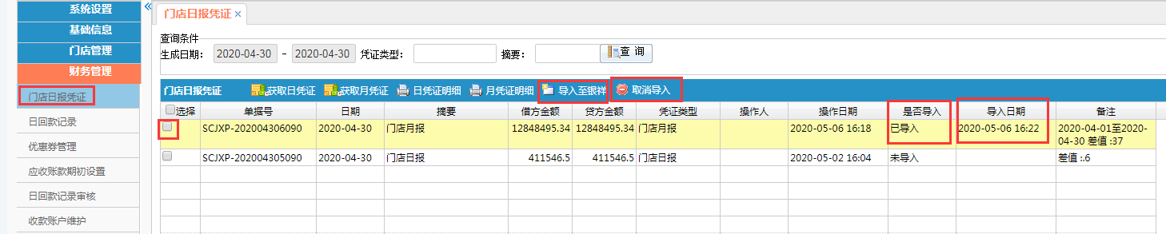

选中需导入至银祥数据库（zhuok）的记录，导入成功，会显示导入日期。导入成功后提供凭证类型(门店月报、门店日报)、日期给信息部，信息部的后台从银祥zhuok数据库导入至K3数据库即可。

门店月报：默认日期为该月最后一天

4.取消导入

如发现已导入的数据有异常，需重新导入，先取消导入。对应会更新银祥数据库（zhuok）的记录标识为不导入。

如取消导入前，已导入至K3数据库，则系统进入K3系统，删除掉对应的凭证。

## 二、导入K3数据库

1.zhuok导入函数

zhuok库中create_k3_Voucher

参数：p_source 门店月报=60;门店日报=50

P_date 日期

2.导入操作

根据财务部提供的凭证类型(门店月报、门店日报)、日期

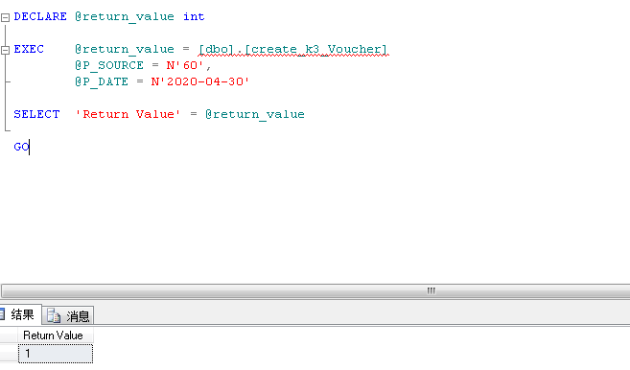

## 三、相关表、视图

1.凭证细表记录数

CREATE VIEW [dbo].[K3V_GL_VOUCHER_DETAIL_Count] AS

select a.VOU_ID,COUNT(*) FEntryCount from K3T_GL_VOUCHER_DETAIL a group by a.VOU_ID;

2.凭证辅助项目视图

CREATE VIEW [dbo].[K3V_GL_VOUCHER_DETAIL_Item_A] AS

SELECT a.ID_KEY,a.CCUS_ID,a.CCUS_NM,a.CDEPT_ID,a.DEPT_NM,a.S_ITEM_ID,a.S_ITEM_NM,isnull((select TOP 1 Fitemid from test_yxspzhuok.dbo.t_item

WHERE FItemClassID=1 and FNumber=a.CCUS_ID),0) f1,0 f2,0 f3 ,0 f8,

isnull((select TOP 1 Fitemid from test_yxspzhuok.dbo.t_item

WHERE FItemClassID=3001 and FNumber=a.CDEPT_ID),0) f3001

FROM K3T_GL_VOUCHER_DETAIL a ;

CREATE VIEW [dbo].[K3V_GL_VOUCHER_DETAIL_Item_B] AS

select a.ID_KEY,a.CCUS_ID,a.CCUS_NM,a.CDEPT_ID,a.DEPT_NM,a.S_ITEM_ID,a.S_ITEM_NM,a.f1,a.f2,a.f3,a.f8,a.f3001,

c.FDetailCount,c.FDetailID

from K3V_GL_VOUCHER_DETAIL_Item_A a, test_yxspzhuok.dbo.t_itemdetail c where a.f1<>0 and a.f3001=0

AND a.f1=c.f1 AND a.f2=c.f2 AND a.f3=c.f3 AND a.f8=c.f8 and a.f3001=c.f3001

union all

select a.ID_KEY,a.CCUS_ID,a.CCUS_NM,a.CDEPT_ID,a.DEPT_NM,a.S_ITEM_ID,a.S_ITEM_NM,a.f1,a.f2,a.f3,a.f8,a.f3001,

c.FDetailCount,c.FDetailID

from K3V_GL_VOUCHER_DETAIL_Item_A a, test_yxspzhuok.dbo.t_itemdetail c where a.f1=0 and a.f3001<>0

AND a.f1=c.f1 AND a.f2=c.f2 AND a.f3=c.f3 AND a.f8=c.f8 and a.f3001=c.f3001

union all

select a.ID_KEY,a.CCUS_ID,a.CCUS_NM,a.CDEPT_ID,a.DEPT_NM,a.S_ITEM_ID,a.S_ITEM_NM,a.f1,a.f2,a.f3,a.f8,a.f3001,

c.FDetailCount,c.FDetailID

from K3V_GL_VOUCHER_DETAIL_Item_A a, test_yxspzhuok.dbo.t_itemdetail c

where (a.f1<>0 and a.f3001<>0) AND a.f1=c.f1 AND a.f2=c.f2 AND a.f3=c.f3 AND a.f8=c.f8 and a.f3001=c.f3001

union all

select a.ID_KEY,a.CCUS_ID,a.CCUS_NM,a.CDEPT_ID,a.DEPT_NM,a.S_ITEM_ID,a.S_ITEM_NM,a.f1,a.f2,a.f3,a.f8,a.f3001,

0 FDetailCount,0 FDetailID

from K3V_GL_VOUCHER_DETAIL_Item_A a

where (a.f1=0 and a.f3001=0);

3.凭证会计科目视图

select a.ID_KEY,a.CCODE,a.CCODE_NM,

1 FDC,*--余额方向*

a.INID-1 FEntryID,*--分录号*

isnull((select top 1 FAccountID from test_yxspzhuok.dbo.t_Account t where t.fNumber=a.CCODE),0) FAccountID,*--科目内码*

1086 FAccountID2*--对方科目*

from K3T_GL_VOUCHER_DETAIL a where a.CCODE is not null

union all

select a.ID_KEY,a.CCODE_EQUAL CCODE,a.CCODE_EQUAL_nm CCODE_NM,

0 FDC,*--余额方向*

a.INID-1 FEntryID,*--分录号*

isnull((select top 1 FAccountID from test_yxspzhuok.dbo.t_Account t where t.fNumber=a.CCODE_EQUAL),0) FAccountID,*--科目内码*

1710 FAccountID2*--对方科目*

from K3T_GL_VOUCHER_DETAIL a where a.CCODE_EQUAL is not null;

4.凭证主表视图

CREATE VIEW [dbo].[K3V_t_Voucher] AS

select a.ID_KEY,a.S_DATE,-1 FApproveID *--审批,,*

,0 FAttachments *--附件张数,*

,0 FBrNo *--公司代码,*

,-1 FCashierID *--出纳员,,*

,0 FChecked *--是否审核,*

,-1 FCheckerID *--审核人,,*

,a.S_DF_MONEY FCreditTotal *--贷方金额合计,*

,a.S_DATE+' 00:00:00' FDate

*--,CONVERT(datetime,a.S_DATE+' 00:00:00',120) FDate --凭证日期,*

,a.S_JF_MONEY FDebitTotal *--借方金额合计,*

,b.FEntryCount FEntryCount *--分录数,,*

,a.S_CONTENT FExplanation *--备注,,*

,'' FFootNote *--批注,,*

,-1 FFrameWorkID *--集团组织机构内码*

,1 FGroupID *--凭证字内码,*

,null FHandler *--会计主管,*

,null FInternalInd *--机制凭证,*

,null FModifyTime *--修改时间,*

,0 FNumber *--凭证号,,*

,null FObjectName *--对象接口,*

,0 FOwnerGroupID *--制单人所属工作组*

,null FParameter *--接口参数,*

, CONVERT(INTEGER,right(a.S_MONTH,2)) FPeriod *--会计期间,*

,0 FPosted *--是否过账,*

,-1 FPosterID *--记账人,,*

,16598 FPreparerID *--制单人,,*

,null FReference *--参考信息,*

,'' FSerialNum *--凭证序号,*

,a.S_DATE+' 00:00:00' FTransDate

*--,CONVERT(datetime,a.S_DATE+' 00:00:00',120) FTransDate --业务日期,*

,0 FTranType *--单据类型,*

,0 FVoucherID *--凭证内码,*

,CONVERT(INTEGER,left(a.S_MONTH,4)) FYear *--会计年度,*

from dbo.K3T_GL_VOUCHER a

left join K3V_GL_VOUCHER_DETAIL_Count b on a.ID_KEY=b.VOU_ID ;

5.凭证细表视图

CREATE VIEW [dbo].[K3V_t_VoucherEntry] AS

select c.FAccountID FAccountID,*--科目内码*

c.FAccountID2 FAccountID2,*--对方科目*

a.MONEY FAmount ,*--本位币金额*

isnull(a.MONEY_F,a.MONEY) FAmountFor,*--原币金额*

0 FBrNo ,*--公司代码*

0 FCashFlowItem,*--现金流量*

1 FCurrencyID,*--币别*

c.FDC FDC ,*--余额方向*

isnull(b.FDetailID,0) FDetailID,*--核算项目*

c.FEntryID FEntryID,*--分录号*

1 FExchangeRate,*--汇率*

1 FExchangeRateType ,*--汇率类型*

a.S_CONTENT FExplanation,*--摘要*

null FInternalInd,*--机制凭证*

0 FMeasureUnitID,*--单位内码*

0 FQuantity,*--数量*

0 FResourceID,*--项目资源内码*

null FSettleNo,*--结算号*

0 FSettleTypeID,*--结算方式*

0 FTaskID ,*--项目任务内码*

null FTransNo,*--业务号*

0 FUnitPrice,*--单价*

0 FVoucherID,*--凭证内码*

a.ID_KEY,a.VOU_ID,a.S_ITEM_ID,a.S_ITEM_NM

from K3T_GL_VOUCHER_DETAIL a

left join K3V_GL_VOUCHER_DETAIL_Item_B b on a.ID_KEY=b.ID_KEY

left join K3V_GL_VOUCHER_DETAIL_Account c on a.ID_KEY=c.ID_KEY

;

6.导入日志表

CREATE TABLE [dbo].[k3t_gl_voucher_log](

[vou_id] [nvarchar](30) NULL,

[VoucherID] [nvarchar](100) NULL,

[S_SOURCE] [nvarchar](100) NULL,

[S_DATE] [nvarchar](100) NULL,

[FSerialNum] [nvarchar](100) NULL,

[INO_ID] [nvarchar](30) NULL,

[PROW_NUM] [nvarchar](30) NULL,

[FYear] [nvarchar](30) NULL,

[fPeriod] [nvarchar](30) NULL,

[z_opt_dt] [datetime] NULL,

[Z_REMARK] [nvarchar](200) NULL

) ON [PRIMARY];