**Context menu**

A **context menu** (also called **contextual**, **shortcut**, and **popup** or **pop-up menu**) is a menu in a graphical user interface (GUI) that appears upon user interaction, such as a right-click mouse operation. A context menu offers a limited set of choices that are available in the current state, or context, of the operating system or application to which the menu belongs. Usually the available choices are actions related to the selected object. From a technical point of view, such a context menu is a graphical control element.

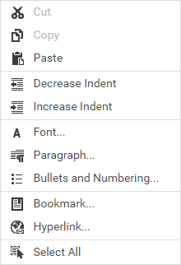

**History**

Context menus first appeared in the Smalltalk environment on the Xerox Alto computer, where they were called pop-up menus. The NEXTSTEP operating system further developed the idea, incorporating a feature whereby the right or middle mouse button brought the main menu (which was vertical and automatically changed depending on context) to the location of the mouse, thereby eliminating the need to move the mouse pointer all the way across the large (for the time) NextStep screen.

Microsoft Office v3.0 introduced the context menu for copy and paste functionality in 1990. Lotus 1-2-3/G for OS/2 v1.0 added additional formatting options in 1991. Borland Quattro Pro for Windows v1.0 introduced the Properties context menu option in 1992.

From Wikipedia, the free encyclopedia