Acme Robotics — Annual Report 2043
Total revenue for fiscal year 2043 reached 840 million EUR, a 15 percent increase over 2042. The robotics division accounted for 60 percent of revenue.
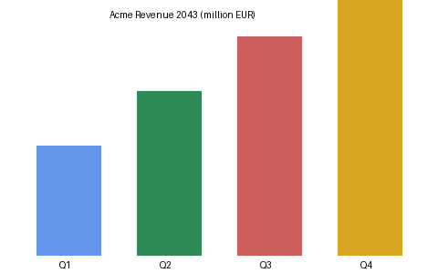
Quarterly revenue progression is shown above: Q1 40, Q2 60, Q3 80, and Q4 100 million EUR.

Headcount
The company ended 2043 with 1,240 employees, of whom 780 work in engineering. The Berlin office grew fastest, adding 95 people.

