Assessment 1
Advanced Statistical Machine Learning
and Pattern recognition
Wenyang Cai
Feb 21, 2013

Error Compare
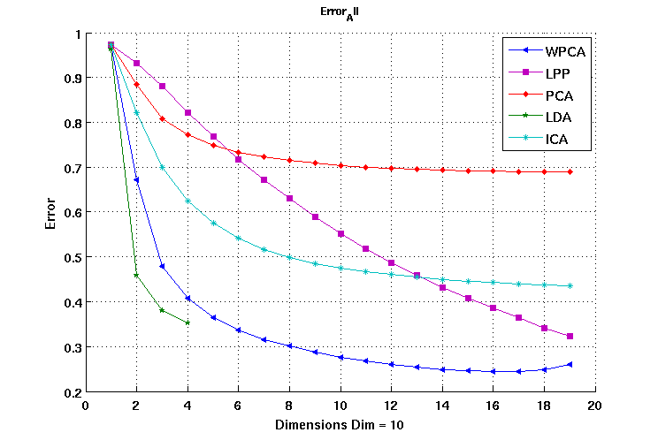
If we keep as many as dimension as possible, the whited-pca would be best but if we keep dimension as few as possible , then LDA may be best.
LDA reduce dimension much faster and it also remain a better performance than PCA, so LDA is definitely better than PCA.
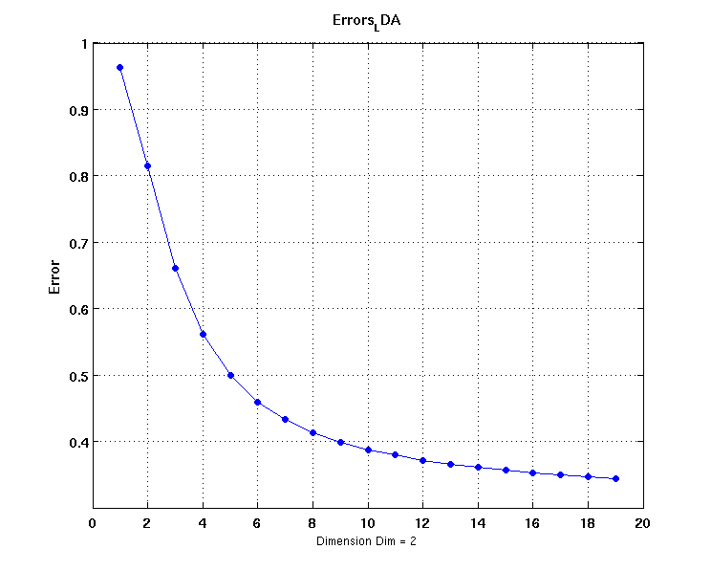
This figure is
Time Comare
LDA is the fastest in processing in matlab and the performance is good.
LPP is the slowest in processing and ICA could be very slow, dependce on the converge condition.

