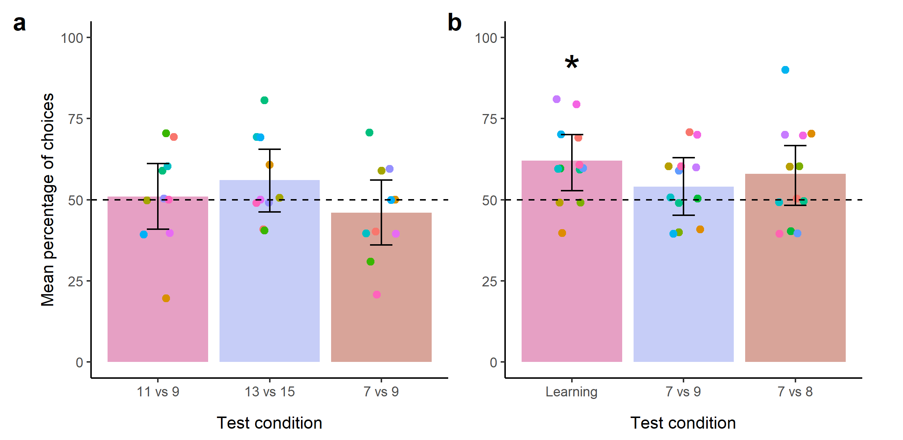
Test phase for: a = 60 trials of priming b = 60 choices training

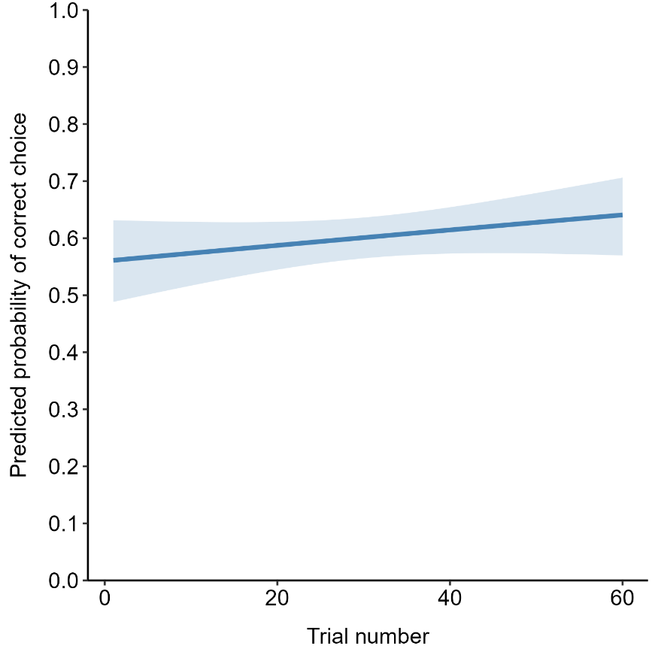
Figure x. Learning phase for 60 trials of training (appetitive-aversive). Not statistically significant effect of trial, but overall a statistically significantly different from 50%.

