http://gamedevelopment.tutsplus.com/tutorials/how-to-create-a-custom-2d-physics-engine-the-basics-and-impulse-resolution--gamedev-6331

struct AxisAlignedBoundingBox
Vec2 min
Vec2 max

Separating Axis Theorem

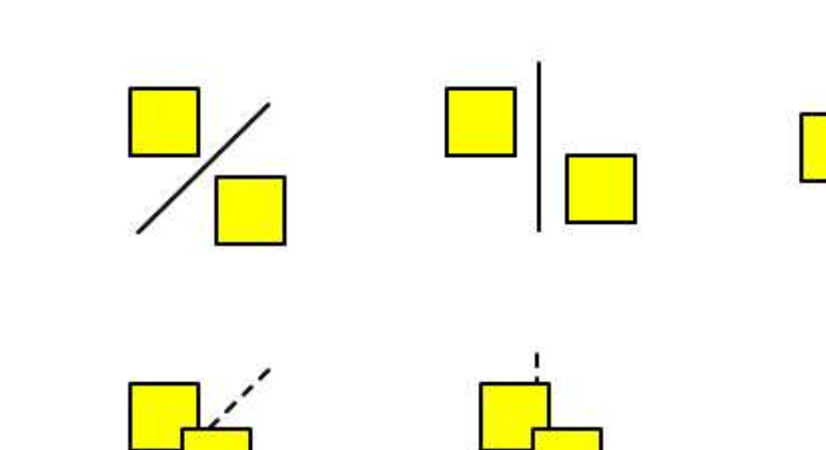
bool AABBvsAABB( AABB a, AABB b )

// if found separated along an axis, there is no intersection
if ( a.max.x < b.min.x or a.min.x > b.max.x ) return false
if ( a.max.y < b.min.y or a.min.y > b.max.y ) return false

// No separating axis found, so there must be an overlap
return true

struct Circle
float radius
Vec2 pos

// squaring the radius eliminates the need to find square roots
// (multiplication is computationally cheaper than addition

bool CircleVCircleOptimized ( Circle a, Circle b )
float r = (a.radius + b.radius) ^ 2
return r < (a.x + b.x)^2 + (a.y + b.y)^2

Impulse Resolution

Rigid body ~ shape implicitly defined to be non deformable. Allows for lots of math and derivations to be simplified

// consider storing 1/mass somewhere
void ResolveCollision( Object A, Object B )

// calculate relative velocity
vec2 rv = B.velocity – A.velocity

// calculate relative velocity in terms of the normal direction
float velAlongNormal = DotProduct( rv, normal )

// do not resolve if velocities are separating
if (velAlongNormal > 0) return

// calculate restitution
float e = min( A.restitution, B.restitution )

// calculate impulse scalar
float j = -(1 + e) * velAlongNormal
j /= 1 / A.mass + 1 / B.mass

// apply impulse
vec2 impulse = j * normal
A.velocity -= 1/ A.mass * impulse
B.velocity += 1/ B.mass * impulse

