Title
Table of Contents
1 Heading one 1
2 Heading 1b 1
2.1 Heading 2 1
2.1.1 Heading 3 1
3 Heading two 2
2.2 Heading 2 2
2.2.1 Heading 3 2
2.2.2 Heading 3 2

Heading one

Heading 1b

Some text

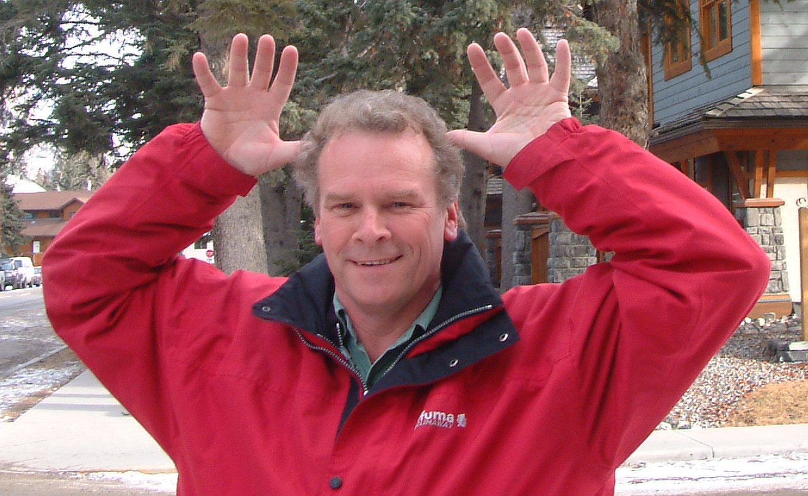
Heading 2
- The quick brown fox jumps over the lazy dog. The quick brown fox jumps over the lazy dog. The quick brown fox jumps over the lazy dog. The quick brown fox jumps over the lazy dog. The quick brown fox jumps over the lazy dog. The quick brown fox jumps over the lazy dog. The quick brown fox jumps over the lazy dog. The quick brown fox jumps over the lazy dog. The quick brown fox jumps over the lazy dog. The quick brown fox jumps over the lazy dog. The quick brown fox jumps over the lazy dog. The quick brown fox jumps over the lazy dog.


Heading 3
The quick brown fox jumps over the lazy dog. The quick brown fox jumps over the lazy dog. The quick brown fox jumps over the lazy dog. The quick brown fox jumps over the lazy dog. The quick brown fox jumps over the lazy dog. The quick brown fox jumps over the lazy dog. The quick brown fox jumps over the lazy dog. The quick brown fox jumps over the lazy dog. The quick brown fox jumps over the lazy dog. The quick brown fox jumps over the lazy dog. The quick brown fox jumps over the lazy dog. The quick brown fox jumps over the lazy dog.

Heading 3
The quick brown fox jumps over the lazy dog. The quick brown fox jumps over the lazy dog. The quick brown fox jumps over the lazy dog. The quick brown fox jumps over the lazy dog. The quick brown fox jumps over the lazy dog. The quick brown fox jumps over the lazy dog. The quick brown fox jumps over the lazy dog. The quick brown fox jumps over the lazy dog. The quick brown fox jumps over the lazy dog. The quick brown fox jumps over the lazy dog. The quick brown fox jumps over the lazy dog. The quick brown fox jumps over the lazy dog.

Heading 2
Body 2
Text written vertically.

Footer

Heading 3
Body 3

Heading 3
Body 3

Heading two

Footnote below
List contents
- Bulleted list one.
- Bulleted list two.
A table | Heading | Three columns
First row
Second row with more text that will wrap

And a blank line.
 |  | Third line.
 | Vertical text

- Numbered list
- two entries
i²c

A foot note Page 2

