B2B - Start Page
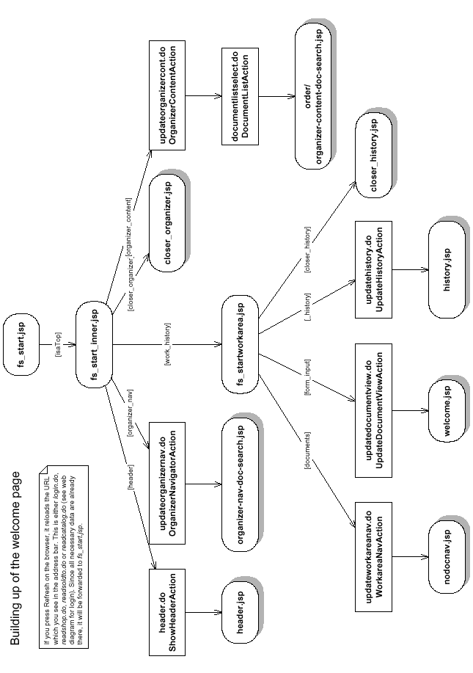

B2B - LogIn Process
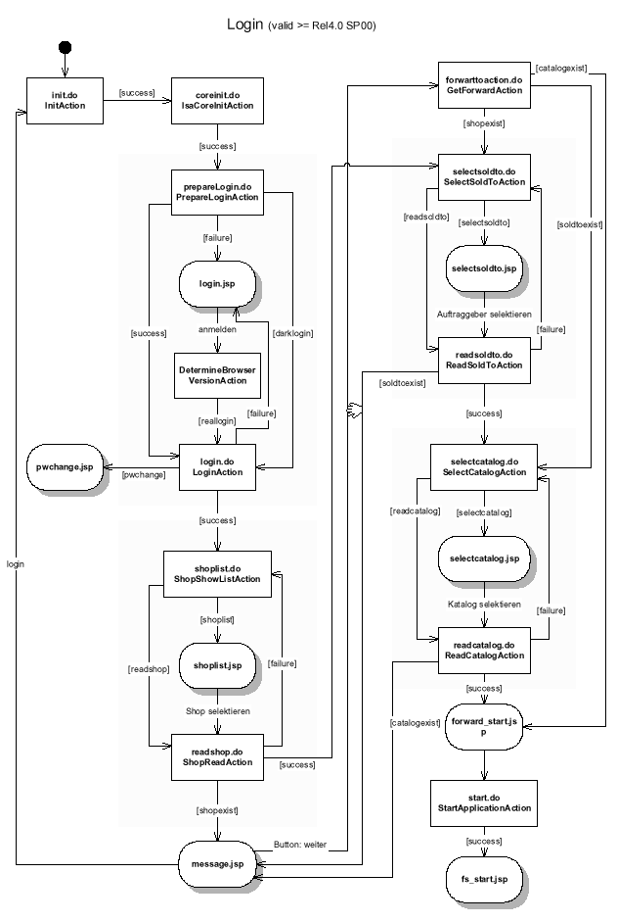

B2B - Create Basket
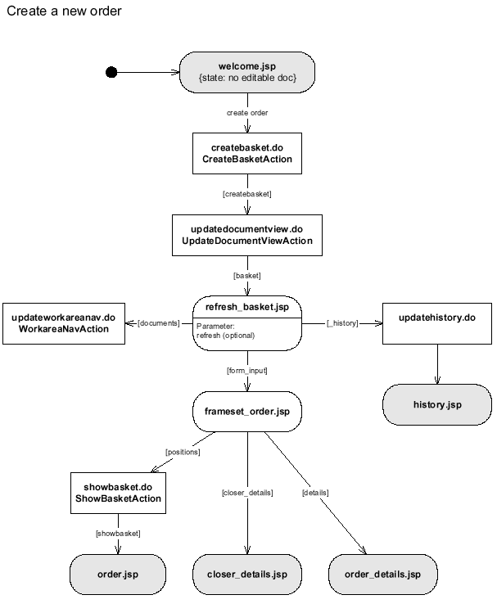

B2B - Display Order Status
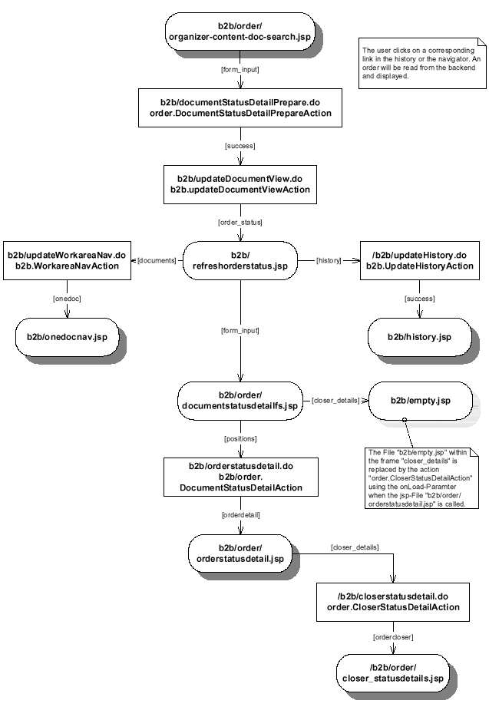

References
- “SAP E-Commerce Development and Extension Guide: Examples and Tutorials” on SAP Service Marketplace: http://service.sap.com/crm-inst → mySAP CRM 2005 → CRM Core.
- SAP CRM 5.0 Java. InstallationGuide on SAP Service Marketplace: http://service.sap.com/crm-inst → mySAP CRM 2005 → CRM Core and follow the link “Installation mySAP CRM 2005 (SAP CRM 5.0)”. Follow the “Java” link that is applicable for the database and operating system, you want to use.
- Struts documentation: http://jakarta.apache.org/struts/userGuide/index.html
- SAP Java Connector: On the SAP Service Marketplace: http://service.sap.com/connectors → Java Connector

Update History

Version | Date | Remarks
1.0 | March 2006

