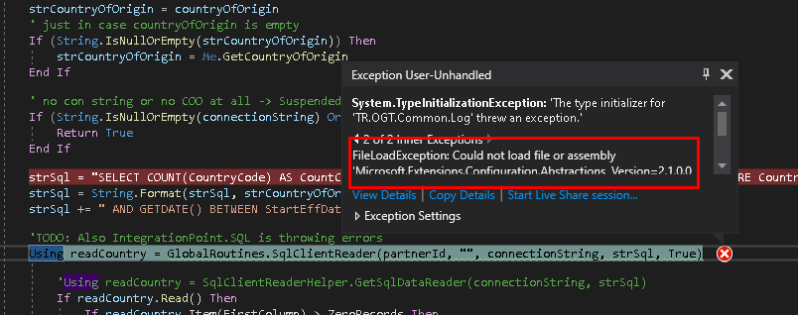

TR.OGT.Common uses

Microsoft.Extensions.Configuration.Abstractions 2.1.0

But somehow is also pointing to

Microsoft.Extensions.Configuration.Abstractions 3.1.0

Unload the project

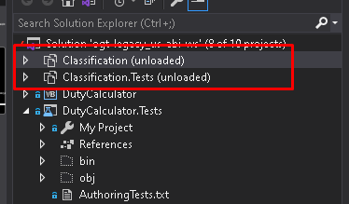

Add the following lines at the end of the 1st <Property Group> Debug

<AutoGenerateBindingRedirects>true</AutoGenerateBindingRedirects>

<GenerateBindingRedirectsOutputType>true</GenerateBindingRedirectsOutputType>

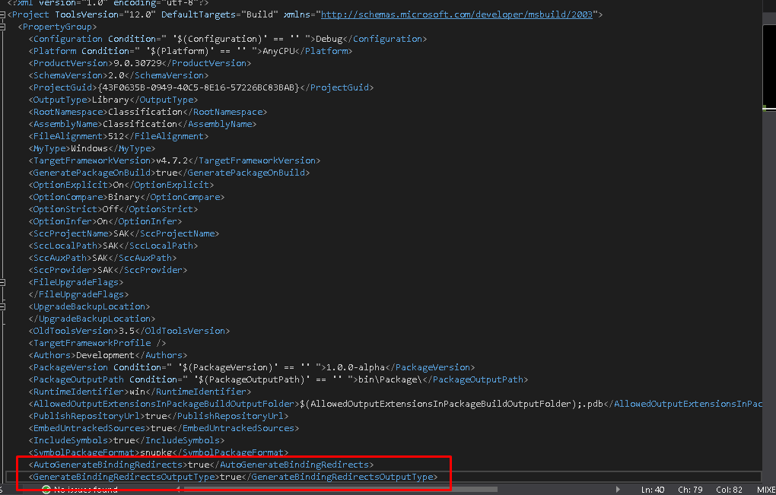

Reload the Project(s)

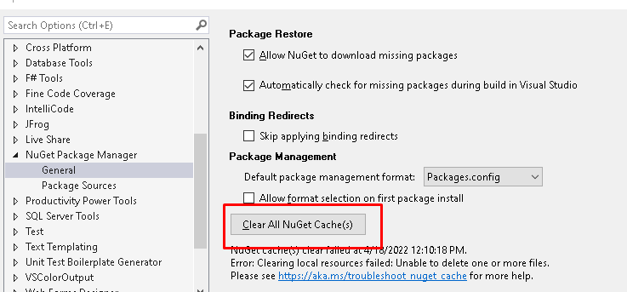

Clear the Nuget Cache

Rebuild the project(s)

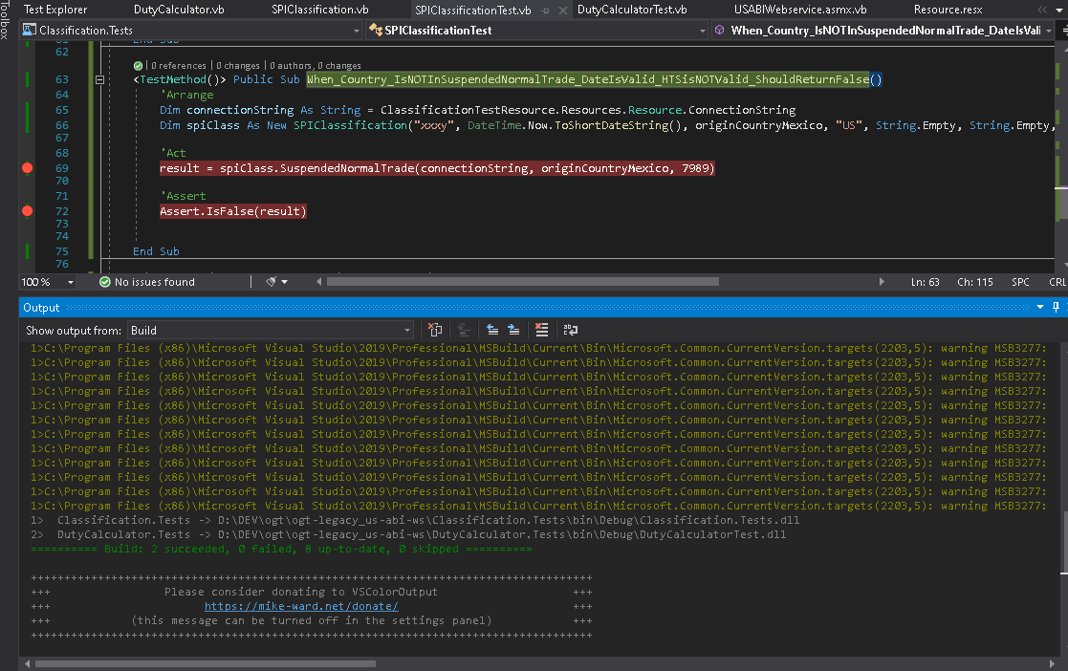

And the dependency should not throw error

