Production-grade infra-terraform screenshots
1. Remote backend s3 for terraform remote state
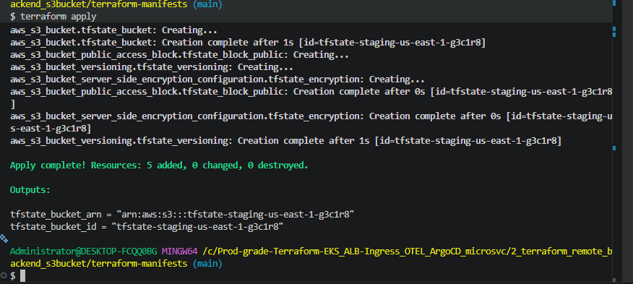
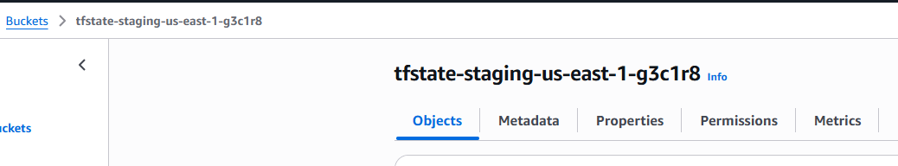
2. Production grade VPC with 3 private subnets and 3 public subnets in 3 AZs
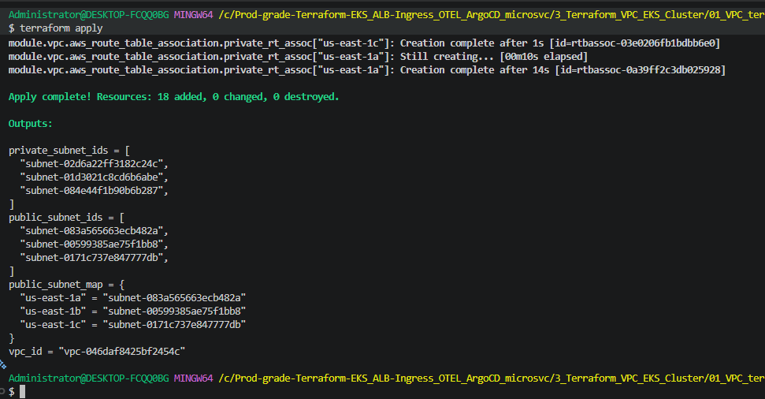
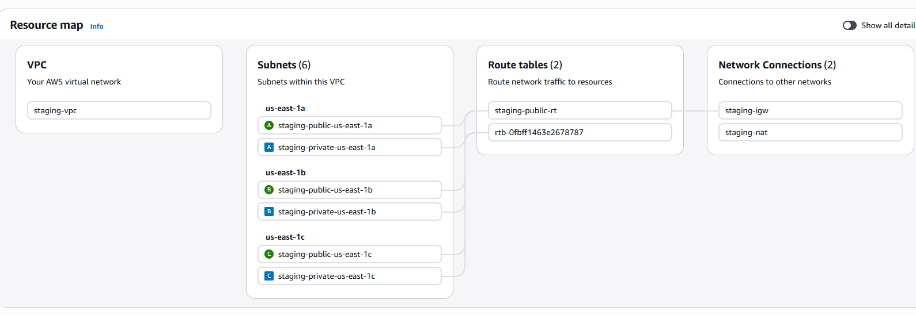
3. Production grade EKS cluster with 2 worker nodes
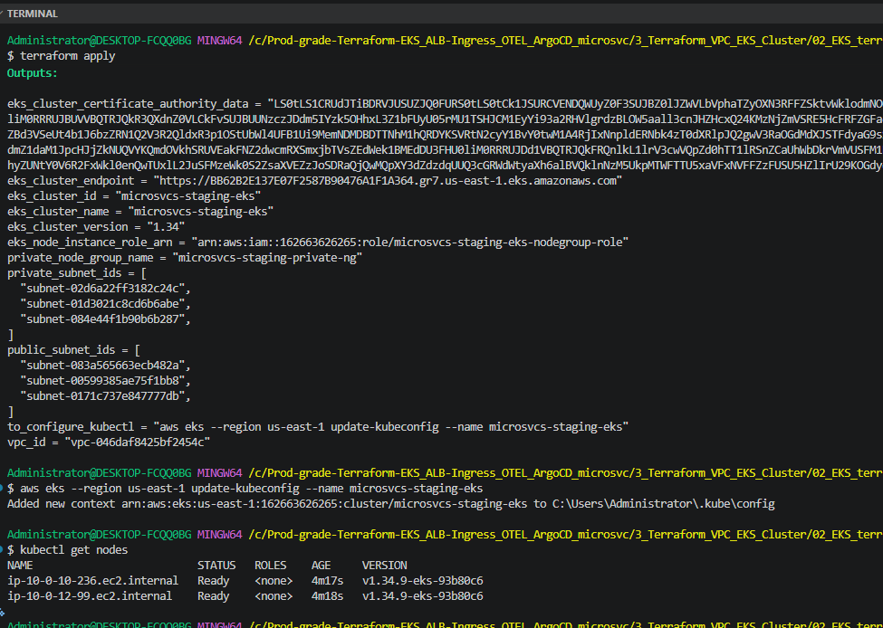
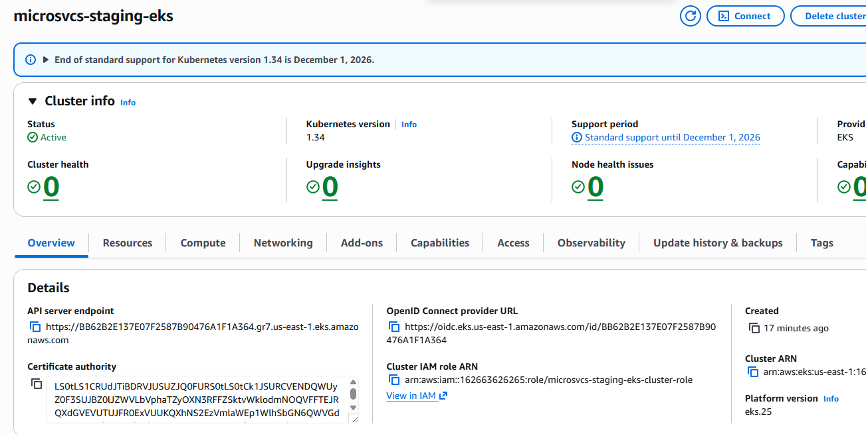

4. EKS Pod Identity Association Implementation:
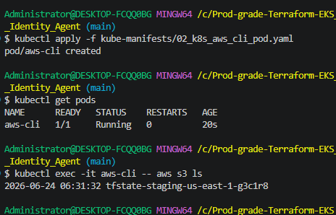
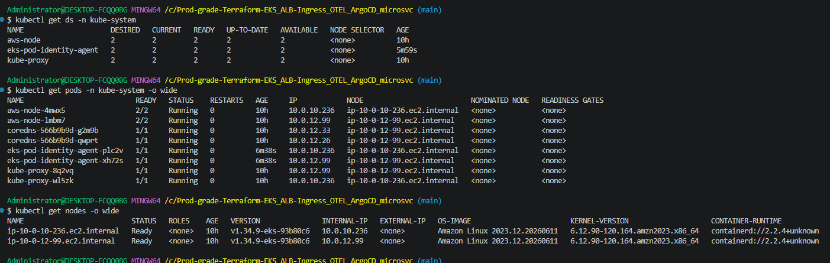
4a. Secret Store CSI Driver installation using helm:
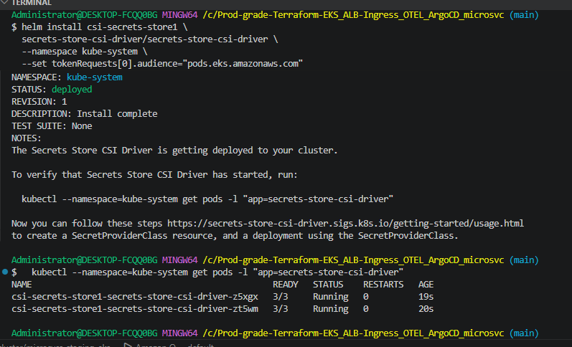
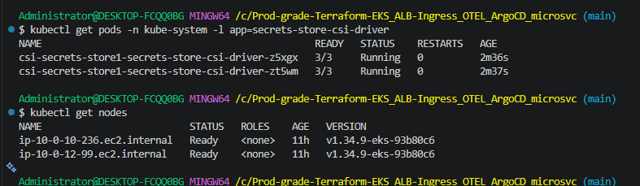
4b. Install ASCP: fetch secrets from AWS Secrets Manager and return them EKS CSI driver
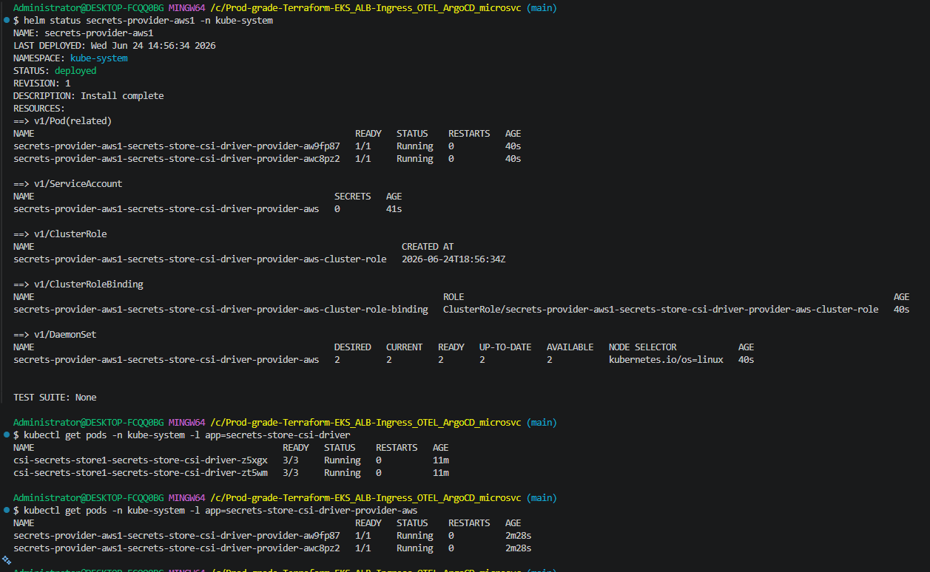
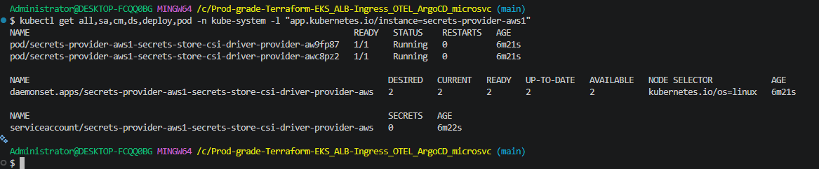
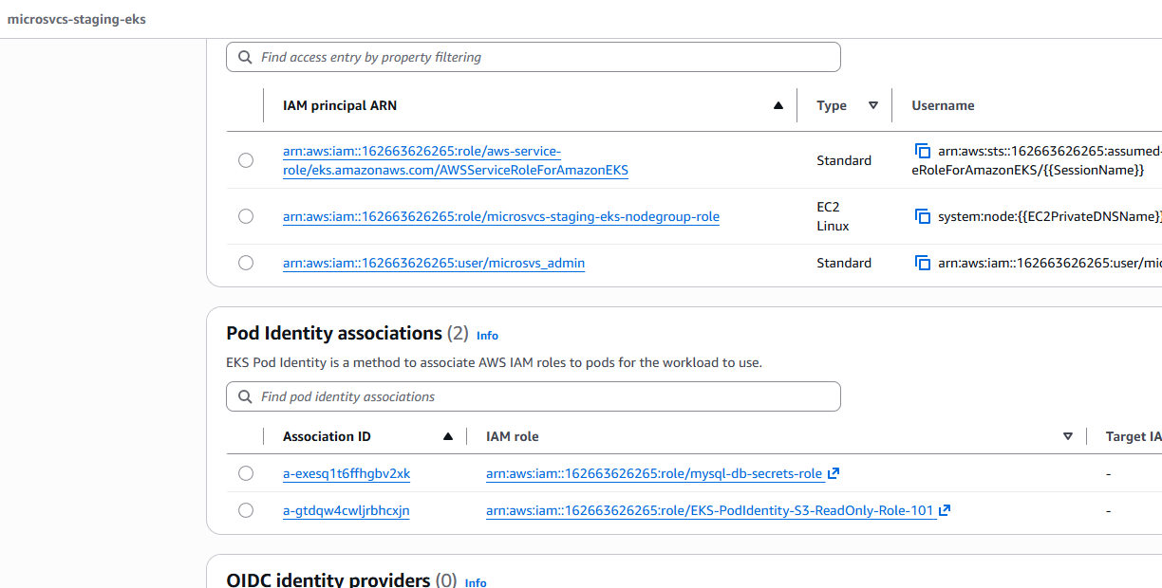
4c. Integrate AWS Secrets Manager with microservice database (MySQL)
Create database secrets and store them in AWS Secrets Manager
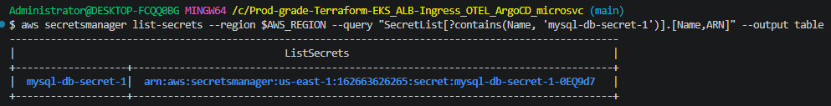
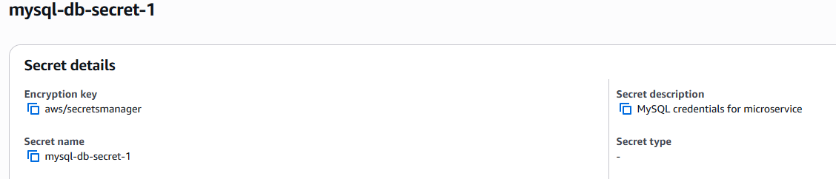

5. Install Implement EBS CSI Driver for secured dynamically creation of EBS volumes via PIA
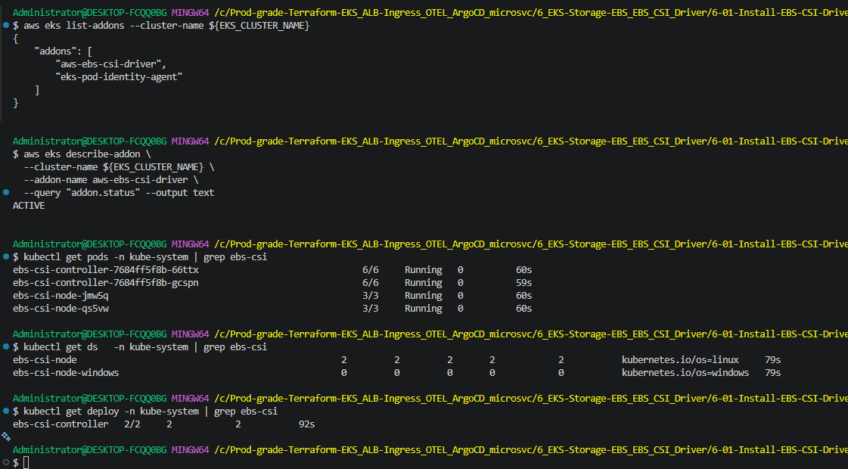

Securely fetch MySQL password from ASM and deploy MySQL service.
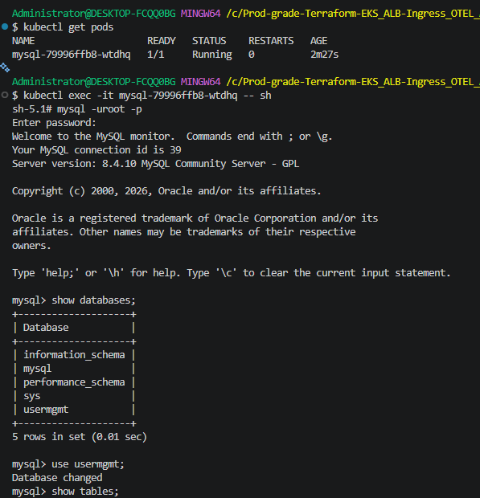

RDS MySQL database
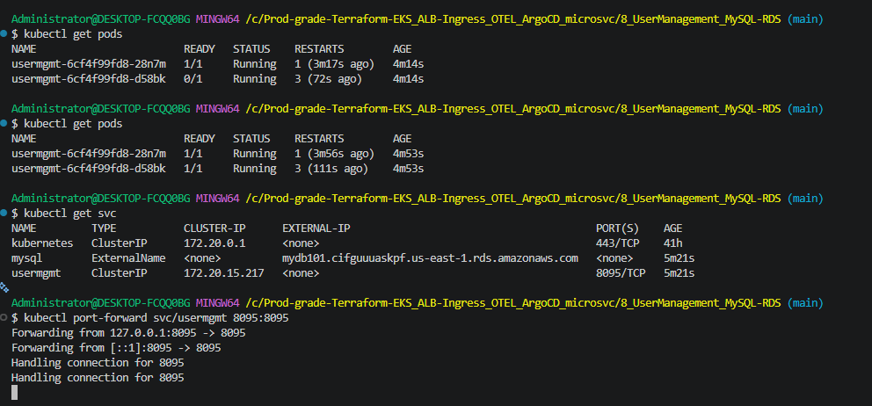
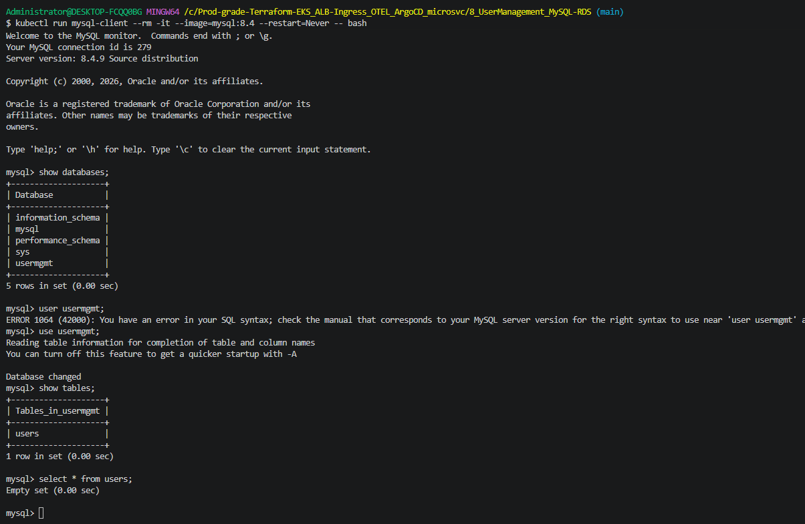

Create Policy, IAM role and PIA for Load Balancer Controller to be created.
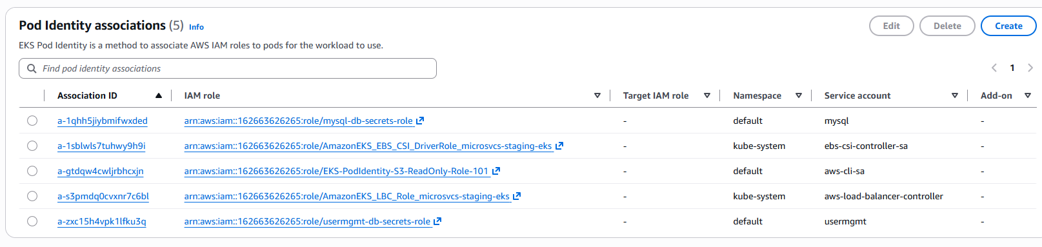
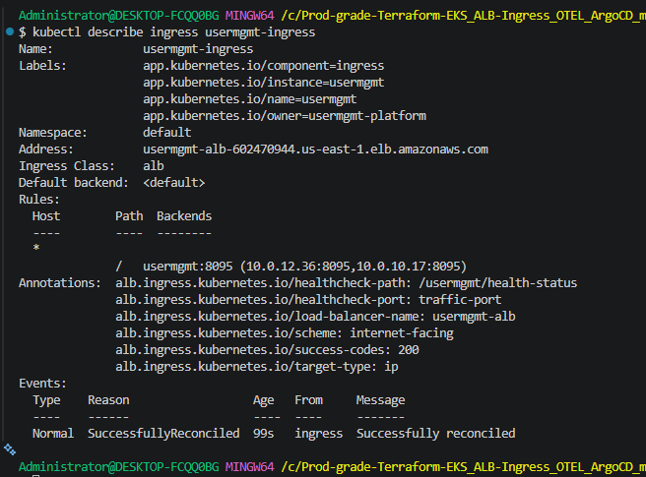
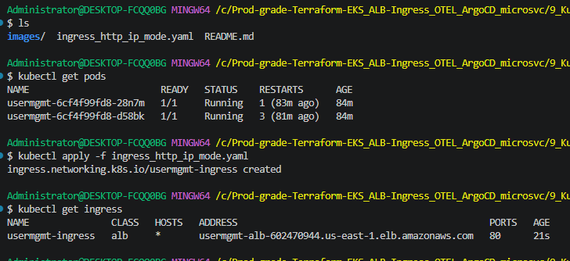

ALB
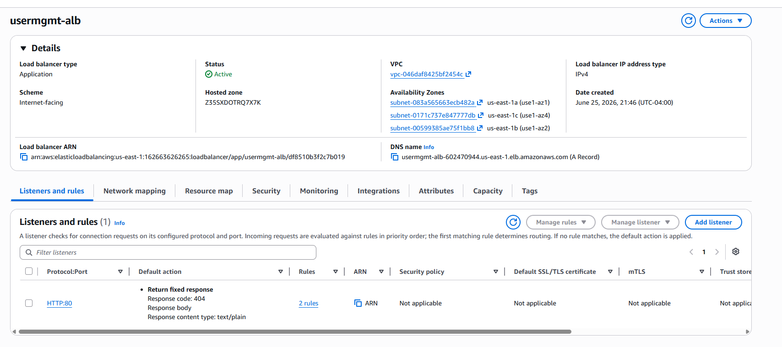
HTTP:
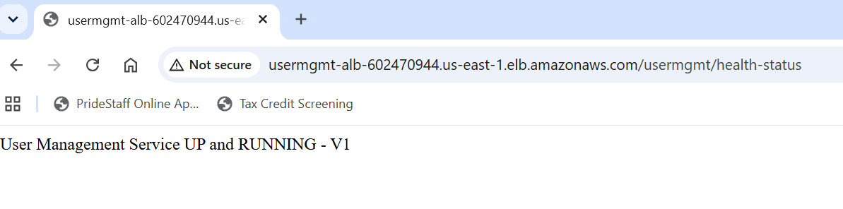

HTTPS:

