usermgmt ci/cd screenshots
1. ArgoCD controller installation and implementation
Install Argo CD with Helm, ALB ingress, and CLI access
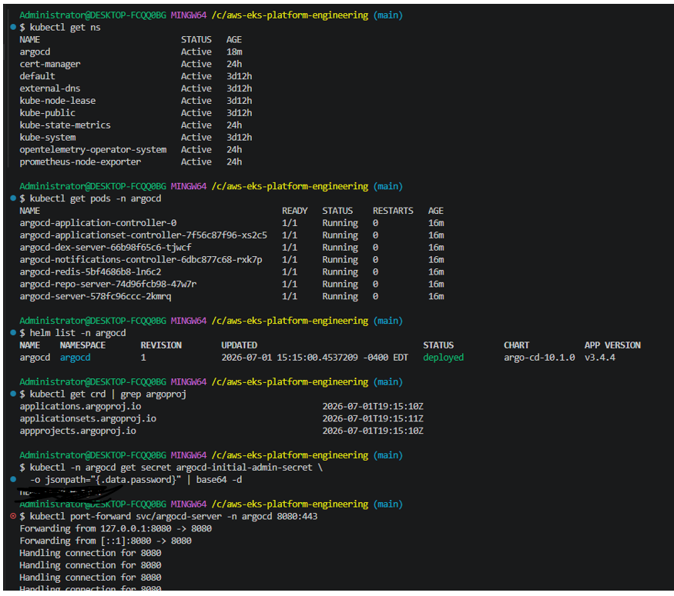
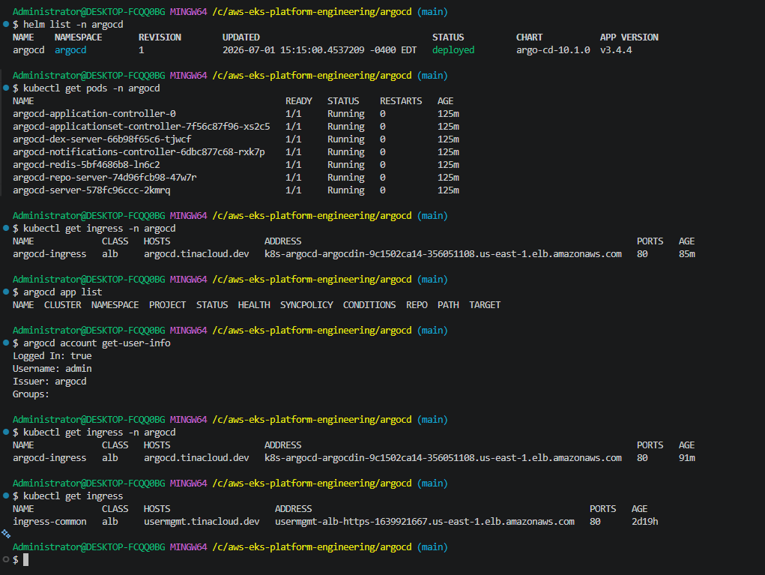
Get argocd ui default admin password and change it. 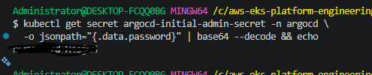
Route53 with argocd and usermgmt service dns records
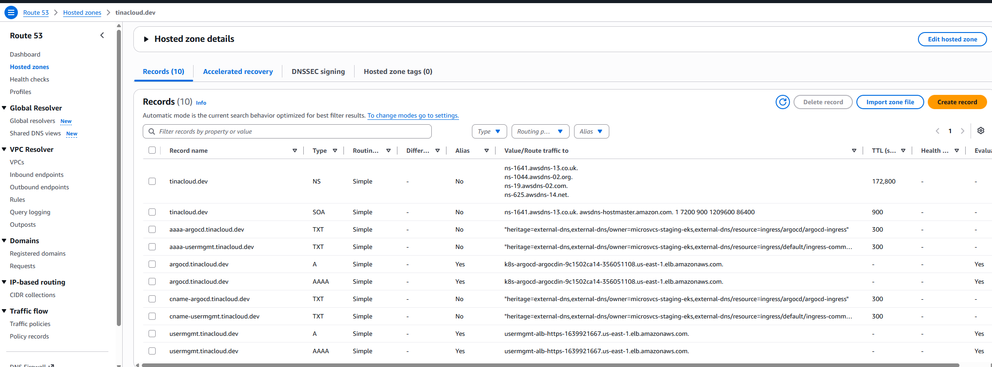
ArgoCD ui (applications have not yet been deployed by ArgoCD)
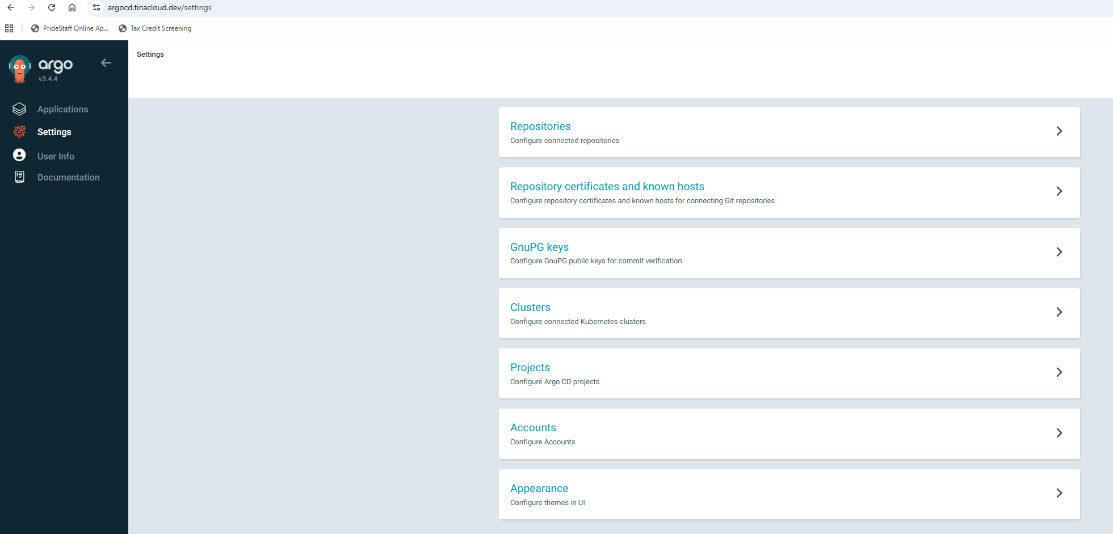
ACM 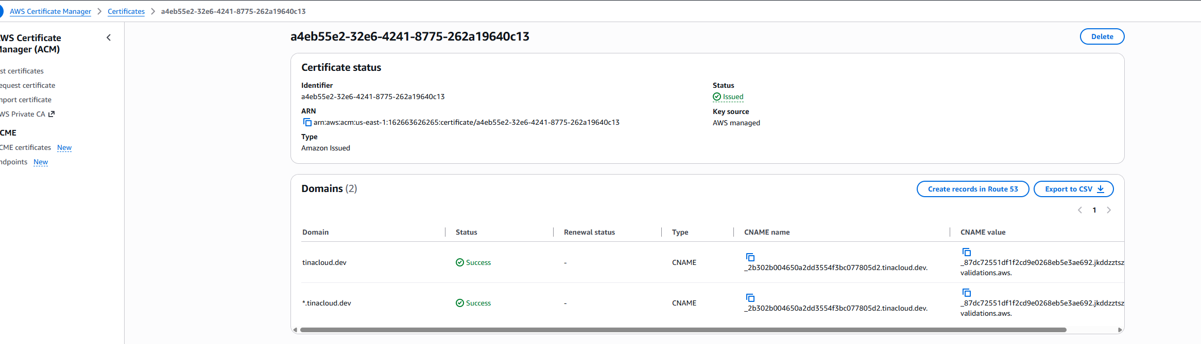
Usermgmt and argocd ALB
