Data Guard failover, primary rebuild, and recovery validation

- Documented manual Data Guard failover and standby promotion
- Documented former-primary rebuild after failover
- Captured Flashback Database recovery to standby-became-primary SCN
- Converted rebuilt database back to physical standby
- Restarted managed recovery and validated redo apply
- Documented listener restart and post-reboot Oracle connectivity
- Documented return switchover to the original primary
- Captured final transport and apply lag validation
Failover Promotion: Promote DB02 to PRIMARY and record when the standby became primary SCN
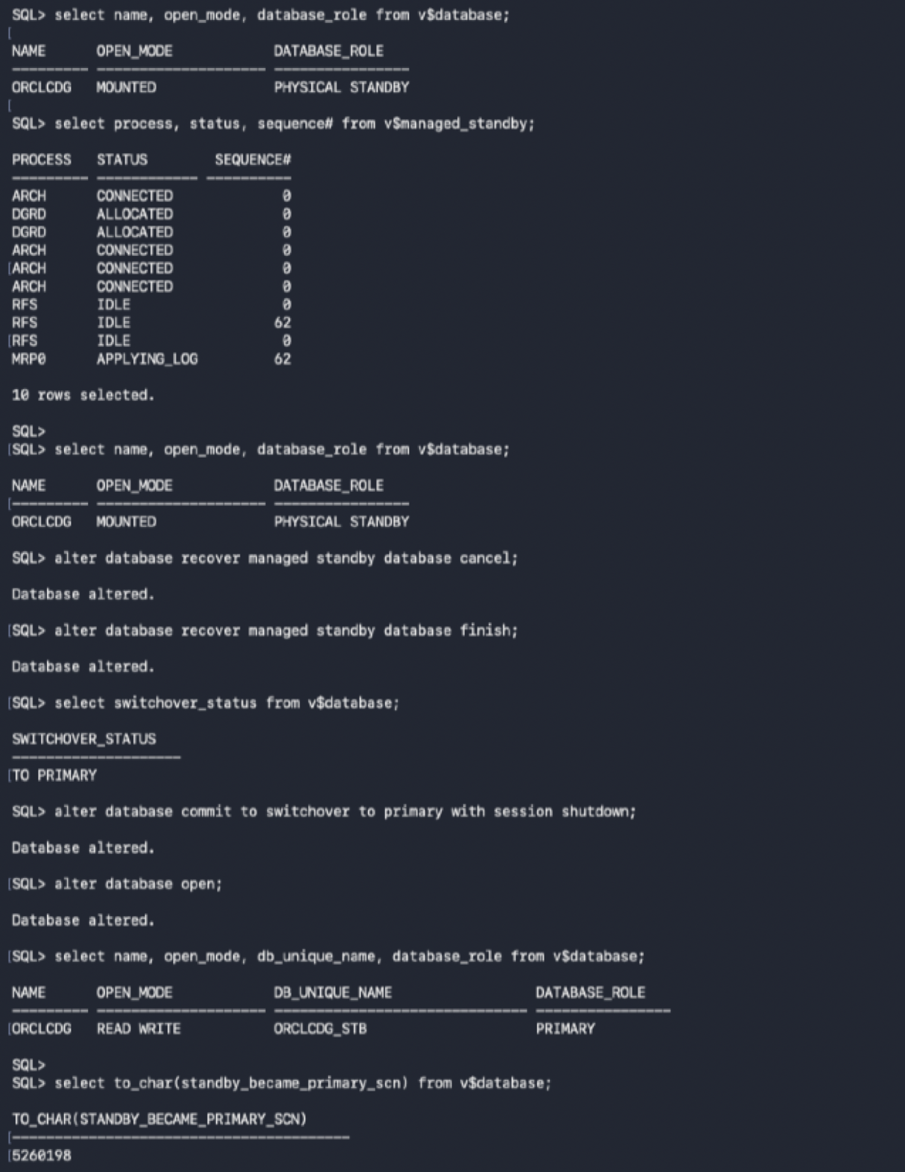

Rebuild Former Primary: Flashback DB01 to the standby became primary SCN and convert it to a physical standby
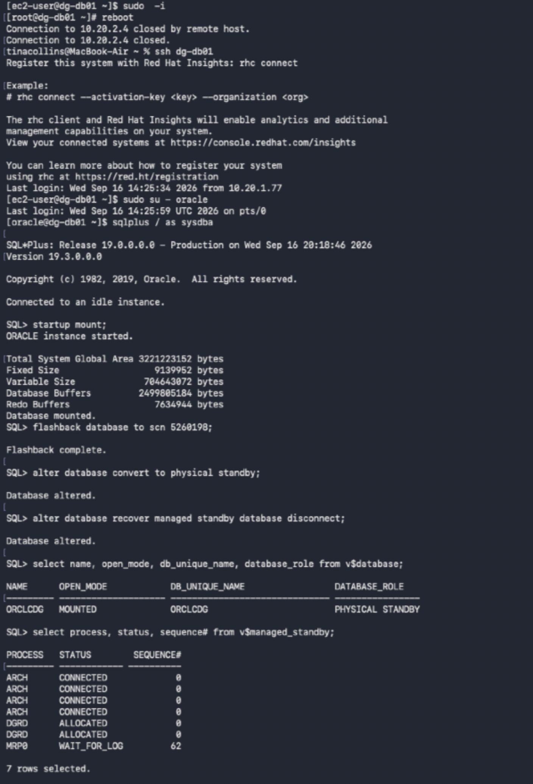

Rebuild Validation: Reboot DB01, restore the Oracle listener, and reconnect to the rebuilt standby
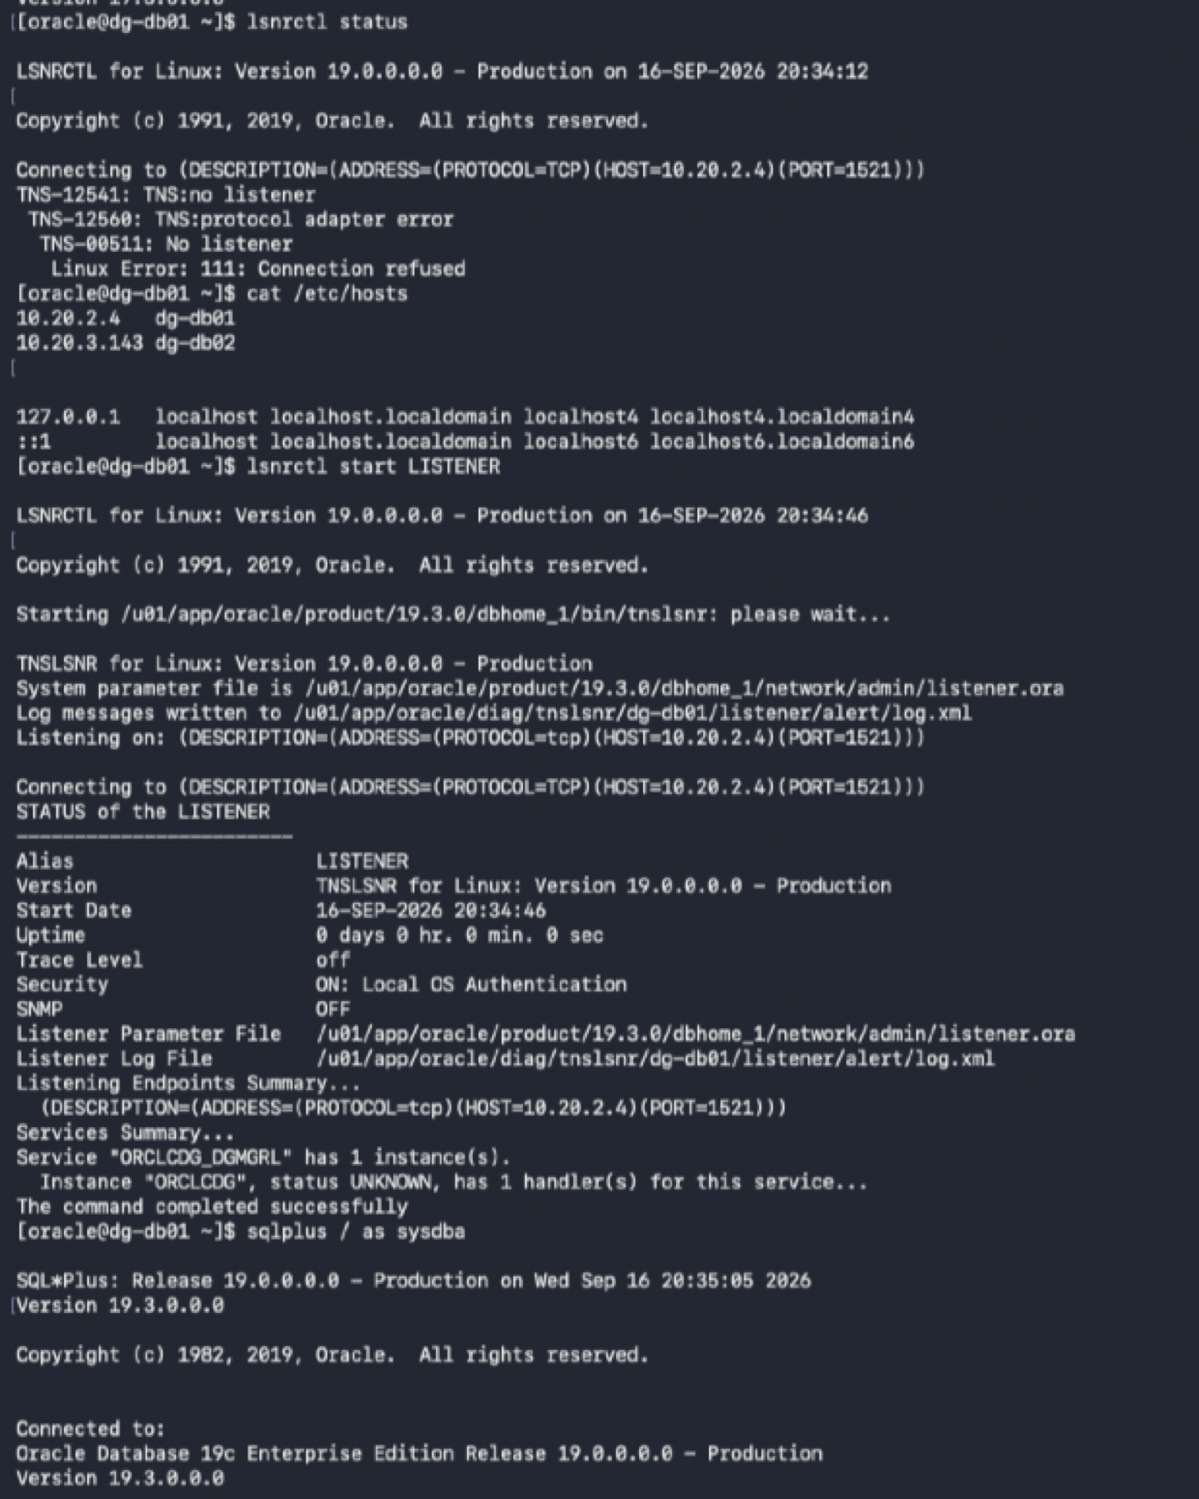

Standby Recovery: Restart managed recovery on DB01 and confirm MRP resumes redo application
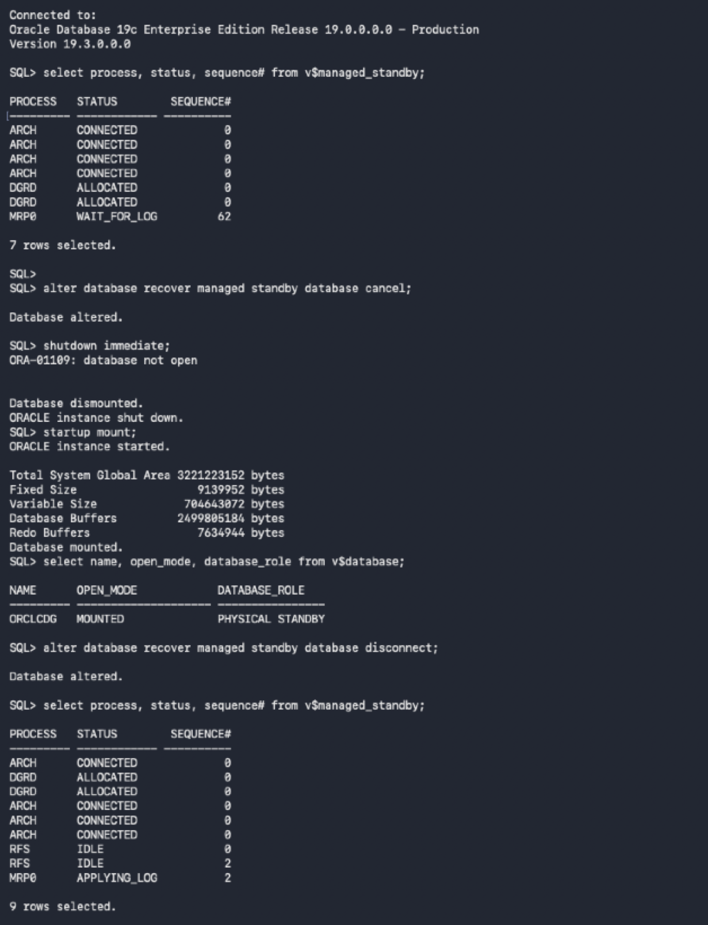

Return Switchover: Promote DB01 back to PRIMARY and verify the database role
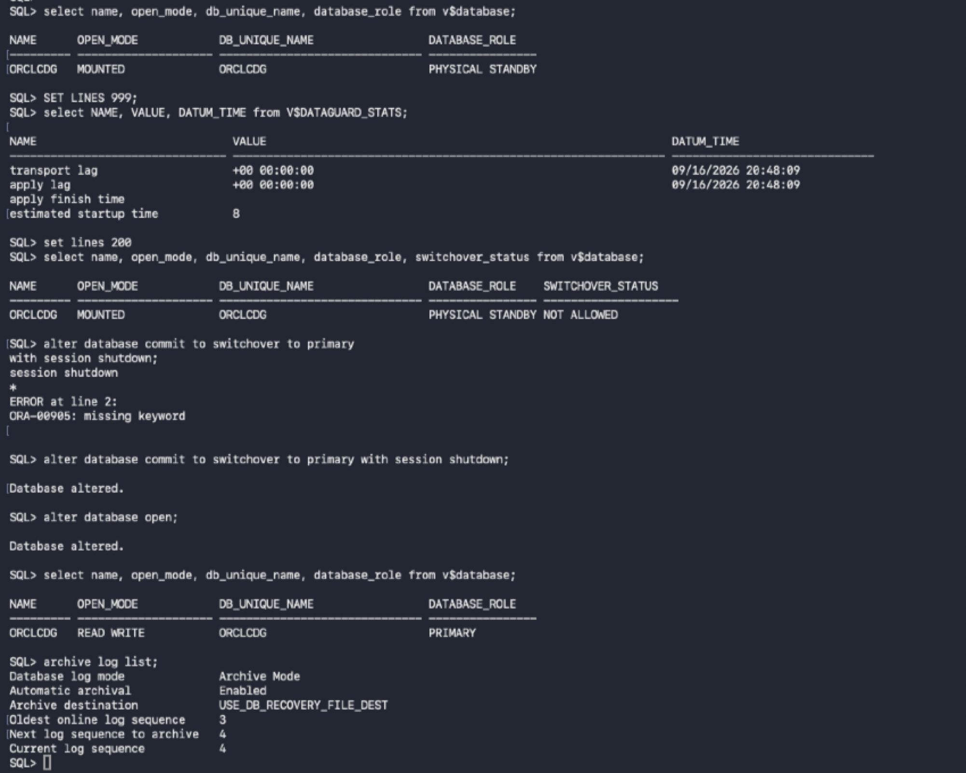

Reverse Role Transition: Demote DB02 and remount it as the physical standby
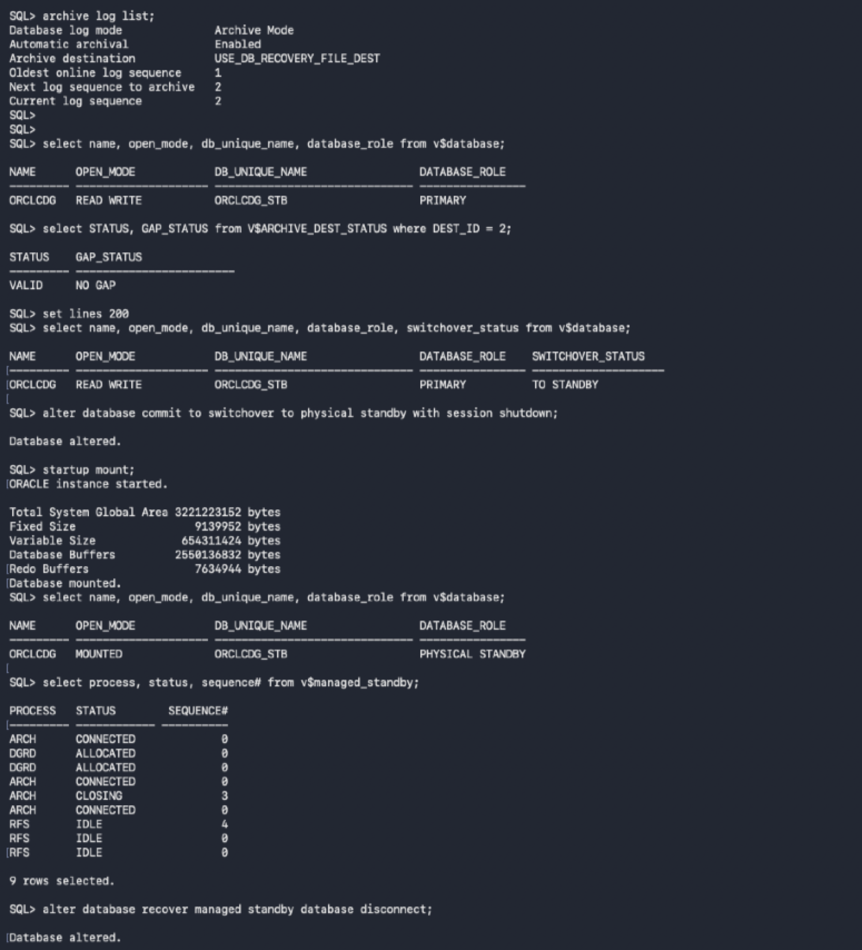

Final DR Validation: Confirm the restored standby is applying redo with zero transport and apply lag
