Data Guard Administration and Client Connectivity in Data Guard Configuration
Primary — Generate redo with controlled logfile switches
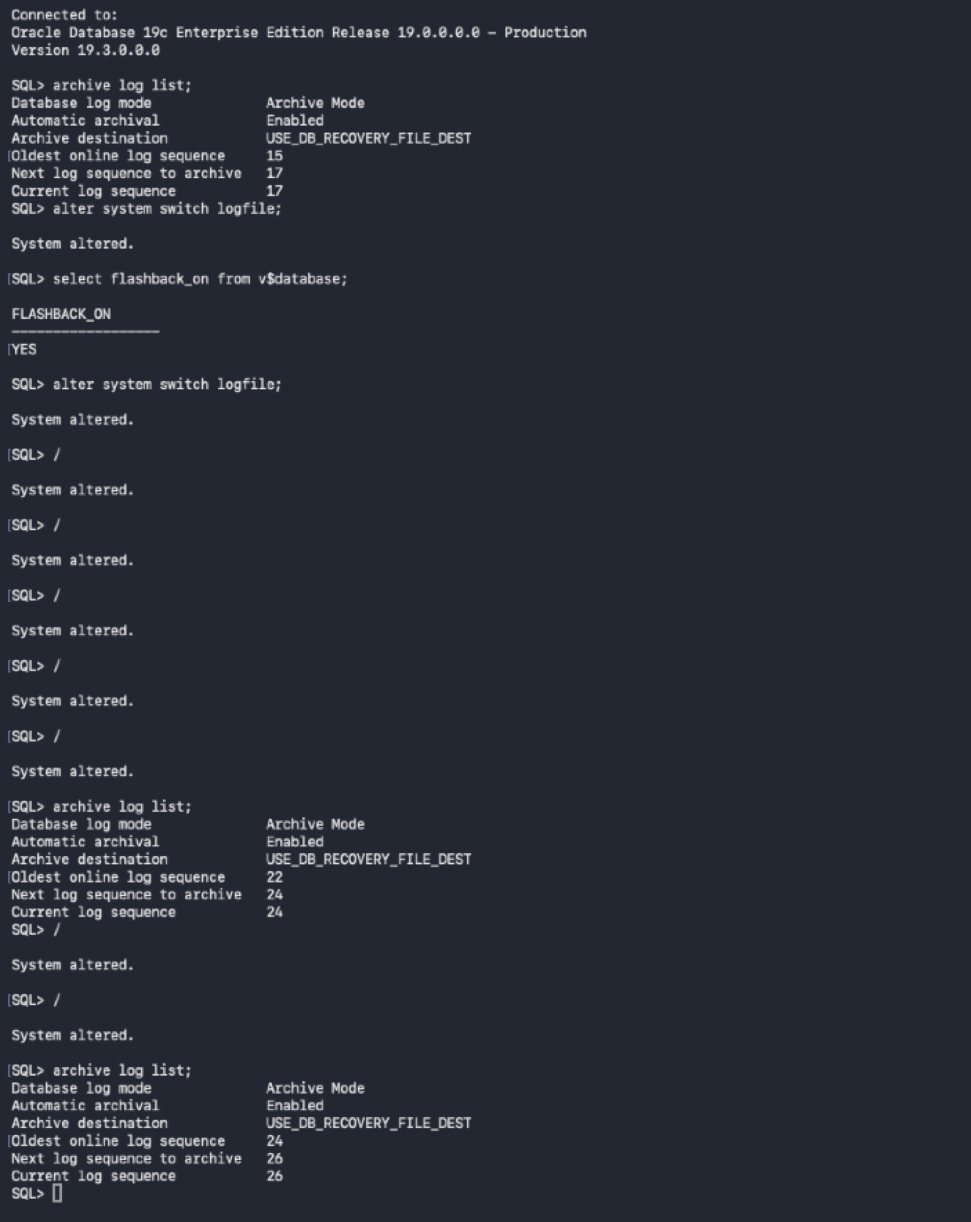

Stop MRP process on standby:
Stop the Managed Recovery Process (MRP0)
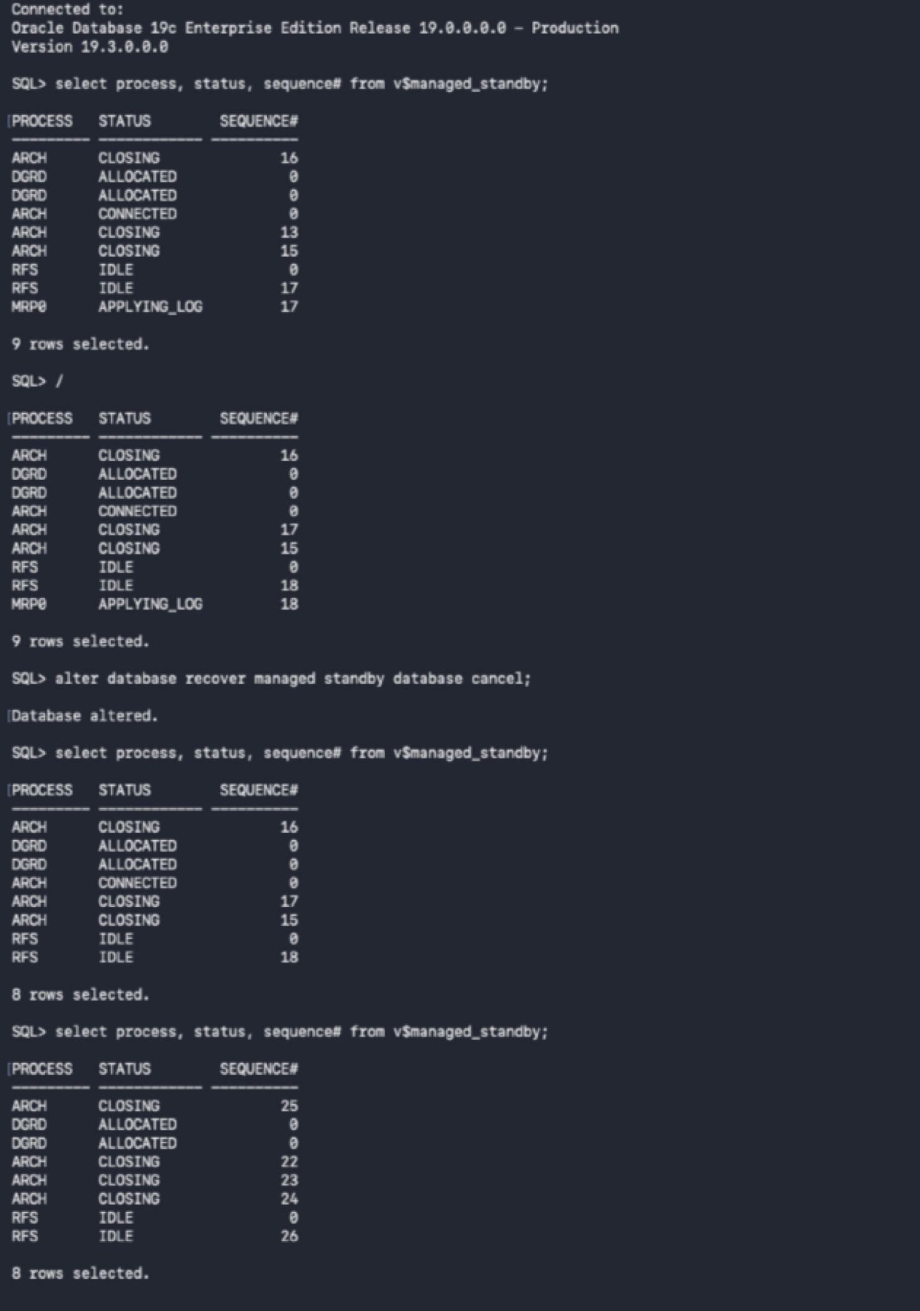
Restart Managed Recovery and verify redo apply
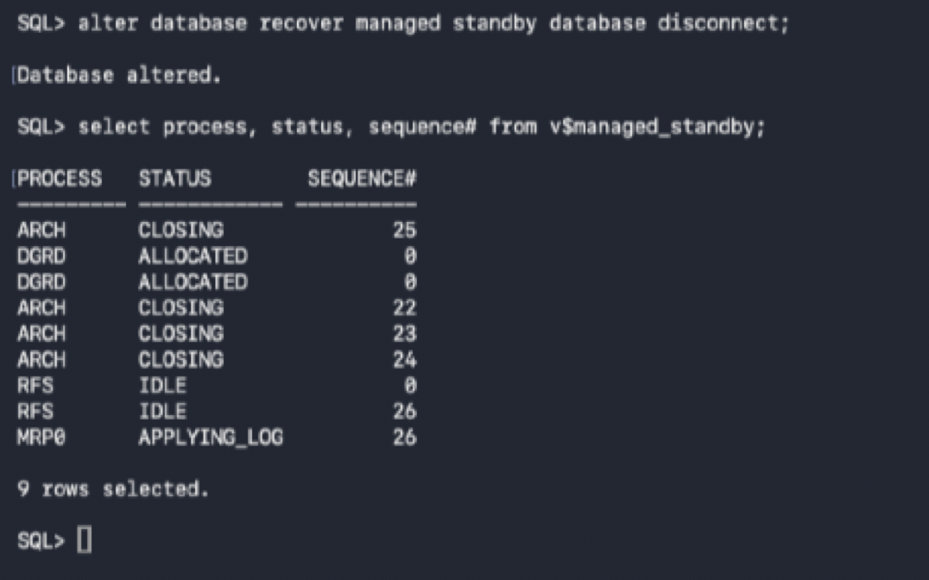

Stop logs from being sent to the standby database
Primary — Defer redo transport to the physical standby
alter system set log_archive_dest_state_2='DEFER';
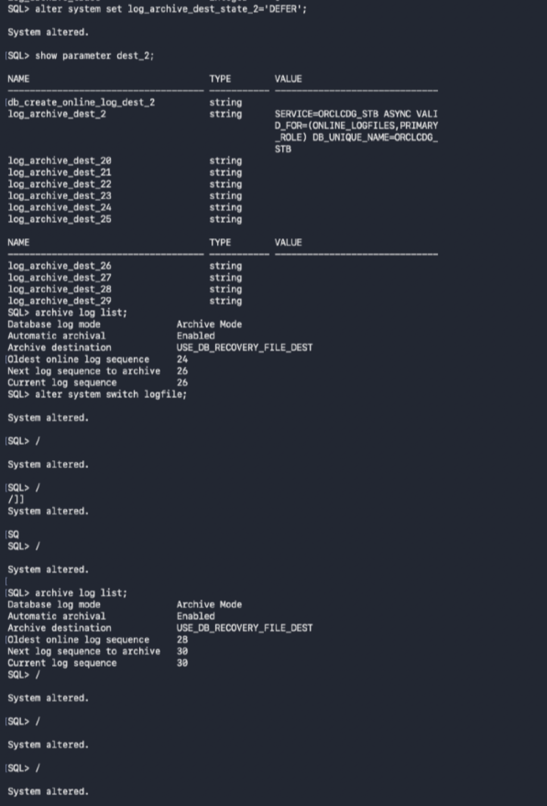
Standby
Standby — Observe redo transport/apply state while shipping is deferred
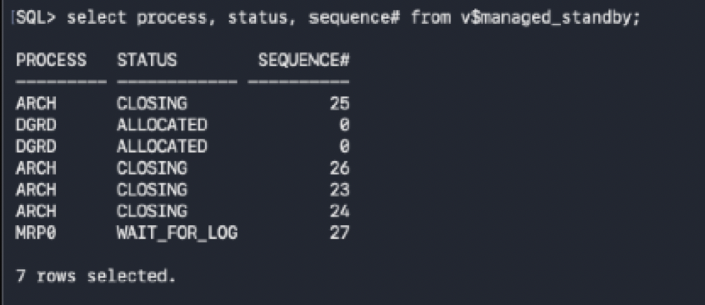

Enable log shipping again and verify that these no gap
alter system set log_archive_dest_state_2='ENABLE';
Primary — Re-enable redo transport and validate the destination
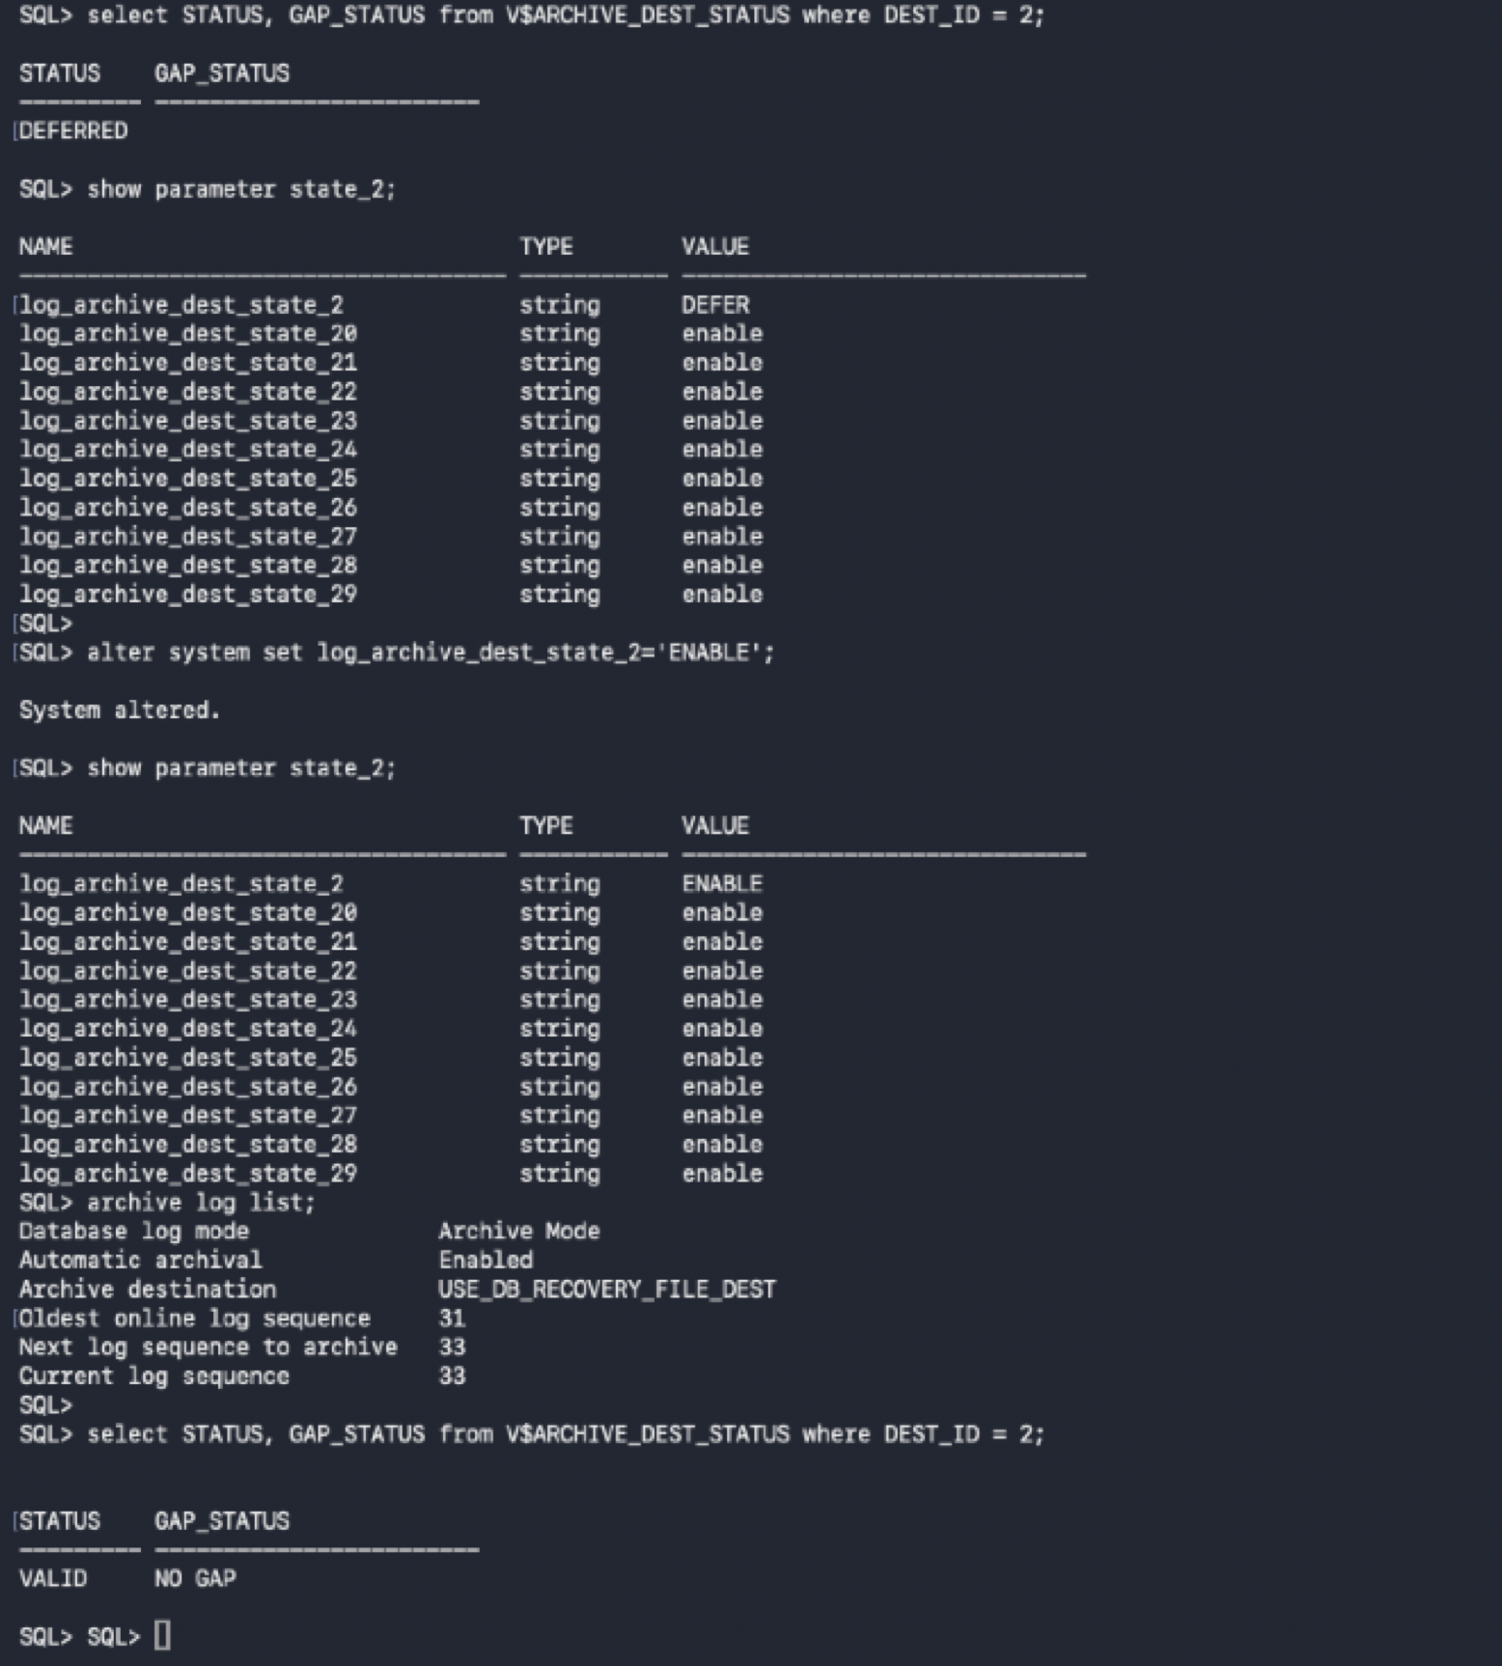

Standby
Standby — Review managed recovery state before shutdown
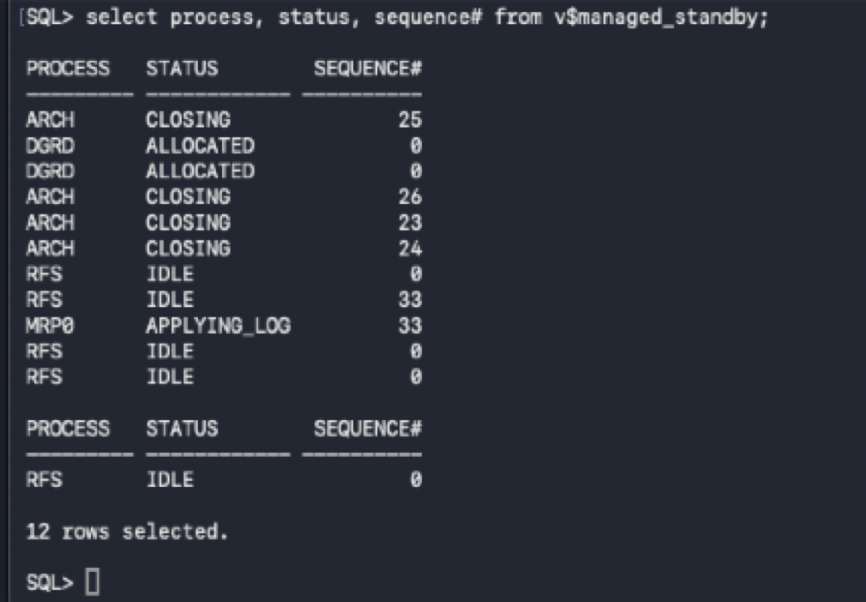

How to cleanly bring down standby database and apply service.
- Stop MRP process
- Shutdown database
Logs will be shipped to standby, but they will not be applied
Standby — Cancel managed recovery and cleanly shut down the database
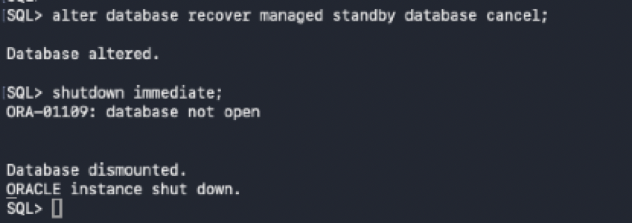

Start standby database in mount state and start MRP apply service again
Standby — Mount the database and restart Managed Recovery
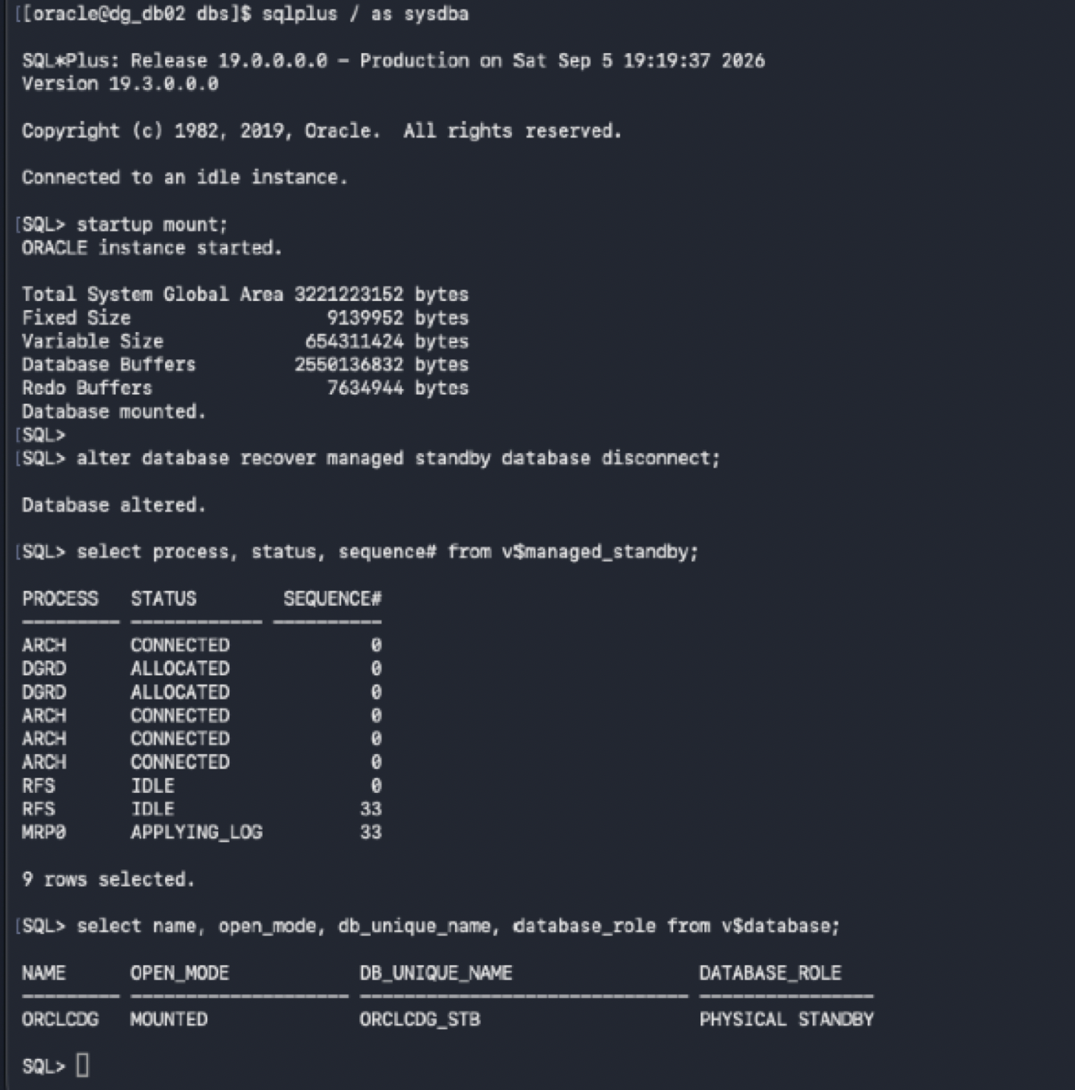

Verify there’s no gap after stopping and starting standby database.
Standby — Verify recovery resumed with no redo gap
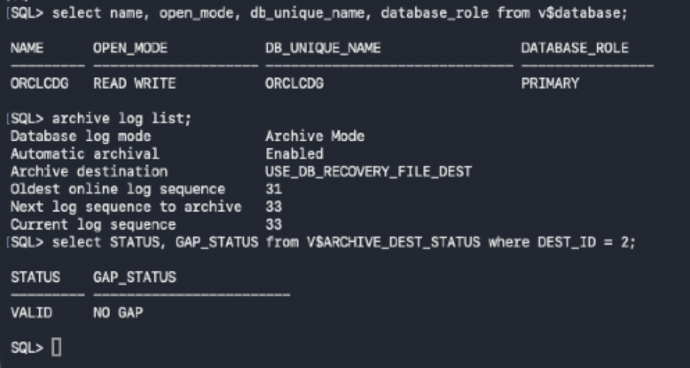

Client Connectivity in Data Guard Configuration
- Create a Service on the Primary database so when you perform a switchover or failover, client can smoothly connect to the new primary database in the data guard configuration
Validate database role and redo transport before HA service configuration
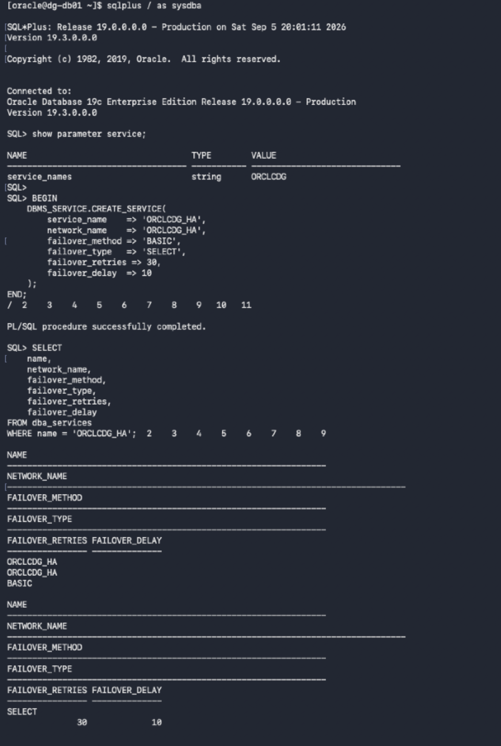

- create a small PL/SQL procedure that starts ORCLCDG_HA only when the database is PRIMARY and then have the startup of the database trigger call that procedure.
Primary —Create the ORCLCDG_HA client failover service with TAF
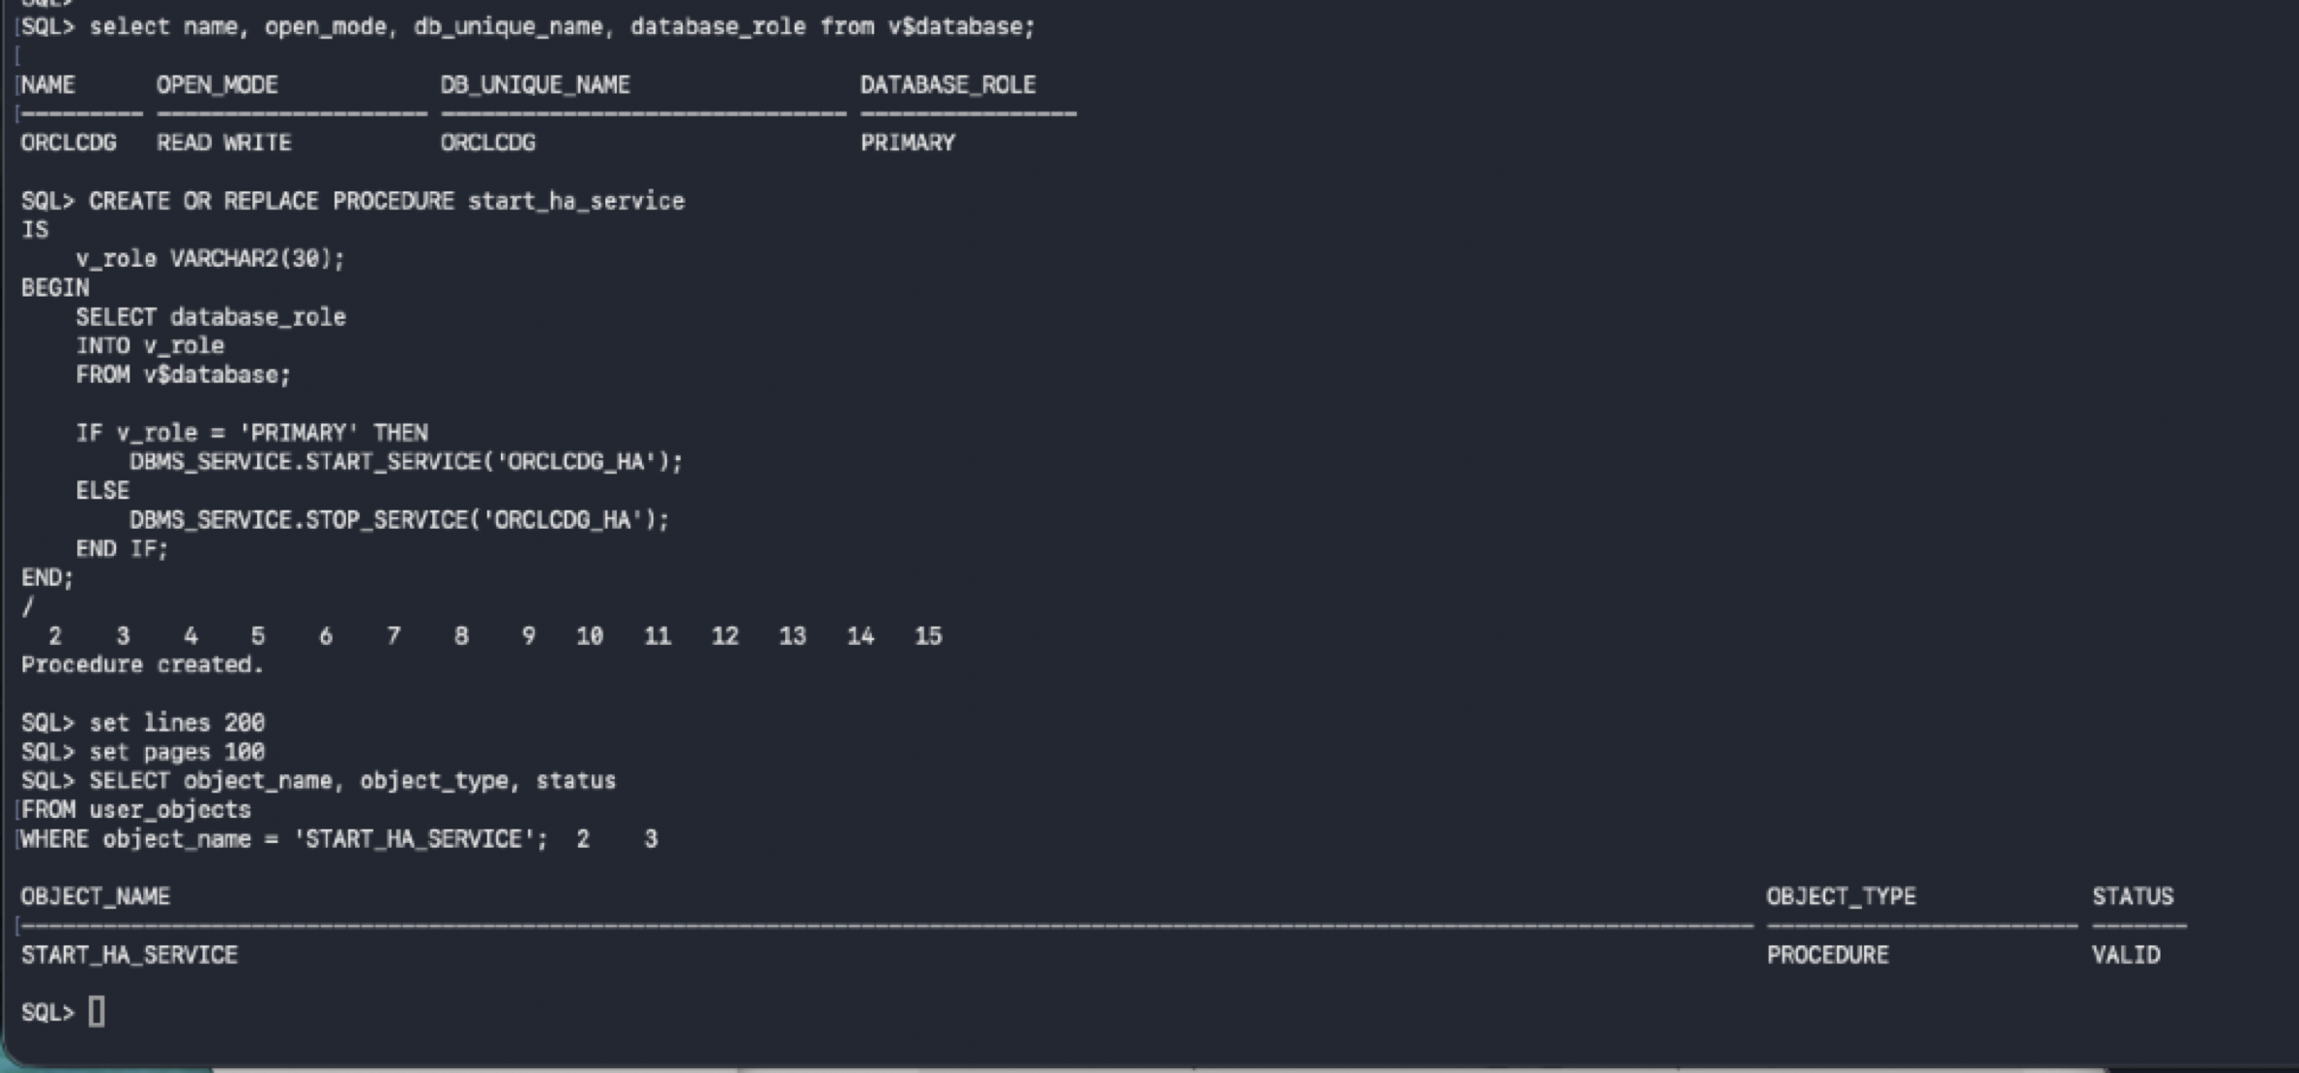

- Create 2 triggers that starts ORCLCDG_HA whenever the database opens, based on the database role, so you don't have to manually start it after every restart or role change, and a trigger that handles a switchover/failover role transition
The trigger gets executed when the database with the role as primary database starts up
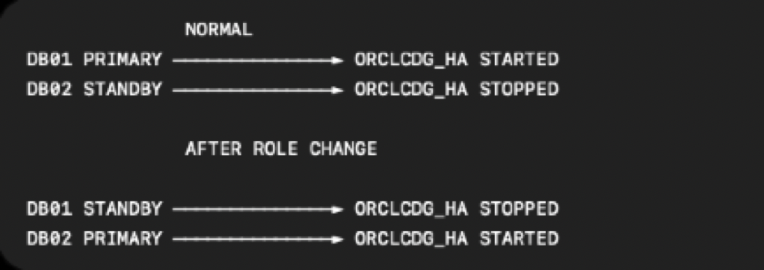
HA Service — Role-aware service behavior across PRIMARY and STANDBY roles
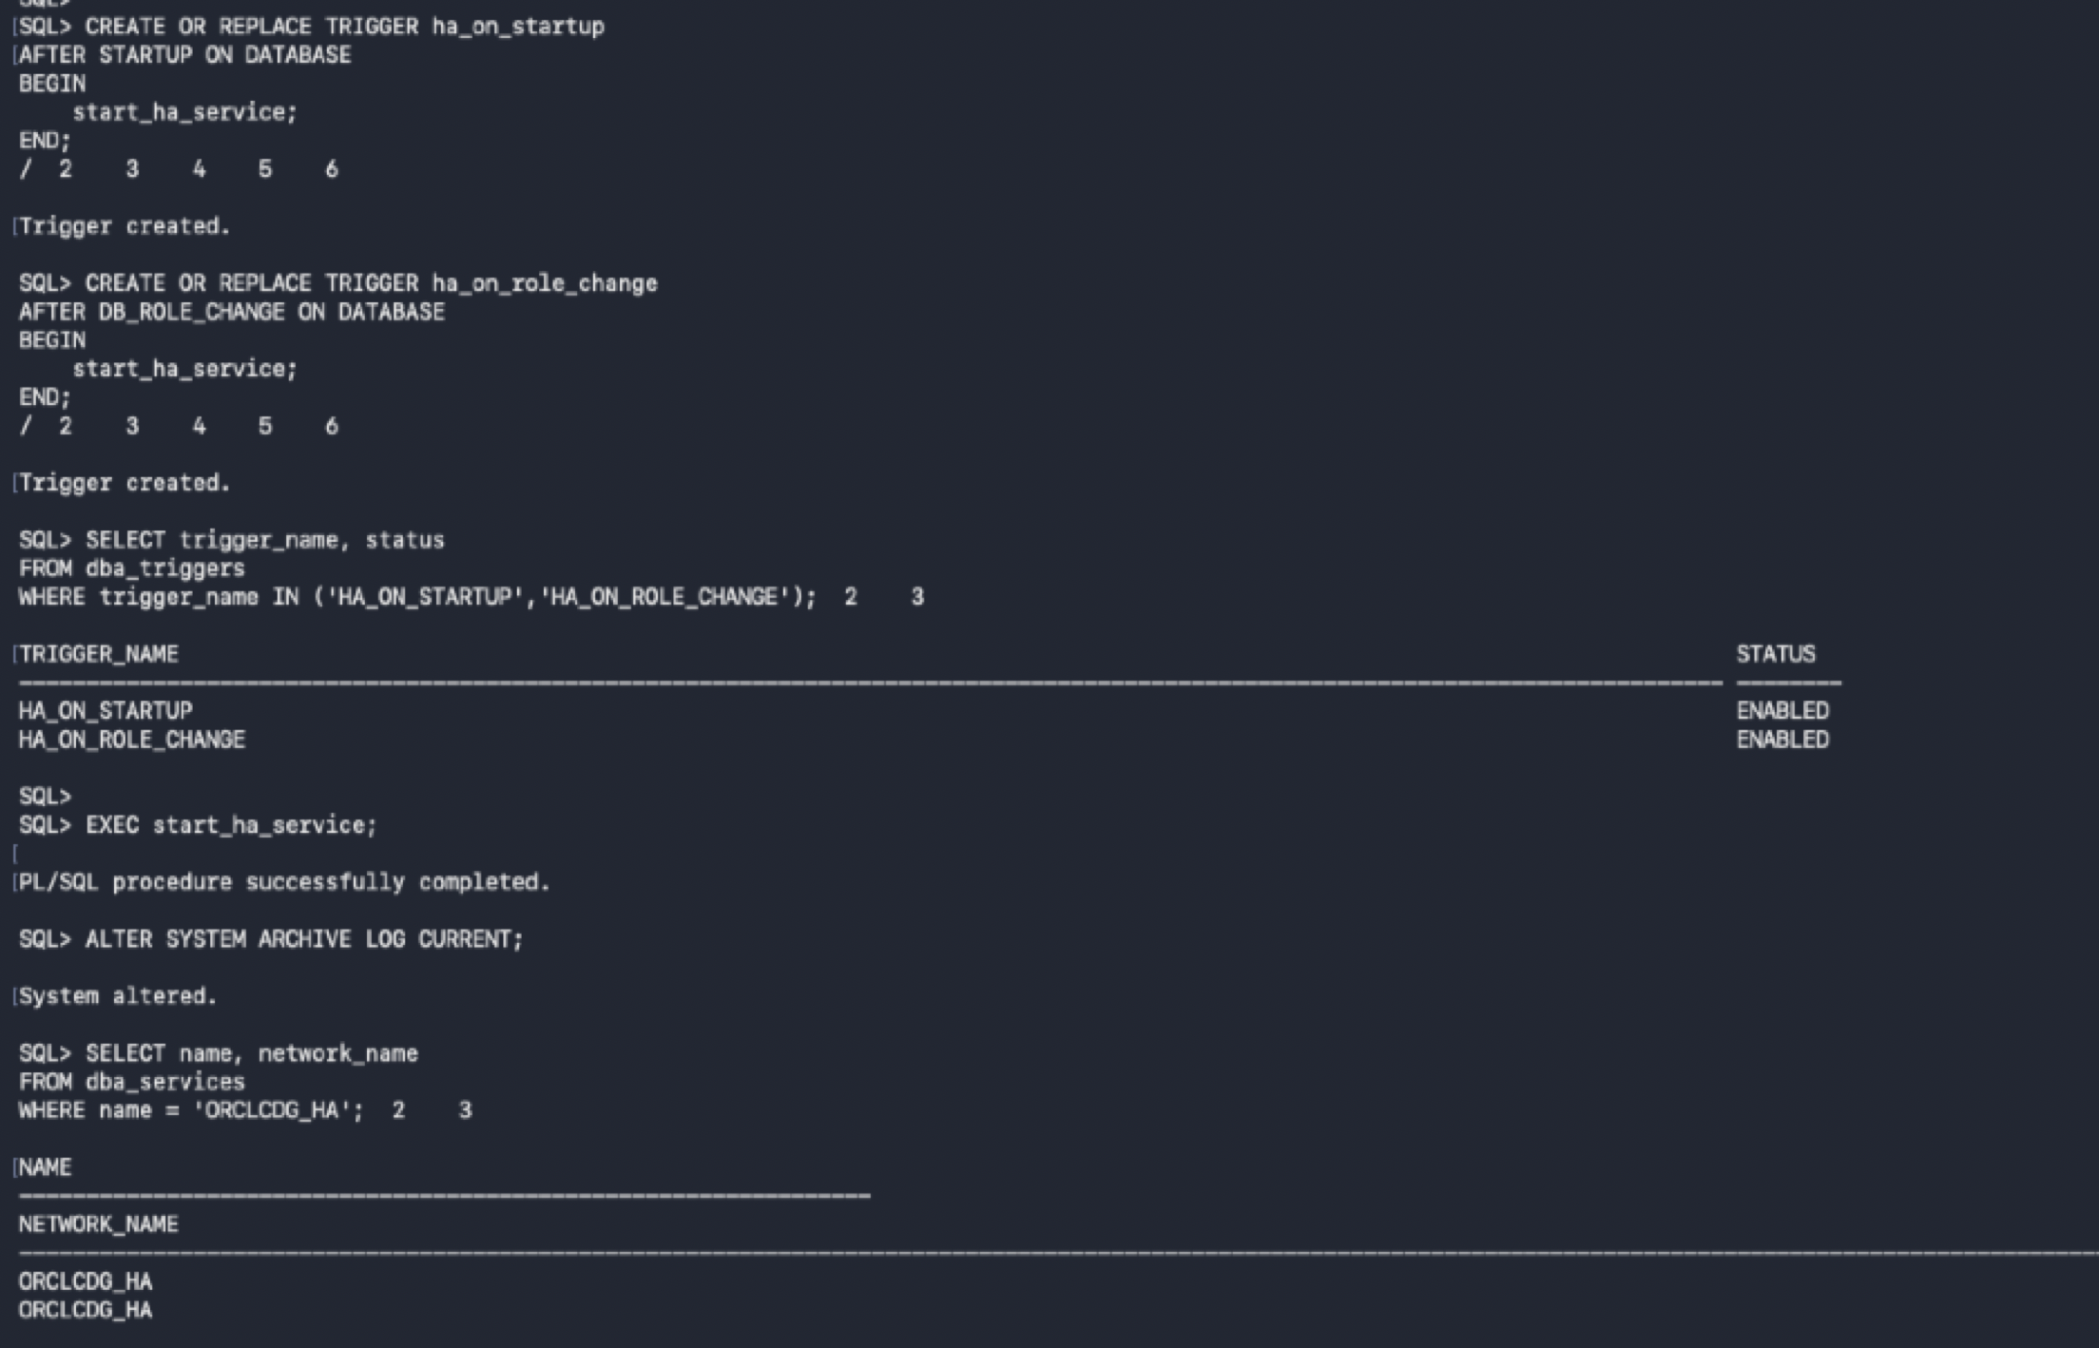
Primary — Validate the HA service management procedure is valid
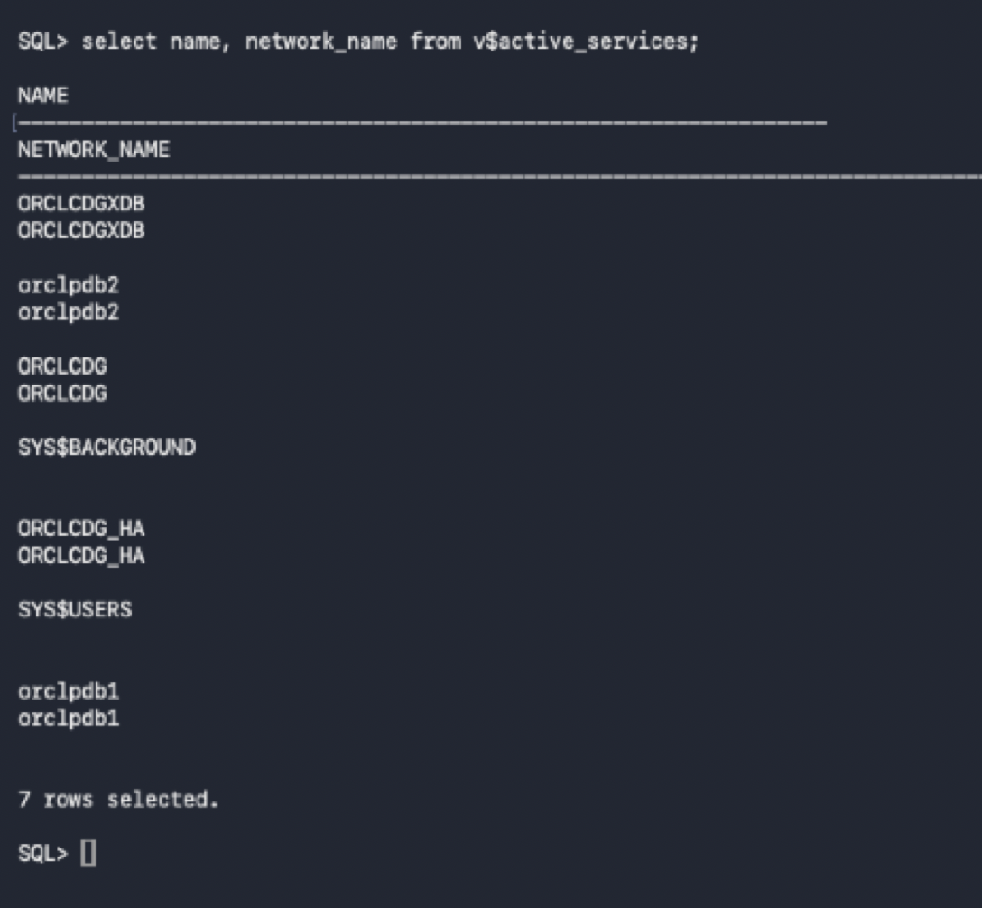
Primary — Verify ORCLCDG_HA is registered as an active service
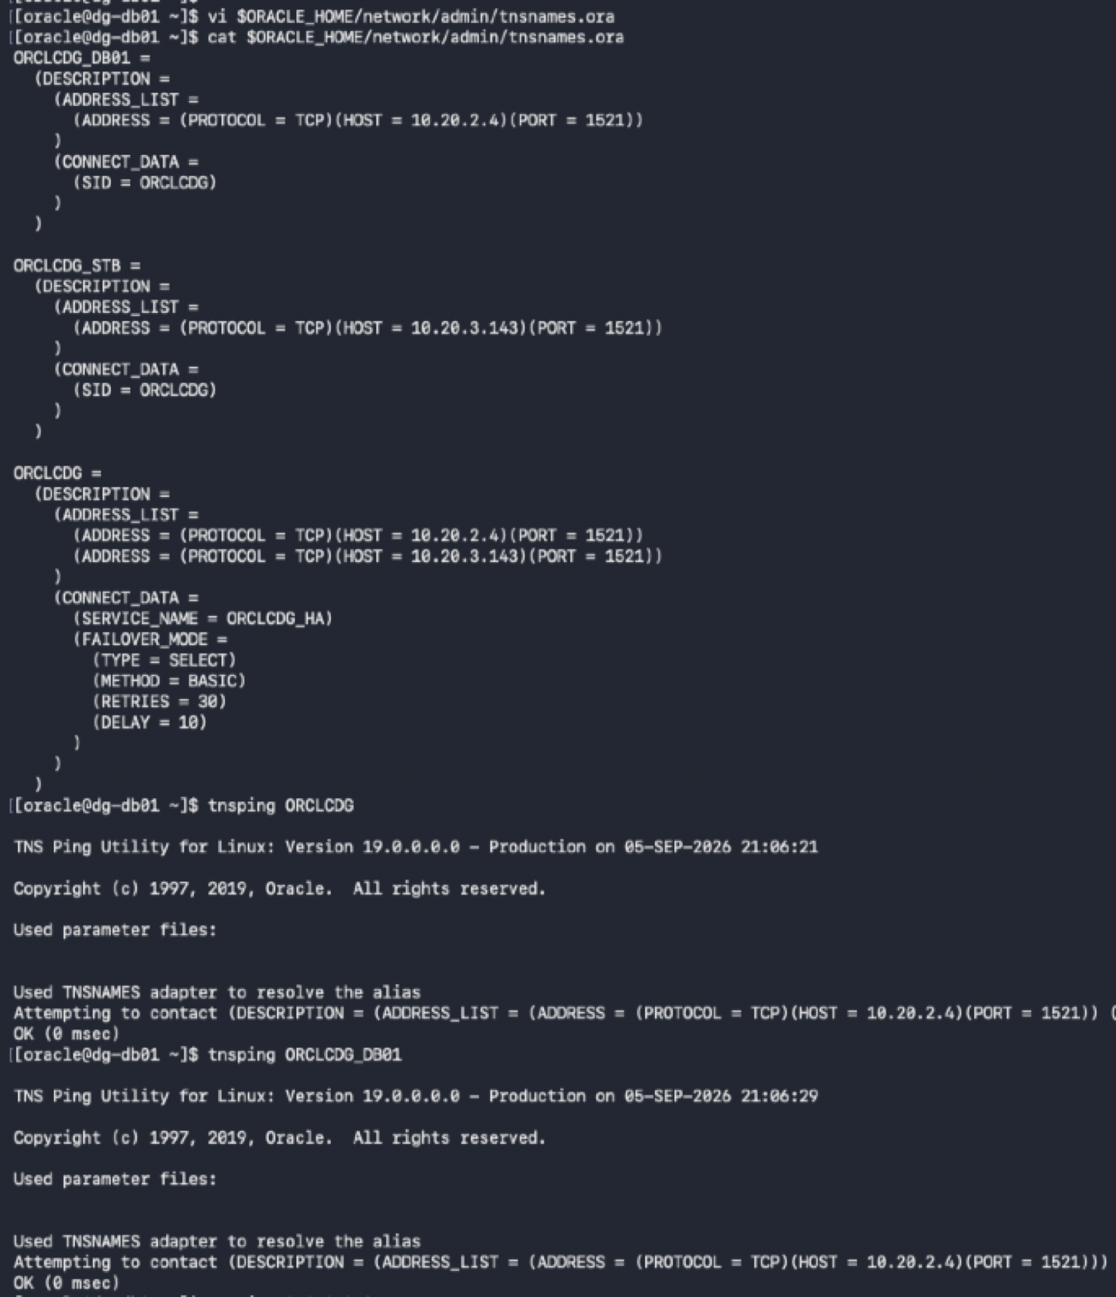
Client Connectivity — Configure dual-address TNS alias with TAF
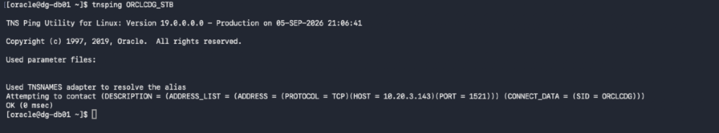

Primary — Test SQL*Plus connectivity and refresh listener registration
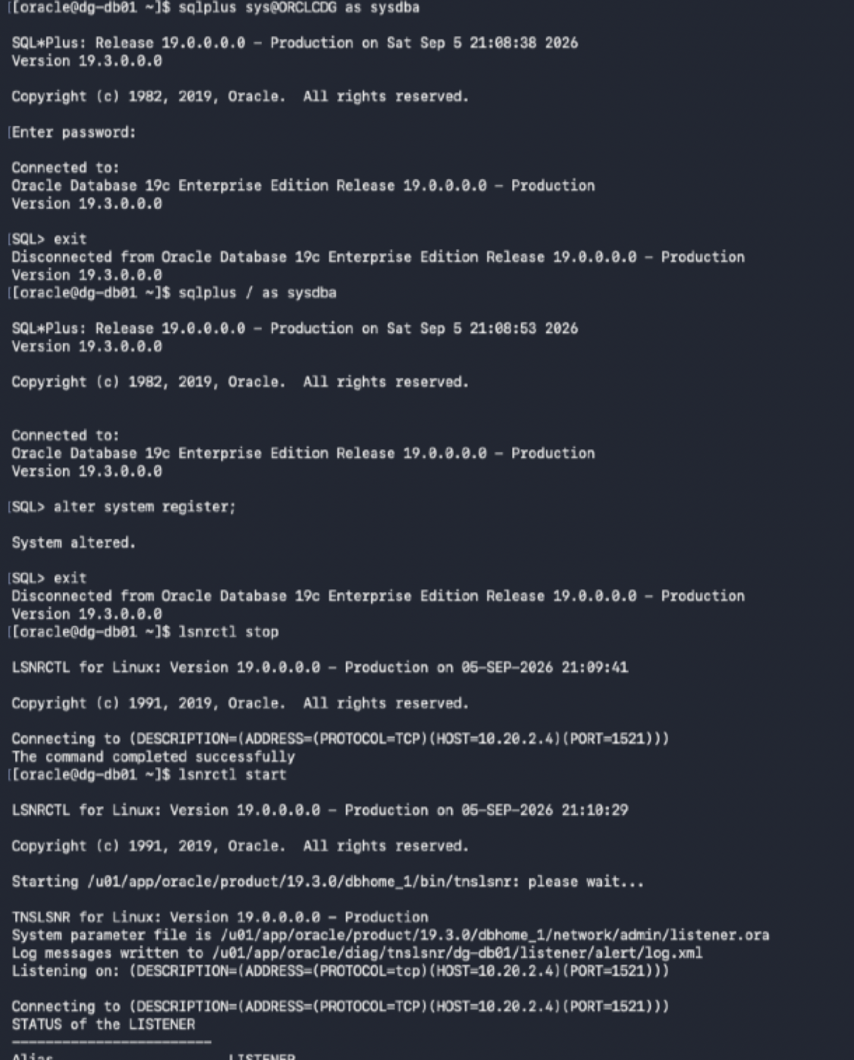
Primary — Verify listener services including ORCLCDG_HA are READY
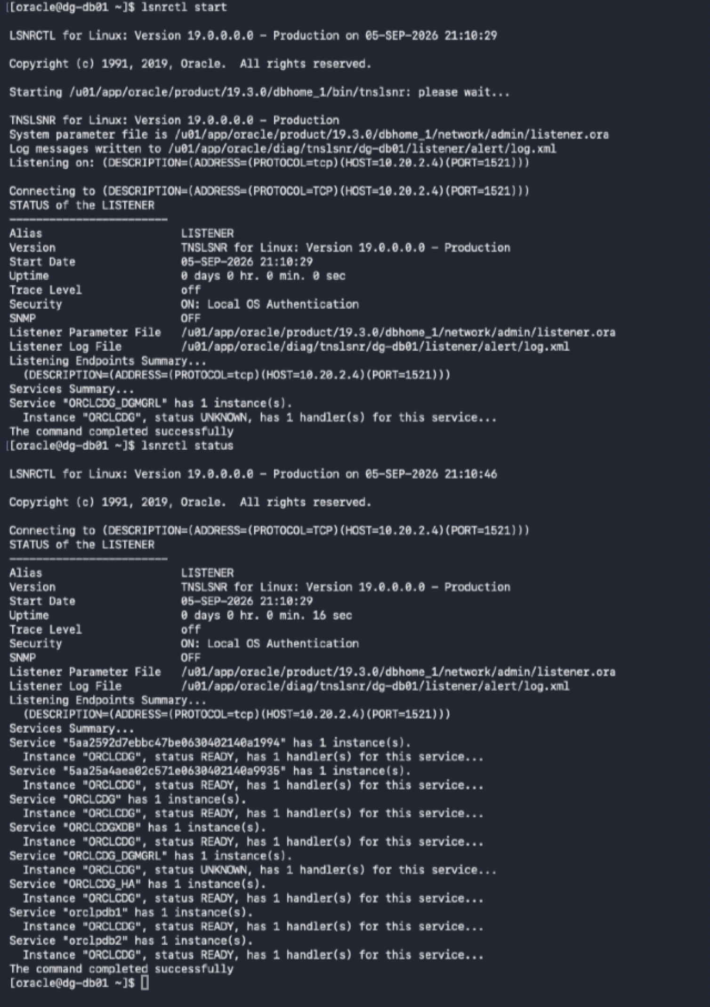
Primary — Final DB01 state: PRIMARY with ORCLCDG_HA ready for clients
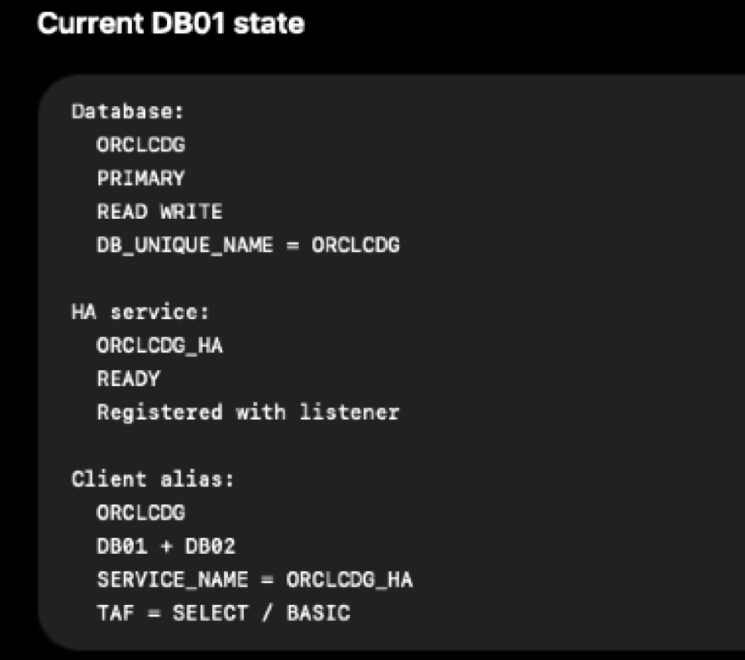

Oracle Data Guard — Minimal primary/standby architecture with RFS, MRP, and SRLs
