Data Guard Manual Switchover
Initiate primary-to-standby switchover on DB01
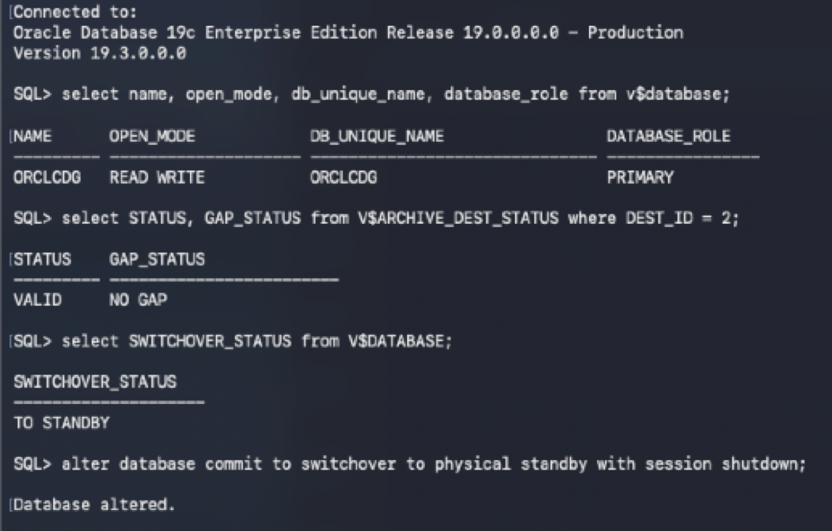
Mount DB01 as the physical standby
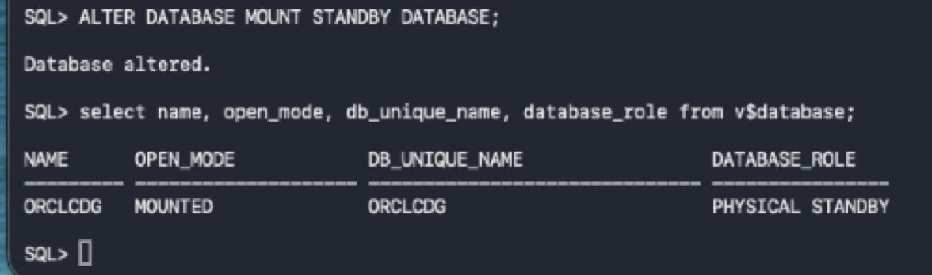

Verify DB02 standby readiness before promotion
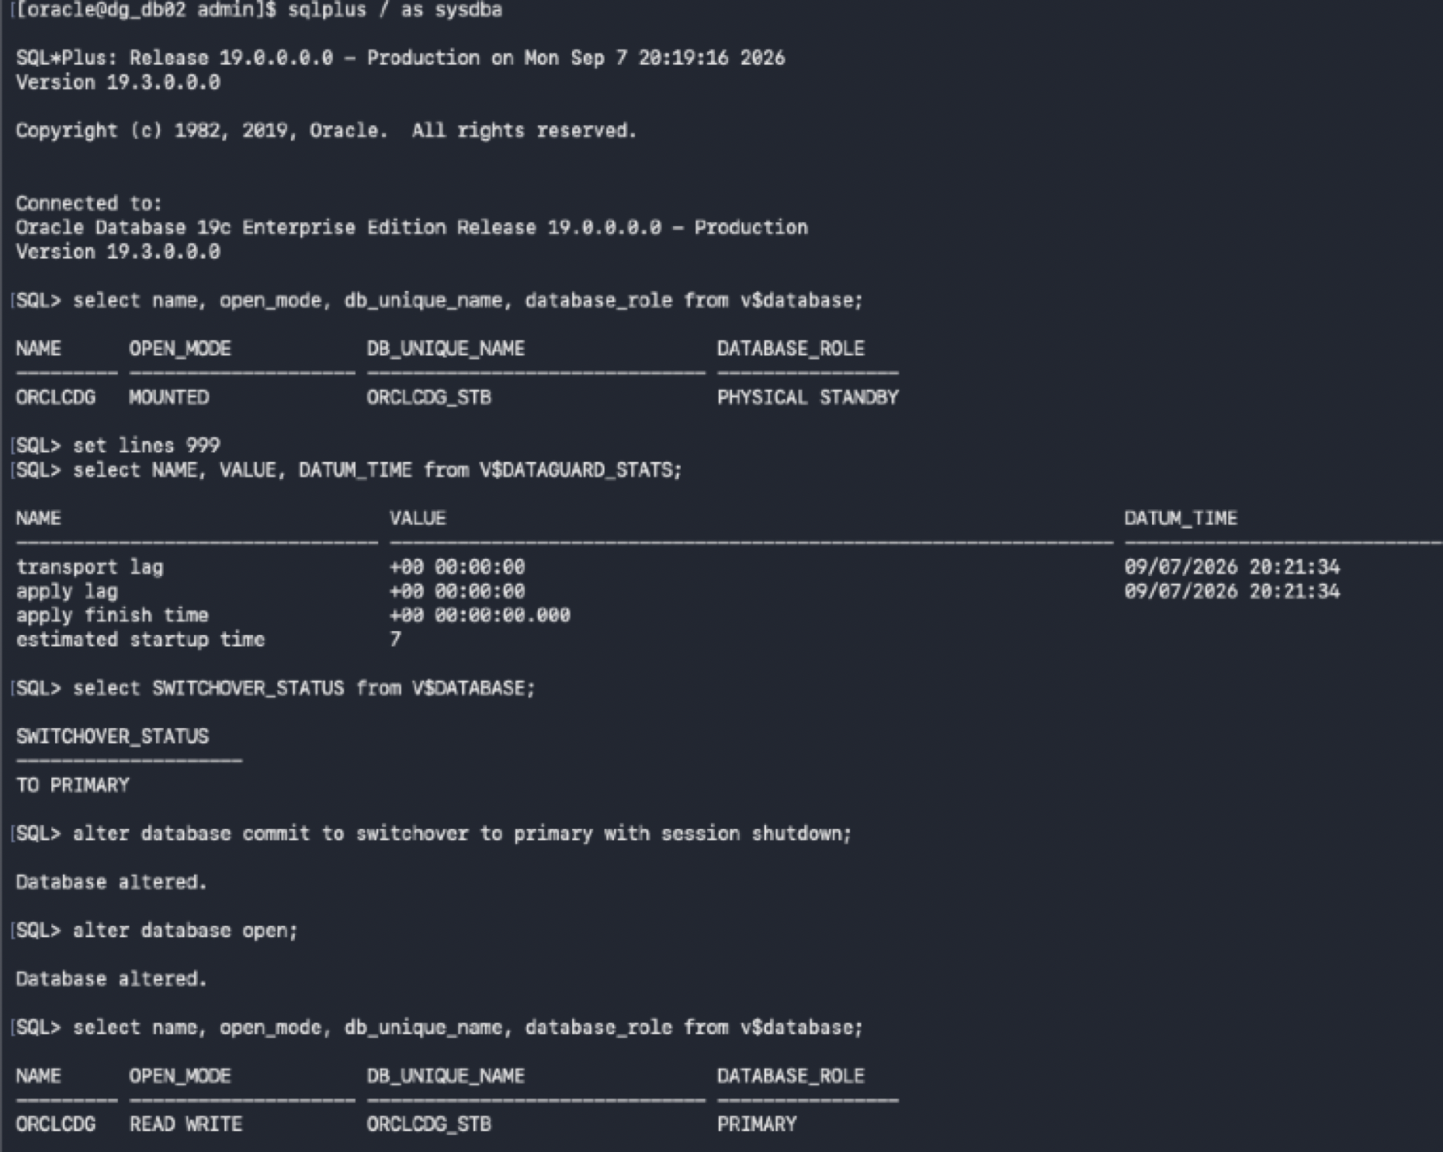
Promote DB02 to the primary role
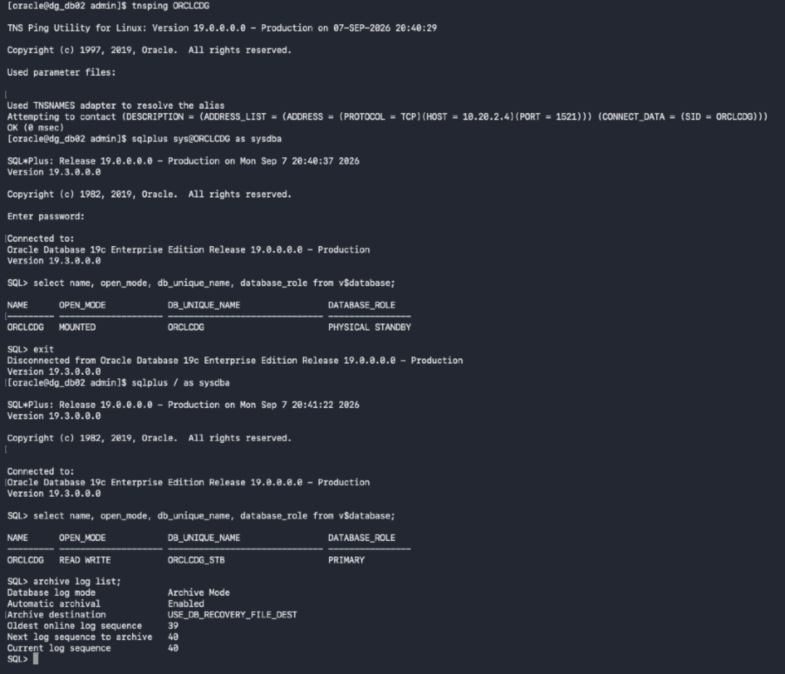
Verify DB02 is the new primary and HA service is available
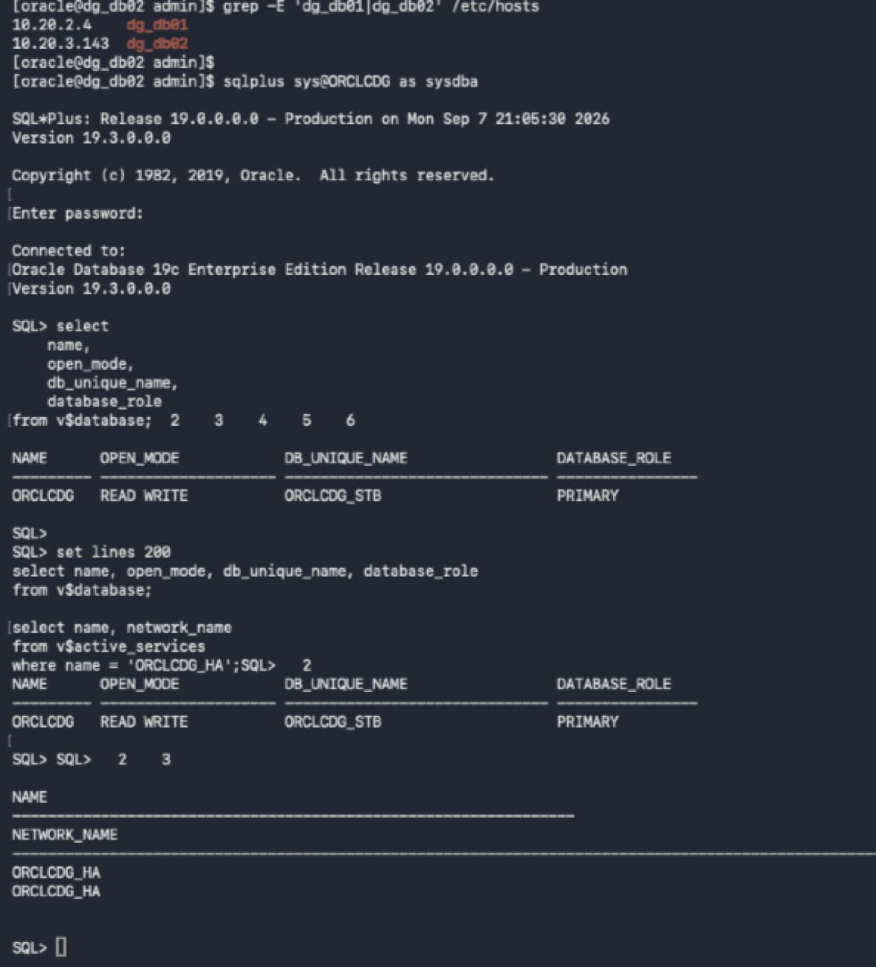

Enable managed recovery (MRP) on the new standby DB01
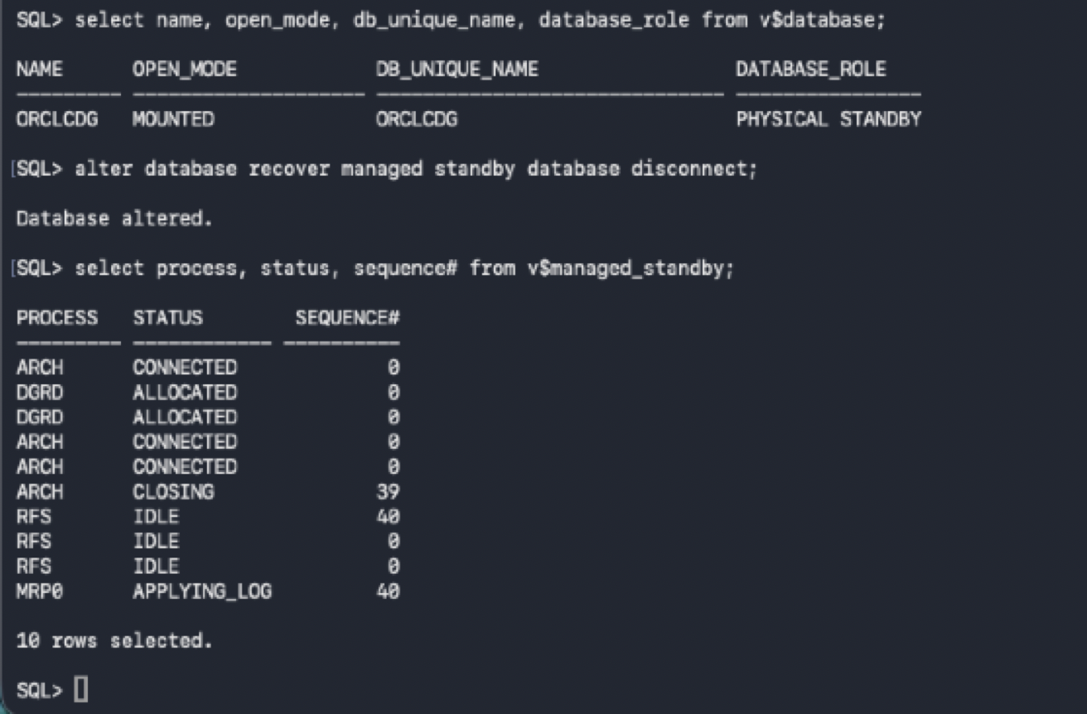
Perform log switch on new primary:
Generate redo on the new primary DB02
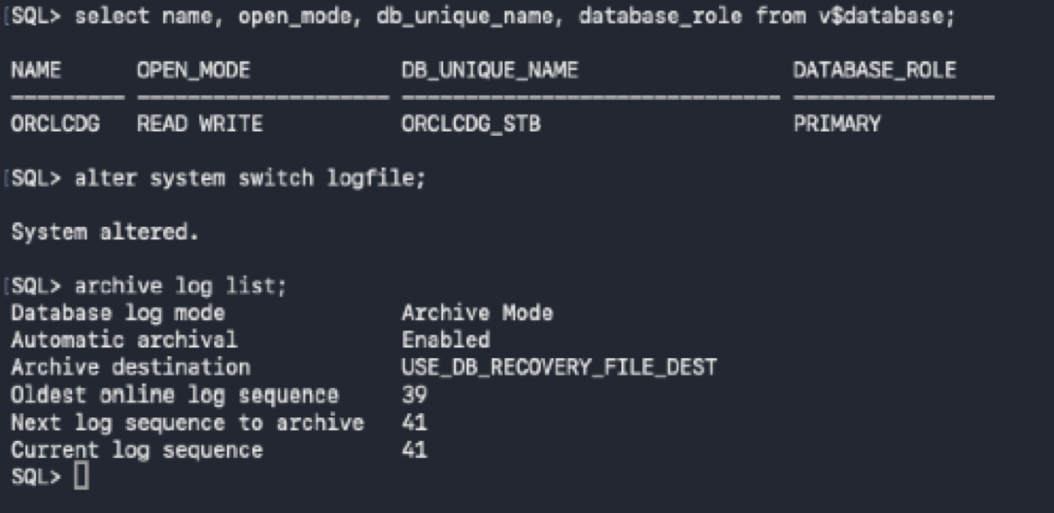
Verify redo is received and applied on DB01
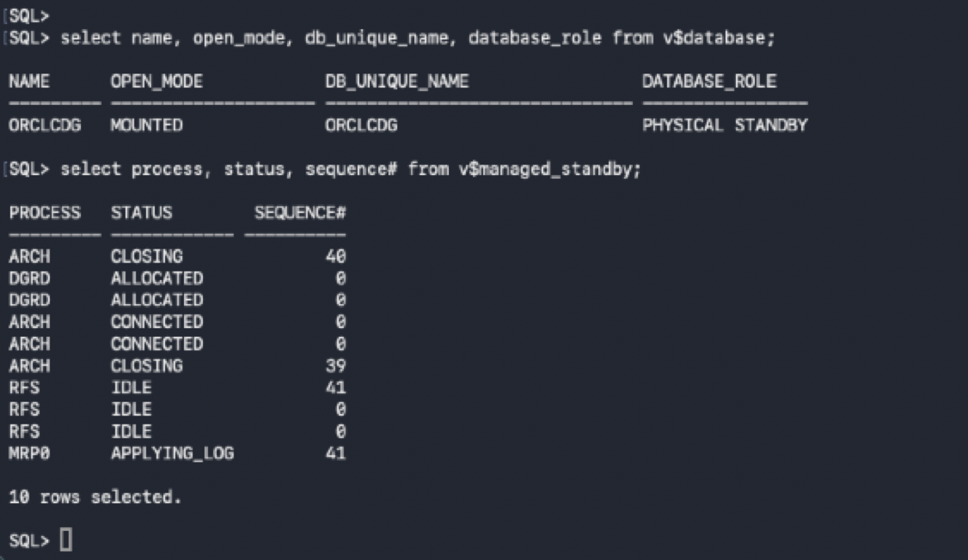

Primary
Validate reverse redo transport from DB02 to DB01
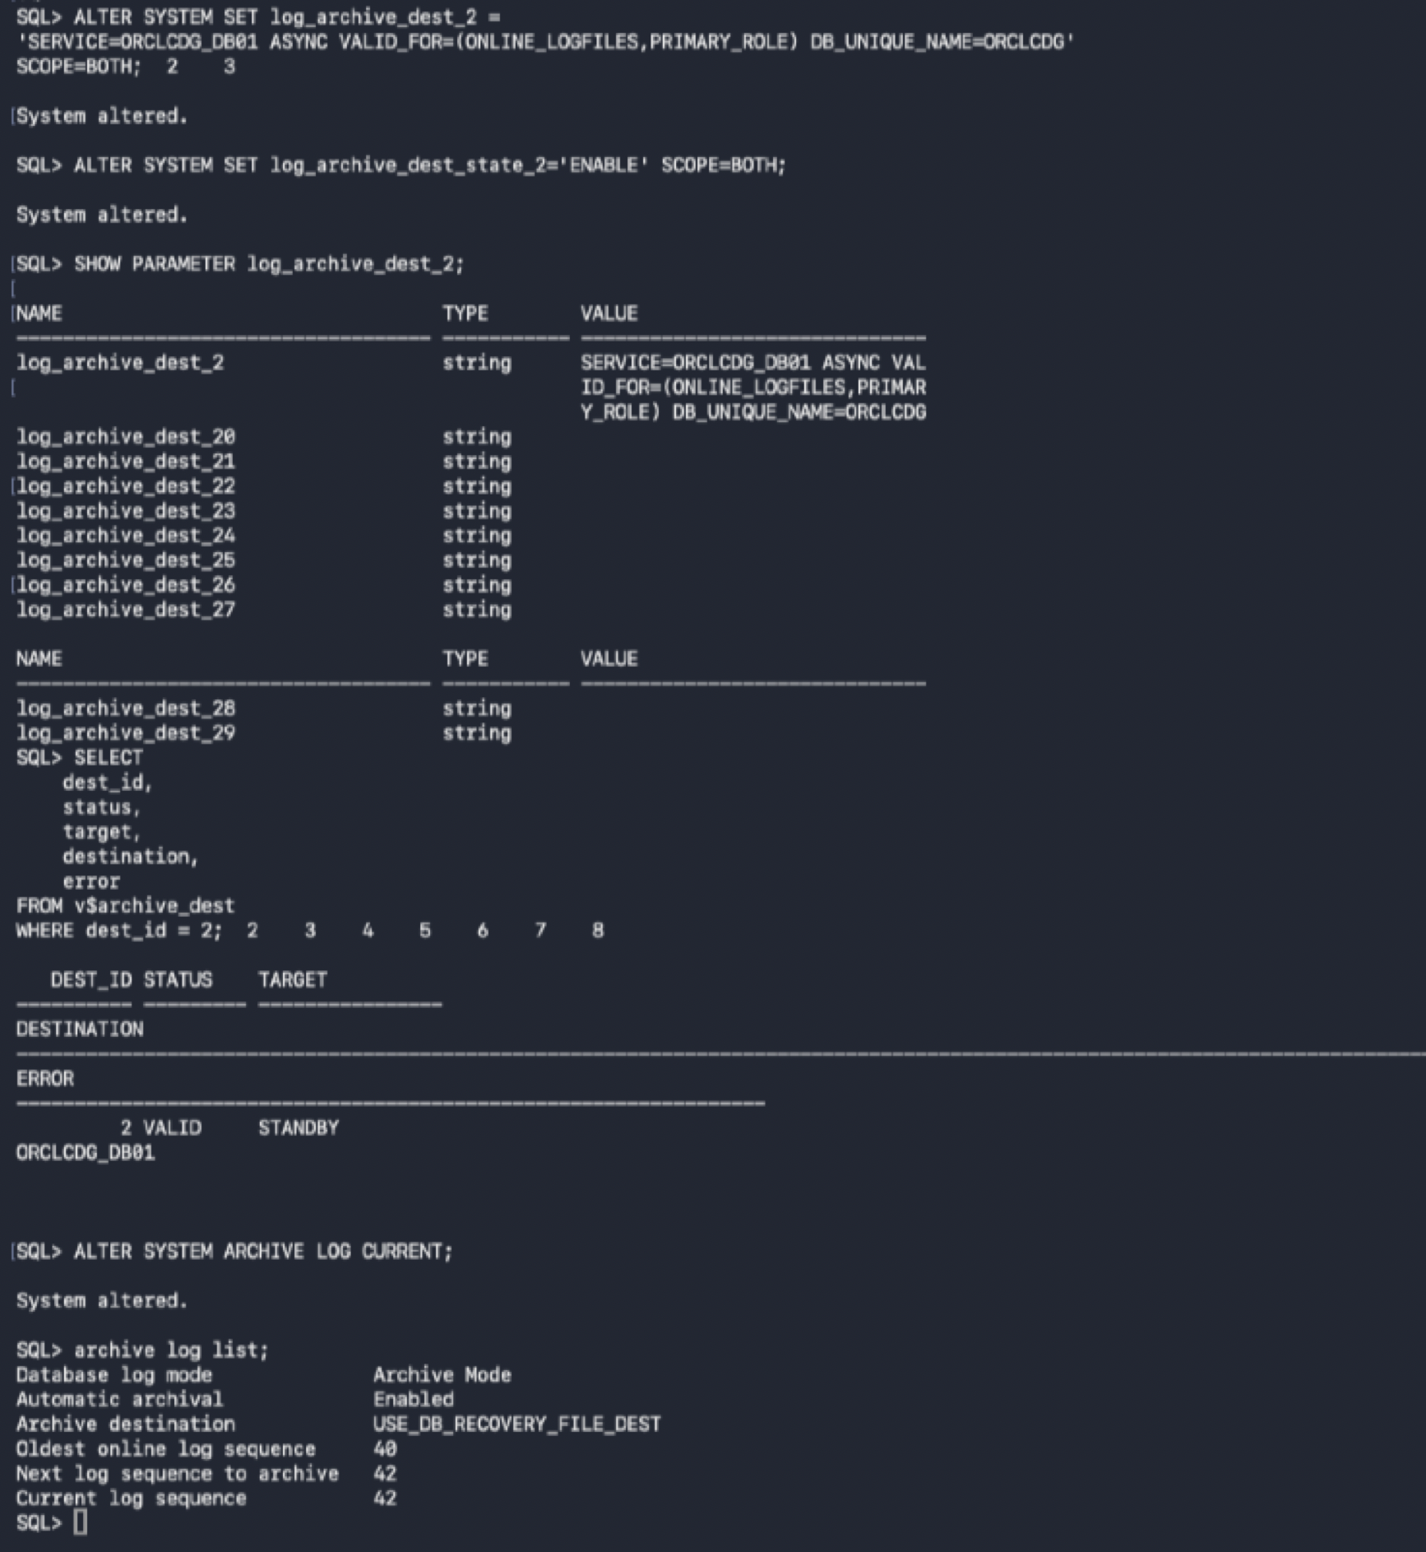

2ND Switchover: Switch new primary back to standby
Initiate the second switchover: demote DB02 to standby
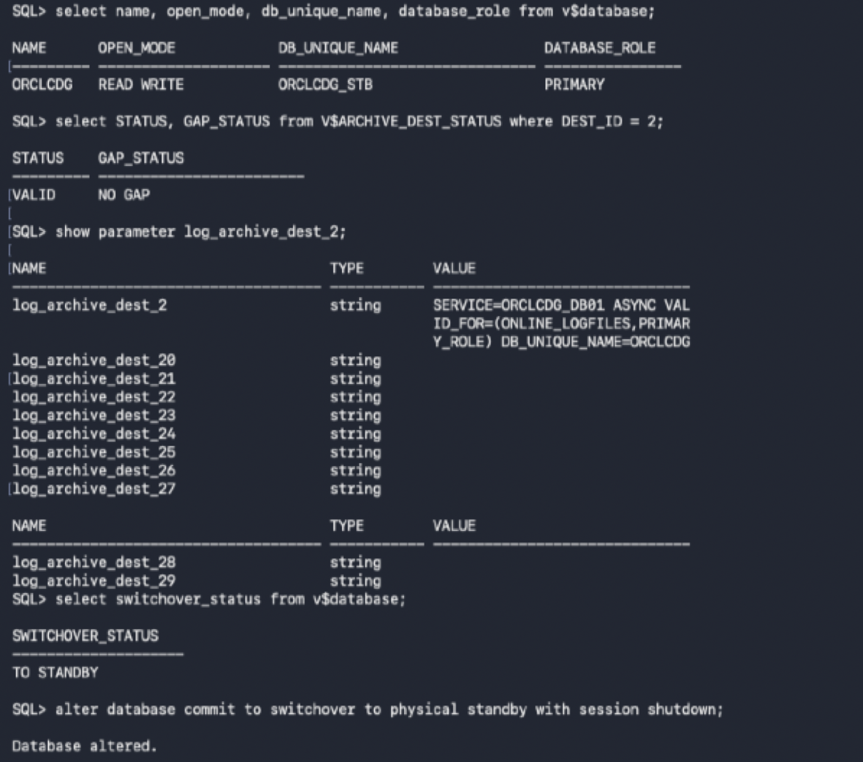
Mount DB02 as the physical standby
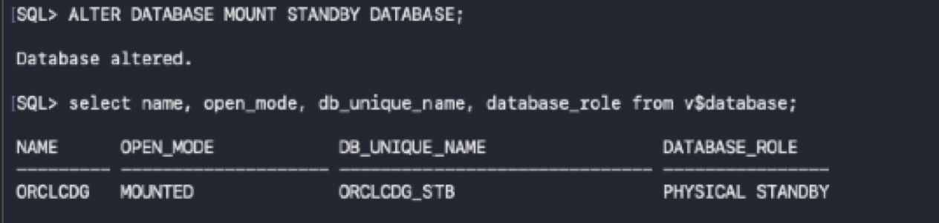

Switch new standby back to primary
Promote DB01 back to the primary role
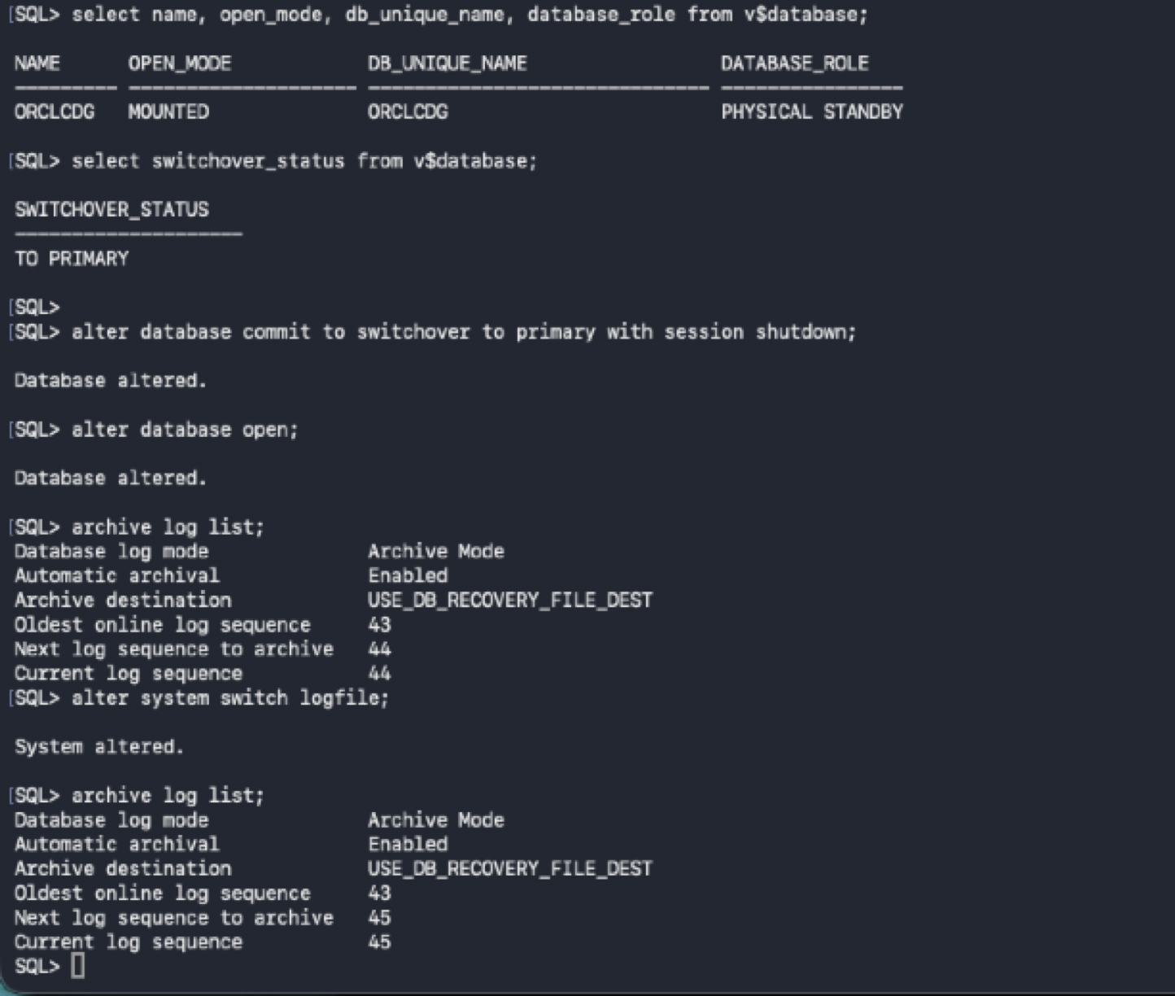
Enable MRP on the new standby DB02
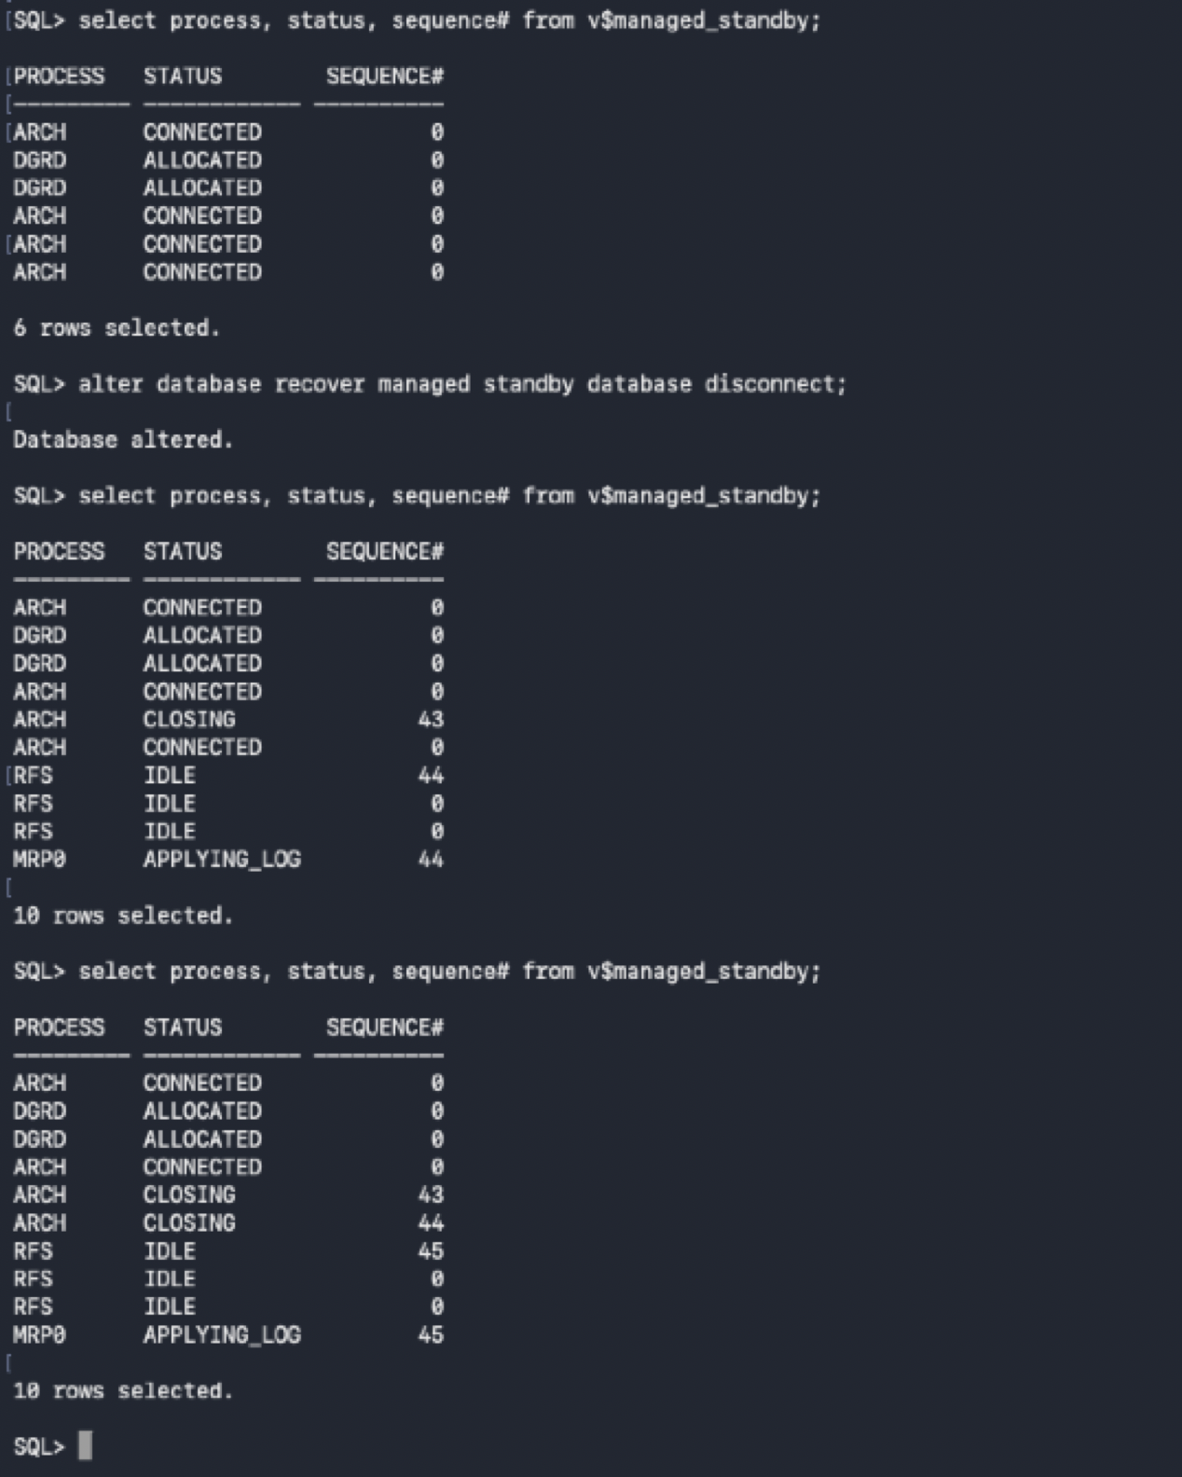

Snapshot Standby Test — PASSED: Converted the physical standby to Snapshot Standby, opened it read/write for controlled application testing, created and committed test data, then converted it back to a physical standby. Managed recovery resumed successfully with MRP0 applying redo. Final validation confirmed zero transport lag, zero apply lag, and a valid Data Guard destination.
