ORACLE 23ai DATABASE, WEBLOGIC 14.1.2, FORMS AND REPORTS
DEPLOYMENT VALIDATION
Oracle Database 23ai – ORACLE_HOME, Listener, Services, and TNS Validation
Validates the FORMSDB listener on db02:1521, registered database services, listener status, listener.ora, and tnsnames.ora.
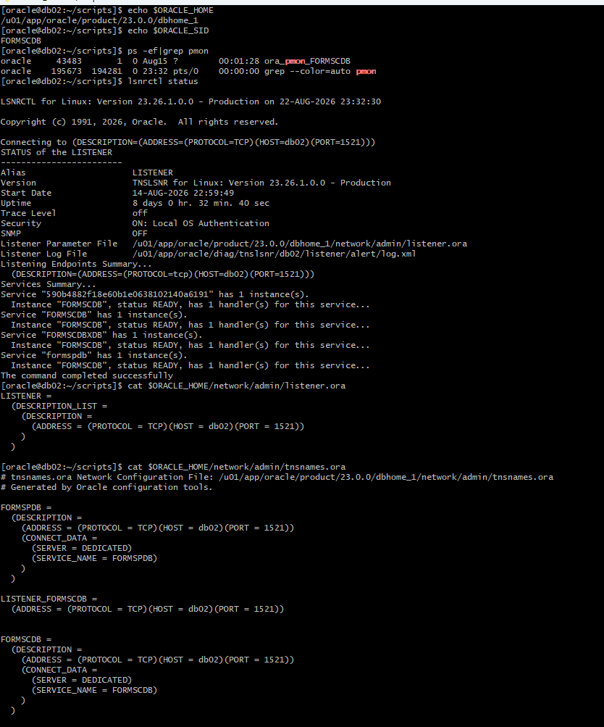

Oracle Database 23ai Storage, PDB, and Datafile Validation
Validates filesystem capacity, FORMSCDB/FORMSPDB datafiles, Oracle Database 23ai connectivity, and PDB open state.
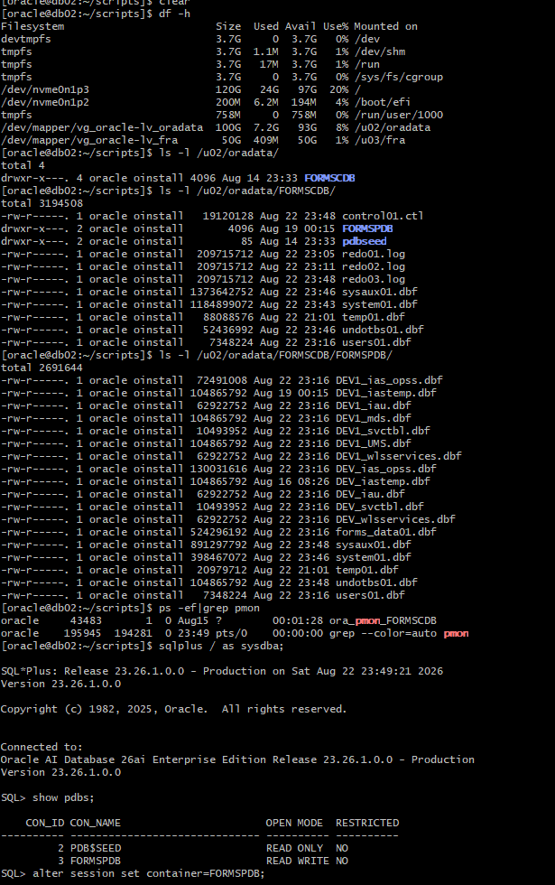

Oracle Database Tablespace Capacity Validation
Validates tablespace size, free space, used space, and datafile allocation for the FORMS database.
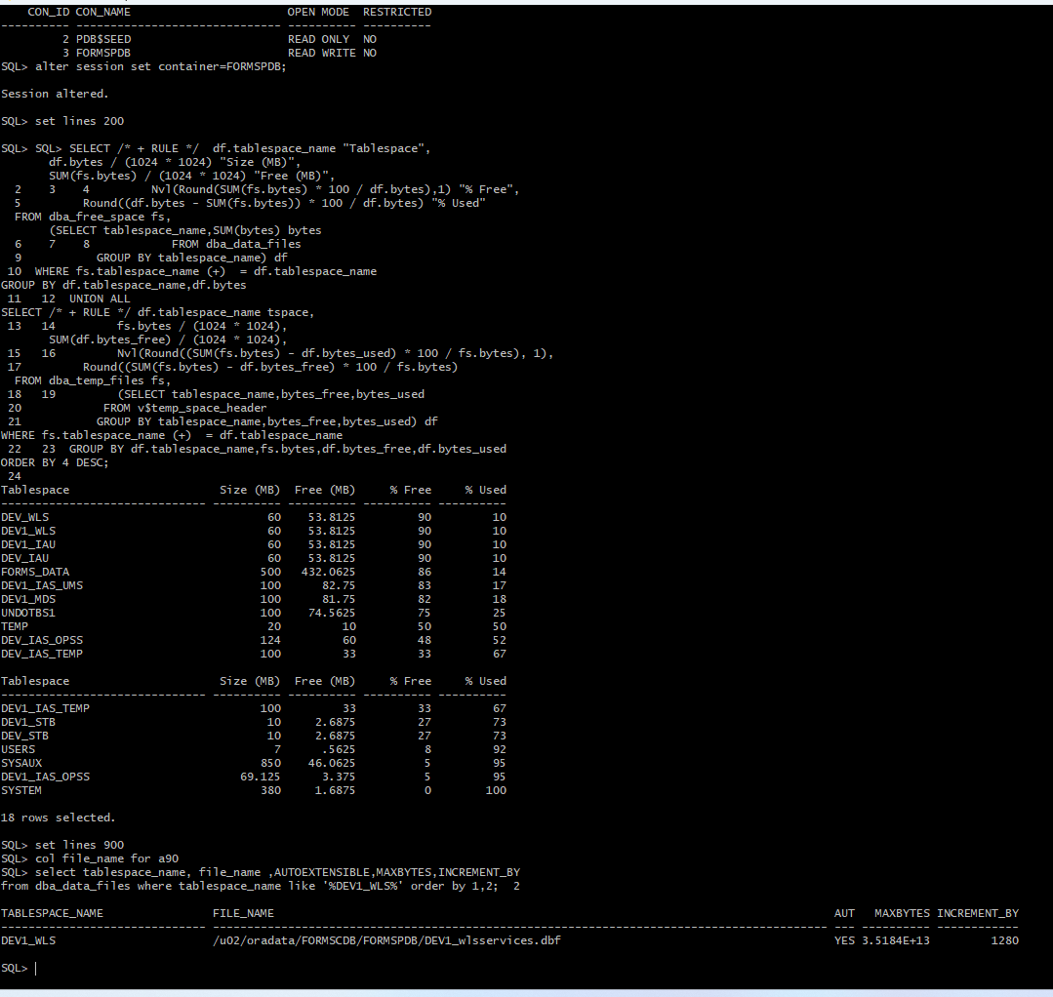

RMAN Level 0 Full Backup Validation
Shows a successful RMAN Level 0 full backup for FORMSCDB, including 19 backup files and the completed backup log.
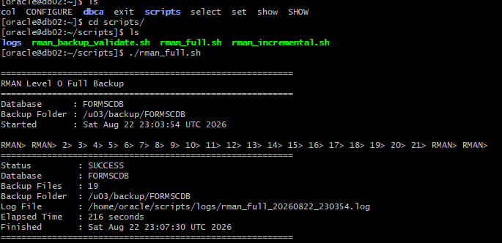

RMAN Level 1 Incremental Backup Validation
Shows a successful RMAN Level 1 incremental backup and the resulting backup pieces in /u03/backup/FORMSCDB.
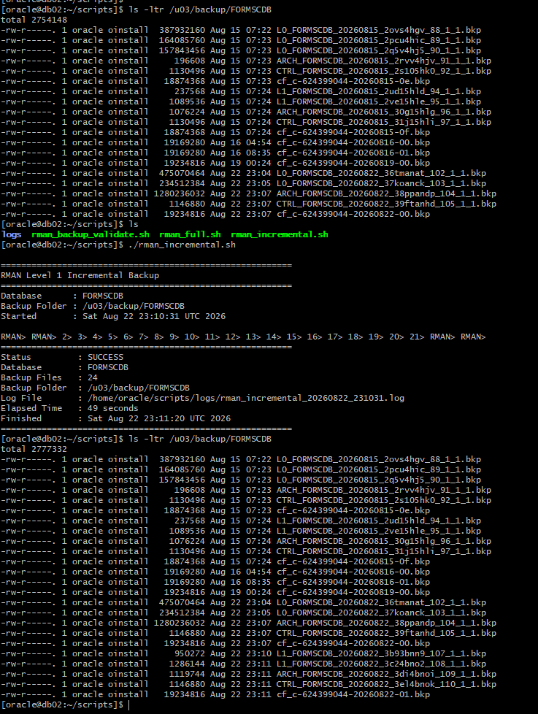

RMAN Full Backup Execution Log
Shows RMAN backup execution against FORMSCDB, including completed database backup pieces.
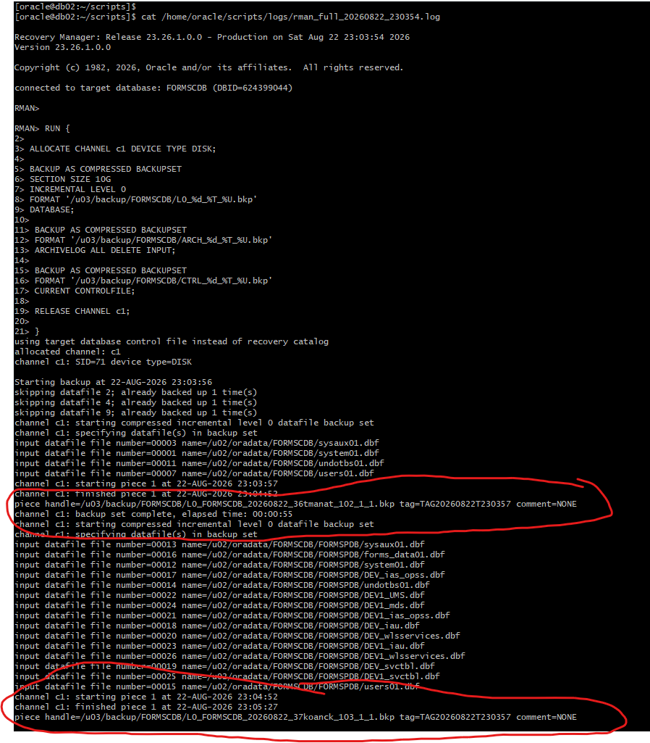

RMAN Archive Log and Control File Backup Completion
Shows completed archive-log processing, backup-set completion, control-file/SPFILE backup, and RMAN completion.
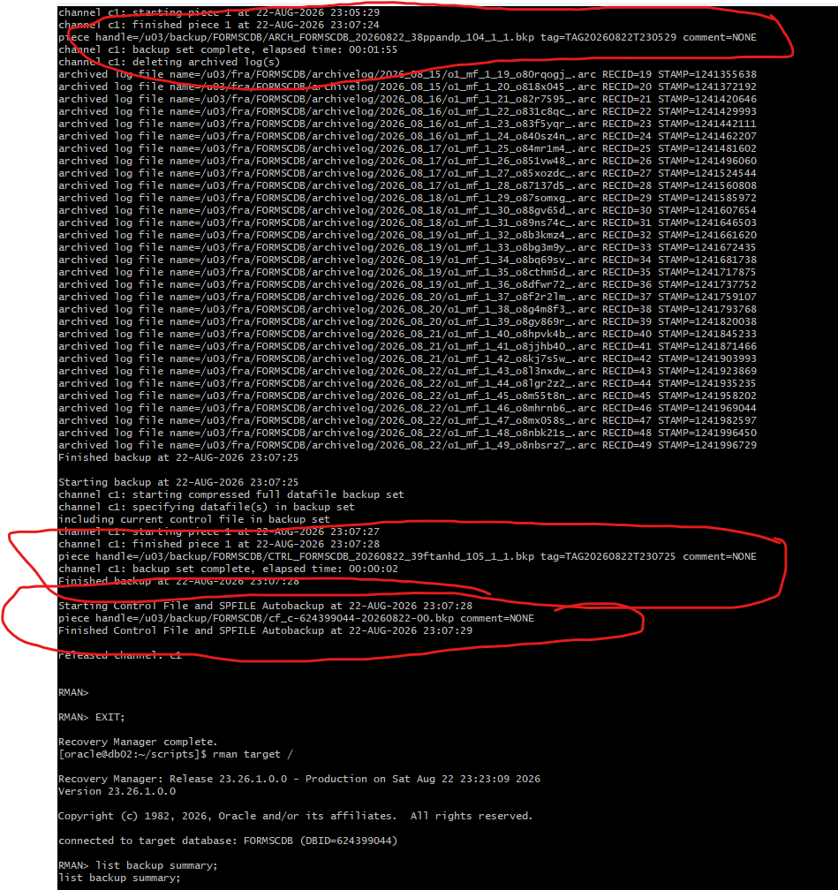

RMAN Backup Summary Validation
Shows RMAN LIST BACKUP SUMMARY output confirming available backup sets and tags.
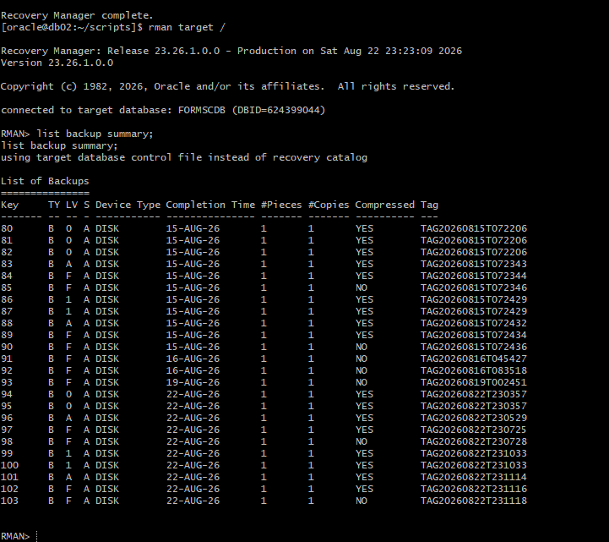

Employee Management Database Schema Validation
Validates the EMPLOYEE_APP schema in FORMSPDB and confirms EMPLOYEES and DEPARTMENTS, including their column definitions.
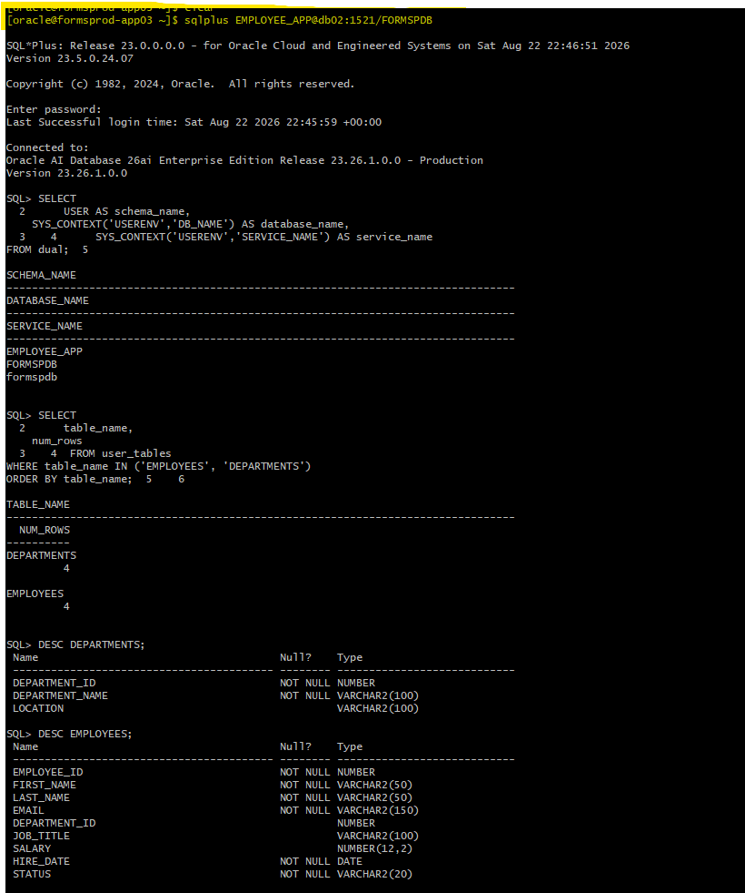

WebLogic, Forms, Reports, and Node Manager Runtime Validation
Validates Node Manager, WLS_FORMS, WLS_REPORTS, Forms HTTPS port 9501, and Reports HTTPS port 9512.
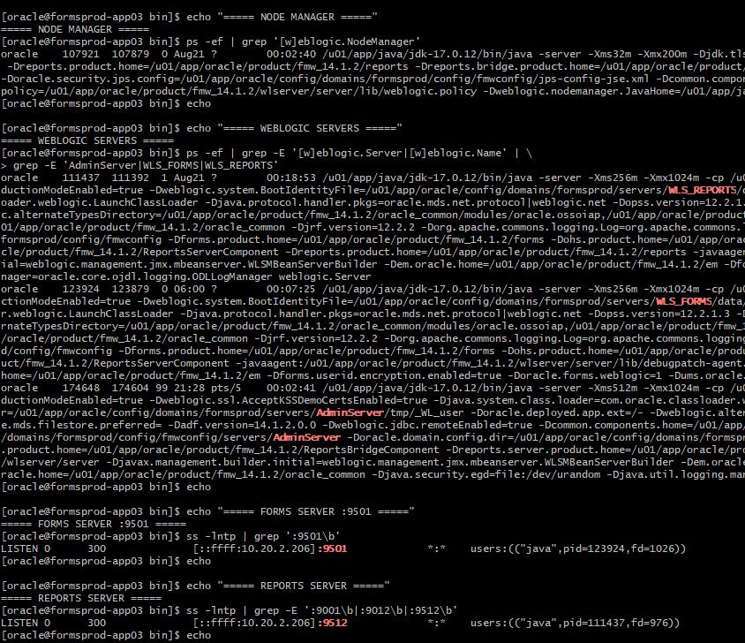

Employee Management Forms Compilation
Shows Forms Builder compiling test.fmb with no compilation errors, creating test.fmx, and placing it in the compiled directory.
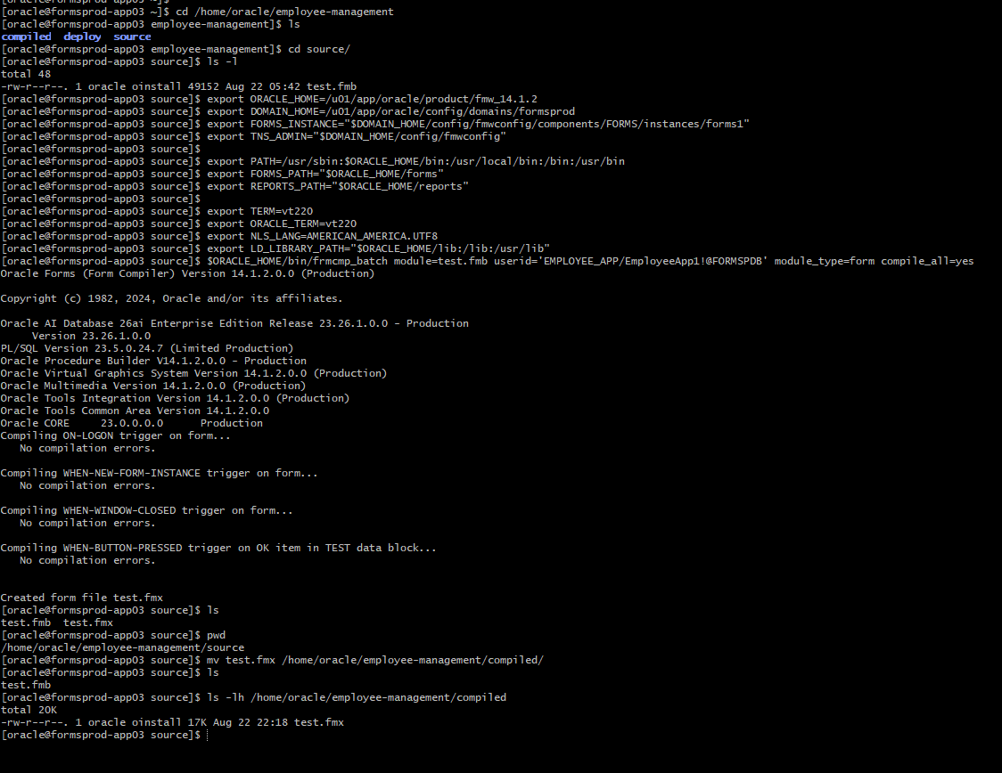

Forms, Reports, and Employee Management Deployment Validation
Validates Forms servlet HTTP 200 on port 9501, Reports port 9512, Reports engine presence, and Employee Management source/compiled/deployed artifacts.
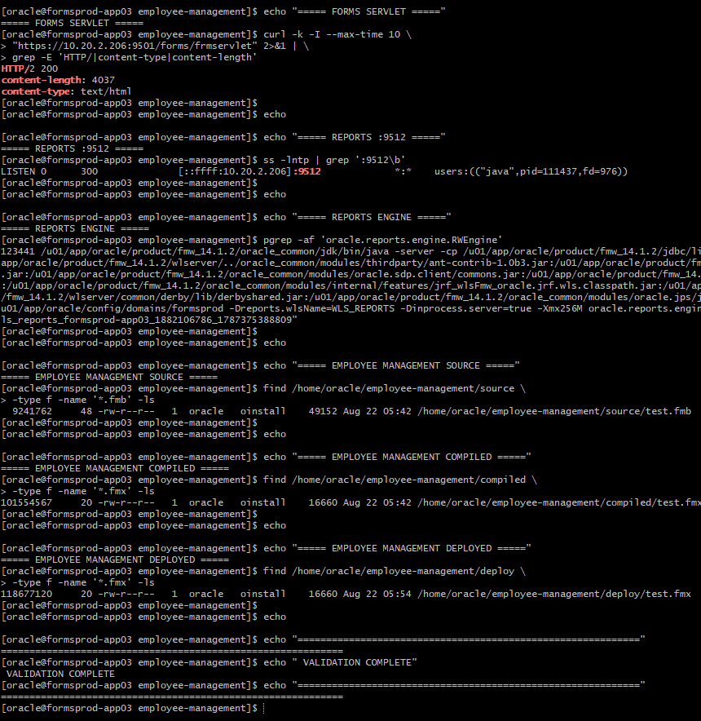

WLST Managed Server State Validation
Validates Node Manager connectivity and confirms WLS_FORMS and WLS_REPORTS report RUNNING through WLST nmServerStatus().


