Weblogic Server 14.1.2 enterprise and Oracle JDK 17 deployment and domain creation using script
Screenshot 1 — Initial app02 host and operating-system validation
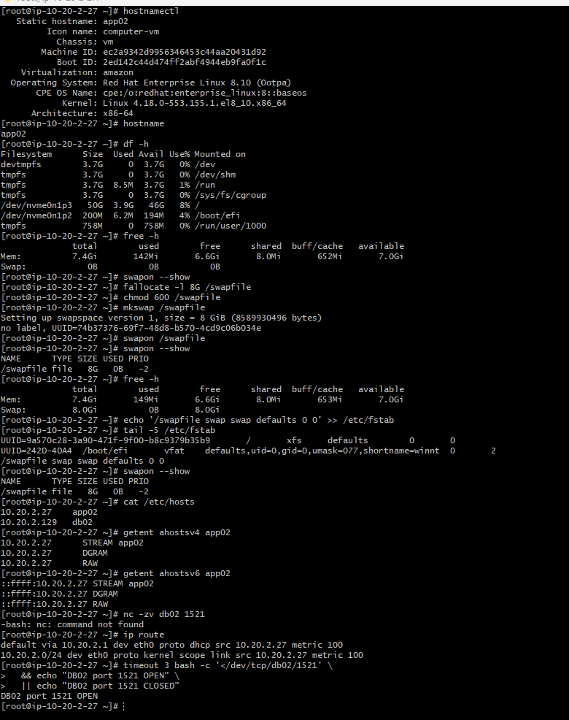
Memory, swap, filesystem, and host configuration validation
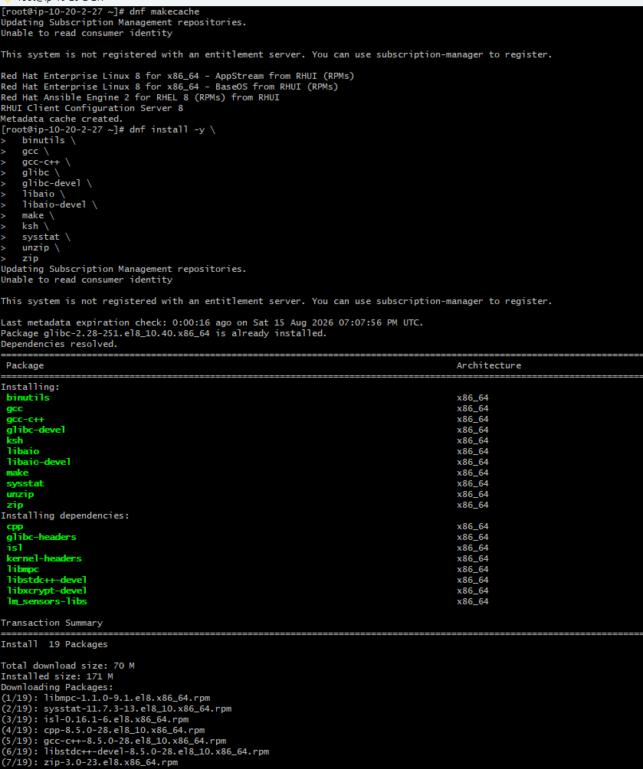Network routing and Oracle database connectivity check
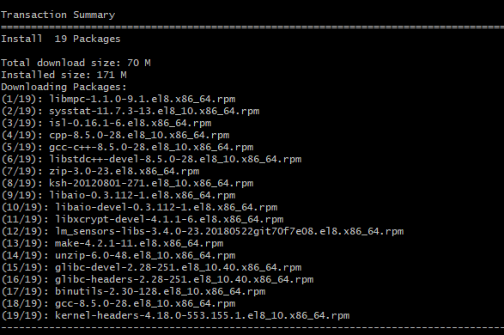
Screenshot 4 — RHEL 8 repository and prerequisite installation preparation
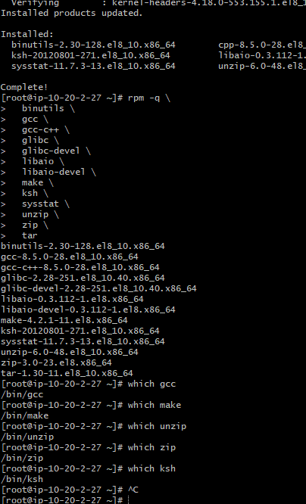

Oracle groups/user creation and /u01 directory structure
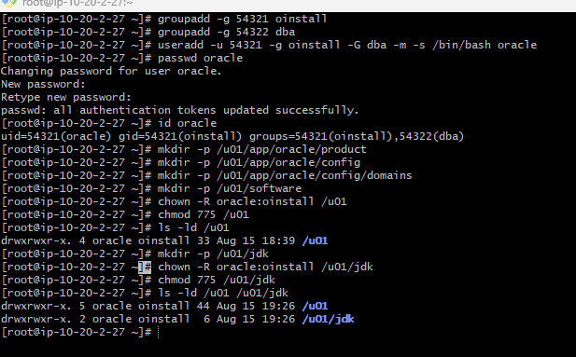
Download WebLogic FMW server and Oracle JDK 17.0.12
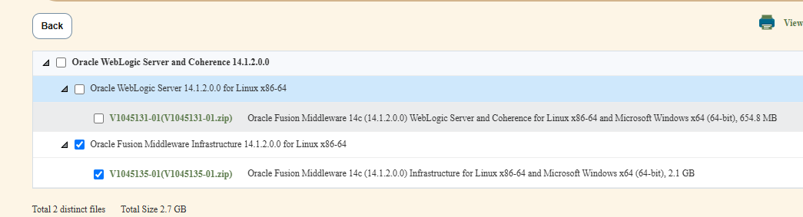
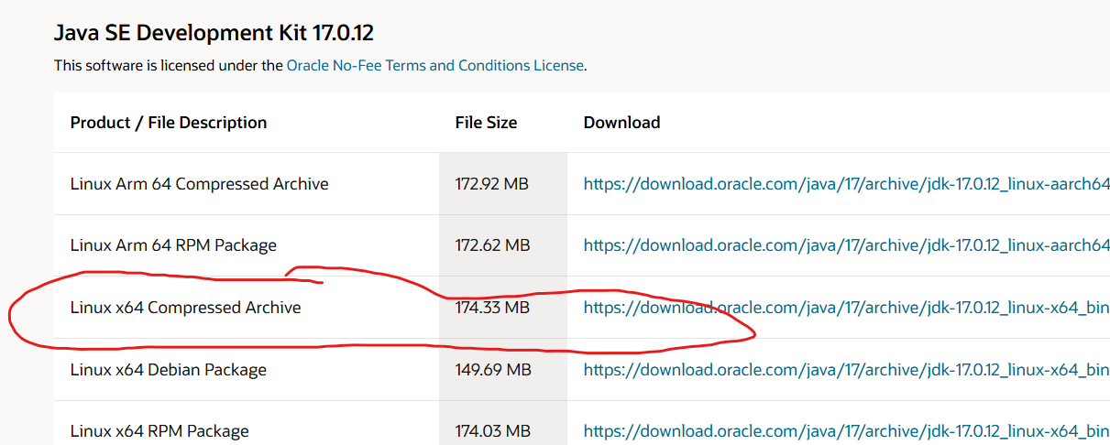

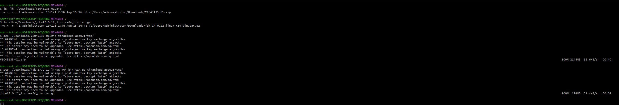
JDK 17.0.12 deployment under /u01/app/java
JAVA_HOME and Oracle environment configuration
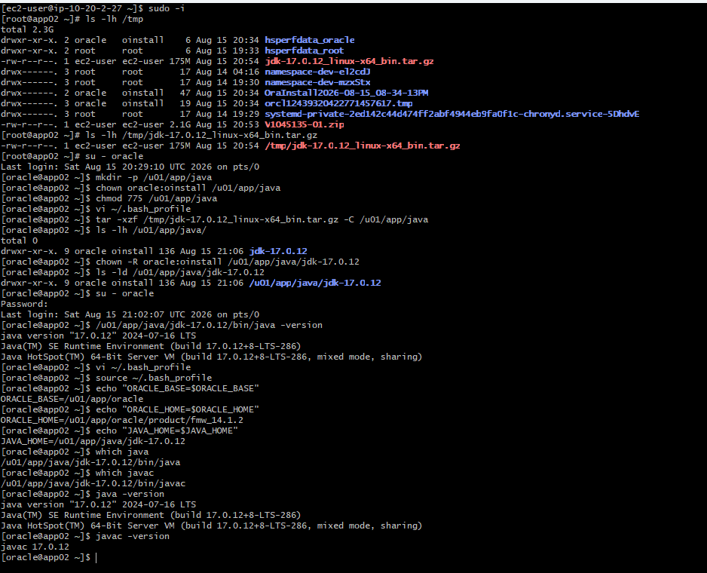

Oracle Inventory and FMW Oracle Home preparation
FMW response-file configuration
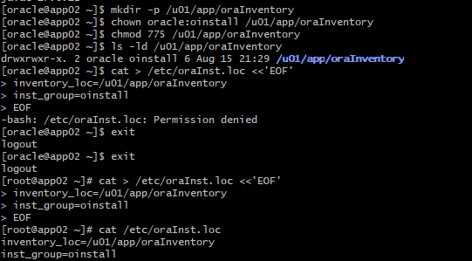
Installer, Java, Oracle Home, and inventory verification
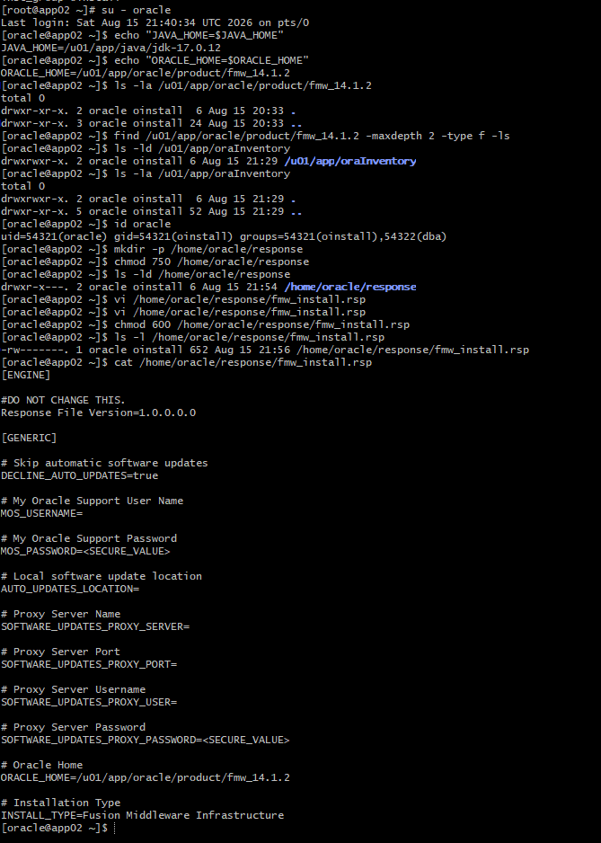
Verify installer and response file
Final pre-install validation
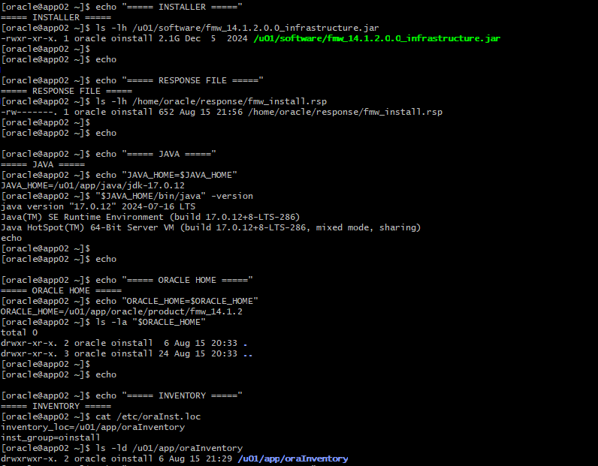

Install FMW Infrastructure 14.1.2 using custom responseFile
FMW Infrastructure 14.1.2 installation and successful completion
Oracle Home contents and WLST verification
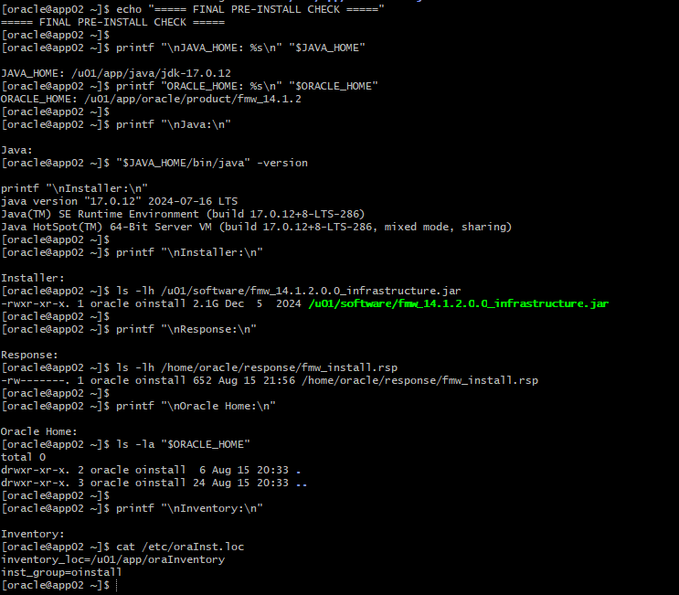

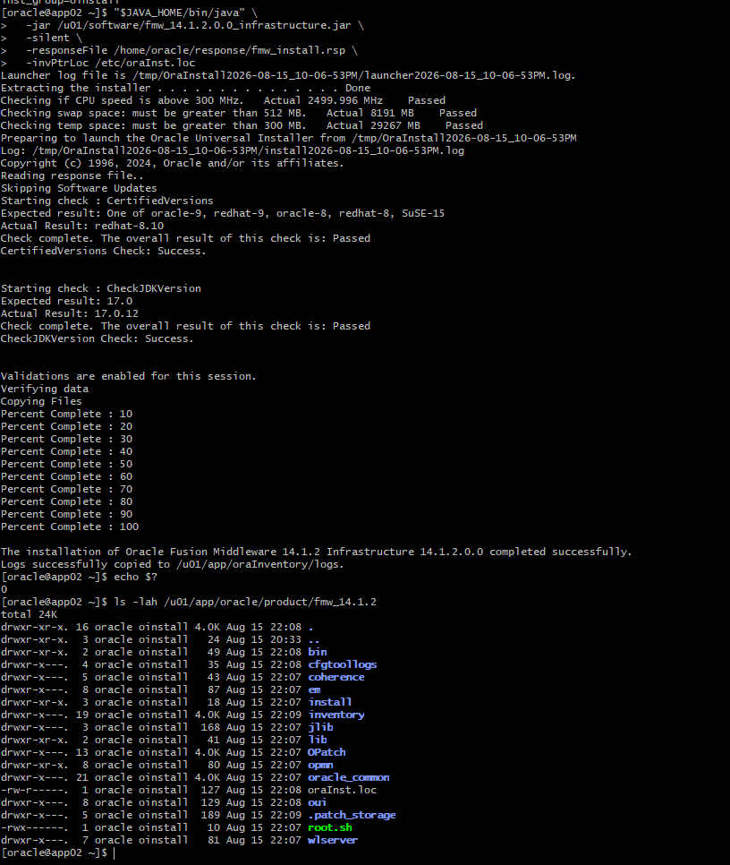
Oracle inventory verification and installation logs
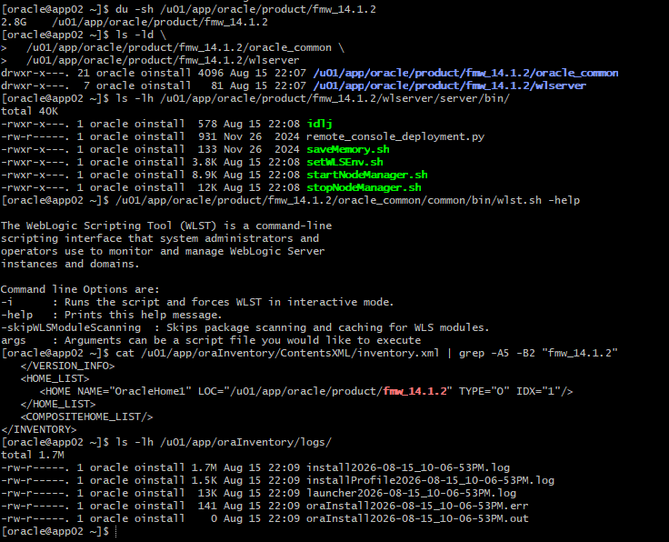

Automated WLST script for the formsprod domain
- AdminServer
- WLS_FORMS Server
- WLS_REPORTS Server
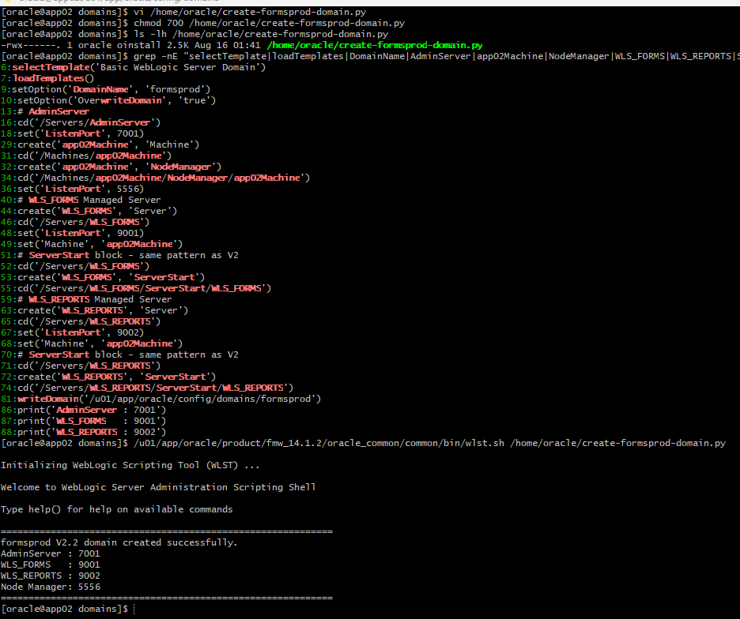

Successful formsprod domain creation
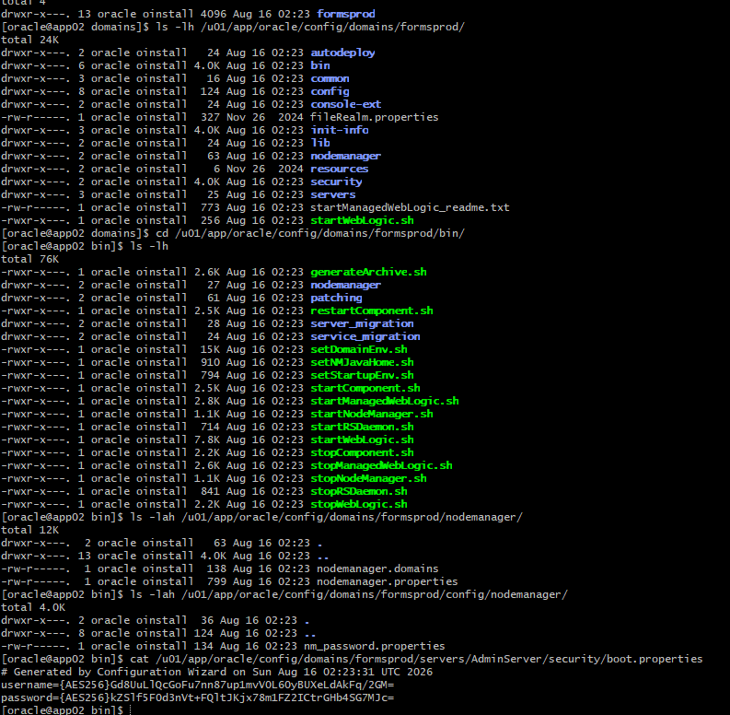

Starting Node Manager from the domain bin directory
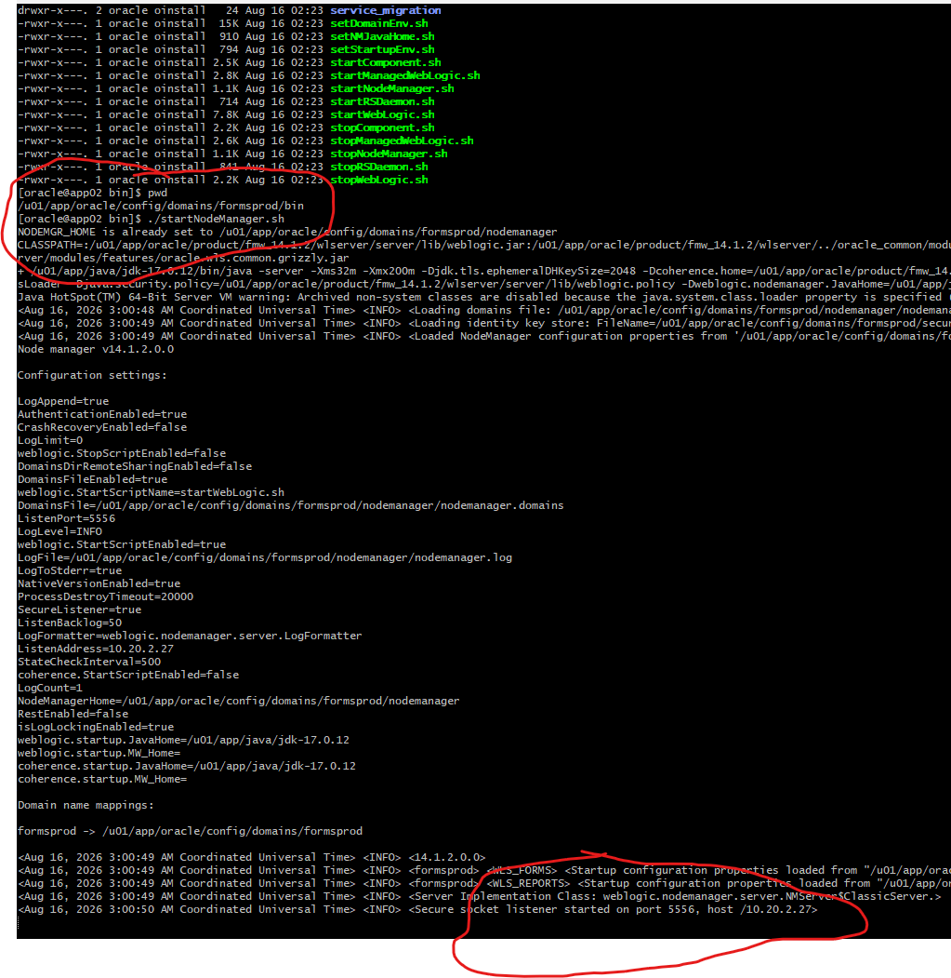

Starting the WebLogic AdminServer
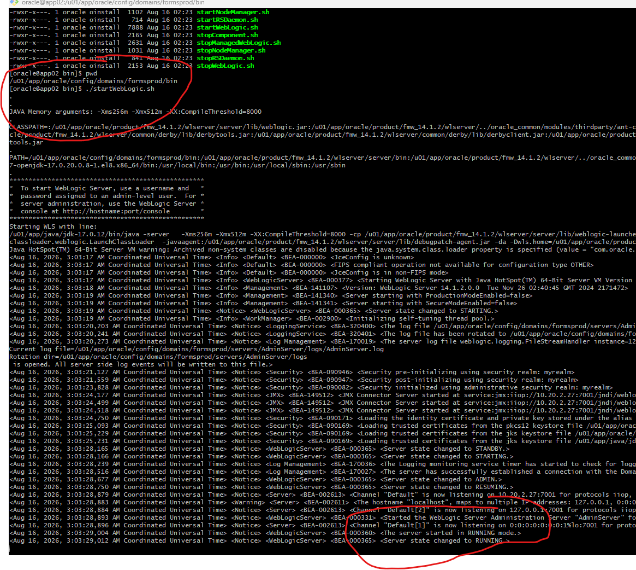
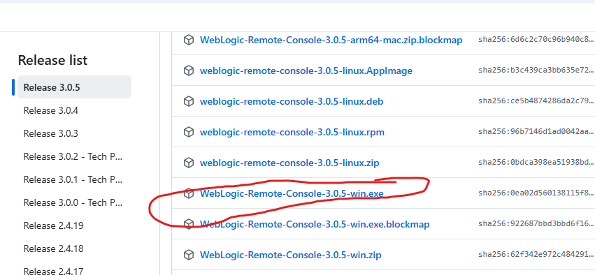
AdminServer startup and RUNNING state
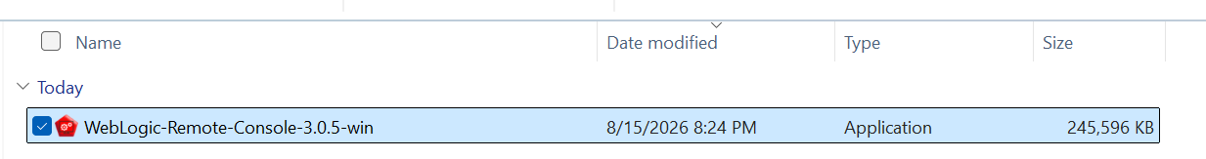
Screenshot 26 — WebLogic Remote Console 3.0.5 download and installation
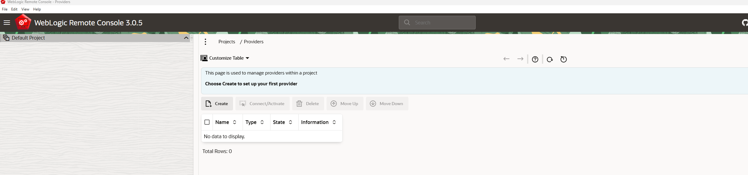

Admin Server connection provider configuration
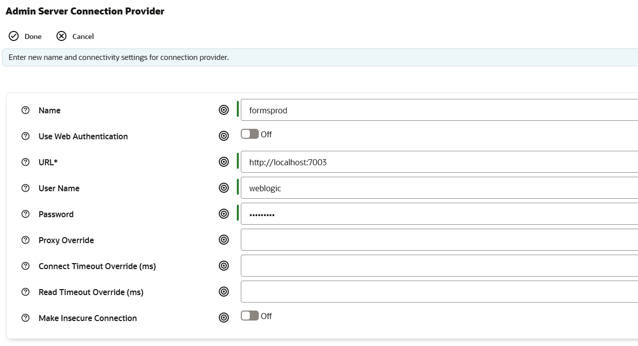

WebLogic Remote Console server configuration view
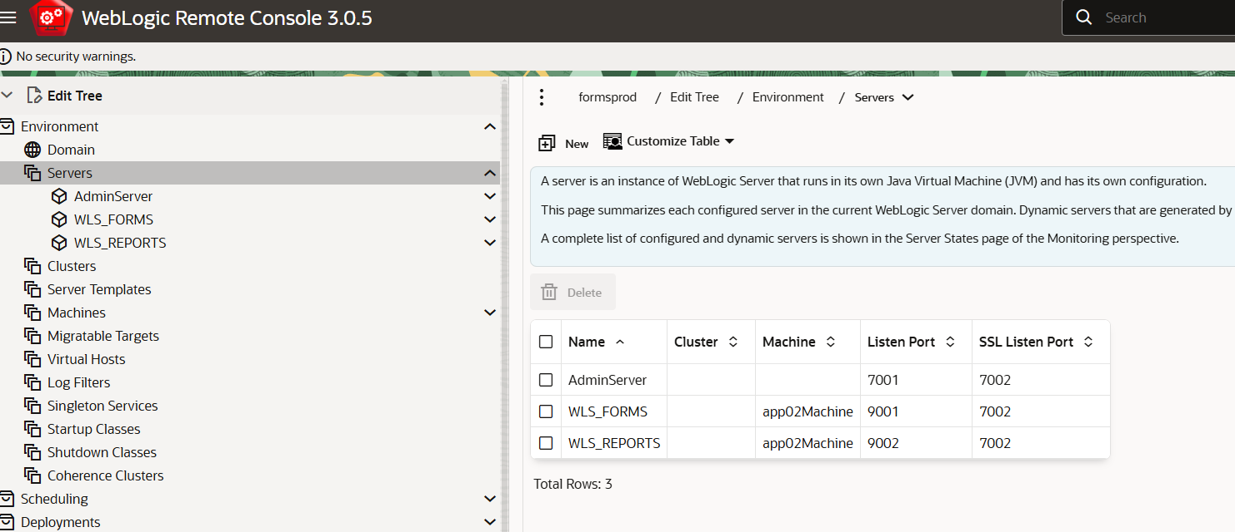

Starting WLS_FORMS and WLS_REPORTS through Node Manager
- Start WLS_FORMS server
- Start WLS_REPORTS server
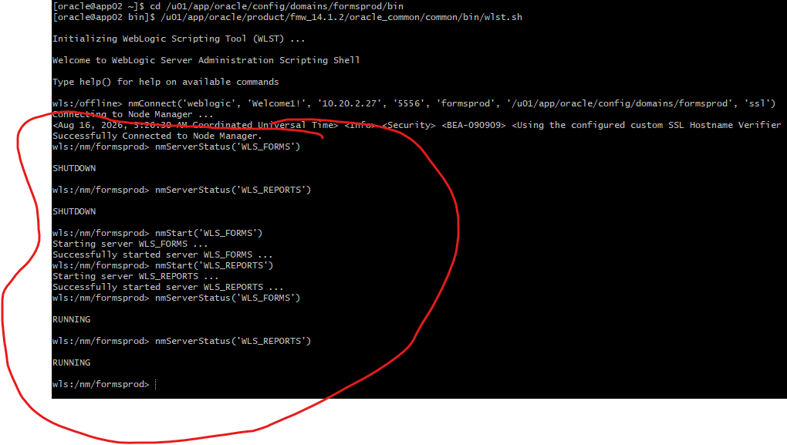

Final WebLogic processes and listening ports
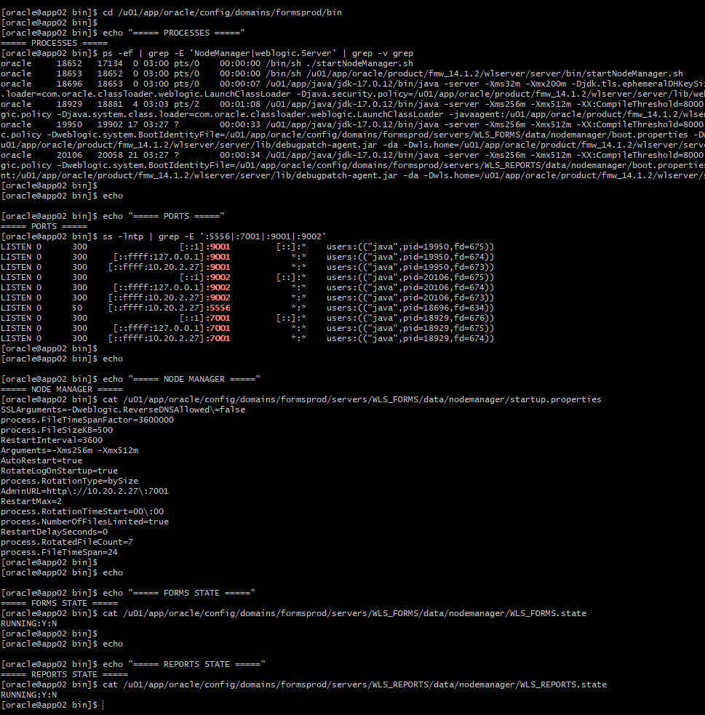

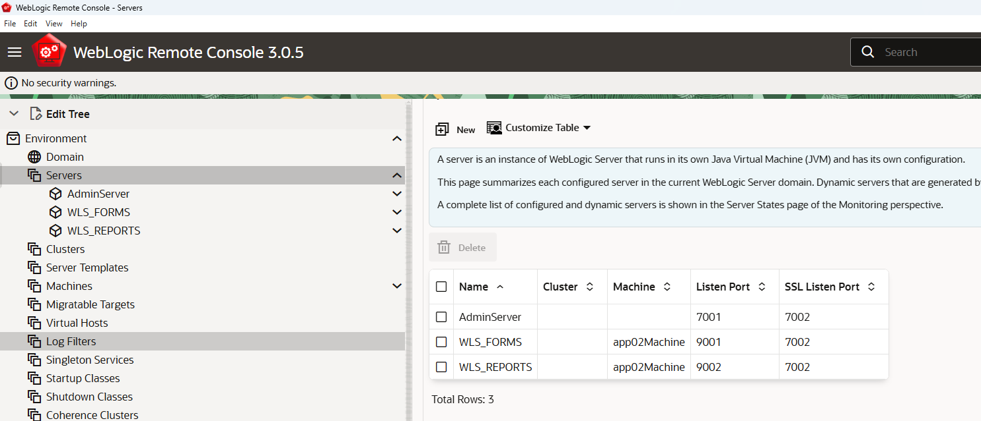

WebLogic Remote Console server configuration and runtime monitoring
