Oracle Forms and Reports Installation and Domain Creation using WebLogic Configuration Wizard
Forms and Reports Configuration and Integration
Oracle Forms & Reports 14.1.2 installation
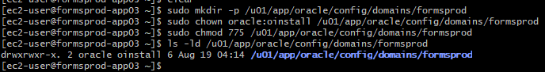
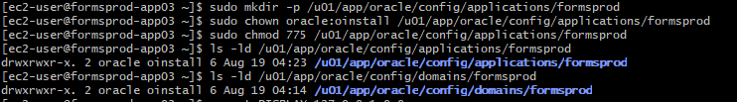
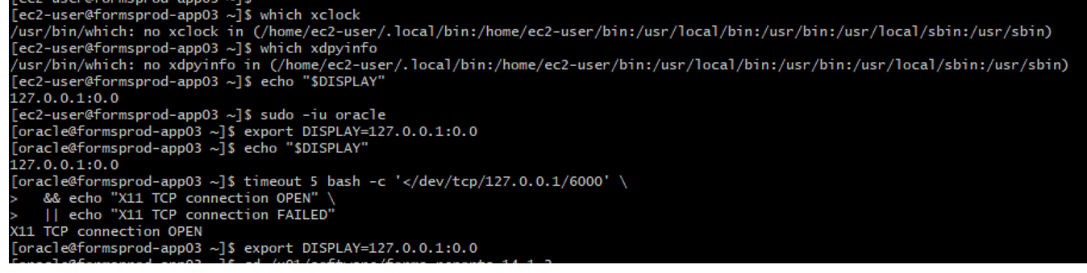
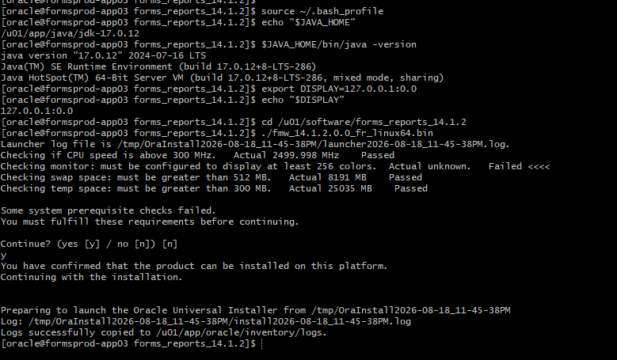
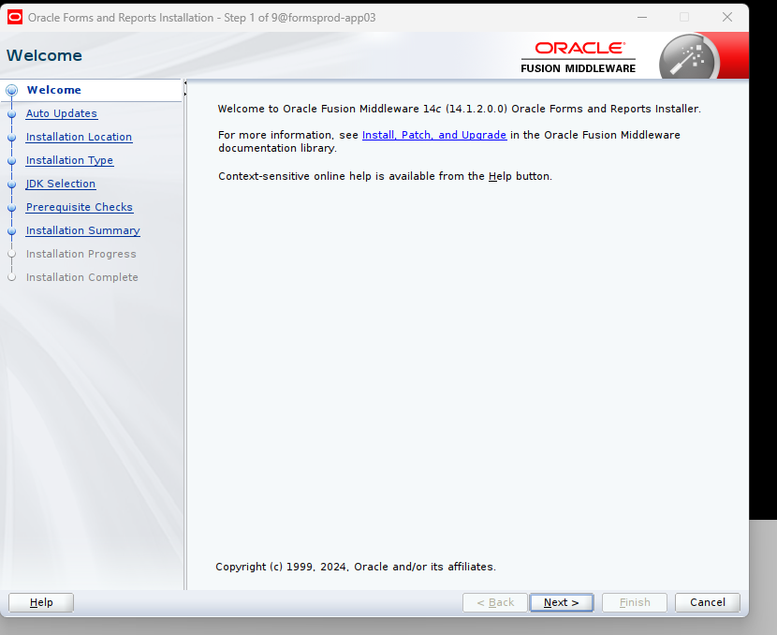
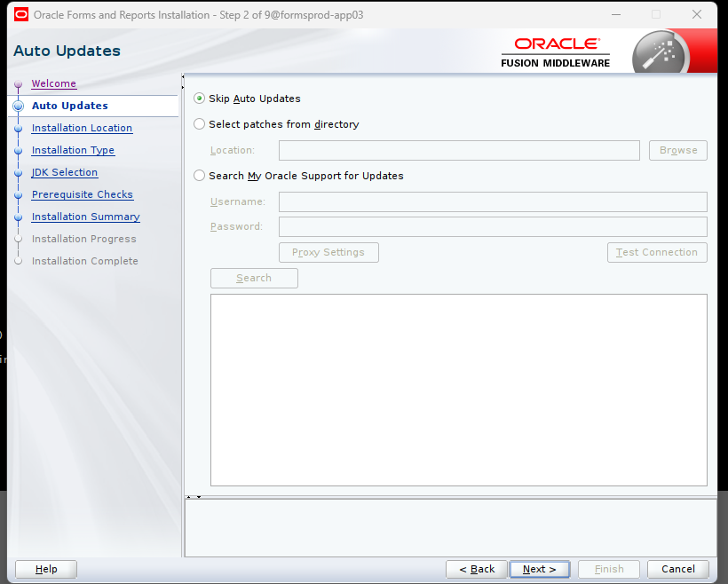
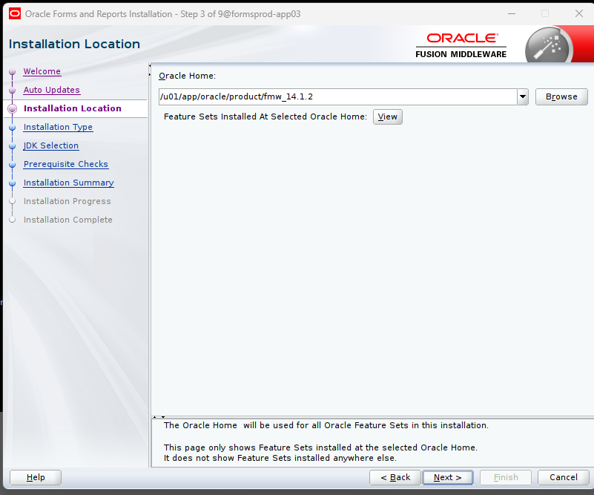
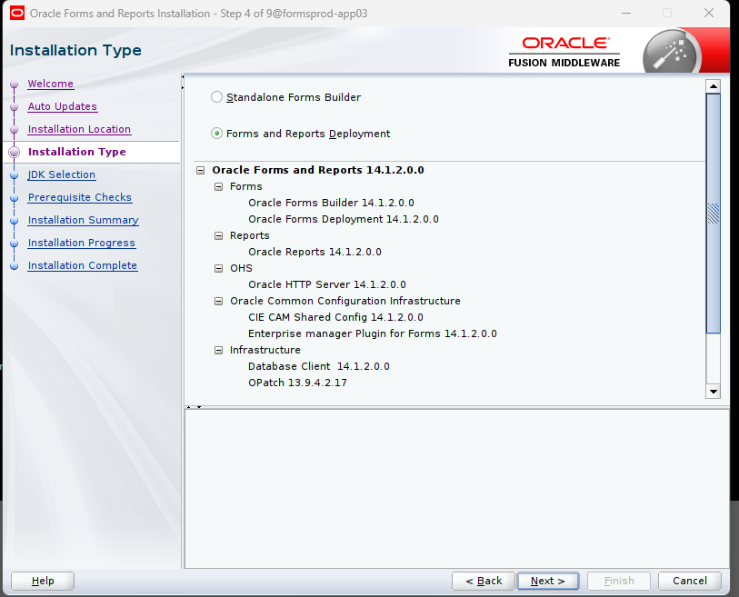
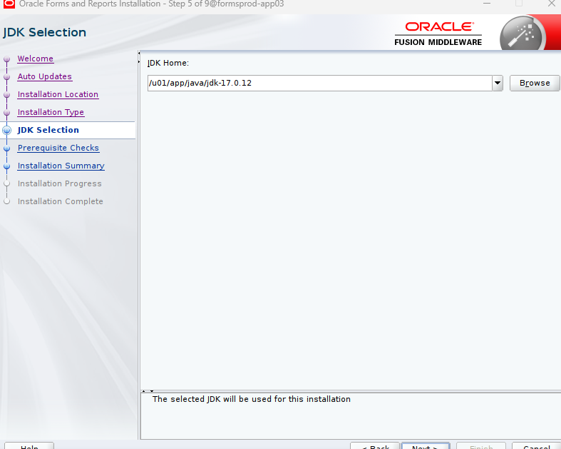

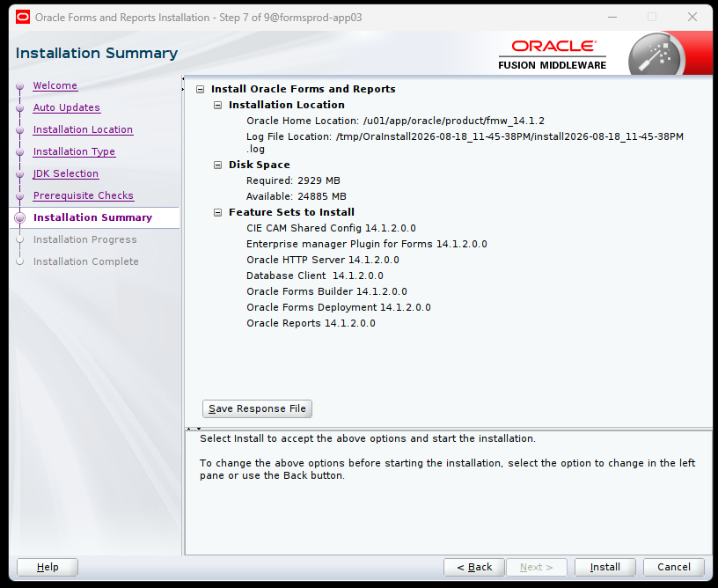
Screenshot 11 — Oracle Forms & Reports 14.1.2 installation
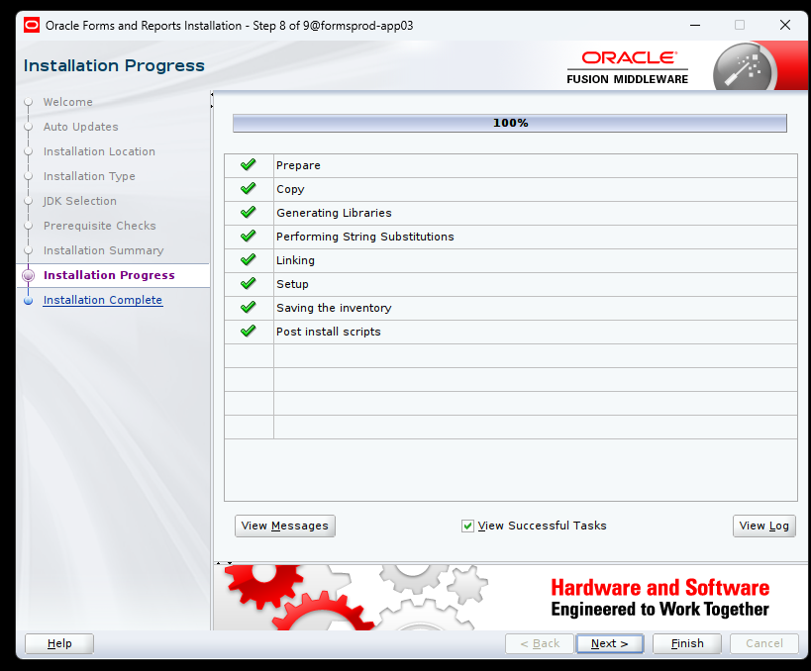
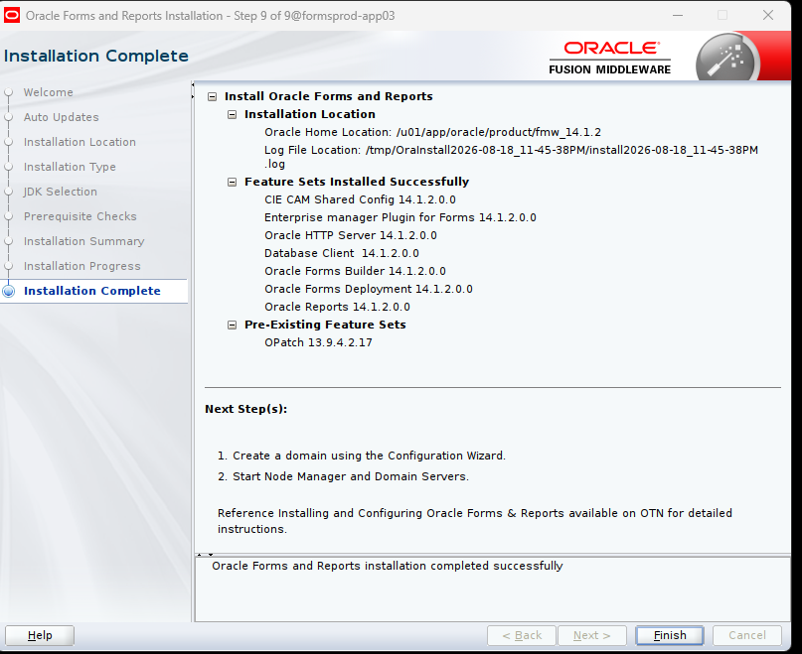
Forms & Reports 14.1.2 Installation
✅ COMPLETE
↓
RCU Repository
↓
WebLogic / Forms Domain
↓
Node Manager
↓
AdminServer
↓
WLS_FORMS
↓
WLS_REPORTS
↓
OHS
↓
Forms application testing
↓
Reports testing

Phase 2 — Create the Forms/Reports Repository schemas and tablespaces with RCU in FORMSPDB
1. Click Finish on the installer
Once you're back at the oracle@formsprod-app03 shell, make sure you're Oracle:
whoami
Expected:
oracle
2. Load the new JDK environment
source ~/.bash_profile
Verify:
echo "$JAVA_HOME"
java -version
We want:
/u01/app/java/jdk-17.0.12
and:
java version "17.0.12"
3. Set the Oracle environment
export ORACLE_HOME=/u01/app/oracle/product/fmw_14.1.2
export PATH=$JAVA_HOME/bin:$ORACLE_HOME/bin:$ORACLE_HOME/oracle_common/bin:$PATH
Verify:
echo "$ORACLE_HOME"
Expected:
/u01/app/oracle/product/fmw_14.1.2
4. Keep our working X display
We're using the VcXsrv tunnel that we just proved works:
export DISPLAY=127.0.0.1:0.0
Verify:
echo "$DISPLAY"
Expected:
127.0.0.1:0.0
5. Verify RCU exists
Run:
ls -l $ORACLE_HOME/oracle_common/bin/rcu
Then:
$ORACLE_HOME/oracle_common/bin/rcu -help
Don't worry if the help output is lengthy.
6. Launch RCU
$ORACLE_HOME/oracle_common/bin/rcu
That should bring up the Repository Creation Utility GUI on your Windows desktop.

🚨 Stop when RCU opens
Don't start entering database information yet.
Send me a screenshot of the RCU Welcome screen, and we'll go through it one screen at a time.
Our sequence will be:
Forms & Reports installation ✅
↓
RCU repository ← WE ARE HERE
↓
WebLogic Configuration Wizard
↓
Forms/Reports domain
↓
Node Manager
↓
AdminServer
↓
WLS_FORMS / WLS_REPORTS
↓
OHS
↓
Validation
And this time we're using the actual app03 paths we've verified, including:
JAVA_HOME=/u01/app/java/jdk-17.0.12
ORACLE_HOME=/u01/app/oracle/product/fmw_14.1.2
Let's launch RCU.
Screenshot 13 — Repository Creation Utility (RCU)
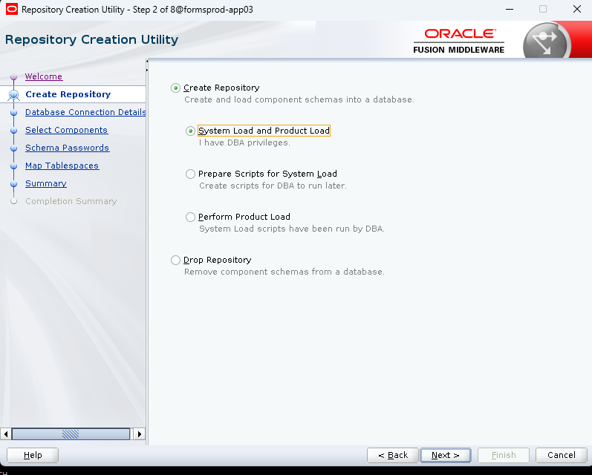
Screenshot 14 — Repository Creation Utility (RCU)
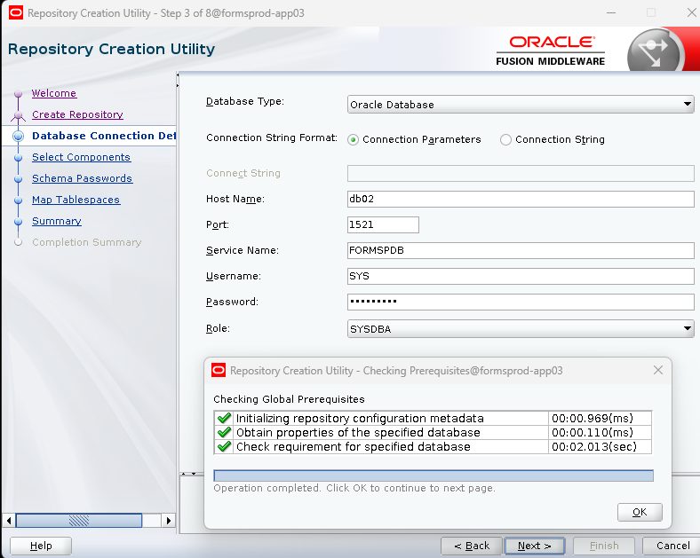
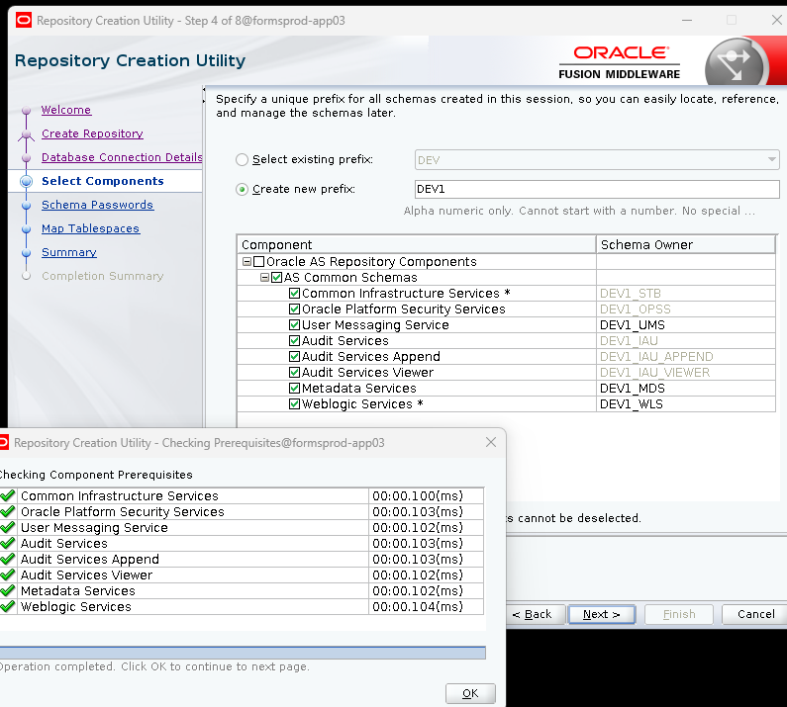

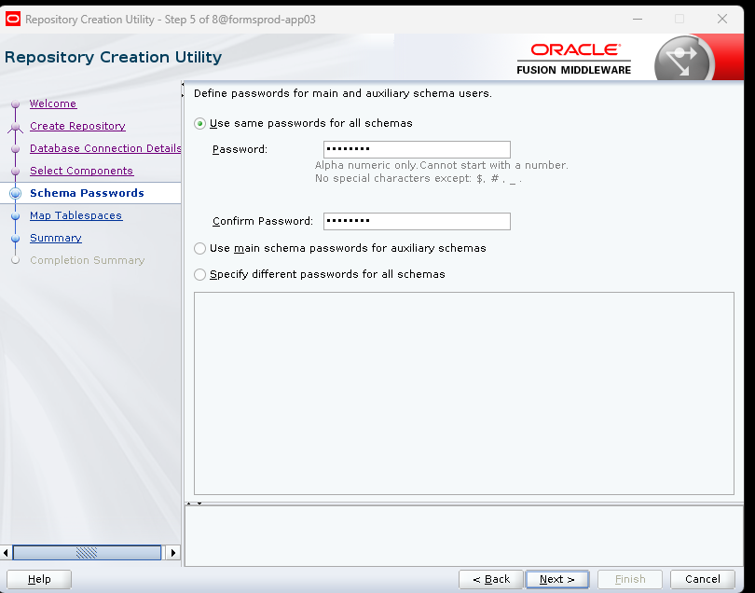
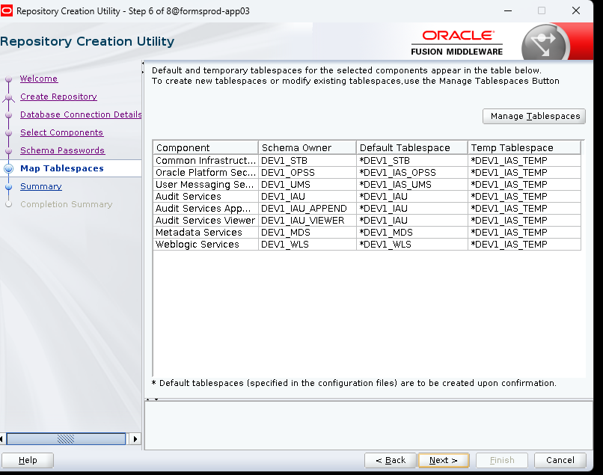
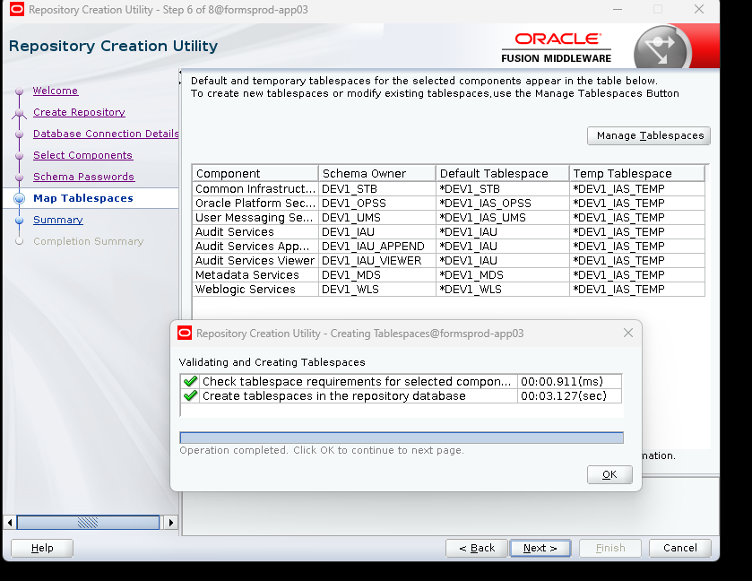
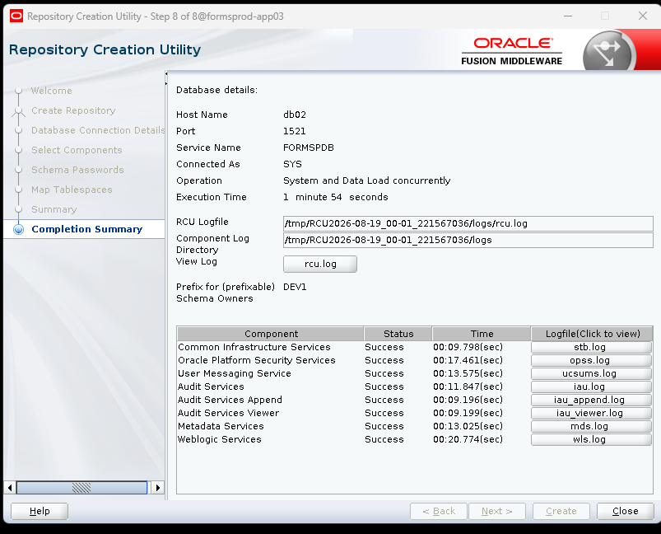

RCU is done, so we're moving to the WebLogic domain creation.
We're going to do this one screen at a time.
1. Back at oracle@formsprod-app03
Run:
whoami
Then:
source ~/.bash_profile
Verify:
echo "JAVA_HOME=$JAVA_HOME"
echo "ORACLE_HOME=$ORACLE_HOME"
java -version
We want:
JAVA_HOME=/u01/app/java/jdk-17.0.12
DOMAIN_HOME=/u01/app/oracle/config/domains/formsprod
2. Set the GUI display
export DISPLAY=127.0.0.1:0.0
Verify:
echo "$DISPLAY"
Expected:
127.0.0.1:0.0
3. Launch the WebLogic Configuration Wizard
Run:
cd /u01/app/oracle/product/fmw_14.1.2/oracle_common/common/bin
Then:
./config.sh
That should open the Fusion Middleware Configuration Wizard on your Windows desktop.
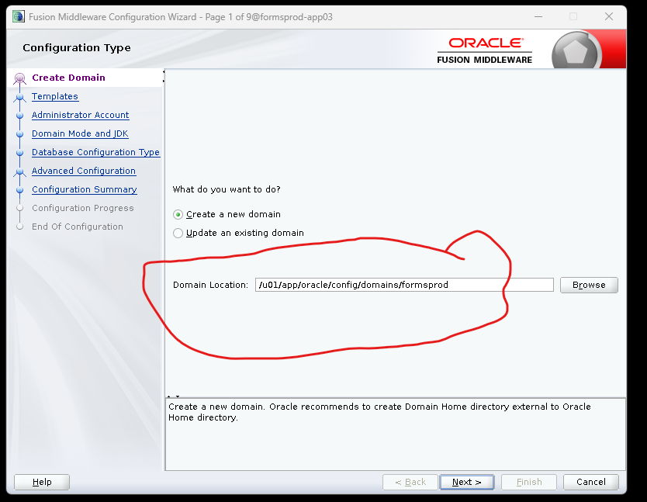
WebLogic Configuration Wizard: domain configuration
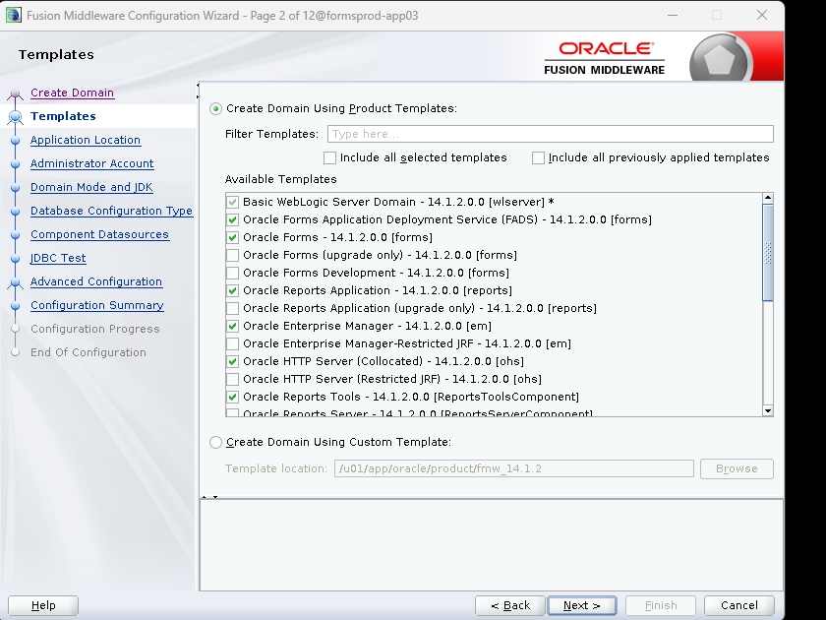
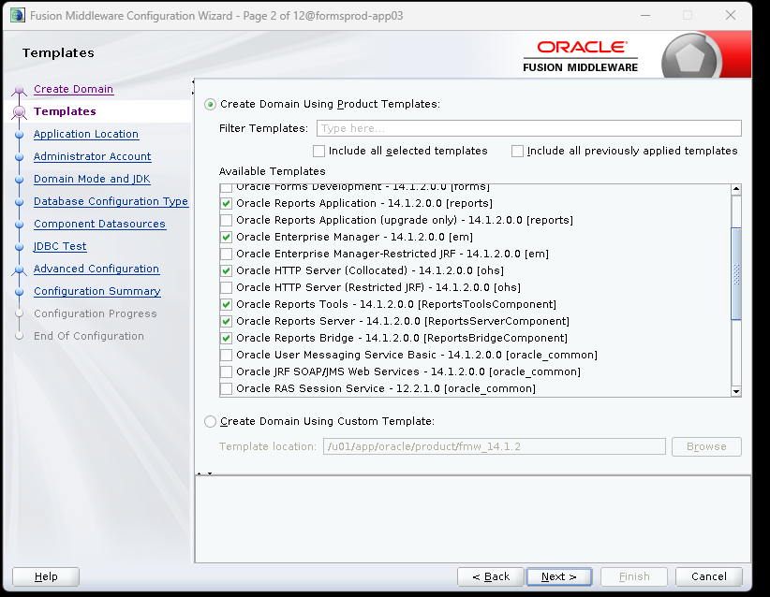
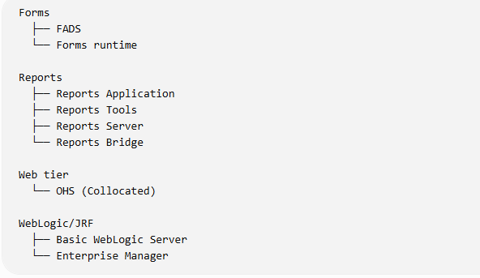
Screenshot 24 — WebLogic Configuration Wizard: domain configuration
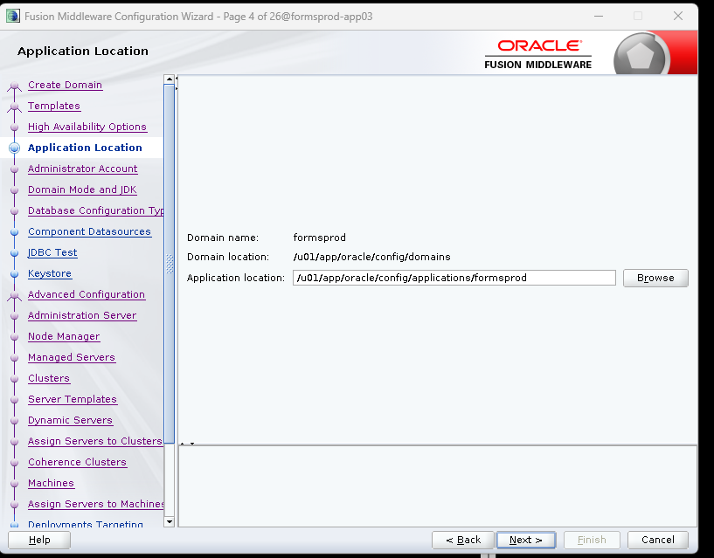

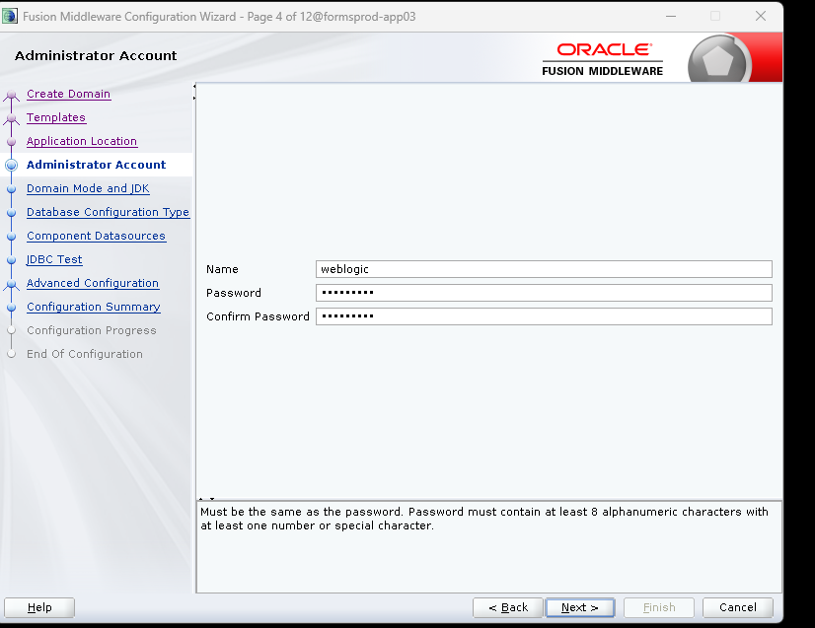
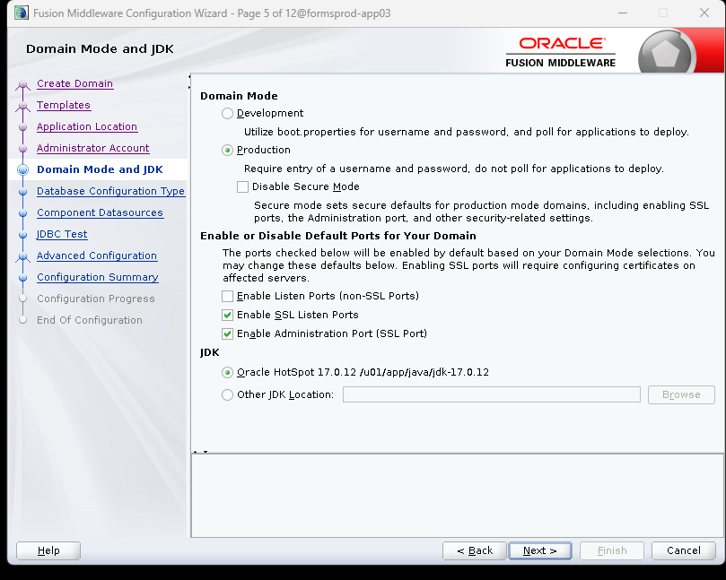
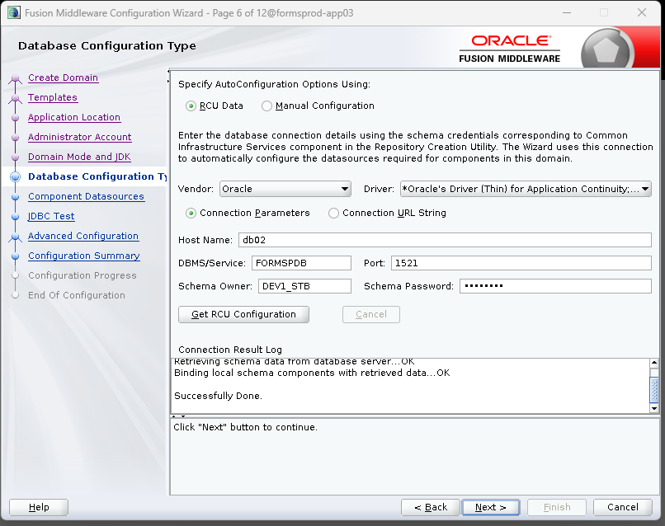
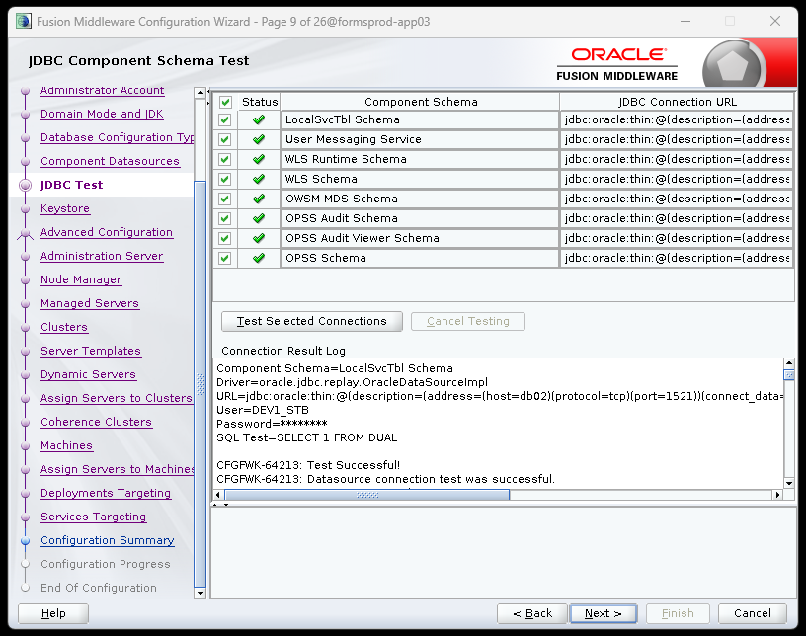
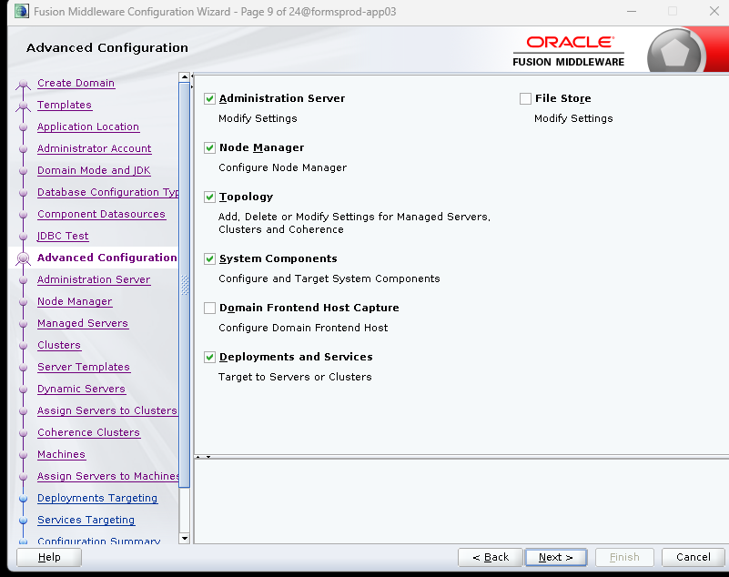
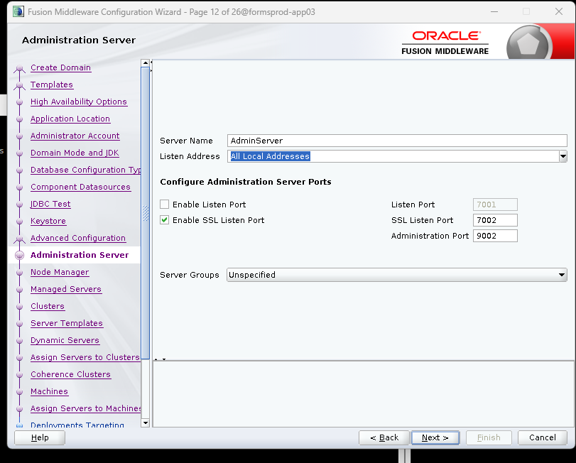
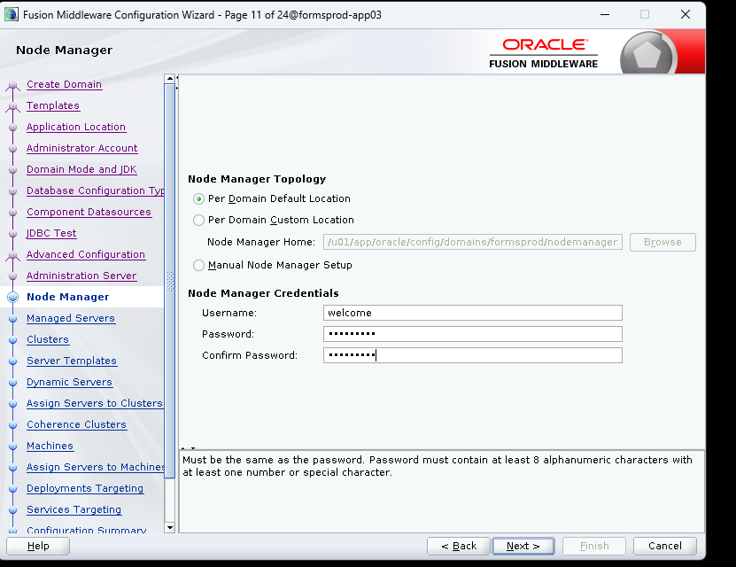
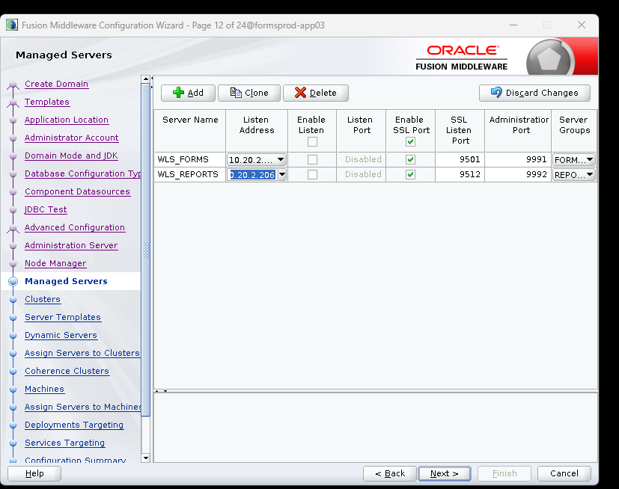
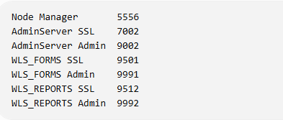
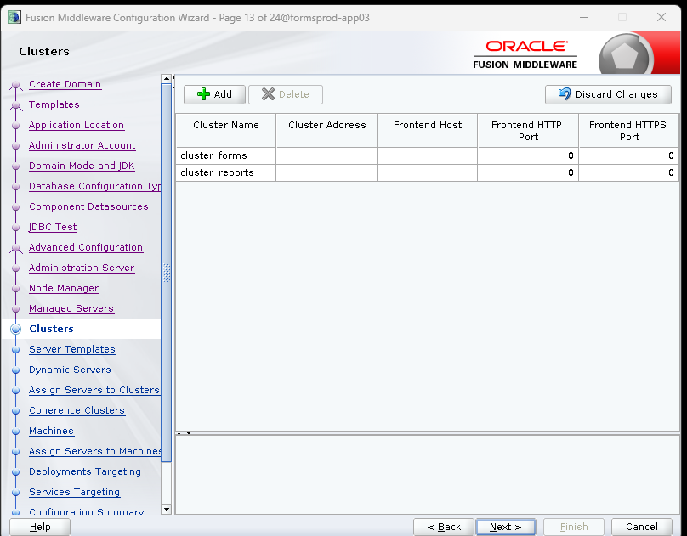
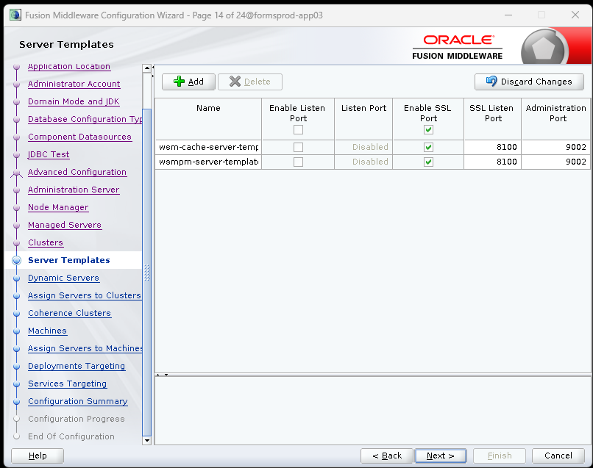
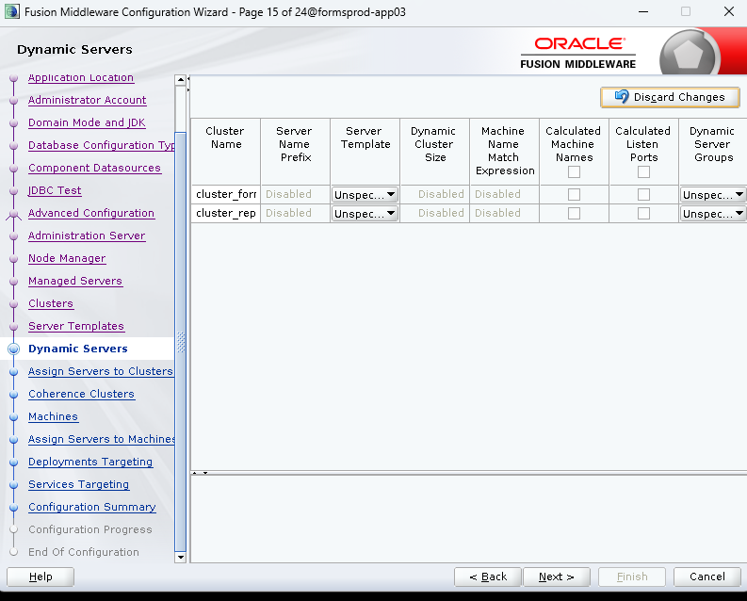
Screenshot 37 — WebLogic Configuration Wizard: domain configuration
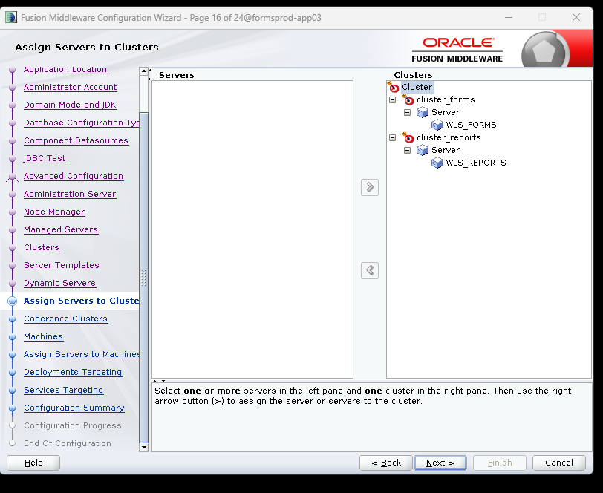
Screenshot 38 — WebLogic Configuration Wizard: domain configuration
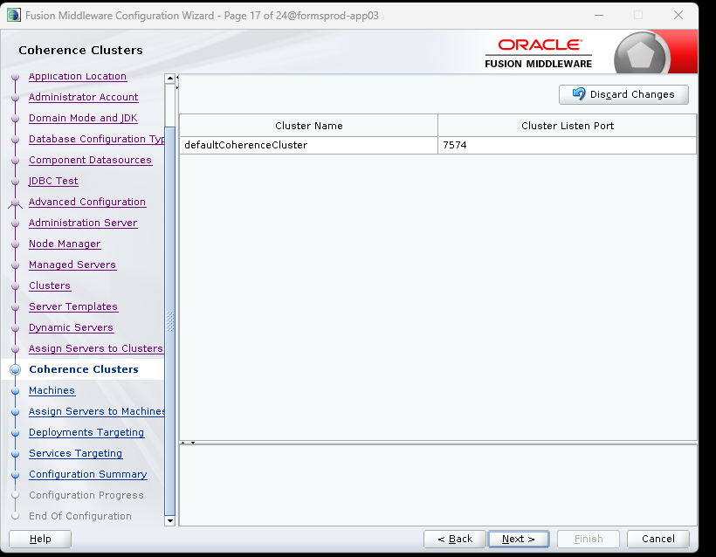
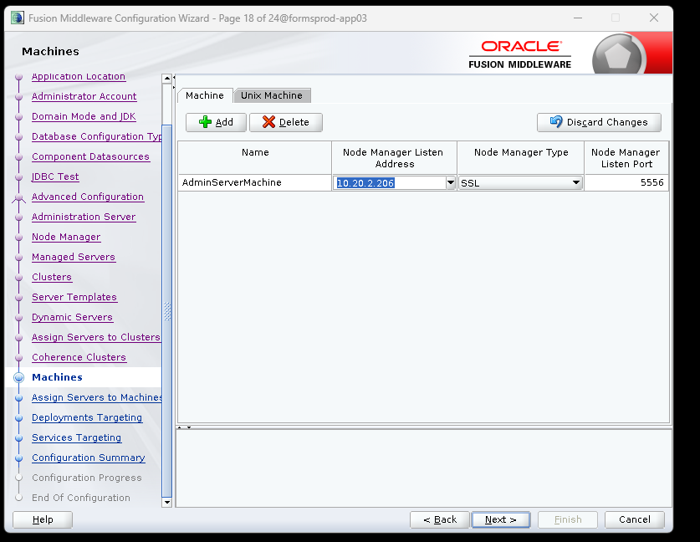
Screenshot 40 — WebLogic Configuration Wizard: domain configuration
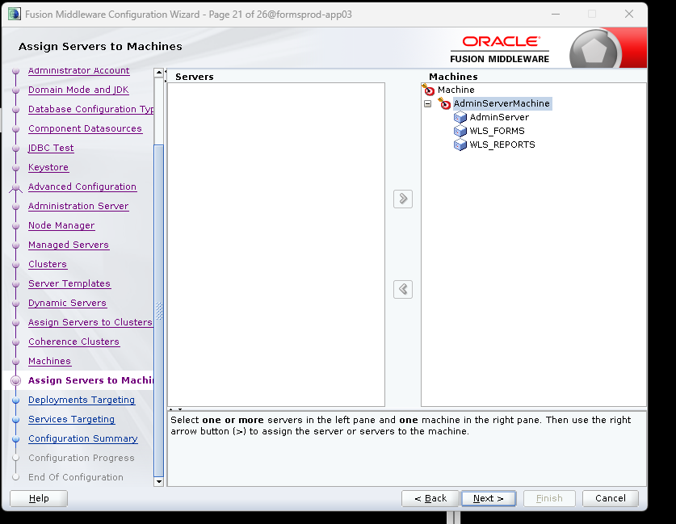
Screenshot 41 — WebLogic Configuration Wizard: domain configuration
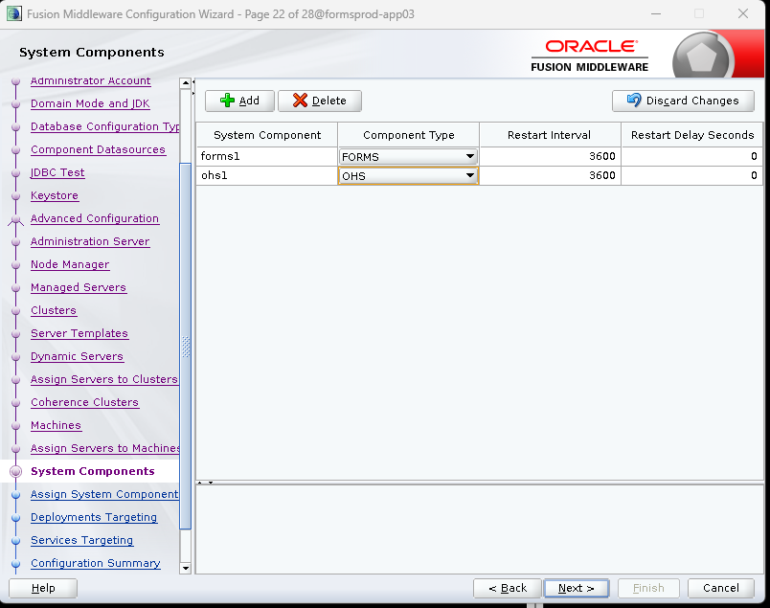
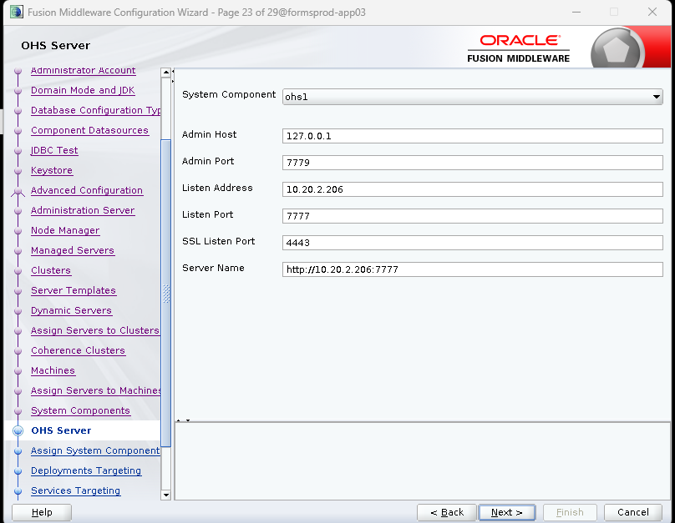
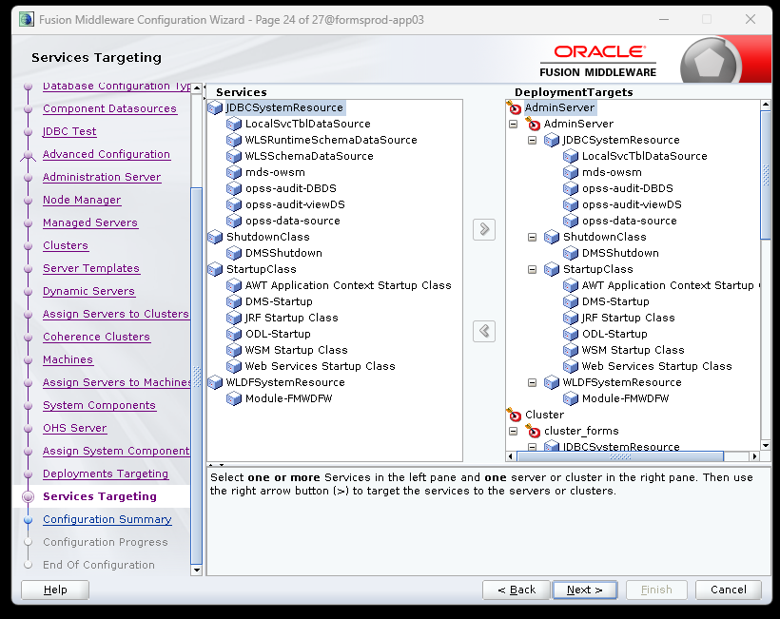
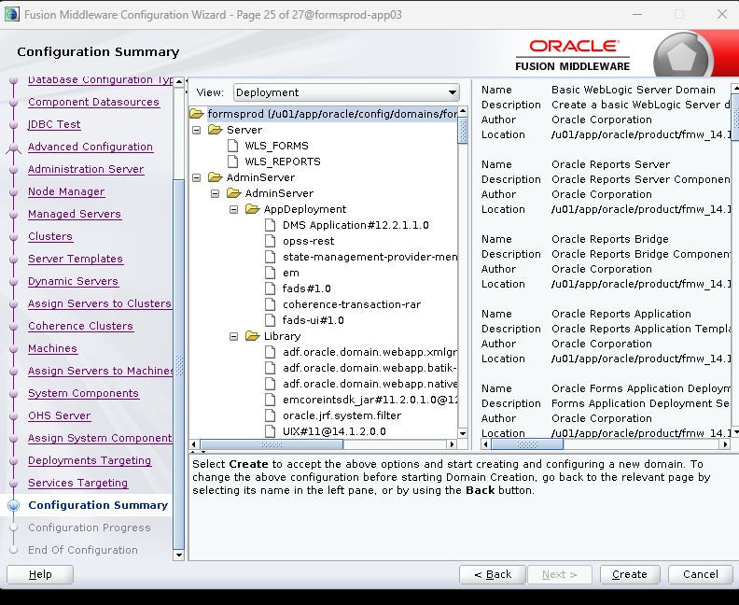
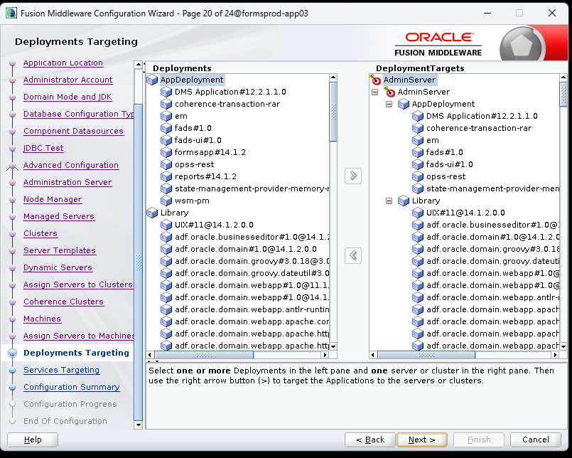
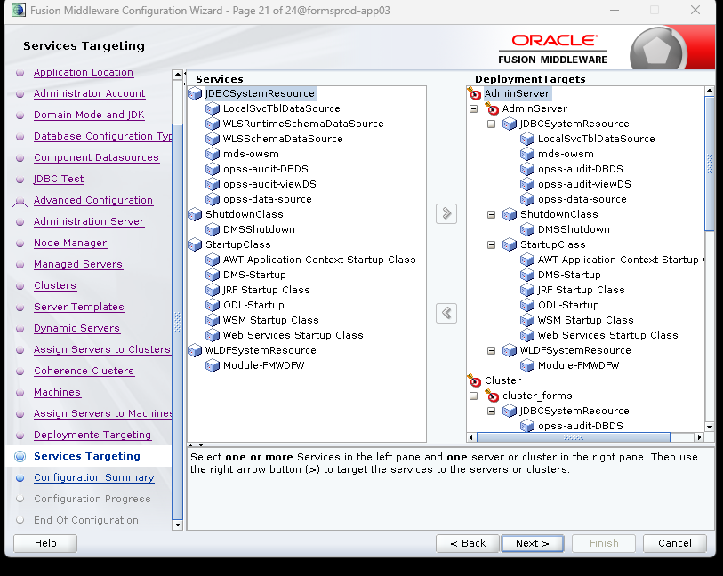

Screenshot 47 — WebLogic Configuration Wizard: domain configuration
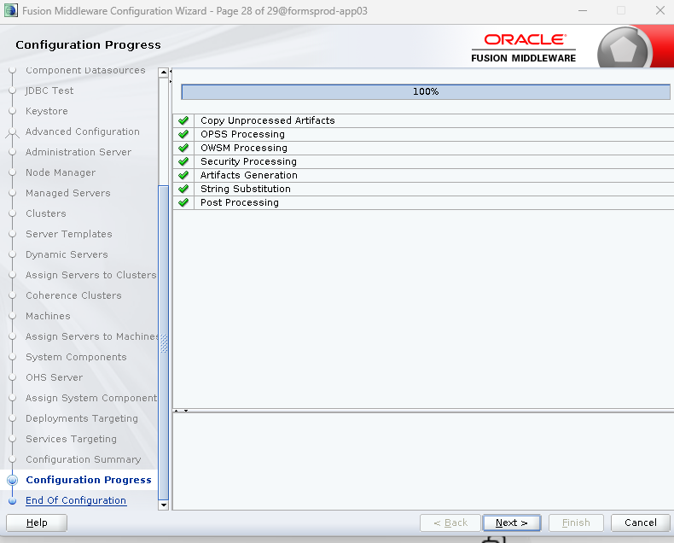

Validate DOMAIN_HOME and environment
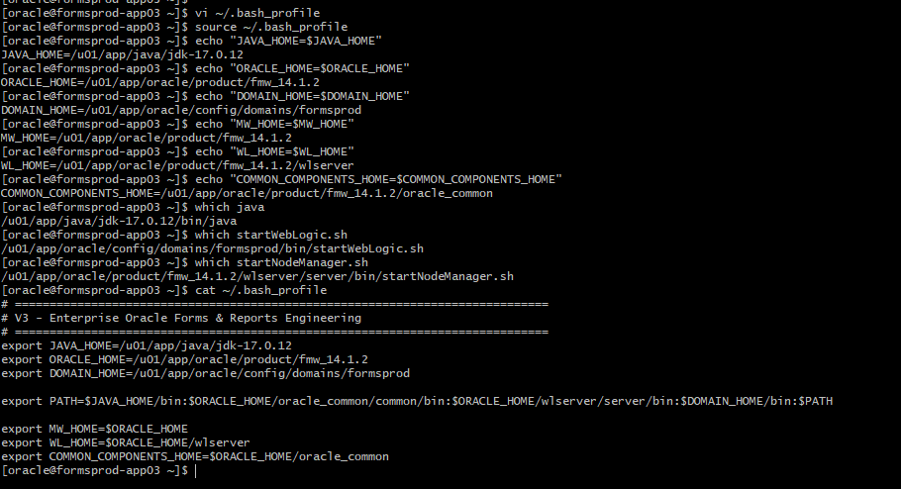
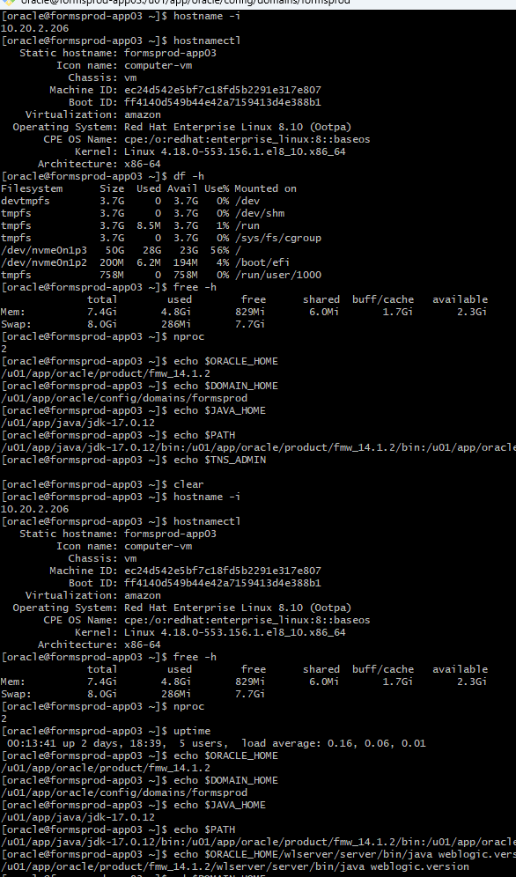

Node Manager configuration properties
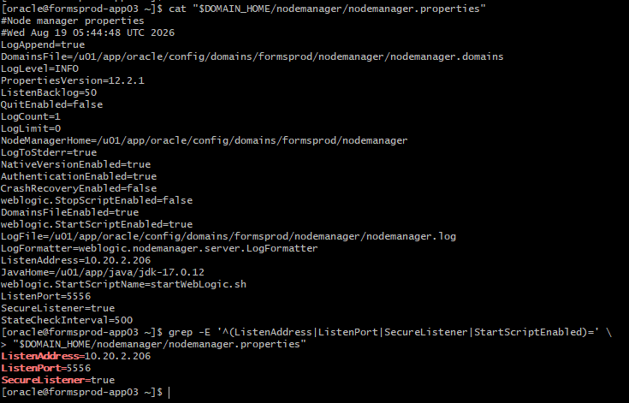

Node Manager started and listening on port 5556
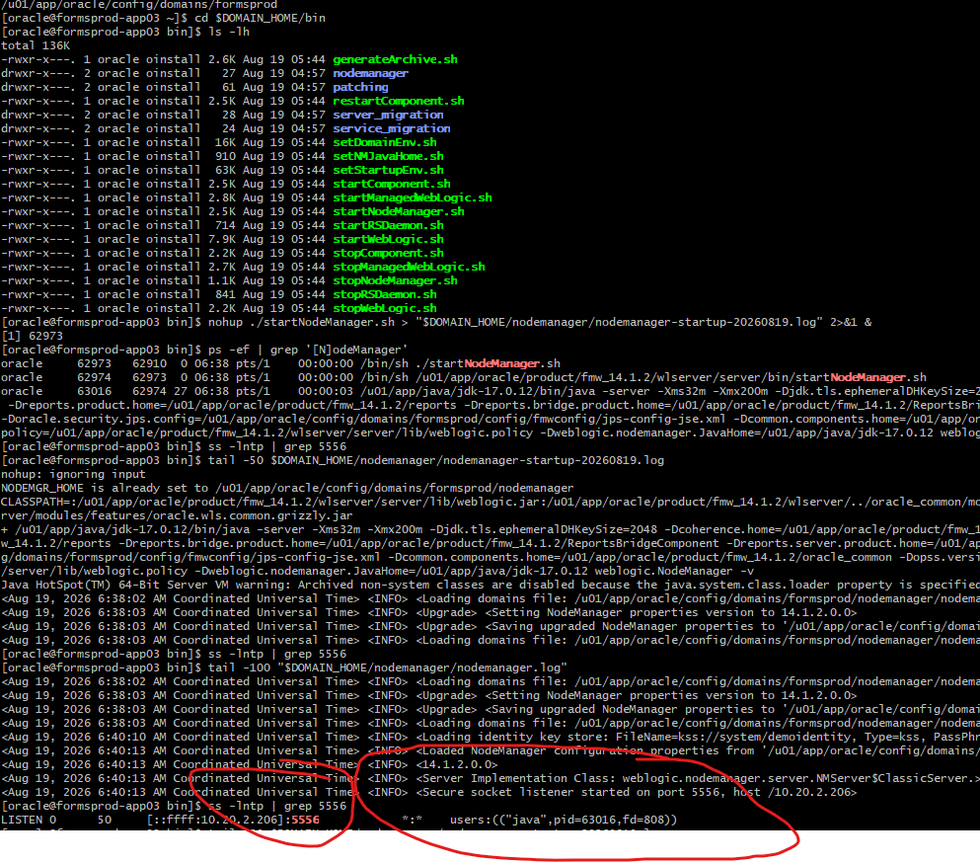

Start Admin Server
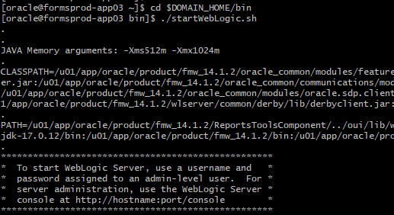
AdminServer reached RUNNING state
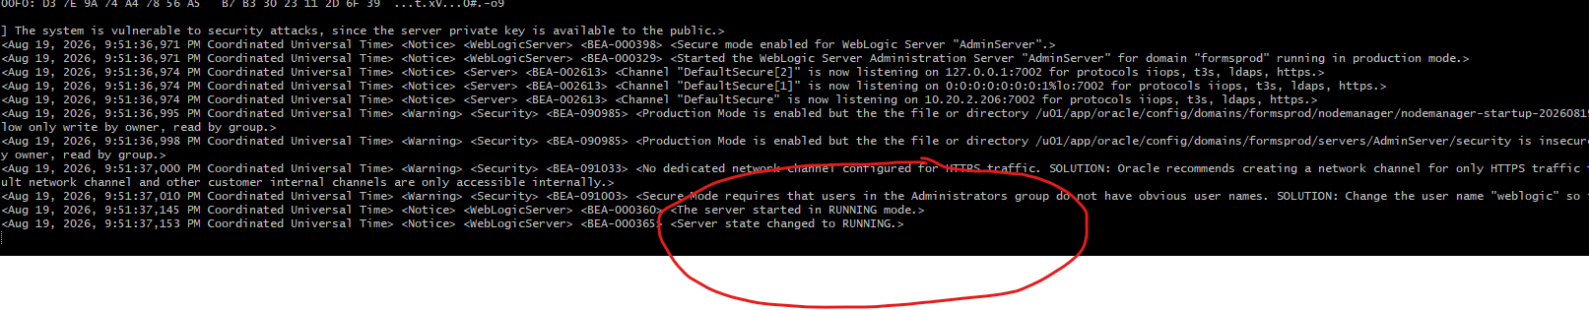

AdminServer process and WebLogic listener validation
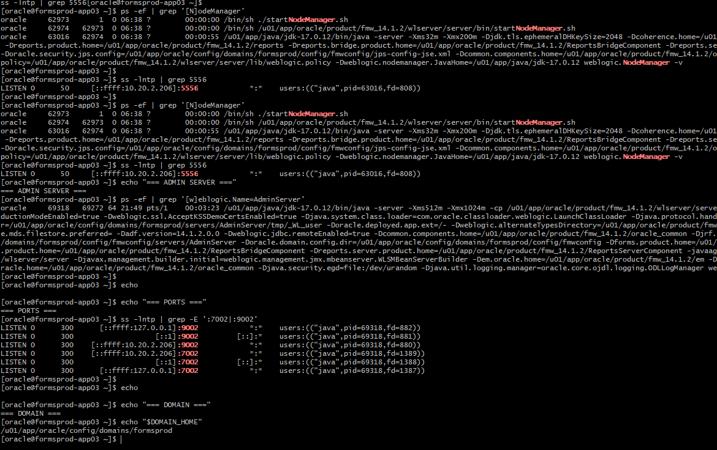
WebLogic Remote Console connection provider for formsprod-app03
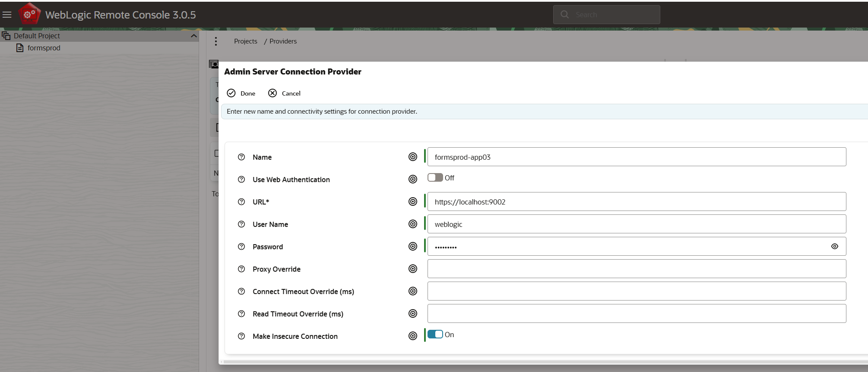

Start WLS_FORMS:
Node Manager connection and WLS_FORMS startup validation
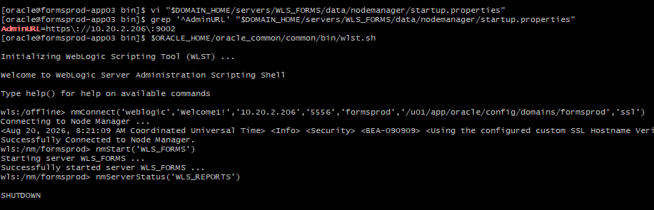
WLS_REPORTS startup.properties updated with AdminURL
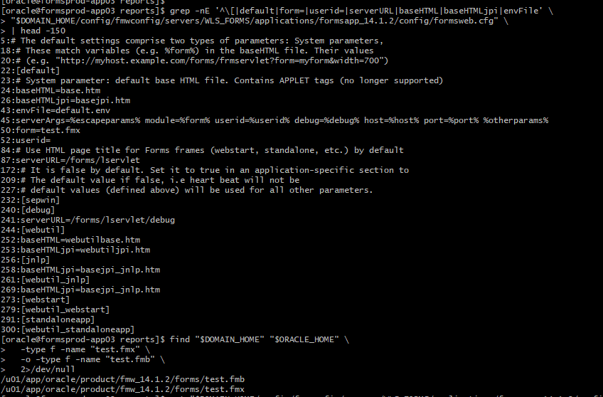

Create the Reports Tools instance using WLST
Reports Tools instance created and Reports directories initialized
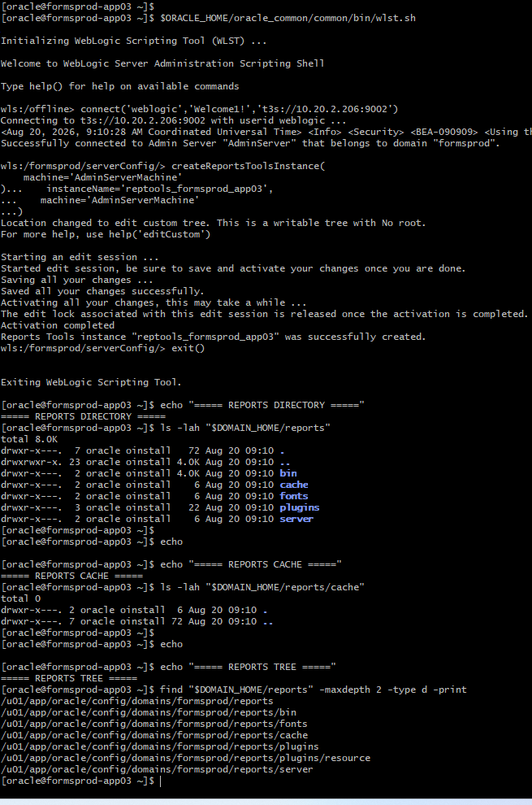
Restart Report server after creating report:
WLS_REPORTS successfully restarted and RUNNING
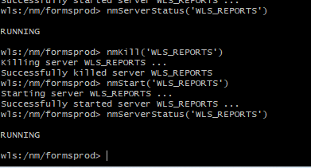

JPS policy store backup and pre-policy inspection
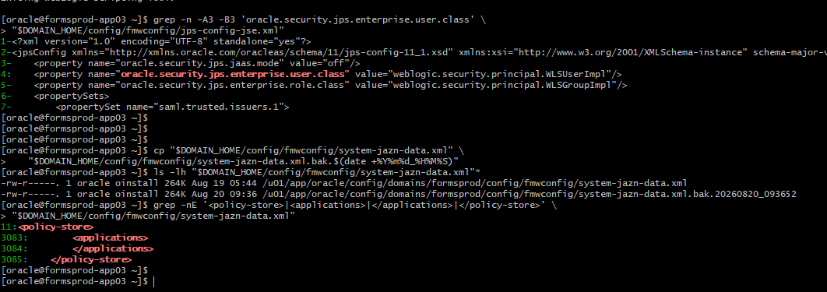

Insert Oracle Reports policy
Oracle Reports JPS policy inserted successfully
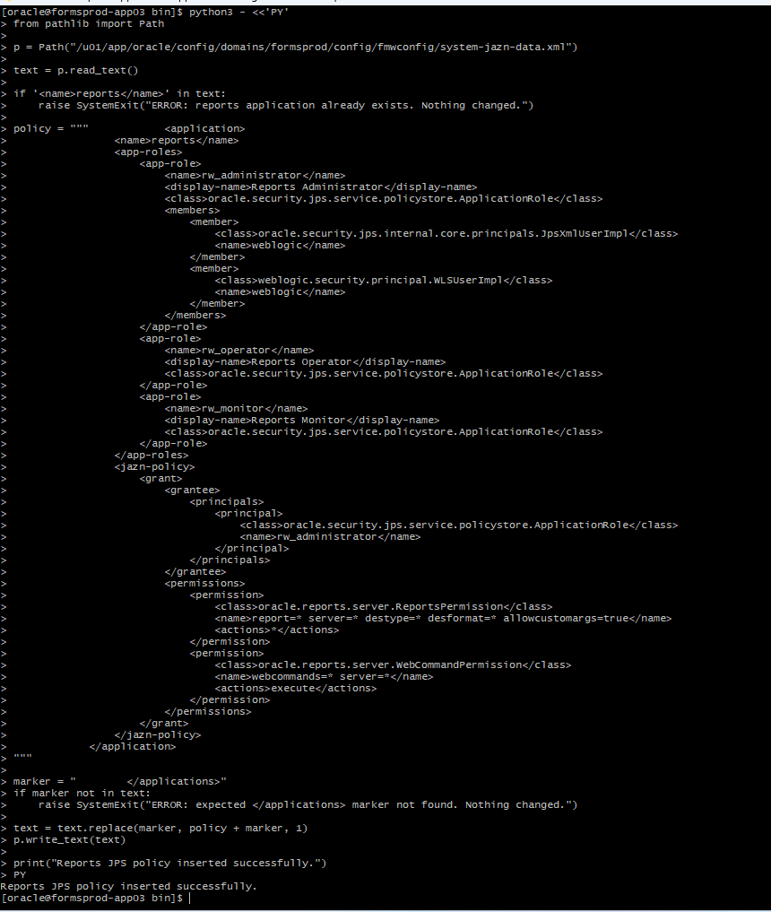

Reports application role and permissions verified in JPS policy
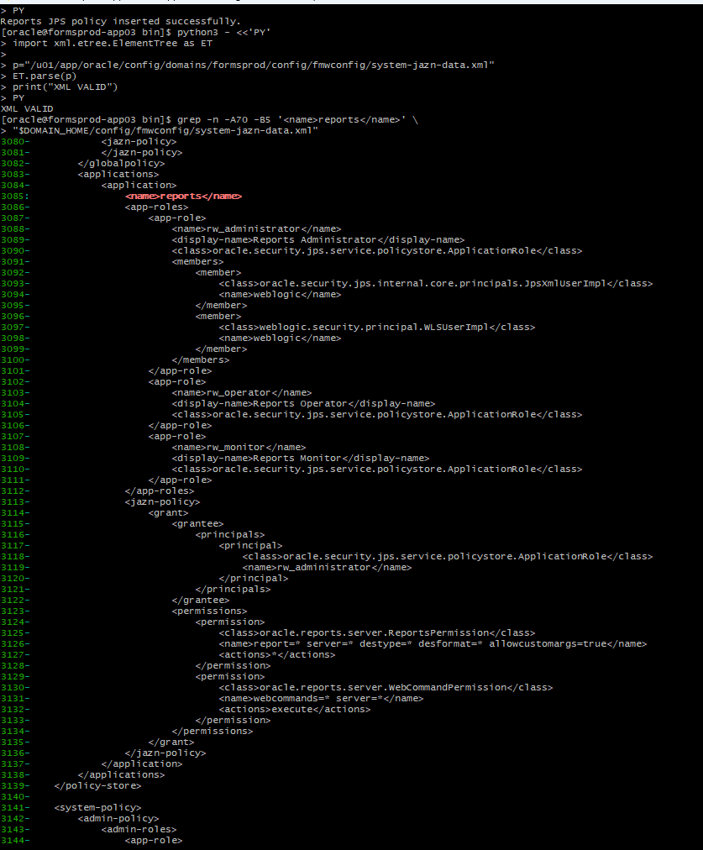

Continuation of verified Reports JPS policy
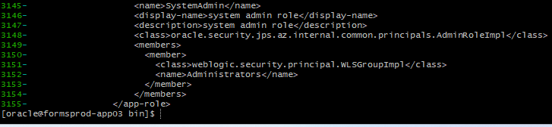
Restart reports server after Inserting the Oracle Reports policy
WLS_REPORTS successfully started through Node Manager
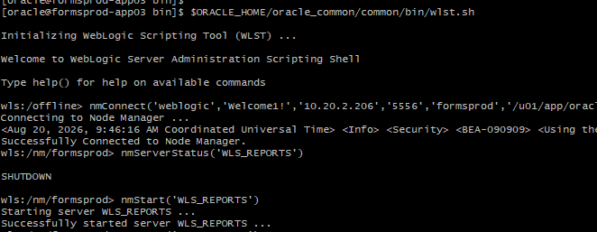
Reports runtime directories:
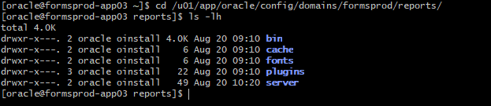

Resolved Oracle Reports authorization issue by assigning the WebLogic weblogic user to the Reports RW_ADMINISTRATOR application role in the OPSS policy store and validating successful authenticated access to /reports/rwservlet/showenv.
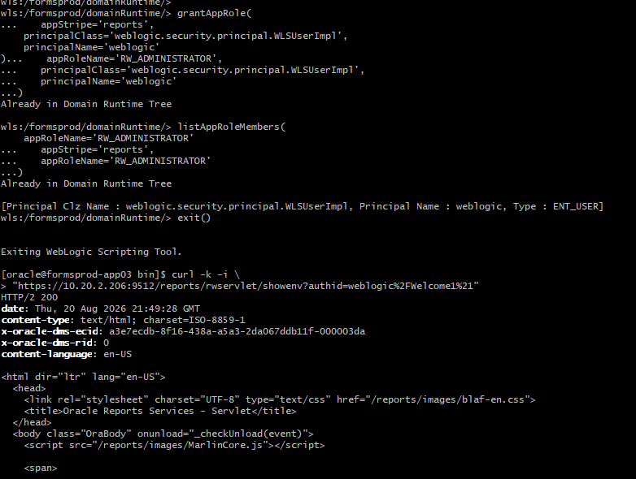
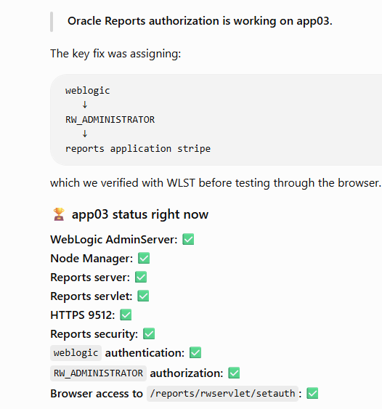
Validate Forms servlet:
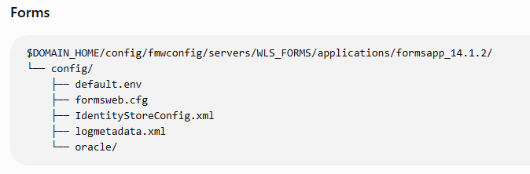
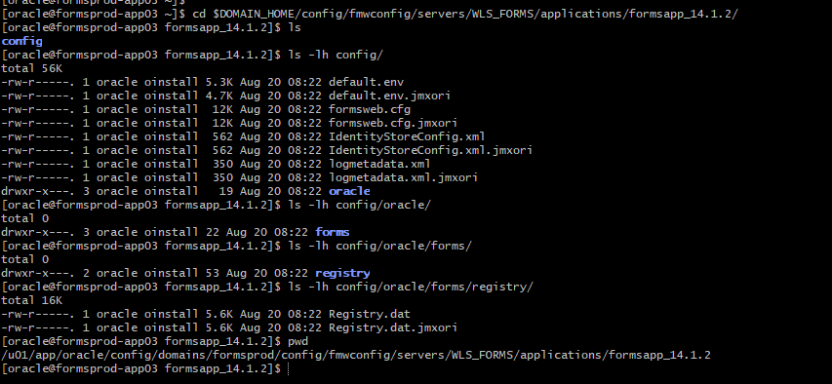

Oracle Forms Product Installation and Configuration Templates for Development by Developers:
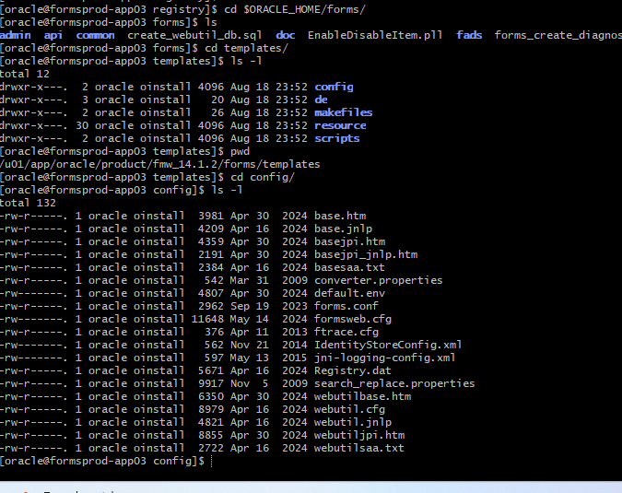

Validate Reports Servlet:
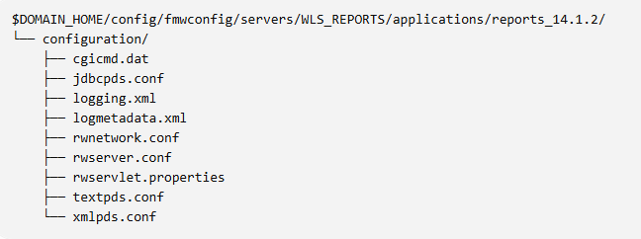
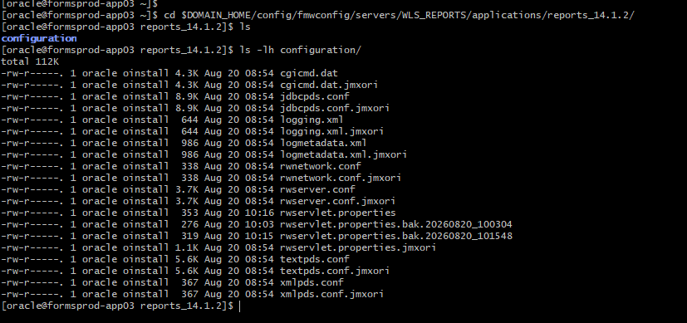
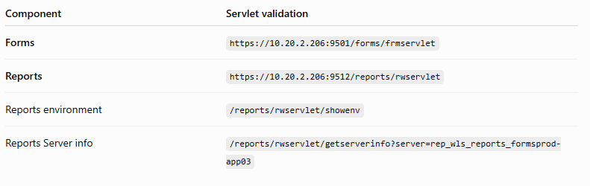
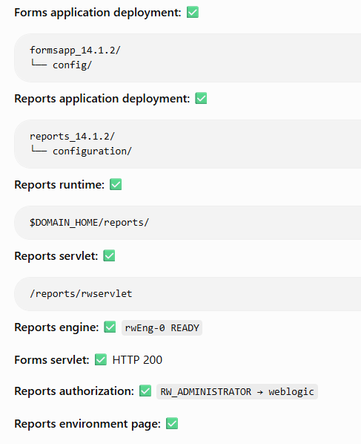

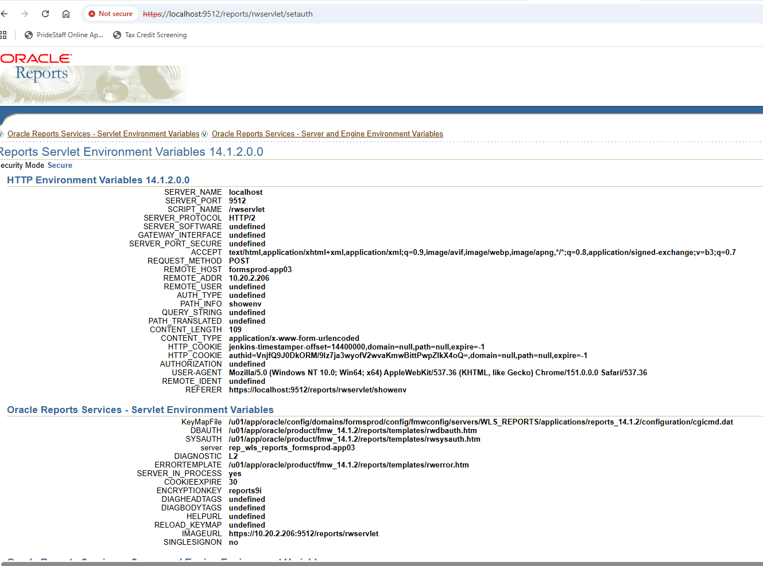

end-to-end Forms + Reports validation

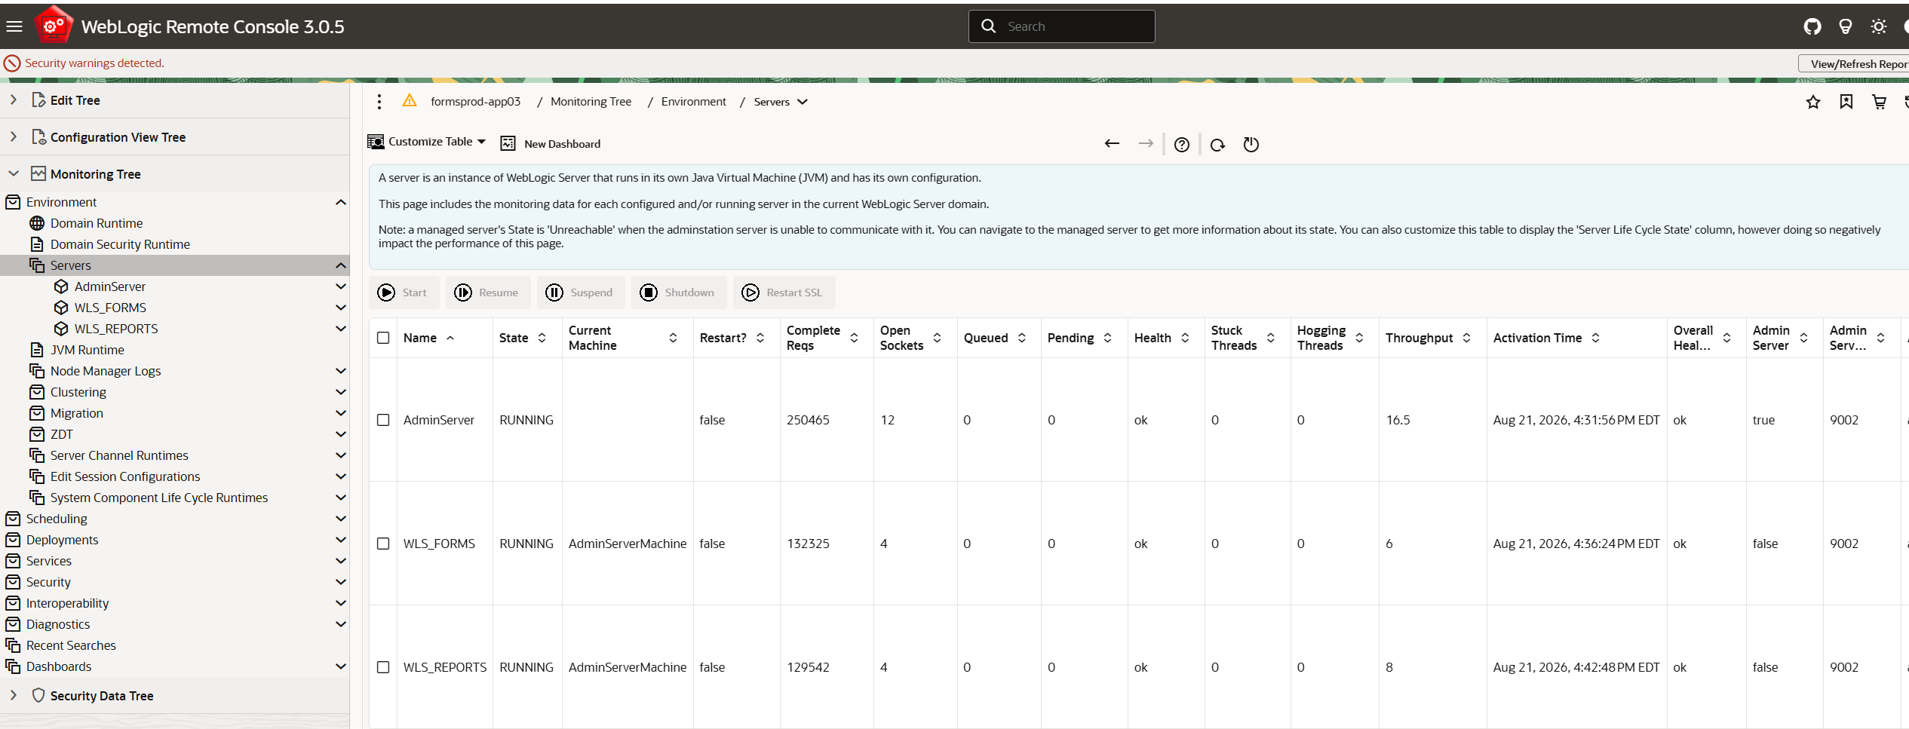
.fmb and .fmx files available
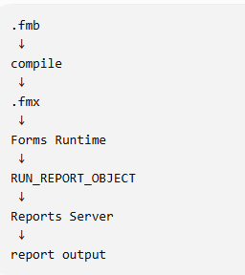

End-to-end validation:


