WeblLogic tasks automation
Created and implemented Weblogic tasks automation scripts:
1. WebLogic domain creation automated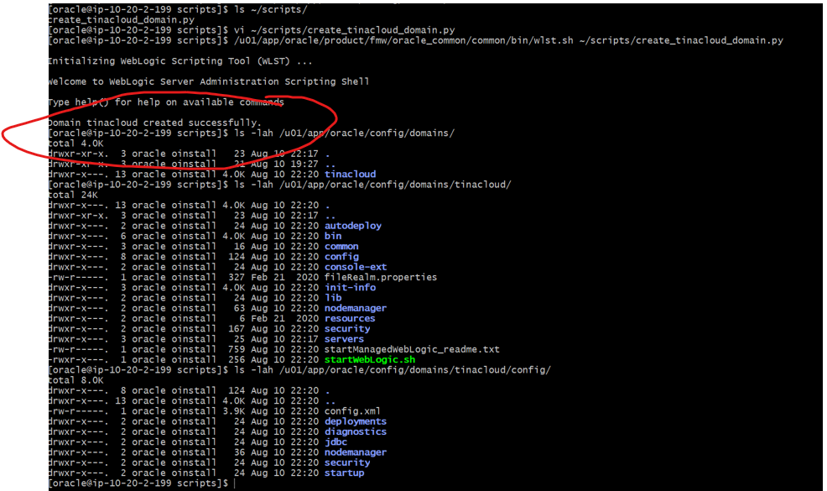
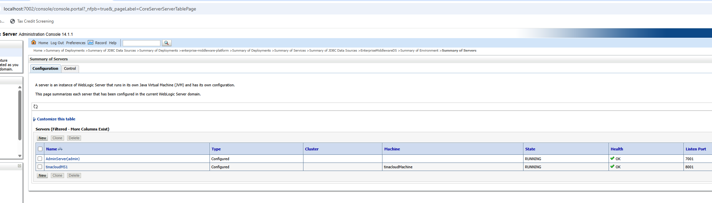
Data source creation automated:
2. EnterpriseMiddlewareDS — successfully configured, deployed, activated, and validated against Oracle Database 12.2.0.1 from WebLogic Server 14.1.1 using the Oracle JDB driver and WLST
