Oracle_12c_Installation_RMAN_Backup_validations
-Provision complete AWS infrastructure using terraform
-Install Oracle 12.2.0
-Implement rman backups

Provision remote backend s3:
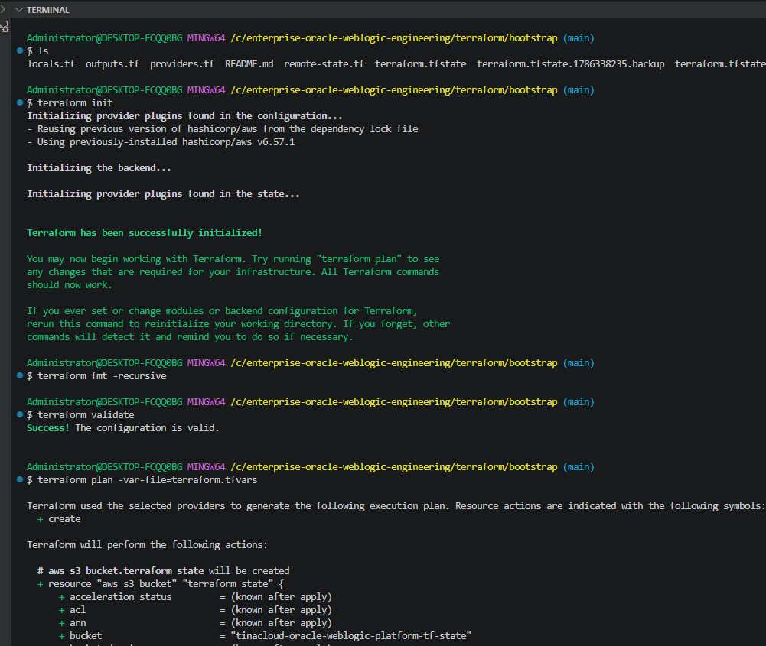

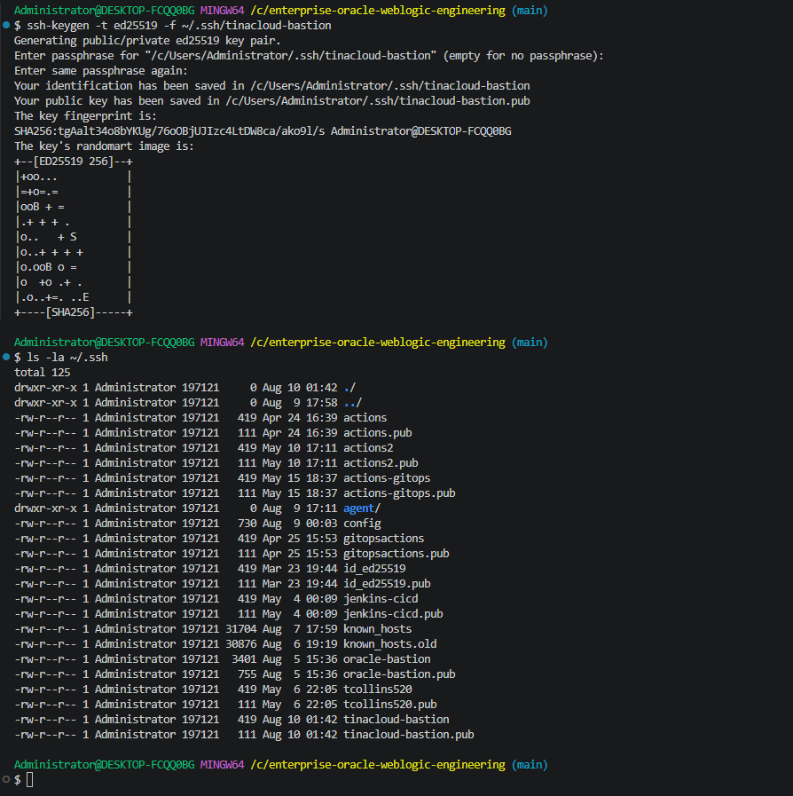
generate key pair:

Terraform plan for AWS compute and networking resources
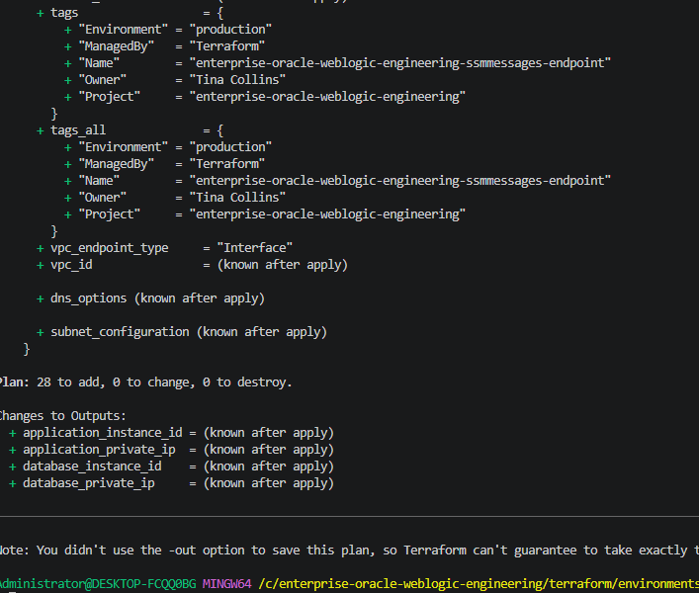

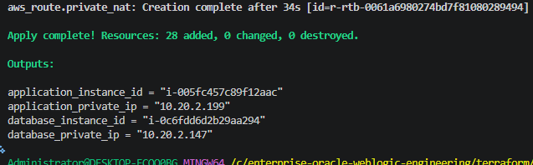

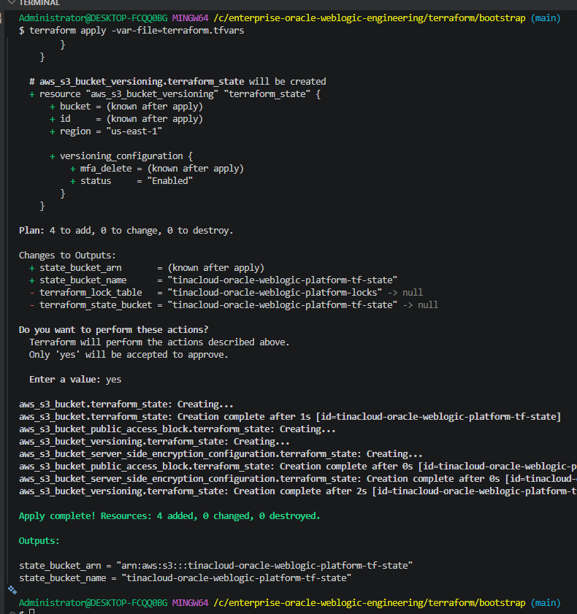

Database and app servers deployment on ec2 instances in private subnet with bastion host in public subnet
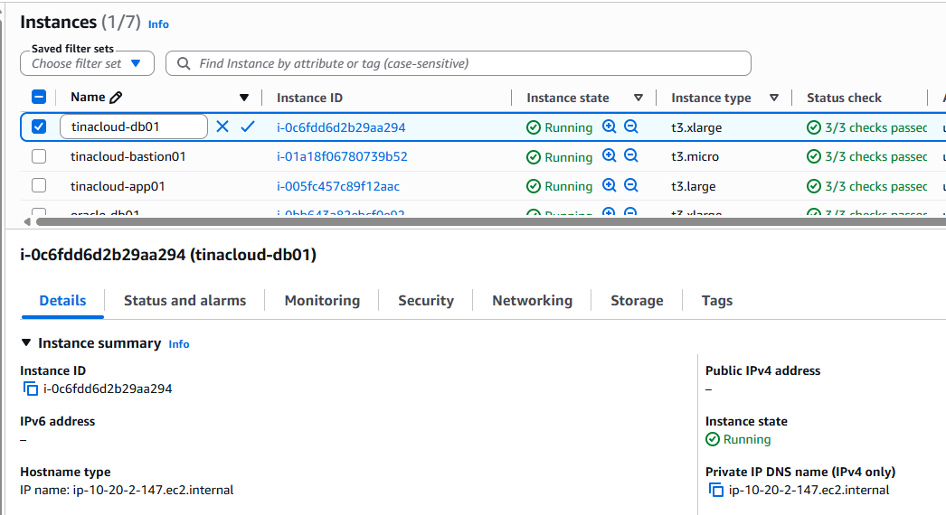

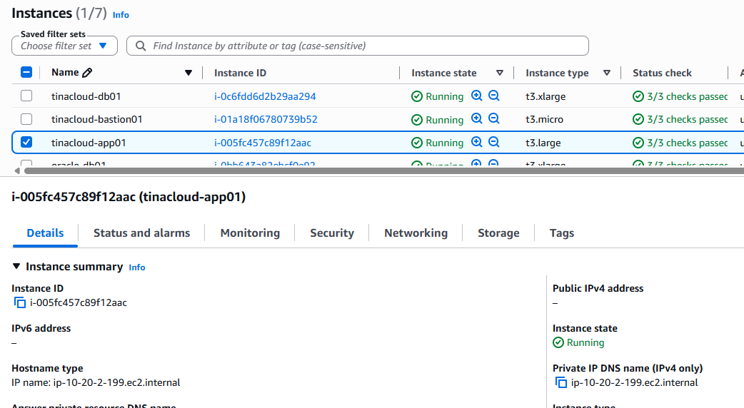

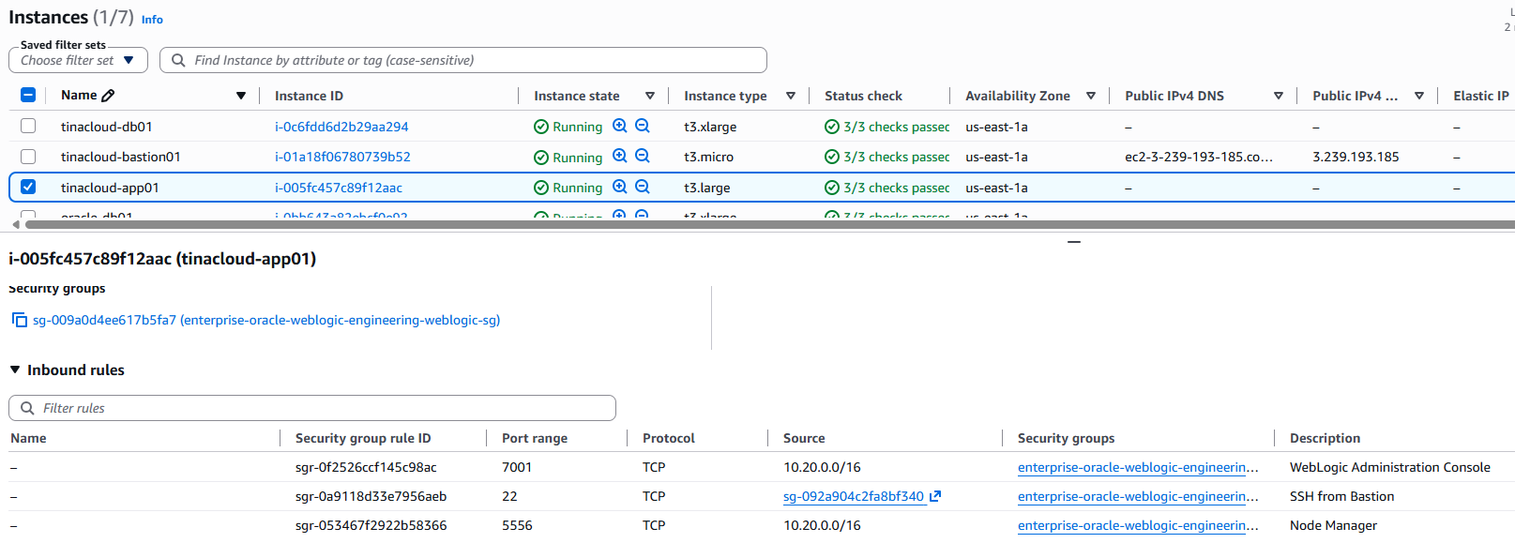
Figure 08 — Security-group configuration and access rules for the EC2 hosts
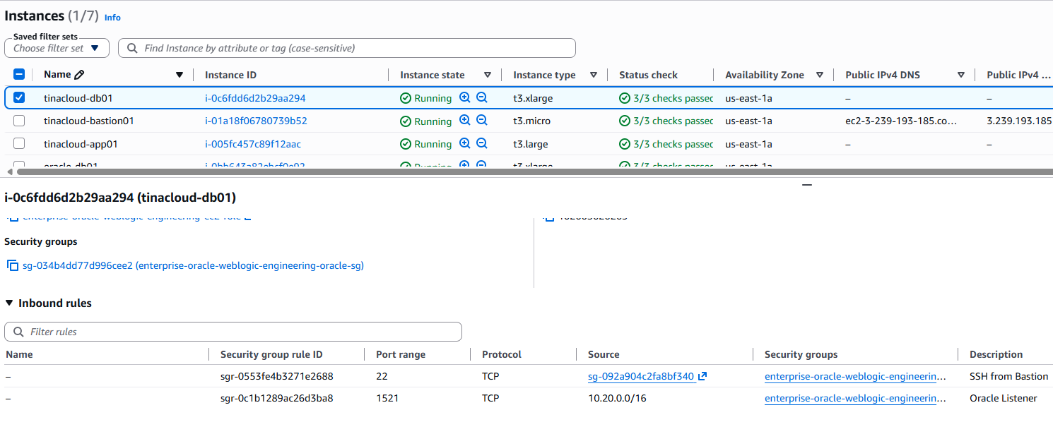

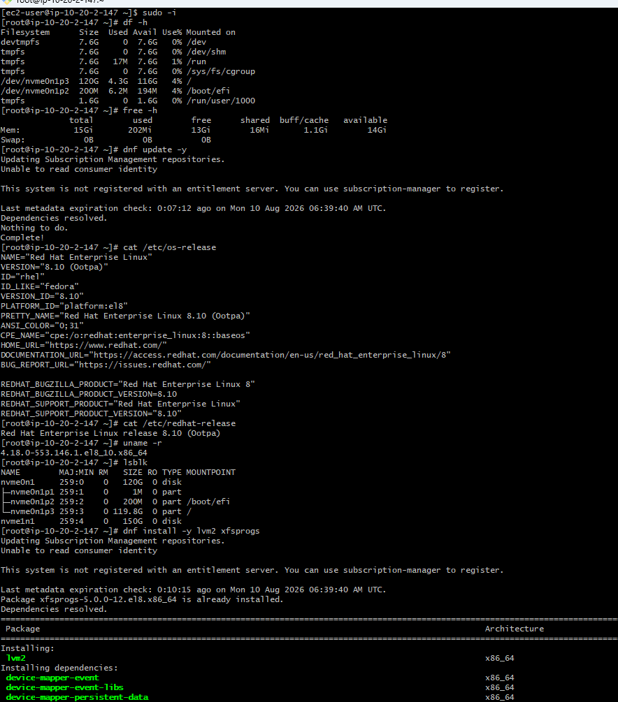

LVM provisioning for Oracle storage
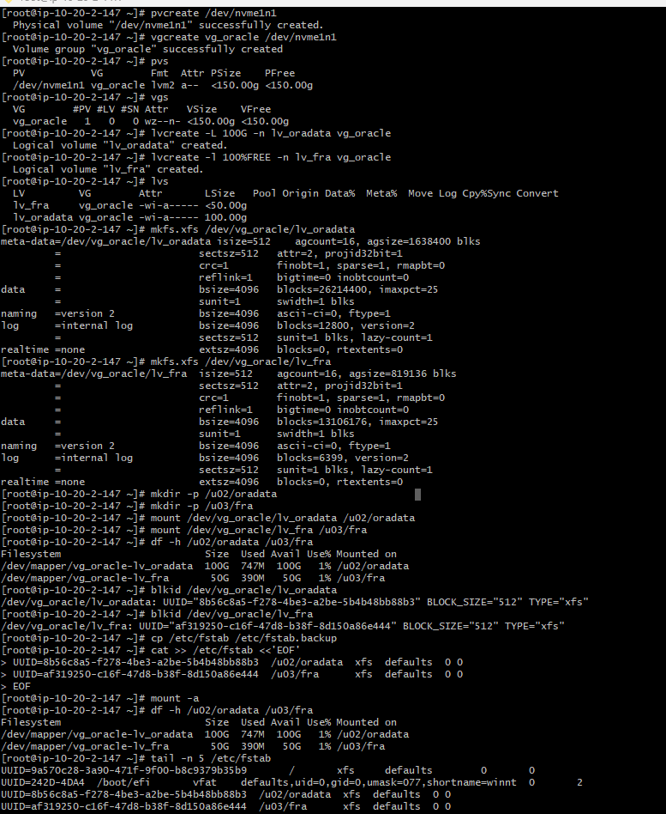

Oracle filesystem mounts and persistent /etc/fstab configuration
Swap creation and activation
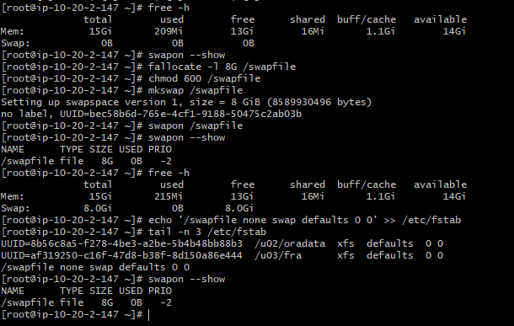

Create the Oracle data directory structure, OS groups and user, establish ownership and give permissions:
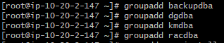

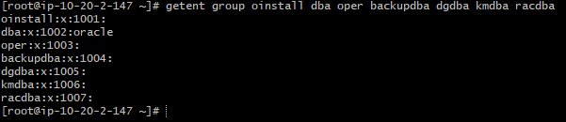

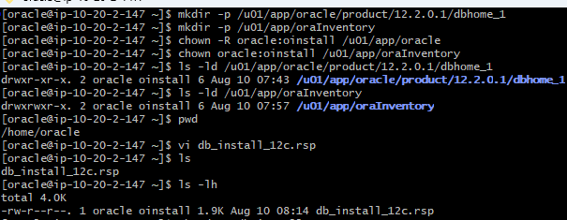

Oracle 12.2 software staging
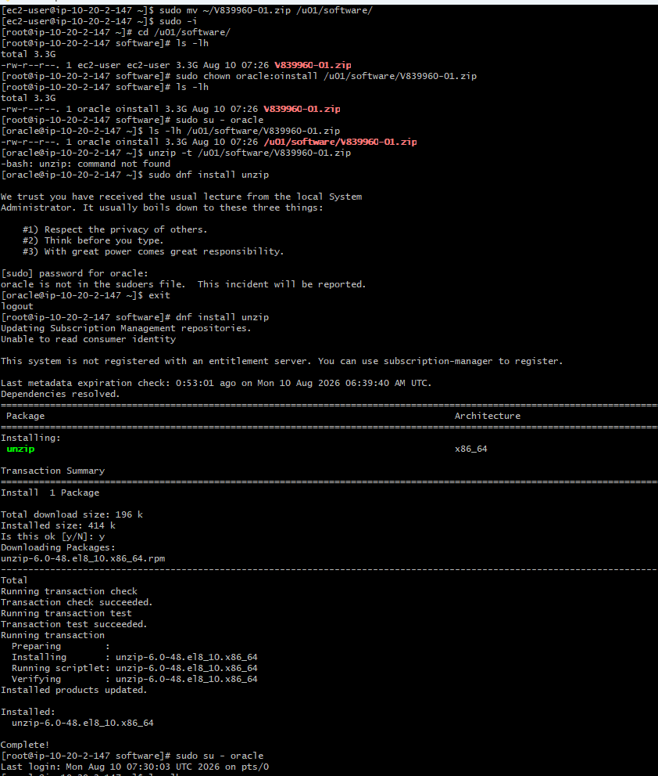

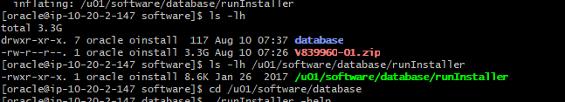
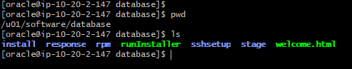
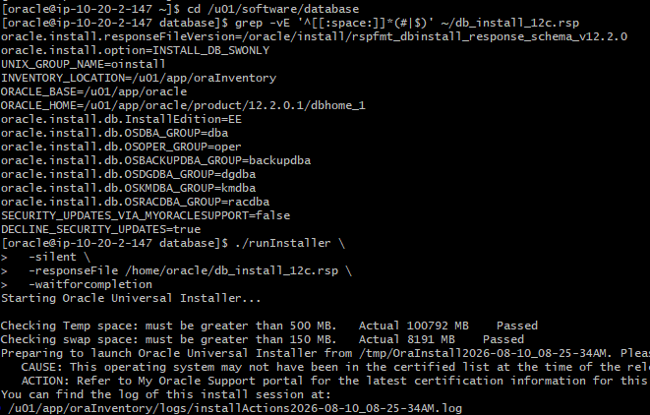

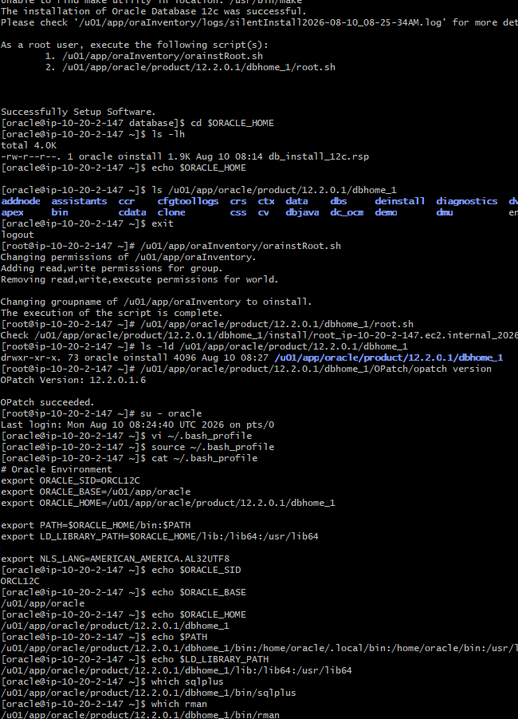
Configure oracle networking: listener and tnsnames.ora
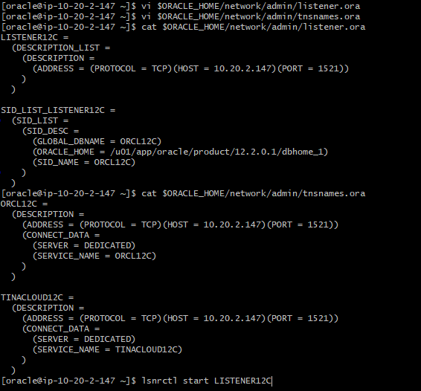
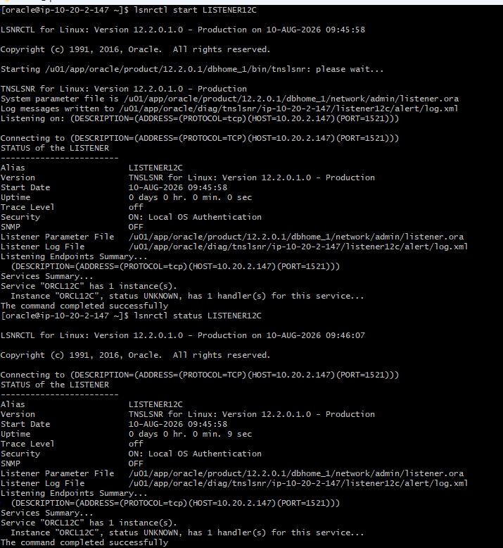

Database creation and PDB verification
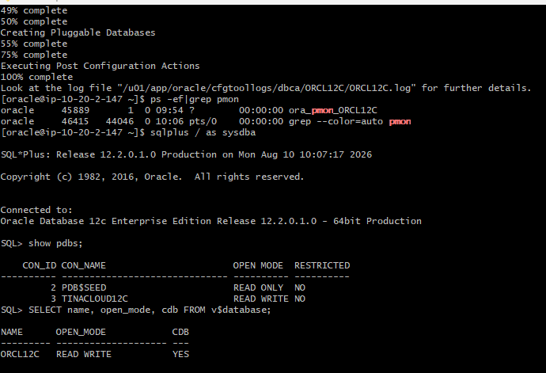

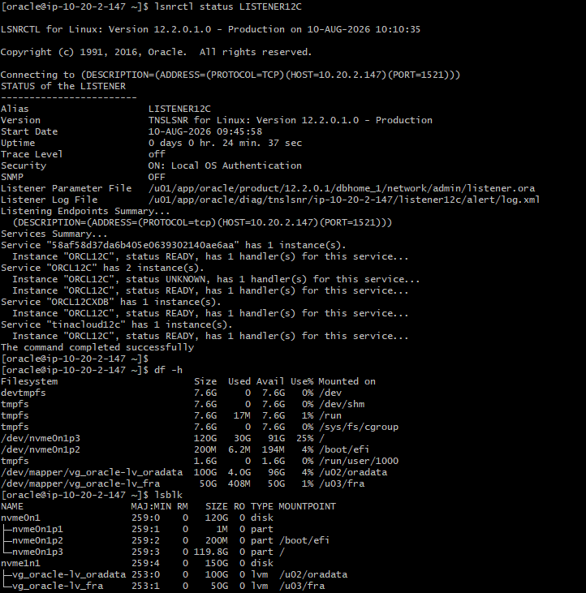
Figure 24 — RMAN backup directory creation and filesystem capacity check

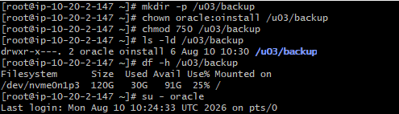

Enable ARCHIVELOG mode and configure the Fast Recovery Area
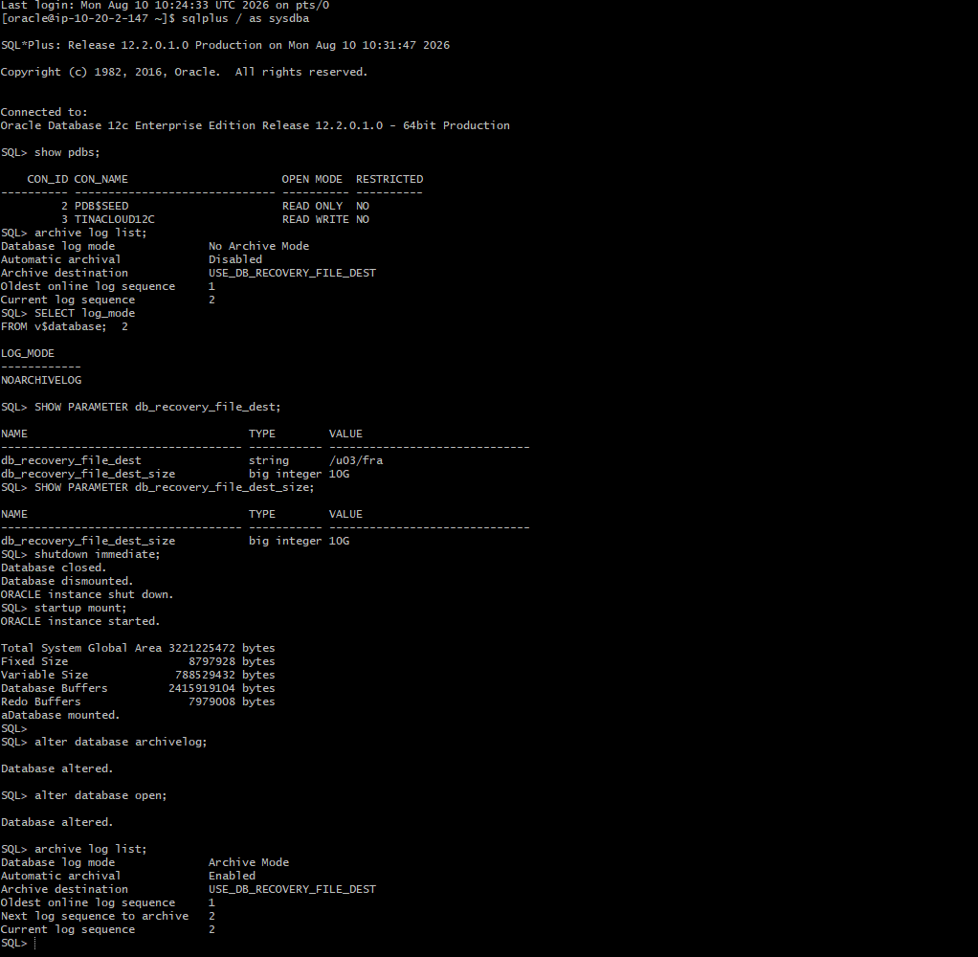

Force log switch and verify archived redo generation
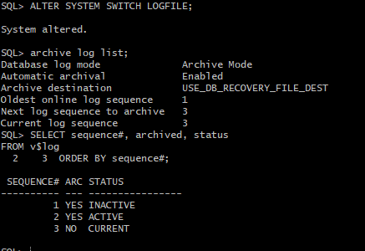

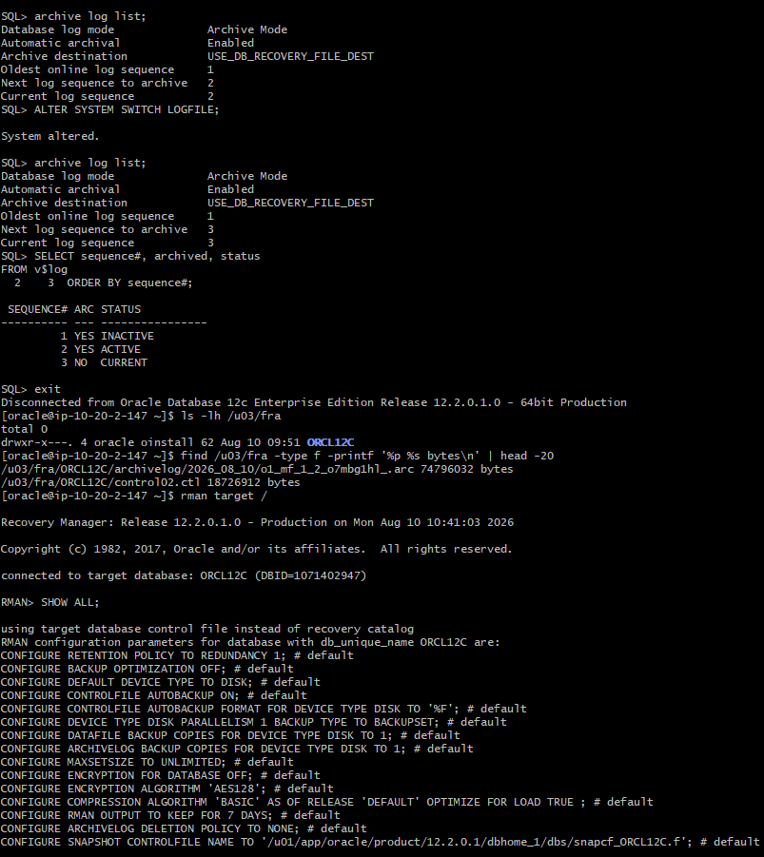

RMAN retention, backup optimization, and archive-log deletion policy
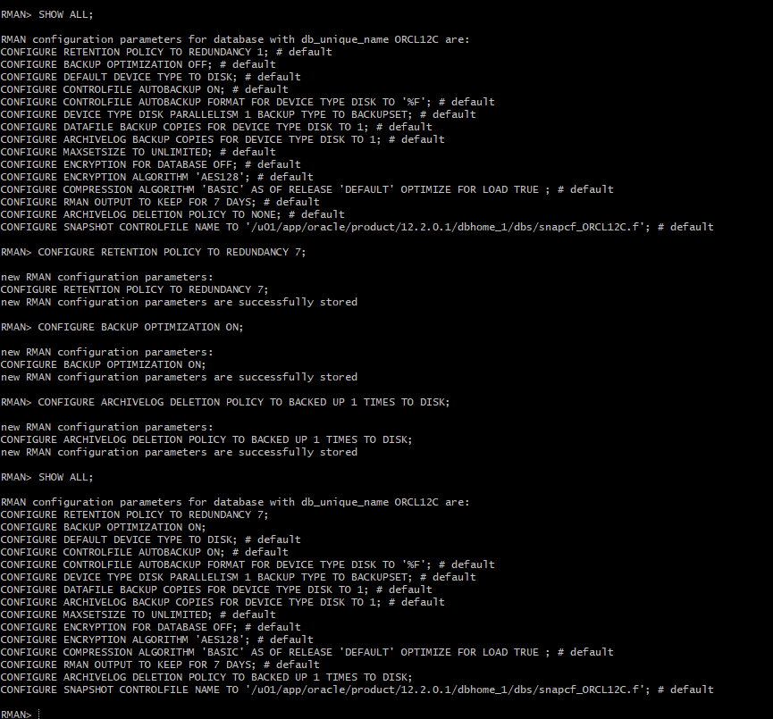

RMAN backup script deployment
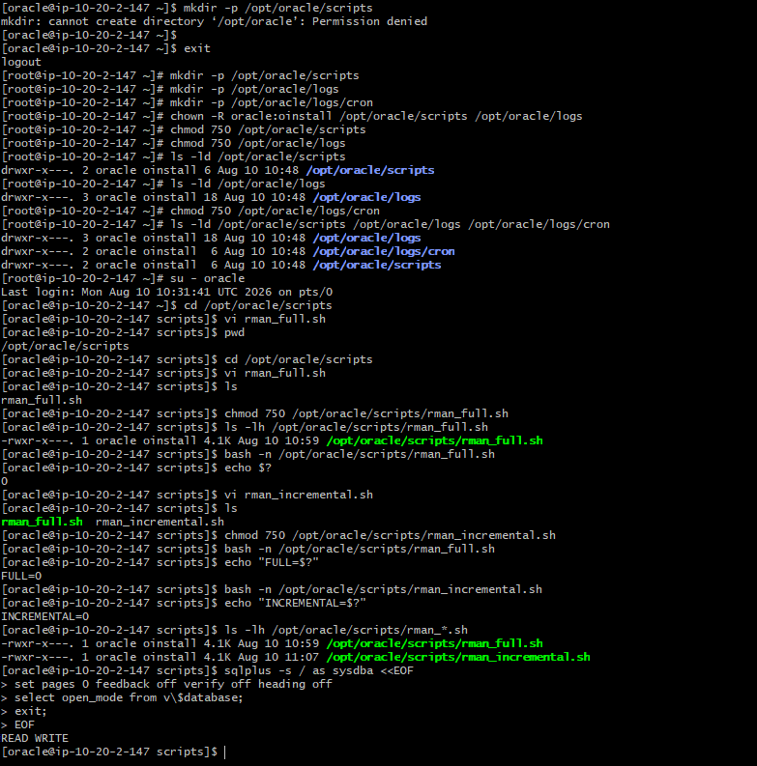

RMAN Level 0 full backup execution

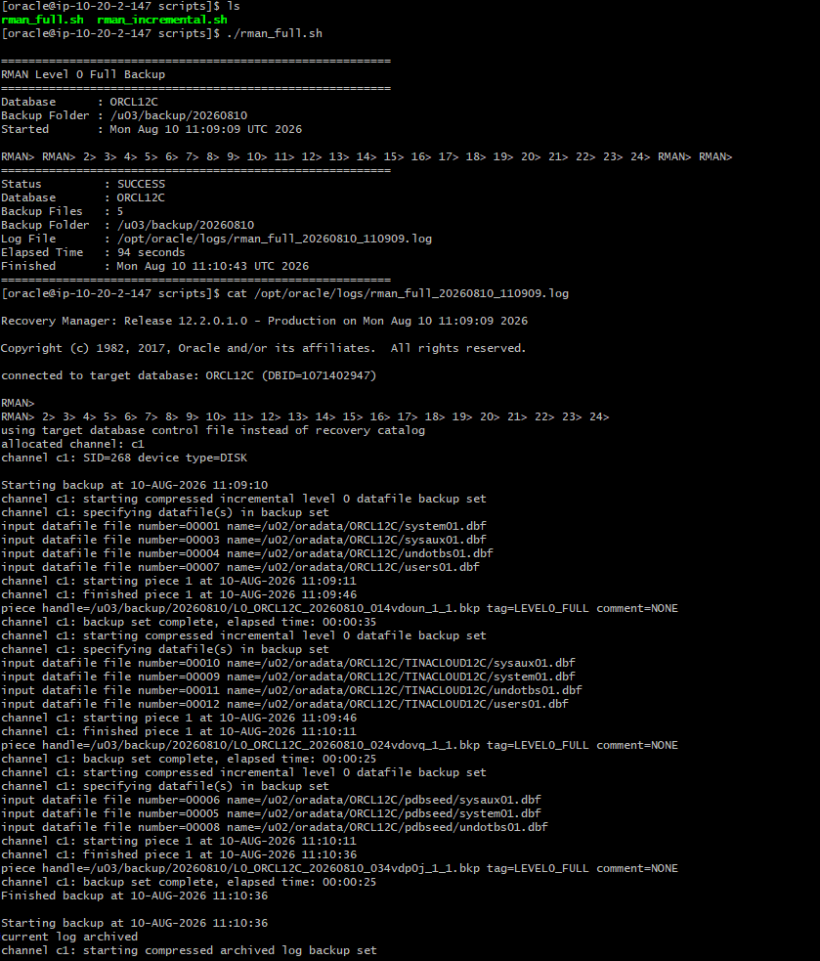

RMAN Level 0 backup completion, backup inventory, and backup files 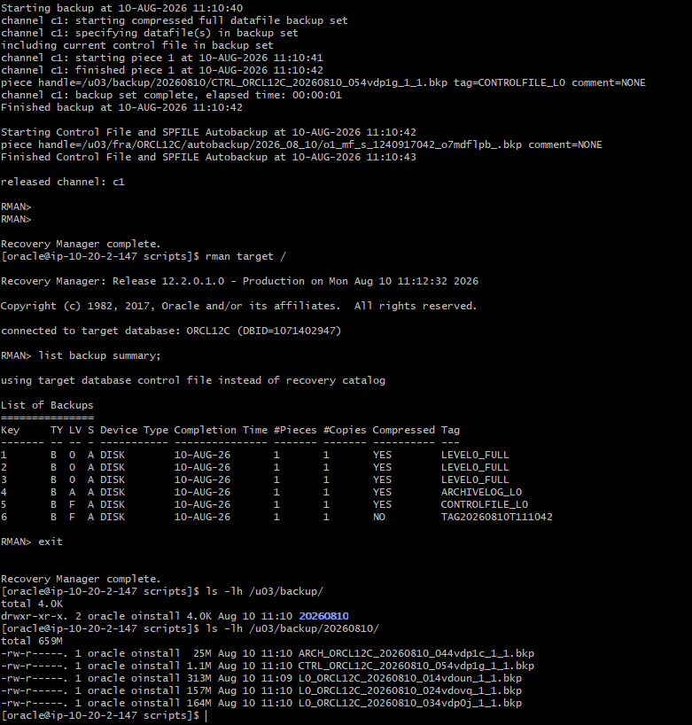

RMAN incremental-backup test data and Level 1 backup execution
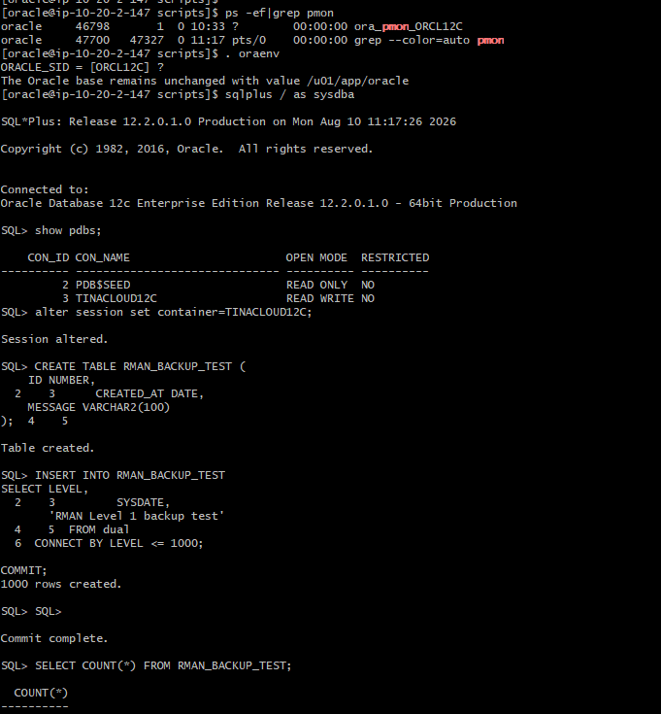

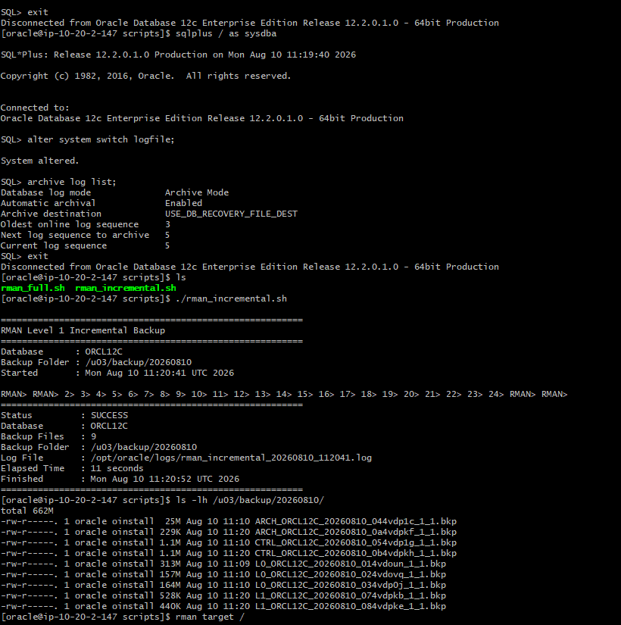

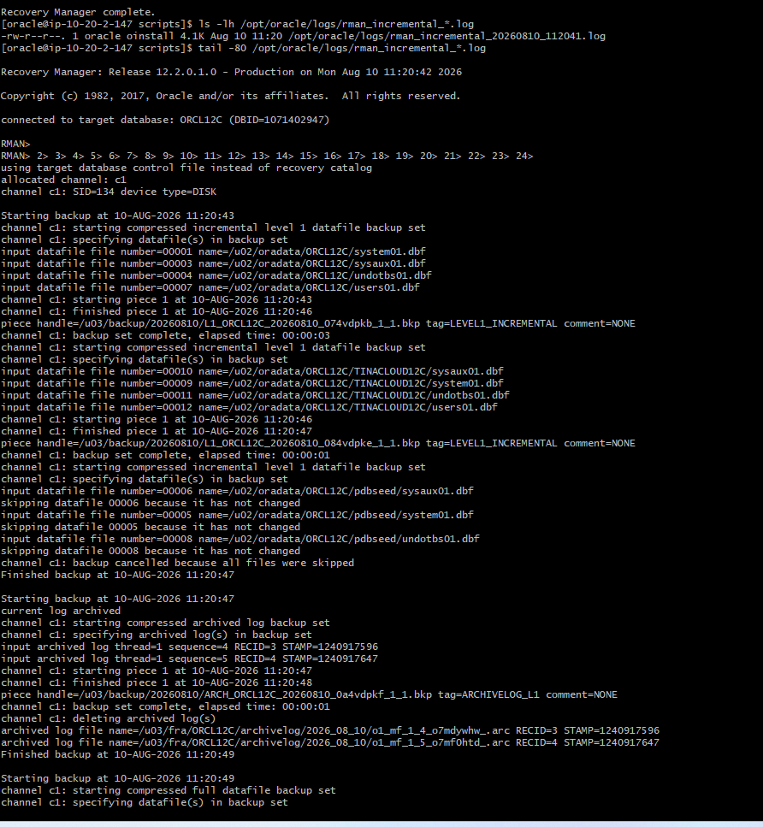

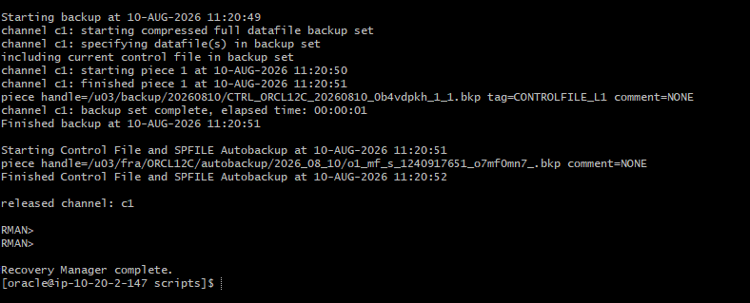

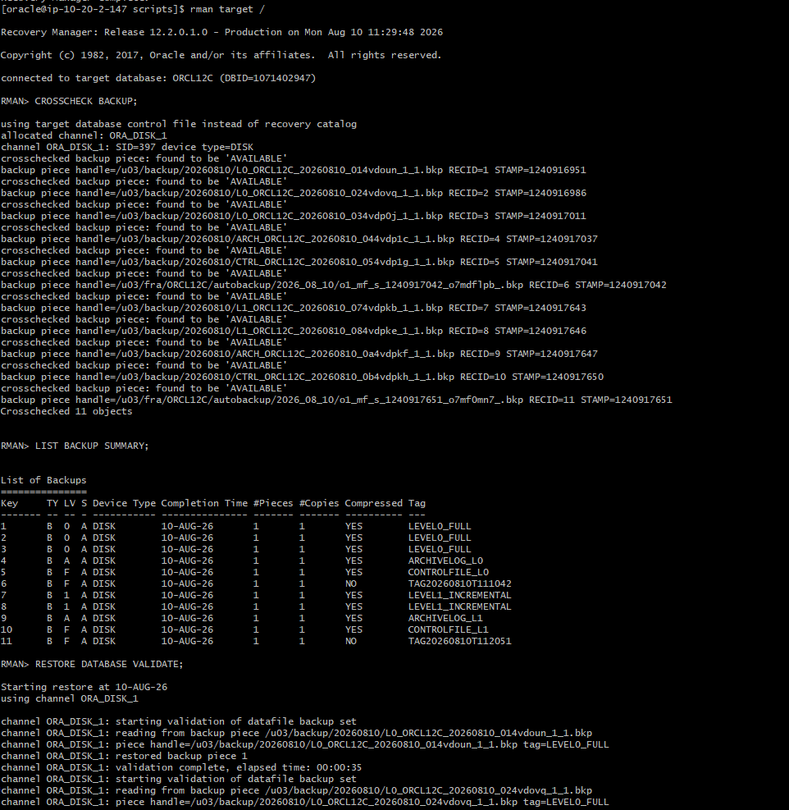

Cron schedule definition for weekly Level 0 and daily Level 1 backups
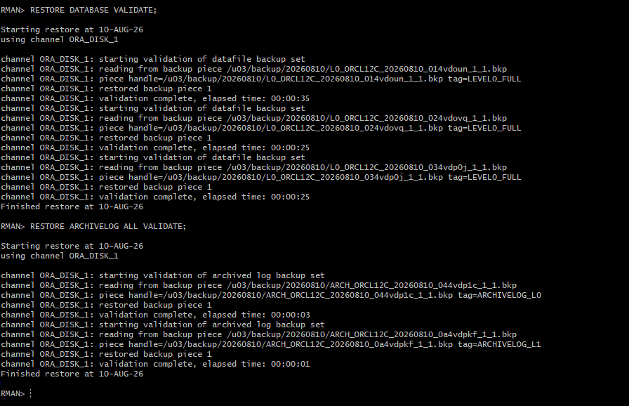

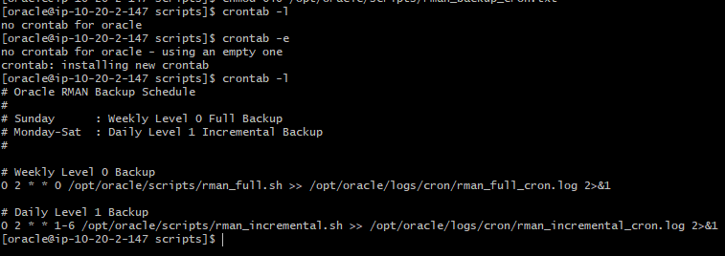

RMAN CROSSCHECK and RESTORE DATABASE/ARCHIVELOG VALIDATE verification
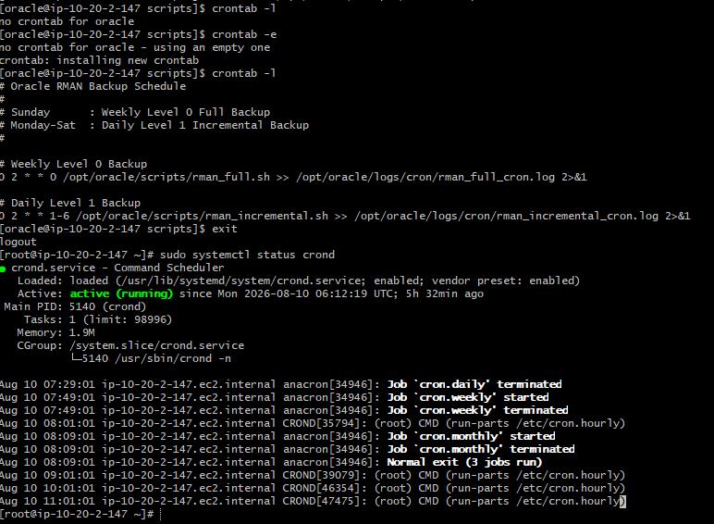

ORCL12C
│
┌─────────┴─────────┐
│ │
ARCHIVELOG FRA /u03/fra
│
▼
┌───────────────┐
│ RMAN DISK │
│ /u03/backup │
└───────┬───────┘
│
┌──────┴──────┐
▼ ▼
LEVEL 0 LEVEL 1
Weekly Daily
│ │
└──────┬──────┘
│
Archived Redo
│
▼
Point-in-Time Recovery

