MongoDB_AWS_Installation_TLS_Replication_Failover

Summary — Key Configurations and Implementations

1. AWS infrastructure and node layout
• Deployed three MongoDB EC2 nodes in separate Availability Zones in us-east-1, plus a bastion host for administration.
• Recorded the private addresses used by the replica set: mongo-cs1 10.20.11.249, mongo-cs2 10.20.21.49, and mongo-cs3 10.20.31.199.
• MongoDB traffic uses TCP 27017 and should remain restricted to approved sources and the database nodes; database nodes should not be exposed publicly.

2. Operating system and MongoDB Enterprise installation
• Confirmed RHEL 8.10 on x86_64 for the MongoDB nodes.
• Configured the MongoDB Enterprise 8.0 repository and refreshed DNF metadata on each node.
• Installed MongoDB Enterprise using the project command: sudo dnf install -y mongodb-enterprise.
• Verified MongoDB version 8.0.34.

3. TLS certificates and trust
• Prepared a project CA certificate and individual node certificate bundles with node-specific identities.
• Installed each node certificate bundle and the CA certificate under /etc/mongodb/pki/ on all three nodes.
• Set certificate files to root:mongod ownership and mode 640; restricted the PKI and secrets directories.
• Configured mongod to require TLS and trust the project CA. allowConnectionsWithoutCertificates: true allowed TLS clients without a client certificate while preserving server-certificate validation.

4. Replica-set internal authentication
• Generated a shared replica-set keyfile at /etc/mongodb/secrets/rs0-keyfile and distributed it to all three nodes.
• Set the keyfile owner to mongod:mongod and permissions to 400.
• Enabled authorization and configured the keyFile setting in mongod.conf.

5. mongod.conf and service validation
• Configured port 27017, loopback plus each node's private IP in bindIp, TLS certificate and CA paths, authorization, and the shared keyfile.
• Configured replication with replSetName: rs0 on all three nodes.
• Validated the effective configuration with mongod --config /etc/mongod.conf --outputConfig, restarted mongod, and confirmed the service was active.

6. Replica-set initialization and replication
• Initialized rs0 from mongo-cs1 with all three private IP addresses as members.
• Checked replica-set status and confirmed one PRIMARY and two SECONDARY members with healthy status.
• Inserted a test document into replicationTest on the primary and verified it was visible on both secondary nodes.

7. Controlled failover and post-failover replication
• Ran rs.stepDown(60) on the original primary to trigger a controlled election.
• Observed mongo-cs2 become PRIMARY while mongo-cs1 and mongo-cs3 became SECONDARY; all members reported health 1.
• Inserted a failover-validation document on mongo-cs2 and verified it replicated to the other members.

Important follow-up items
• The screenshots document installation, TLS/internal authentication, replica-set setup, replication, and failover. They do not yet demonstrate the planned application-user RBAC tests, backup/recovery, or sharding.

AWS VPC resource map showing the MongoDB network layout.
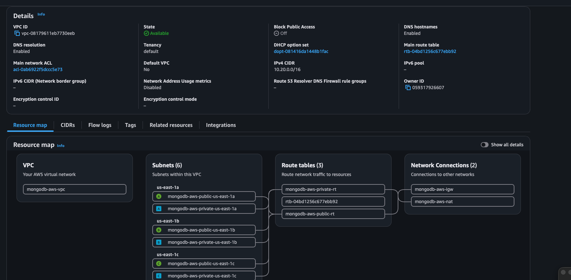
AWS security-groups view for the MongoDB environment.
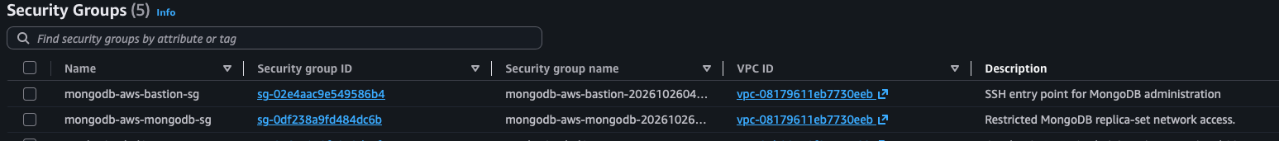
MongoDB nodes and bastion instance running on EC2 instances
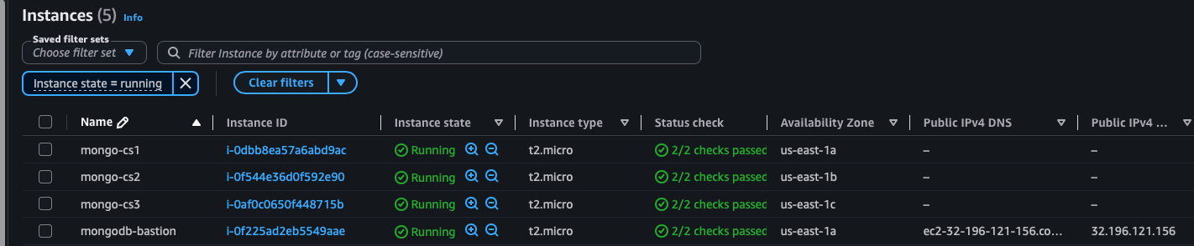
AWS CLI instance inventory with Availability Zones, private IPs, and instance states.
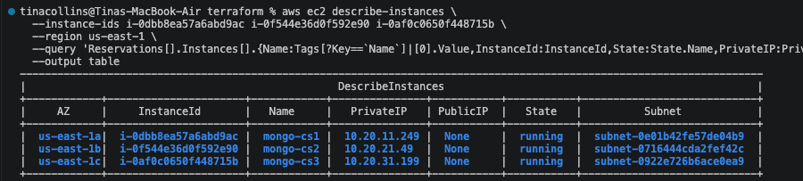
Confirmed private IP and subnet mapping for mongo-cs1, mongo-cs2, and mongo-cs3.
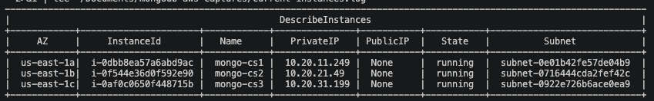
Host operating-system and disk details on mongo-cs1 (RHEL 8.10, x86_64).
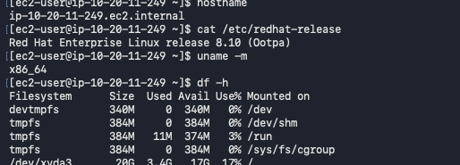
/etc/hosts and getent output confirming mongo-cs1 resolves to 10.20.11.249.
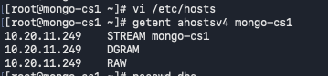

MongoDB Enterprise repository configuration and DNF metadata refresh.
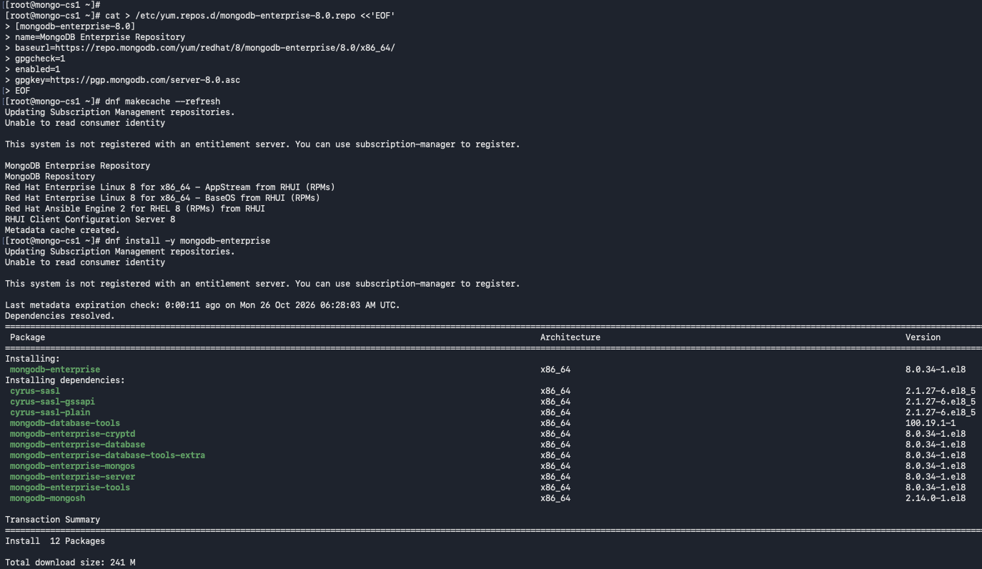
MongoDB Enterprise package installation on mongo-cs1.
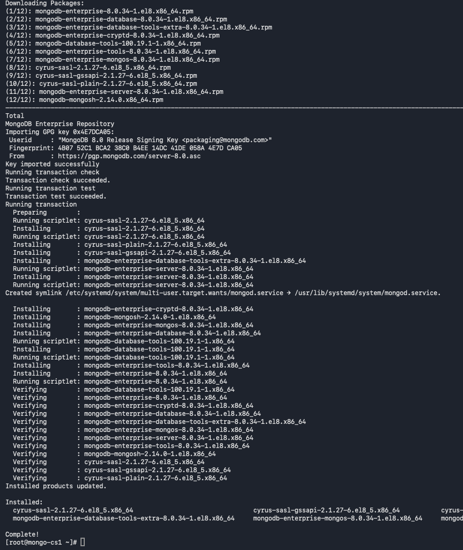
MongoDB Enterprise repository setup and package installation on mongo-cs2.
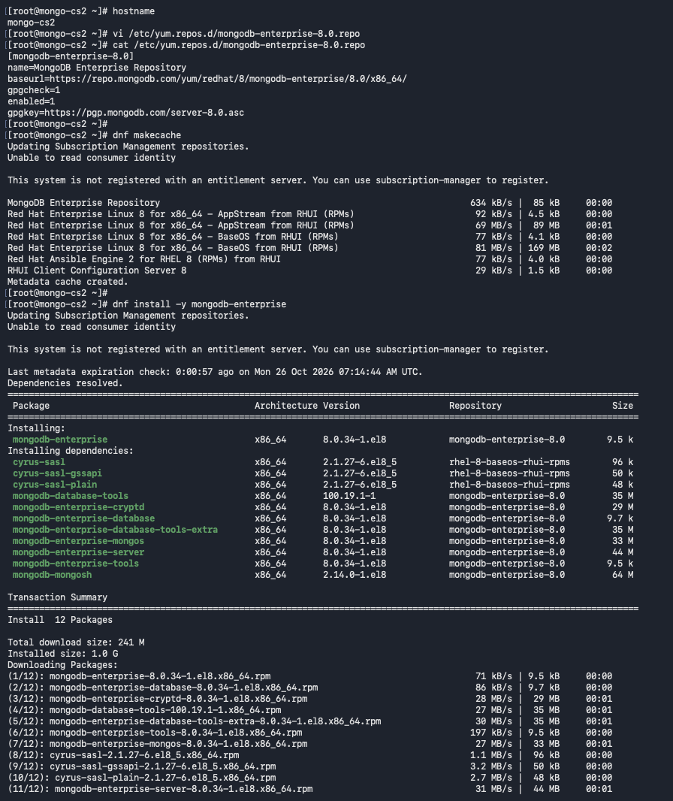
DNF installation transaction and package verification on mongo-cs2.
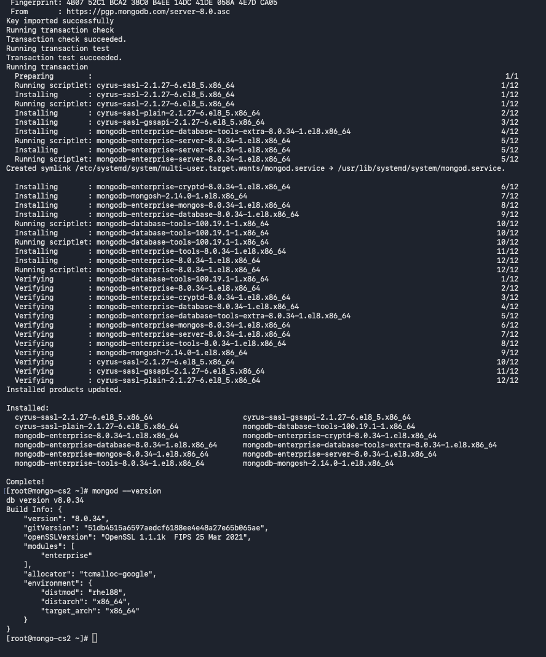
MongoDB version check on mongo-cs2 confirming version 8.0.34.
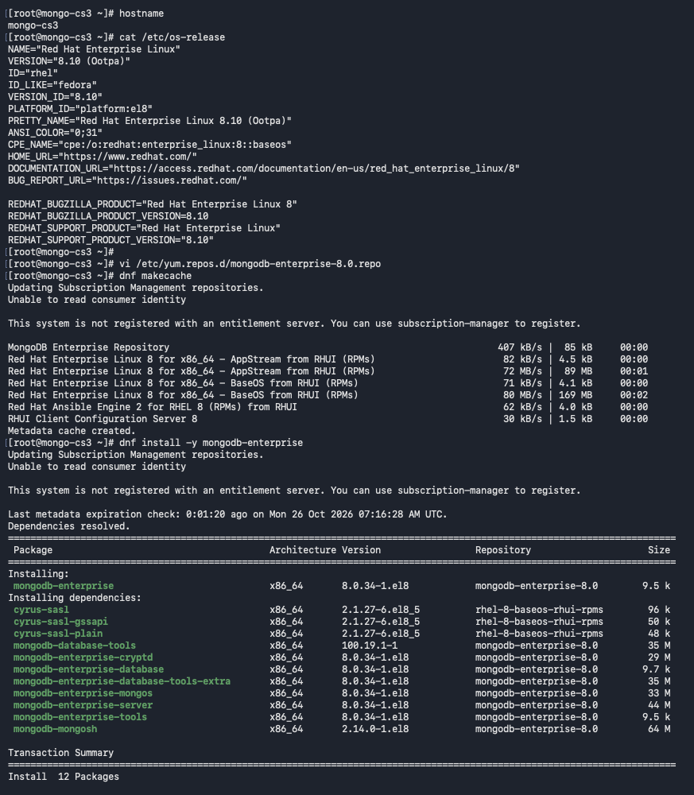
mongo-cs3 operating-system details, repository configuration, and DNF metadata refresh.
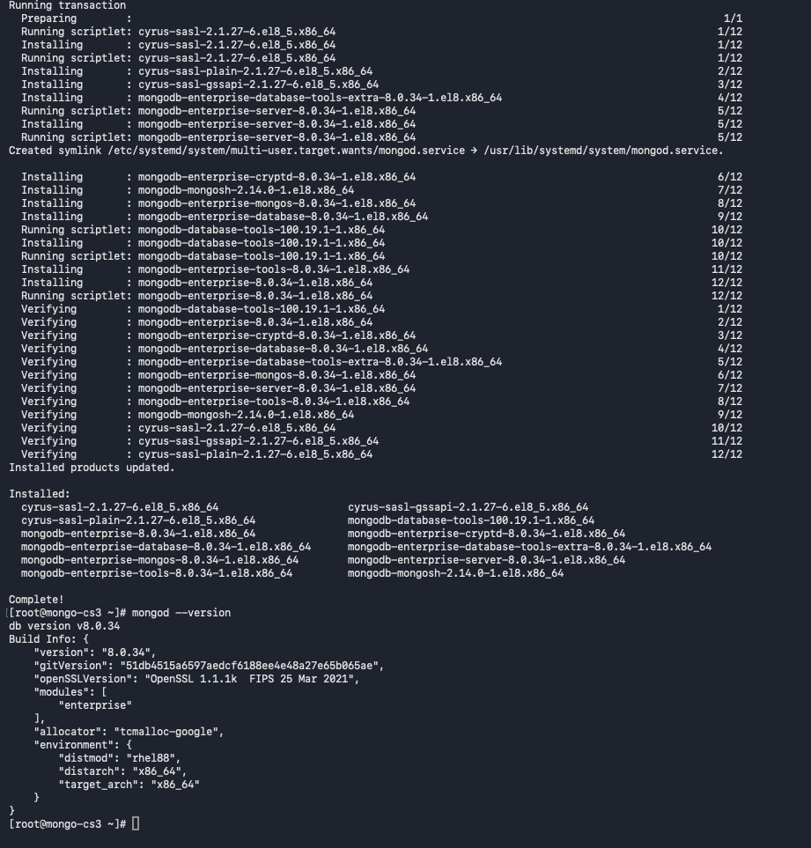

Prepare TLS and internal authentication: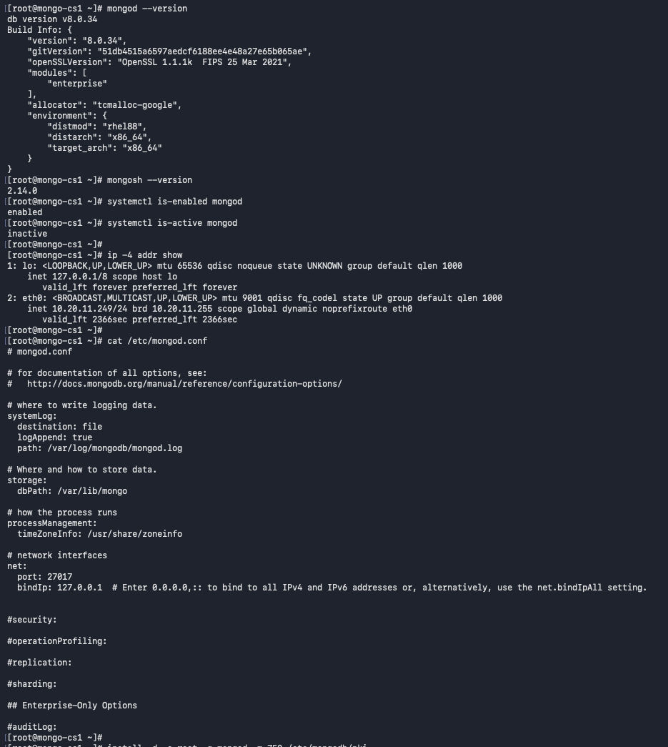

Copying the MongoDB CA certificate and mongo-cs1 node certificate bundle through the bastion.
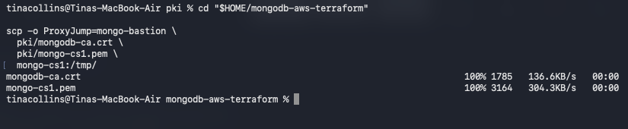
TLS certificates and CA certificates installed with the correct ownership and permissions on all 3 nodes
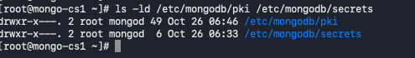
mongo-cs1 TLS certificate files, ownership, permissions, and temporary-file cleanup.
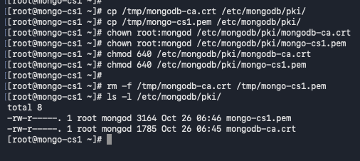

Installing the CA certificate and mongo-cs2 node certificate bundle with root:mongod ownership and mode 640.
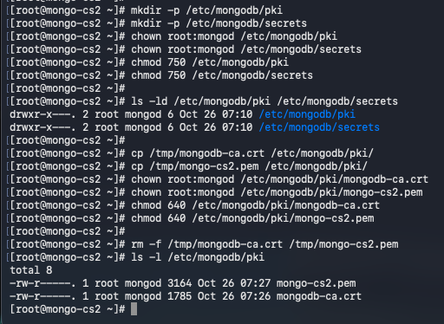

Creating /etc/mongodb/pki and /etc/mongodb/secrets on mongo-cs3 and setting directory permissions.
Installing the CA certificate and mongo-cs3 node certificate bundle with root:mongod ownership and mode 640.
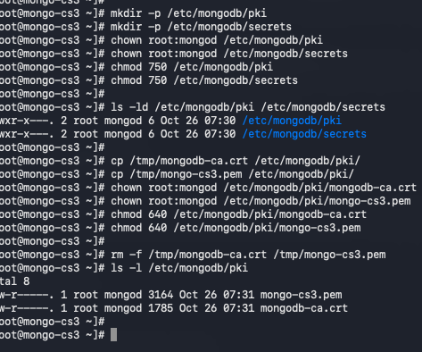
Create the replica-set authentication key file
Generating the shared rs0 keyfile on mongo-cs1 and setting mongod ownership with mode 400.
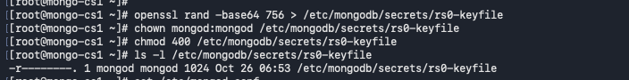
Temporarily staging the keyfile for transfer from mongo-cs1.
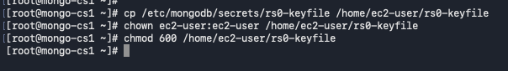

Copying the shared rs0 keyfile to mongo-cs2 and mongo-cs3, then setting mongod:mongod ownership and mode 400.
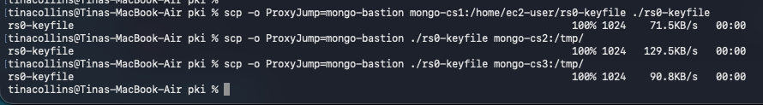
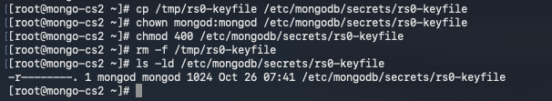
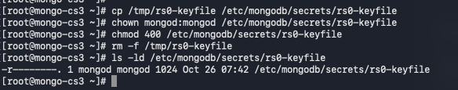
Updating mongo-cs1 mongod.conf with TLS, authorization, and the replica-set keyfile; validating configuration and restarting mongod.
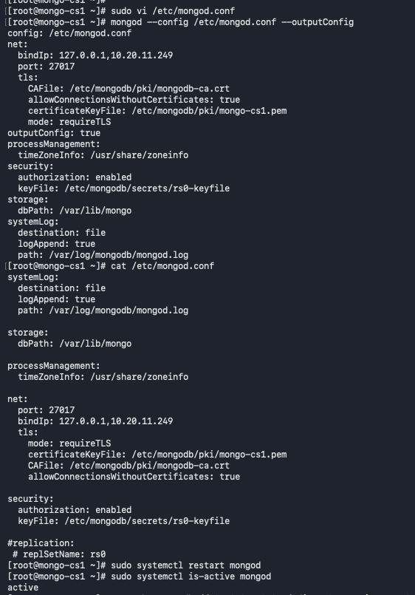
Starting replica-set initialization from mongo-cs1 using the three private IP addresses.
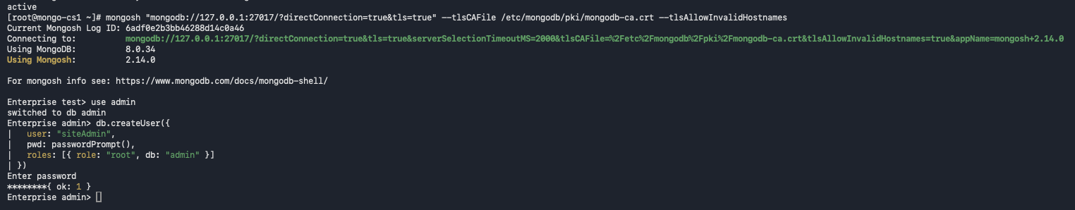

Replica-set status output showing member roles and health during election and validation.
Replica-set initialization response and initial member configuration.
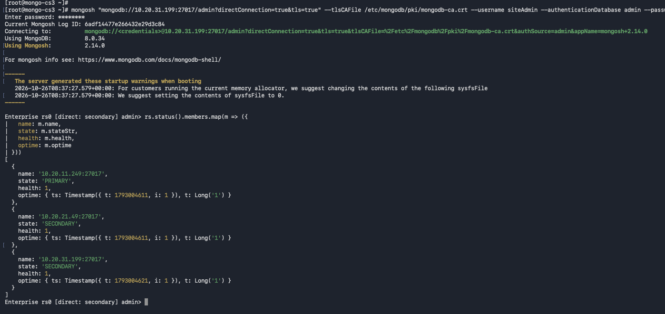
Replica-set status and member-role checks during controlled failover validation.
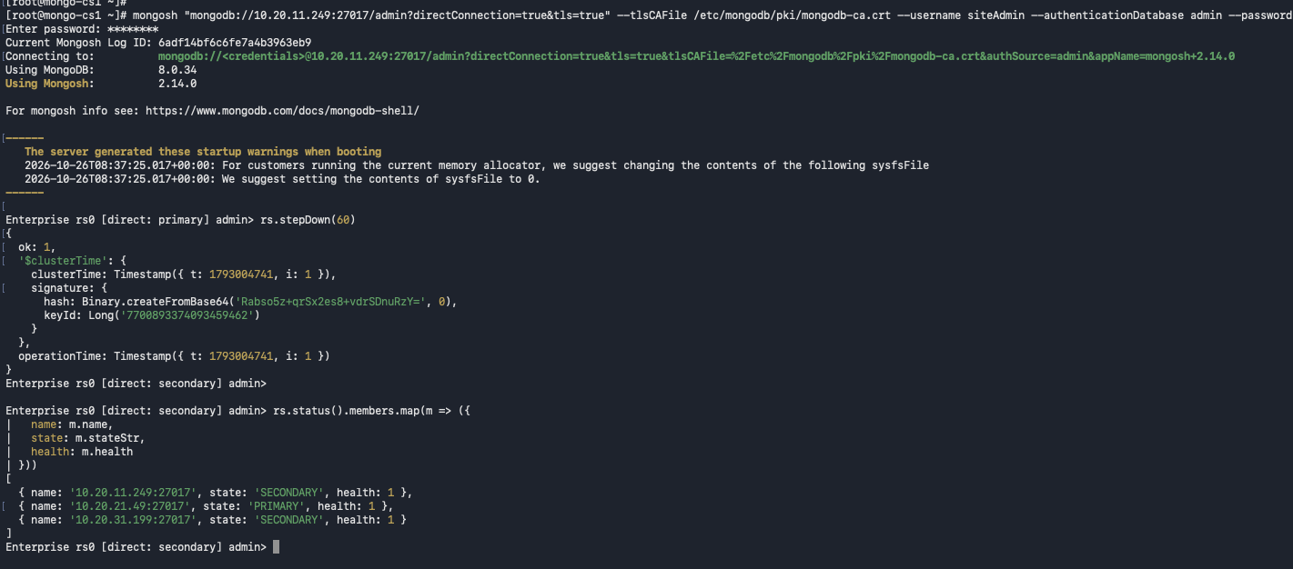
Writing the failover validation document to replicationTest on the new primary, mongo-cs2.
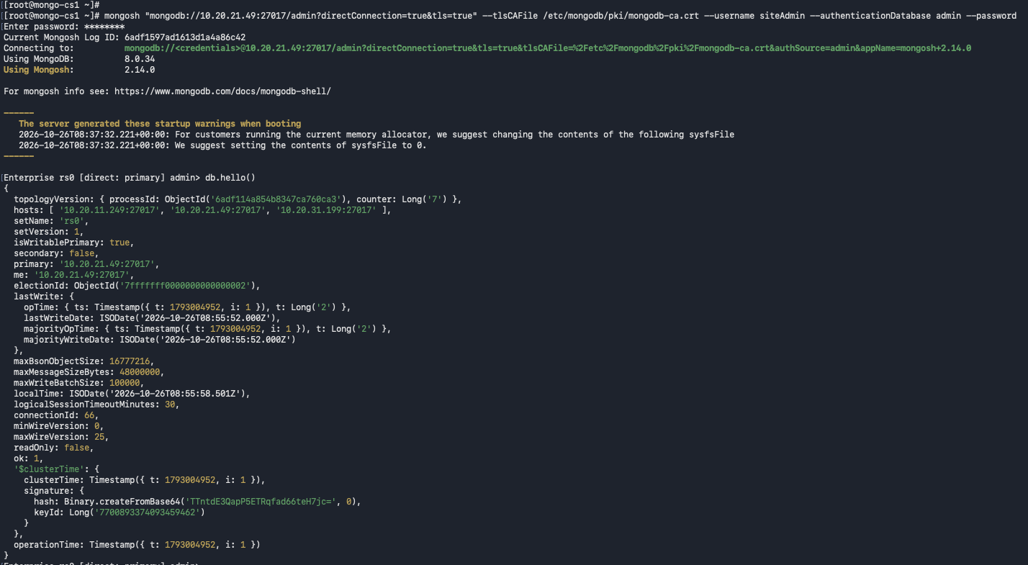
Reading the replicated failover validation document from a secondary.
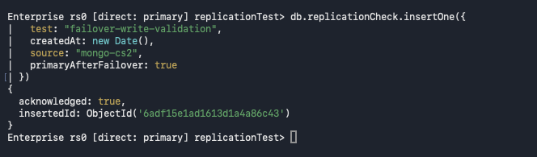
Final replica-set member-state check showing one primary and two secondaries.
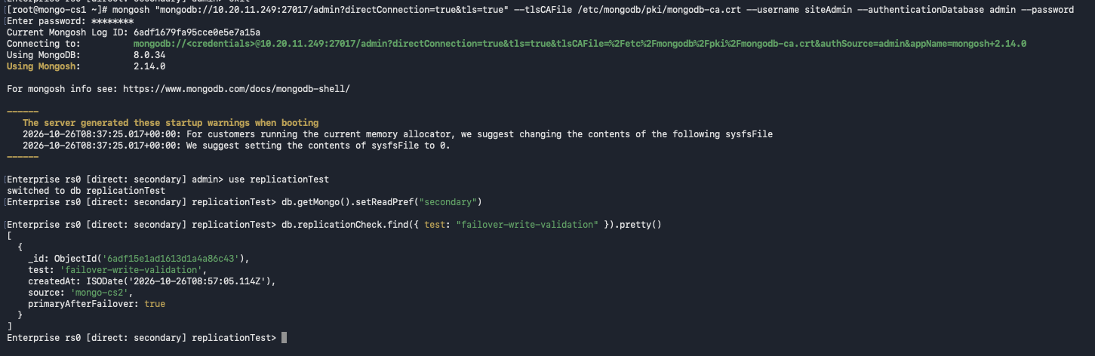
Final replication verification across the replica-set members.
