POSTGRESQL RDS ETL PIPELINE
Complete Architecture, Workflow Diagrams & Documentation

Architecture documentation for the CSV and Oracle 19c ingestion workflows using Apache NiFi, Apache Airflow, and Amazon RDS for PostgreSQL 18.6.

Document scope | Included
Cloud architecture | AWS VPC, bastion, private ETL EC2, RDS PostgreSQL Multi-AZ
ETL services | Apache NiFi 2.12 and Apache Airflow 3.3.2
Source systems | CSV customer files and Oracle 19c LYRIS_APP.CUSTOMERS
Data flow | Staging, validation, transformations, production, audit
Data engineering | Customer SCD Type 2, reconciliation, SQL reporting and analysis

1. Executive architecture summary
This project integrates customer data from CSV files and an Oracle 19c source into Amazon RDS for PostgreSQL 18.6. Apache NiFi performs source extraction and ingestion. Apache Airflow orchestrates the workflows by calling the NiFi REST API, monitoring ingestion, validating PostgreSQL staging data, executing SQL transformation/load steps, and recording audit outcomes.
The AWS deployment uses a VPC with private application and database resources. A bastion EC2 instance provides the SSH access path to the private ETL EC2 instance. The ETL EC2 instance hosts NiFi and Airflow. Amazon RDS for PostgreSQL is deployed privately with Multi-AZ.

Key architecture components
Component | Role in the solution
AWS VPC | Private network boundary for ETL and database resources.
Bastion EC2 | SSH entry point used to reach private resources.
Private ETL EC2 | Hosts Apache NiFi 2.12 and Apache Airflow 3.3.2.
Apache NiFi | Extracts and ingests CSV and Oracle LYRIS customer data.
Apache Airflow | Schedules workflows, invokes NiFi REST API, monitors execution, validates staging, runs SQL loads, and records audit outcomes.
Amazon RDS PostgreSQL 18.6 | Managed PostgreSQL target database, private and configured for Multi-AZ.
staging schema | Landing area for source records before target processing.
production schema | Curated target tables, including the customer SCD Type 2 dimension.
audit schema | Stores ETL batch execution and outcome records.

2. AWS deployment architecture
The diagram below shows the major infrastructure components and their connectivity. The private ETL host runs both NiFi and Airflow; the database is reached over PostgreSQL connectivity using TLS.

2.1 AWS architecture diagram
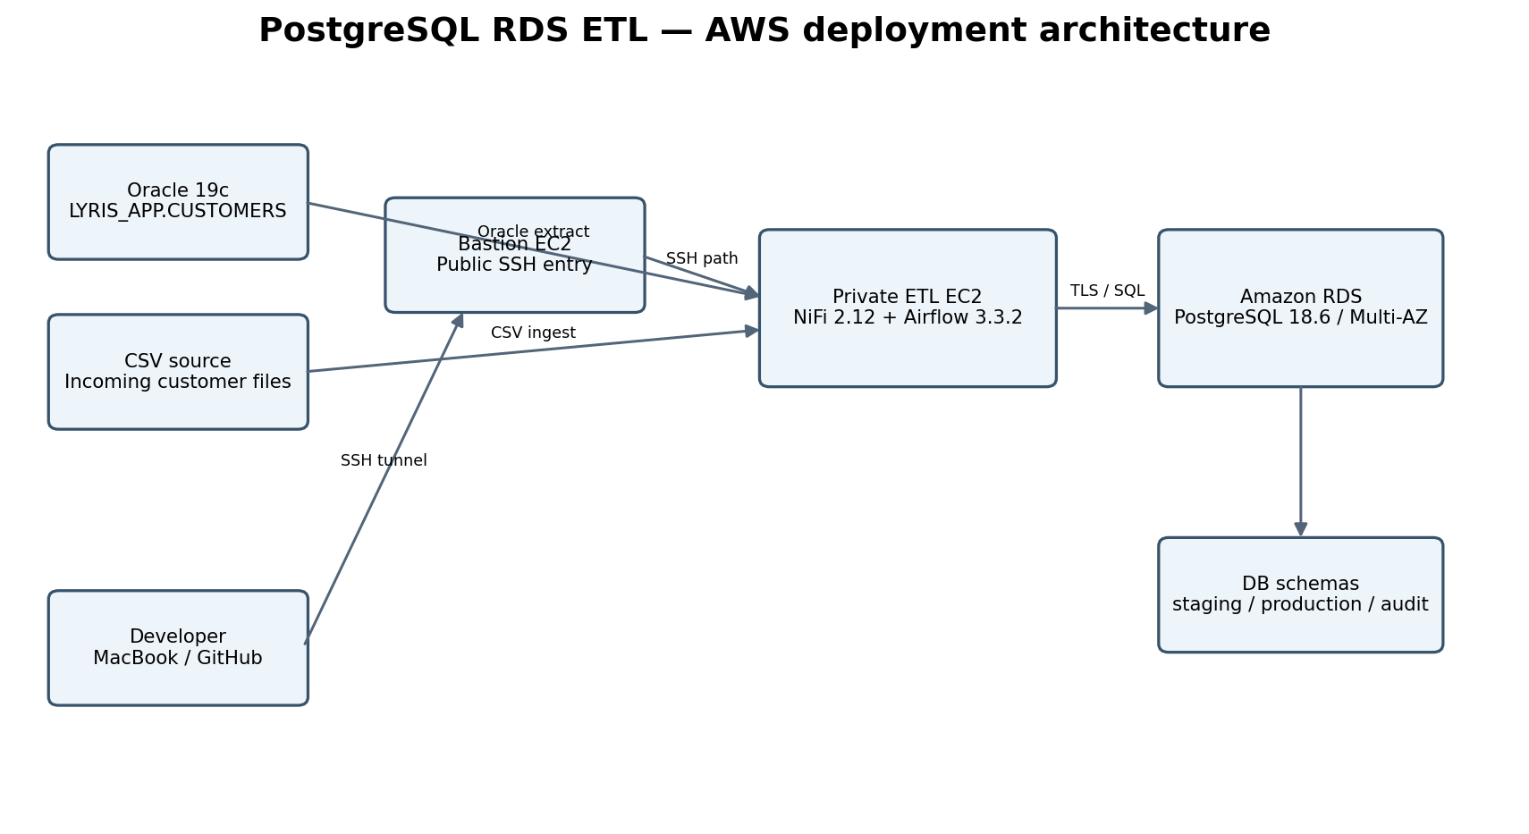
Figure 1. AWS deployment architecture for the PostgreSQL RDS ETL project.

Network and access path
- The developer workstation reaches private infrastructure through SSH using the bastion EC2 instance.
- The ETL EC2 instance is private and hosts the NiFi and Airflow services.
- NiFi and Airflow web interfaces are accessed from the workstation using local SSH port forwarding.
- The ETL host connects to Amazon RDS PostgreSQL over the approved network path; database connections use TLS.
- RDS is not intended to be exposed directly to the public internet.

Known project environment details
Setting | Recorded value
AWS Region | us-east-1
Database engine | Amazon RDS for PostgreSQL 18.6
Database name | operations
RDS deployment | Private Multi-AZ
Bastion public IP | 32.198.112.67
ETL EC2 private IP | 10.30.10.196
SSH user | ec2-user
SSH key path on Mac | ~/.ssh/postgres-rds-bastion
NiFi version | 2.12.0
Airflow version | 3.3.2

Note: IP addresses and host details are included as recorded project configuration. Reconfirm them before reusing commands because cloud addresses and infrastructure can change.

3. Accessing NiFi and Airflow from the workstation
Both web interfaces are reached through SSH tunnels. Open a separate terminal window for each tunnel and leave both windows running while using the browser interfaces.

3.1 NiFi SSH tunnel
ssh -i ~/.ssh/postgres-rds-bastion \
-o "ProxyCommand=ssh -i ~/.ssh/postgres-rds-bastion -W %h:%p ec2-user@32.198.112.67" \
-L 8443:10.30.10.196:8443 \
ec2-user@10.30.10.196
Browser URL: https://localhost:8443/nifi/

3.2 Airflow SSH tunnel
ssh -i ~/.ssh/postgres-rds-bastion \
-o "ProxyCommand=ssh -i ~/.ssh/postgres-rds-bastion -W %h:%p ec2-user@32.198.112.67" \
-L 8080:127.0.0.1:8080 \
ec2-user@10.30.10.196
Browser URL: http://localhost:8080

3.3 Disconnecting
- Keep both terminal windows open while using NiFi and Airflow.
- When finished, return to each terminal window and press Control+C to close its SSH tunnel.
The SSH commands establish port forwarding; they do not start the NiFi or Airflow services. Those services must already be running on the ETL EC2 instance.

4. ETL orchestration: Airflow and NiFi
Airflow is the orchestrator. It calls the NiFi REST API to initiate ingestion and then coordinates monitoring, validation, database loading, and audit handling. NiFi performs the source ingestion and database writes configured in its flows.

4.1 Airflow and NiFi execution diagram
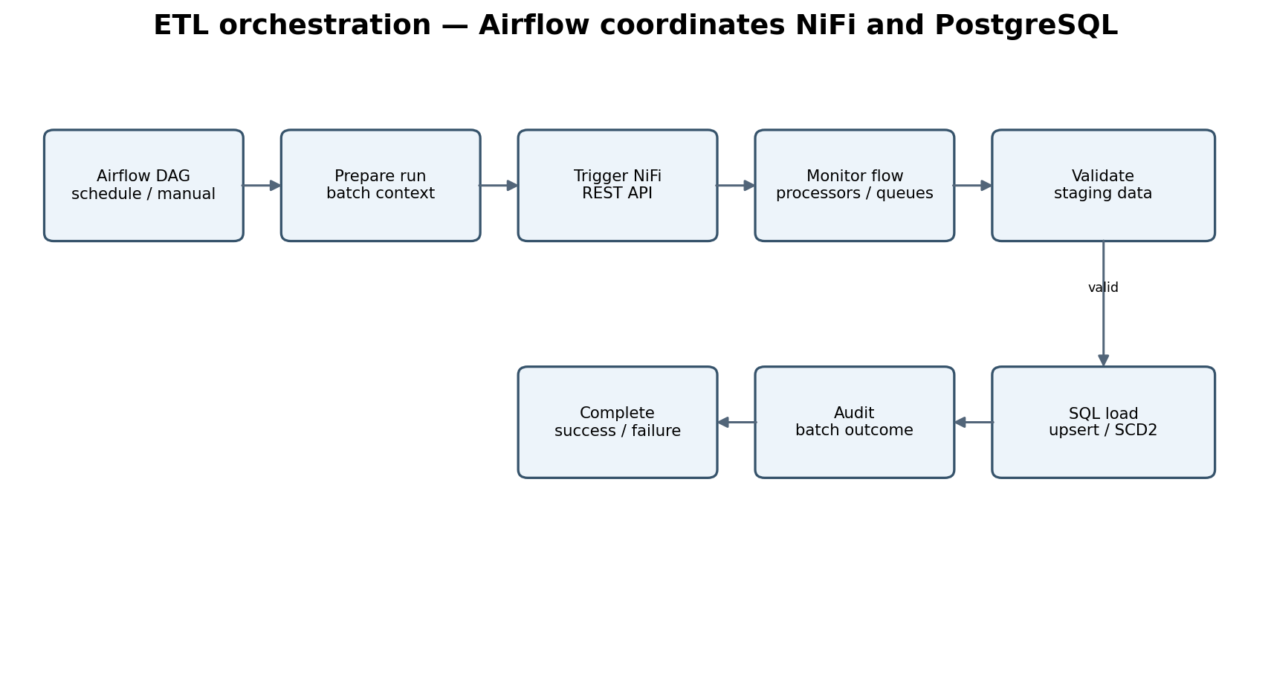
Figure 2. Orchestration sequence showing Airflow coordinating NiFi and PostgreSQL.

4.2 CSV customer workflow
- Airflow prepares the run context and batch identifier.
- Airflow archives the incoming CSV source file.
- Airflow triggers the NiFi CSV ingestion flow through the NiFi REST API.
- NiFi reads the CSV file and loads records into staging.stg_customers.
- Airflow monitors NiFi ingestion completion.
- Airflow validates the staging data.
- Airflow executes the customer dimension SCD Type 2 load.
- Airflow records the ETL execution outcome in the audit schema.

4.3 Oracle LYRIS workflow
- Airflow starts the downstream NiFi processors.
- Airflow triggers the Oracle ExecuteSQL processor through the NiFi REST API.
- NiFi extracts customer records from Oracle 19c table LYRIS_APP.CUSTOMERS.
- NiFi loads staging.stg_lyris_customers and the production LYRIS target.
- Airflow monitors NiFi queues and ingestion completion.
- Airflow validates staging and production results.
- Airflow writes the audit outcome.

4.4 Orchestration design considerations
- Airflow owns scheduling and end-to-end workflow status.
- NiFi owns source extraction and ingestion processing.
- Airflow monitors NiFi execution rather than assuming that an API trigger means ingestion completed successfully.
- Validation should confirm the expected batch or source slice, not simply that a table contains rows.
- Retries and reruns should be designed around idempotent loads and batch-aware processing.
- The Oracle workflow's batch correlation should be hardened so that a run validates the exact batch it triggered, especially before allowing concurrent runs.

5. Data flow, schemas, and dimensional modeling

5.1 ETL data flow diagram
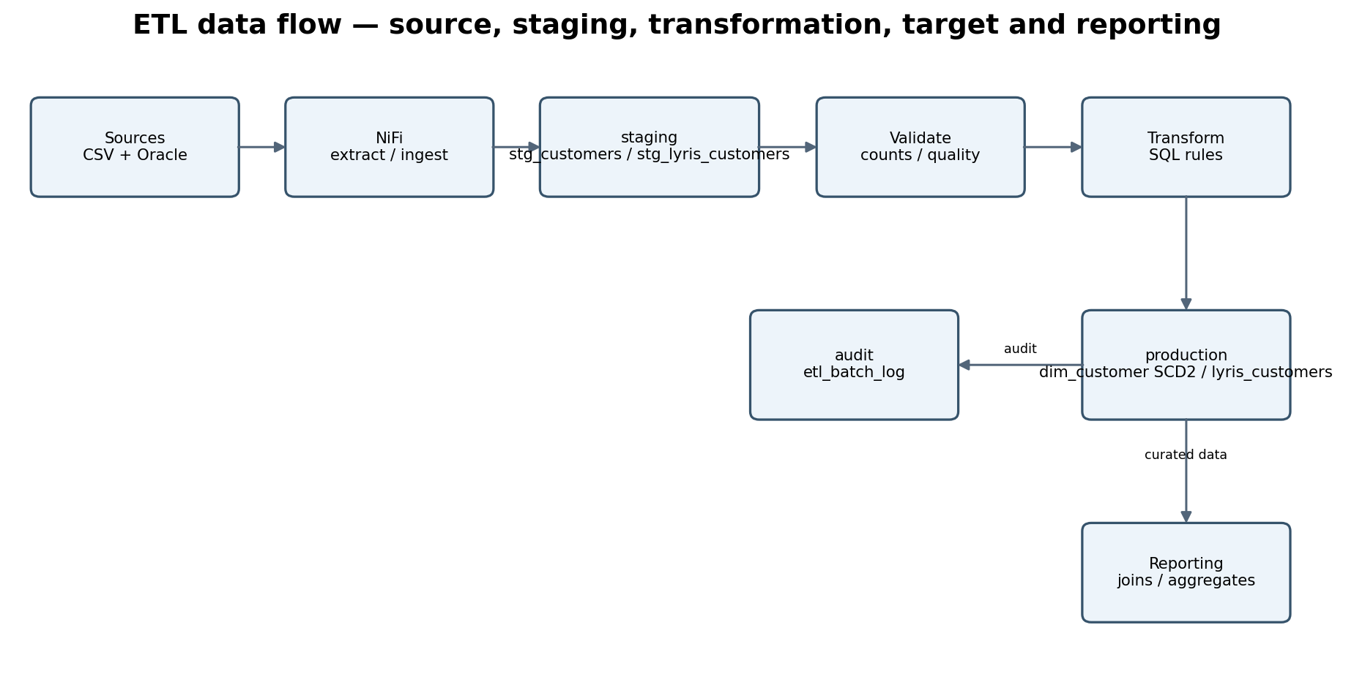
Figure 3. Source-to-target data flow from ingestion through staging, validation, production, audit, and reporting.

5.2 Database schemas and key tables
Schema / table | Purpose
staging.stg_customers | Landing table for CSV customer data.
staging.stg_lyris_customers | Landing table for Oracle LYRIS customer data.
production.dim_customer | Customer dimension using SCD Type 2 to preserve historical versions.
production.lyris_customers | Production target for Oracle LYRIS customer records.
audit.etl_batch_log | ETL batch execution audit and outcome records.

5.3 SCD Type 2
Slowly Changing Dimension Type 2 preserves historical versions of a dimension record rather than overwriting the previous version. When tracked customer attributes change, the prior version is expired and a new current version is inserted. The current version is identified by the current-row indicator. A surrogate customer key distinguishes historical versions.
- Use the business/customer identifier to match source records to the dimension.
- Compare the tracked attributes to determine whether a new version is required.
- Expire the existing current row when tracked attributes change.
- Insert a new dimension row with a new surrogate key and current-row indicator.
- Preserve effective dates and batch lineage so historical changes can be explained.

6. Data validation, reconciliation, and audit
Validation protects the target from incomplete or inconsistent ingestion. Audit records provide traceability for each workflow execution.
Control | What it checks
Staging validation | Expected staging rows are present and required fields are populated.
Source-to-target reconciliation | Source and target counts or business keys are compared for the relevant batch.
Data quality checks | Nulls, data types, key constraints, duplicates, and required attributes are reviewed.
SCD Type 2 validation | Current-row uniqueness and historical version behavior are checked.
Audit logging | Batch status, timestamps, workflow context, and relevant record metrics are recorded.
Failure handling | Errors are captured and the workflow reports failure rather than silently accepting partial results.

Interpret audit counts in context. NiFi and Airflow may both write audit records, and multiple rows per batch can be valid. Airflow inserted/updated counts for a dimension load describe dimension operations, not necessarily unique source-row counts.

7. SQL reporting and analysis
The curated production layer can support reporting through SQL joins, filtering, grouping, and aggregate functions. Use the actual implemented reporting tables and relationships when preparing portfolio examples. The examples below are illustrative patterns; adapt table and column names to the final schema before running them.

7.1 Join customer records to a customer dimension
SELECT
c.customer_id,
c.first_name,
c.last_name,
d.customer_key,
d.is_current
FROM production.customers AS c
JOIN production.dim_customer AS d
ON d.customer_id = c.customer_id
AND d.is_current = TRUE;

7.2 Aggregate customer counts by current dimension status
SELECT
is_current,
COUNT(*) AS customer_version_count
FROM production.dim_customer
GROUP BY is_current
ORDER BY is_current DESC;

7.3 Aggregate records by ETL batch and outcome
SELECT
batch_id,
status,
COUNT(*) AS audit_event_count,
MIN(start_time) AS first_start_time,
MAX(end_time) AS last_end_time
FROM audit.etl_batch_log
GROUP BY batch_id, status
ORDER BY first_start_time DESC;
Confirm the audit table's exact status and timestamp column names before using this query. The project notes record start_time and end_time.

7.4 Join and aggregate reporting pattern
-- Illustrative dimensional reporting pattern.
-- Use only after the corresponding fact and dimension tables
-- and foreign-key relationships have been implemented.

SELECT
d.customer_id,
COUNT(*) AS transaction_count,
SUM(f.sales_amount) AS total_sales,
AVG(f.sales_amount) AS average_sale
FROM production.fact_sales AS f
JOIN production.dim_customer AS d
ON f.customer_key = d.customer_key
GROUP BY d.customer_id
ORDER BY total_sales DESC;
The fact_sales table and sales_amount column are illustrative reporting examples, not confirmation that this exact sales workload is populated in the current project. The recorded project schema includes planned or existing dimensional objects; verify implementation status before presenting results as completed.

8. GitHub repository integration
Recommended repository layout for the architecture documentation:
postgres-rds-etl-pipeline/
├── docs/
│ └── architecture/
│ ├── README.md
│ ├── images/
│ │ ├── 01_aws_architecture.png
│ │ ├── 02_airflow_nifi_execution.png
│ │ └── 03_data_flow_model.png
│ └── diagrams/
│ ├── 01_aws_architecture.mmd
│ ├── 02_airflow_nifi_execution.mmd
│ └── 03_data_flow_model.mmd
└── README.md

8.1 Git commands
git add docs/architecture
git commit -m "Add ETL architecture diagrams and documentation"
git push origin main

8.2 Main repository README link
## Architecture

See [ETL Architecture Documentation](docs/architecture/README.md)
for the AWS deployment, Airflow and NiFi orchestration,
source-to-target data flow, and database schema overview.
The Mermaid .mmd files are editable diagram sources. The PNG files are convenient rendered images for README previews and documentation.

9. Security and operational considerations
- Keep the RDS database private and restrict inbound access to approved security groups and sources.
- Use TLS for PostgreSQL client connections.
- Use SSH through the bastion for administrative access to private infrastructure.
- Use controlled credentials and secrets management; never hardcode secrets in DAGs, NiFi flow exports, scripts, or documentation.
- Do not commit private keys, passwords, access tokens, certificates containing private key material, credential-bearing connection strings, or Terraform state files.
- Apply least-privilege database roles and grants for ingestion, orchestration, and reporting.
- Retain logs and audit data according to project requirements while avoiding sensitive data in logs.
- Test failure handling, retries, duplicate prevention, and batch-level reconciliation before describing the workflow as production-ready.

10. Scope boundaries and implementation accuracy
This document describes the components and workflows recorded as implemented for the project. It intentionally avoids presenting planned or unverified components as completed.
Area | Documented status / qualification
RDS PostgreSQL 18.6 | Deployed in AWS, private, Multi-AZ.
NiFi 2.12 | Deployed on private ETL EC2; CSV and Oracle LYRIS ingestion flows recorded.
Airflow 3.3.2 | Deployed on private ETL EC2; CSV and Oracle DAGs recorded.
Customer SCD Type 2 | Manual demonstration completed and automated load included in the CSV DAG.
Separate RDS read replica | Planned; do not describe as deployed unless subsequently implemented.
CloudWatch dashboards and alarms | Monitoring phase planned; do not claim completed until configured and tested.
Databricks production deployment | Not part of the recorded deployed architecture.
Sales fact reporting workload | Treat as illustrative unless the fact table and data load are confirmed implemented.

Appendix A. Editable Mermaid diagram sources
The following Mermaid definitions are included in the Word document so the architecture diagrams can be recreated or edited without downloading separate source files.

A1. AWS architecture
flowchart LR
ORA["Oracle 19c: LYRIS_APP.CUSTOMERS"] --> ETL
CSV["Incoming CSV files"] --> ETL
DEV["MacBook / GitHub"] -. SSH tunnel .-> BASTION
subgraph AWS["AWS VPC"]
BASTION["Bastion EC2"]
ETL["Private ETL EC2: NiFi 2.12 + Airflow 3.3.2"]
RDS[("Amazon RDS PostgreSQL 18.6: private / Multi-AZ")]
SCHEMAS["staging / production / audit schemas"]
BASTION -. SSH access .-> ETL
ETL -- TLS / SQL --> RDS
RDS --- SCHEMAS
end

A2. Airflow and NiFi execution
flowchart TD
A["Airflow DAG: scheduled or manual"] --> B["Prepare run context / batch"]
B --> C["Trigger NiFi through REST API"]
C --> D["Monitor NiFi processors and queues"]
D --> E{"Ingestion complete?"}
E -- No / timeout --> F["Fail task / capture error"]
E -- Yes --> G["Validate PostgreSQL staging"]
G --> H["Execute SQL transformation"]
H --> I["Customer dimension SCD Type 2 load"]
I --> J["Write audit outcome"]
J --> K["DAG success"]
F --> L["DAG failure / retry policy"]

A3. Data flow model
flowchart LR
SRC["CSV + Oracle 19c"] --> NIFI["NiFi ingestion"]
NIFI --> STG["staging: stg_customers / stg_lyris_customers"]
STG --> VAL["Validation: counts / quality / reconciliation"]
VAL --> SQL["SQL transformations"]
SQL --> DIM["production.dim_customer: SCD Type 2"]
SQL --> LYRIS["production.lyris_customers"]
SQL --> AUD["audit.etl_batch_log"]
DIM --> REP["Reporting and analysis: joins / aggregates"]
LYRIS --> REP

