PostgreSQL_RDS_ETL_Engineering
Document Summary
The screenshots document the PostgreSQL RDS engineering build from AWS infrastructure provisioning through database setup, PostgreSQL Roles, Schemas, and Access Control enforcement, ETL ingestion, orchestration, and validation.
- VPC networking, subnets, security groups, a bastion host, and the PostgreSQL 18.6 Multi-AZ RDS instance and accessing the RDS instance through the bastion host.
- TLS connectivity, certificate handling
- Database role/schema permissions creation
- Dimensional and staging schema creation, customer SCD Type 2 history, and the retail dimensional model
- NiFi controller-service configuration and CSV/Oracle LYRIS ingestion flows
- Airflow DAG execution, controlled failure testing, audit records, and final database validation.
- Airflow task outcomes and PostgreSQL inventory and row-count checks, including 10 customer dimension records across 8 distinct customers.

1. AWS Infrastructure Provisioning and RDS Deployment
This section documents the Terraform deployment of the AWS foundation for the PostgreSQL RDS environment. The screenshots cover VPC networking, public and private subnets, route tables, security groups, the bastion host, the RDS subnet group, PostgreSQL 18.6 Multi-AZ configuration, deployment outputs, and the AWS RDS and Secrets Manager consoles.
Terraform apply output confirming creation of the VPC, private subnets, route tables, security group, and RDS DB subnet group.
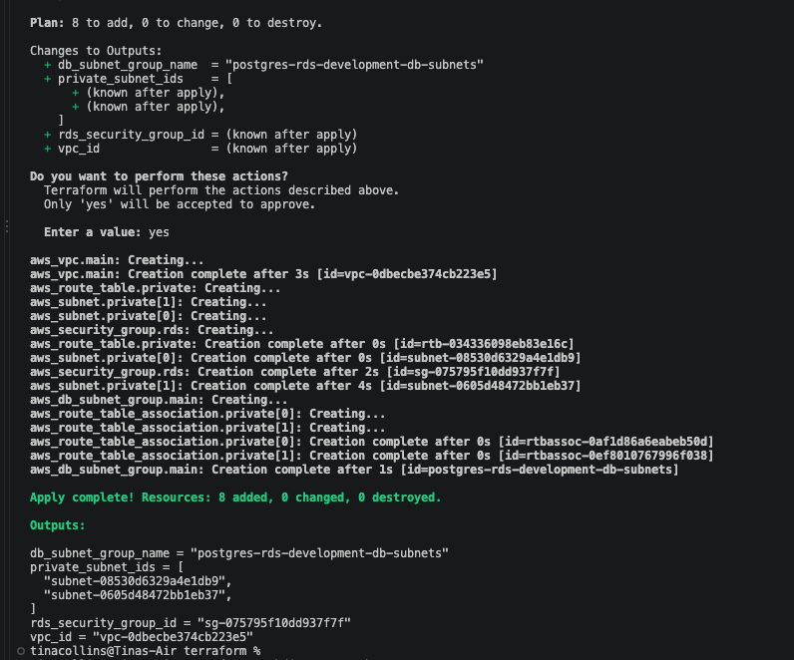
Terraform plan details for the public bastion host, including public-IP assignment and the PostgreSQL ingress rule on TCP 5432.
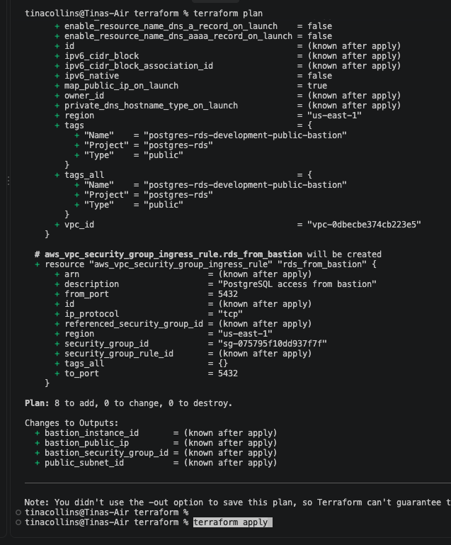
Terraform plan for the PostgreSQL RDS instance, including PostgreSQL 18.6, db.t3.medium, Multi-AZ, encryption, gp3 storage, and deletion protection.
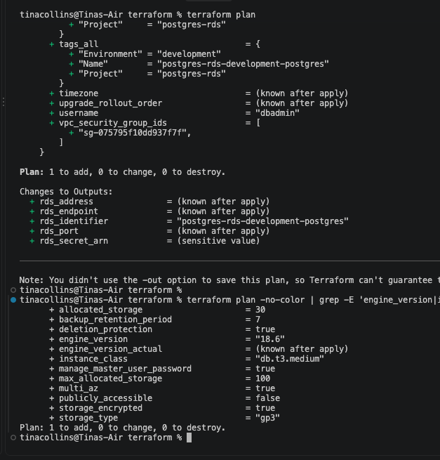
Terraform output listing the deployed bastion, subnet group, security group, VPC, and RDS endpoint values.
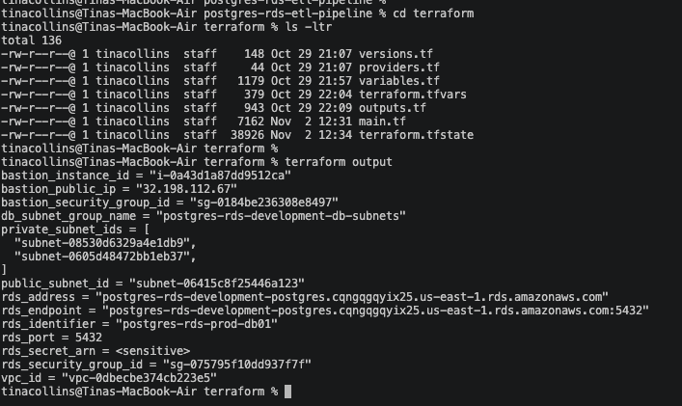

AWS VPC resource map showing the project VPC, public/private subnets, route tables, and network connectivity.
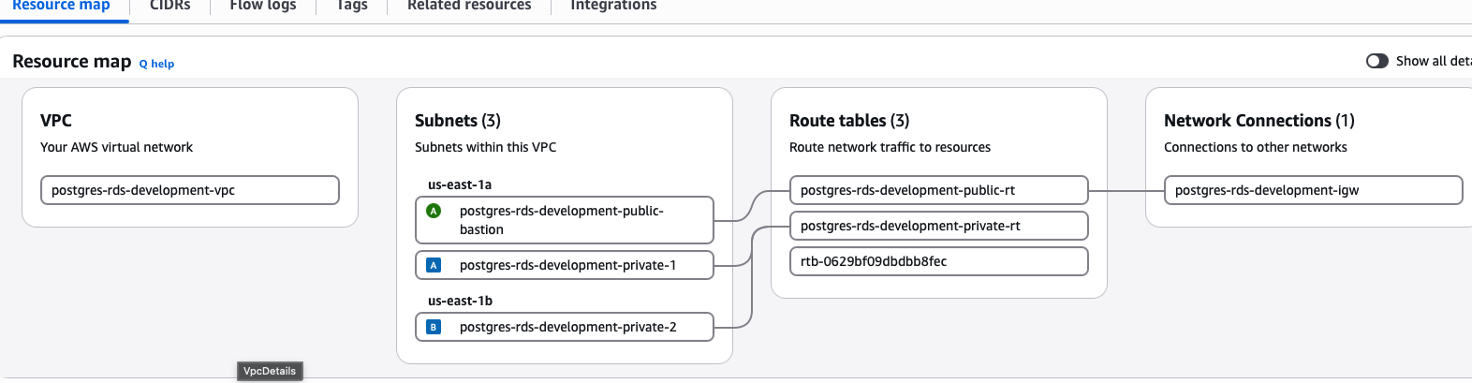
AWS EC2 Instances console showing the security-agent and PostgreSQL RDS bastion instances and their running states.
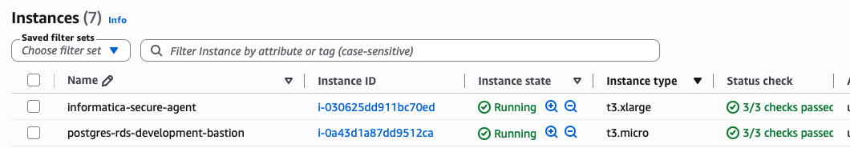
Amazon RDS console overview for the PostgreSQL database instance postgres-rds-prod-db01.
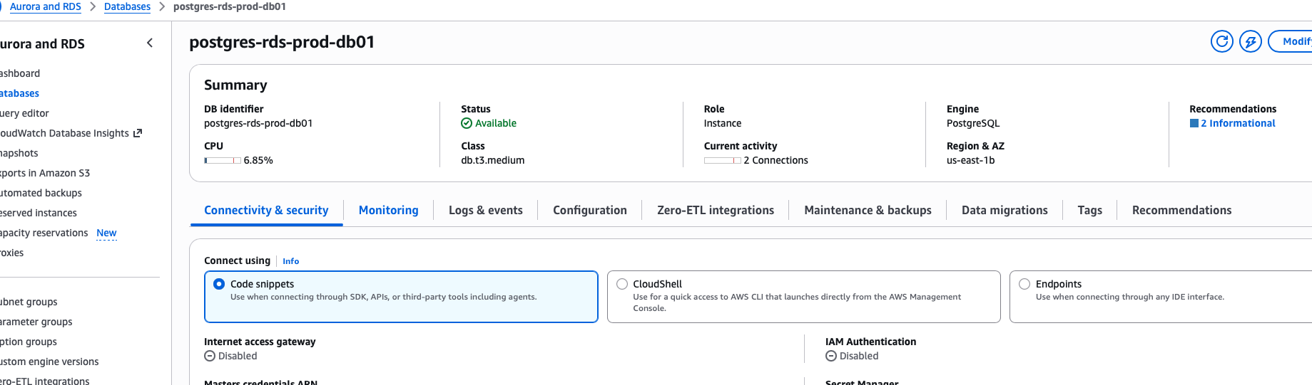
AWS Secrets Manager view of the RDS-managed database secret. Sensitive secret name and ARN should be redacted before public sharing.
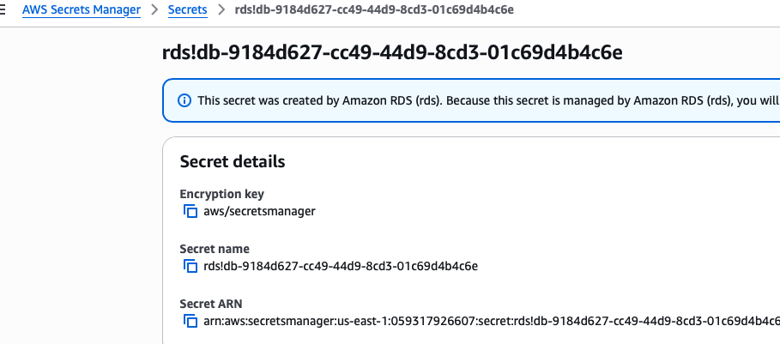

2. Bastion Host Setup and Secure RDS Connectivity
This section shows how the bastion host was accessed and prepared to connect securely to the private RDS instance. The screenshots cover the host environment, PostgreSQL 18 client installation, the postgres operating-system account, AWS RDS CA certificate placement and permissions, initial psql access, database inventory, and TLS connection verification.
SSH session to the bastion host, including Amazon Linux 2023 identification and host resource checks.
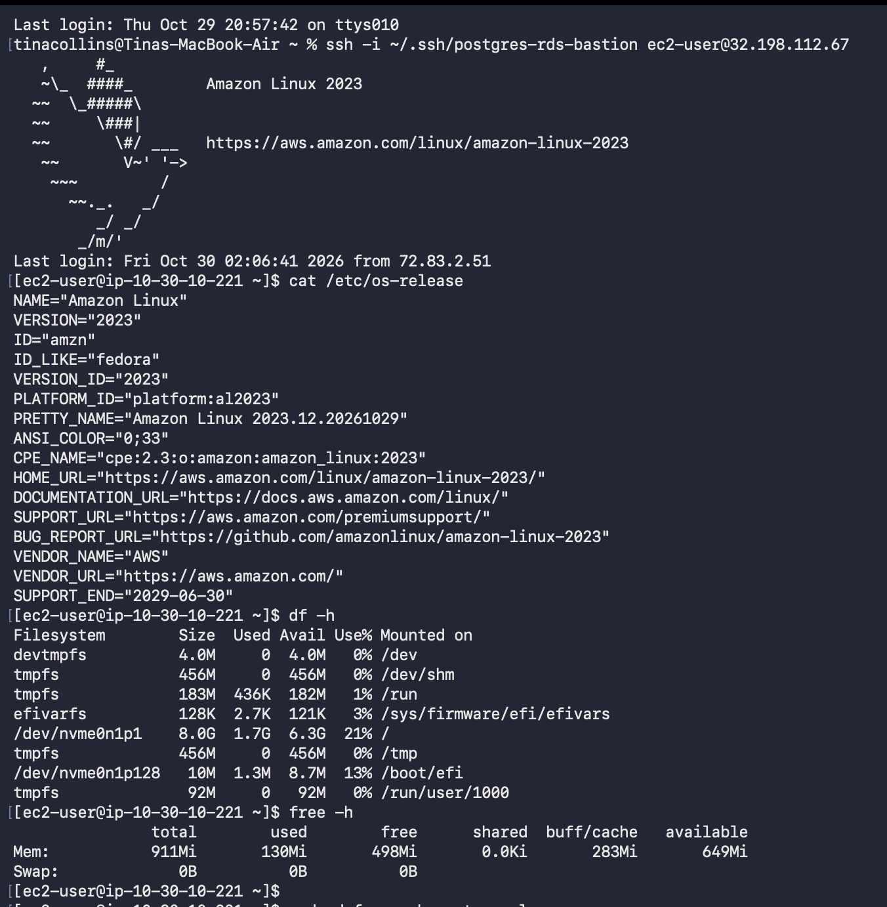
DNF repository search results showing PostgreSQL packages available on the bastion host.
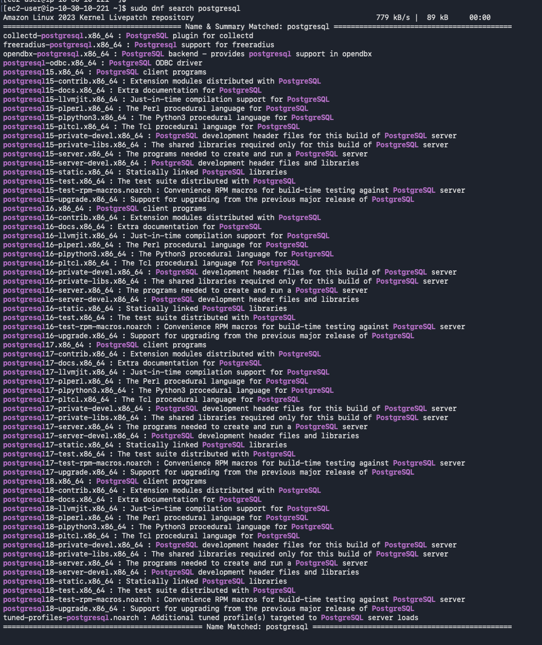
Installation of PostgreSQL 18 client packages on the bastion host and confirmation that psql is version 18.6.
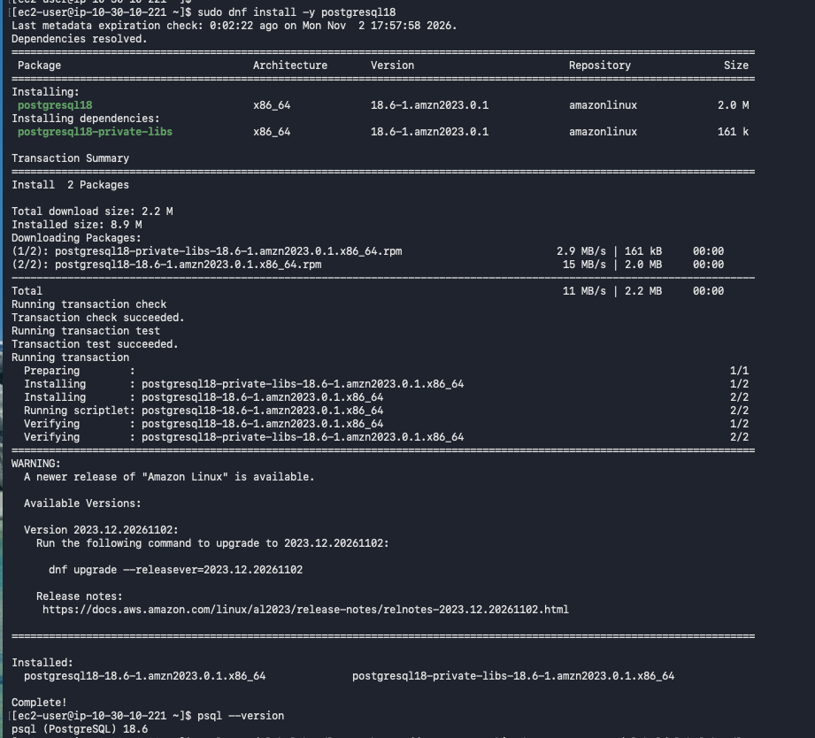
Creation of the postgres operating-system account, password setup, and switch to the postgres account.
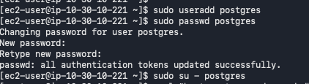
Copying the AWS RDS CA certificate bundle to the postgres home directory and setting ownership and file permissions.
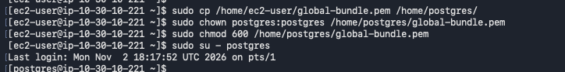
Initial psql connection to the RDS operations database using postgres_admin; database inventory and creation of the postgres_admin role and its privileges.
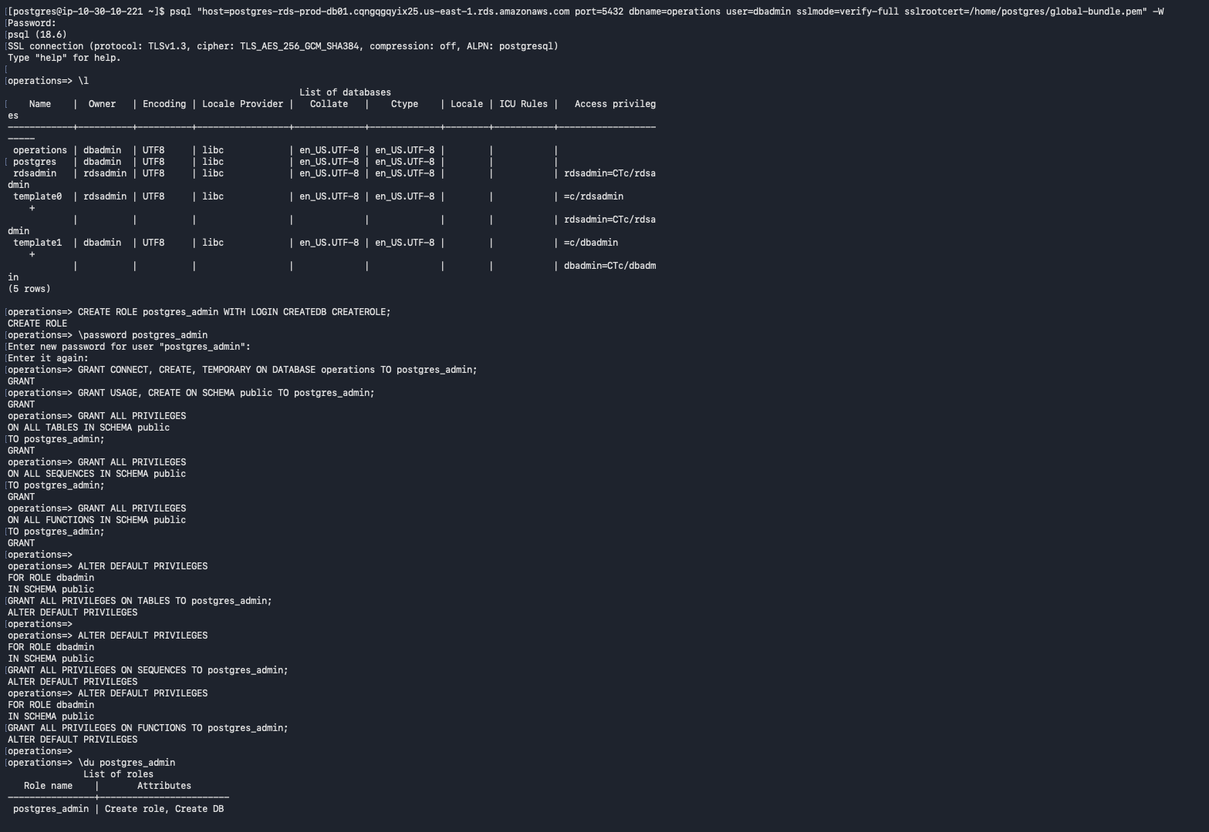
RDS connection verification showing PostgreSQL 18.6, the operations database, postgres_admin, and database inventory.
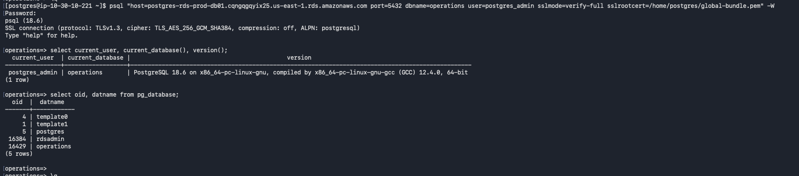
RDS connection details and TLS status, followed by creation of the staging, production, audit, and admin schemas.
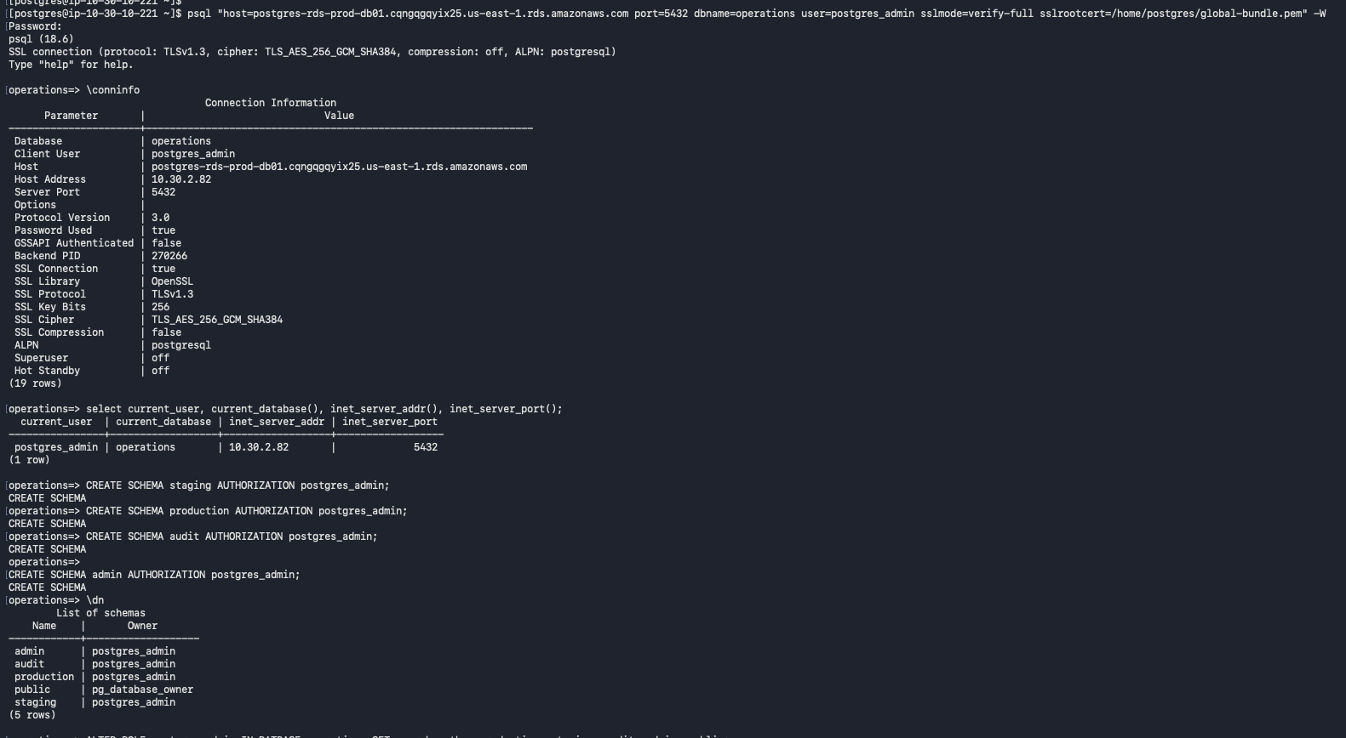

3. PostgreSQL Roles, Schemas, and Access Control
This section documents the PostgreSQL security foundation. The screenshots show creation of the application login role, schema-level permissions, table and sequence
grants, default privileges for future objects, search_path configuration, and verification of role attributes, schema ownership, and access rights.
Creation of the etl_user login role and grants for schema usage, table access and default privileges for future tables and sequences.
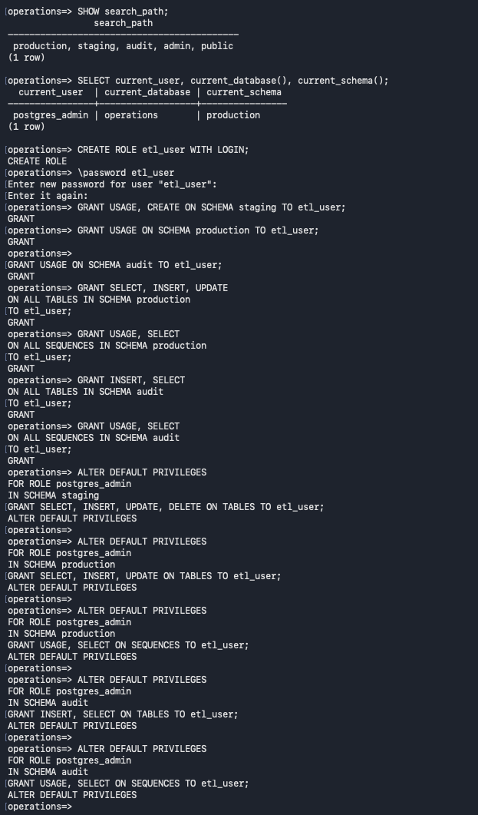

search_path configuration.
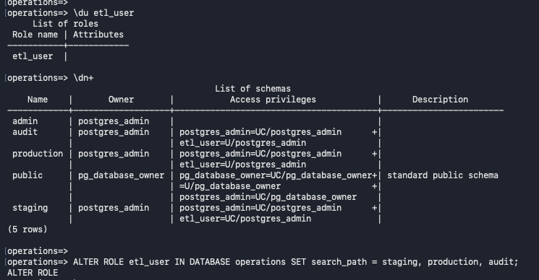
Verification of etl_user role attributes, schema ownership and access privileges
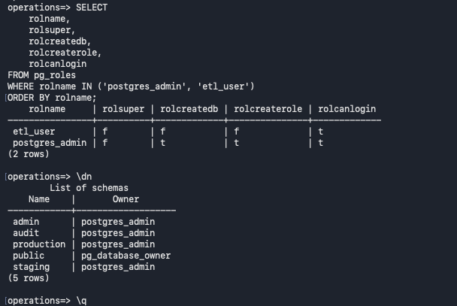

4. Dimensional Model, Staging Tables, and ETL Audit Design
This section covers the target data model and ETL database structures. The screenshots show the customer dimension and SCD Type 2 history, product/store/date dimensions, the sales fact table, staging tables for source entities, the ETL batch audit table, and the resulting schema and table inventory.
Creation of production.dim_customer table with effective-date columns, a current-row flag, and a filtered unique index.
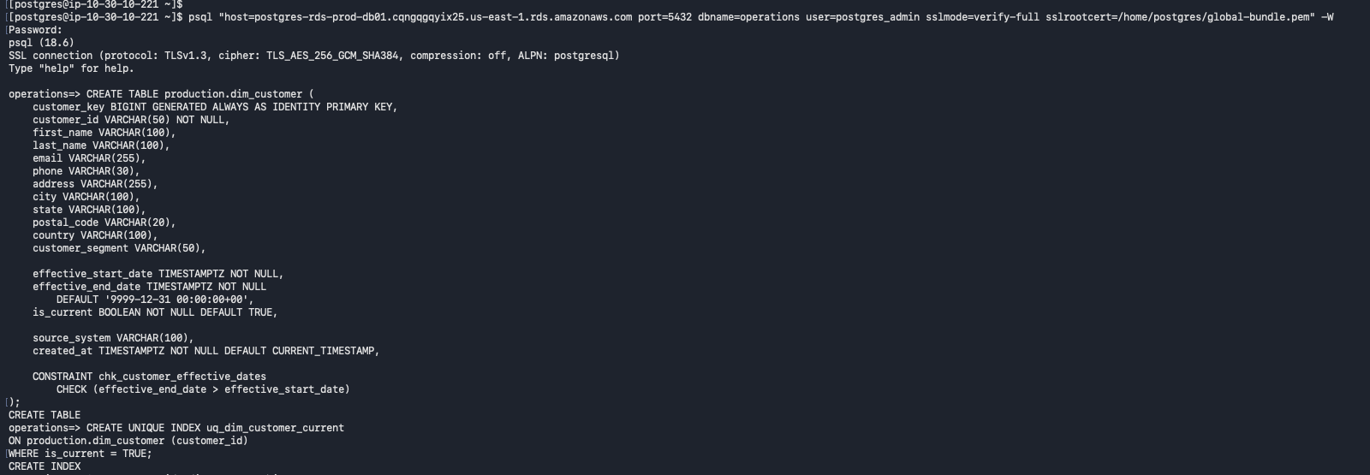
Insertion of the initial C1001–C1003 customer records and query results showing the current dimension rows.
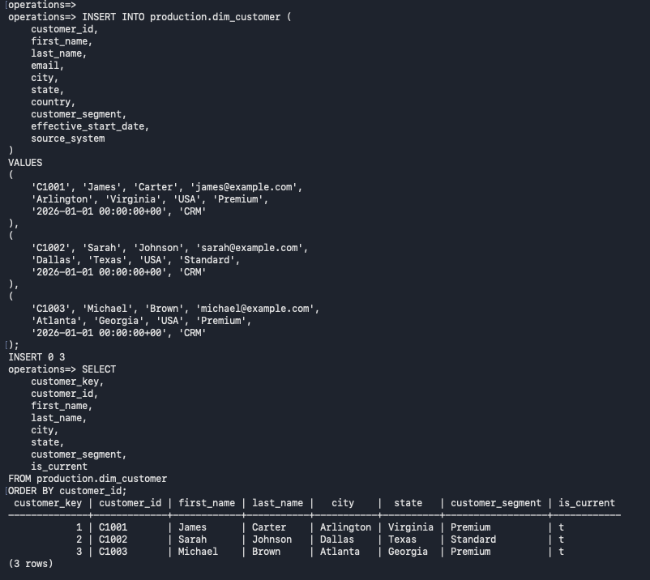
SCD Type 2 change demonstration: expire the prior C1001 row and insert a new version with an updated city.
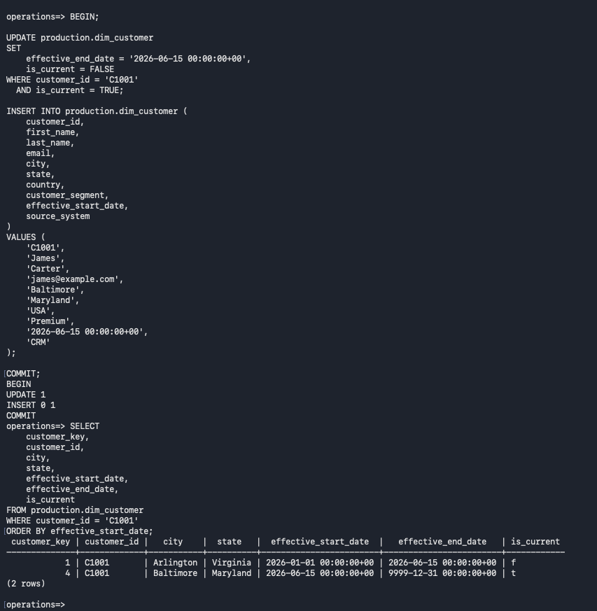
SCD Type 2 validation using effective-date lookup, current-row lookup, and version-count checks.
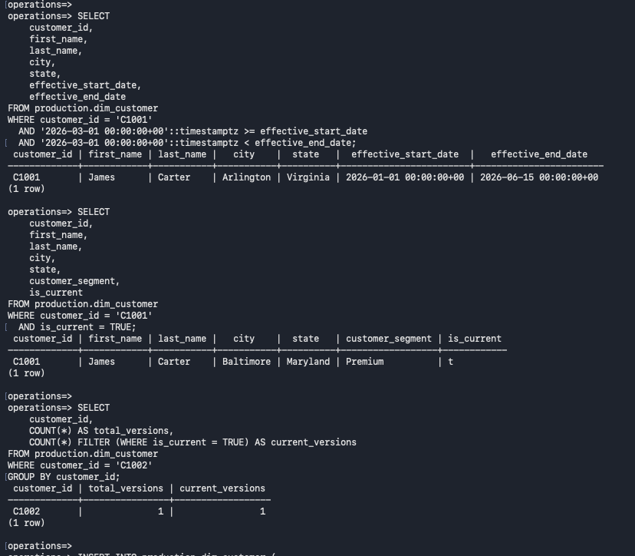
Insertion of customer C1004 and creation of the production.dim_product table.
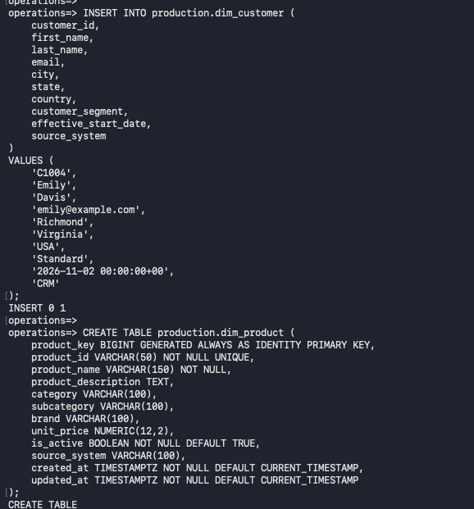
Insertion of three product dimension records and creation of the production.dim_store table.
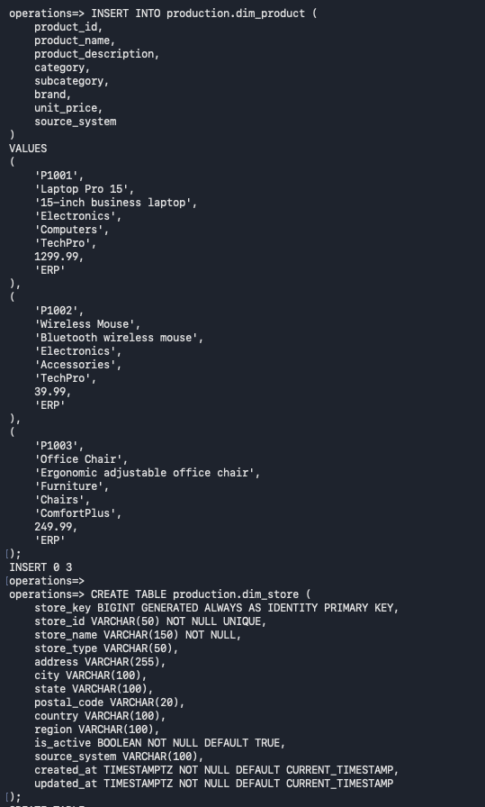
Insertion of three store dimension records and creation of the production.dim_date table.
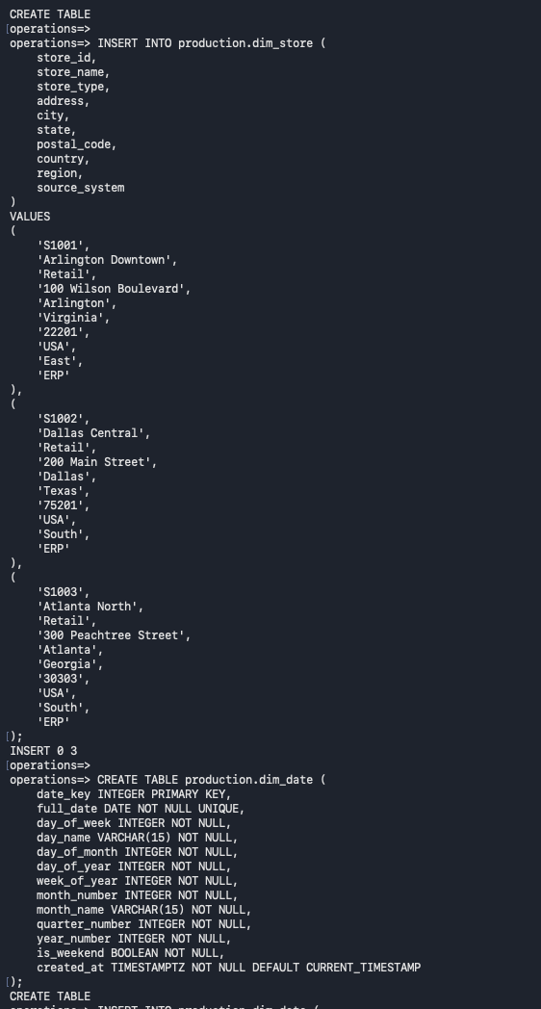
Population of the date dimension for 2026–2027 and creation of production.fact_sales with dimension foreign keys and constraints.
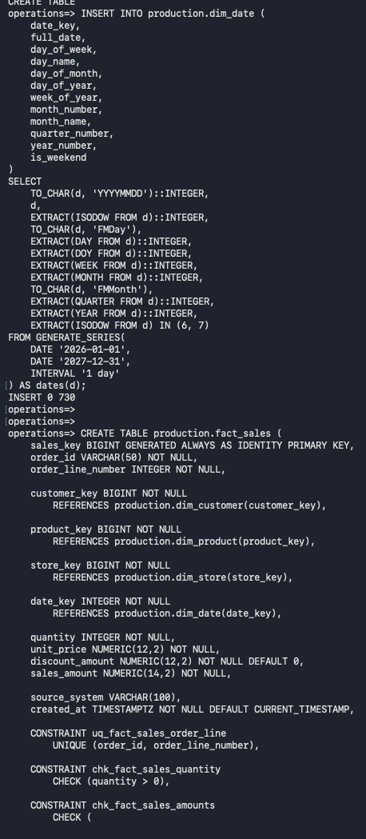
Creation of staging tables for customers, products, stores, and orders, including source, batch, and load metadata.
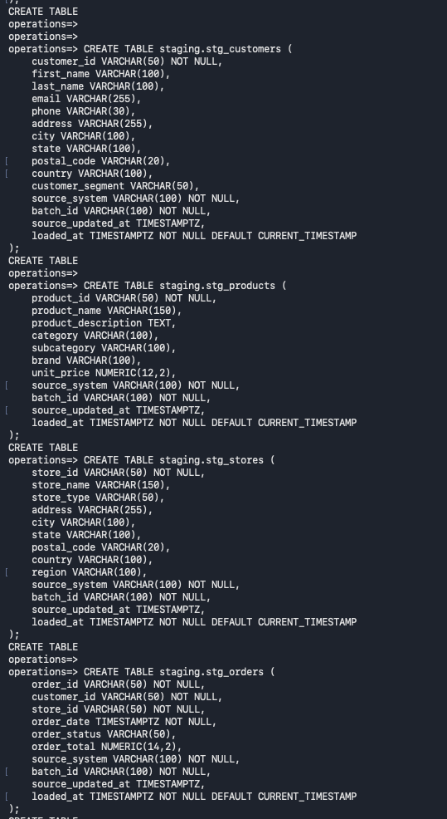
Creation of staging.stg_order_items and audit.etl_batch_log with batch status, record counts, and error-message fields.
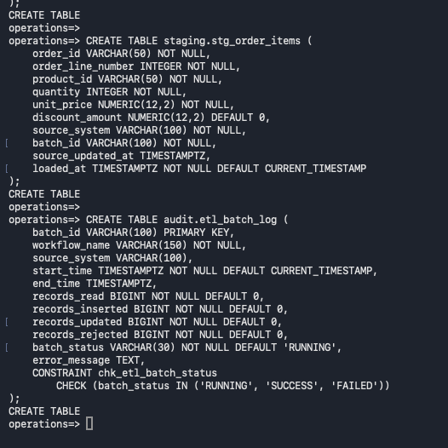
PostgreSQL schema and table inventory showing the audit, production, and staging objects.
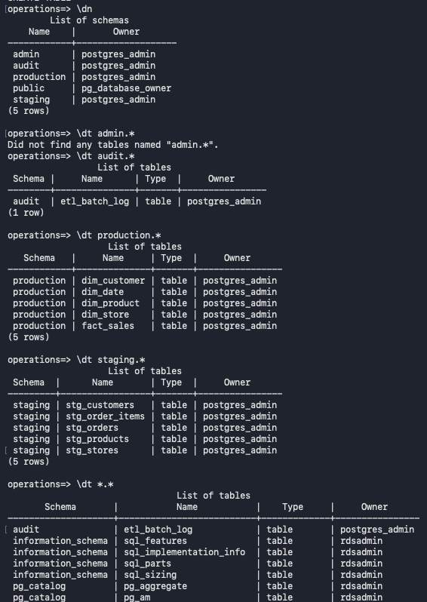

5. NiFi CSV Ingestion, Failure Handling, and RDS Validation
This section documents the retail CSV ingestion workflow and its database-side validation. The screenshots cover the NiFi flow and its success/failure paths, ingestion audit results, a controlled failure caused by an invalid staging target, the corresponding NiFi error, secure RDS connectivity, TLS status, and staging/production validation results.
Apache NiFi canvas showing the CSV customer ingestion flow and its success and failure processing paths.
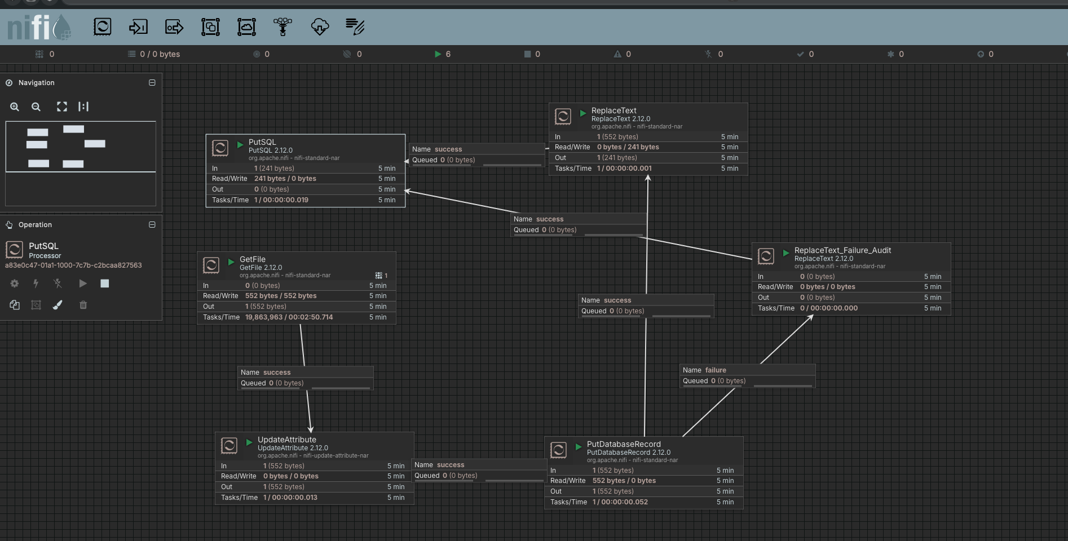
Audit query results showing successful CSV_CUSTOMER_INGESTION executions for batch BATCH_20261103_001.
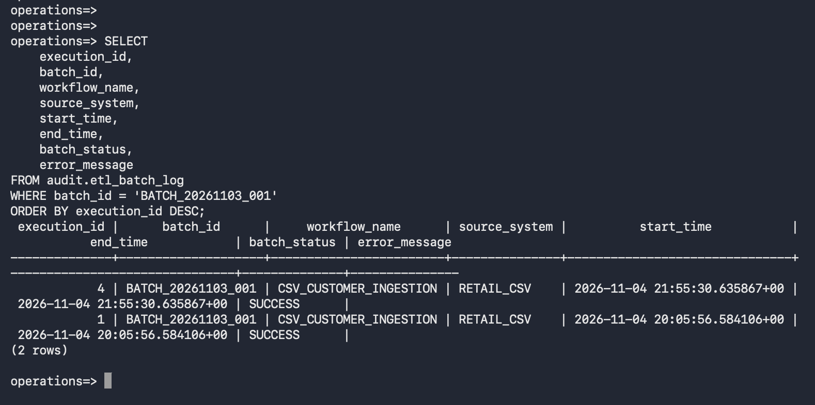

NiFi flow configuration showing the controlled failure-test path and the deliberately invalid staging target.
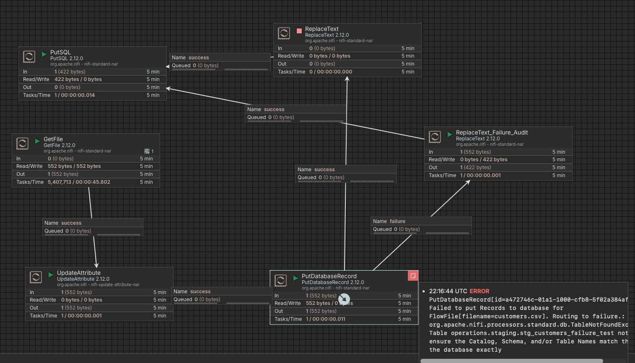
Audit query results showing the failed CSV ingestion execution alongside successful executions for the same batch.
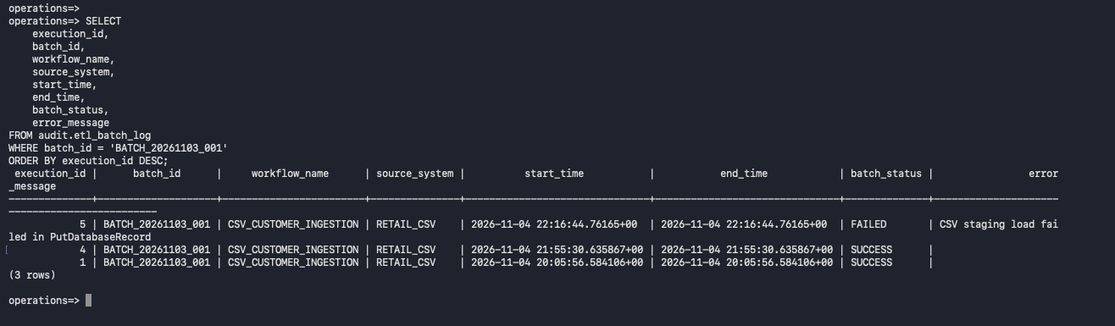

NiFi PutDatabaseRecord bulletin showing the database error caused by the configured staging table not being found.
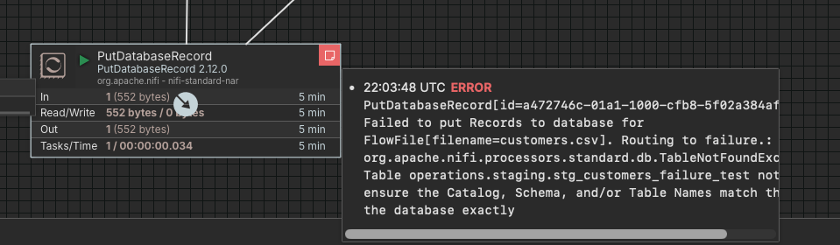
RDS database validation showing PostgreSQL version, current database and user, SSL status, schemas, and project tables.
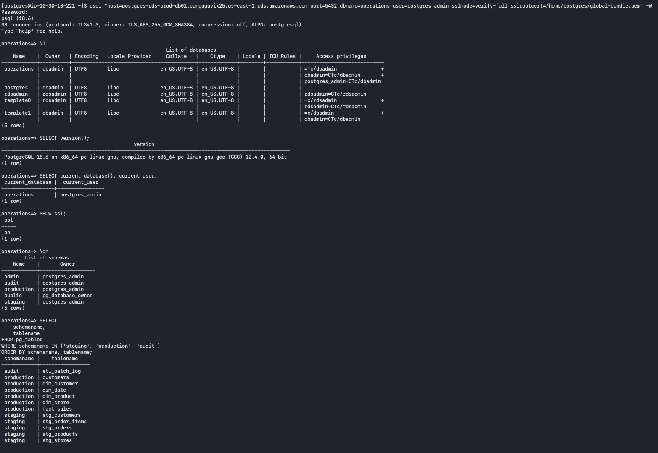
TLS and staging validation showing the negotiated TLS 1.3 cipher, staging row counts by batch/source, and staged customers.
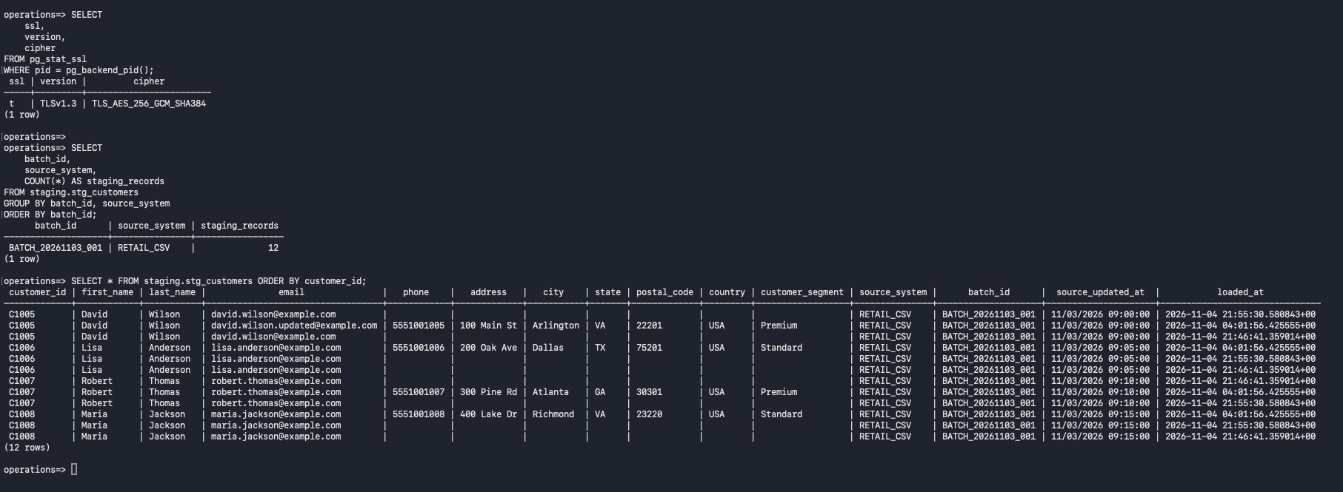
Production customer validation showing the loaded customer rows, updated email for C1005, total row count, and primary key.
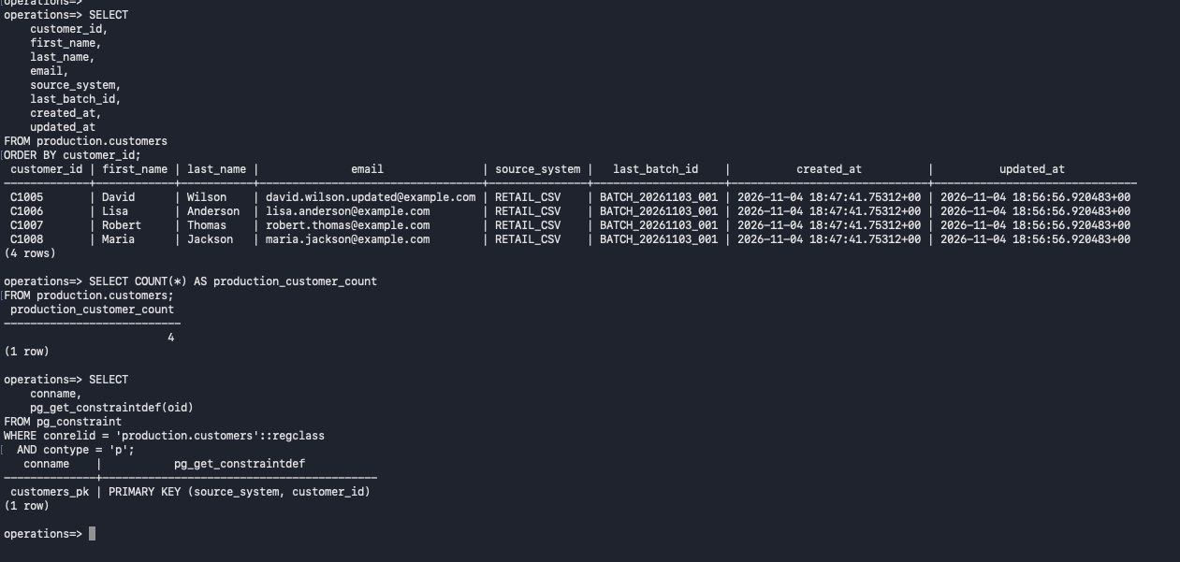
ETL audit validation showing execution-level read/insert/update/reject counts, statuses, and execution totals.
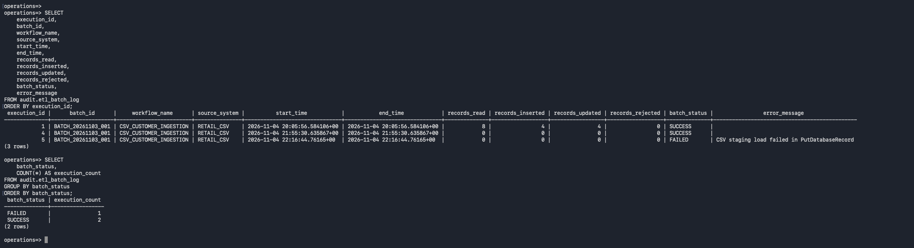

6. Oracle Source Preparation and NiFi LYRIS Extraction
This section documents preparation of the Oracle 19c source and extraction of LYRIS customer data into PostgreSQL. The screenshots show Oracle host and CDB/PDB checks, source-table inventory, read-only extraction accounts and grants, NiFi Oracle connection services and processor configuration, creation of the PostgreSQL LYRIS staging table, extraction flow execution, staged customer rows, and production load validation.
Oracle 19c source host verification showing PMON, Oracle environment variables, SQL*Plus connectivity, and CDB/PDB open modes.
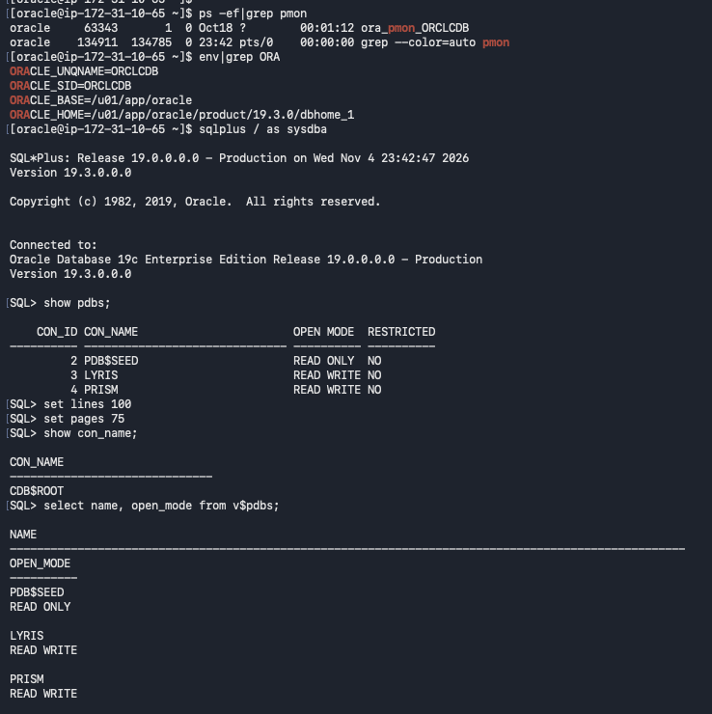
Oracle LYRIS_APP table inventory showing CUSTOMERS, ORDERS, ORDER_ITEMS, and PRODUCTS with estimated row counts.
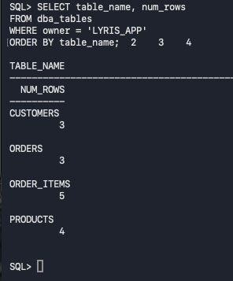

Oracle source access setup showing the read-only NIFI_LYRIS_RO and NIFI_PRISM_RO accounts creation and their SELECT grants.
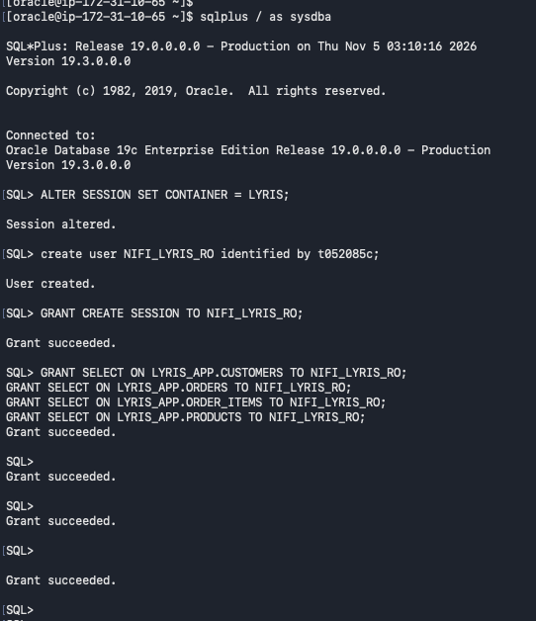
NiFi Oracle connection/controller-service setup, including DBCP connection pools and ExecuteSQL configuration for LYRIS.
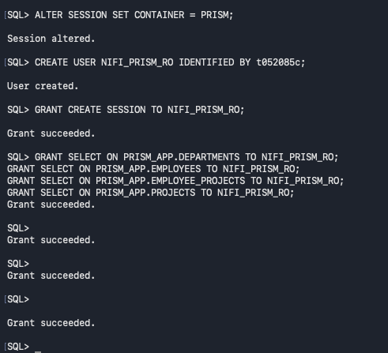
Creation of PostgreSQL staging.stg_lyris_customers with source-system, batch, and load-timestamp metadata.
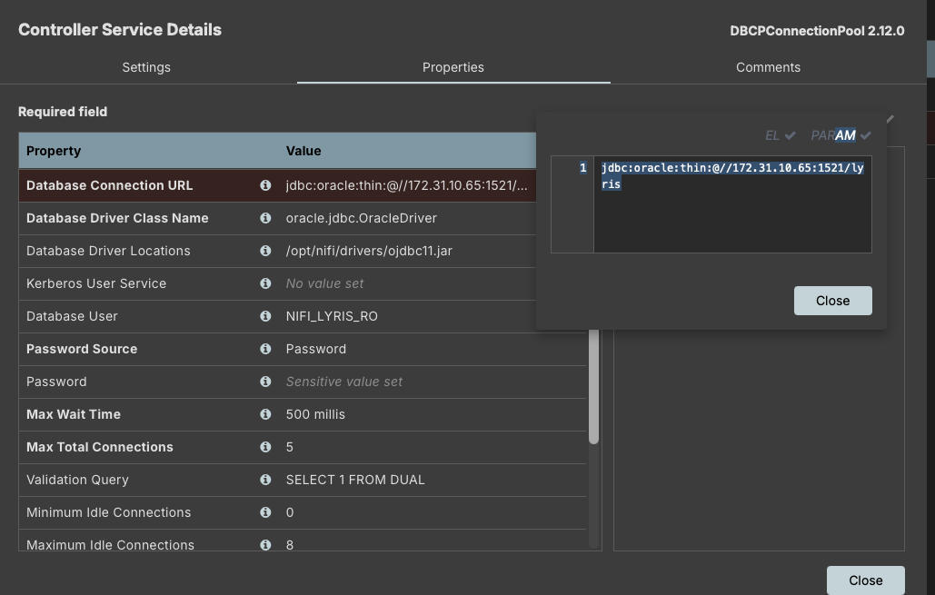
NiFi DBCPConnectionPool configuration for the Oracle PRISM source, using the NIFI_PRISM_RO account and the PRISM JDBC connection URL.
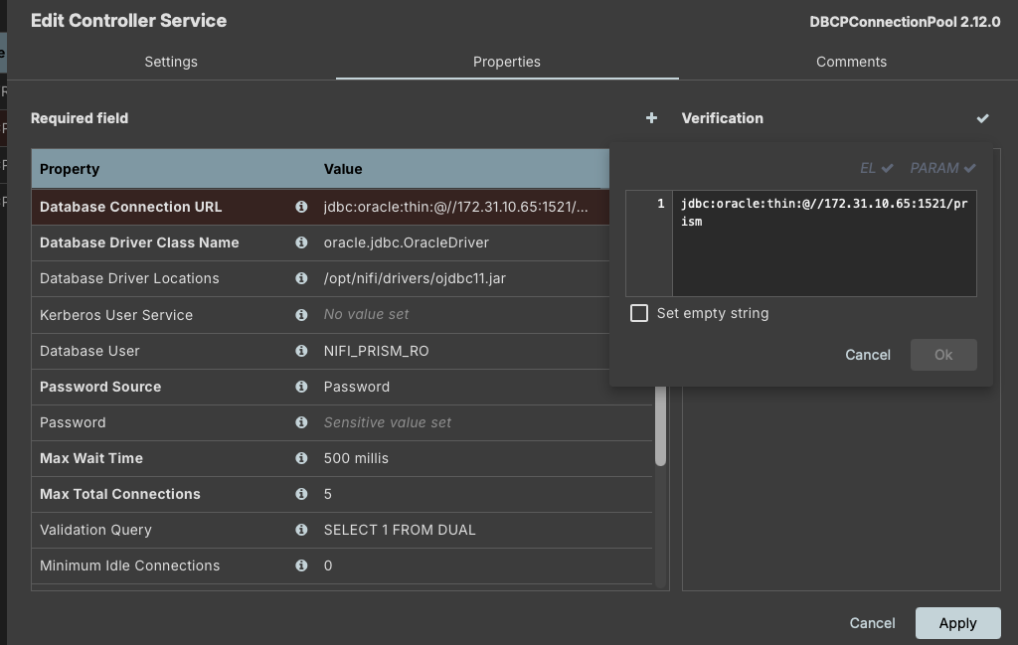
NiFi Controller Services inventory showing the configured Oracle and PostgreSQL database connection pools.
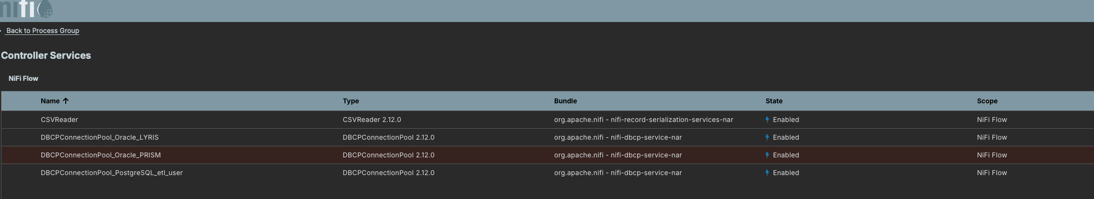
NiFi ExecuteSQL processor configuration for the Oracle LYRIS source, using the LYRIS connection pool and a COUNT query against LYRIS_APP.CUSTOMERS.
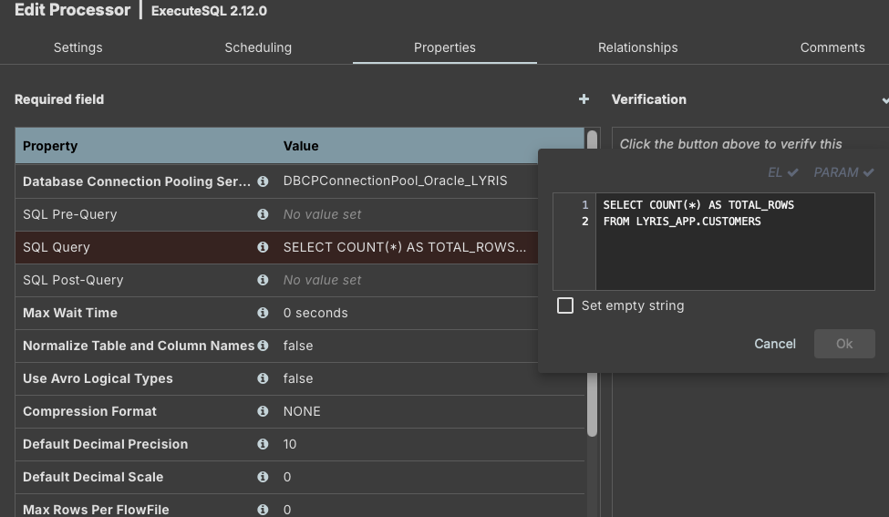
PostgreSQL DDL creating staging.stg_lyris_customers with customer fields, source_system, batch_id, loaded_at, and a composite primary key.
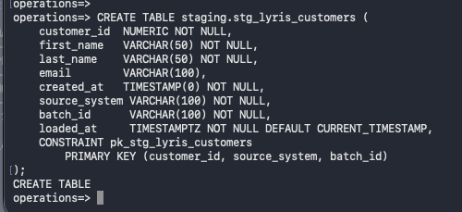
NiFi Oracle LYRIS customer extraction flow showing ExecuteSQL, UpdateAttribute, logging, and PostgreSQL loading processors with success/failure relationships.
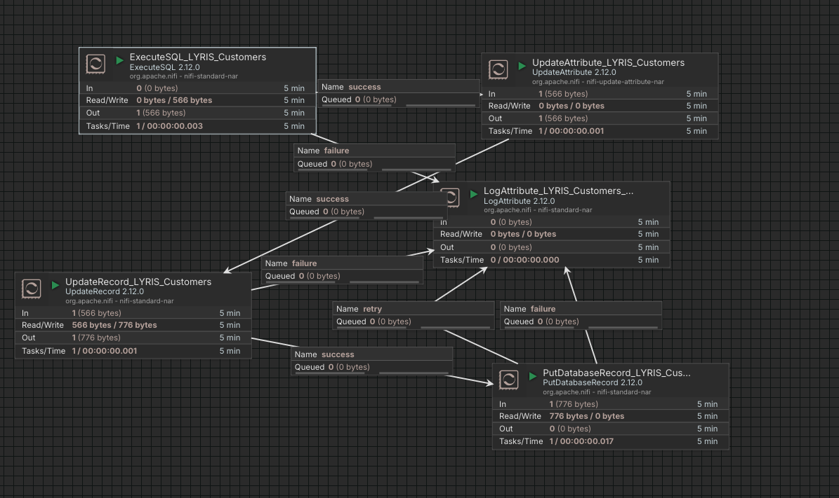
Query results from staging.stg_lyris_customers showing the three extracted LYRIS customers—Alice Johnson, Robert Smith, and Maria Garcia—with source and batch metadata.
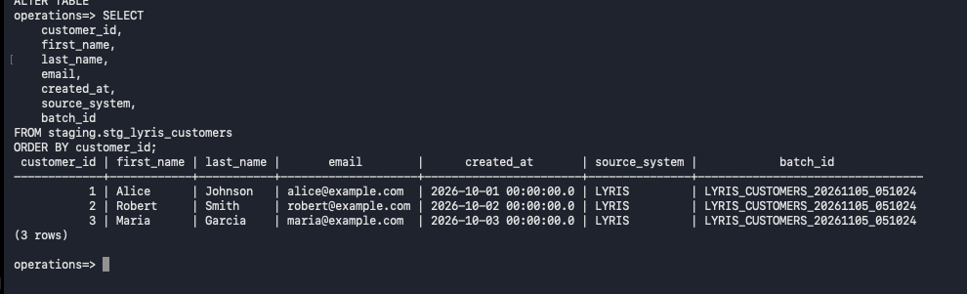
Expanded NiFi LYRIS ingestion flow showing the extraction, attribute update, logging, and database-record loading paths.
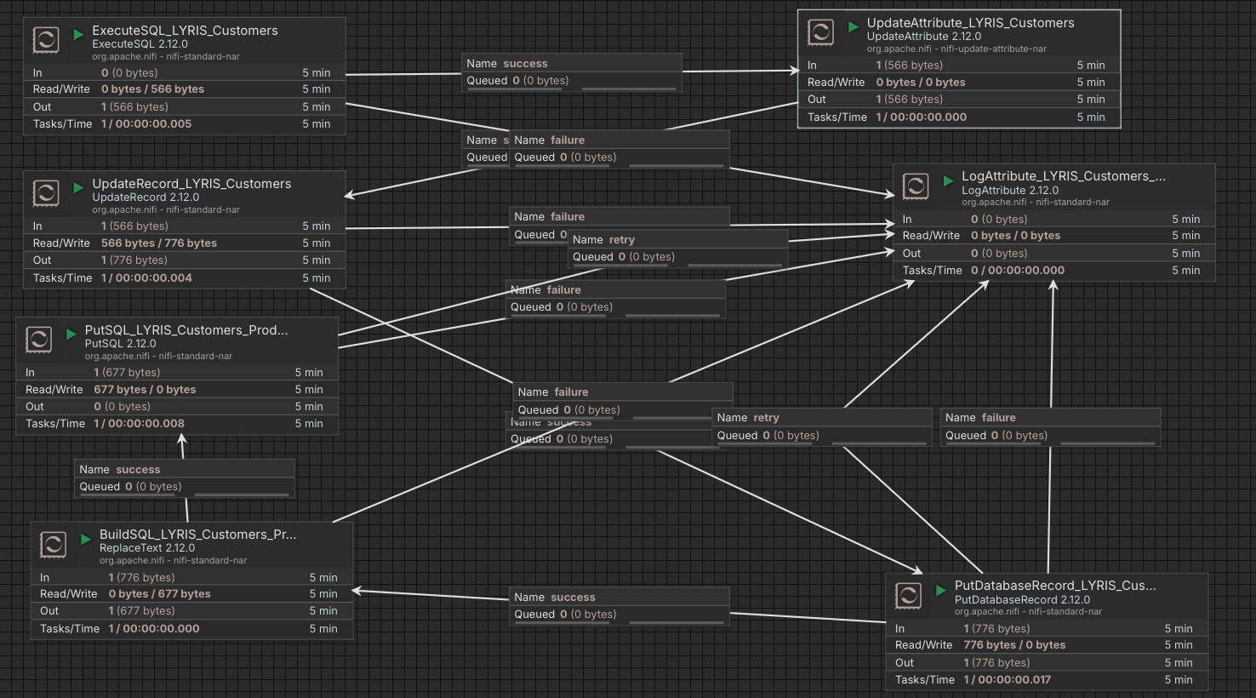
Production validation query showing the three LYRIS customer records loaded into production.lyris_customers, including source and last-batch metadata.
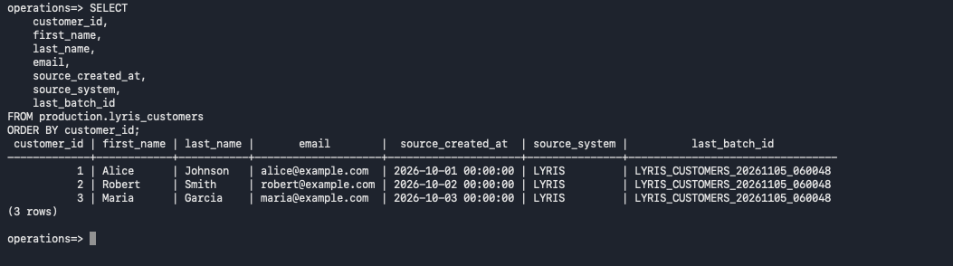

7. Airflow Deployment and DAG Execution
This section presents the Airflow orchestration layer and its execution results. The screenshots show the retail_customer_etl workflow and its validation, dimension-load, and audit tasks, successful manual DAG runs, task-instance outcomes, and a deliberately invalid batch used to confirm that validation failures are captured in the audit table.
Airflow retail_customer_etl DAG overview showing its three tasks: validate_staging, load_customer_dimension, and audit_etl_run.
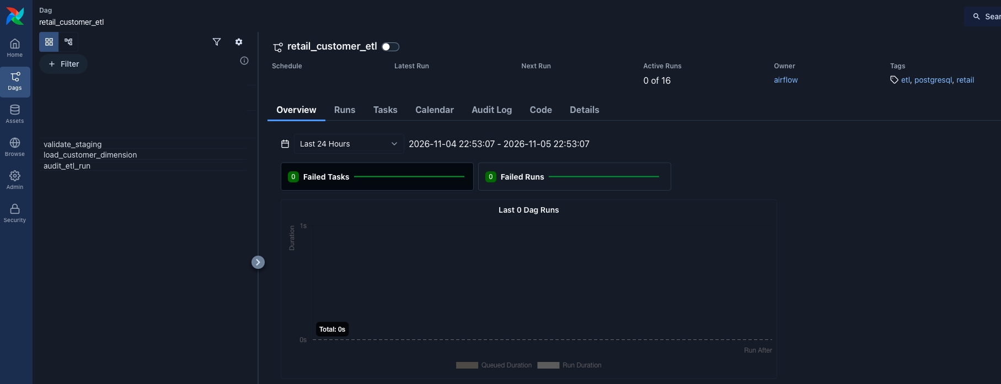
Airflow manual DAG run details showing a successful run and all three task instances completed successfully.
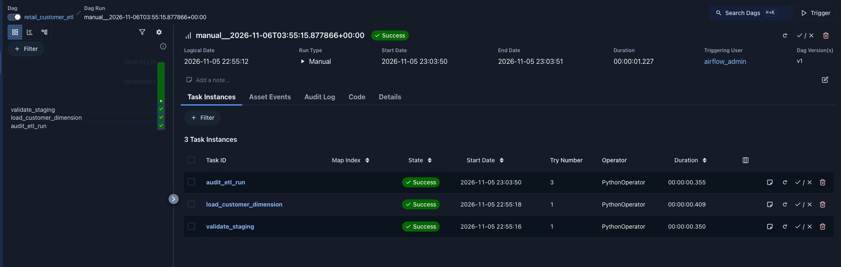
Airflow manual DAG run task-instance view showing successful completion of validate_staging, load_customer_dimension, and audit_etl_run.
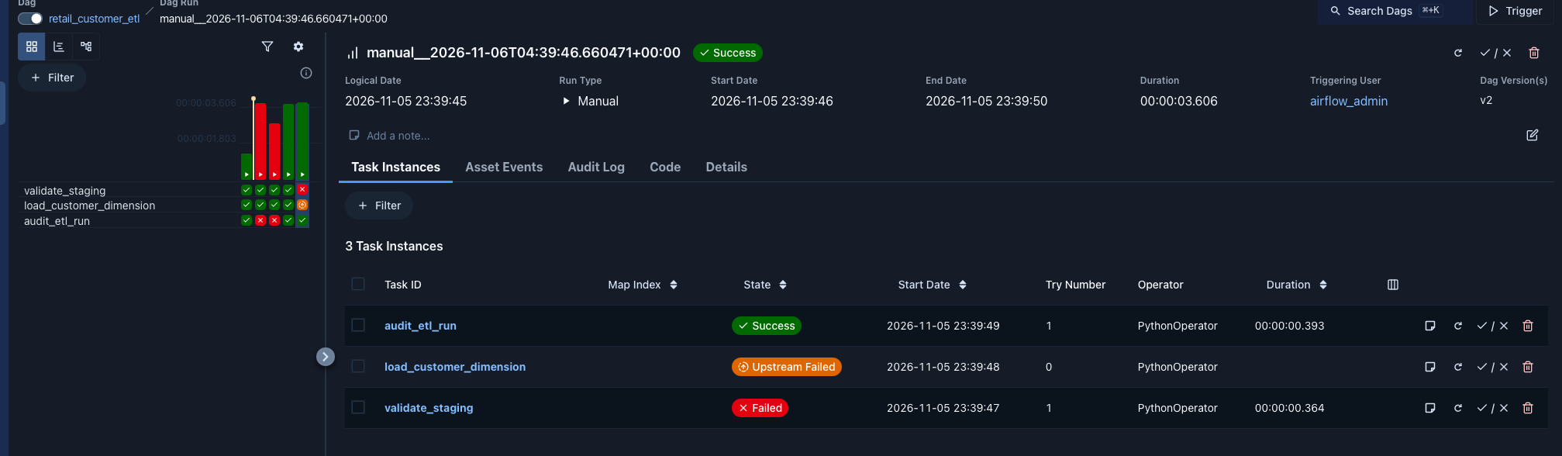
Audit query result for BATCH_AUDIT_FAILURE_TEST showing FAILED status, zero records read, and the validation-task failure recorded in error_message.
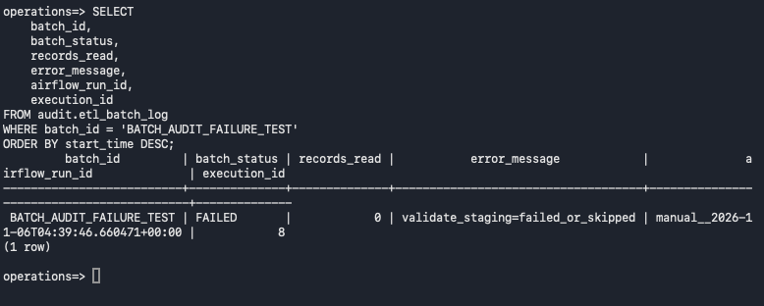

8. Airflow Operations, ETL Audit, and Final PostgreSQL Validation
This section consolidates operational checks and end-to-end project validation. The screenshots show NiFi and Airflow service status, Airflow version and DAG discovery, CLI and task checks, successful workflow execution, PostgreSQL database and staging inventories, customer dimension reconciliation, ETL audit outcomes, and final secure RDS connectivity and schema/role inventory.
NiFi service verification on the ETL EC2 host showing NiFi status UP, the HTTPS listener on port 8443, and the HTTP response from the NiFi endpoint.
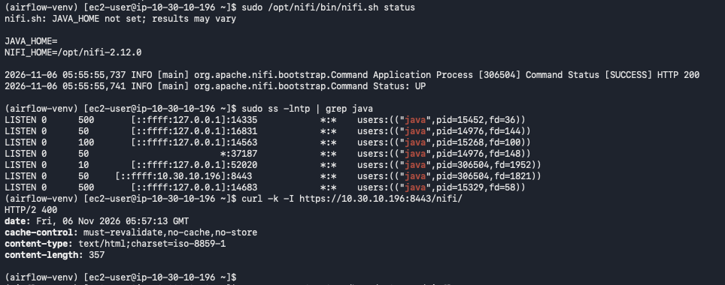
Airflow environment and CLI verification showing Airflow 3.3.2, DAG import checks, task listing, and discovery of the project DAGs including retail_customer_etl.
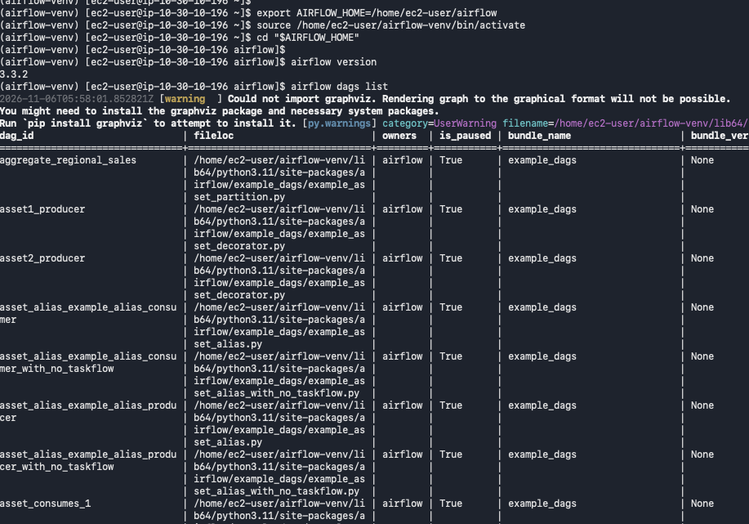
Airflow CLI validation showing no DAG import errors, the retail_customer_etl task list, and discovery of the project's DAG files.
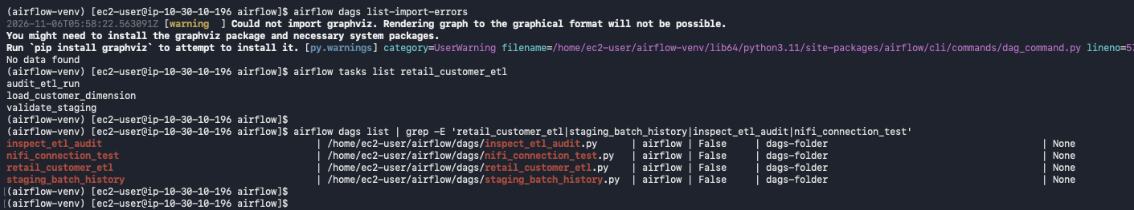
Airflow manual DAG run details showing a successful retail_customer_etl execution and successful completion of all three task instances.
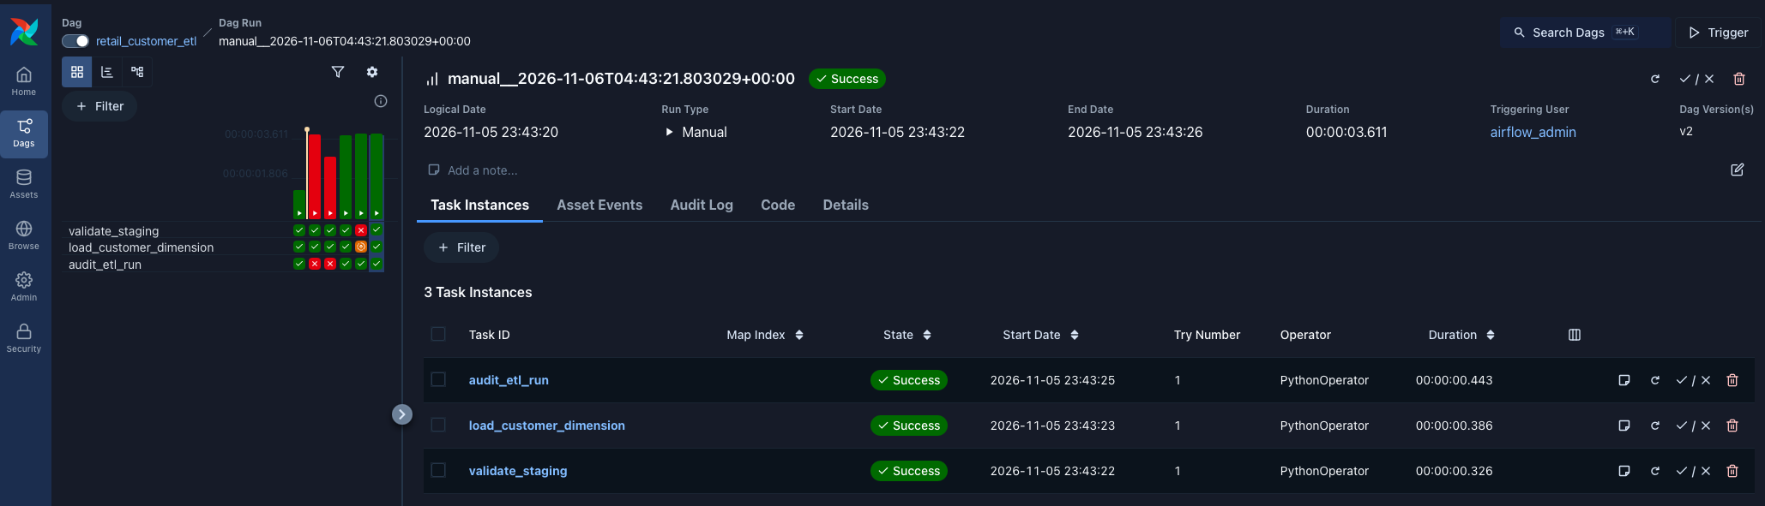
PostgreSQL database inventory and retail CSV staging validation, showing the operations and airflow_db databases, 12 rows in batch BATCH_20261103_001, and the staged customer records.
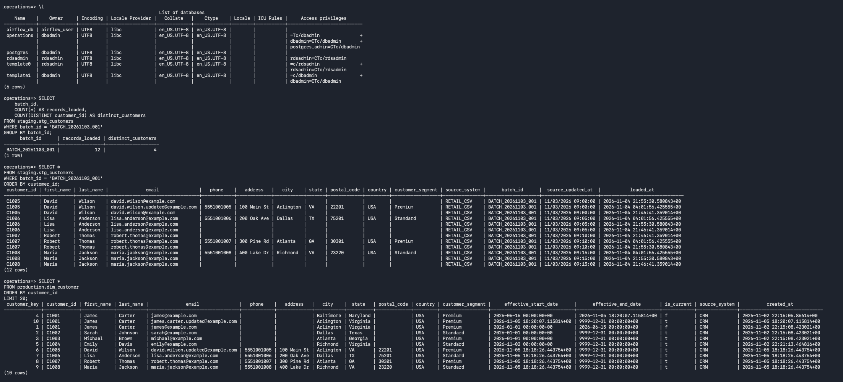
PostgreSQL customer-dimension reconciliation query showing 10 total dimension records across 8 distinct customers.
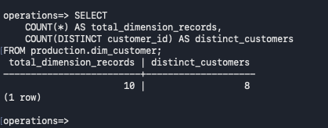
ETL audit verification showing execution-level batch records and the batch_status summary, including success/failure counts and aggregate read, insert, update, and reject totals.
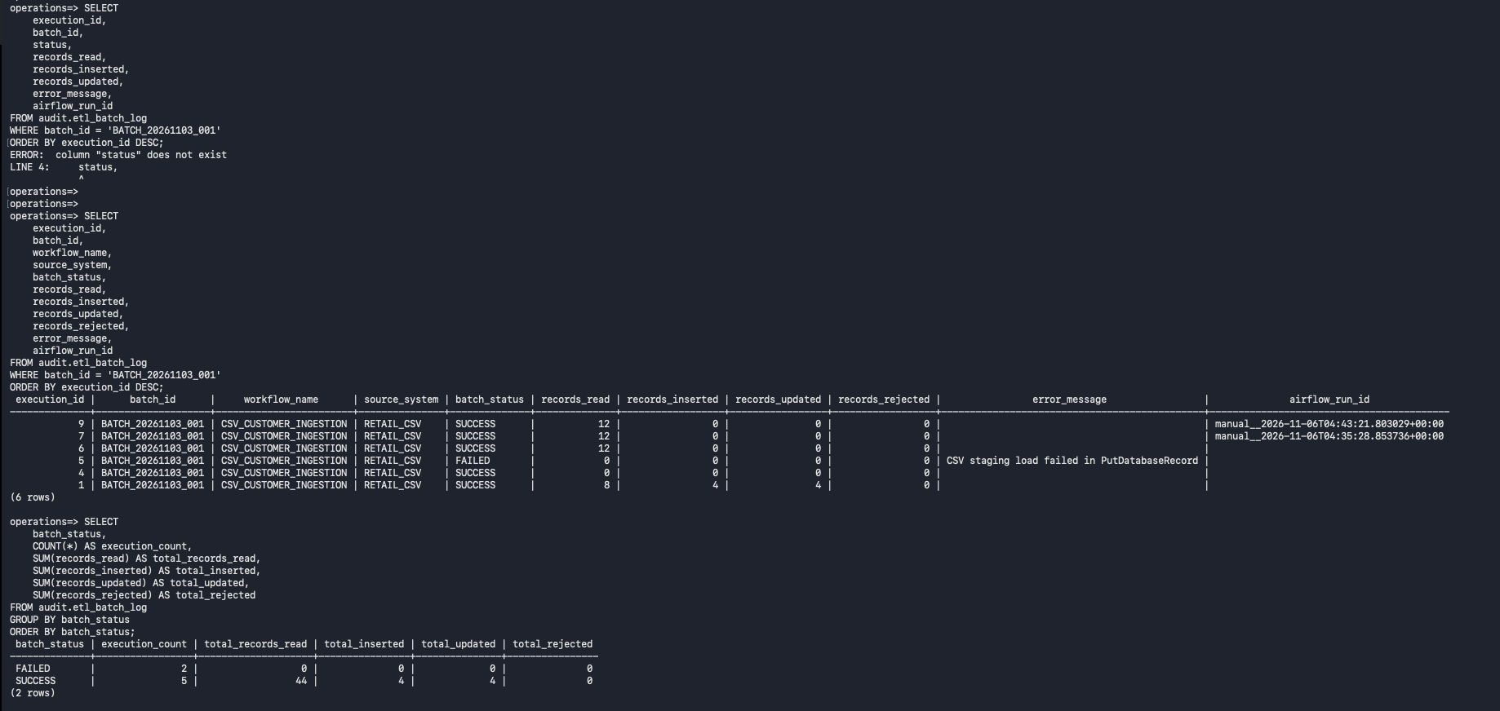
Final secure RDS access and database inventory check showing a TLS 1.3 connection, database list, PostgreSQL roles, and schema inventory.


