Implementation Summary
The screenshots document PostgreSQL 18.6 backup and recovery implementation and testings, and an in-place database migration.
• WAL and recovery preparation: Reviewed WAL settings and pg_wal usage, created the WAL archive directory, configured archiving, checked pg_stat_archiver, and enabled summarize_wal to support PostgreSQL 18 incremental backups.
• Logical backup and restore: Created and inspected a custom-format pg_dump of lyris_prod, exported global objects separately, restored to an isolated test database, and checked schemas, tables, row counts, indexes, sequences, roles, and application grants.
• Full physical backup and restore: Created a streamed-WAL pg_basebackup with a backup manifest and verified it with pg_verifybackup. Copied it into a separate data directory, configured an isolated instance on port 5433, validated database objects and row counts, and stopped the test instance.
• Incremental backup creation: Enabled WAL summarization, created and verified a fresh full parent backup, inserted a known product after the parent backup, then created an incremental backup using the parent backup_manifest and verified the incremental backup.
• Combine backup implementation: Ran pg_combinebackup with the parent and incremental backup directories to assemble a complete data directory at /var/lib/pgsql/backups/physical/combined-20261024. Verified the combined output with pg_verifybackup, copied it to /var/lib/pgsql/18/combined5435, removed inherited standby connection settings, and started it as an isolated instance on port 5435. Confirmed lyris_prod was not in recovery and both test products (IDs 4 and 5) were present, then stopped the instance cleanly.
PostgreSQL_Backup_Restore_Recovery
Inspect WAL and replication-related configuration settings.
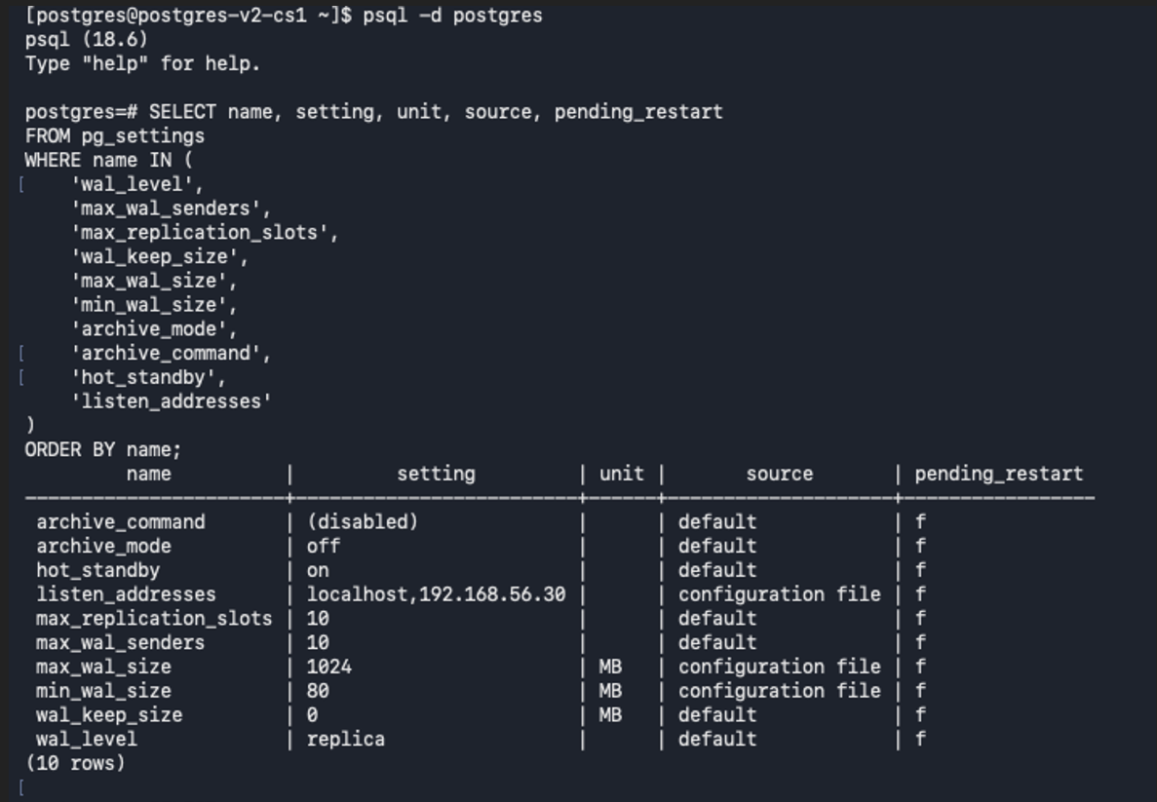

Check filesystem capacity and PostgreSQL WAL-directory usage.
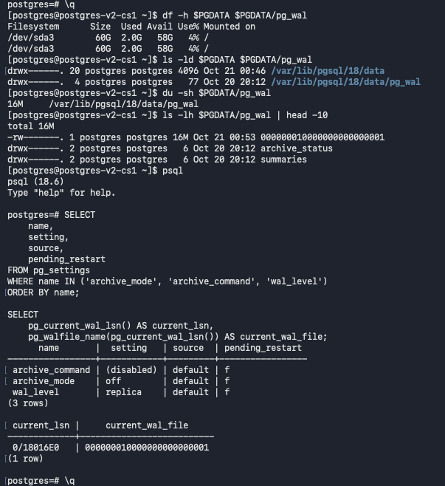

WAL archive directory creation
Creates the dedicated WAL archive directory and sets ownership and restrictive permissions so PostgreSQL can archive WAL safely.
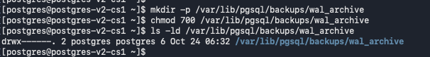
WAL archiving configuration edits
Shows configuration changes for the archive destination and archiving settings; these settings support recovery beyond the base-backup point.
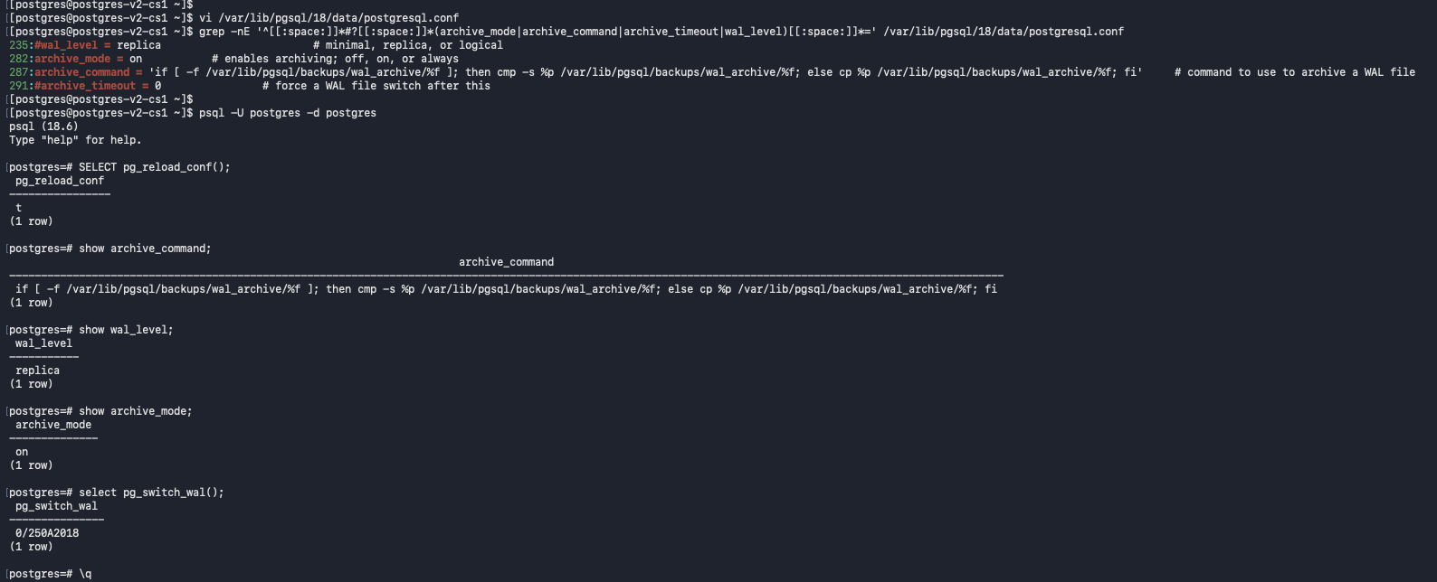
Archived WAL verification
Lists archived WAL files and checks pg_stat_archiver counters, including the last archived WAL and failed-archive count.
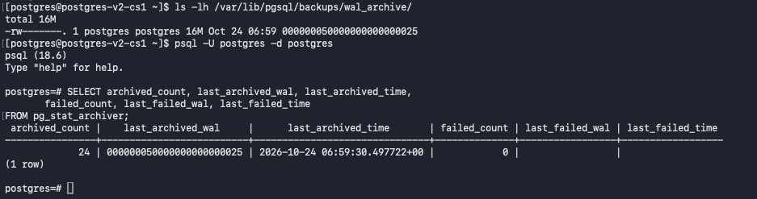

WAL summarization prerequisite
Shows summarize_wal initially off and then enabled by configuration reload; PostgreSQL 18 needs WAL summarization to create incremental backups.
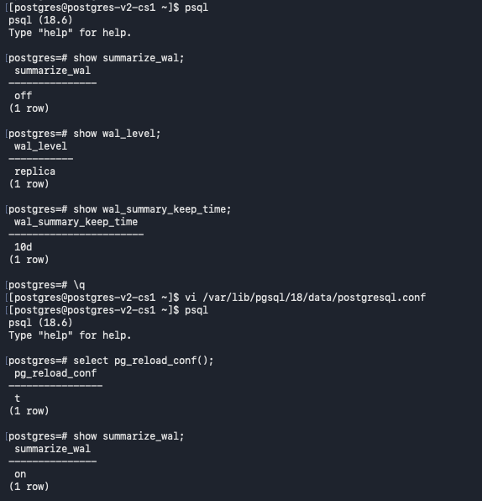

Backup directory structure and permissions
Creates separate logical, physical, and log backup directories and applies restrictive permissions to protect backup contents.
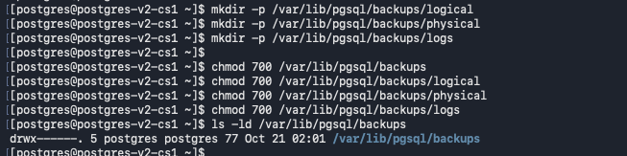
pg_dump
Logical dump creation and archive inspection
Creates a custom-format pg_dump backup of lyris_prod and inspects the archive contents with pg_restore --list before relying on it.
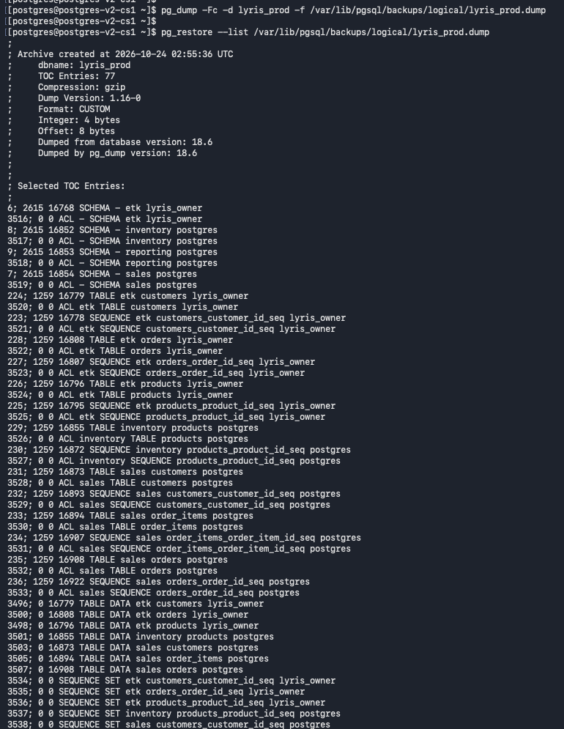
Logical backup file and global-object export
Checks the dump file and exports PostgreSQL global objects to a separate SQL file; globals are separate from the database dump.
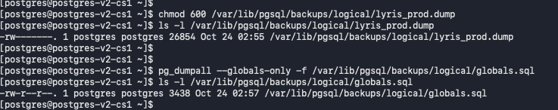
Restore pg_dump into a test database and validate objects
Restores the logical dump into an isolated test database, then checks schemas, tables, and row counts to confirm the data was restored.
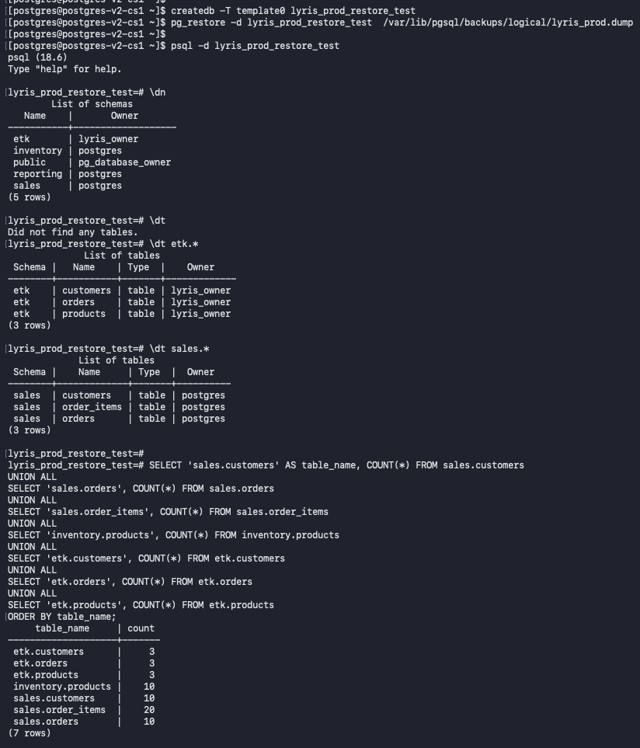
Restored role inventory
Database roles and attributes in the test restore are reviewed after recovery.
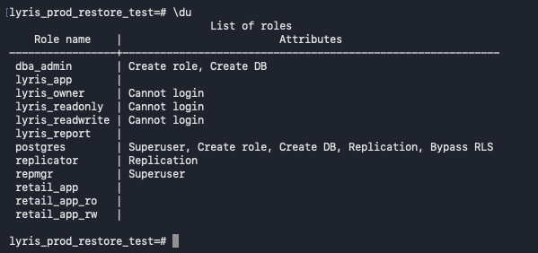
Restored indexes
Queries pg_indexes to confirm indexes across the etk, sales, and inventory schemas are present after the logical restore.
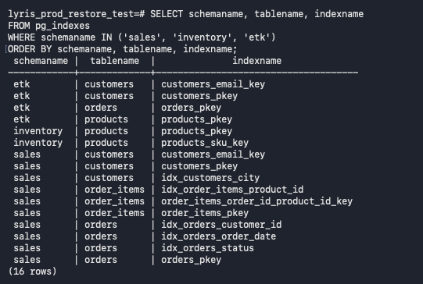
Sequences and application grants verified after restore
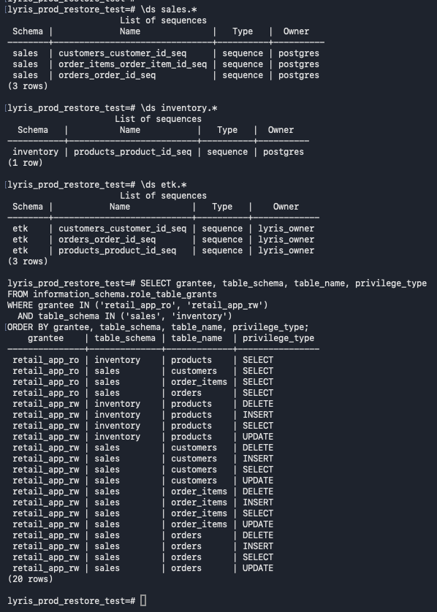
pg_basebackup
Full physical base backup and verification
Creates a full physical backup using pg_basebackup with streamed WAL, verifies the backup's integrity using pg_verifybackup, and confirms the backup_manifest file exists, establishing a verified baseline for physical recovery and subsequent restore testing. 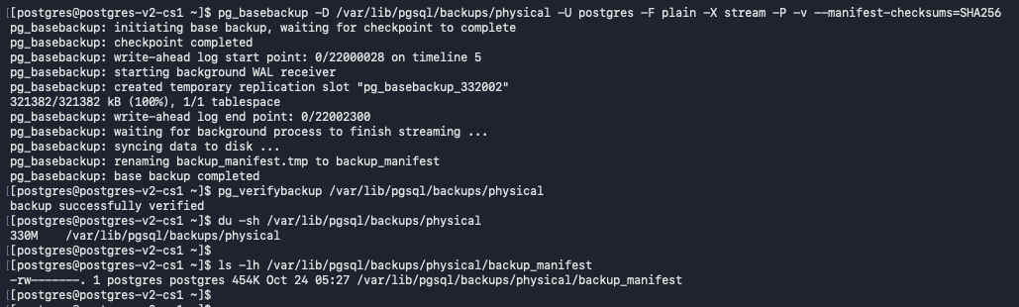
Physical backup directory contents
Inspects the generated backup files and manifest, confirming the backup is a physical PostgreSQL data-directory copy.
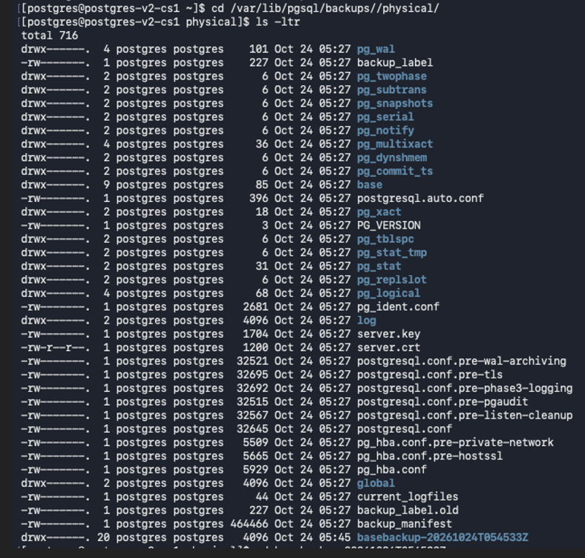
Verify the Timestamped Physical Backup
Inspects the timestamped backup contents and runs pg_verifybackup against that specific backup directory to confirm its integrity.
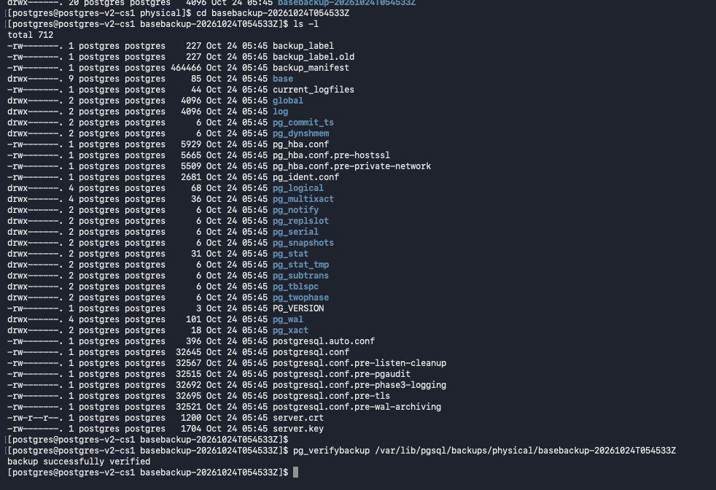
Isolated physical-restore configuration
Copy and Verify the Physical Restore Directory
Creates /var/lib/pgsql/18/restore5433, copies the verified base backup into it, verifies the copied data directory, and confirms port 5433 is not already listening.
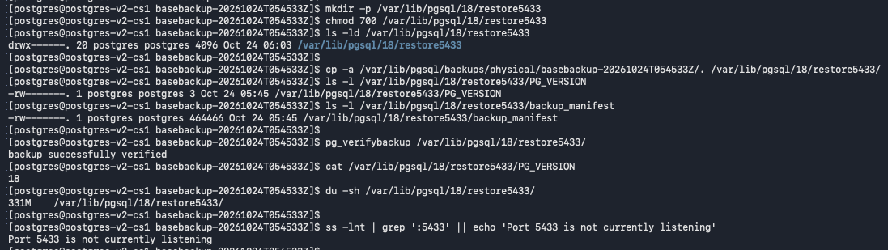
Configure and Start the Isolated Restore
Edits the copied configuration for port 5433 and localhost-only access, removes inherited standby connection settings, and starts the restore instance with its own log.
Configures the restore on a separate port and checks startup logs and listeners without replacing the primary.
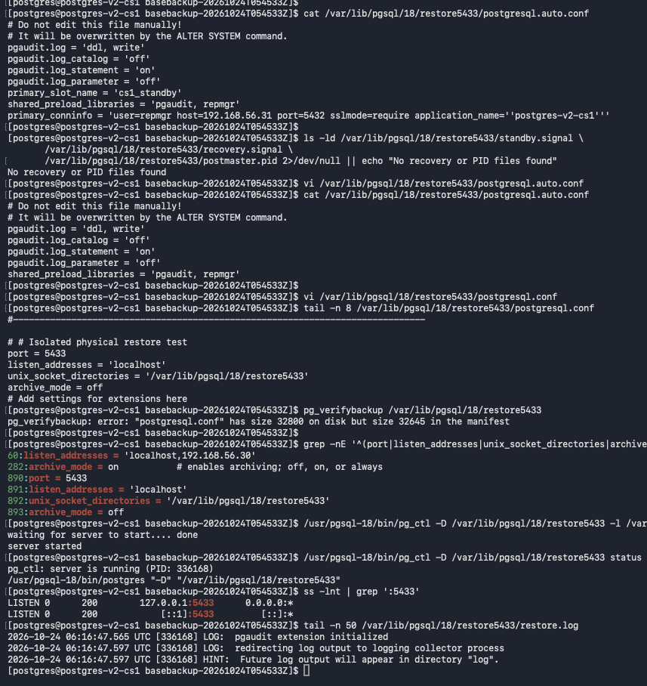
Restore connection and database-object validation
Confirm the Restore Instance Is Running
Checks the isolated PostgreSQL process, confirms port 5433 is listening, and reviews the startup log for successful initialization.
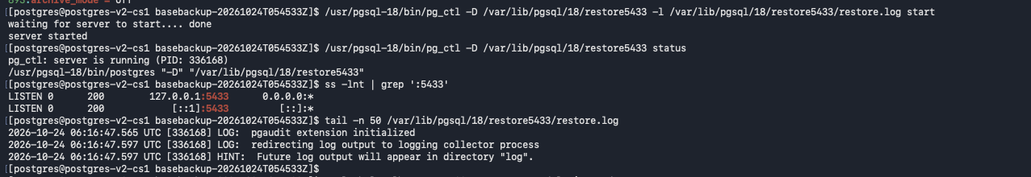
Validate the Restored Database Objects
Connects to the restored lyris_prod database on port 5433 and checks recovery state, schemas, tables, and role definitions.
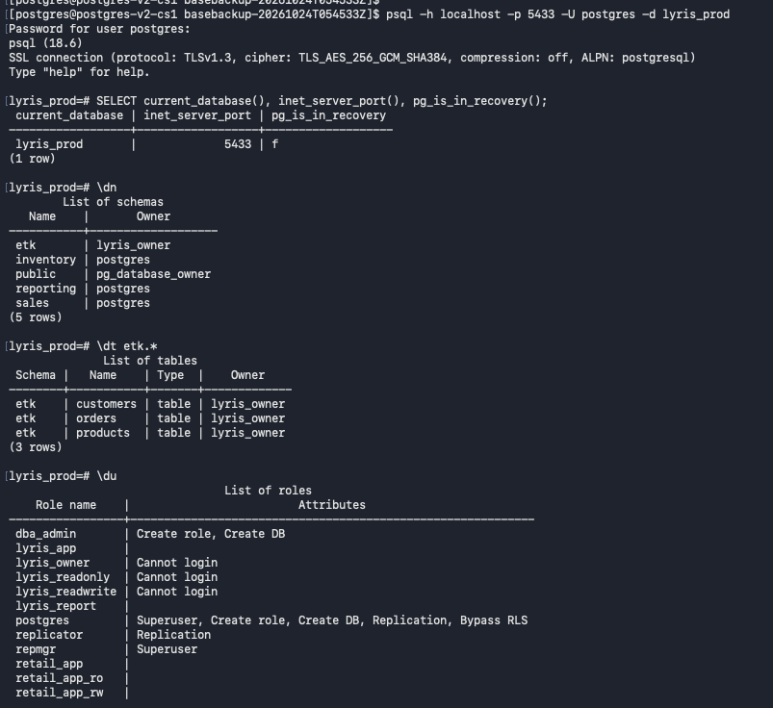
Restored roles and access-control inventory verified
Checks restored roles and application privileges as part of validating the physical restore and the primary instance and , then stops the isolated instance cleanly.
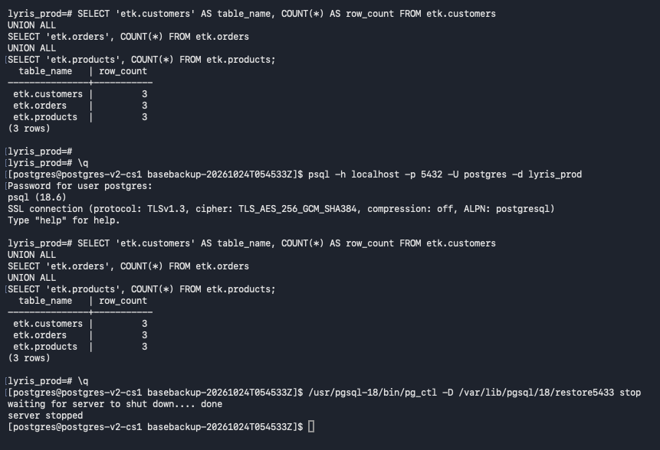

Incremental backups implementation
Create and verify incremental parent backup
Creates a new full parent backup after WAL summarization is enabled and verifies it; this avoids missing historical summaries from the older parent.
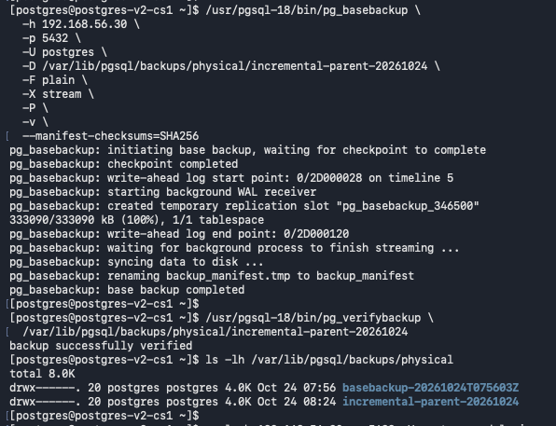
Insert the post-parent test record
Inserts a uniquely named product after the parent backup and confirms it exists, providing a known change to validate incremental recovery.
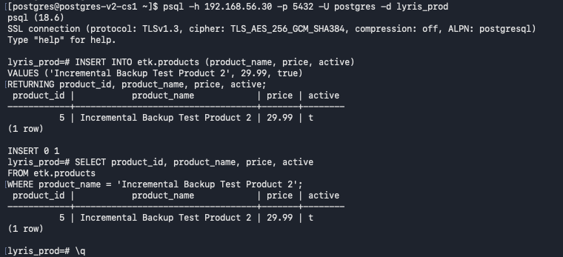
Incremental backup and combine workflow
Creates an incremental backup from the parent manifest, then combines parent and incremental directories into a complete data directory.
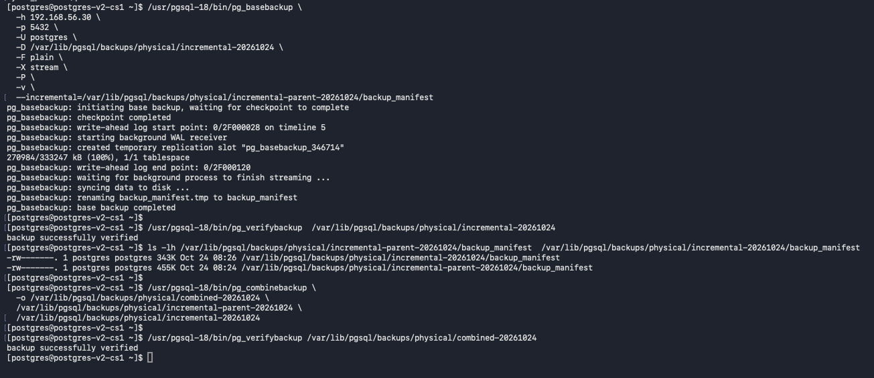
Configure and start combined restore
Uses an isolated data directory and port 5435; removes inherited primary_conninfo and primary_slot_name so the copy does not behave like a standby.
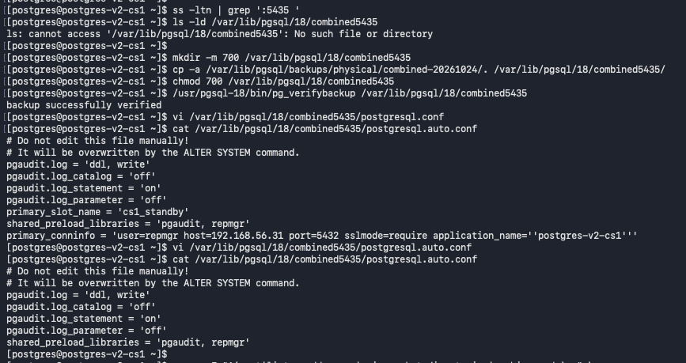
Validate combined restore and stop the instance after validation
Confirms the restored database runs on port 5435 and both test products are present, then stops the test instance cleanly.
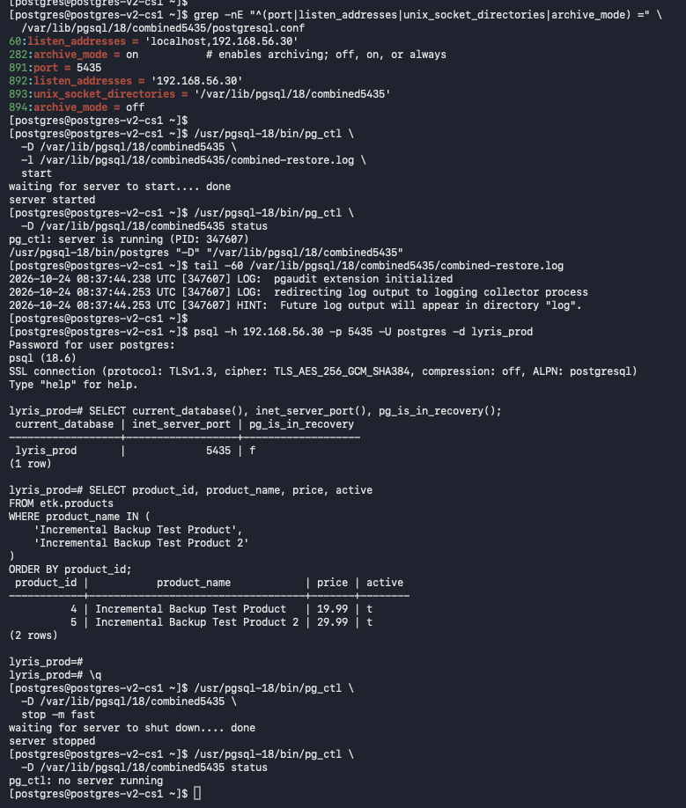
Create the PostgreSQL password file and restrict its permissions with chmod 600.

Query Postgres password file and mask stored passwords before displaying the PostgreSQL connection entries in the password file.
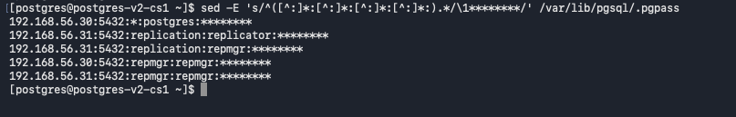
Database objects migration from retail database to lyris_prod, including data validation, RBAC, and primary/standby replication verification.
Source Database Inventory — Lists the original retail database and its schemas and tables before migration.
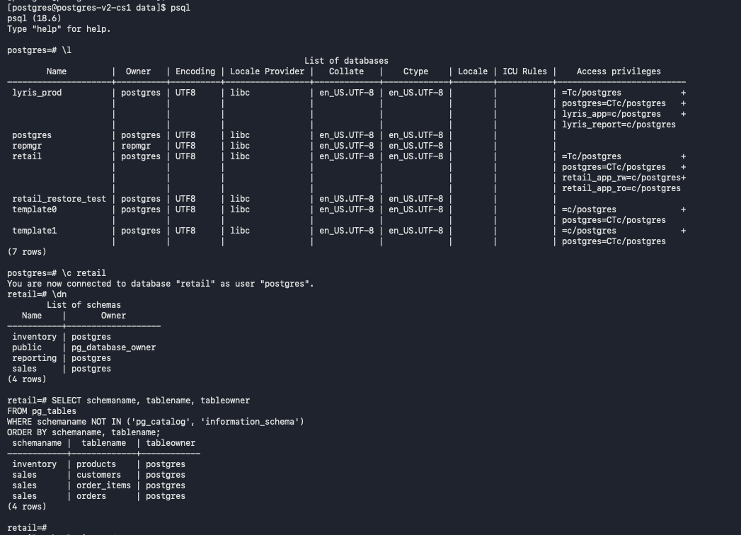

Target Database Objects — Confirms the etk schema and its customers, orders, and products tables in lyris_prod receiving retail database tables
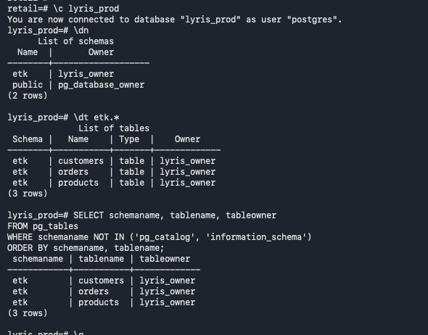

Database Export and Restore — Shows the pg_dump archive creation and pg_restore command for lyris_prod.
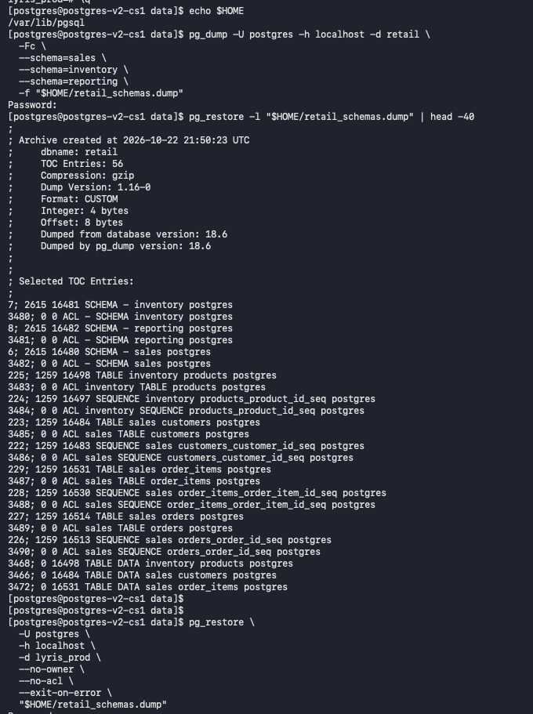

Migrated Data and Role Grants — Verifies migrated table row counts and grants for retail_app_ro and retail_app_rw.
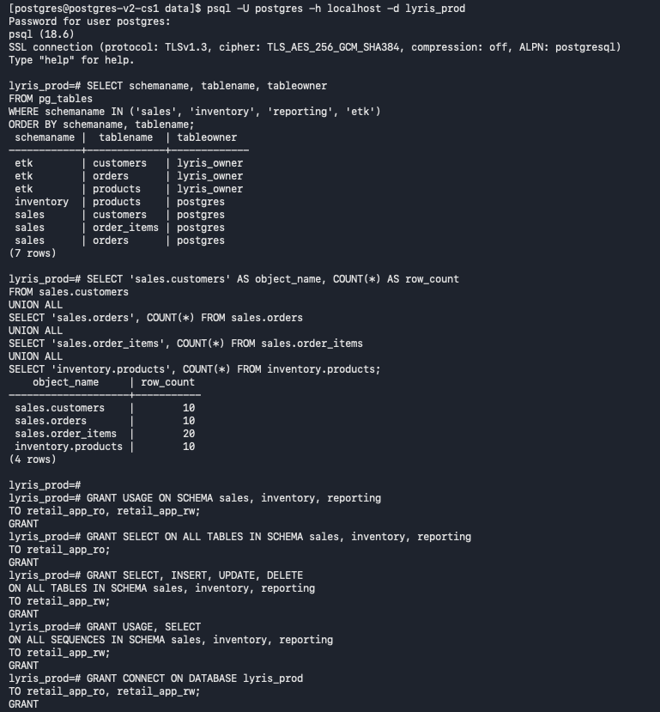

RBAC Privilege verification after migration
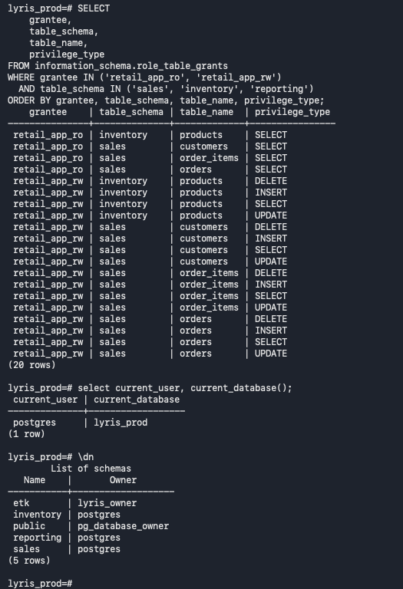

Post Migration Validation — Confirms migrated row counts, primary status, standby streaming, and retail before removal.
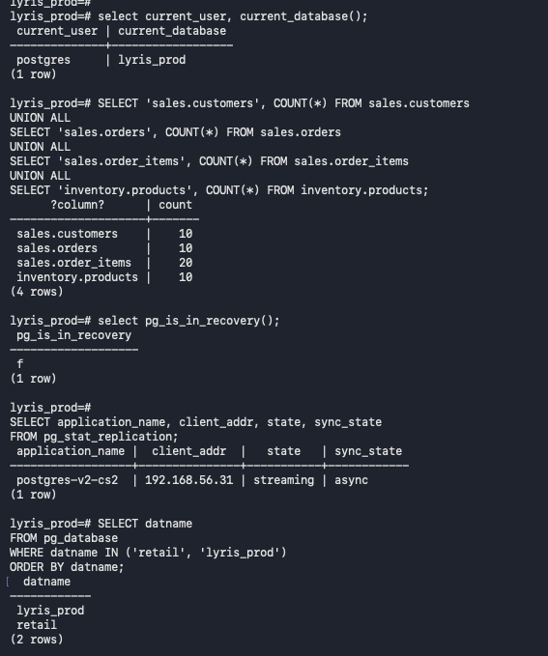

Pre-Removal Database Check — Shows both retail and lyris_prod present on the standby database before retail is dropped.
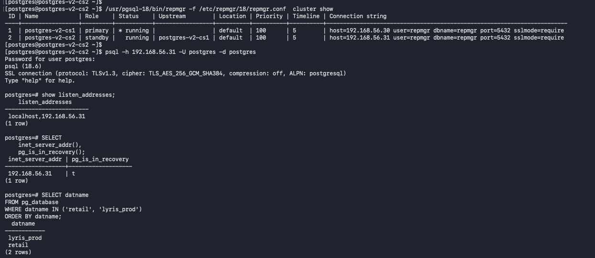

Source Database Removal — Shows DROP DATABASE retail WITH (FORCE) and confirms retail is removed from the primary.
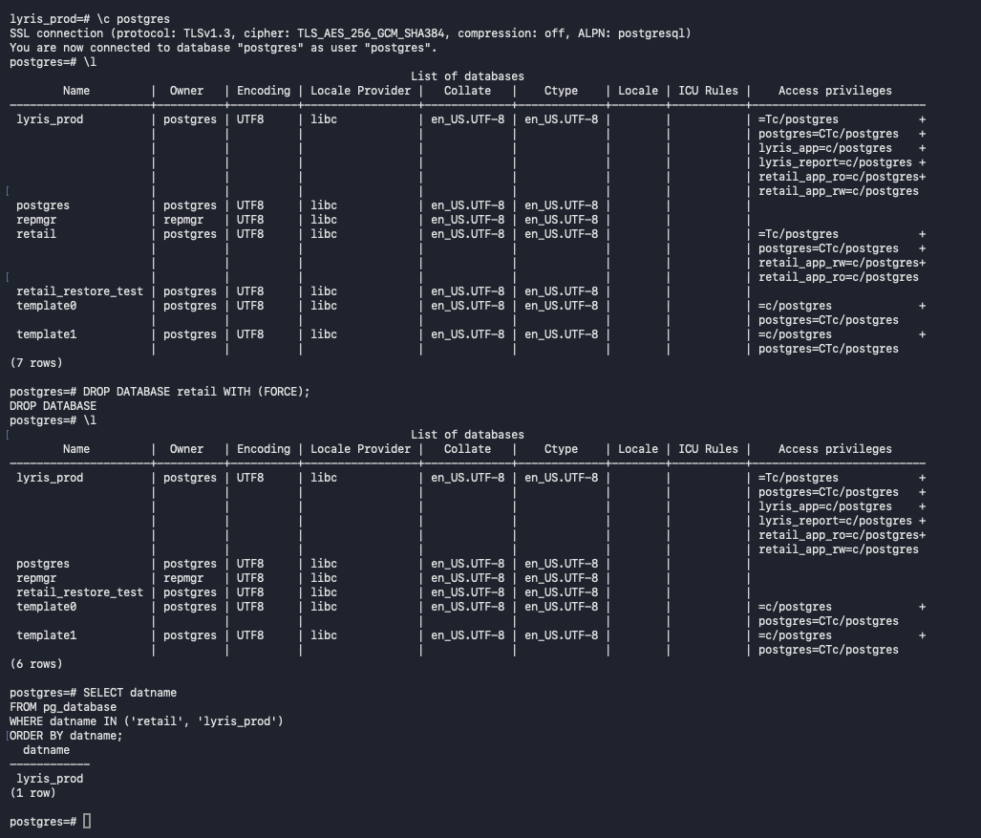

Final Standby Verification — Confirms lyris_prod remains on the standby, retail is absent, and the two-node repmgr cluster is visible.
