PostgreSQL 18 Installation, Administration, Security & RBAC
Project overview
This document records the installation and initial configuration of PostgreSQL 18.6 on two CentOS Stream 9 nodes. The screenshots cover PGDG repository setup, package installation and cluster initialization, service and psql validation, private-network connectivity, firewall and pg_hba.conf access rules, administrative login setup, self-signed TLS configuration, pgaudit configuration checks, role-based access control (RBAC), and database/schema/table setup with sample retail data. It includes checks of read-only and read-write role permissions and relevant database-object privileges.

• Node 1 — postgres-v2-cs1: 192.168.56.30
• Node 2 — postgres-v2-cs2: 192.168.56.31
Installation, administration, and security
• PGDG repository configuration, PostgreSQL installation, and initialization.
• Service and command-line validation, plus private-network connectivity.
• Firewall and pg_hba.conf access configuration.
• Administrative login setup and self-signed TLS configuration.
• pgaudit installation and configuration checks.
Role-Based Access Control (RBAC) and permissions
• RBAC is a key security control in this project: access is separated into read-only and read-write roles, with database-object privileges granted and validated according to each role’s intended access.
• Implementation details: Create read/write and read-only roles, grant schema and table privileges, and configure default privileges for future objects.
• Privilege validation covered migrated tables and the relevant sequences; read-write sequence USAGE was verified.

Node 1: Validate the CentOS Stream 9 environment and private-network configuration.
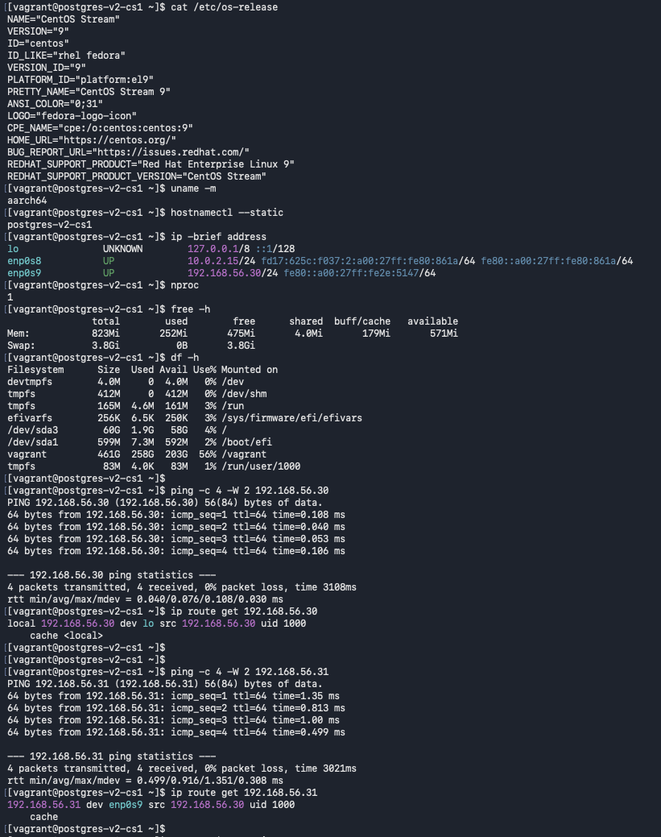
Node 2: Validate the CentOS Stream 9 environment and private-network configuration.
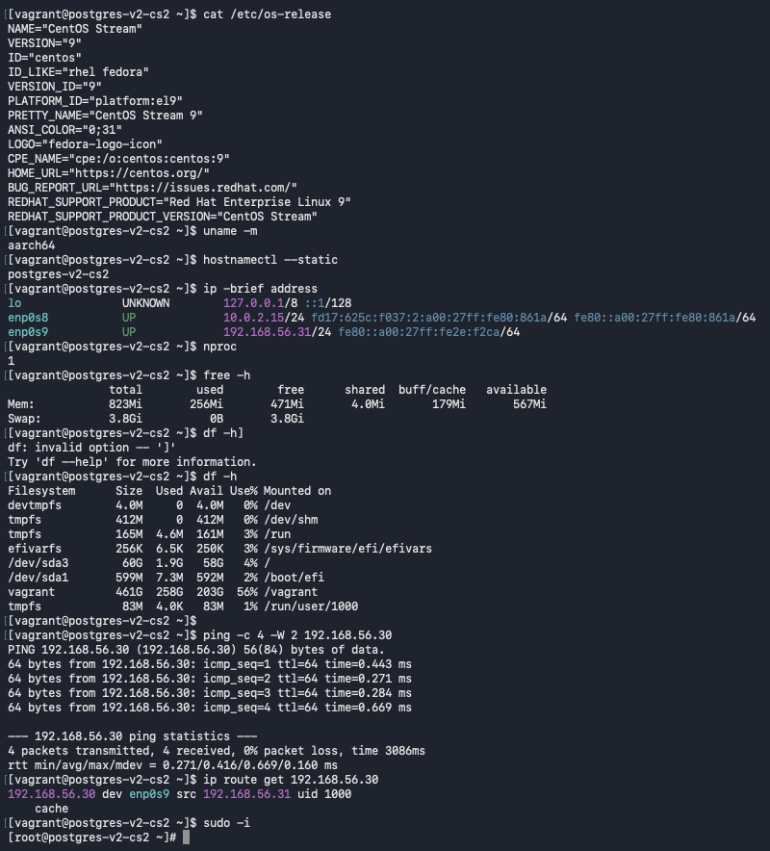
Node 1: Configure the PGDG repository for PostgreSQL packages.
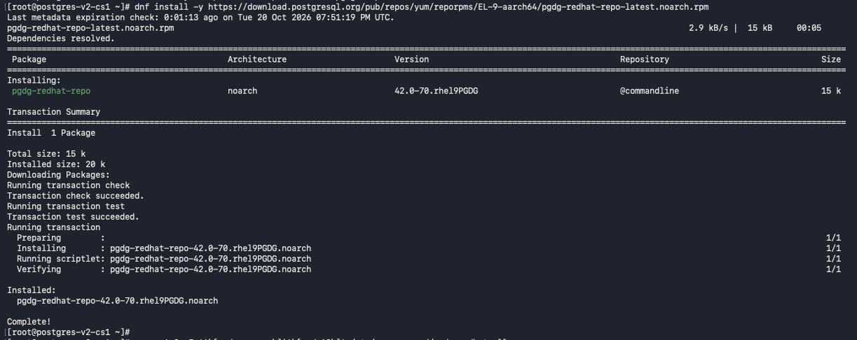
Review available PostgreSQL packages and versions on Node 1
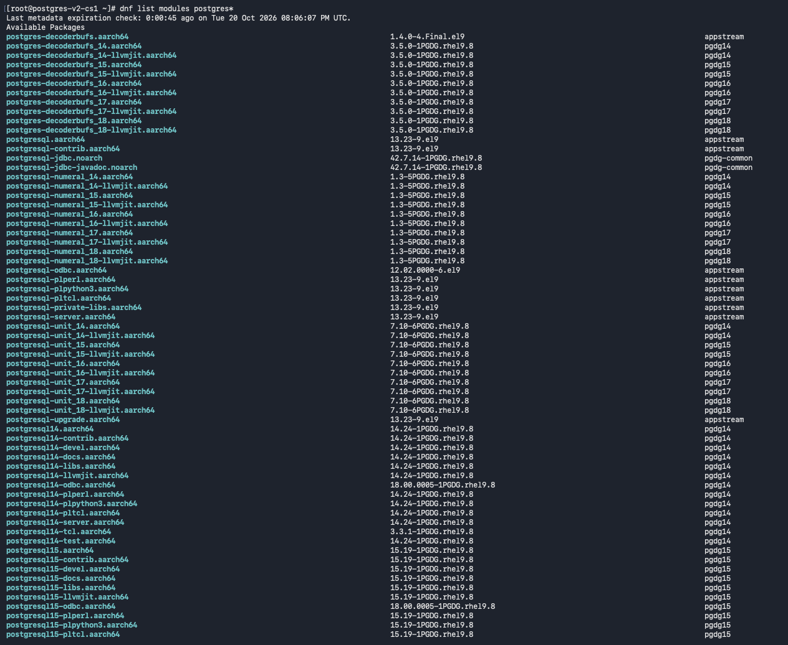
Review PostgreSQL package listings before installing PostgreSQL 18
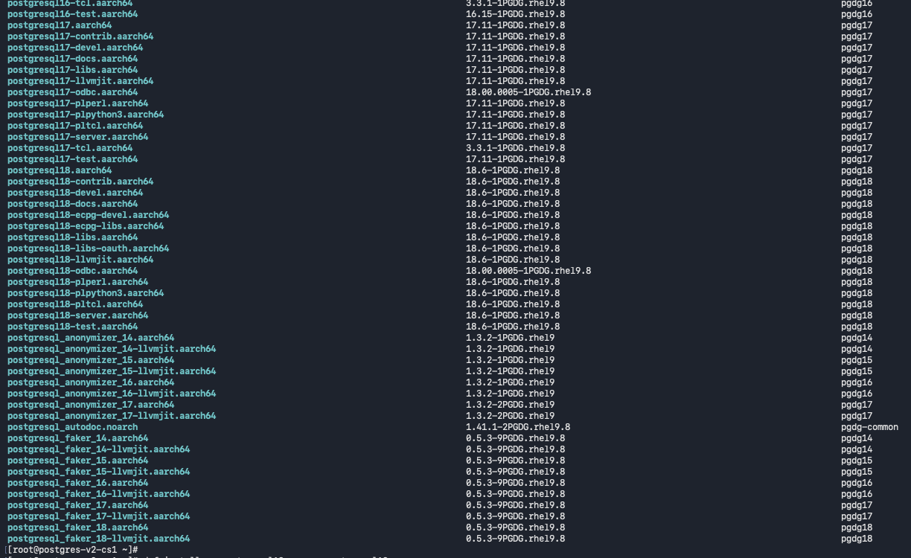
Install PostgreSQL 18 server and client packages on Node 1
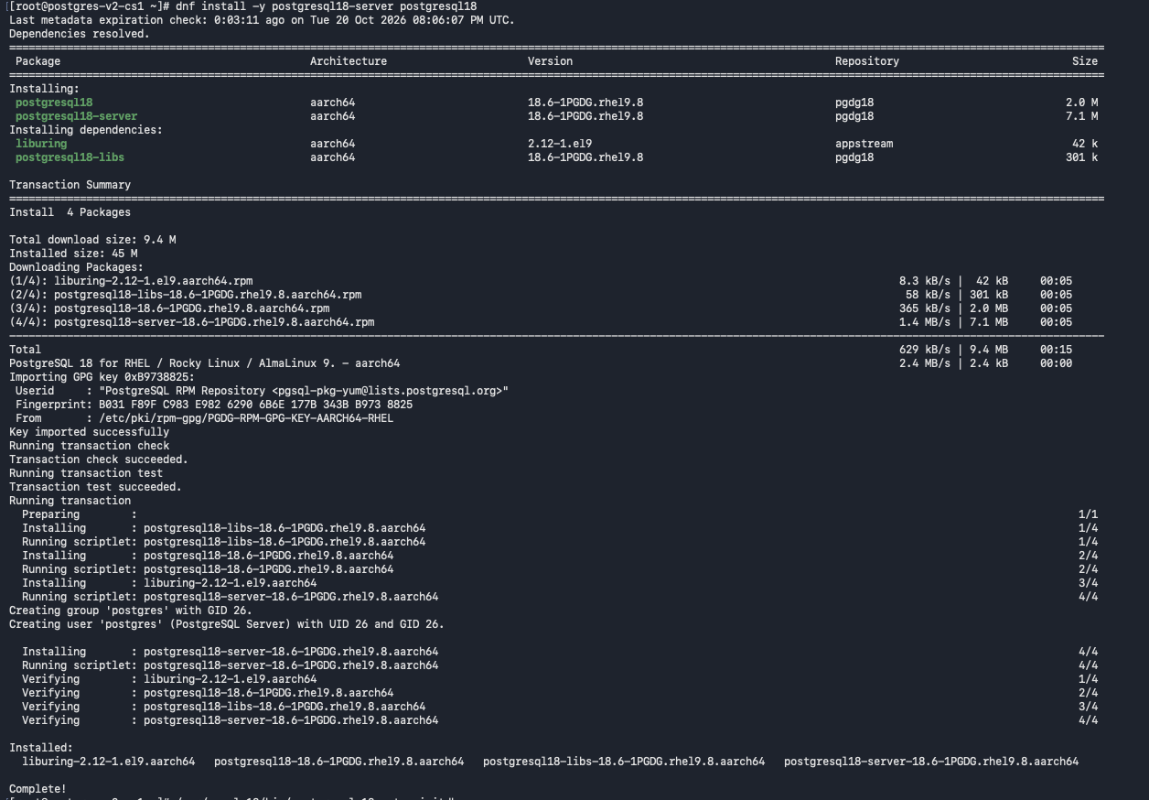
Initialize the PostgreSQL 18 cluster and enable the service on Node 1
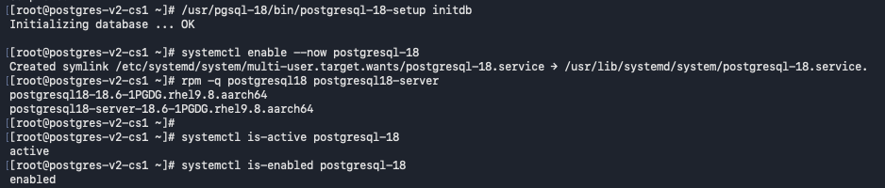
Inspect PostgreSQL 18 directories and initialized data files on Node 1
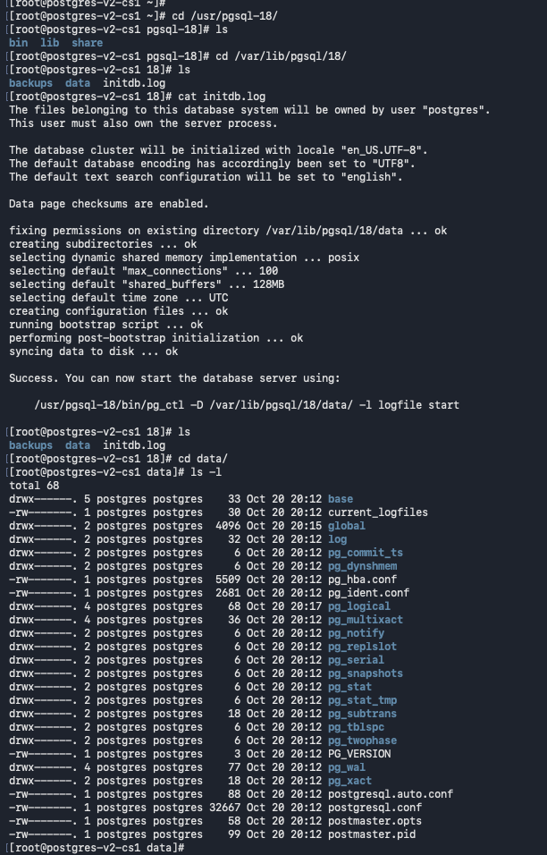
Review the initialized PostgreSQL data directory contents
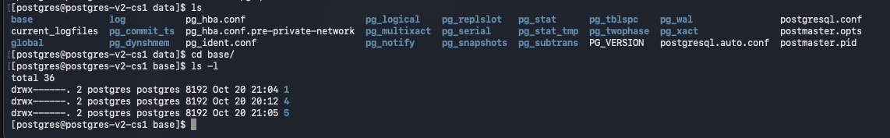
Inspect PostgreSQL 18 command-line utilities in the binary directory
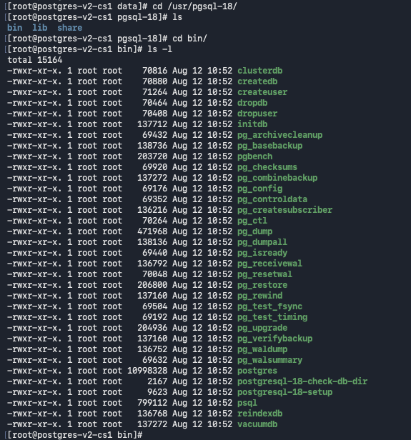
Verify that the PostgreSQL 18 service is active on Node 1
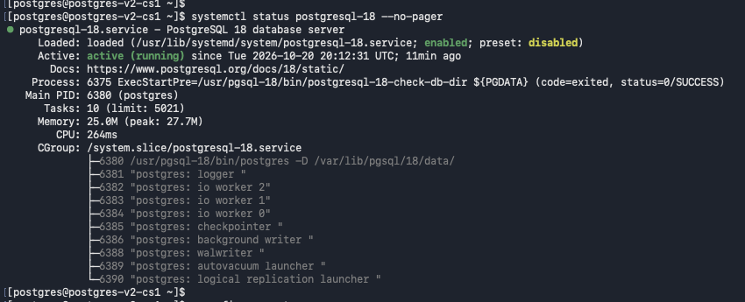
Inspect PostgreSQL server processes and verify the initial cluster in psql
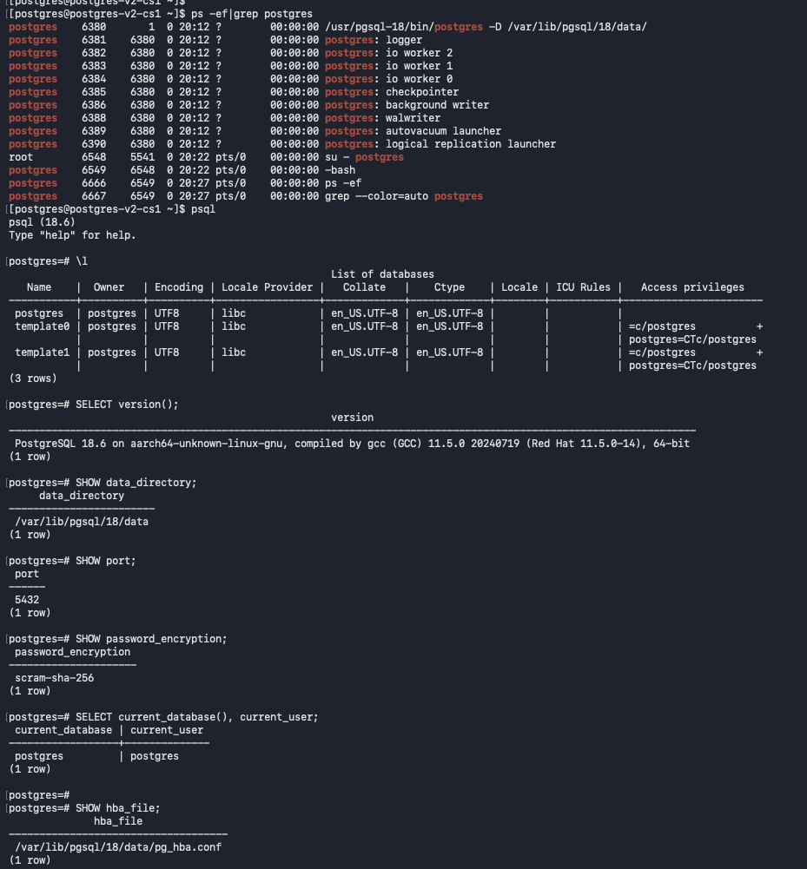
Check PostgreSQL configuration paths, listening address, SSL, logging, and WAL settings
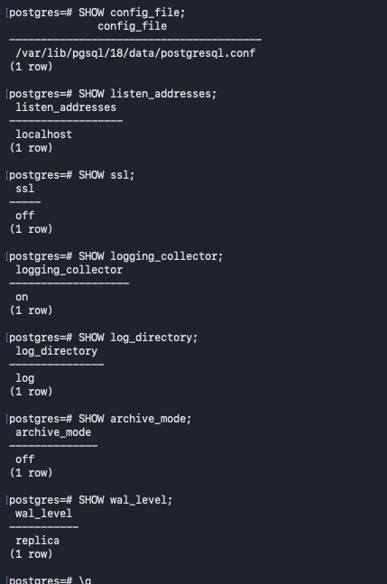

Review built-in PostgreSQL roles and privilege attributes
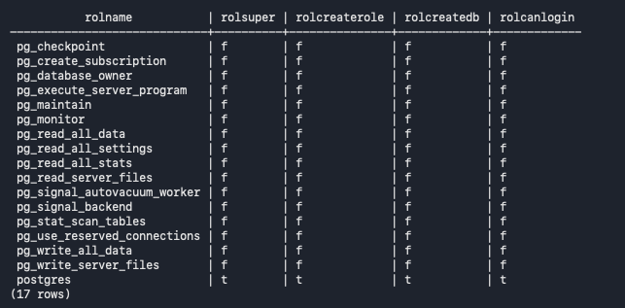
Configure the postgres user's shell environment and verify psql connectivity
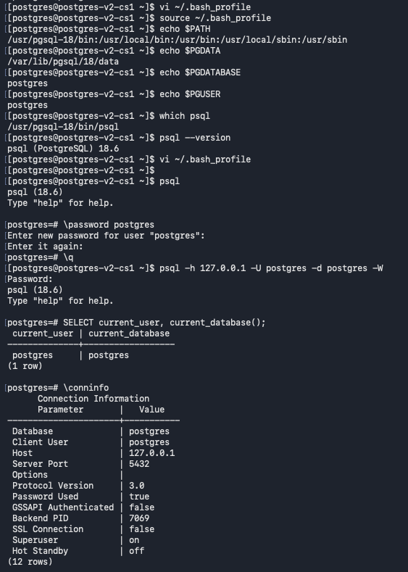
Update pg_hba.conf and restart PostgreSQL to listen on the private network
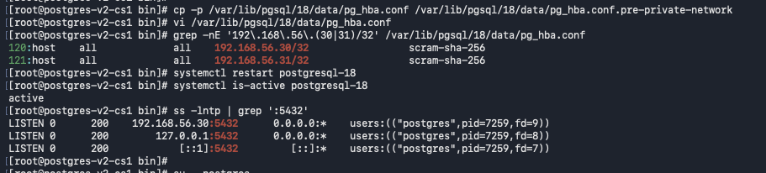
Verify network connectivity from Node 1 to Node 2
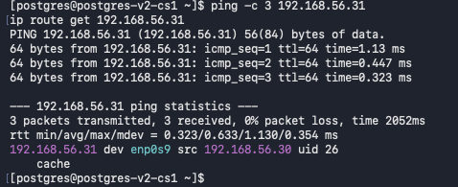
Inspect firewalld state and active zone on Node 1
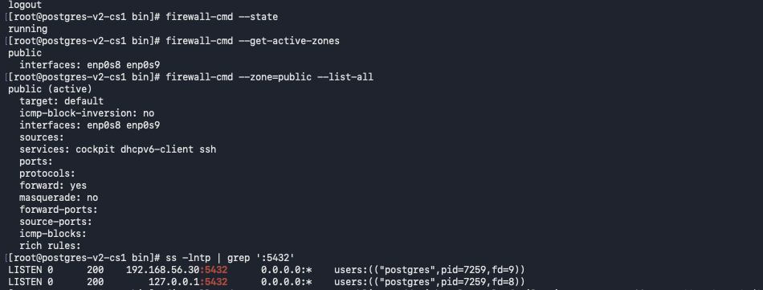

Add and verify a firewall rule for PostgreSQL traffic from the peer node
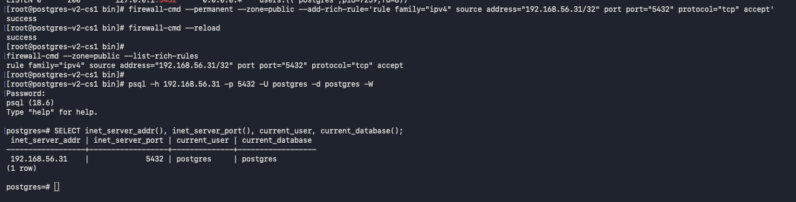
Verify PostgreSQL data-directory contents and local database connectivity
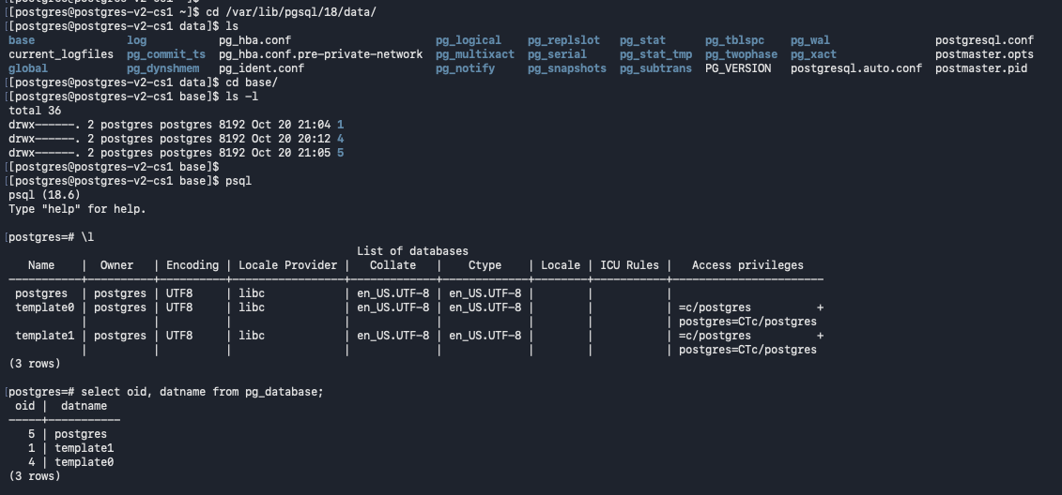

Node 2: Configure the PGDG repository for PostgreSQL packages.
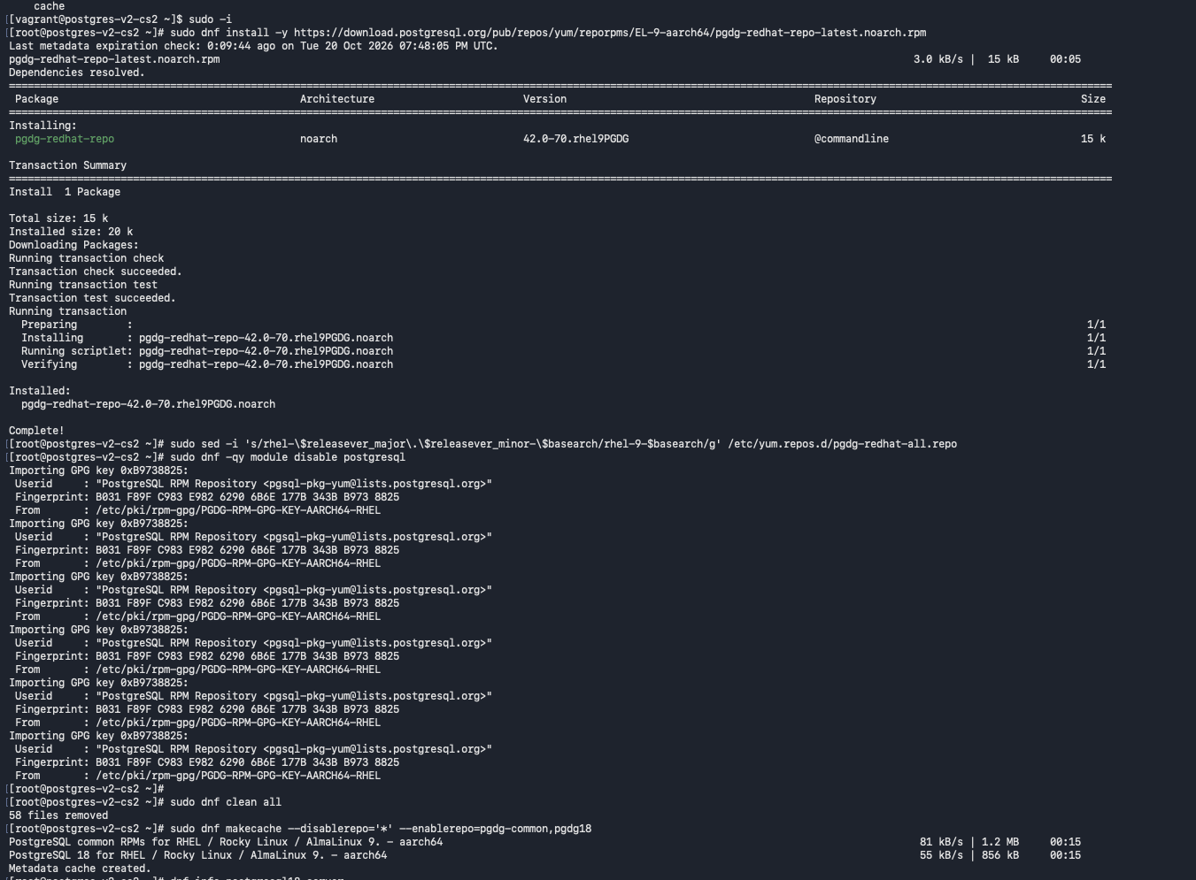
Inspect PostgreSQL 18 server package metadata on Node 2
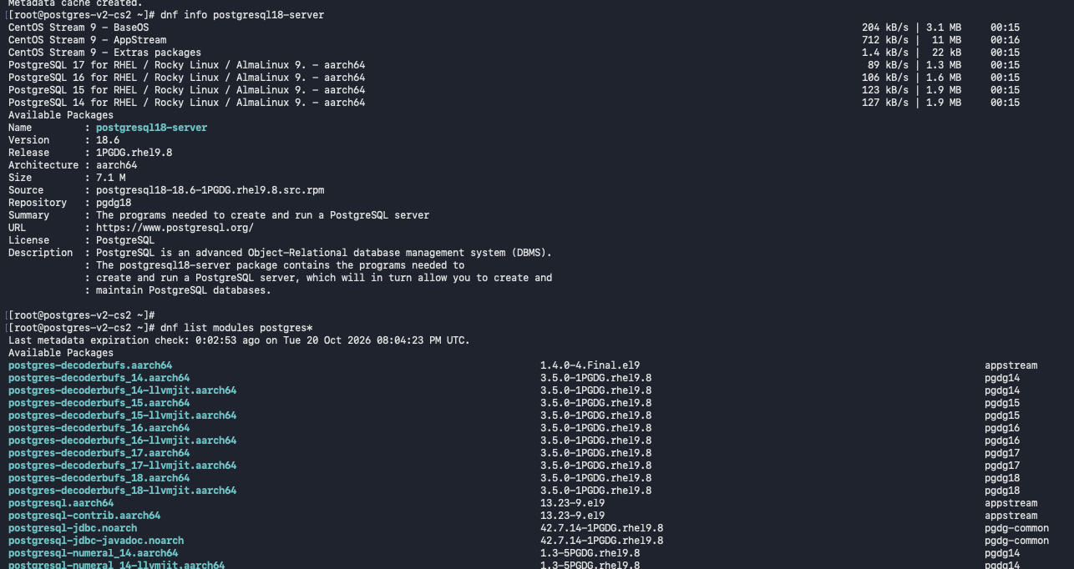
Install PostgreSQL 18 server and client packages on Node 2
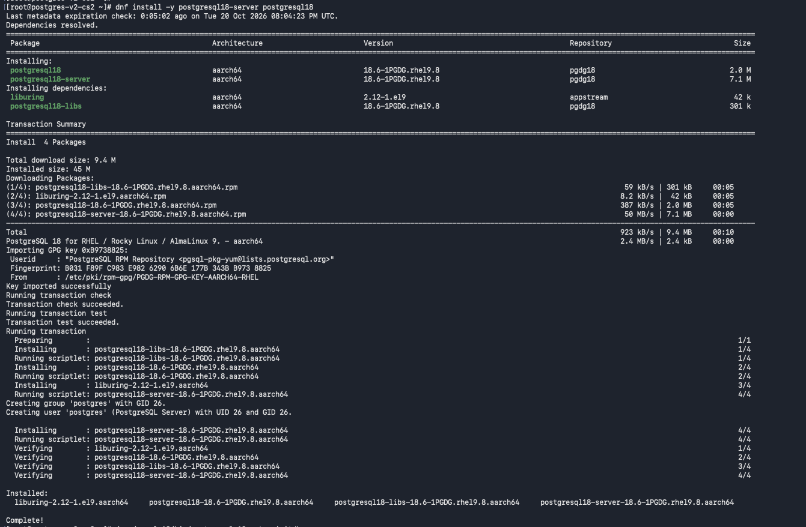
Initialize PostgreSQL 18 and enable the service on Node 2
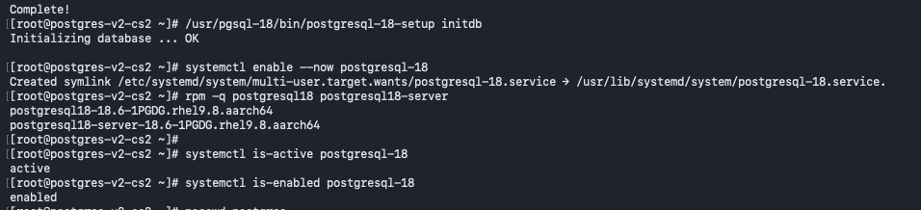
Review the PostgreSQL cluster initialization log on Node 2
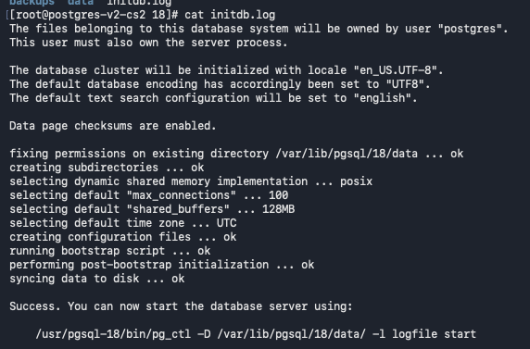
Inspect PostgreSQL data files and command-line utilities on Node 2
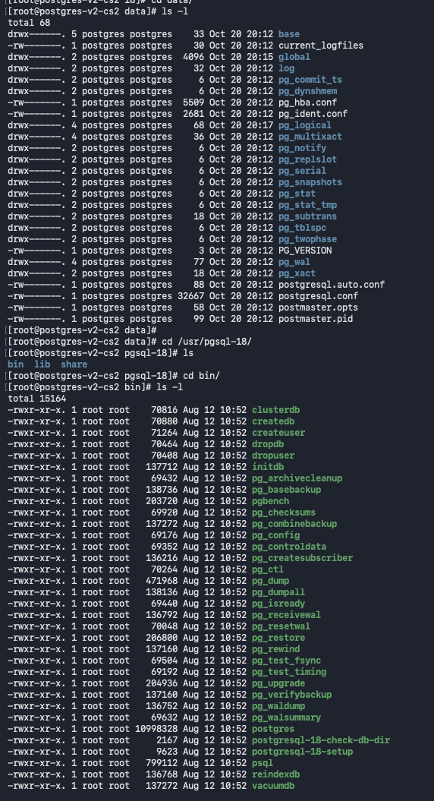

Verify PostgreSQL service status and server processes on Node 2
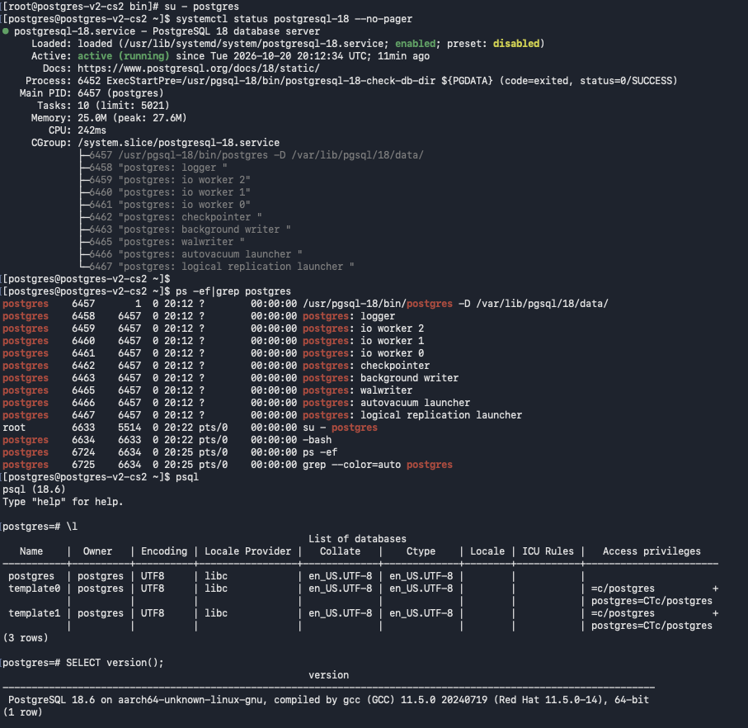
Review the initialized data directory on Node 2
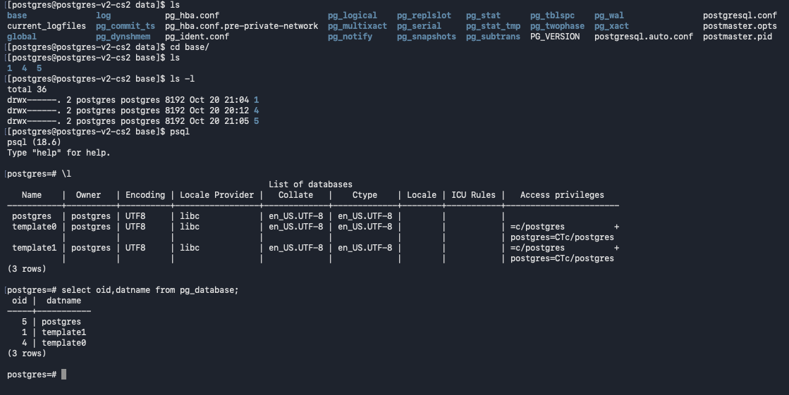
Verify PostgreSQL data directory, port, password encryption, and configuration paths
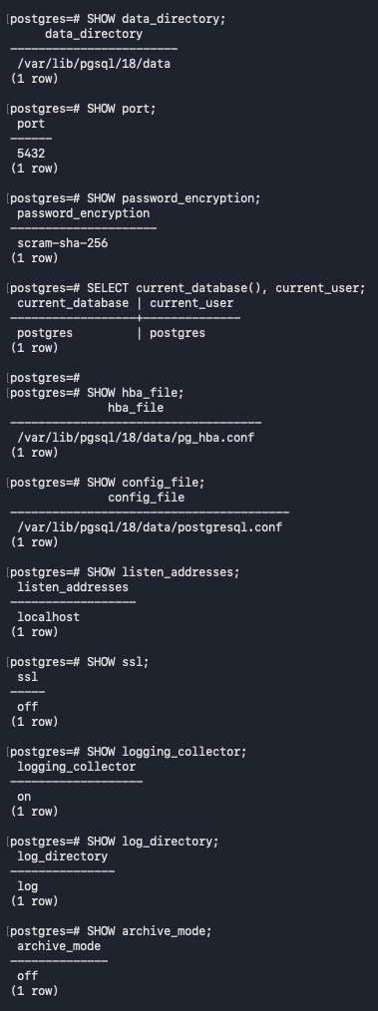
Check PostgreSQL security settings and built-in role privileges on Node 2
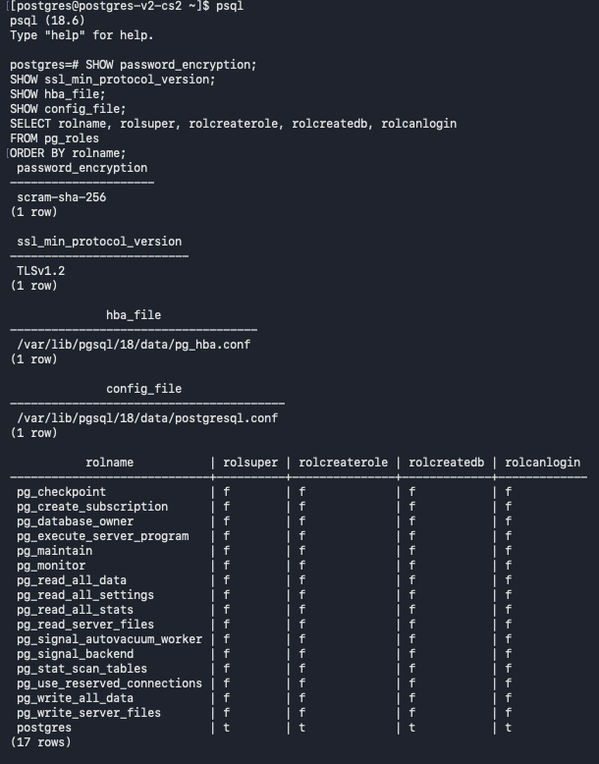
Configure the postgres user's shell environment and verify the psql version on Node 2
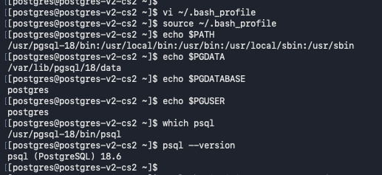
Verify Node 2 network interface configuration and private IP address
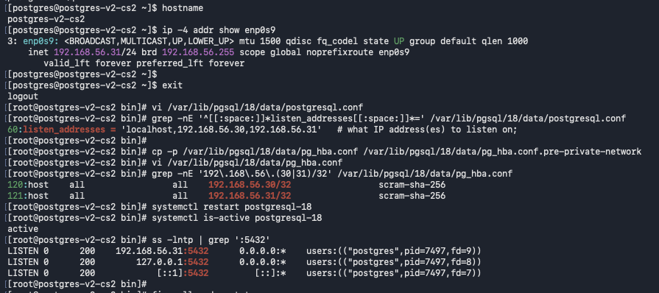
Allow PostgreSQL traffic from Node 1 through the firewall on Node 2
Set the postgres role password and test password-authenticated local connections
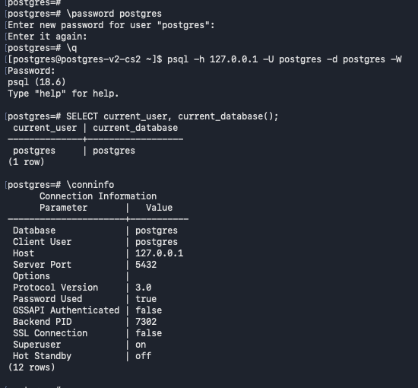

Test a remote PostgreSQL connection from Node 2 to Node 1
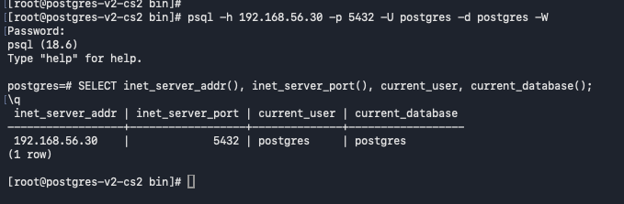

Create the dba_admin login role and verify its privileges on Node 2
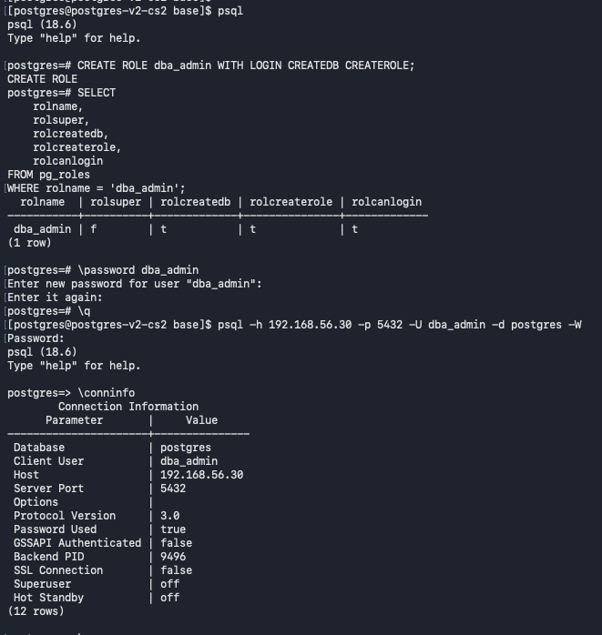
Repeat the dba_admin role creation and validate a remote login to Node 1
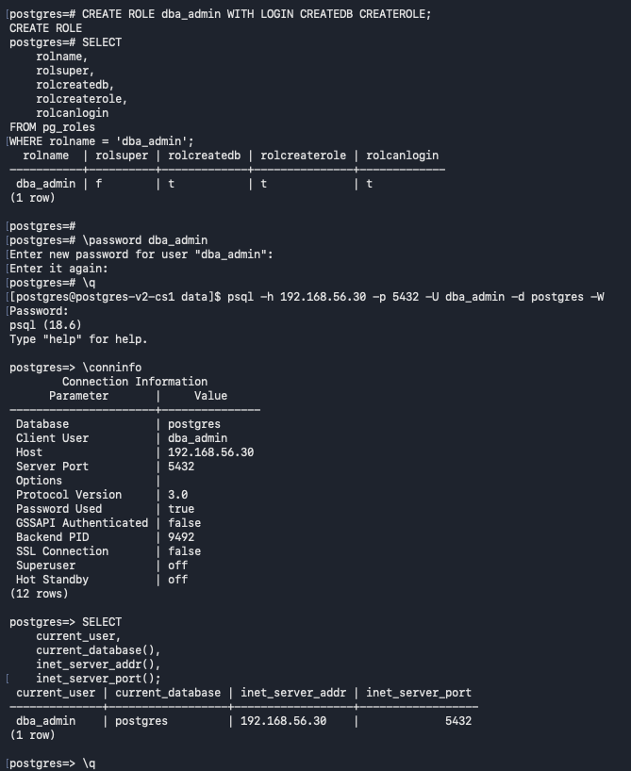
Verify dba_admin connectivity to Node 2
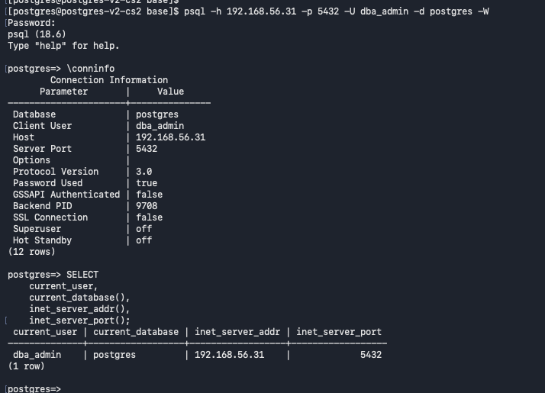

TSL certificate:
Generate a self-signed TLS certificate and private key for Node 1
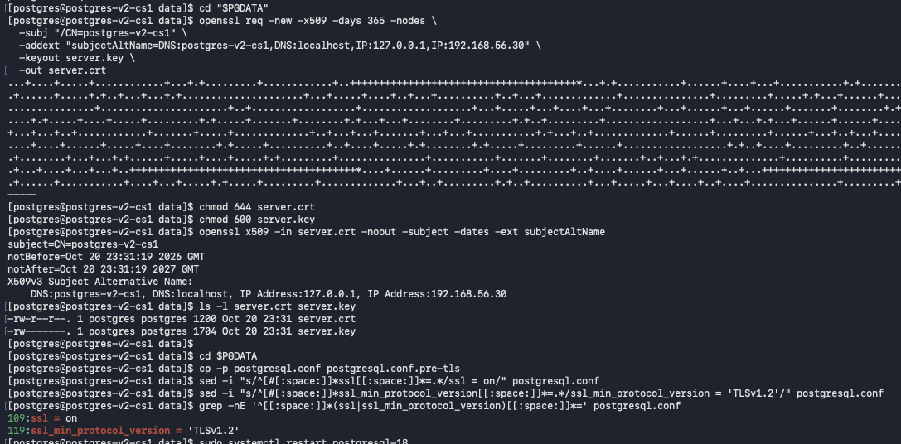
Restart PostgreSQL and verify the service after TLS configuration on Node 1
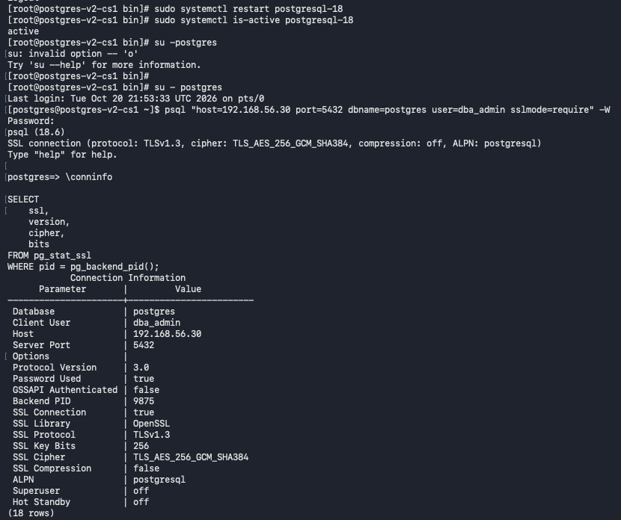

Generate a self-signed TLS certificate and private key for Node 2
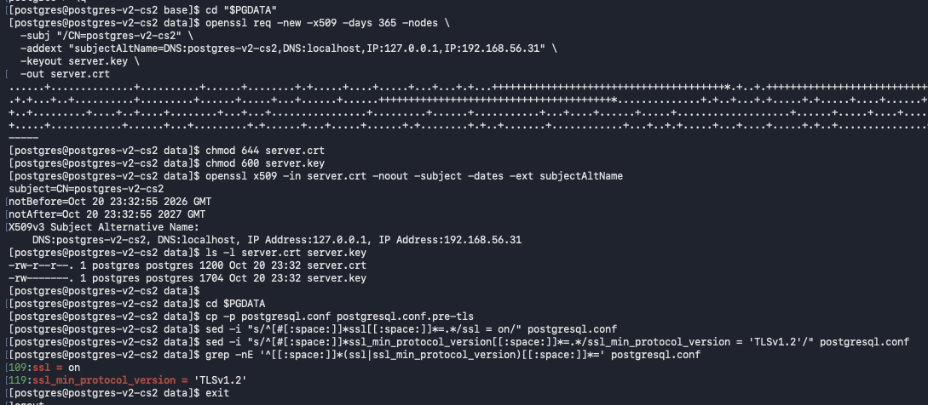
Restart PostgreSQL and verify the service after TLS configuration on Node 2
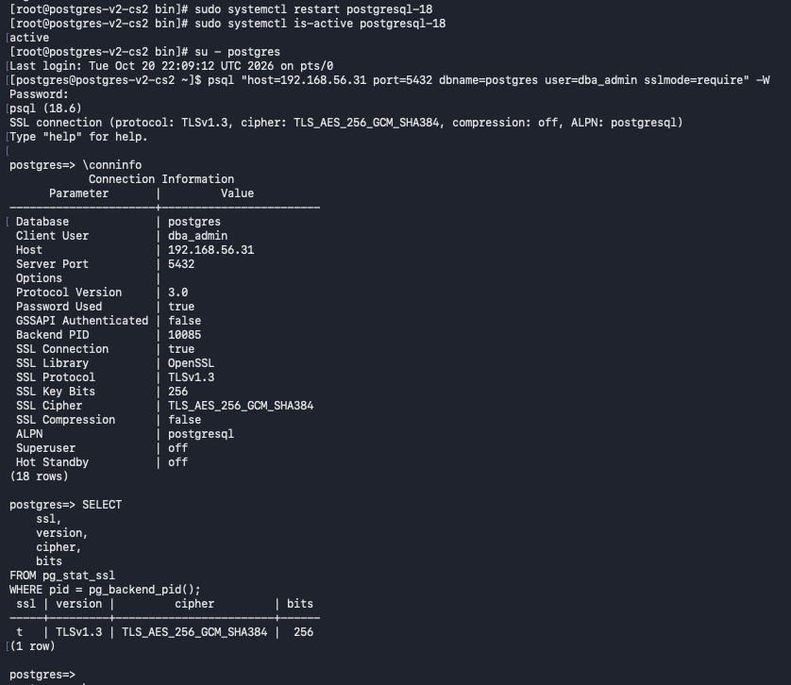

Check PGDG package availability for the PostgreSQL 18 pgaudit extension
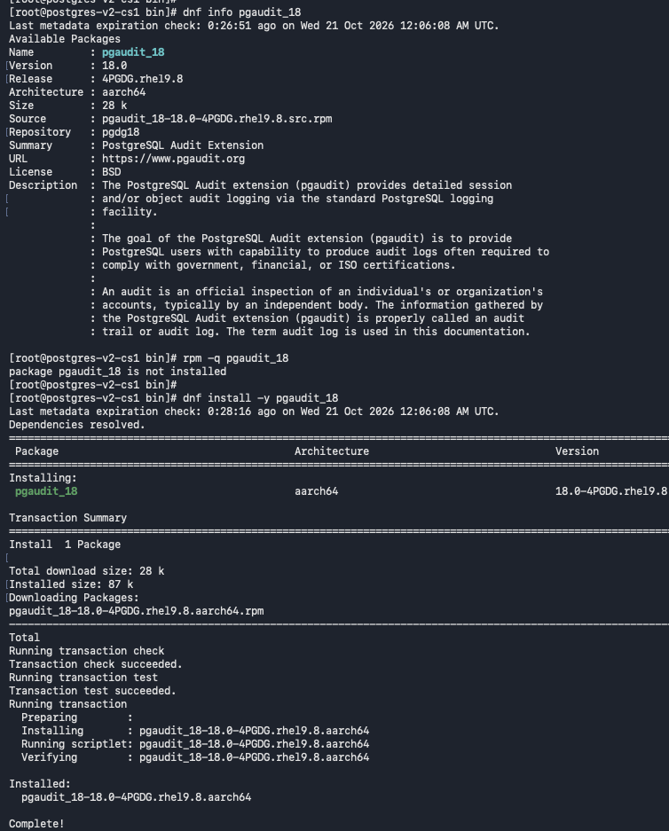
Check pgaudit package availability on the second PostgreSQL node
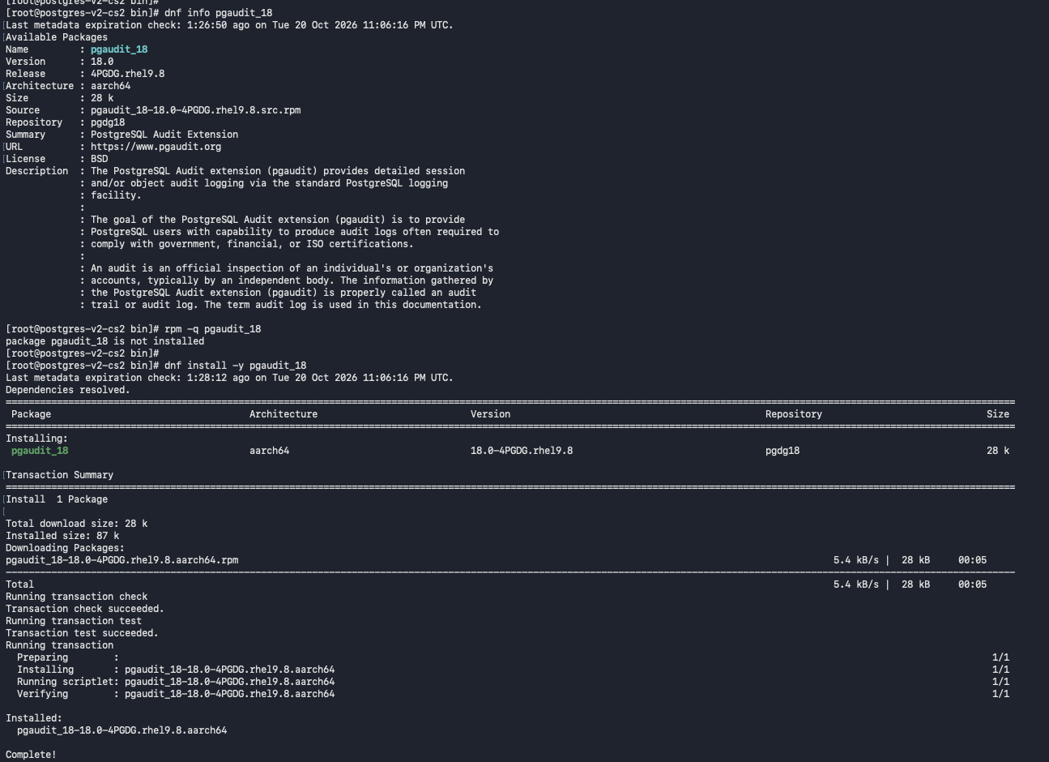
Node 1: Configure PostgreSQL audit logging with pgaudit.
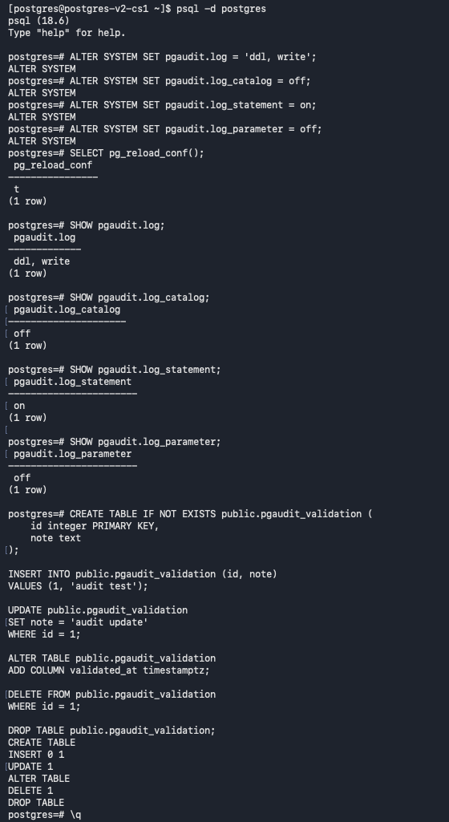
Node 2: Configure PostgreSQL audit logging with pgaudit.
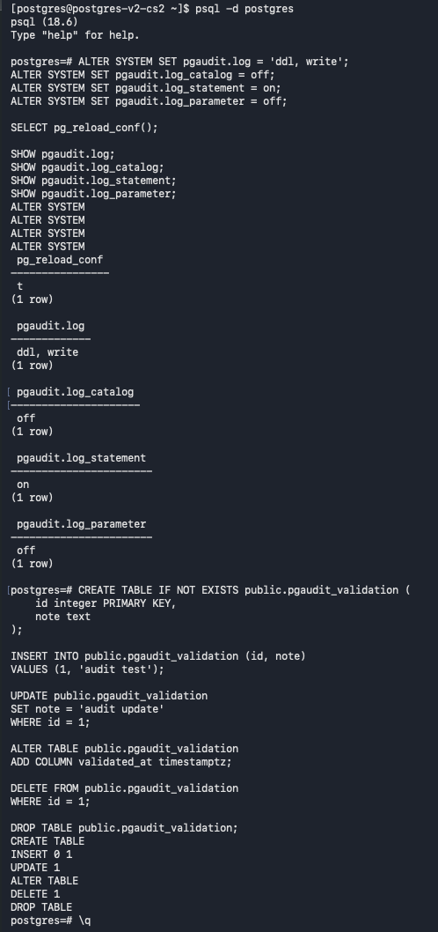
Node 1: Verify that pgaudit records are written to the PostgreSQL log.
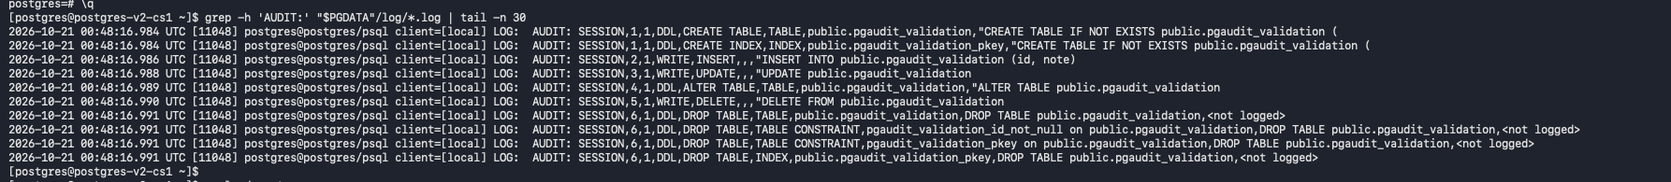
Node 2: Verify that pgaudit records are written to the PostgreSQL log.
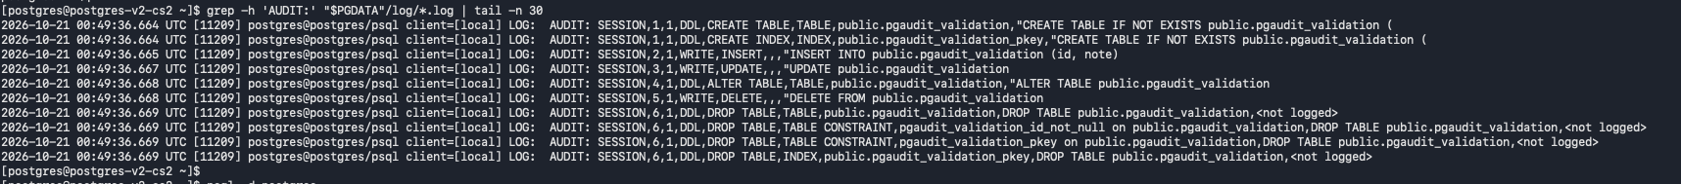

PostgreSQL Role-Based Access Control (RBAC): Create Read/Write and Read-Only Roles, Grant Schema and Table Privileges, and Configure Default Privileges for Future Objects.
RBAC_PostgreSQL
PostgreSQL database and schema setup — create and verify the lyris_prod database and etk schema.
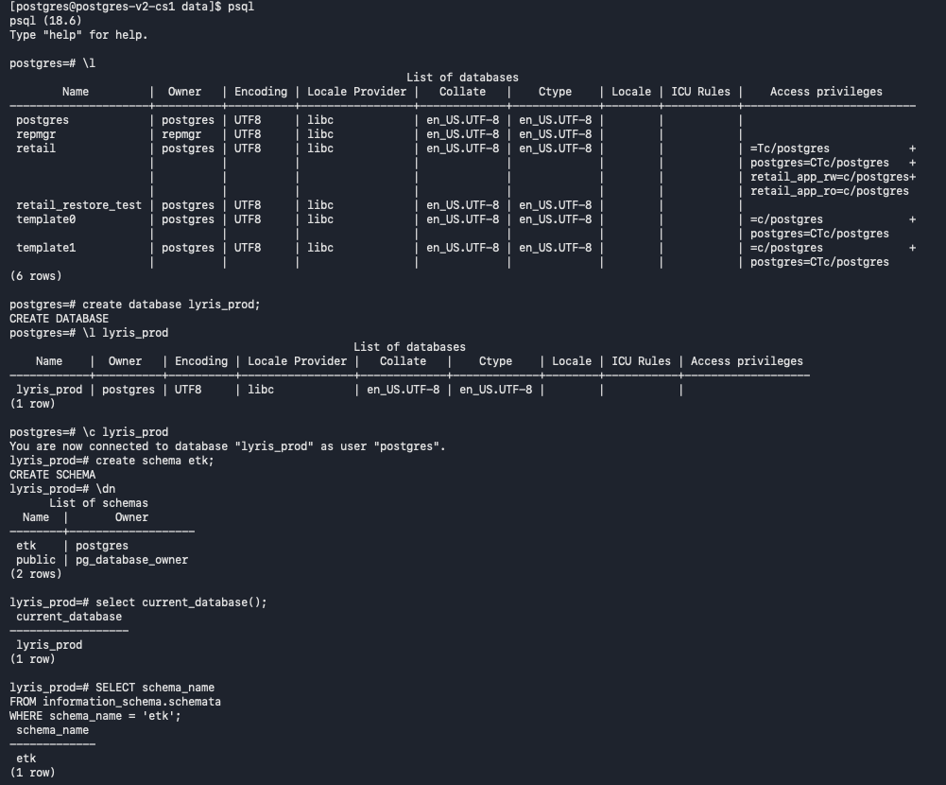
RBAC role creation and grants — define owner, read-only, read-write, application, and reporting roles; configure schema, table, sequence, and default privileges.
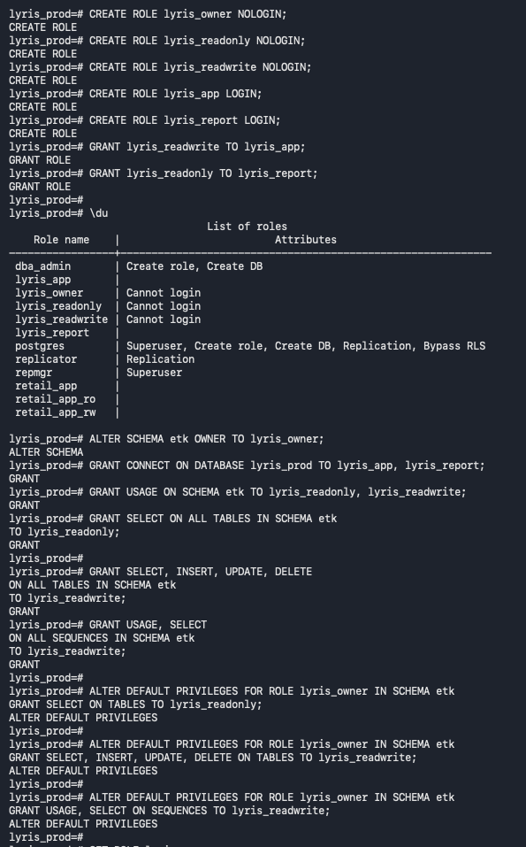
Role verification — review role attributes and confirm lyris_owner is NOLOGIN while lyris_app and lyris_report can log in.
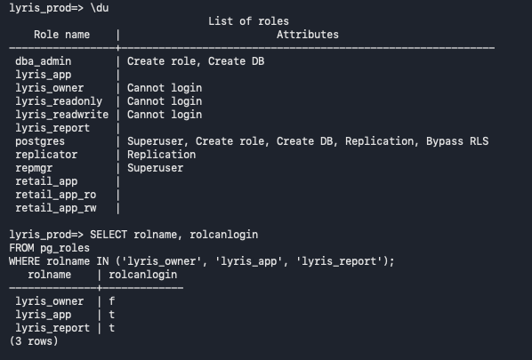
Application login validation — set the lyris_app password and confirm a successful TLS-encrypted connection to lyris_prod.
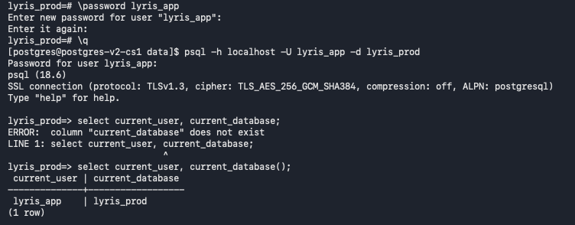
Object ownership and table creation — assume lyris_owner with SET ROLE, create the customers, products, and orders tables, then reset the role.
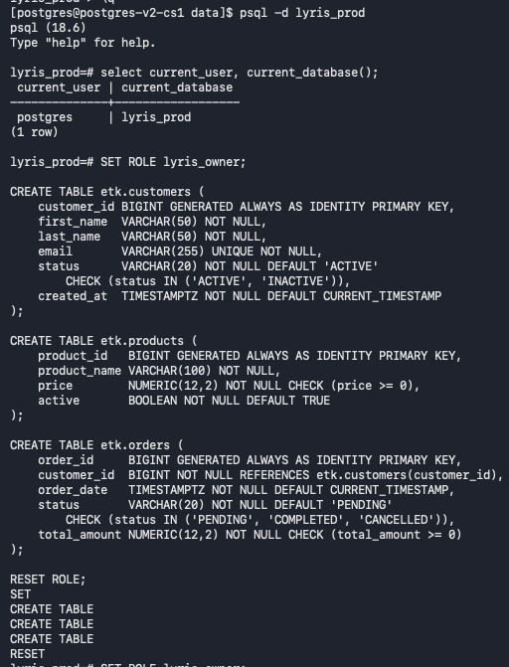
Sample data and ownership verification — insert sample customer, product, and order records as lyris_owner and confirm the tables are owned by that role.
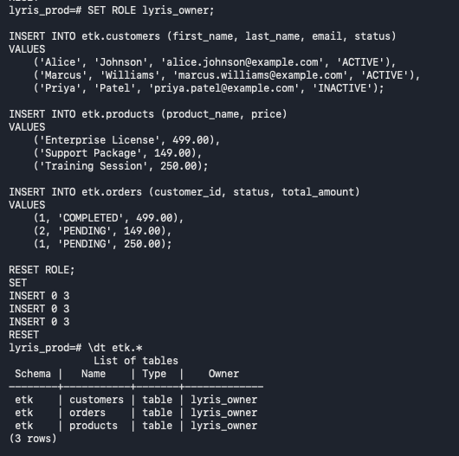
Read-write RBAC test — connect as lyris_app over TLS, read customer records, and successfully insert, update, and delete a test record.
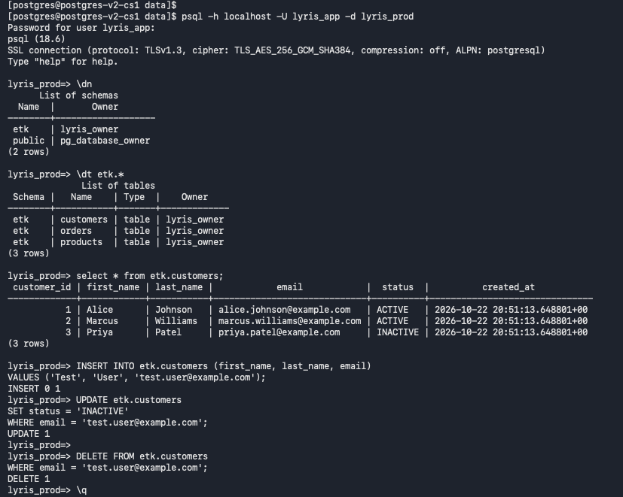
Read-only RBAC test — connect as lyris_report over TLS; SELECT succeeds while INSERT, UPDATE, and DELETE are denied.
