Replication, Failover, Rejoin & repmgr Switchover
Summary:
Key configuration changes
1. Replication role and authentication
- Created the replicator role with LOGIN and REPLICATION privileges, without SUPERUSER.
- Updated pg_hba.conf to allow replication connections from the standby using scram-sha-256.
- Checked pg_hba_file_rules for configuration errors.
2. Streaming replication and TLS
- Configured PostgreSQL WAL settings to support physical streaming replication.
- Configured TLS certificate and key paths for secure replication connections.
- Reinitialized the standby with pg_basebackup, requiring TLS and using SHA-256 manifest checksums.
- Configured primary_conninfo and primary_slot_name on the standby.
- Created and verified the physical replication slot cs2_standby.
3. Failover and rejoining the former primary
- Stopped PostgreSQL on postgres-v2-cs1 and promoted postgres-v2-cs2 to primary.
- Created the cs1_standby replication slot on the new primary.
- Rebuilt the former primary's data directory using pg_basebackup.
- Restored its PostgreSQL configuration and TLS files, removed conflicting replication settings, and configured it to follow postgres-v2-cs2.
4. repmgr configuration
- Installed repmgr 5.5.0 on both nodes.
- Created the repmgr database and login role.
- Configured repmgr.conf and registered both nodes with repmgr.
- Inspected the repmgr-18 systemd service; it was loaded but disabled and inactive during the documented checks.
- Configured SSH key-based authentication between the PostgreSQL nodes for passwordless access.
- Updated shared_preload_libraries to include pgaudit and repmgr.
- Ran a repmgr switchover dry run and proceeded through the switchover workflow.
5. Validation checks
- Used pg_stat_replication and pg_stat_wal_receiver to check streaming replication.
- Checked replication slot activity and WAL receive/replay positions.
- Compared replicated retail table counts: customers — 10, products — 10, orders — 10, and order_items — 20.
- Checked repmgr cluster status after node registration and switchover.
Replication role creation and verification on the primary; the replicator role has LOGIN and REPLICATION, but not SUPERUSER.
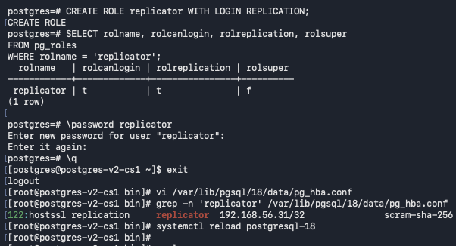
Primary pg_hba.conf replication rule allowing the replicator role from standby 192.168.56.31 using SCRAM-SHA-256.
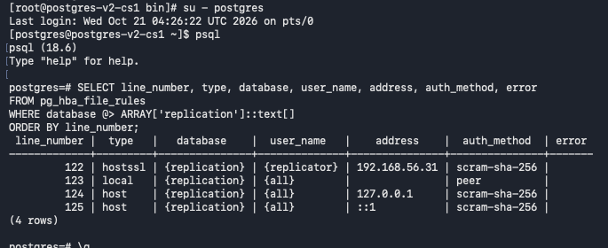
Query pg_hba_file_rules on the standby and confirm no HBA parsing errors are reported.
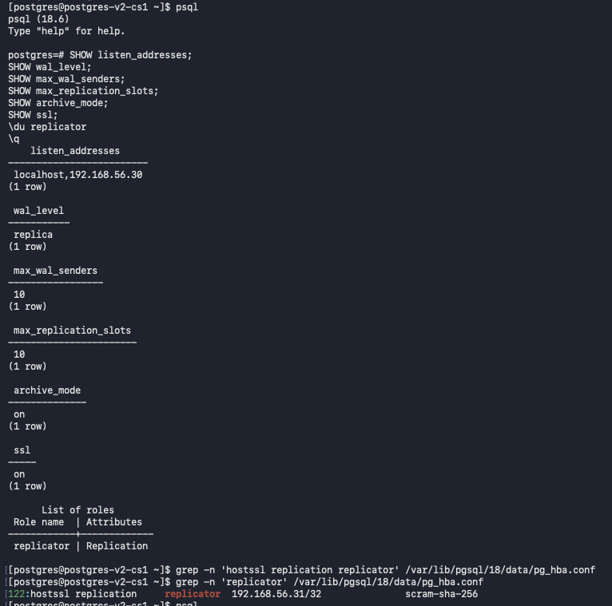
Edit the standby's pg_hba.conf and reload PostgreSQL
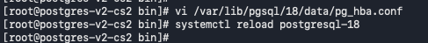
Standby-side pg_hba_file_rules query returns zero rows with errors.
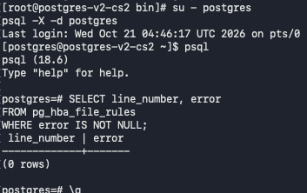
Display PostgreSQL password-file entries with passwords masked before sharing the output.
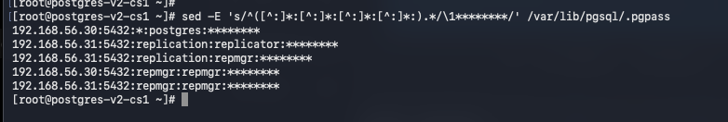
Run a temporary pg_receivewal connectivity test from the standby; the command is interrupted because the test passed; and leaves an incomplete partial WAL file.
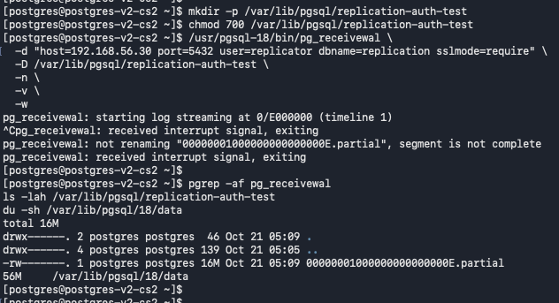

Inspect the standby's PostgreSQL data directory, configuration-file paths, listen address, archive settings, and TLS certificate/key paths before rebuilding it.
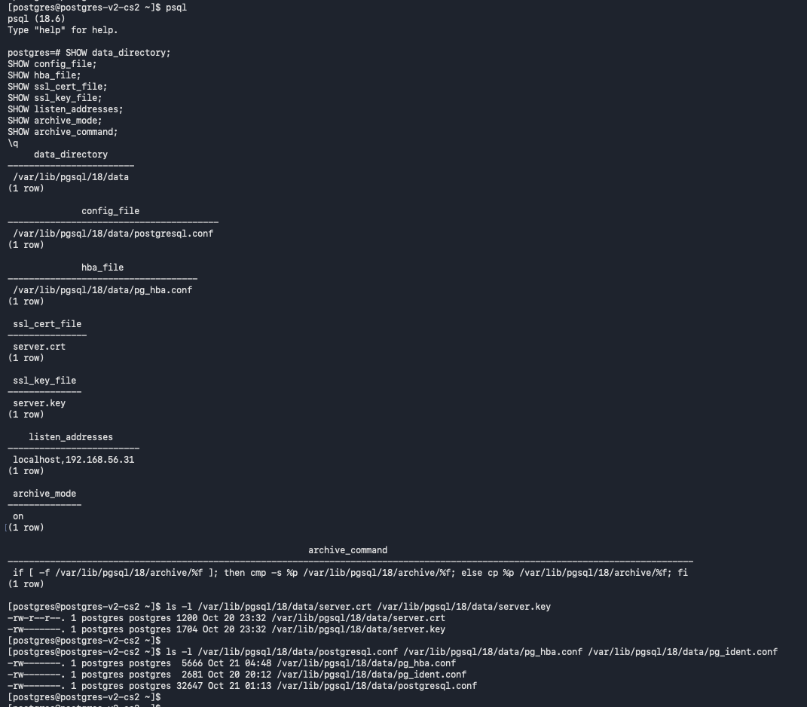
Stop PostgreSQL on the standby and move its existing data directory to a timestamped pre-reinitialization path.
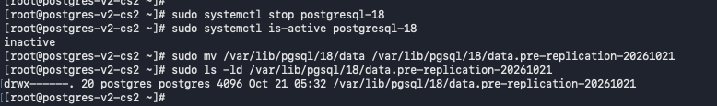
Run pg_basebackup on node 2 against primary 192.168.56.30 with TLS required and SHA-256 manifest checksums.
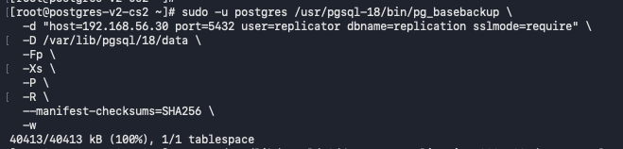
pg_basebackup reaches 100% and reports completion for the standby data copy.
Standby initialization section: restore the saved PostgreSQL data files and configuration after the base backup.
Standby configuration review section covering TLS, WAL archiving, and primary connection parameters.
Inspect the standby's listen address, SSL, archive settings, shared_preload_libraries, and postgresql.auto.conf values.
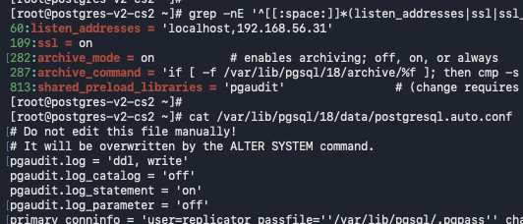
Start PostgreSQL on the standby and confirm the service is active and accepting local connections.
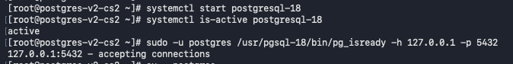
Verify the standby is in recovery and its WAL receiver is streaming from 192.168.56.30.
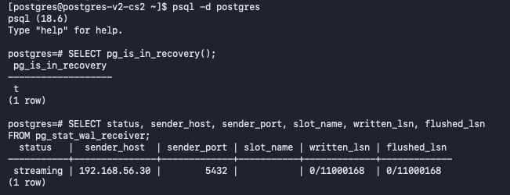

Inspect retail database schemas, tables, and row counts on the standby after replication is established.
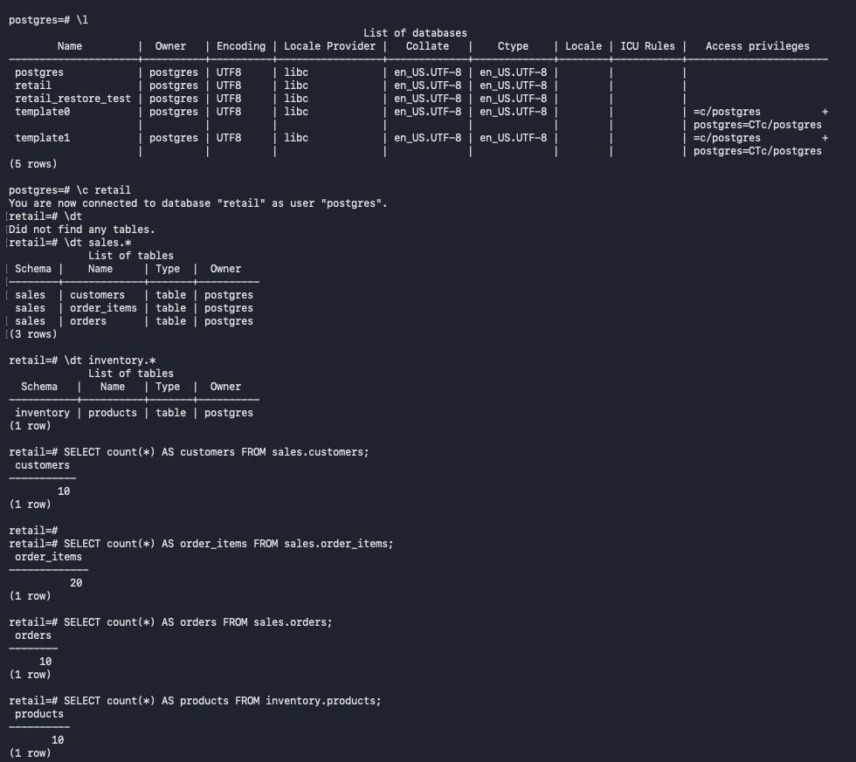
Connect to the primary remotely and verify its primary role, standby streaming state, WAL positions, and replication-slot status.
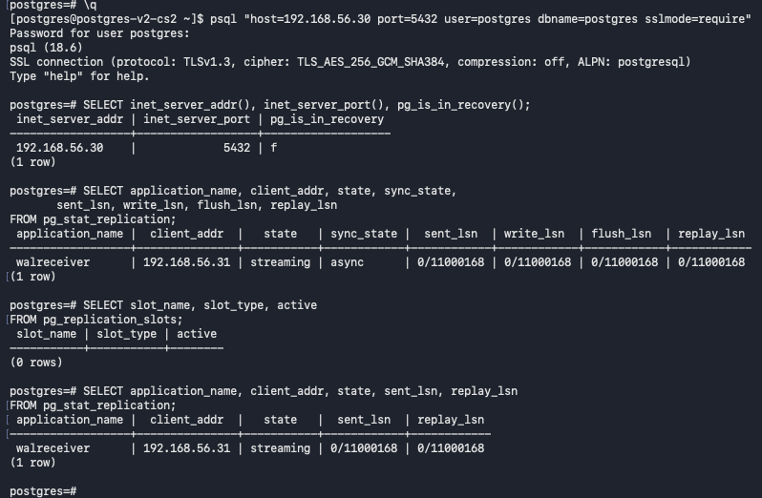

Set primary_slot_name on the standby, then create the cs2_standby physical slot on the primary.
Create/configure cs2_standby and verify its initial physical-slot status before attaching the standby to it.
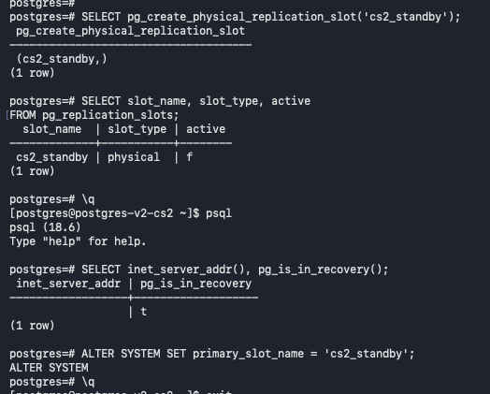
Restart PostgreSQL on the standby and verify cs2_standby is active while pg_stat_replication reports asynchronous streaming.
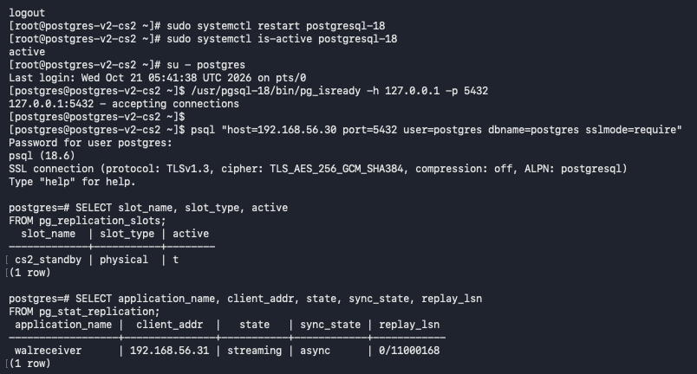
Create and query public.replication_validation on the primary to test whether the row replicates to the standby.
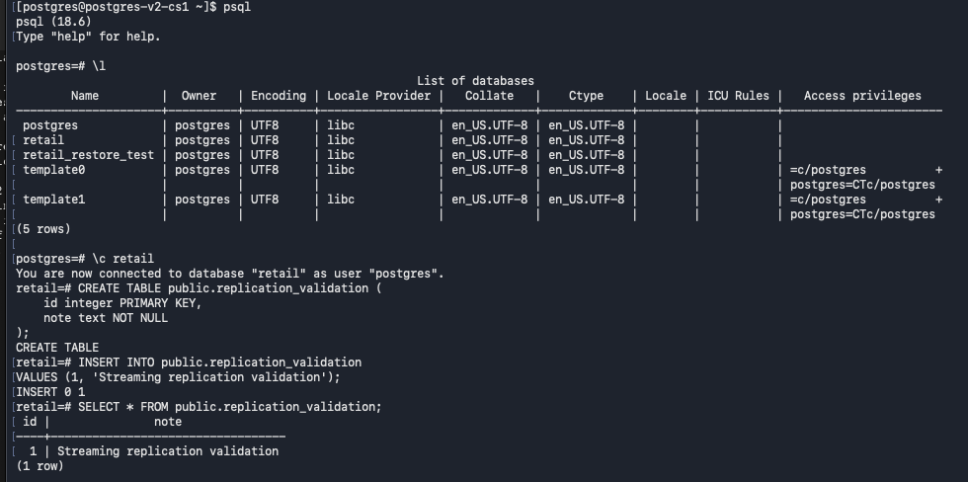
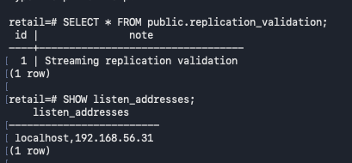
Read the replicated validation row on the standby, then drop the temporary table and check node role/listen-address context.
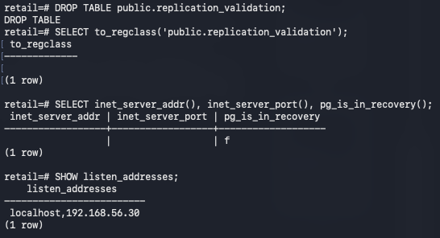
Check primary-side pg_stat_replication and replication-slot state after removing the temporary validation table.
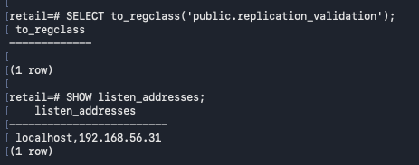

Check standby listen address, streaming state, WAL receive/write/flush/replay positions, and the active cs2_standby slot.
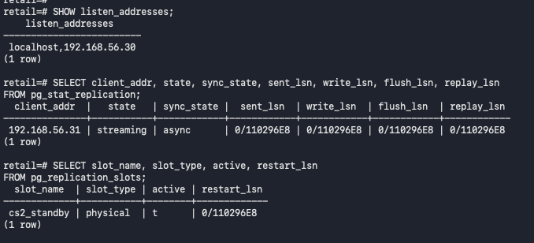
Final streaming-replication checks on the standby: recovery mode, WAL receiver status, slot name, and received/replayed LSNs.
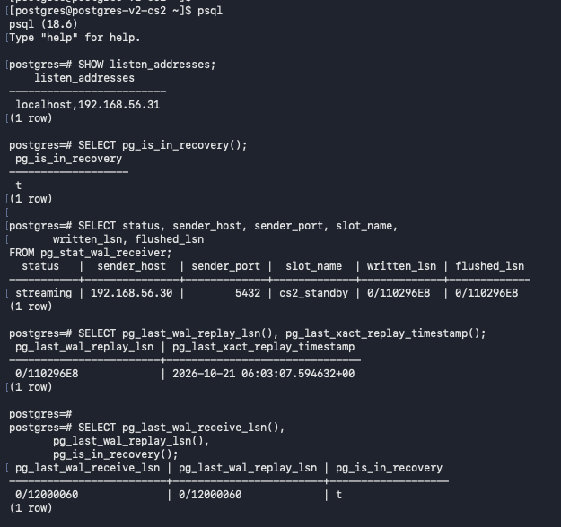

Pre-failover validation on cs2: confirm recovery mode, upstream host, cs2_standby slot, and replay position.
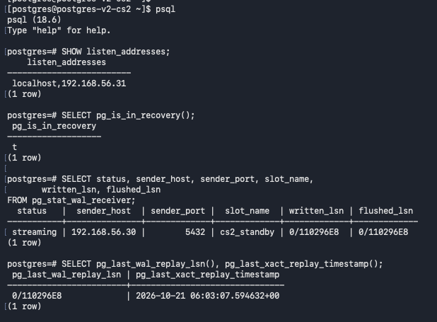
Advance WAL on the primary and compare current flush LSN with standby receive/replay positions before failover.
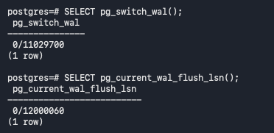
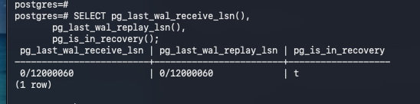

Failover procedure heading: stop the current primary and promote the standby.
Stop PostgreSQL cleanly on cs1 before promoting cs2.
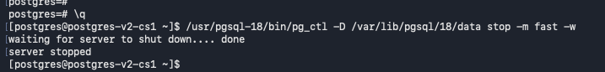
Promote cs2 with pg_ctl and verify pg_is_in_recovery() returns false.
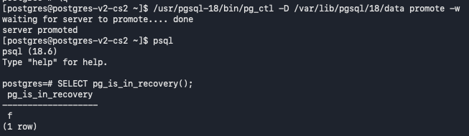

On promoted cs2, review PostgreSQL settings, the replicator role, and replication-slot state before rebuilding cs1 as a standby.
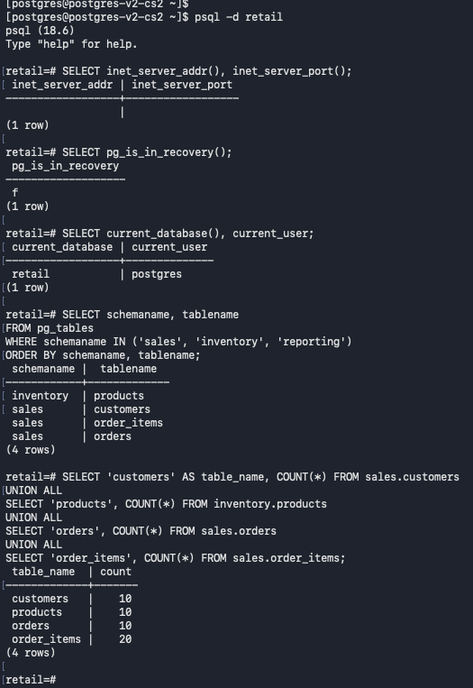

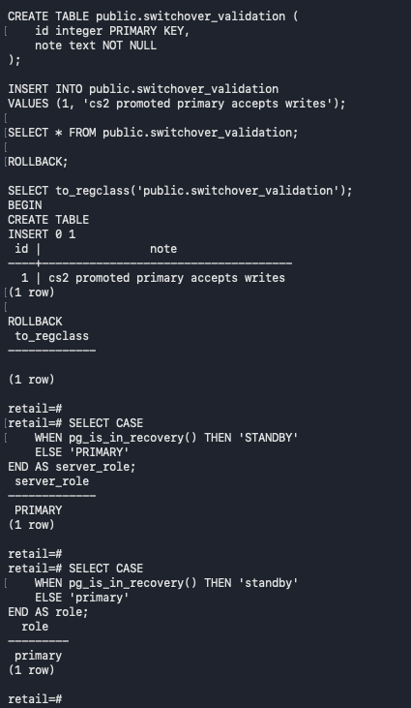
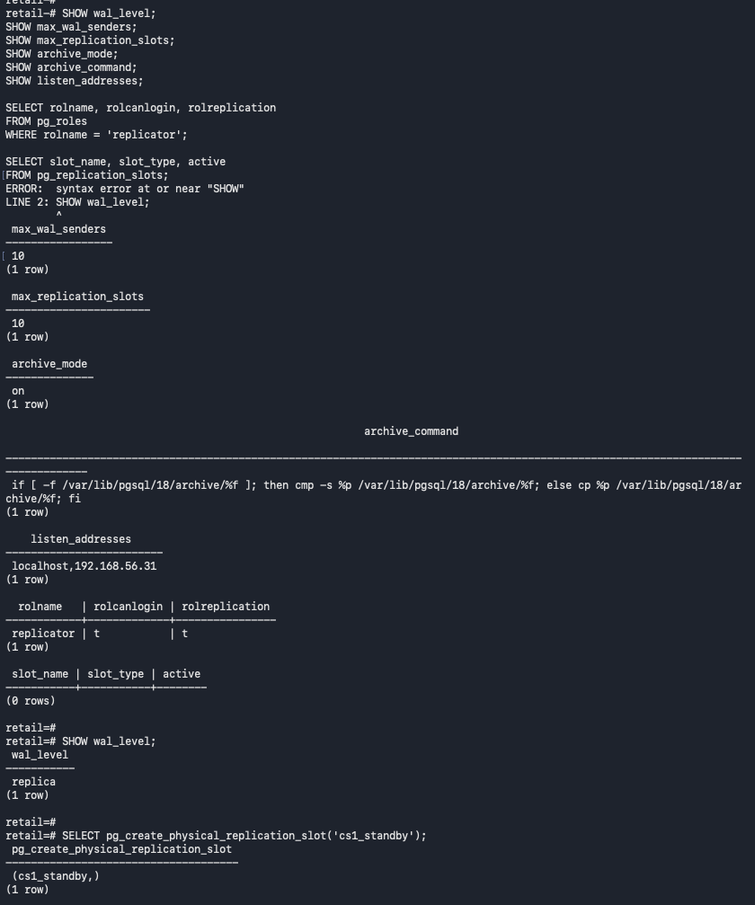

Check PostgreSQL service status on former primary cs1 before creating the replacement data directory; the service is not running.

On the promoted cs2 primary, create the physical replication slot cs1_standby and verify that it exists and is initially inactive.
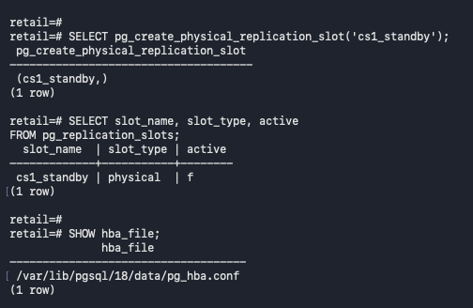
Inspect the former primary cs1's PostgreSQL installation, data directory, configuration files, and saved pre-switchover files before rebuilding it.
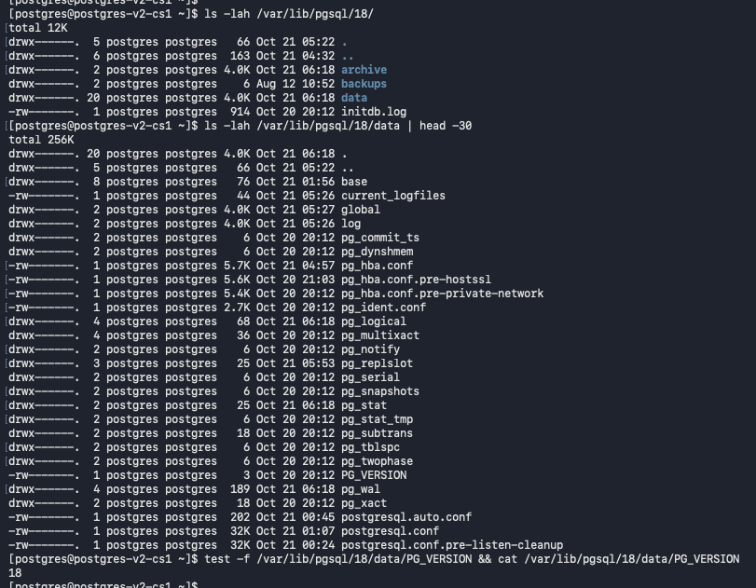
Stop PostgreSQL on cs1, move the old data directory to a timestamped pre-switchover backup, and create a fresh data directory with restricted permissions.
Check the former primary cs1 after it has been stopped; pg_ctl status reports that no PostgreSQL server is running.
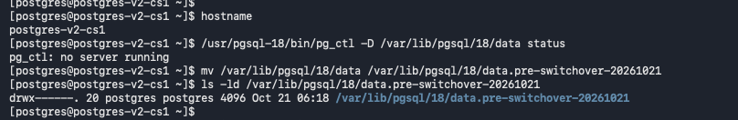

Run pg_basebackup on former primary cs1 from the current primary at 192.168.56.31, using the replicator account, TLS, the cs1_standby slot, and SHA-256 manifest checksums.
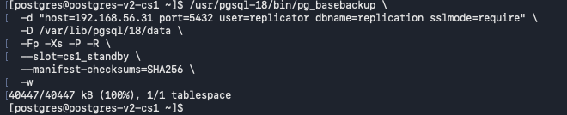
Restore cs1's saved PostgreSQL configuration and TLS files, remove the old primary_conninfo/slot settings, configure cs1 to follow cs2 through cs1_standby, and start PostgreSQL.
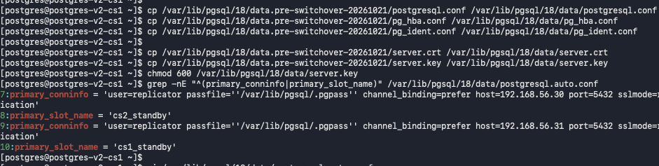

Verify that rebuilt cs1 is in recovery and its WAL receiver is streaming from cs2 (192.168.56.31) using the cs1_standby slot.
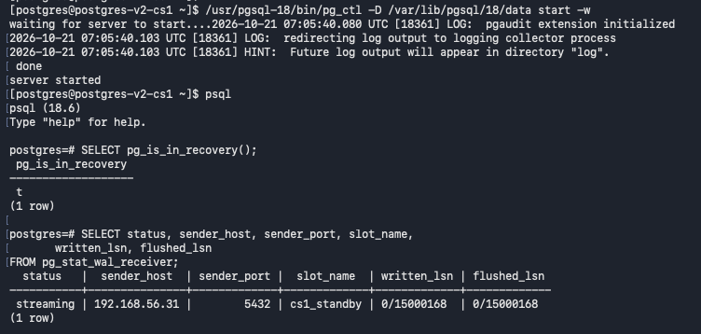

Verify reverse streaming replication after cs1 rejoins: cs1 is in recovery and receives WAL from cs2 through cs1_standby.
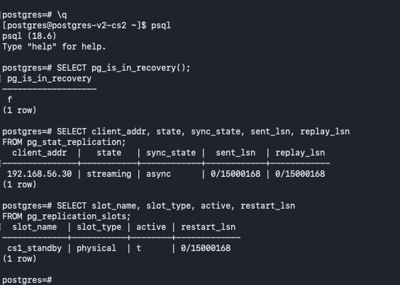
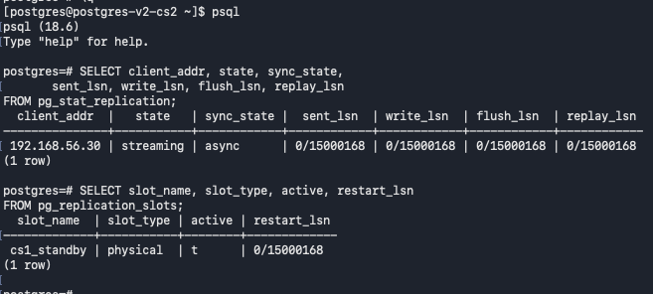

Verify reverse streaming replication after cs1 rejoins: cs1 is in recovery and receives WAL from cs2 through cs1_standby.
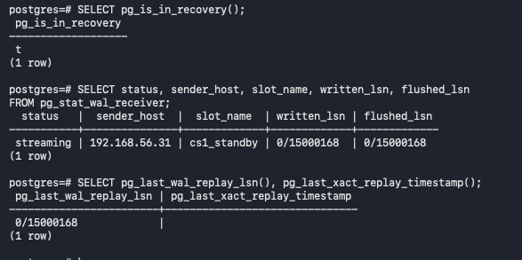
Compare the retail table row counts after cs1 rejoins; the displayed counts are customers 10, products 10, orders 10, and order_items 20.
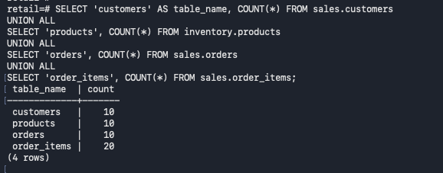

Install repmgr 5.5.0 on cs1
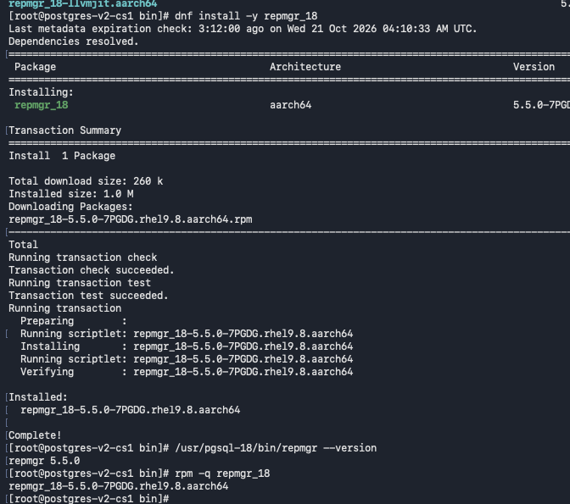

Install repmgr 5.5.0 on cs2 and verify the installed package version.
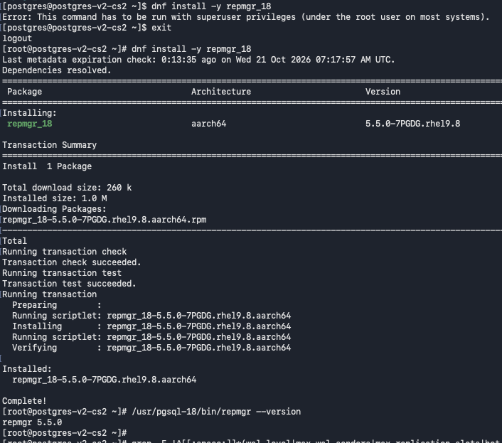

Inspect repmgr.conf and pg_hba.conf on cs1; verify the replicator and repmgr role/database prerequisites and note that the repmgr database is not yet present
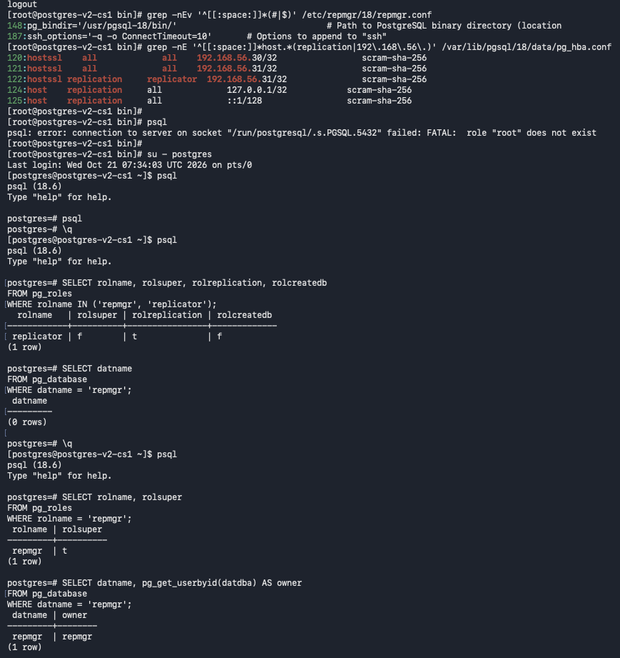

Inspect repmgr.conf and pg_hba.conf on cs2; verify the replicator and repmgr role/database prerequisites and note that the repmgr database is not yet present.
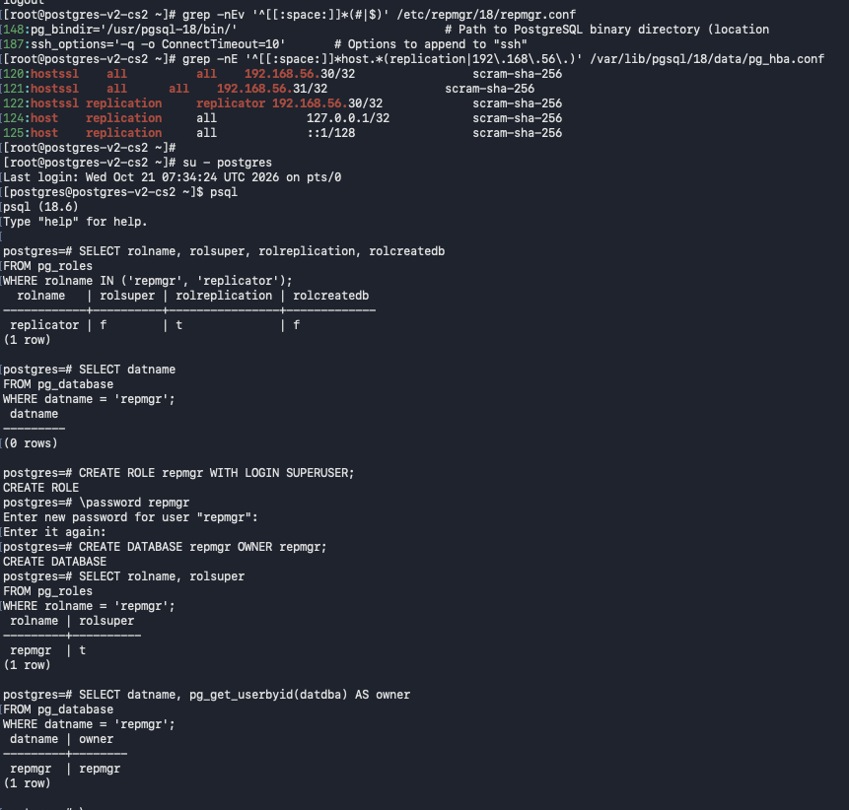

Install repmgr 5.5.0 on cs2; note the initial permission error and the successful privileged installation.
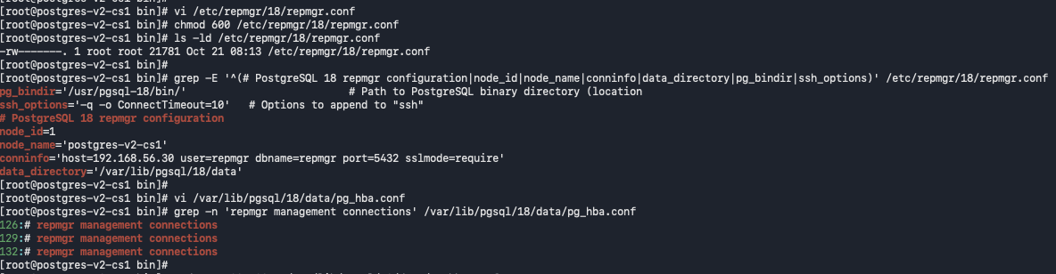
Inspect repmgr.conf, SSH options, and replication HBA entries on both nodes before registering the cluster.
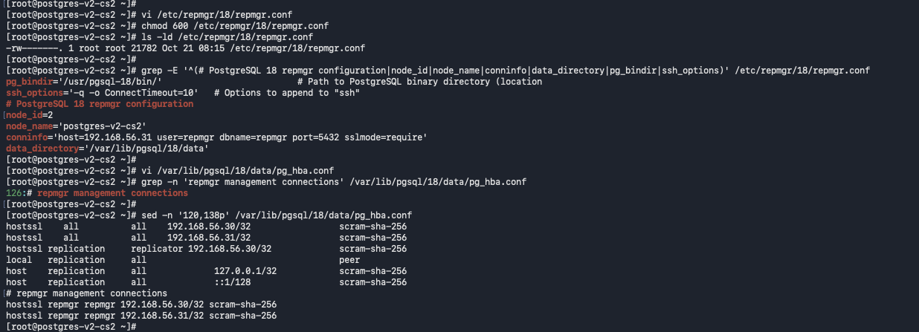
Reload PostgreSQL on cs1 and test a connection to the repmgr database at 192.168.56.30; the connection resolves to the expected node.
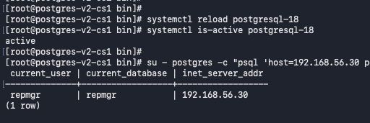

Test a connection to the repmgr database on cs2 at 192.168.56.31 and verify the current node can be reached.
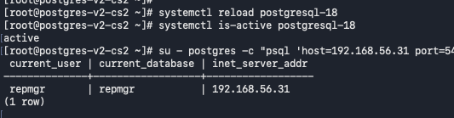

Register cs2 as a standby with repmgr and verify that both nodes appear in the cluster status output.
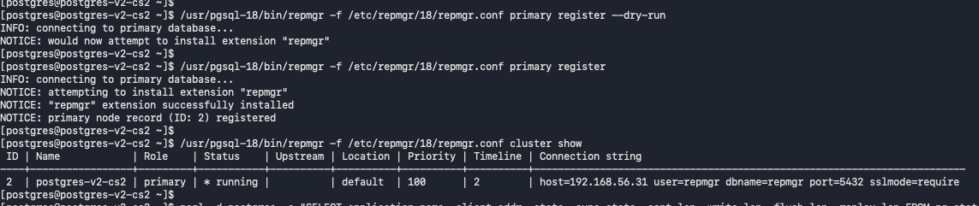
Register cs1 as the repmgr primary and display the initial cluster membership and node status.
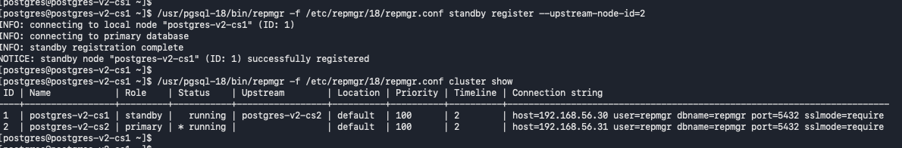
Inspect repmgr-18 systemd status and unit contents on cs2; the service is also disabled and inactive.

Check shared_preload_libraries on cs2 and update the setting to include pgaudit and repmgr.
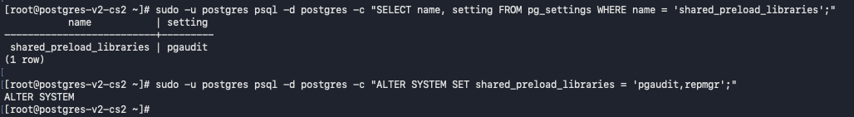

Generate an SSH key pair on cs1 and attempt SSH to cs2
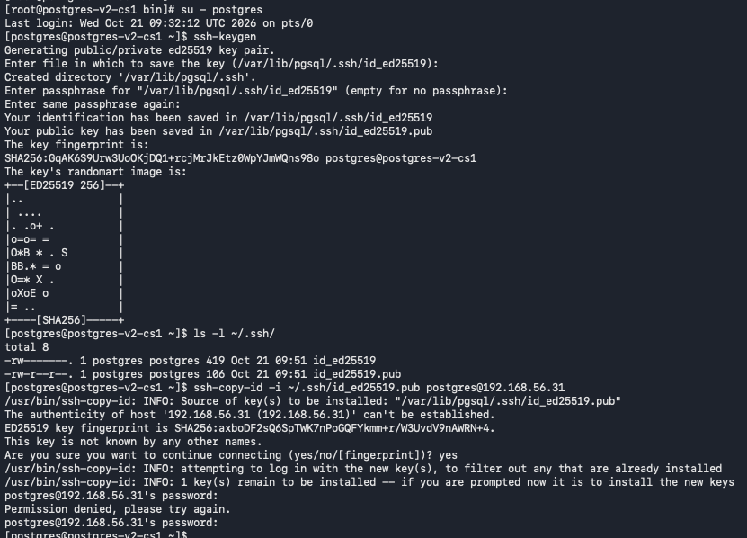
Install cs1's public SSH key on cs2 and verify the key-installation command completes.
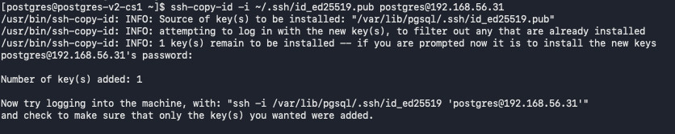
Generate an ED25519 SSH key pair on cs2 and inspect the private/public key files.
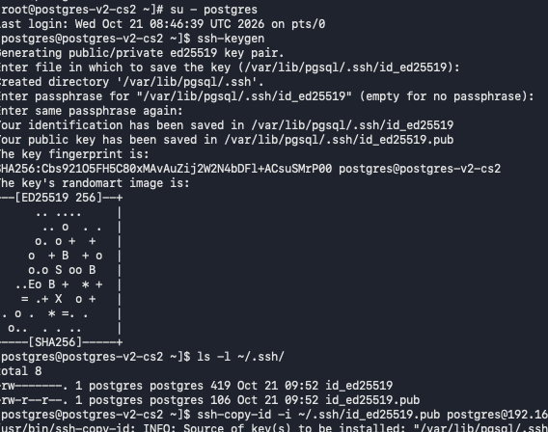
Install cs2's public SSH key on cs1 and verify SSH reaches the remote host without a password prompt.
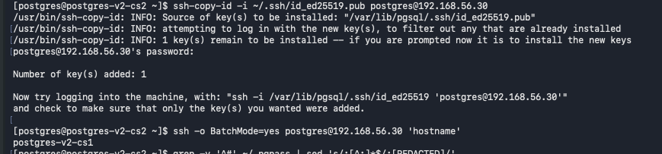
Run repmgr standby switchover in dry-run mode, review prerequisite checks, and perform the actual switchover if there are no failed prerequisite checks.
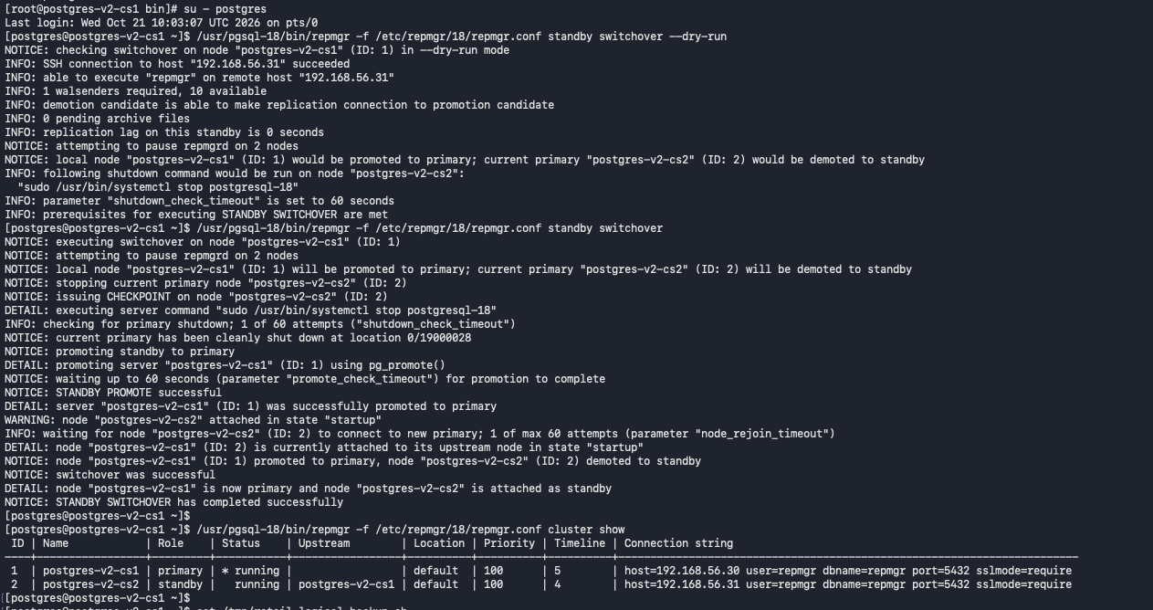
Final repmgr cluster view: cs1 is registered as standby and cs2 as primary, with both nodes running; validate live streaming independently after the switchover.

