Streaming Replication, Switchover , Failover, Rejoin & repmgr
Summary:
Key configuration changes
1. Replication role and authentication
- Created the replicator role with LOGIN and REPLICATION privileges, without SUPERUSER.
- Updated pg_hba.conf to allow replication connections from the standby using scram-sha-256.
- Checked pg_hba_file_rules for configuration errors.
2. Streaming replication and TLS
- Configured PostgreSQL WAL settings to support physical streaming replication.
- Configured TLS certificate and key paths for secure replication connections.
- Reinitialized the standby with pg_basebackup, requiring TLS and using SHA-256 manifest checksums.
- Configured primary_conninfo and primary_slot_name on the standby.
- Created and verified the physical replication slot cs2_standby.
3. Failover and rejoining the former primary
- Stopped PostgreSQL on postgres-v2-cs1 and promoted postgres-v2-cs2 to primary.
- Created the cs1_standby replication slot on the new primary.
- Rebuilt the former primary's data directory using pg_basebackup.
- Restored its PostgreSQL configuration and TLS files, removed conflicting replication settings, and configured it to follow postgres-v2-cs2.
4. repmgr configuration
- Installed repmgr_18- 5.5.0 on both nodes.
- Created the repmgr database and login role.
- Configured repmgr.conf and registered both nodes with repmgr.
- Inspected the repmgr-18 systemd service
- Configured SSH key-based authentication between the PostgreSQL nodes for passwordless access.
- Updated shared_preload_libraries to include pgaudit and repmgr.
- Ran a repmgr switchover dry run and proceeded through the switchover workflow.
5. Validation checks
- Used pg_stat_replication and pg_stat_wal_receiver to check streaming replication.
- Checked replication slot activity and WAL receive/replay positions.
- Compared replicated retail table counts: customers — 10, products — 10, orders — 10, and order_items — 20.
- Checked repmgr cluster status after node registration and switchover.
Replication role creation and verification on the primary; the replicator role has LOGIN and REPLICATION, but not SUPERUSER.
Create a dedicated least-privilege account for replication instead of granting superuser access.
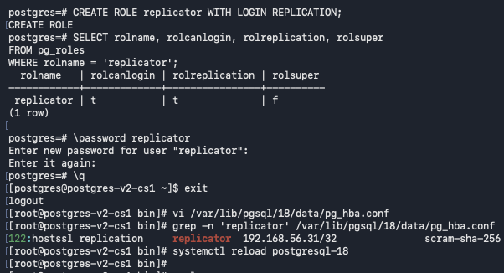
Primary pg_hba.conf replication rule allowing the replicator role from standby 192.168.56.31 using SCRAM-SHA-256.
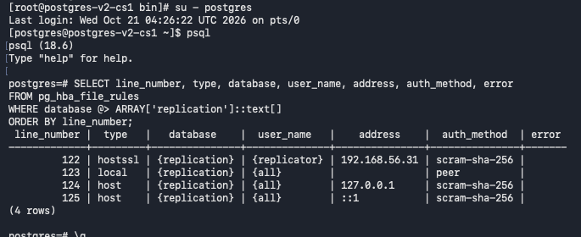
Query pg_hba_file_rules on the standby and confirm no HBA parsing errors are reported.
Confirms replication access is restricted to the intended host and authentication rules parse without errors.
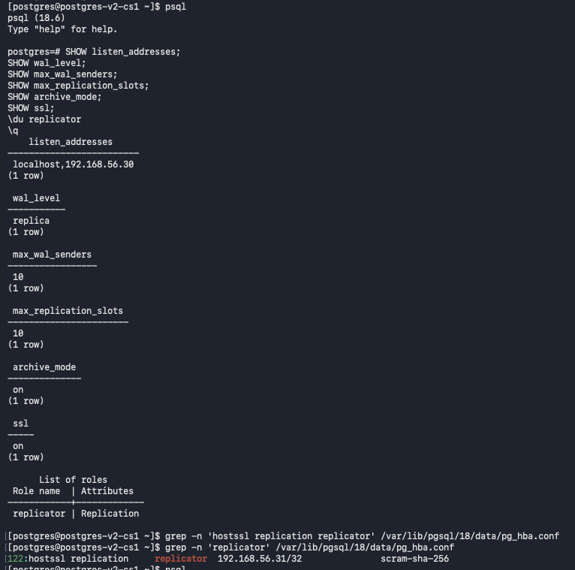
Edit the standby's pg_hba.conf and reload PostgreSQL
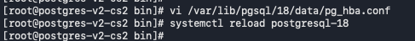
Replicator user password is set in .pgpass file so you are not prompted to enter the password
Checks replication credentials are present while avoiding disclosure of plaintext passwords.
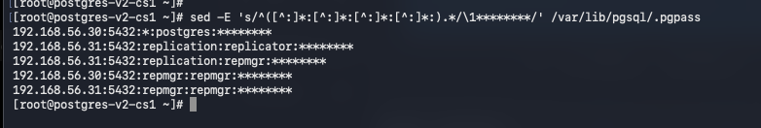
Run a temporary pg_receivewal connectivity test from the standby; the command is interrupted because the test passed; and leaves an incomplete partial WAL file.
Test secure WAL connection reachability before configuring continuous streaming.
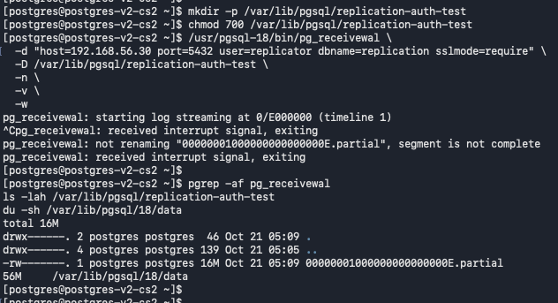

Inspect the standby's PostgreSQL data directory, configuration-file paths, listen address, archive settings, and TLS certificate/key paths before rebuilding it after a failover
Creates a consistent physical copy from the current primary so the standby can safely join the cluster.
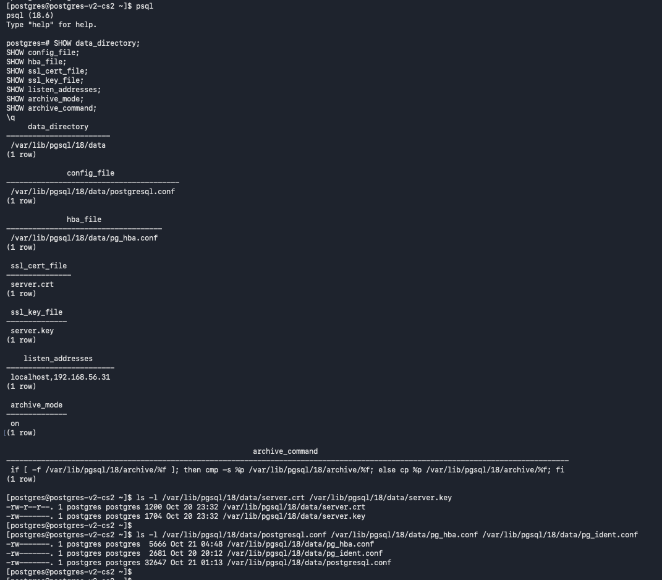

Start Streaming Replication:
Stop PostgreSQL on the standby and move its existing data directory to a timestamped pre-reinitialization path.
Ensures the node is stopped before replacing its data directory or changing its replication role.
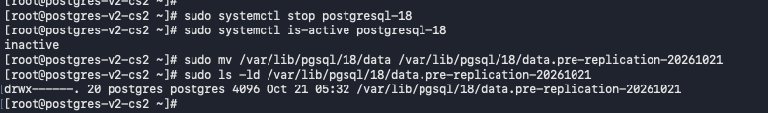
Run pg_basebackup on node 2 against primary 192.168.56.30 with TLS required and SHA-256 manifest checksums.
pg_basebackup reaches 100% and reports completion for the standby data copy.
Creates a consistent physical copy from the current primary so the standby can safely join the cluster.
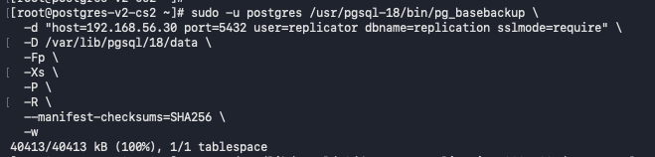

Start PostgreSQL on the standby and confirm the service is active and accepting local connections.
Confirms PostgreSQL starts cleanly after the standby configuration is applied.
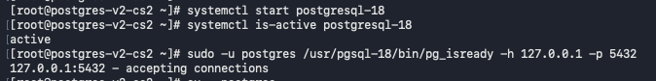
Verify the standby is in recovery and its WAL receiver is streaming from 192.168.56.30.
Verifies the node's primary/standby role and confirms WAL is being received and replayed.
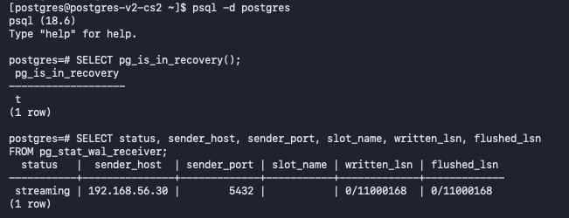

Inspect retail database schemas, tables, and row counts on the standby after replication is established.
Compares replicated objects and row counts to check application data is present on the expected node.
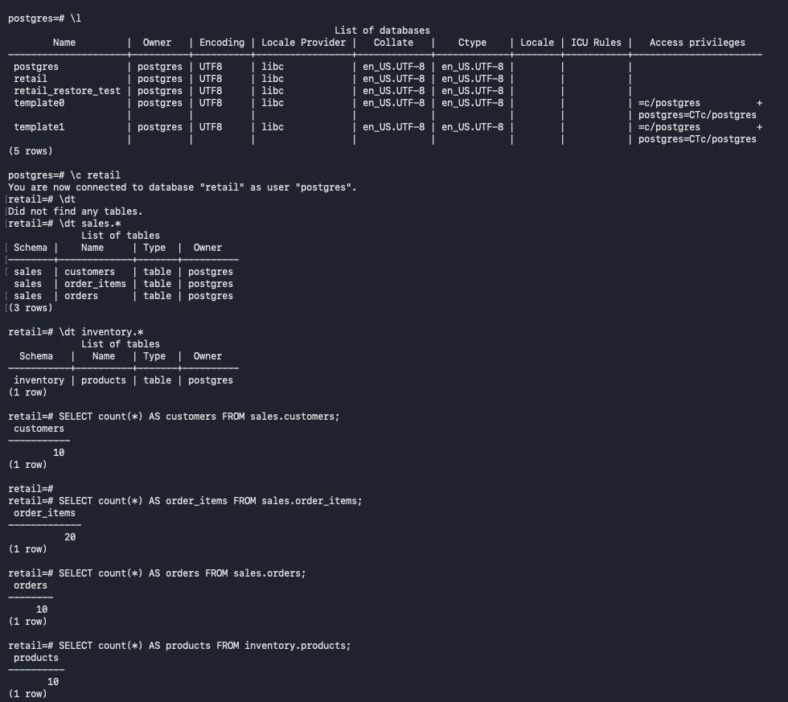
From the standby, Connect to the primary remotely and verify its primary role, standby streaming state, WAL positions, and replication-slot status.
Verifies the node's primary/standby role and confirms WAL is being received and replayed.
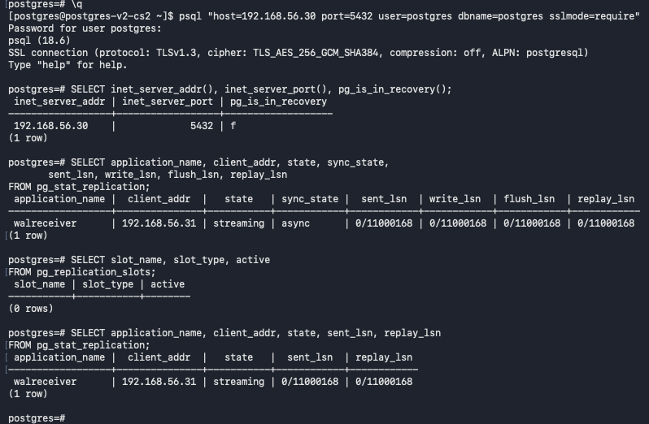

Setup Log Shipping:
Set primary_slot_name on the standby, then create the cs2_standby physical slot on the primary.
- Create/configure cs2_standby replication slot and verify its initial physical-slot status before attaching the standby to it.
Confirms the physical replication slot exists and can retain WAL needed by its standby.
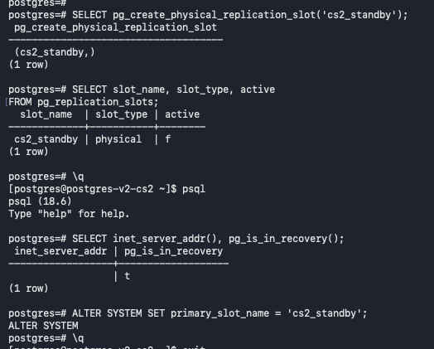
Restart PostgreSQL on the standby and verify cs2_standby is active while pg_stat_replication reports asynchronous streaming.
Confirms PostgreSQL starts cleanly after the replication slot configuration is applied.
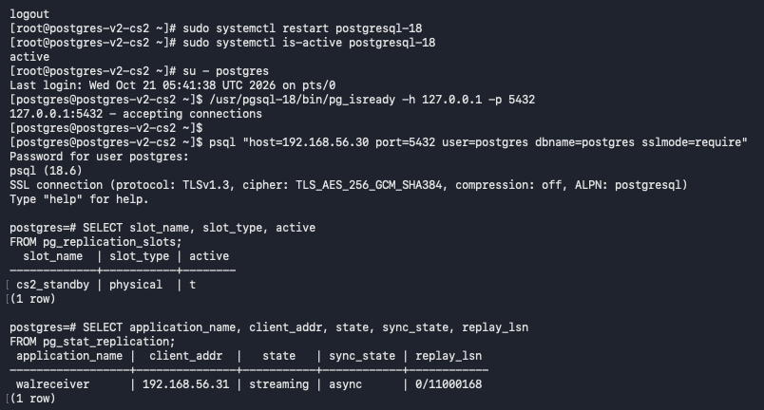

Create a temporary test row to prove that a write on the primary appears on the standby.
Create and query public.replication_validation on the primary to test whether the row replicates to the standby.
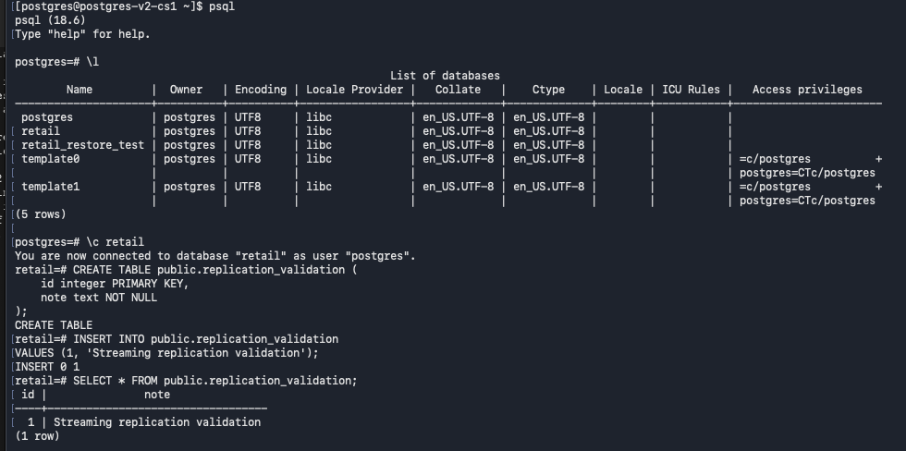
Uses a temporary test row to prove that a write on the primary appears on the standby.
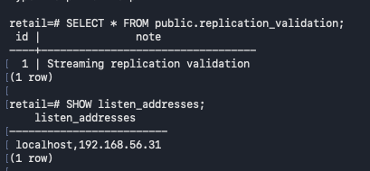
Read the replicated validation row on the standby, then drop the temporary table and check node role/listen-address context.
Provides a checkpoint that the replication configuration or cluster operation is behaving as expected.
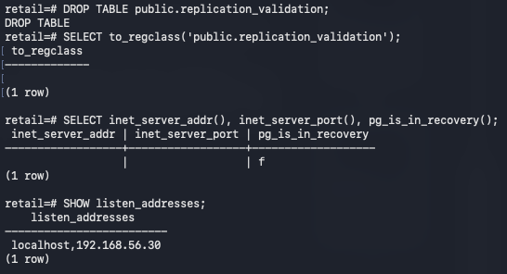
Replication monitoring and validation:
Check primary-side pg_stat_replication and replication-slot state after removing the temporary validation table.
Why: Confirms the physical replication slot exists and can retain WAL needed by its standby.
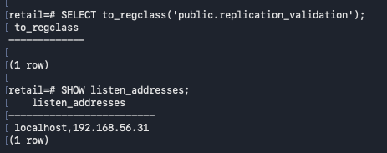

Check standby listen address, streaming state, WAL receive/write/flush/replay positions, and the active cs2_standby slot.
Verifies the node's primary/standby role and confirms WAL is being received and replayed. Primary and Standby are insync.
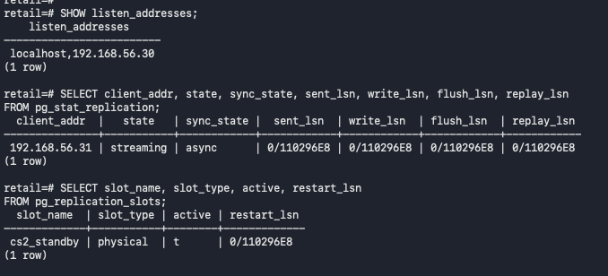
Final streaming-replication checks on the standby: recovery mode, WAL receiver status, slot name, and received/replayed LSNs.
Why: Verifies the node's primary/standby role and confirms WAL is being received and replayed.
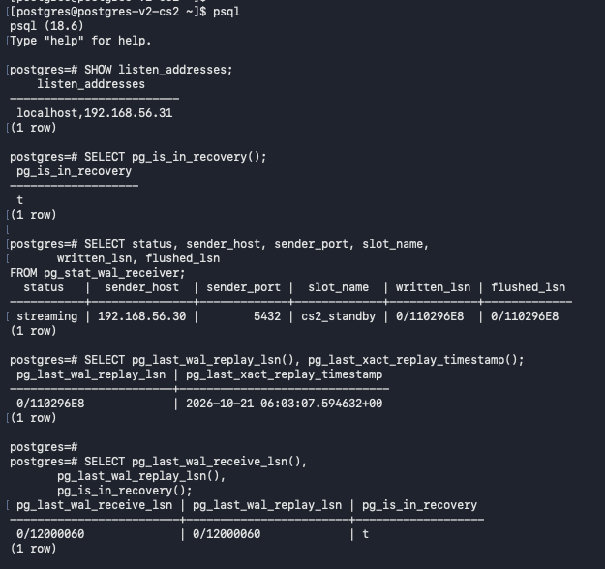

Pre-failover validation on cs2: confirm recovery mode, upstream host, cs2_standby slot, and replay position.
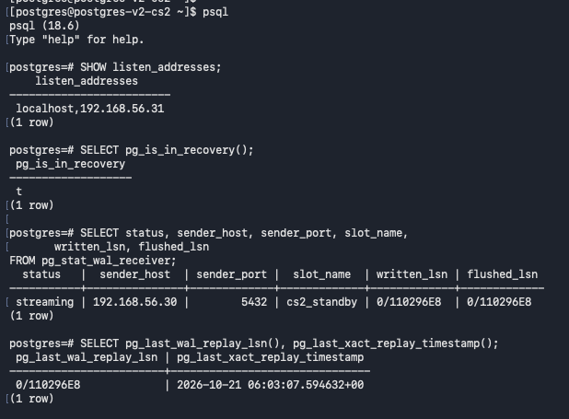
Perform a WAL switch on the primary and compare current flush LSN with standby receive/replay positions before failover.
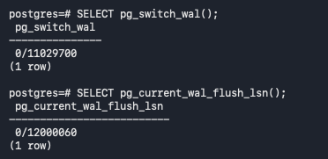
confirms WAL is being received and replayed and are in sync
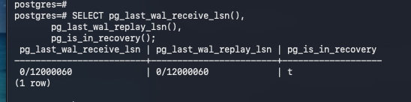

Failover procedure: stop the current primary and promote the standby to become the primary
Stop PostgreSQL cleanly on cs1 before promoting cs2.
Ensures the node is stopped before changing its replication role.
This is also stimulating a real time failure like your primary is down and you need to failover to your standby
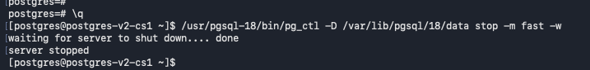
Promote cs2 with pg_ctl and verify pg_is_in_recovery() returns false.
Promote cs2 to primary and verify the node's role and confirms cs2 is now the primary database
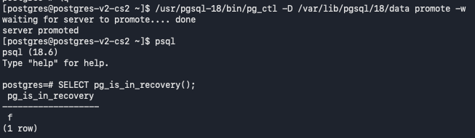

On promoted cs2, review PostgreSQL settings, the replicator role, replication-slot state, and test Write operations on the new primary.
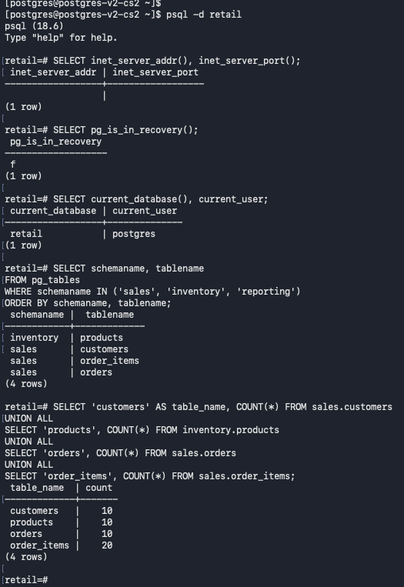

Test Write operations on the new Primary
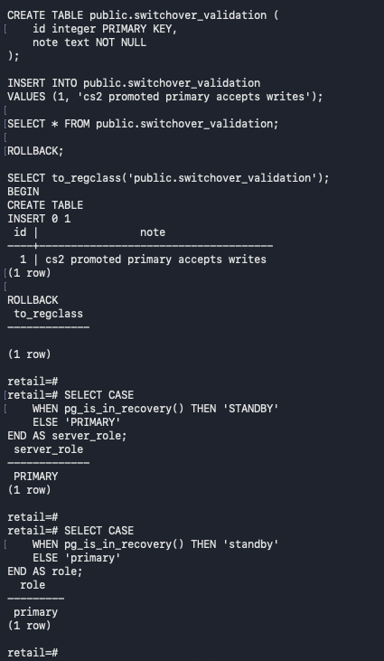
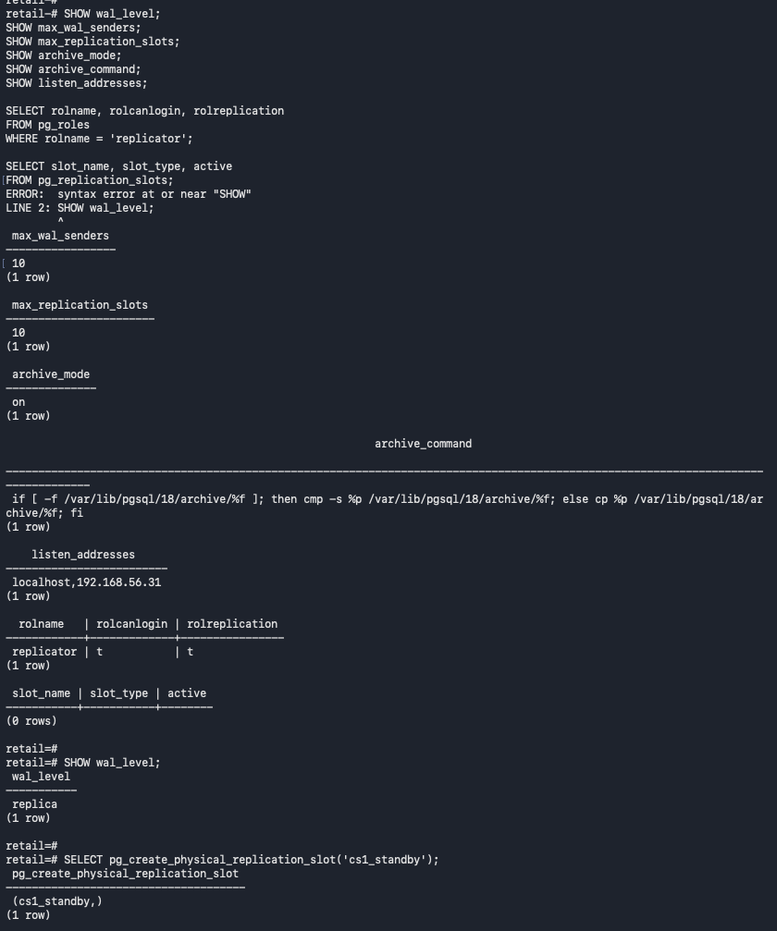

On the promoted cs2 primary, create the physical replication slot cs1_standby and verify that it exists and is initially inactive.
Confirms the physical replication slot exists on the new primary and can retain WAL needed by its standby
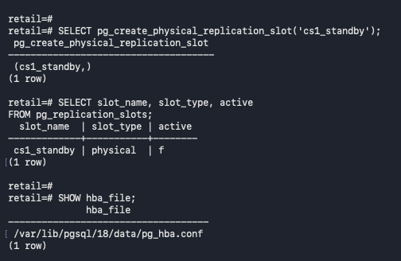

Rebuild the failed primary (CS1):
Check PostgreSQL service status on former primary cs1 before creating the replacement data directory; the service is not running.
Ensures the node is stopped before replacing its data directory or changing its replication role.
Inspect the former primary cs1's PostgreSQL installation, data directory, configuration files, and saved pre-switchover files before rebuilding it.
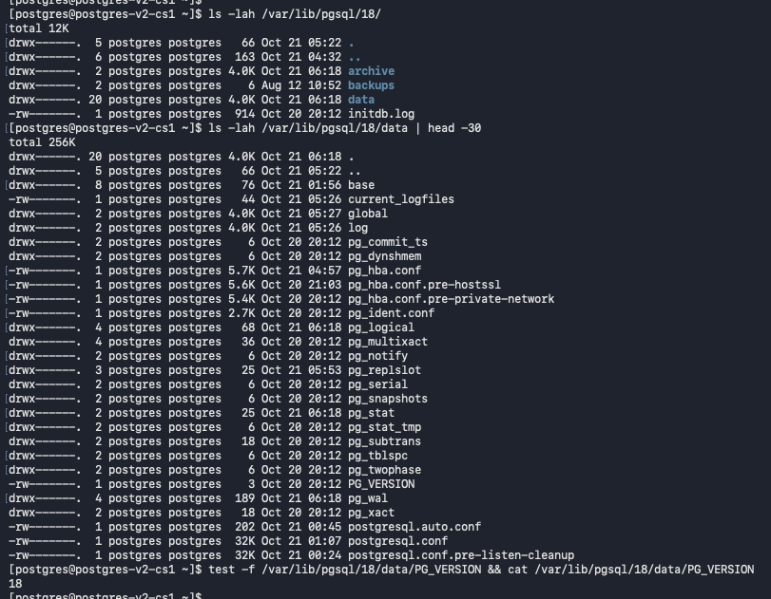
While the former primary is still stopped, move the old data directory to a timestamped pre-switchover backup, and create a fresh data directory with restricted permissions.
Create a consistent physical copy from the current primary so the standby can safely join the cluster.
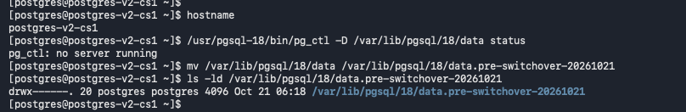
Create a new pgsql data directory for the rebuild server

Run pg_basebackup on former primary cs1 from the current primary at 192.168.56.31, using the replicator account, TLS, the cs1_standby slot, and SHA-256 manifest checksums.
Creates a consistent physical copy from the current primary to replicate it so the standby can safely join the cluster.
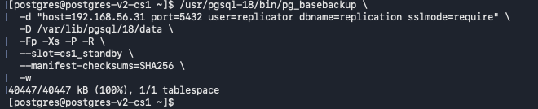
Restore cs1's saved PostgreSQL configuration and TLS files, remove the old primary_conninfo/slot settings, configure cs1 to follow cs2 through cs1_standby, and start PostgreSQL.
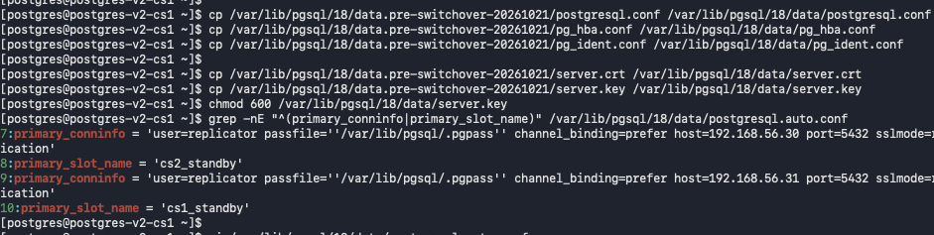

Verify that rebuilt cs1 is in recovery and its WAL receiver is streaming from cs2 (192.168.56.31) using the cs1_standby slot.
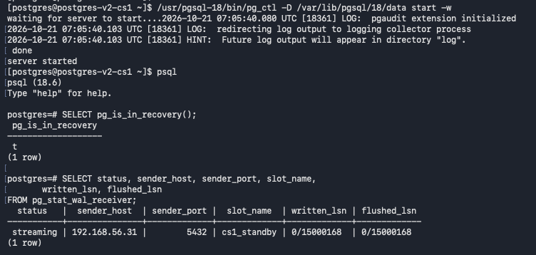

Verify reverse streaming replication after cs1 rejoins: cs1 is in recovery and receives WAL from cs2 through cs1_standby.
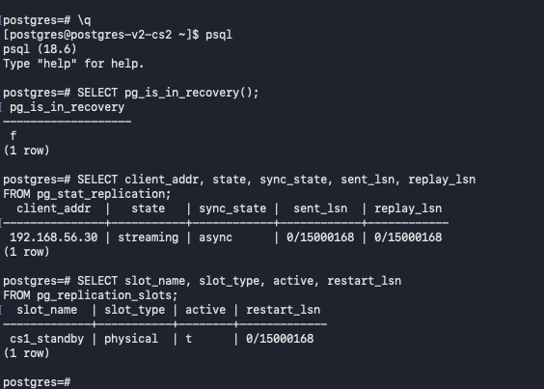
Verifies the node's primary/standby role and confirms WAL is being received and replayed.
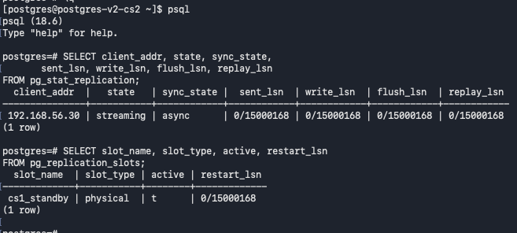

Verify reverse streaming replication after cs1 rejoins: cs1 is in recovery and receives WAL from cs2 through cs1_standby.
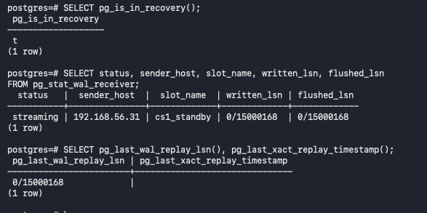
Compare the retail table row counts after cs1 rejoins; the displayed counts are customers 10, products 10, orders 10, and order_items 20.
Why: Compares replicated objects and row counts to check application data is present on the expected node.
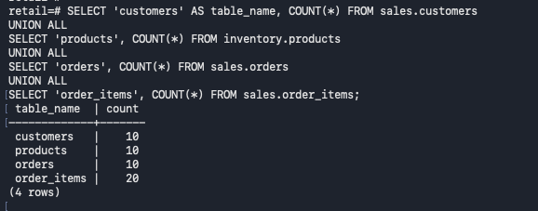

Rep Manager Implementation:
Install repmgr_18-5.5.0 on cs1
Installs the cluster-management utility for node registration and controlled role transitions.
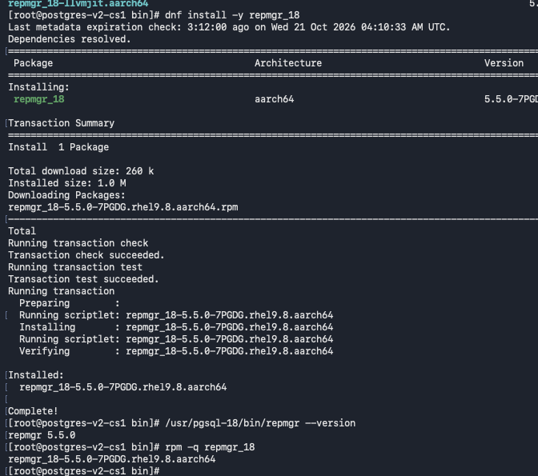

Install repmgr_18-5.5.0 on cs2 and verify the installed package version.
Why: Installs the cluster-management utility for node registration and controlled role transitions.
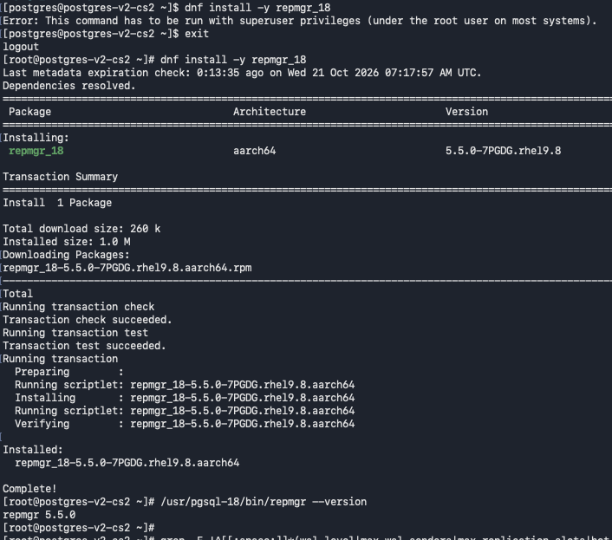

Inspect repmgr.conf and pg_hba.conf on cs1; verify the replicator and repmgr role/database prerequisites and note that the repmgr database is not yet present
Why: Confirms replication access is restricted to the intended host and authentication rules parse without errors.
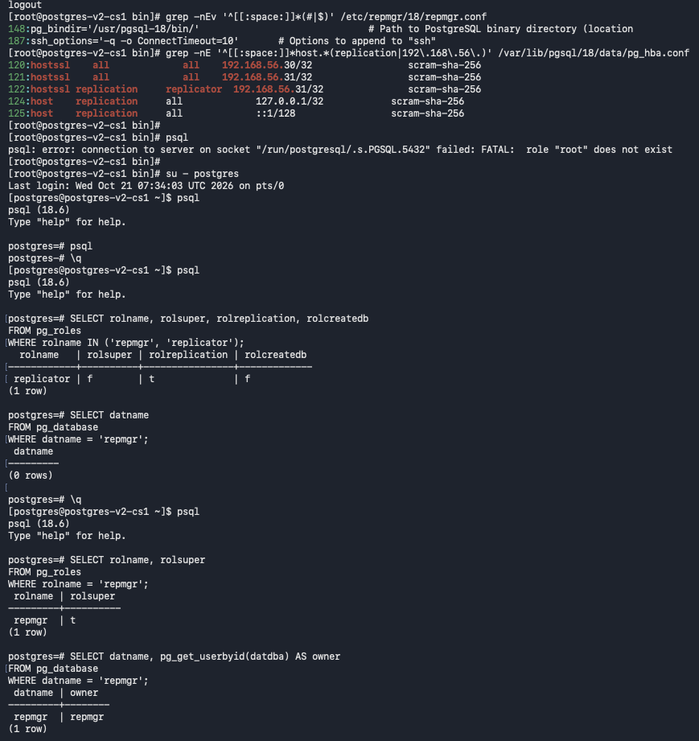

Inspect repmgr.conf and pg_hba.conf on cs2;
Create repmgr super user and database to be used by rep manager
Why: Confirms replication access is restricted to the intended host and authentication rules parse without errors.
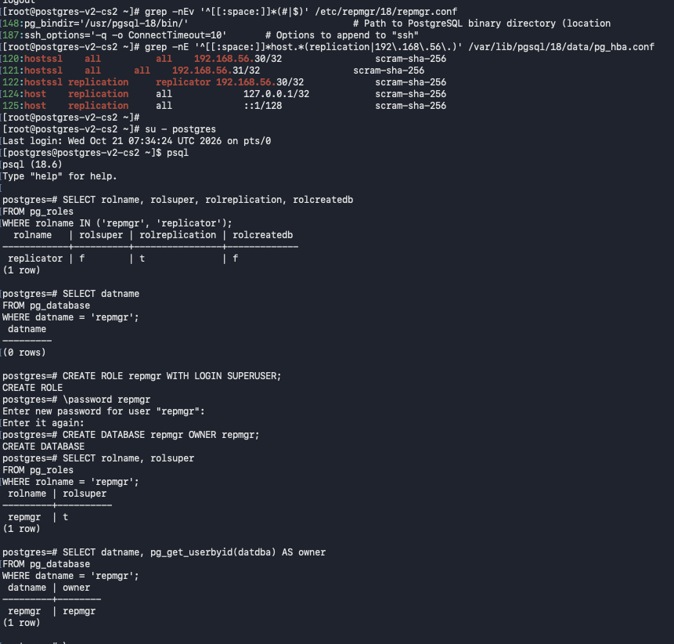

Node 1: configure repmgr settings, including node_id, node_name, conninfo, data_directory in repmgr.conf file
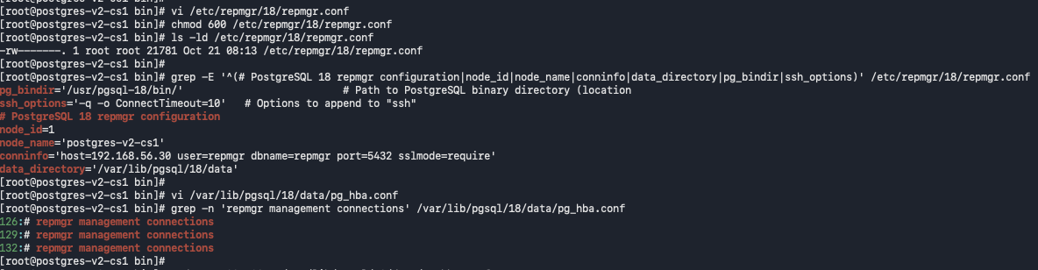
Node2: configure repmgr settings, including node_id, node_name, conninfo, data_directory in repmgr.conf file
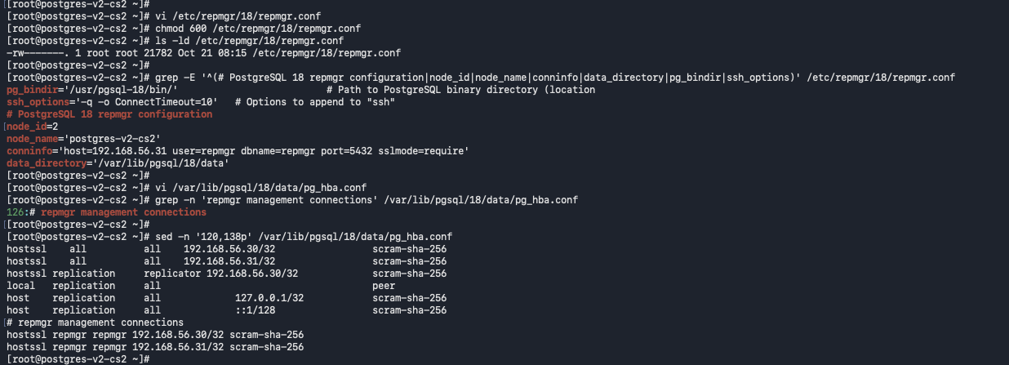
Reload PostgreSQL on cs1 and test a connection to the repmgr database at 192.168.56.30; the connection resolves to the expected node.
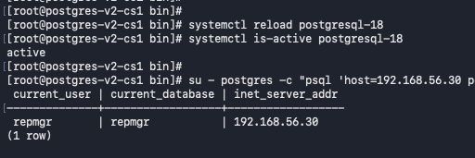

Test a connection to the repmgr database on cs2 at 192.168.56.31 and verify the current node can be reached.
Why: Installs the cluster-management utility for node registration and controlled role transitions.
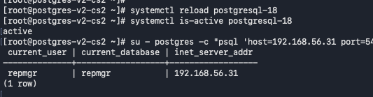

Register cs2 as a primary with repmgr and verify that both nodes appear in the cluster status output.
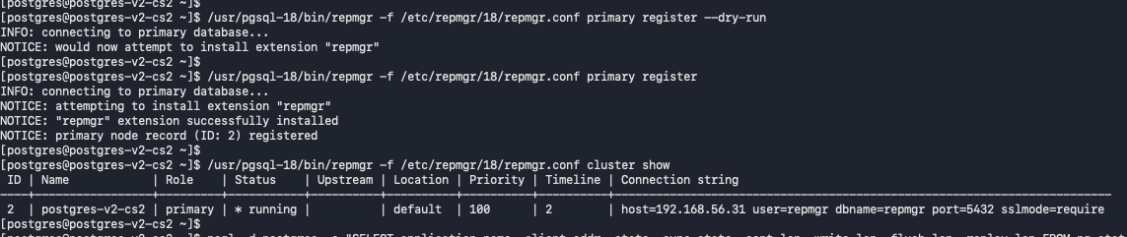
Register cs1 as the repmgr standby and display the initial cluster membership and node status.
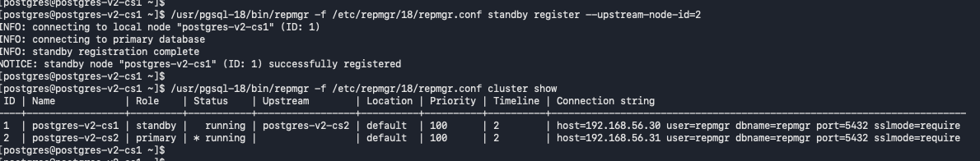
Inspect repmgr-18 systemd status and unit contents on cs2; the service is also disabled and inactive.

Check shared_preload_libraries on cs2 and update the setting to include repmgr.
Why: Installs the cluster-management utility for node registration and controlled role transitions.
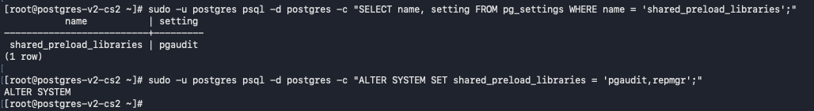
Why: Installs the cluster-management utility for node registration and controlled role transitions.

Generate an SSH key pair on cs1 and attempt SSH to cs2
Enables remote, non-interactive SSH operations used by repmgr workflows.
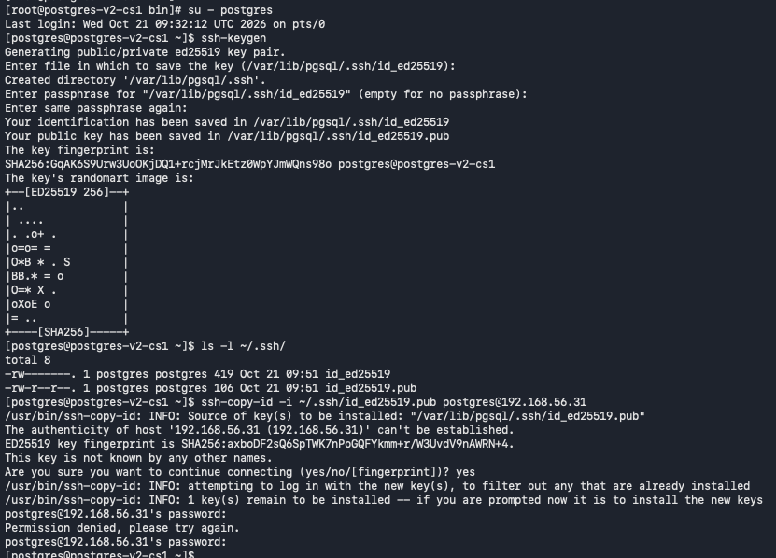
Copy/Install cs1's public SSH key on cs2 and verify SSH reaches the remote host without a password prompt.
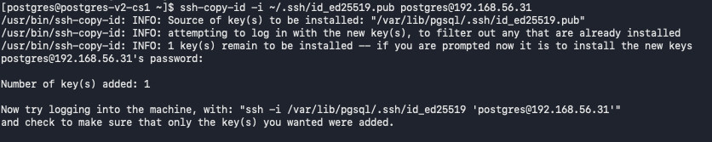
Generate an ED25519 SSH key pair on cs2 and inspect the private/public key files.
Enables remote, non-interactive SSH operations used by repmgr workflows.
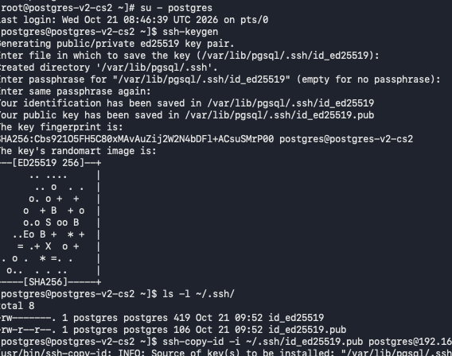
Copy/Install cs2's public SSH key on cs1 and verify SSH reaches the remote host without a password prompt.
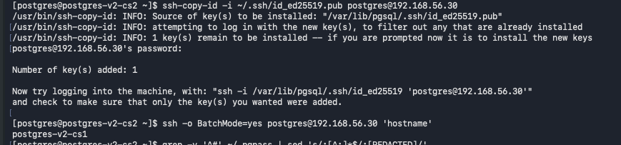
Perform a Switchover using Rep Manager
Run repmgr standby switchover in dry-run mode, review prerequisite checks, and perform the actual switchover if there are no failed prerequisite checks.
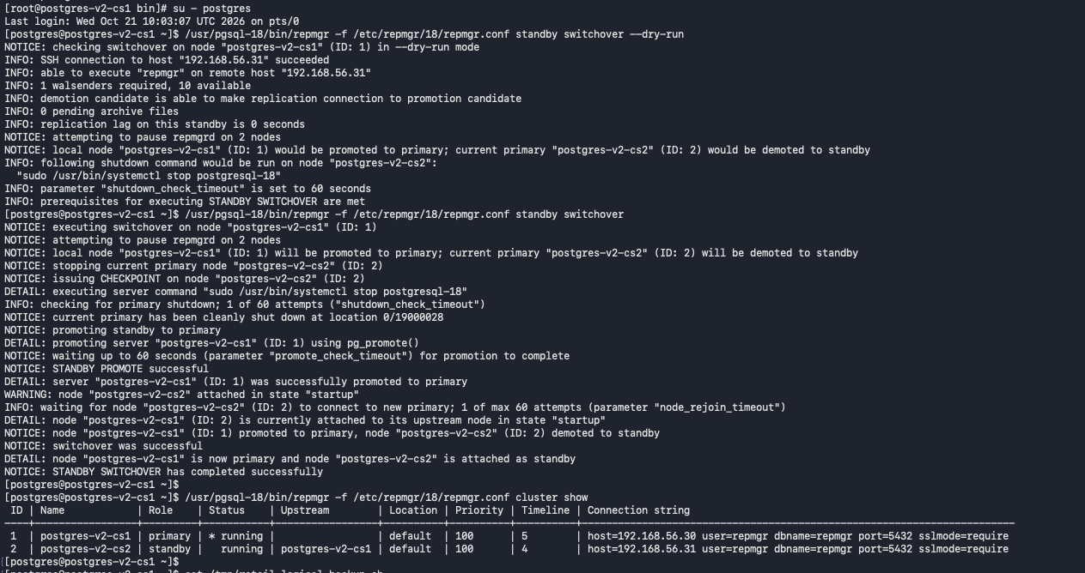
Final repmgr cluster view: cs1 is registered as Primary and cs2 as Standby, with both nodes running; validate live streaming independently after the switchover.

