feat: add Retail Store v2 application source and production Dockerfiles
- Add Retail Store v2 application source code
- Implement production-grade multi-stage Dockerfiles
- Harden containers with non-root users
- Validate Docker Compose deployment
- Configure health checks and startup dependencies
- Prepare applications for Kubernetes deployment
Docker compose implementation and validations:
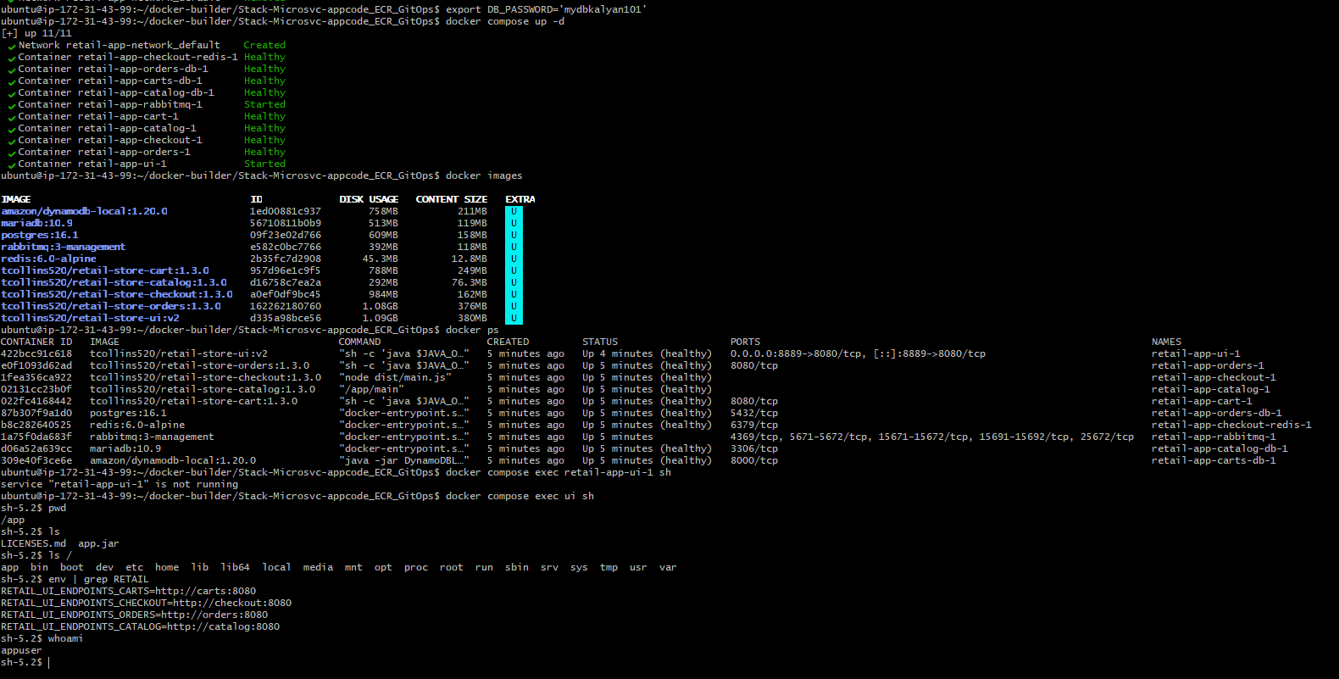
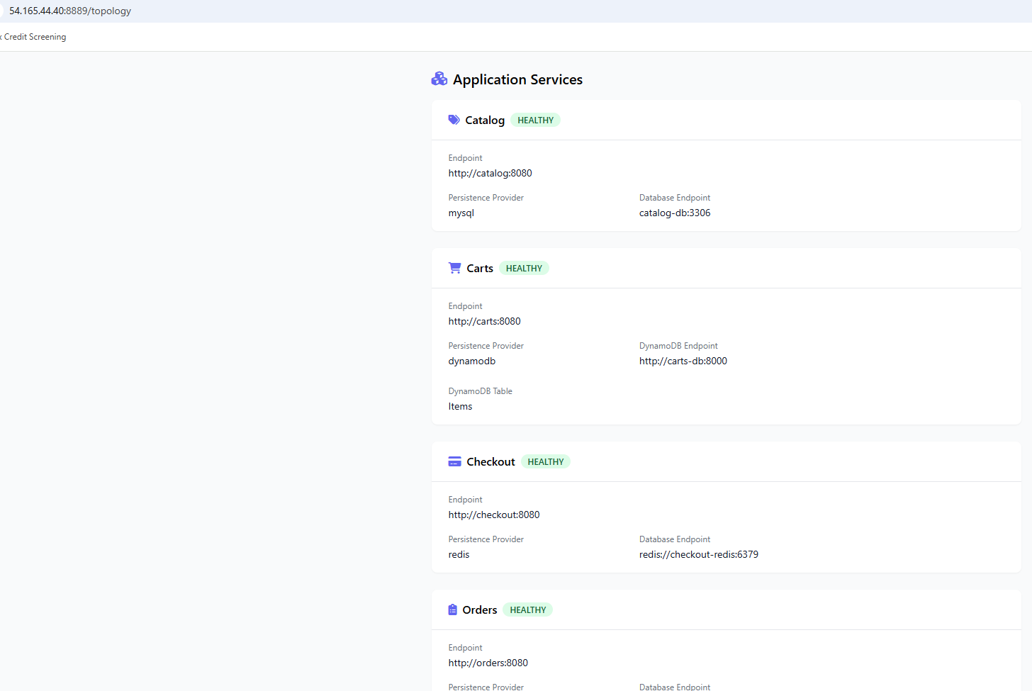
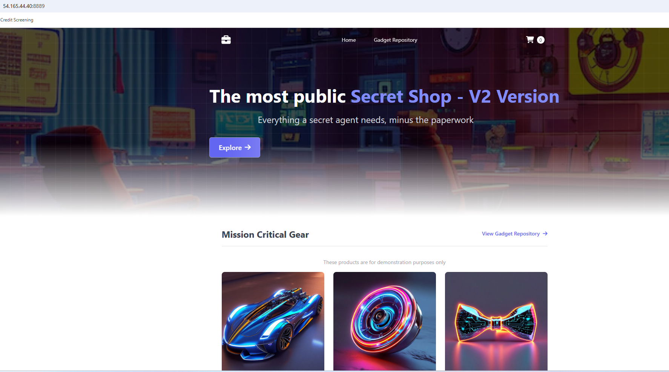
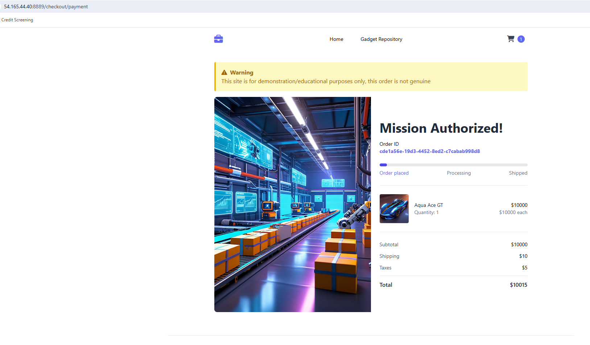
Remote-state s3: Use remote backend state file for team collaboration to maintain the state of your cloud infrastructure and record the cloud resources that were created.
State file is also used by EKS cluster to get the VPC ID of where to create private worker nodes in.
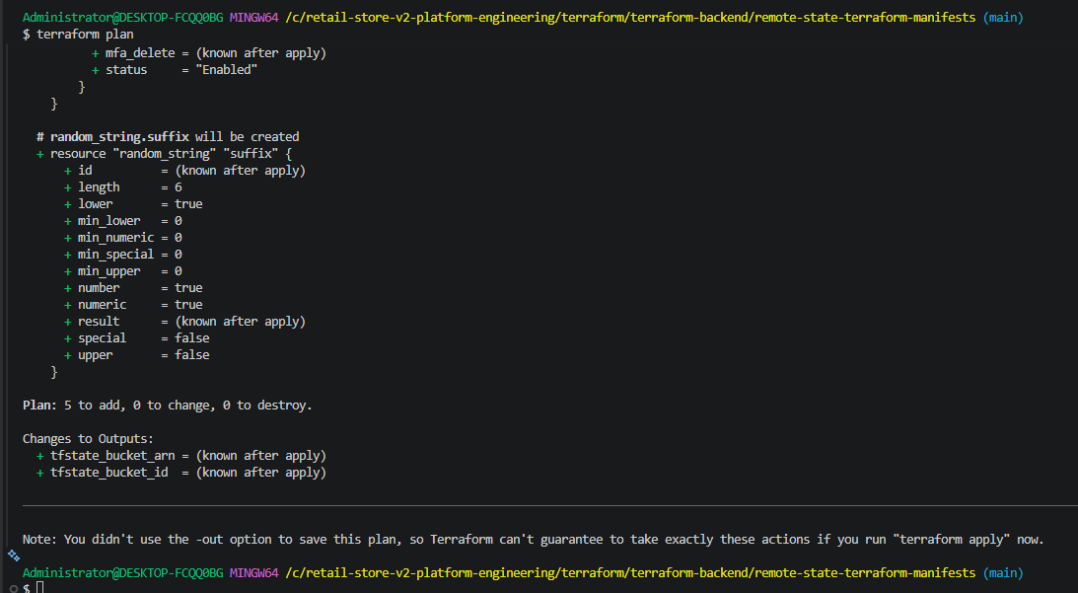
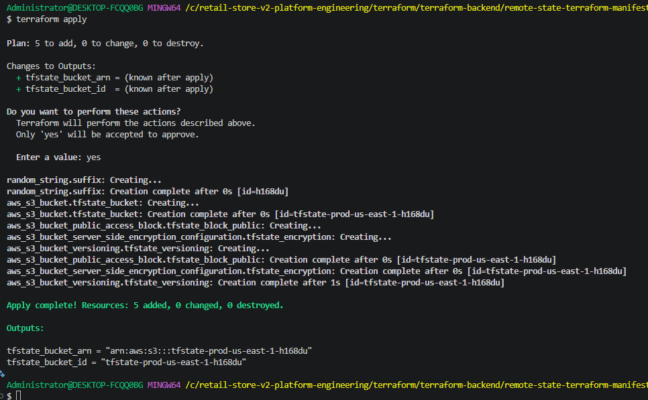
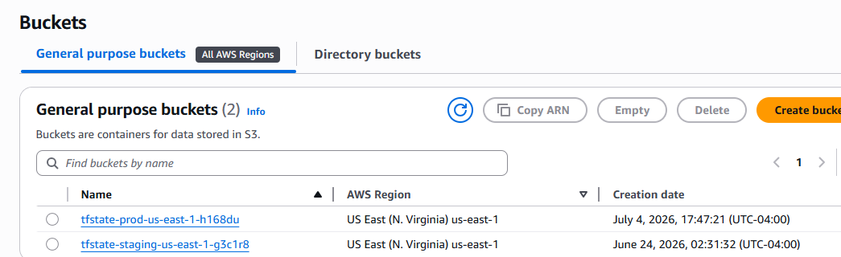

"feat(terraform): provision production networking foundation"
- Configure Terraform remote state backend with Amazon S3
- Provision production VPC across three Availability Zones
- Create public and private subnet topology
- Deploy Internet Gateway and NAT Gateway
- Configure public and private route tables
- Export networking outputs for future EKS deployment
Production-grade VPC:
AWS VPC with 3 Public and 3 Private subnets.
1. Three availability zones with public and private subnets in each zone.
a. Each Public subnet has a NAT Gateway which will allow traffic to go from the private subnet to the NAT Gateway, to the Internet Gateway and lastly to the internet.
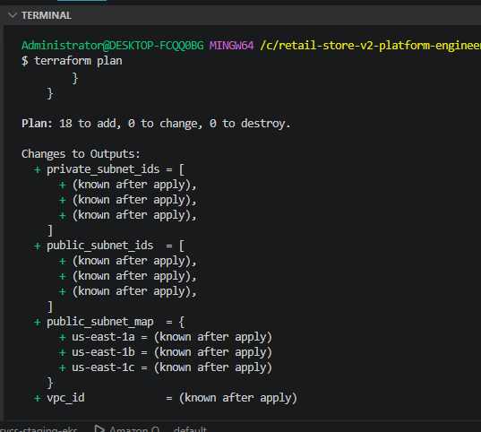
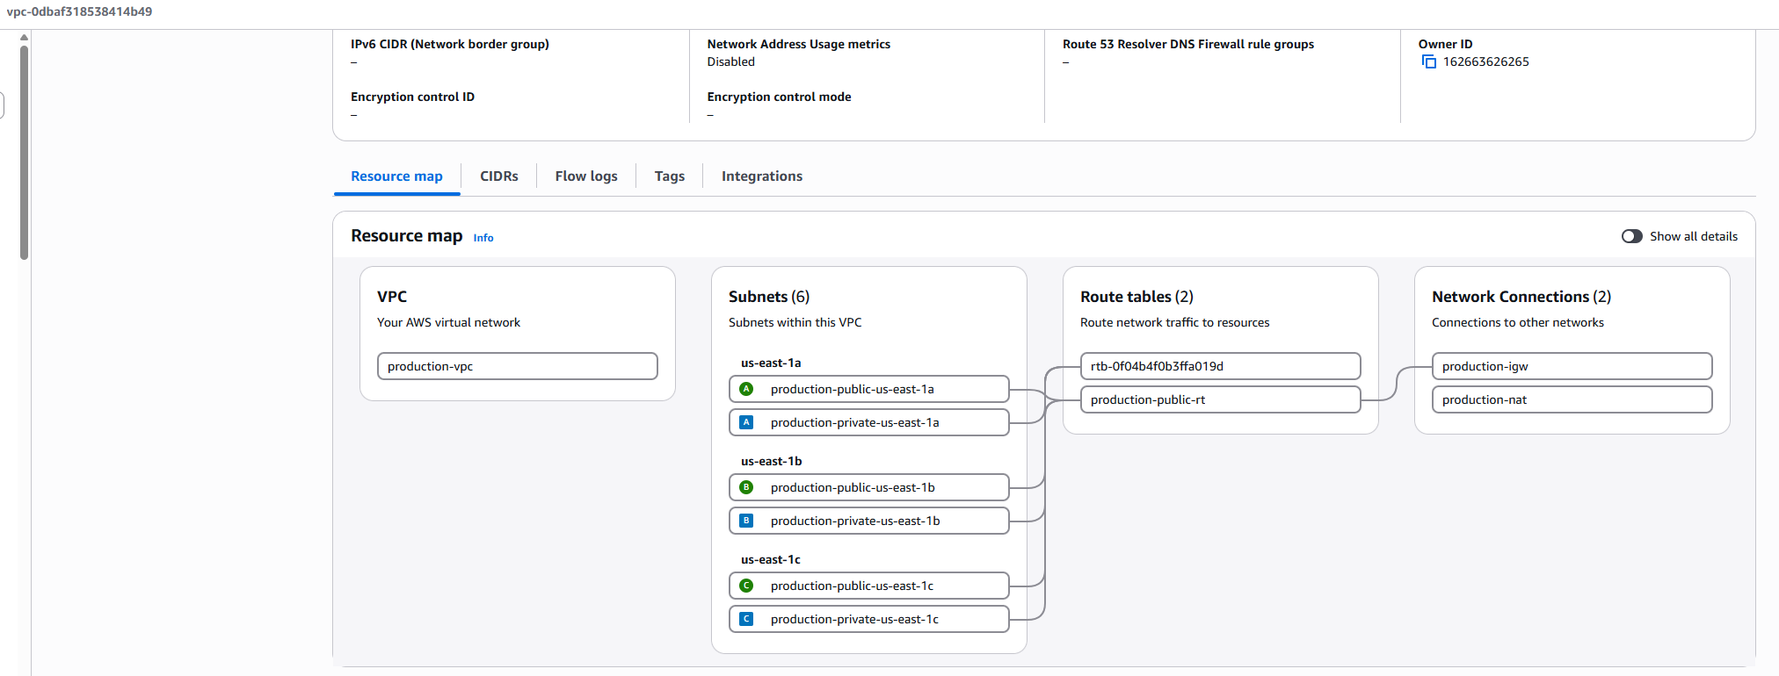
Nat gateway
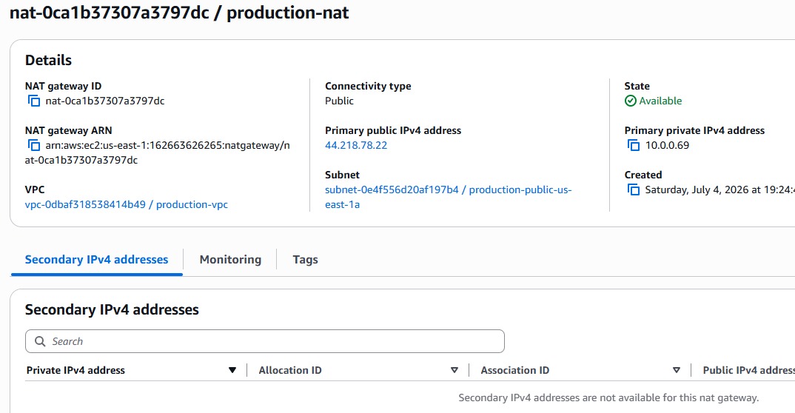
igw 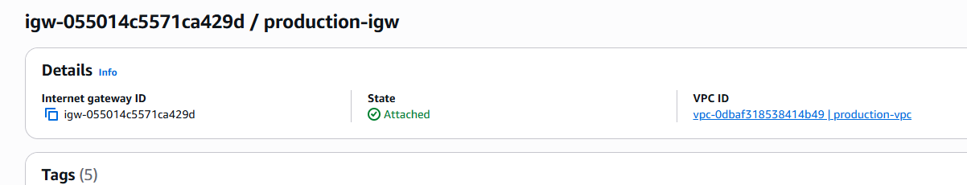

provision Amazon EKS production cluster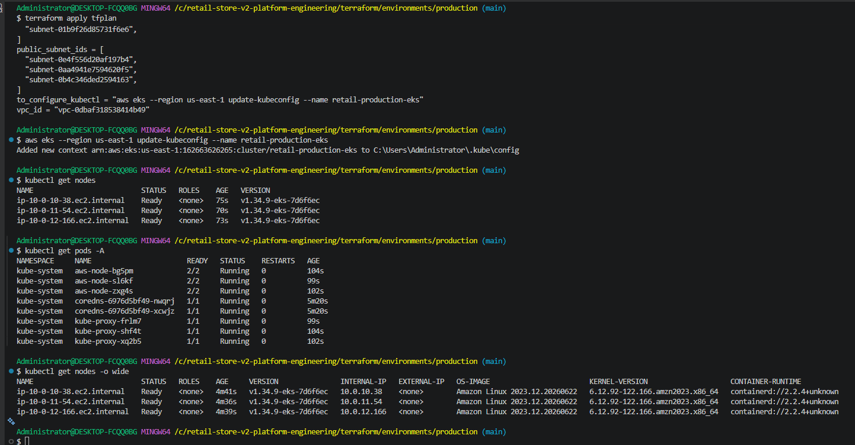
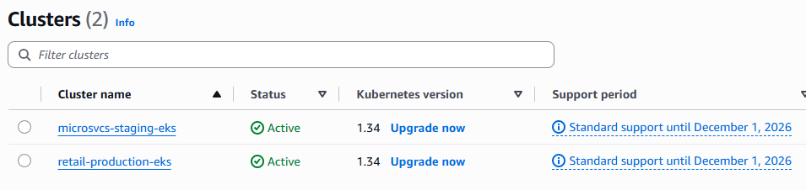
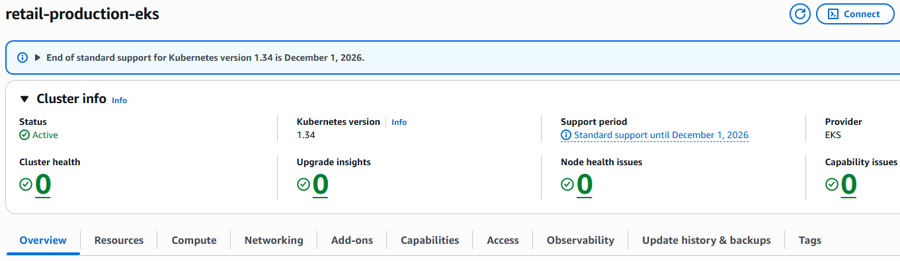
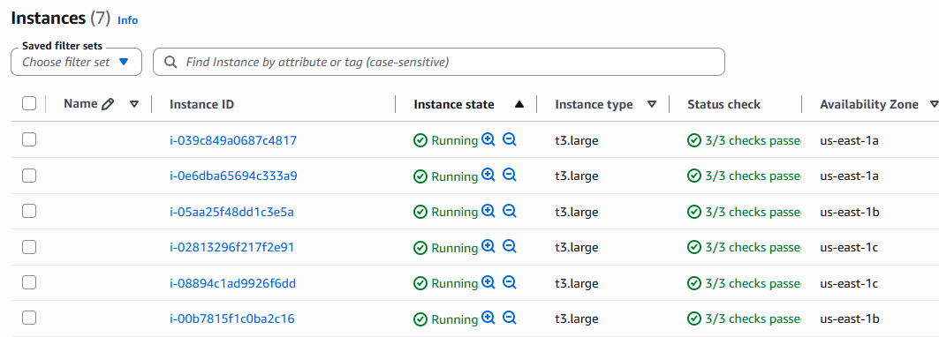
feat(platform): bootstrap EKS cluster with Metrics Server and Pod Identity Agent
Install metrics server:
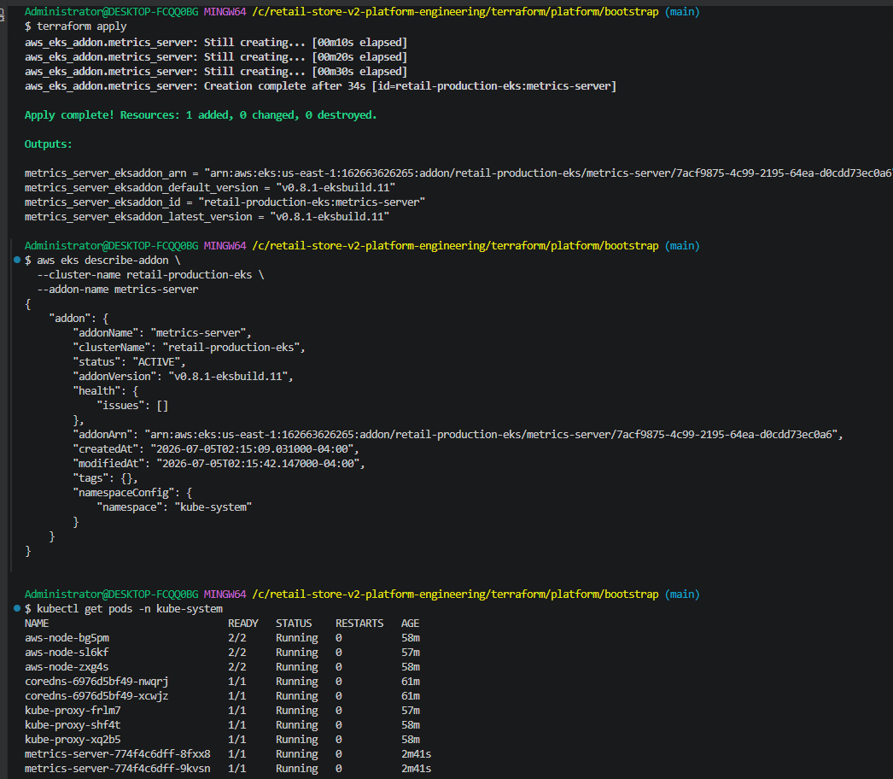
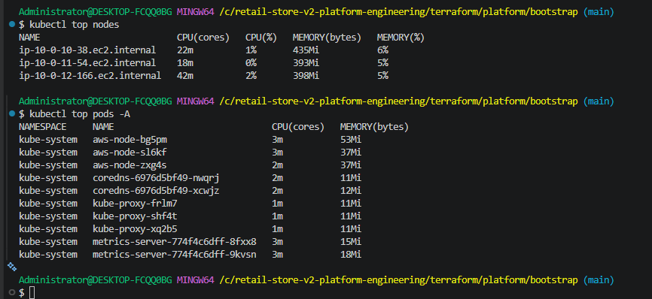
Pod Identity Agent installed and running as a daemonset on each node in the cluster for secured workload identity to AWS resources.
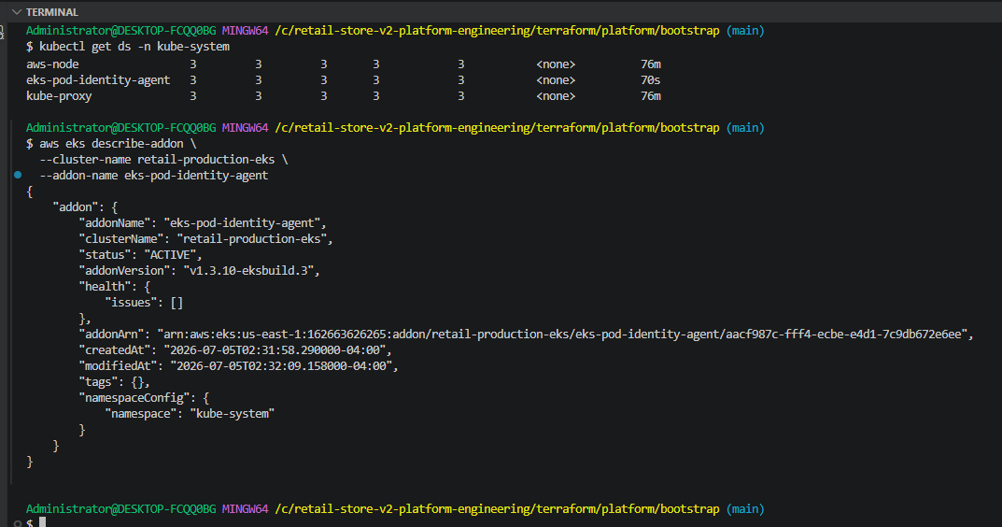
Pod Identity Association for ebs-csi-driver
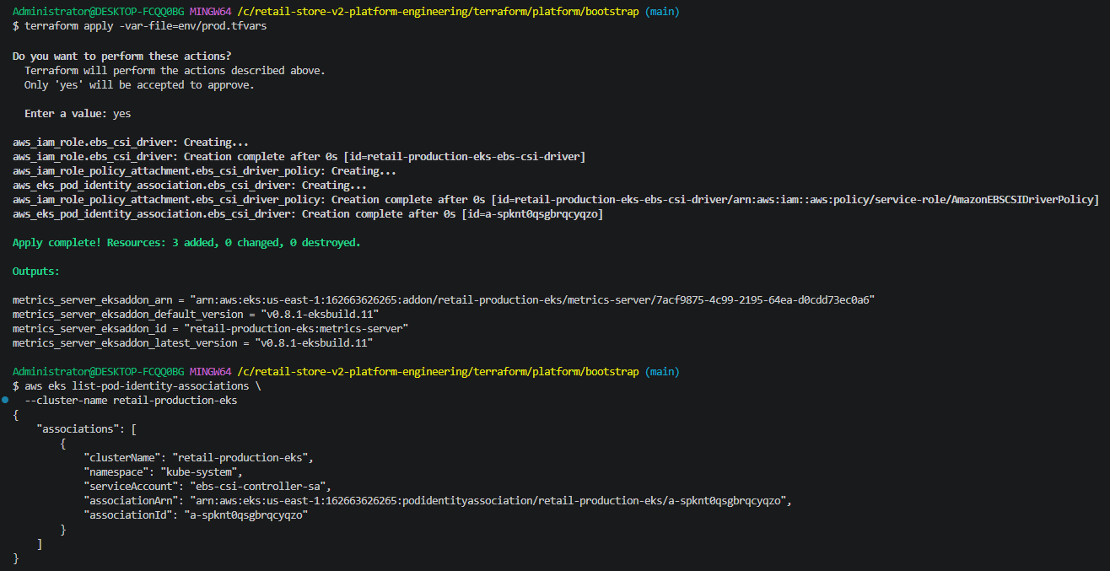
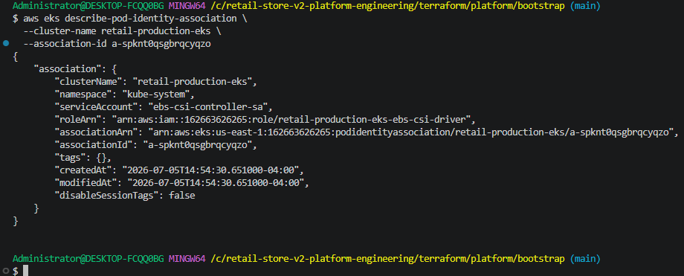
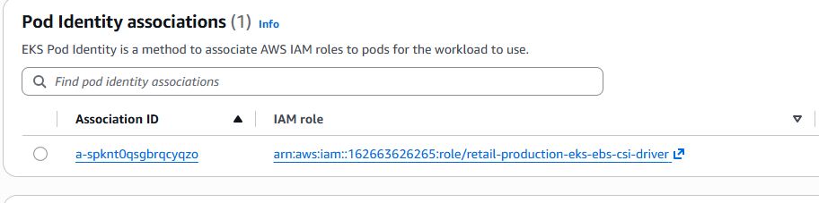
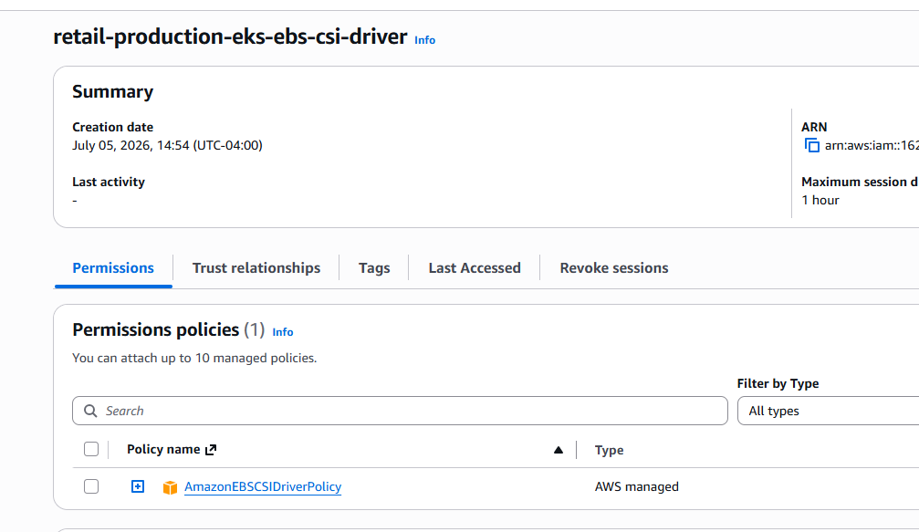

feat(storage): implement Amazon EBS CSI Driver with EKS Pod Identity 