Adders can be implemented using basic logic gates XOR, AND gates. By constructing half and full adders, a gate level ripple carry 8-bit adder can be simulated with Verilog using ModelSim.
Lab 3
Thomas Cooper
Computer Engineering Major

INTRODUCTION
AN 8-bit ripple carry adder allows the sum of two 8-bit numbers to be produced. Several full adders are chained off of each other to pass a binary 1 to the next adder in succession, ending with a final carry over output that could conceivably act as a ninth bit.
Building the circuit from the basic components up proved to be the easiest method based on current skill. Once the circuit had been written, a series of test equations were used to determine the circuit’s accuracy.
The lab begins by tasking with the design of an 8-bit adder with gate level ripple carry using Verilog, and the creation of the test bench. A half adder was constructed using a single XOR gate, and a single AND gate.
module halfAdder (output S, C, input x, y);
xor (S, x, y);
and (C, x, y);
endmodule
Figure 1 Verilog HDL model for half adder

With the completion of the half adder, a full adder is constructed using two instantiations of the half adder and an OR gate. Wires are created to connect the half adders and the OR gate together.
module fullAdder ( output S, C, input x, y, z);
wire S1, C1, C2;
halfAdder HA1 (S1, C1, x, y);
halfAdder HA2 (S, C2, S1, z);
or G1 (C, C2, C1);
endmodule
Figure 2 Verilog HDL model for full adder

To finish the 8-bit adder, a chain of full adders is created with a wire connected between the carry outputs and inputs. This allows the carry signal to travel down he path of adders so that next component knows the output of the previous. The input and the Sum are written to be 8-bits wide so that a single number can be passed in instead of several individuals.
module rippleCarry8bitAdder (output [7: 0] Sum, output C8, input [7: 0] A, B, input C0);
wire C1, C2, C3, C4, C5, C6, C7;

fullAdder FA0 (Sum[0], C1, A[0], B[0], C0),
FA1 (Sum[1], C2, A[1], B[1], C1),
FA2 (Sum[2], C3, A[2], B[2], C2),
FA3 (Sum[3], C4, A[3], B[3], C3),
FA4 (Sum[4], C5, A[4], B[4], C4),
FA5 (Sum[5], C6, A[5], B[5], C5),
FA6 (Sum[6], C7, A[6], B[6], C6),
FA7 (Sum[7], C8, A[7], B[7], C7);
endmodule
Figure 3 Verilog HDL model for 8-bit adder

With the 8-bit adder in hand, the test bench is written to simulate the circuit. A series of simple addition equations are provided for the simulation. The numbers are provided in decimal, so the equivalent binary numbers are used in place of inputs; 100 + 99 (0110 0100 + 0110 0011 = 1100 0111), 22 + 33 (0001 0110 + 0010 0001 = 0011 0111), 0 + 200 (0000 0000 + 1100 1000 = 1100 1000), and 178 + 134 (1011 0010 + 1000 0110 = 0001 0011 1000). These are the equations that will be tested with the adder to determine functionality.
//100 + 99
//‭01100100 + ‬‭01100011‬ = 1100 0111
#10 A=8'b01100100;B=8'b01100011;

//22 + 33
//‭00010110‬ + ‭00100001‬ = ‭0011 0111
#10 A=8'b00010110;B=8'b00100001;

//0 + 200
//00000000 + ‭11001000‬ = 1100 1000
#10 A=8'b00000000;B=8'b11001000;

//178 + 134
//‭10110010‬ + ‭10000110‬ = ‭0001 0011 1000‬
#10 A=8'b10110010;B=8'b10000110;
Figure 4 8-bit numbers passed into the adder

The circuit is initialized with all zeros, then each equation is passed in as inputs in 10 nanosecond iterations. The augend is assigned input A, with the addend assigned input B. The circuit is simulated, and the wave form is generated.

Results
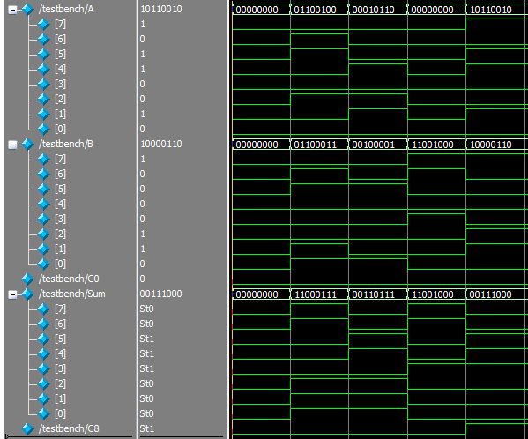
Figure 5 Waveform of the 8-bit adder

As the circuit is simulated a series of wave forms are generated. Looking at figure 5 reveals the input states represented as binary. The two 8-bit numbers are passed into the adder, and a single 8-bit number is passed back. The initial carry C0 is set to zero at all times, as there is no other circuit providing input. In addition, the extra output from the last adder, c8, acts as a ninth digit.
Conveniently, the binary numbers inputted and outputted are labeled at the top of each column for the separate inputs and outputs. They show the expected values outputted from the circuit, and shows the main objective was a success. The last equation, 178 + 134, sums to be a number larger than 8 bits. When it is passed into the ripple carry adder, the output of the last adder turns on, using the technical 9th bit in the circuit. It is the only time that it is on.
There were some difficulties initially as the last output did not need a wire, however receiving one, and creating issues as the output was technically already assigned.
In the beginning there was an attempt made at creator only one source, where only the 8-bit adder was constructed. It proved much simpler, however, constructing the entire adder from scratch with the multiple instantiations of half adders.

Conclusion
The circuit is a success. All of the inputs and outputs appear to be operating predictably, as correct numbers are produced in the simulation. Multiple instantiations throughout the project were performed. This particular model could be scaled up infinitely, connecting the output of the last carry from the last adder to the initial carry to the input of the next. Care would be needed to ensure the correct wires are written in.
Ideally, to fully test the model, every single combination of input and output would be tested. The truth table for such a test bench would be 65,536 lines long. Minimally to ensure full accuracy of the model, a test bench that tests both inputs where one is a higher number than the other, testing the both with the addition of nothing, and testing beyond the 8-bits to ensure the last carry is functioning correctly. The provided equations are suitable for the test bench, and the last carry is shown to be perfectly operational.
Appendix
//halfAdder.v
module halfAdder (output S, C, input x, y);
xor (S, x, y);
and (C, x, y);
endmodule

//fullAdder.v
module fullAdder ( output S, C, input x, y, z);
wire S1, C1, C2;
halfAdder HA1 (S1, C1, x, y);
halfAdder HA2 (S, C2, S1, z);
or G1 (C, C2, C1);
endmodule

//adder8bit.v
module rippleCarry8bitAdder (output [7: 0] Sum, output C8, input [7: 0] A, B, input C0);
wire C1, C2, C3, C4, C5, C6, C7;

fullAdder FA0 (Sum[0], C1, A[0], B[0], C0),
FA1 (Sum[1], C2, A[1], B[1], C1),
FA2 (Sum[2], C3, A[2], B[2], C2),
FA3 (Sum[3], C4, A[3], B[3], C3),
FA4 (Sum[4], C5, A[4], B[4], C4),
FA5 (Sum[5], C6, A[5], B[5], C5),
FA6 (Sum[6], C7, A[6], B[6], C6),
FA7 (Sum[7], C8, A[7], B[7], C7);
endmodule

//testbench.v
`timescale 1ns / 1ns

module testbench;

reg [7:0] A, B;
reg C0;
wire [7:0] Sum;
wire C8;

rippleCarry8bitAdder adder0 (Sum, C8, A, B, C0);
initial begin
//initialize to zero so the wave looks nice
A=8'b00000000;B=8'b00000000;C0=1'b0;

//100 + 99
//‭01100100 + ‬‭01100011‬ = 1100 0111
#10 A=8'b01100100;B=8'b01100011;

//22 + 33
//‭00010110‬ + ‭00100001‬ = ‭0011 0111
#10 A=8'b00010110;B=8'b00100001;

//0 + 200
//00000000 + ‭11001000‬ = 1100 1000
#10 A=8'b00000000;B=8'b11001000;

//178 + 134
//‭10110010‬ + ‭10000110‬ = ‭0001 0011 1000‬
#10 A=8'b10110010;B=8'b10000110;
end
initial
$monitor($stime,, A,, B,, C0,, Sum,, C8);
endmodule

References
- Provided class slides.

 

