It is possible to design a finite state machine using flip flops. The initial state of the machine can be set before starting the simulation, and changed quickly, allowing for multiple tests.
Lab 4
Thomas Cooper
Computer Engineering Major

INTRODUCTION
AFINITE state machine is a machine that is able to be in exactly one particular state out of a set of states at any given time. The provided state diagram allows for the extrapolation of the state table, which then leads to the state equation.
The possible states are listed times the number of possible inputs. Since there is only one input, each state is listed twice, one for x = 0, and one for x = 1. The state transitions are listed, then followed by the outputs.
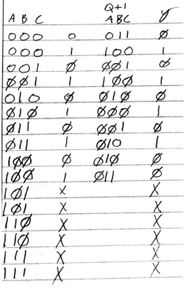
Figure 1 State table

With the state table constructed, k-maps are used to build the state equations for the circuit design. The minterms are selected based on the transition of the individual states. This is done for each state and the output.
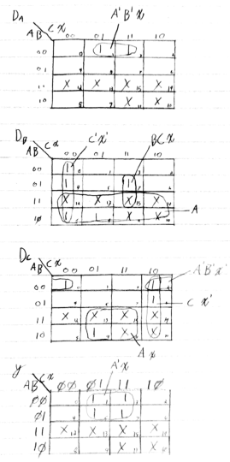
Figure 2 Kmaps for state equation

Once the kmaps are completed, the minterms are grouped together so the equations can be simplified. There are four kmaps because there are four total outputs.

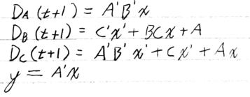
Figure 3 State equations for the FSM
Now that the state equations are derived, the diagram can be constructed. From the equations the various state progression of the states are assigned the various gates associated with their state transitions. For instance, the A D flip flop will transition to a 1 state if it’s current state is a 0, the current B state is a 0, and the input x is a one. It does not care what the state of C is.
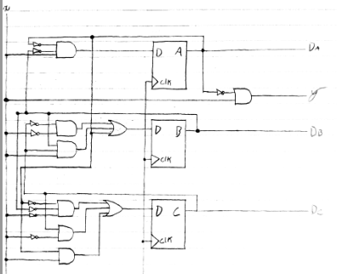
Figure 4 FSM diagram
Now that the diagram is constructed, the HDL model is created. Starting with the fsm.v module, the outputs and inputs are assigned. The machine will have 5 distinct states, which are defined as parameters in the module. The model is then instructed to update always on either the positive clock edge, or on the state reset. The model finishes with a series of case statements for each possible state and an if else decision based on the state of the x input.
case (state)
a:
begin next_y = 0;
if (x == 0) next_state = d;
else begin next_state = e; next_y = 1; end
end
Figure 5 one of the case statements

With the module completed, a testbench environment is created. The test bench starts by defining the inputs, outputs, and wires. The fsm is instantiated. A forever loop is created to toggle the inverse of the clock to create the clock pulse. Then the simulation begins. The x input is initially set to 0, and the reset is set to 1. The initial state is set, and the reset is then set back to 0. The x input is then changed using the provided values every 10 ns.

Results
The first case states to simulate the input series starting with an initial state of 001. The testbench is madofied to pass in the starting state 001 at the start_state. The simulation is then ran, and the following wave form is produced.
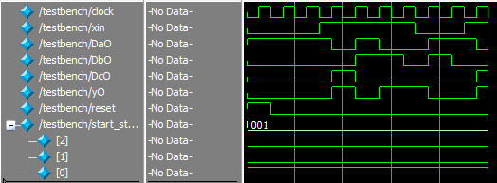
Figure 6 Wave form for the first case

The circuit is successful. The appropriate states are transitioned and the correct outputs in the wave form is produced.
The lab then states to rerun the simulation, however with a different starting state. Since the module is set to easily change the initial state, the testbench is updated with the new state.
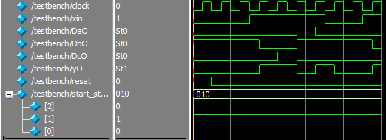
Figure 7 Wave form for the second case

Again, the model sets the state with ease, and runs the appropriate simulation. The simulation is successful once more.

Conclusion
The verification for the fsm is different from a standard combinational circuit because the combinational circuit will always have an output based on the current input, and it does not deviate. The sequential circuit can have a different state starting out, and that can effect the future outputs based on the supplied input.
Appendix
Final code used for lab
//fsm.v
module fsm (output reg y, output Da, Db, Dc, input x, clock, reset, input [2:0] start_state );

parameter
a = 3'b000,
b = 3'b001,
c = 3'b010,
d = 3'b011,
e = 3'b100;

reg [2: 0] state, next_state;
reg next_y;

always @ (posedge clock or posedge reset)
begin
if( reset == 1 ) begin
state <= start_state;
y <= 1'b0;
end else begin // clock edge
state <= next_state;
y <= next_y;
end
end

assign { Dc, Db, Da } = state;

always @ (state, x)
begin
case (state)
a:
begin next_y = 0;
if (x == 0) next_state = d;
else begin next_state = e; next_y = 1; end
end

b:
begin next_y = 0;
if (x == 0) next_state = b;
else begin next_state = e; next_y = 1; end
end

c:
begin next_y = 0;
if (x == 0) next_state = c;
else begin next_state = a; next_y = 1; end
end

d:
begin next_y = 0;
if (x == 0) next_state = b;
else begin next_state = c; next_y = 1; end
end

e:
begin next_y = 0;
if (x == 0) next_state = c;
else next_state = d;
end
endcase
end

endmodule

//testbench.v
`timescale 1ns / 1ns

module testbench;

reg clock;
reg xin;
wire DaO, DbO, DcO, yO;
reg reset;
reg [2:0] start_state;

fsm fsm0 (yO, DaO, DbO, DcO, xin, clock, reset, start_state );

initial begin
clock = 0;
forever #5 clock = ~clock;
end

initial begin

xin = 0;
reset = 1;
start_state = 3'b001;
#10 reset = 0;
// 011110011
#10 xin = 0;
#10 xin = 1;
#10 xin = 1;
#10 xin = 1;
#10 xin = 1;
#10 xin = 0;
#10 xin = 0;
#10 xin = 1;
#10 xin = 1;

end

initial
$monitor($stime,, reset,, clock,, xin,, DaO,, DbO,, DcO,, yO);

endmodule

.
References
- Provided class slides

 

