A synchronous two-digit BCD counter can be constructed using two four-bit binary counters. By adding a parallel load, the state of the counter can then be reprogrammed.
Lab 5
Thomas Cooper
Computer Engineering Major

INTRODUCTION
ABCD counter is a 4 bit binary counter that rolls over back to all zeros upon progressing beyond the binary representation of the decimal number nine. The progression of the count is triggered on the clock edge. The counter for this lab requires that a binary coded value can be passed in, and the counter will start counting from there.
To add the load functionality, a parallel load is added to the module. When writing the abstraction in Verilog, a simple load state is enabled, and the output is assigned the value that was passed in.
The clear on the counter is triggered by the Clear_b signal, that assigns the state of the output to all zeros.
Last, the carryout that triggers the next counter in line is enabled upon the count triggering, the load signal turned off, and the counter rolling over again to zero.

Results
The completion of the main BCD counter module is used to then instantiate twice to create the second digit for the counter creating the module for the two-digit counter. The testbench is setup so that the clear is enabled (disabled for active low) to set the counter to zeros, and then turned back on to allow the registers to start retaining state. The count signal is then enabled, and the counting process begins.
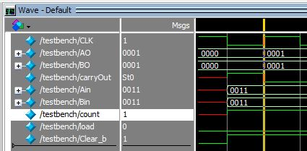
Figure 1 Start of the count after clear
It can be seen in the wave, and logically that when the counter hit 0000 for the clear, it also triggered the carryout which set the count for the second counter to 0001. This is a mistake. The appropriate logic has not been implemented to ensure the second counter triggers upon the first pass through.
Testing the load, the lab required that the number 51 is used to test the load functionality. In the testbench, the registers for the input are assigned as nonblocking assignments so that the values can be instantly transferred upon initiation of the load signal. The load signal is then turned on for 100 cycles to ensure propagation and upon disabling of the load signal, the counter perfectly picks up from the loaded value.
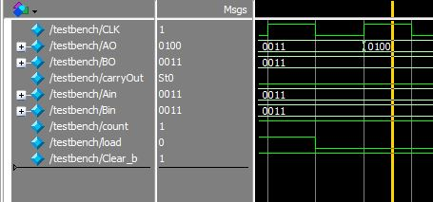
Figure 2 successful load of state.

Last, the counter is tested to ensure that it will cycle over properly upon completion of a 99 state. This is to ensure a continuous count. The wave form for the counter shows that the values go beyond what the BCD counter should be accounting for. However, the counter does roll over again, however it does not hit a perfect all zeros across both counters. There is a delay in the clear. The first counter resets, and the second counter resets on the next clock cycle.
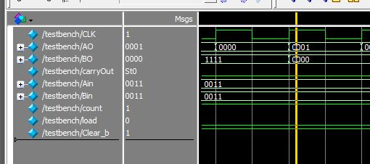
Figure 3 Rollover

.

Conclusion
A BCD counter that continues to count values beyond the base 10 system, is not a BCD counter. It is just a binary counter. The load feature worked perfectly, however more care will be needed to ensure proper resets so as to keep the counter within appropriate values, and to correctly reset to show zeros all across the board.
Appendix
Final code used for lab
module bcdCount (
output reg [3: 0] A_count, // Data output
output C_out, // Output carry
input [3: 0] Data_in, // Data input
input Count, // Active high to count
input Load, // Active high to load
input CLK, // Positive-edge sensitive
input Clear_b ); // Active low

assign C_out = Count && (~Load) && (A_count == 4'b0000);
always @ ( posedge CLK, negedge Clear_b)
if (~Clear_b) A_count <= 4'b0000;
else
begin
if (Load) A_count <= Data_in;
else if (Count) A_count <= A_count + 4'b0001;
else if (A_count == 1001) A_count <= 4'b0000;
else A_count <= A_count;
end
endmodule

module twoDigitCounter (output [3:0] AO,
output [3:0] BO,
output carryOut,
input [3:0] Ain,
input [3:0] Bin,
input count,
input Load,
input CLK,
input Clear_b);

wire carryWire;

bcdCount countA (AO,
carryWire,
Ain,
count,
Load,
CLK,
Clear_b);

bcdCount countB (BO,
carryOut,
Bin,
carryWire,
Load,
CLK,
Clear_b);
endmodule

`timescale 1ns / 1ns

module testbench;

reg CLK;
wire [3:0] AO;
wire [3:0] BO;
wire carryOut;
reg [3:0] Ain;
reg [3:0] Bin;
reg count;
reg load;
reg Clear_b;

twoDigitCounter counter1(AO, BO, carryOut, Ain, Bin, count, load, CLK, Clear_b);

initial begin
CLK = 0;
forever #5 CLK = ~CLK;
end

initial begin
Clear_b = 0;
#10 load = 0;
#300 Clear_b = 1;
count = 1;

Ain = 4'b0011;
Bin = 4'b0011;

#100 load = 1;
#100 load = 0;

end

initial
$monitor($stime,, CLK,, count,, Ain,, Bin,, AO,, BO,, carryOut,, load,, Clear_b);
endmodule

References
- Provided class slides

 

