|  |  |  |  |  |  |  |
| --- | --- | --- | --- | --- | --- | --- |
| **District Summary**  **Conclusions**  Data Removal had minimal effect at the district level. It lowered Average Math Scores by lowering 0.1% and lowered the % Passing in Math, Reading, and Overall Passing by -1% respectively.  **District - All Data** |  |  |  |  |  |  |



**District – Minus Thomas High Data**



**School Summary**

**Conclusions**

The Top 5 Schools were affected significantly. Thomas High dropped out and Wright moved in.

**Top 5 Schools – All Data Followed By Post Removal of Data**

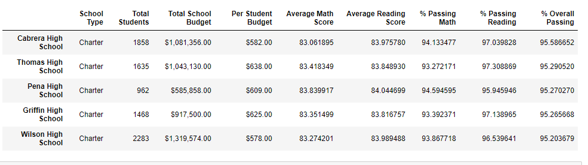

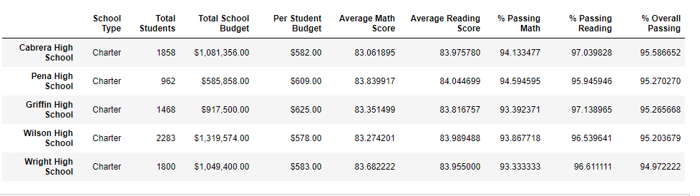

**Conclusions**

As noted, Thomas High moved from one of the Top 5 to one of the Bottom 5 as removing their 9th Grade data had a significant impact on % Overall Passing. Thomas’ Avg Scores for Math and Reading experienced a negligible change of less than 1%.

**Bottom 5 – All Data**

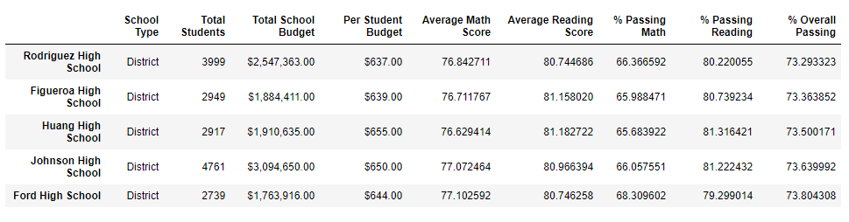

**Bottom 5 – Minus Thomas High Data**

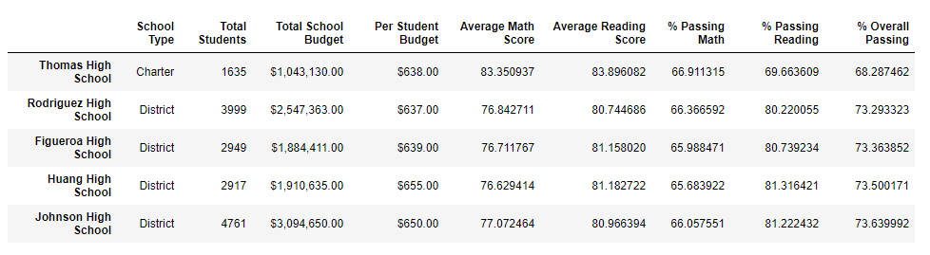

**Conclusions**

Math and Reading Scores by school were not affected what-so-ever except for Thomas High – 9th Grade. Below are the individual school results followed by the Math and Reading – with NaN values replacing Thomas High 9th Grade scores.

**Math and Reading – Pre and Post Removal Data**

**Math Reading**

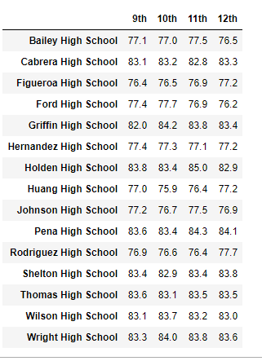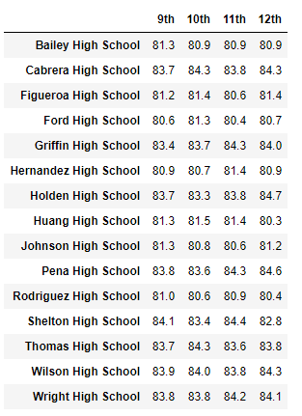

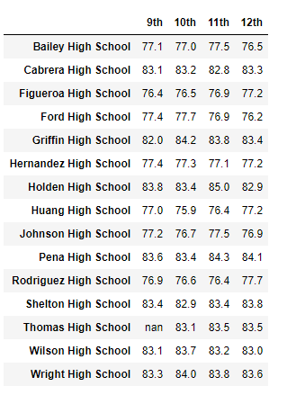 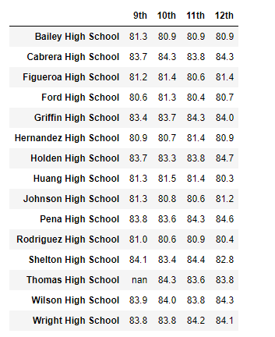

**Conclusions**

Thomas High fell into the $630 - $644 per capita spending and with their specific scores lowered for % Passing Math, Reading, and Overall affected, this Bin was lowered an avg of 6-7% points. Avg Scores were unaffected.

**Per Capita Spending – All Data**

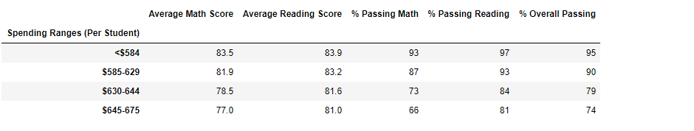

**Per Capita Spending – Minus Thomas Data**

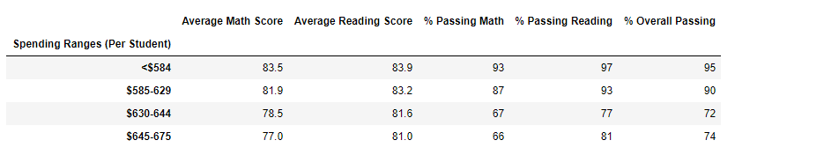

**Conclusions**

Thomas High fell into the Medium BIN and results were similar to “per capita.”

**School Size – All Data**

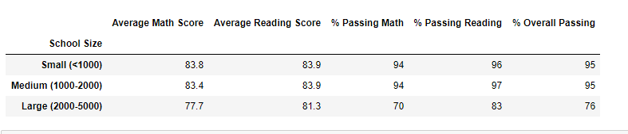

**School Size – Minus Thomas Data**

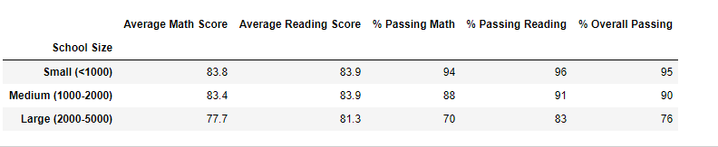

**Conclusions**

As a chartered school, removal of the Thomas High data affected the % Passing numbers for Charter Schools only. Charter school % Overall Passing dropped from 95% to 92%.

**School Type – All Data**

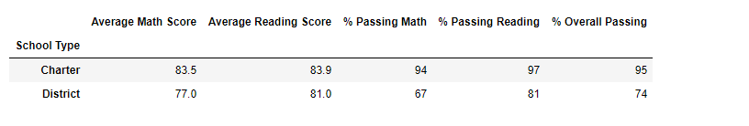

**School Type – Minus Thomas Data**

