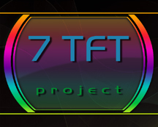

fully functionally off XBMC 2.1 SVN XBMC- 04.Mai 2008 , older than 2008 its posible the skin works with problems/bugs !
please update xbmc to current versions

S e t t i n g s :

!!!! set font in the XBMC settings to "XBOX360 " !!!!
Optional: !!!! unrar ResumX-Script and shift it in the XBMC SCRIPT Folder !!!!
enjoy 7TFT beta_6.60

.:djtoll:.

