**Steps to reproduce the error:**

1. Run the application
2. Index.jsp will lauch successfully.

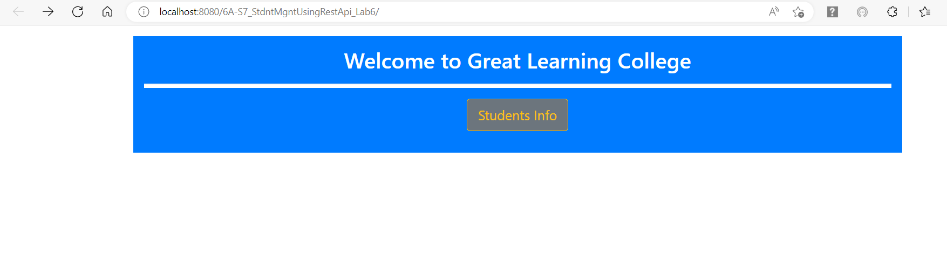

1. Click ‘Students Info’ button, it will navigate to ‘/students/list’ page, there it shows error.

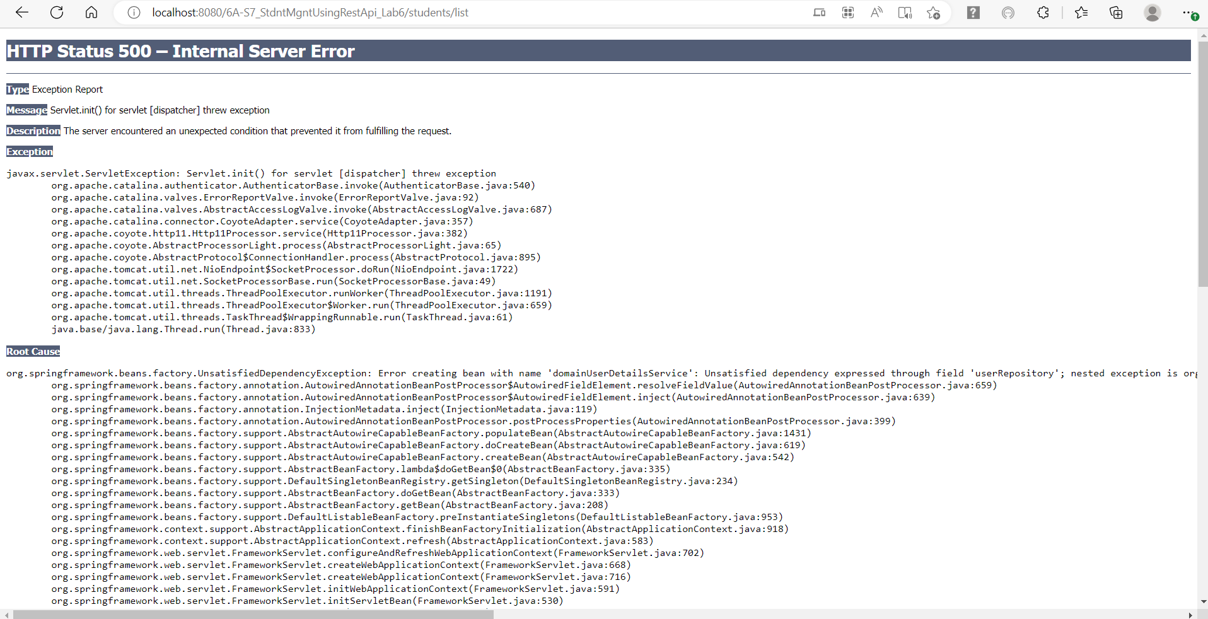

**Error Content:**

**HTTP Status 500 – Internal Server Error**

**Type** Exception Report

**Message** Servlet.init() for servlet [dispatcher] threw exception

**Description** The server encountered an unexpected condition that prevented it from fulfilling the request.

**Exception**

javax.servlet.ServletException: Servlet.init() for servlet [dispatcher] threw exception

org.apache.catalina.authenticator.AuthenticatorBase.invoke(AuthenticatorBase.java:540)

org.apache.catalina.valves.ErrorReportValve.invoke(ErrorReportValve.java:92)

org.apache.catalina.valves.AbstractAccessLogValve.invoke(AbstractAccessLogValve.java:687)

org.apache.catalina.connector.CoyoteAdapter.service(CoyoteAdapter.java:357)

org.apache.coyote.http11.Http11Processor.service(Http11Processor.java:382)

org.apache.coyote.AbstractProcessorLight.process(AbstractProcessorLight.java:65)

org.apache.coyote.AbstractProtocol$ConnectionHandler.process(AbstractProtocol.java:895)

org.apache.tomcat.util.net.NioEndpoint$SocketProcessor.doRun(NioEndpoint.java:1722)

org.apache.tomcat.util.net.SocketProcessorBase.run(SocketProcessorBase.java:49)

org.apache.tomcat.util.threads.ThreadPoolExecutor.runWorker(ThreadPoolExecutor.java:1191)

org.apache.tomcat.util.threads.ThreadPoolExecutor$Worker.run(ThreadPoolExecutor.java:659)

org.apache.tomcat.util.threads.TaskThread$WrappingRunnable.run(TaskThread.java:61)

java.base/java.lang.Thread.run(Thread.java:833)

**Root Cause**

org.springframework.beans.factory.UnsatisfiedDependencyException: Error creating bean with name 'domainUserDetailsService': Unsatisfied dependency expressed through field 'userRepository'; nested exception is org.springframework.beans.factory.NoSuchBeanDefinitionException: No qualifying bean of type 'com.gl.StdntMgnt.repository.UserRepository' available: expected at least 1 bean which qualifies as autowire candidate. Dependency annotations: {@org.springframework.beans.factory.annotation.Autowired(required=true)}

org.springframework.beans.factory.annotation.AutowiredAnnotationBeanPostProcessor$AutowiredFieldElement.resolveFieldValue(AutowiredAnnotationBeanPostProcessor.java:659)

org.springframework.beans.factory.annotation.AutowiredAnnotationBeanPostProcessor$AutowiredFieldElement.inject(AutowiredAnnotationBeanPostProcessor.java:639)

org.springframework.beans.factory.annotation.InjectionMetadata.inject(InjectionMetadata.java:119)

org.springframework.beans.factory.annotation.AutowiredAnnotationBeanPostProcessor.postProcessProperties(AutowiredAnnotationBeanPostProcessor.java:399)

org.springframework.beans.factory.support.AbstractAutowireCapableBeanFactory.populateBean(AbstractAutowireCapableBeanFactory.java:1431)

org.springframework.beans.factory.support.AbstractAutowireCapableBeanFactory.doCreateBean(AbstractAutowireCapableBeanFactory.java:619)

org.springframework.beans.factory.support.AbstractAutowireCapableBeanFactory.createBean(AbstractAutowireCapableBeanFactory.java:542)

org.springframework.beans.factory.support.AbstractBeanFactory.lambda$doGetBean$0(AbstractBeanFactory.java:335)

org.springframework.beans.factory.support.DefaultSingletonBeanRegistry.getSingleton(DefaultSingletonBeanRegistry.java:234)

org.springframework.beans.factory.support.AbstractBeanFactory.doGetBean(AbstractBeanFactory.java:333)

org.springframework.beans.factory.support.AbstractBeanFactory.getBean(AbstractBeanFactory.java:208)

org.springframework.beans.factory.support.DefaultListableBeanFactory.preInstantiateSingletons(DefaultListableBeanFactory.java:953)

org.springframework.context.support.AbstractApplicationContext.finishBeanFactoryInitialization(AbstractApplicationContext.java:918)

org.springframework.context.support.AbstractApplicationContext.refresh(AbstractApplicationContext.java:583)

org.springframework.web.servlet.FrameworkServlet.configureAndRefreshWebApplicationContext(FrameworkServlet.java:702)

org.springframework.web.servlet.FrameworkServlet.createWebApplicationContext(FrameworkServlet.java:668)

org.springframework.web.servlet.FrameworkServlet.createWebApplicationContext(FrameworkServlet.java:716)

org.springframework.web.servlet.FrameworkServlet.initWebApplicationContext(FrameworkServlet.java:591)

org.springframework.web.servlet.FrameworkServlet.initServletBean(FrameworkServlet.java:530)

org.springframework.web.servlet.HttpServletBean.init(HttpServletBean.java:170)

javax.servlet.GenericServlet.init(GenericServlet.java:158)

org.apache.catalina.authenticator.AuthenticatorBase.invoke(AuthenticatorBase.java:540)

org.apache.catalina.valves.ErrorReportValve.invoke(ErrorReportValve.java:92)

org.apache.catalina.valves.AbstractAccessLogValve.invoke(AbstractAccessLogValve.java:687)

org.apache.catalina.connector.CoyoteAdapter.service(CoyoteAdapter.java:357)

org.apache.coyote.http11.Http11Processor.service(Http11Processor.java:382)

org.apache.coyote.AbstractProcessorLight.process(AbstractProcessorLight.java:65)

org.apache.coyote.AbstractProtocol$ConnectionHandler.process(AbstractProtocol.java:895)

org.apache.tomcat.util.net.NioEndpoint$SocketProcessor.doRun(NioEndpoint.java:1722)

org.apache.tomcat.util.net.SocketProcessorBase.run(SocketProcessorBase.java:49)

org.apache.tomcat.util.threads.ThreadPoolExecutor.runWorker(ThreadPoolExecutor.java:1191)

org.apache.tomcat.util.threads.ThreadPoolExecutor$Worker.run(ThreadPoolExecutor.java:659)

org.apache.tomcat.util.threads.TaskThread$WrappingRunnable.run(TaskThread.java:61)

java.base/java.lang.Thread.run(Thread.java:833)

**Root Cause**

org.springframework.beans.factory.NoSuchBeanDefinitionException: No qualifying bean of type 'com.gl.StdntMgnt.repository.UserRepository' available: expected at least 1 bean which qualifies as autowire candidate. Dependency annotations: {@org.springframework.beans.factory.annotation.Autowired(required=true)}

org.springframework.beans.factory.support.DefaultListableBeanFactory.raiseNoMatchingBeanFound(DefaultListableBeanFactory.java:1799)

org.springframework.beans.factory.support.DefaultListableBeanFactory.doResolveDependency(DefaultListableBeanFactory.java:1355)

org.springframework.beans.factory.support.DefaultListableBeanFactory.resolveDependency(DefaultListableBeanFactory.java:1309)

org.springframework.beans.factory.annotation.AutowiredAnnotationBeanPostProcessor$AutowiredFieldElement.resolveFieldValue(AutowiredAnnotationBeanPostProcessor.java:656)

org.springframework.beans.factory.annotation.AutowiredAnnotationBeanPostProcessor$AutowiredFieldElement.inject(AutowiredAnnotationBeanPostProcessor.java:639)

org.springframework.beans.factory.annotation.InjectionMetadata.inject(InjectionMetadata.java:119)

org.springframework.beans.factory.annotation.AutowiredAnnotationBeanPostProcessor.postProcessProperties(AutowiredAnnotationBeanPostProcessor.java:399)

org.springframework.beans.factory.support.AbstractAutowireCapableBeanFactory.populateBean(AbstractAutowireCapableBeanFactory.java:1431)

org.springframework.beans.factory.support.AbstractAutowireCapableBeanFactory.doCreateBean(AbstractAutowireCapableBeanFactory.java:619)

org.springframework.beans.factory.support.AbstractAutowireCapableBeanFactory.createBean(AbstractAutowireCapableBeanFactory.java:542)

org.springframework.beans.factory.support.AbstractBeanFactory.lambda$doGetBean$0(AbstractBeanFactory.java:335)

org.springframework.beans.factory.support.DefaultSingletonBeanRegistry.getSingleton(DefaultSingletonBeanRegistry.java:234)

org.springframework.beans.factory.support.AbstractBeanFactory.doGetBean(AbstractBeanFactory.java:333)

org.springframework.beans.factory.support.AbstractBeanFactory.getBean(AbstractBeanFactory.java:208)

org.springframework.beans.factory.support.DefaultListableBeanFactory.preInstantiateSingletons(DefaultListableBeanFactory.java:953)

org.springframework.context.support.AbstractApplicationContext.finishBeanFactoryInitialization(AbstractApplicationContext.java:918)

org.springframework.context.support.AbstractApplicationContext.refresh(AbstractApplicationContext.java:583)

org.springframework.web.servlet.FrameworkServlet.configureAndRefreshWebApplicationContext(FrameworkServlet.java:702)

org.springframework.web.servlet.FrameworkServlet.createWebApplicationContext(FrameworkServlet.java:668)

org.springframework.web.servlet.FrameworkServlet.createWebApplicationContext(FrameworkServlet.java:716)

org.springframework.web.servlet.FrameworkServlet.initWebApplicationContext(FrameworkServlet.java:591)

org.springframework.web.servlet.FrameworkServlet.initServletBean(FrameworkServlet.java:530)

org.springframework.web.servlet.HttpServletBean.init(HttpServletBean.java:170)

javax.servlet.GenericServlet.init(GenericServlet.java:158)

org.apache.catalina.authenticator.AuthenticatorBase.invoke(AuthenticatorBase.java:540)

org.apache.catalina.valves.ErrorReportValve.invoke(ErrorReportValve.java:92)

org.apache.catalina.valves.AbstractAccessLogValve.invoke(AbstractAccessLogValve.java:687)

org.apache.catalina.connector.CoyoteAdapter.service(CoyoteAdapter.java:357)

org.apache.coyote.http11.Http11Processor.service(Http11Processor.java:382)

org.apache.coyote.AbstractProcessorLight.process(AbstractProcessorLight.java:65)

org.apache.coyote.AbstractProtocol$ConnectionHandler.process(AbstractProtocol.java:895)

org.apache.tomcat.util.net.NioEndpoint$SocketProcessor.doRun(NioEndpoint.java:1722)

org.apache.tomcat.util.net.SocketProcessorBase.run(SocketProcessorBase.java:49)

org.apache.tomcat.util.threads.ThreadPoolExecutor.runWorker(ThreadPoolExecutor.java:1191)

org.apache.tomcat.util.threads.ThreadPoolExecutor$Worker.run(ThreadPoolExecutor.java:659)

org.apache.tomcat.util.threads.TaskThread$WrappingRunnable.run(TaskThread.java:61)

java.base/java.lang.Thread.run(Thread.java:833)

**Note** The full stack trace of the root cause is available in the server logs.

**Apache Tomcat/9.0.55**