**Login with User Role: (username: user and password: welcome)**

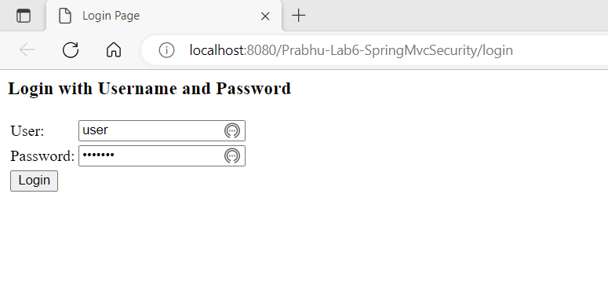

1. On click of login in above screen it will redirect to ‘/students/list’ page (CURD - Read Operation).

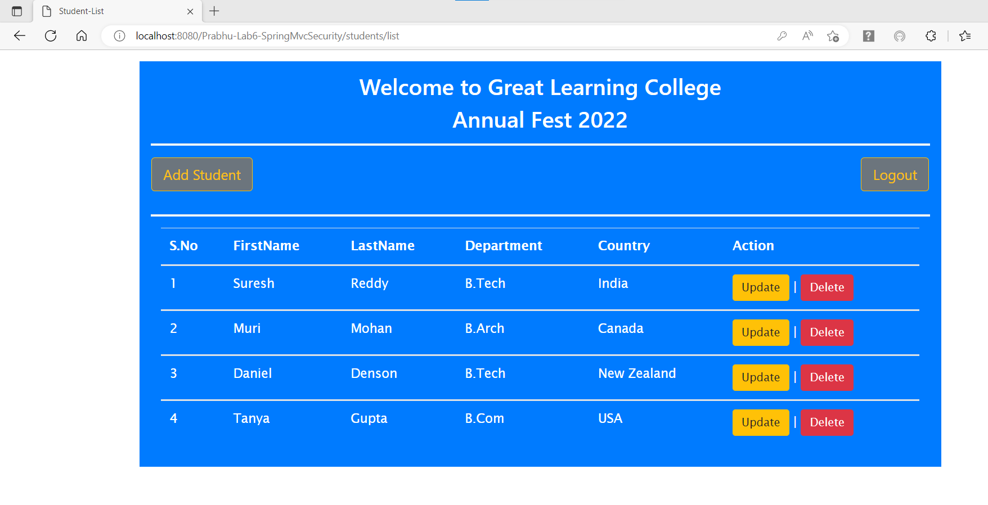

1. On Click of ‘Add Student’ button it will redirect to ‘/students/showStudentForm’ page (CURD – Create Operation).

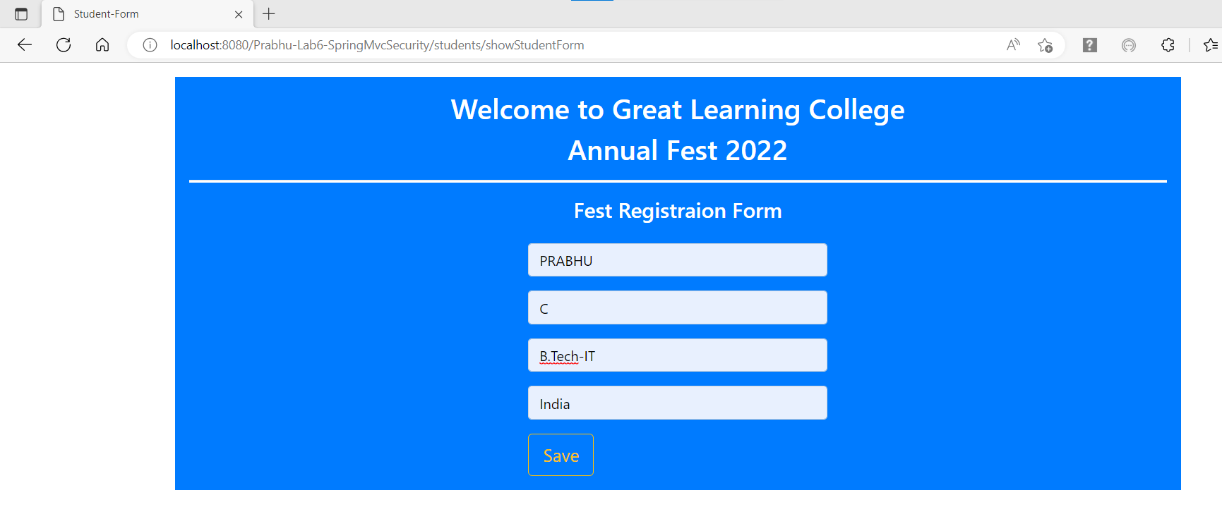

1. On Click of ‘Save’ button above, it will redirect to ‘/students/list’ page with updated list.

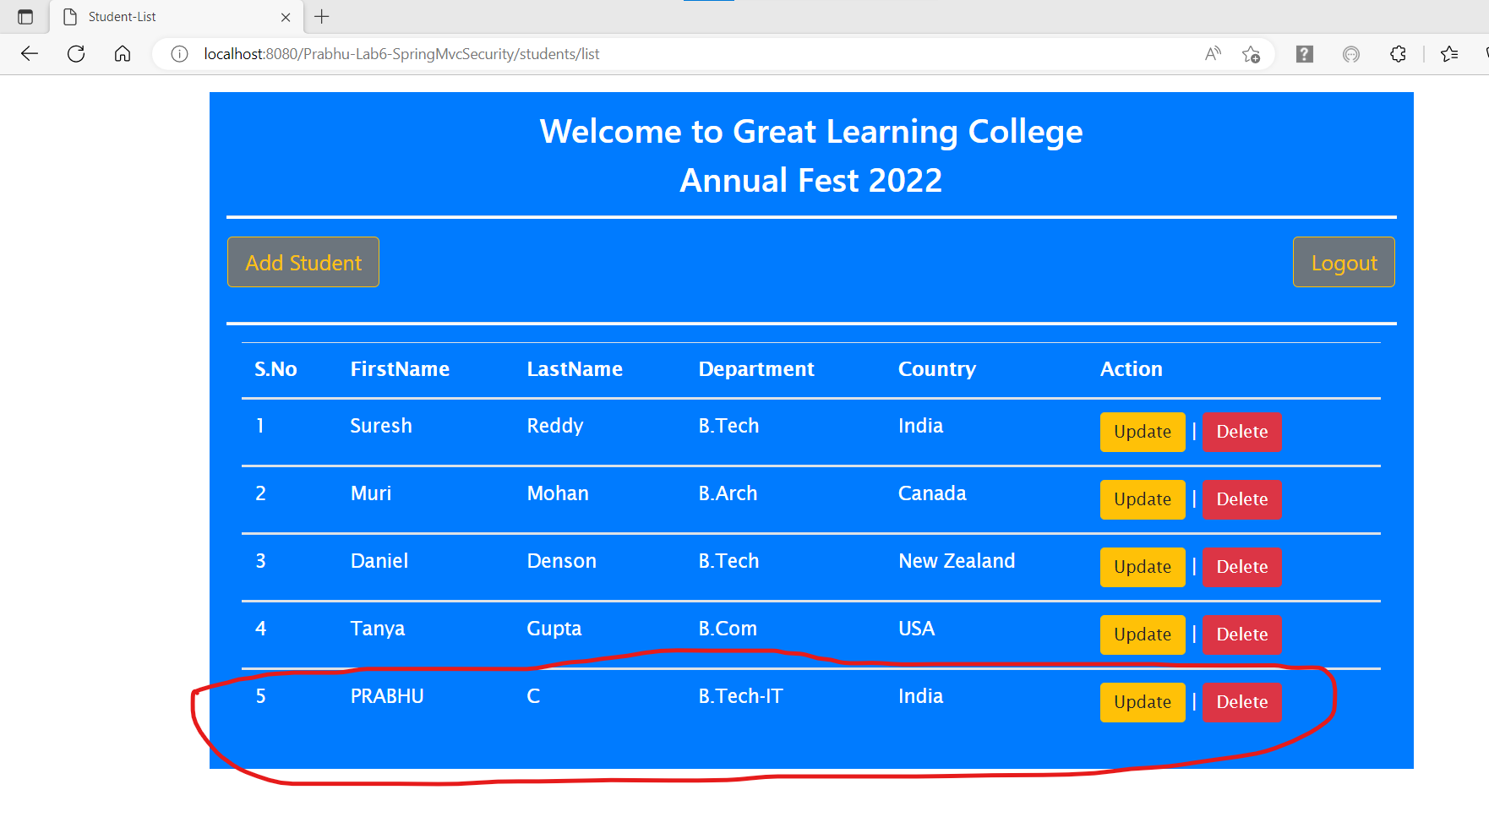

1. On Click of ‘Update’ button on any of the student row, it will show access denied page as user role is restricted from accessing update page (CURD – Update Operation).

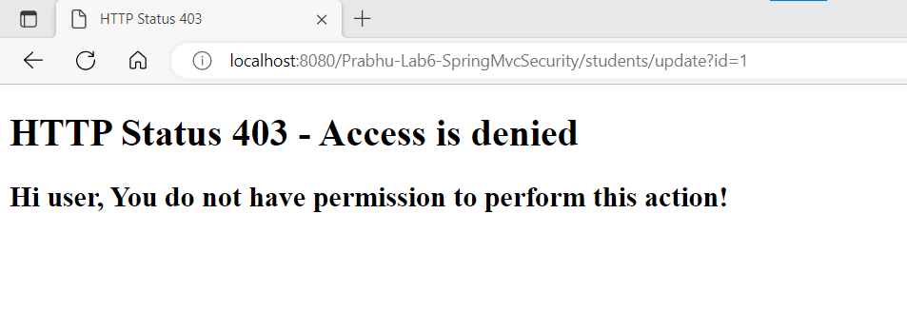

1. On ‘Back’ click on browser it will be redirected to list page.

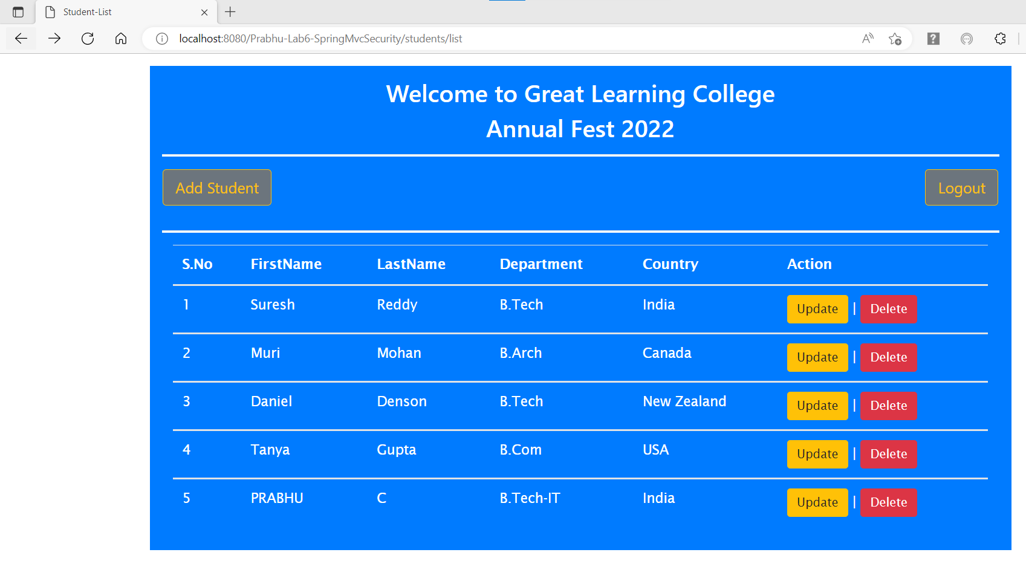

1. On ‘Delete’ button click on any student row, it will show confirmation popup and on click of ‘ok’ in confirmation popup, it will redirect to ‘403 access denied’ page as user role is restricted to do delete operation (CURD – Delete Operation).

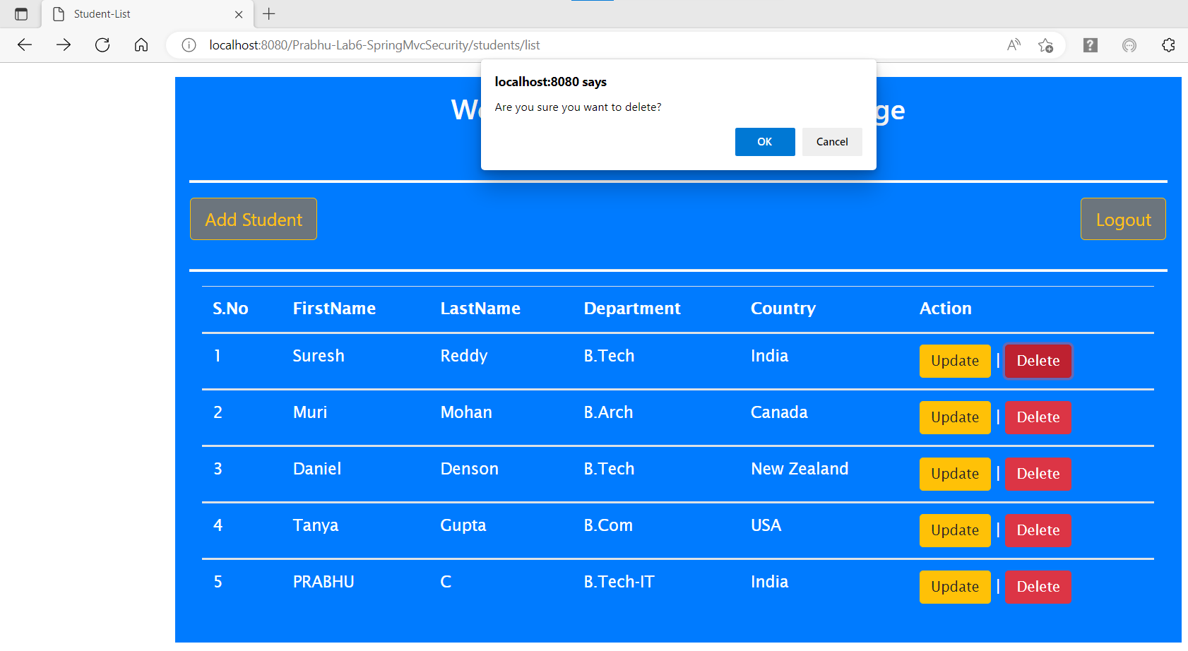

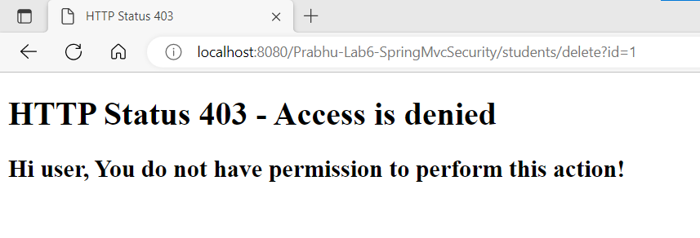

1. On ‘Back’ click on browser it will be redirected to list page.



1. On ‘Logout’ button click it will redirect to ‘Login’ page.

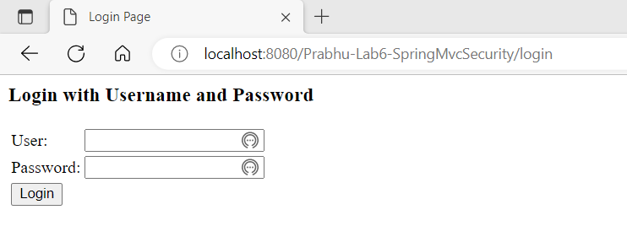

**Login with Admin Role: (username: admin and password: welcome)**

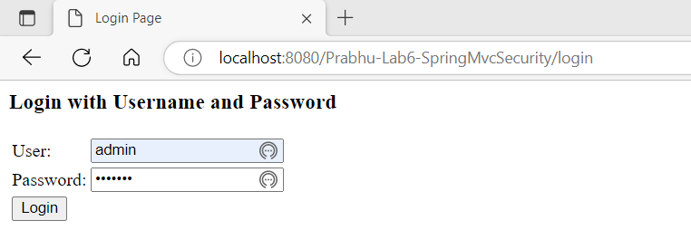

1. On click of login in above screen it will redirect to ‘/students/list’ page (CURD - Read Operation).



1. On Click of ‘Add Student’ button it will redirect to ‘/students/showStudentForm’ page (CURD – Create Operation).

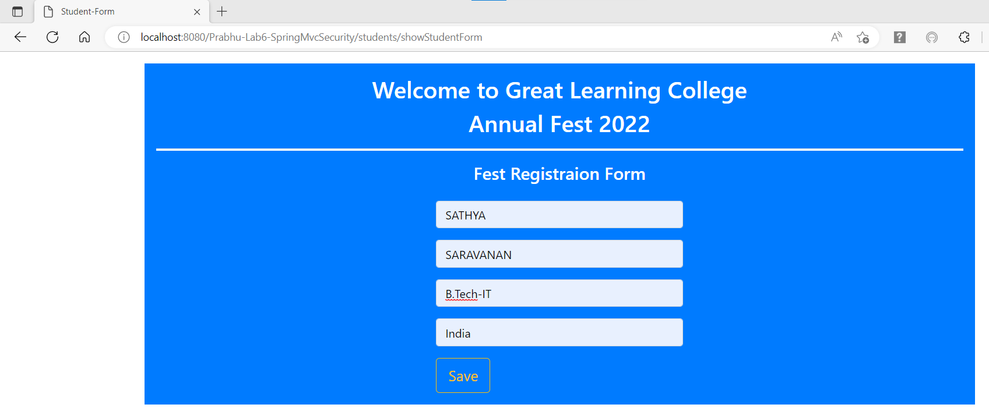

1. On Click of ‘Save’ button above, it will redirect to ‘/students/list’ page with updated list.

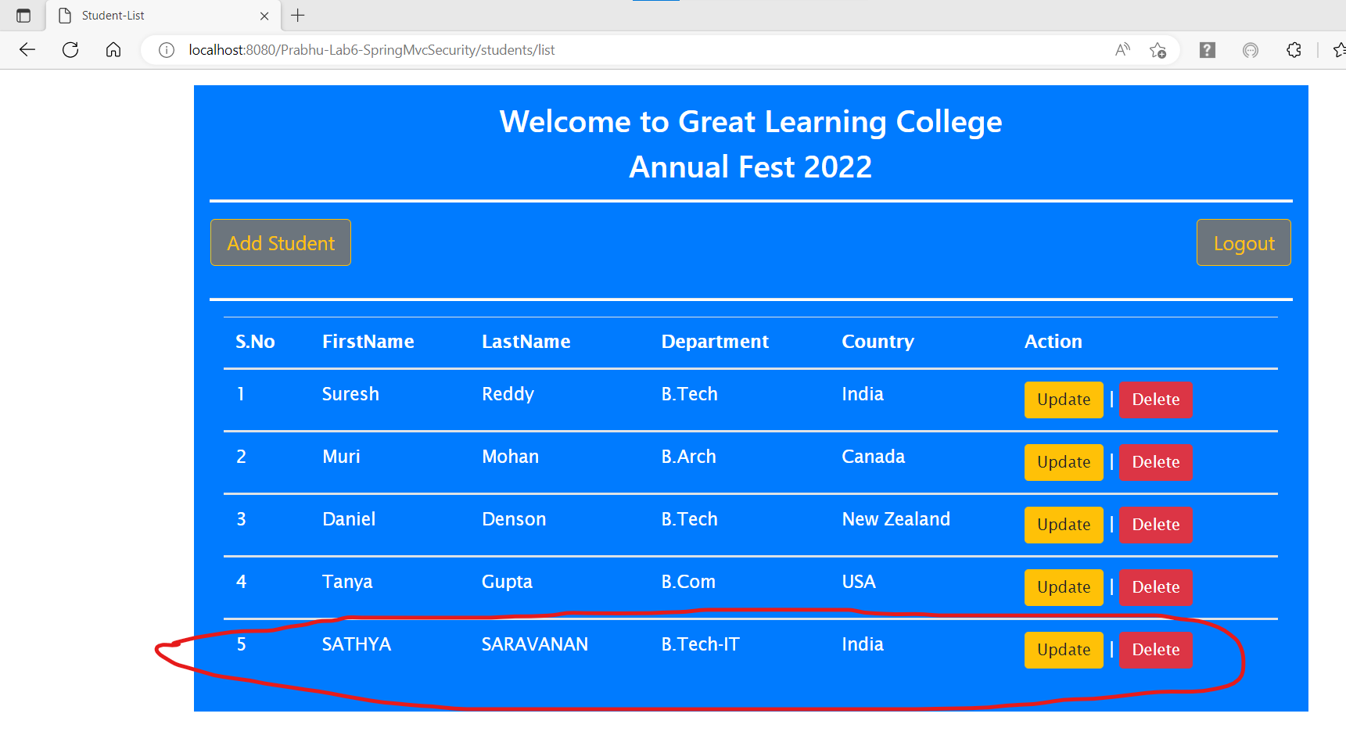

1. On Click of ‘Update’ button on 5th student row, it will redirect to ‘/students/update?id=5’ page andchange first name from ‘Sathya’ to ‘Sarala’ and click Save button it will be redirected to list page with updated details (CURD – Update Operation).

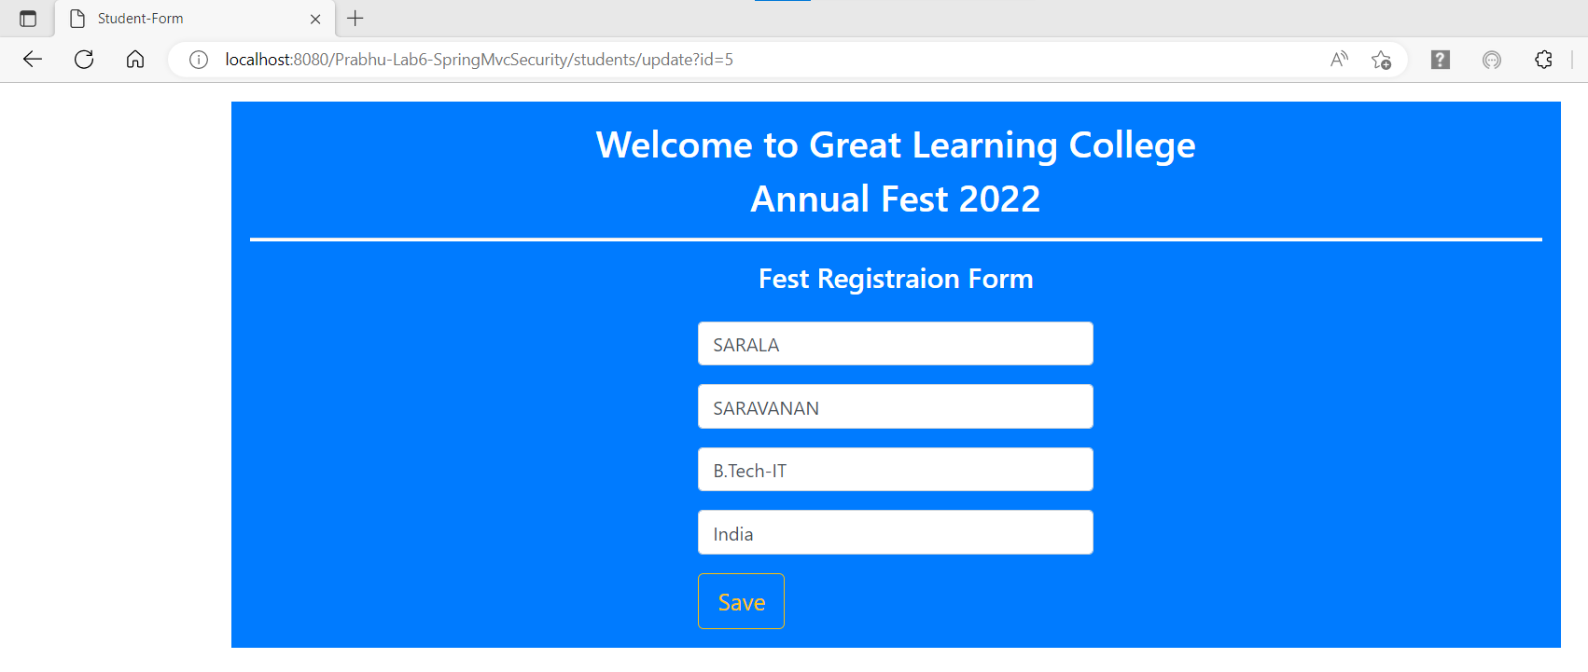

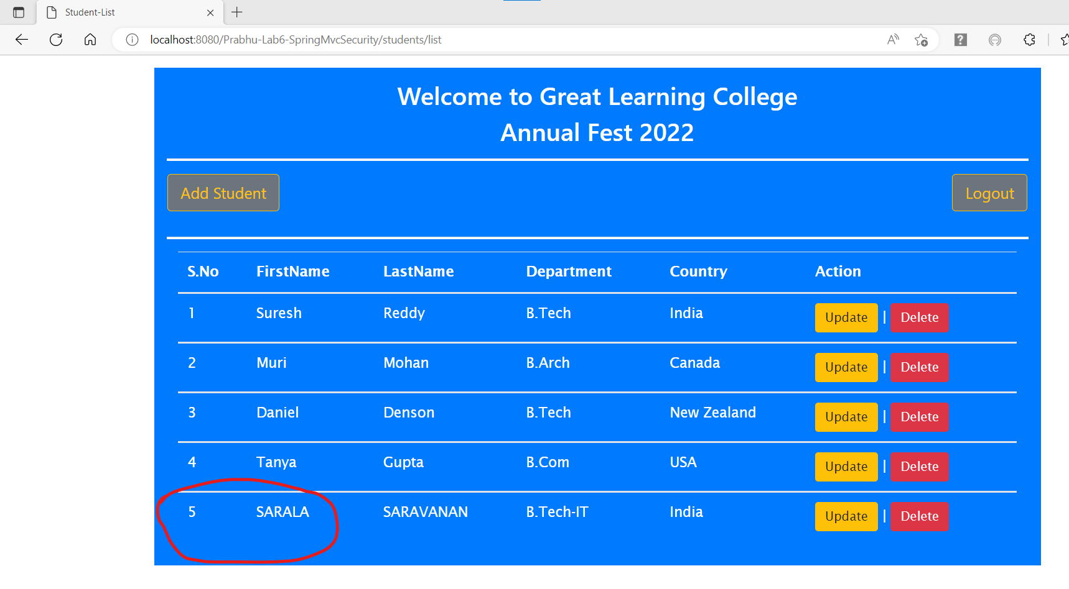

1. On ‘Delete’ button click on 5th student row, it will show confirmation popup and on click of ‘ok’ in confirmation popup, it will delete 5th record (CURD – Delete Operation).

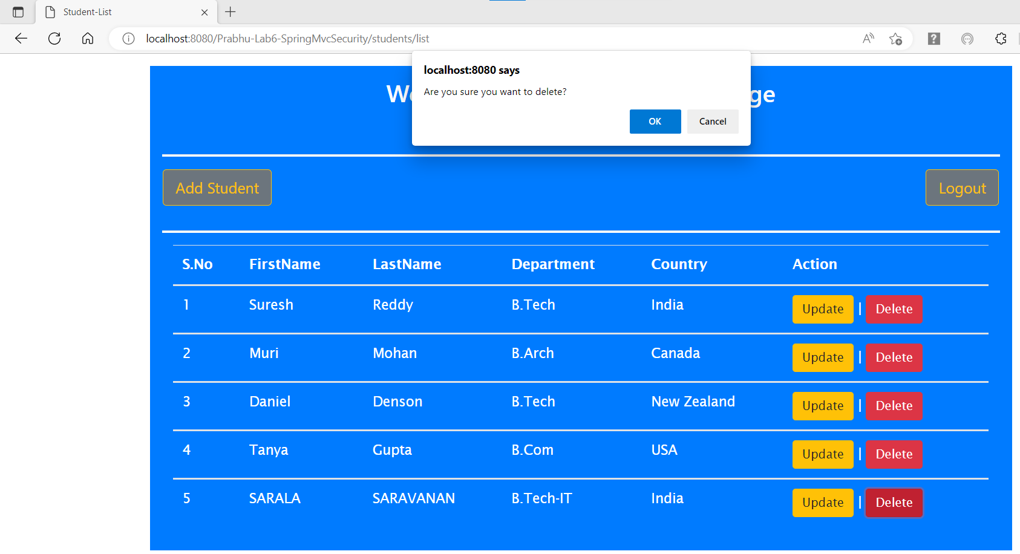

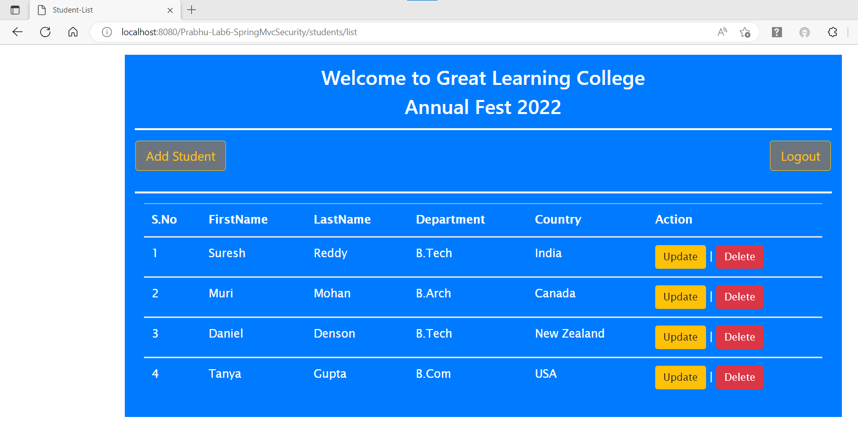

1. On ‘Logout’ button click it will redirect to ‘Login’ page.

