**Read – Operation:**

1. On start, this url (<http://localhost:8081/Prabhu-ORM-SpringMVC/>) will be loaded and it will internally redirect to list view page(<http://localhost:8081/Prabhu-ORM-SpringMVC/customers/list>) (Note: port will differ based on server configuration)

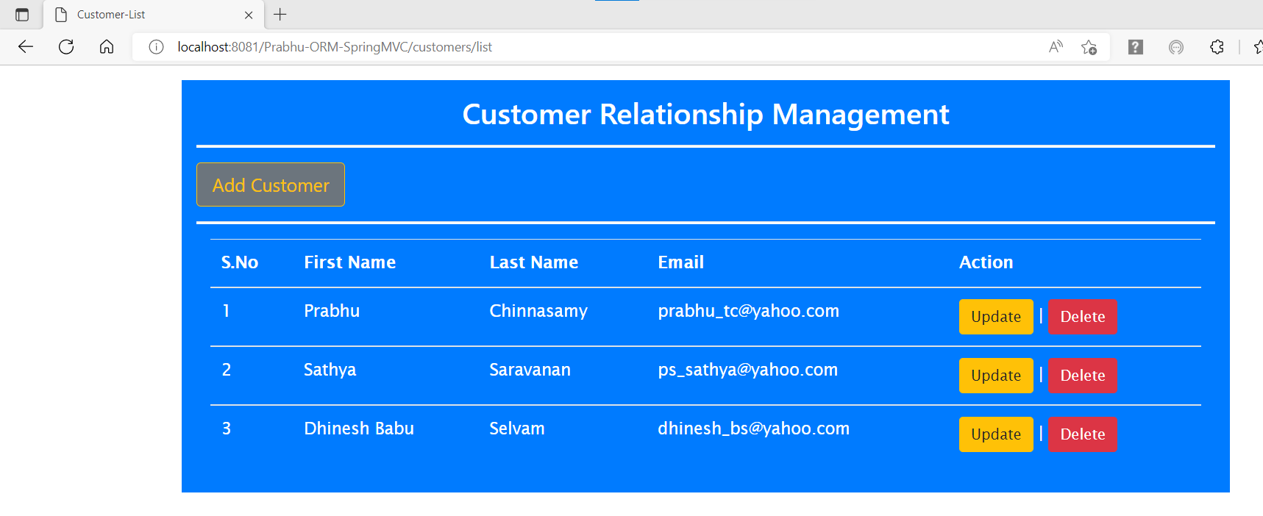

**Create – Operation:**

1. On click of ‘Add Customer’ it opens Add customer page.

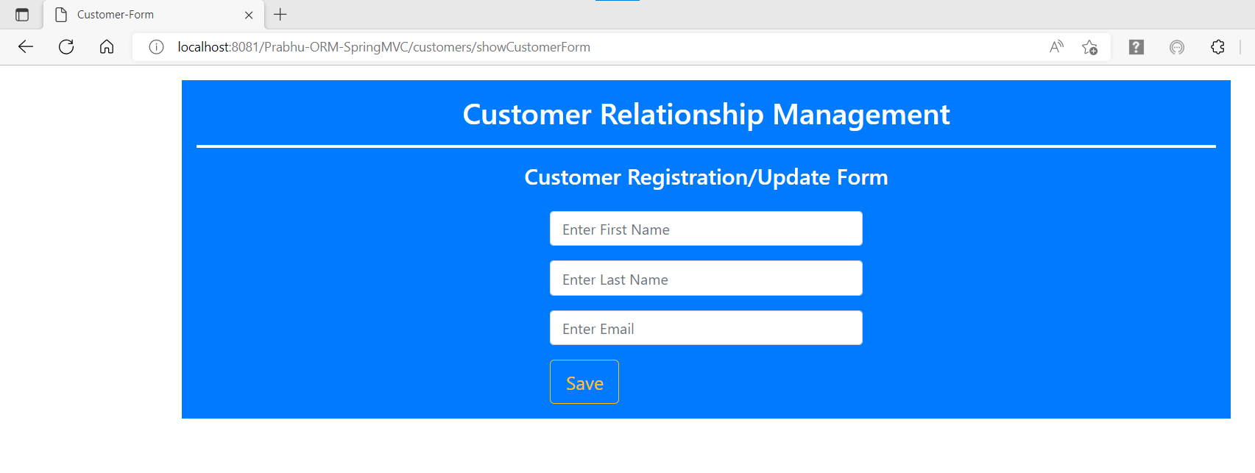

1. Entering First Name as ‘Anand’, last name as ‘Mani’ and email as ‘anand_vj@gmail.com’.

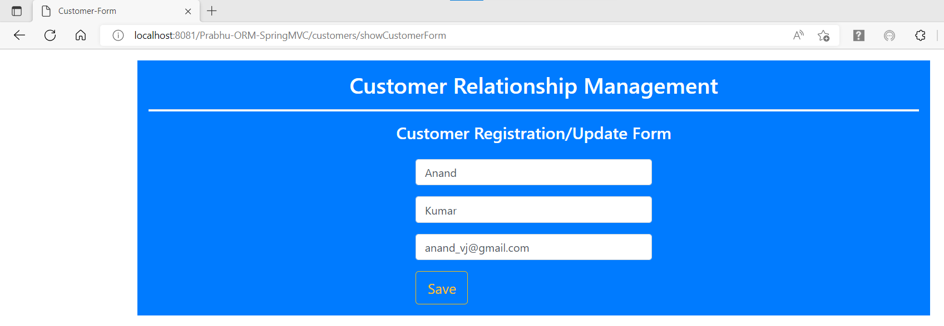

1. On Click of ‘save’ button above, it will save it to DB and redirect to list view with updated customer list.

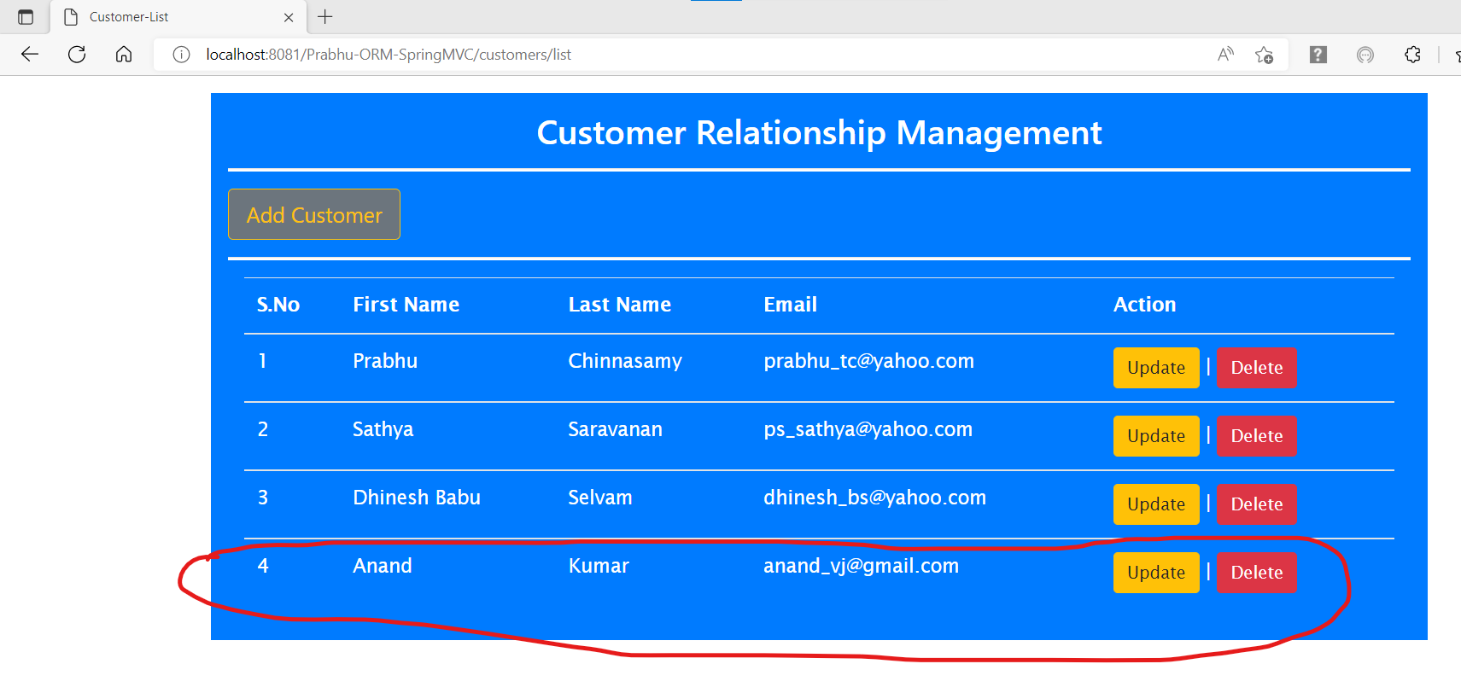

**Update – Operation:**

1. On Click of ‘Update’ button against a customer, it will redirect to edit form with customer details populated.
2. Click ‘Update’ against (S.No: 3) opened edit form with details populated as below:

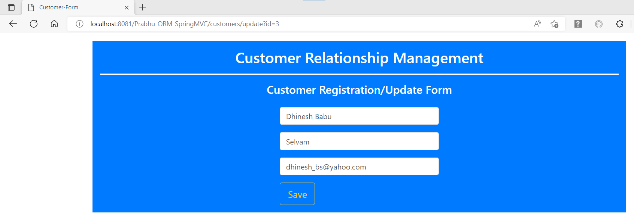

1. Changing email from ‘dhinesh_bs@yahoo.com’ to ‘dhinesh_babu@yahoo.com’ and clicking ‘save’ will update the customer and redirect to list view with updated customer list.

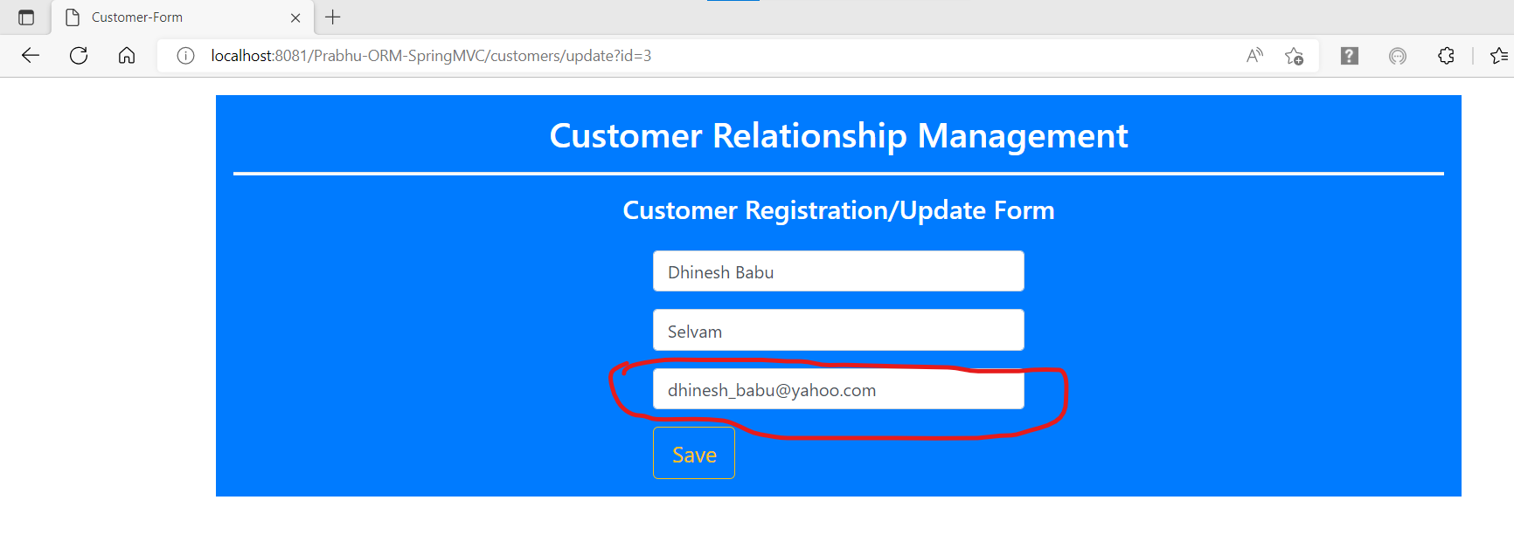

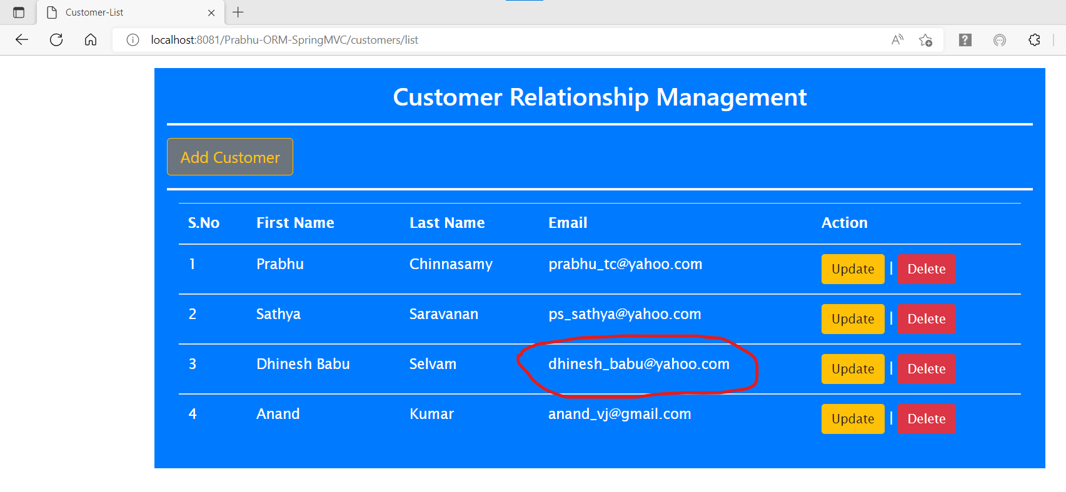

**Delete – Operation:**

1. On Click of ‘Delete’ button against a customer, it will delete the customer and reload the list view with updated customer list.
2. Click ‘Delete’ against (S.No: 2) a warning message will be displayed.

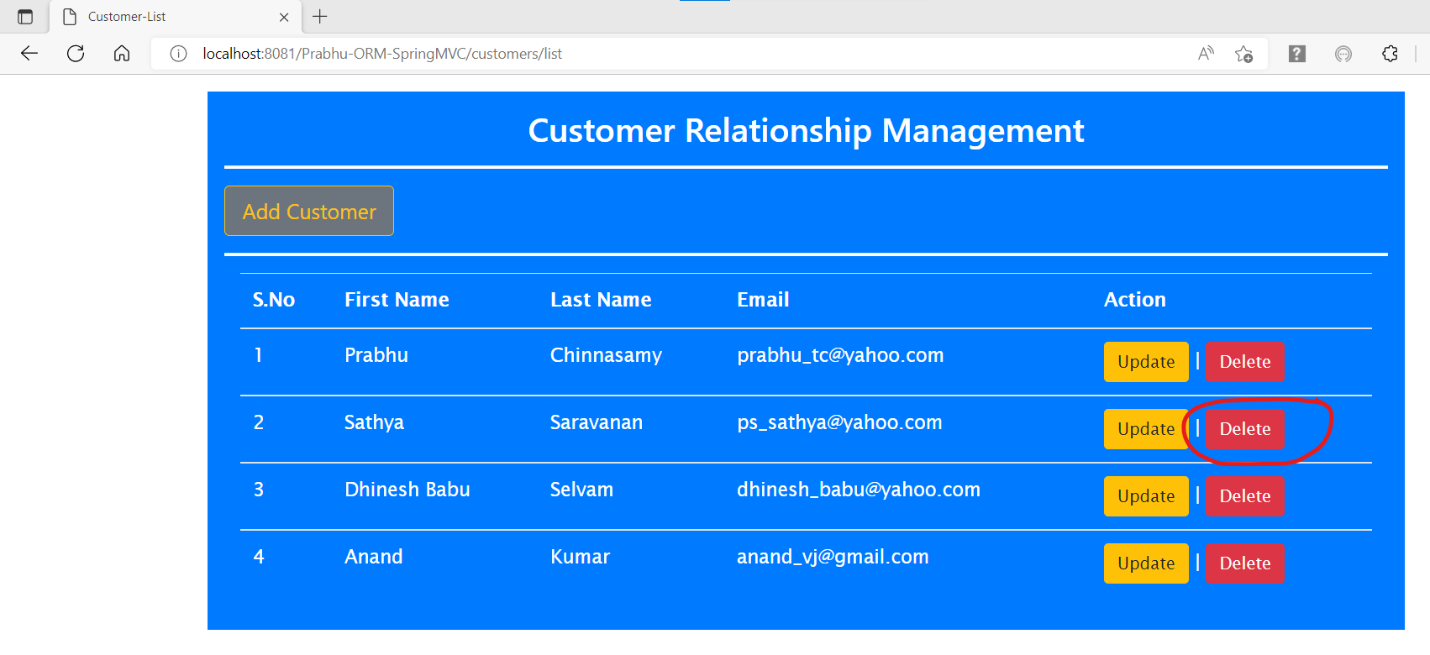

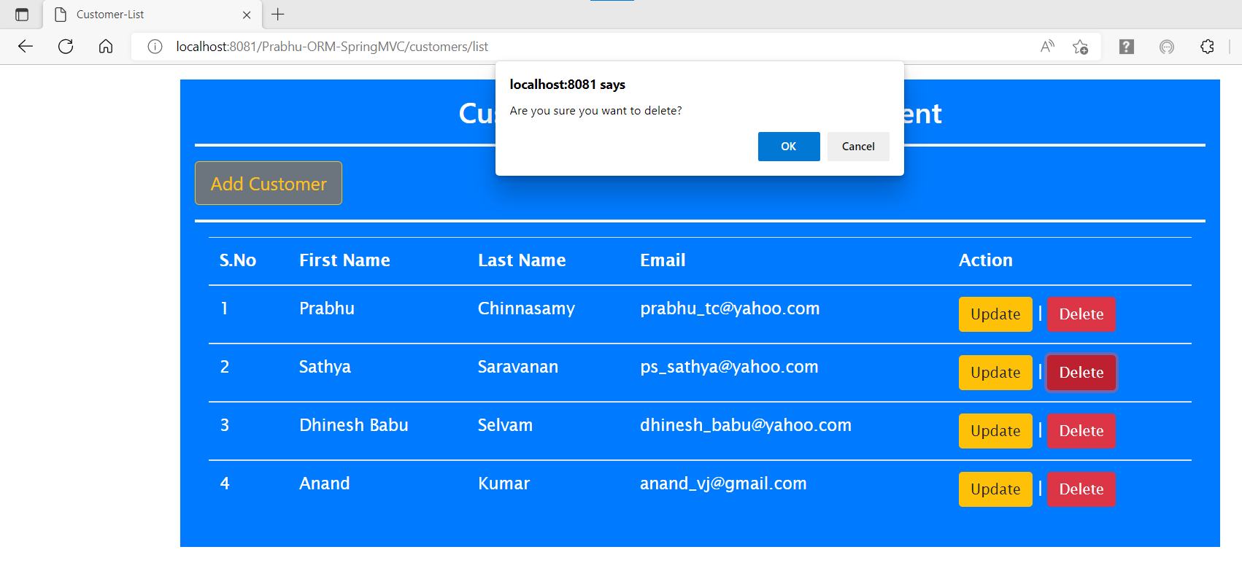

1. On Click of ‘Cancel’ button on the popup nothing happens.
2. On Click of ‘Ok’ button on the popup the corresponding record (S.No: 2) will be deleted. Below is the screenshot after deletion.

