第四周：

学习使用vue去写一些小demo

效果截图：

添加

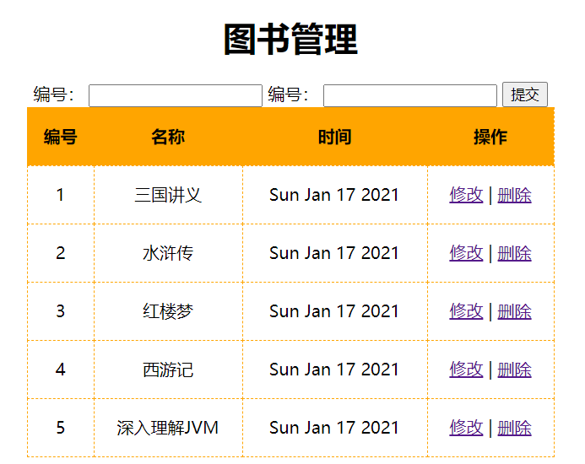

删除

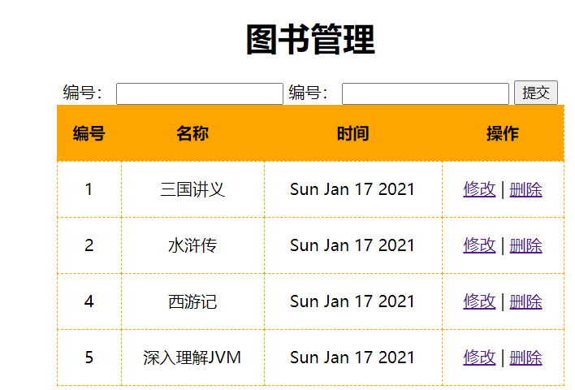

修改：

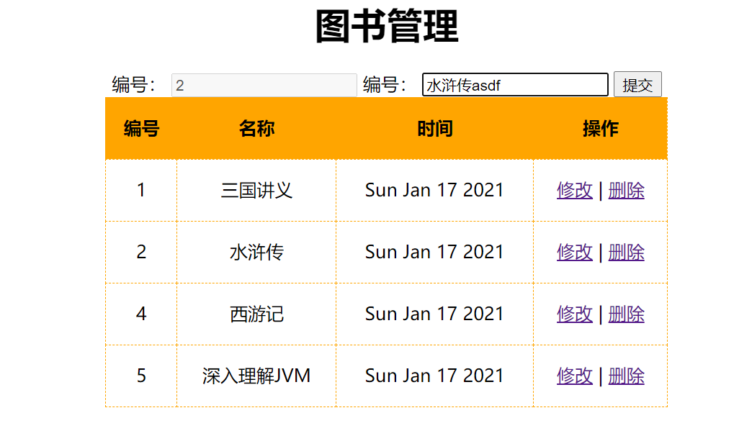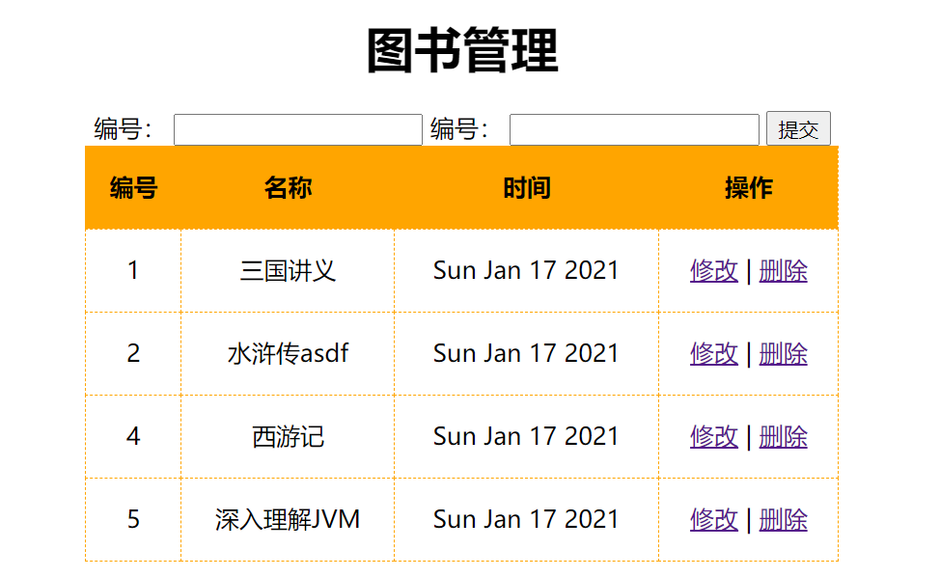

学习基础部分所写代码

<!DOCTYPE html>  
<html lang="en">  
<head>  
 <meta charset="UTF-8">  
 <title>Title</title>  
</head>  
<body>  
<div id="app">  
 <div>  
 <span>  
 <input type="text" v-model="fname">  
 <button @click="add">添加</button>  
 <button @click="del">删除</button>  
 <button @click="replace">替换</button>  
 </span>  
 </div>  
 <ul>  
 <li :key="index" v-for="(item,index) in list">{{item}}</li>  
 </ul>  
 <div>{{info.name}}</div>  
 <div>{{info.age}}</div>  
 <div>{{info.gender}}</div>  
  
</div>  
<script src="js/vuejs/vuejs-2.5.16.js" type="text/javascript"></script>  
<script type="text/javascript">  
 var ***vm*** = new Vue({  
 el: "#app",  
 data: {  
 fname: '',  
 list: ["apple", 'orange', 'peach'],  
 info: {  
 name: 'wangwu',  
 age: 20  
 }  
 },  
 methods: {  
 add: function () {  
 this.list.push(this.fname);  
 },  
 del: function () {  
 this.list.pop();  
  
 },  
 replace: function () {  
 this.list = this.list.slice(0, 2);  
 }  
 }  
 });  
 // vm.list[1]="lemdsgggggggggggggmon";  
 //添加  
 Vue.set(***vm***.list, 2, "lemmon.............");  
 ***vm***.$set(***vm***.list, 1, "hello,world");  
 //不是响应式的  
 // vm.info.gender = 'male'  
 //响应式  
 ***vm***.$set(***vm***.info, 'gender', "famale");  
</script>  
</body>  
</html>

写的一个图书列表管理案例

<!DOCTYPE html>  
<html lang="en">  
<head>  
 <meta charset="UTF-8">  
 <title>Title</title>  
</head>  
<body>  
<div id="app">  
 <div>  
 <span>  
 <input type="text" v-model="fname">  
 <button @click="add">添加</button>  
 <button @click="del">删除</button>  
 <button @click="replace">替换</button>  
 </span>  
 </div>  
 <ul>  
 <li :key="index" v-for="(item,index) in list">{{item}}</li>  
 </ul>  
 <div>{{info.name}}</div>  
 <div>{{info.age}}</div>  
 <div>{{info.gender}}</div>  
  
</div>  
<script src="js/vuejs/vuejs-2.5.16.js" type="text/javascript"></script>  
<script type="text/javascript">  
 var ***vm*** = new Vue({  
 el: "#app",  
 data: {  
 fname: '',  
 list: ["apple", 'orange', 'peach'],  
 info: {  
 name: 'wangwu',  
 age: 20  
 }  
 },  
 methods: {  
 add: function () {  
 this.list.push(this.fname);  
 },  
 del: function () {  
 this.list.pop();  
  
 },  
 replace: function () {  
 this.list = this.list.slice(0, 2);  
 }  
 }  
 });  
 // vm.list[1]="lemdsgggggggggggggmon";  
 //添加  
 Vue.set(***vm***.list, 2, "lemmon.............");  
 ***vm***.$set(***vm***.list, 1, "hello,world");  
 //不是响应式的  
 // vm.info.gender = 'male'  
 //响应式  
 ***vm***.$set(***vm***.info, 'gender', "famale");  
</script>  
</body>  
</html>

总结：

之前都是零碎学习技术点，现在开始写一些小案例容易忘记用法，得多练