**Hidden gem of any linux distro.**

**Xargs** is a great command/binary that reads streams of data from standard input, then generates and executes command lines; meaning it can take output of a command and passes it as argument of another command. If no command is specified, xargs executes echo by default. You may also instruct it to read data from a file instead of stdin.

In simple words “xargs” command allows elegant and efficient way to iterate through line of ascii data.

The most important argument for this command is “–I” which allows to specify a **replacement string**, allowing you to insert input values into a command at a specific location. Replacement is occurring implicit like in this example#1.

**Example#1.** ***********************************************************************

Step 1: create two files in /tmp

touch /tmp/test1;touch /tmp/test2;touch /tmp/test3 (OR – touch /tmp/test{1..3})

Step 2: make one of the three files executable but turning one executable bit:

sudo chmod +x /tmp/test2

Step 3: delete all the file in /tmp folder that starts with word “test” and do have executable bit on.

sudo find /tmp -perm /u+x 'test*' -type f -print | xargs rm –f (implicit replacement)

or

sudo find /tmp -perm /u+x 'test*' -type f -print | xargs –I {} rm –f {} (explicit replacement with {} )

As the result only one file (test2) will be deleted.

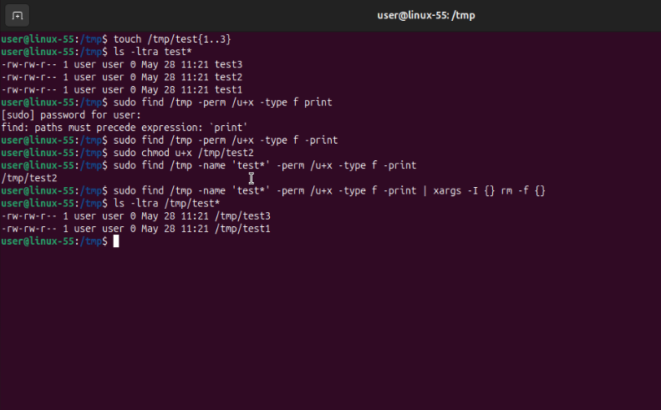

***********************************************************************************.*

**Example#2.**

Step 1: create two files in /tmp and extra backup directory

touch /tmp/test1;touch /tmp/test2;touch /tmp/test3; mkdir /tmp/backup (OR – touch /tmp/test{1..3};mkdir /tmp/backup)

Step 2: create backups of all the files starting with test in /tmp folder and placing them into /tmp/backup folder and adding suffix .bkp

ls test* | tr " " "\n" | xargs -I {} cp {} /tmp/backup/{}.backup

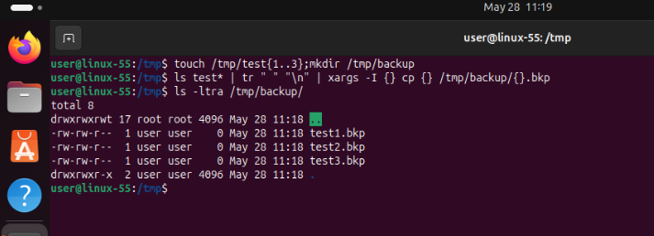

**Example#3** (checking efficiency of the xargs command)

Let’s say we have python script that takes one argument and calculate and output multiplicative persistence number of the input argument.

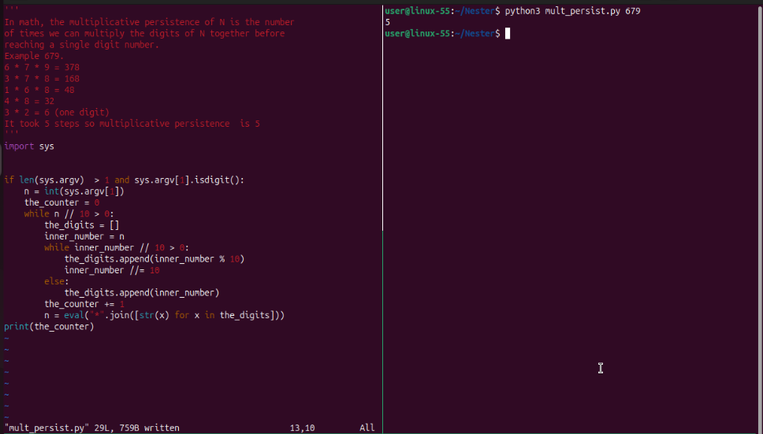

Also we have another file with random 1000 numeric values that must be ran against above mentioned script.

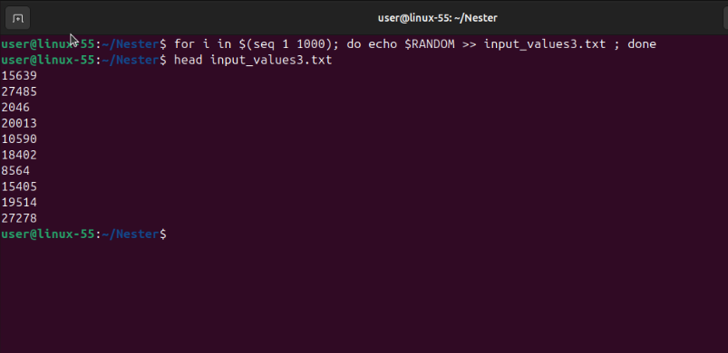

We could simply write bash “while” loop or use the hero of this guide – xargs command. By timing both approach we can see that even so the difference is not huge but still xargs produce result roughly 4 seconds faster.

