THE IAC COMMUNITY ALLIANCE
Preparing for Opportunities
A KNOWLEDGE ENVIRONMENT FOR THE ENTIRE IAC  The Community Alliance actively finds, curates, connects, and distributes knowledge so people across the IAC are better prepared to understand emerging issues, recognize opportunities, and participate intelligently in Community life.  WHY IT EXISTS  • The Internet makes information abundant, but not necessarily understandable.  • People often must already know what to search for and must sort through uneven, algorithmic, or commercially influenced results.  • The Alliance is mission-driven and active: it looks outward for useful ideas, expertise, research, examples, and perspectives before people even know they need them.  HOW IT WORKS  • Builds source relationships with universities, professional associations, conferences, libraries, schools, experts, media, government, business, and other credible sources.  • Uses librarians, students, professionals, volunteers, and Community expertise to discover, evaluate, organize, and explain material.  • Distributes knowledge through the Lens, TeleCenters, schools, libraries, streaming, webinars, newsletters, forums, and other channels.  • Responds to questions and can assemble deeper research when existing material is not enough.  THE RESULT  INFORMATION → KNOWLEDGE → UNDERSTANDING → ENGAGEMENT  The Alliance informs. e-Consensus deliberates. & develops the Action Plan.  A rising tide lifts all boats. | 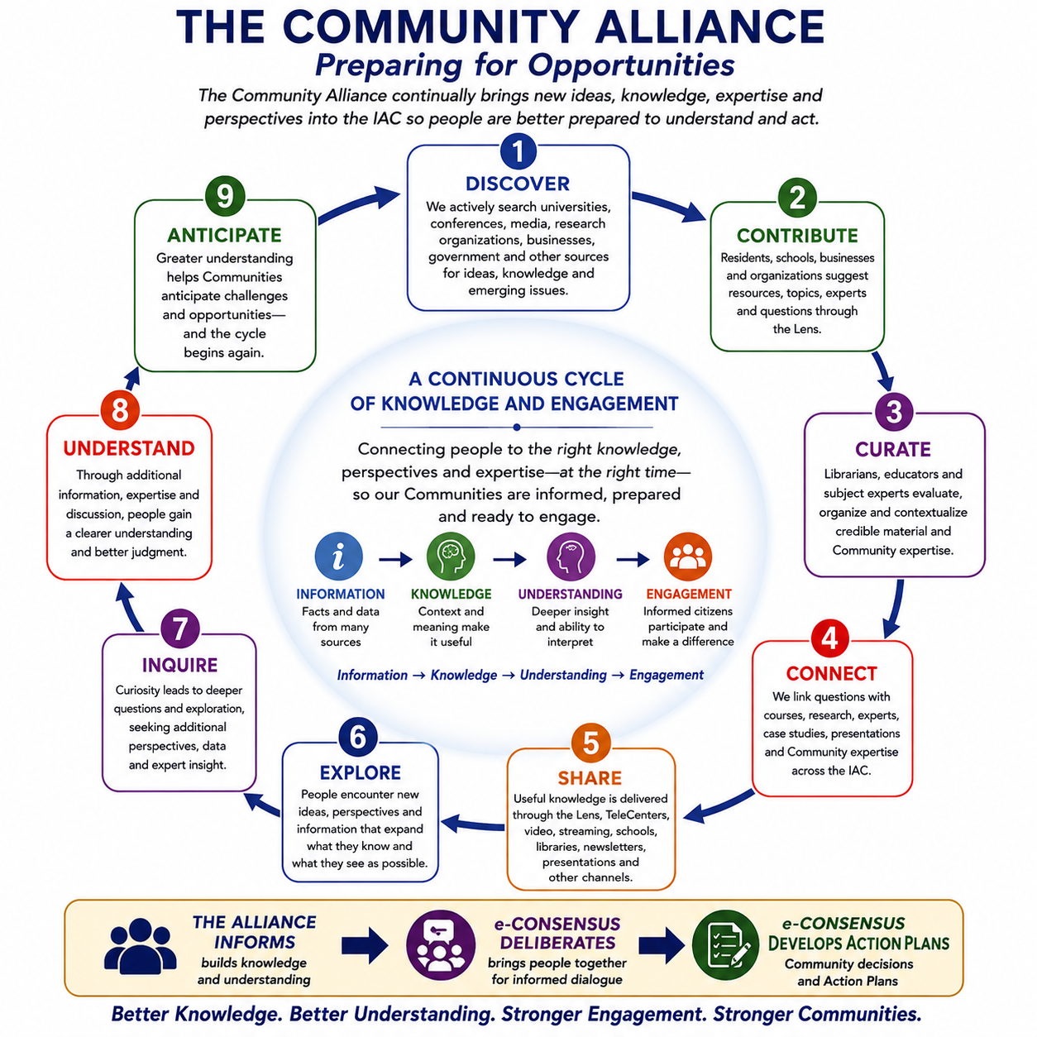  The Community Alliance knowledge and engagement cycle

THE IAC COMMUNITY ALLIANCE
Detailed Concept — Preparing for Opportunities
I. PURPOSE — PREPARING FOR OPPORTUNITIES
The Community Alliance is an IAC-wide knowledge environment designed to continually expand understanding across the Information Age Community. It brings useful ideas, expertise, research, experience, and perspectives within reach when an interest, question, emerging issue, or opportunity makes them relevant.
Its purpose is not to tell people what to think. It is to help people know more, see more possibilities, ask better questions, and engage more intelligently in Community life.
The Alliance is based upon a simple principle: a rising tide raises all boats. Knowledge discovered in one Community, profession, school, conference, institution, or organization should be capable of benefiting people throughout the IAC.
Information → Knowledge → Understanding → Engagement
II. THE ALLIANCE — ACTIVE, DISTRIBUTED KNOWLEDGE
The Internet made information abundant, but abundance alone does not create understanding. Internet use is largely passive and user-initiated: people usually must know what to search for, navigate uneven quality, and sort through results influenced by algorithms, popularity, and commercial interests.
The Community Alliance is active. It continually searches outward, develops source relationships, curates credible material, connects questions with expertise, and distributes useful knowledge throughout the IAC. It is mission-driven rather than commercial and is designed to expose people not only to what they already seek, but also to ideas and developments they may not yet know to look for.
This is a modern form of just-in-time knowledge: bringing the right information, context, expertise, and perspectives within reach when they can broaden understanding and improve engagement.
III. BUILDING THE KNOWLEDGE ENVIRONMENT
The Alliance functions as a large, continuously expanding knowledge “sponge.” It gathers from many sources, organizes what is useful, and redistributes it across the IAC through the most appropriate channels.
1. External Knowledge. Universities, professional conferences, technical symposia, TED Talks, research organizations, businesses, foundations, government, media, free courses, public presentations, and other credible sources continually expand the Alliance knowledge base.
2. IAC Knowledge. The Viability Index, IAC and Community Visions, recurring Community questions, changing conditions, and IAC experience help identify subjects that deserve greater attention and context.
3. Libraries and Librarians. Public, school, college, academic, and research libraries are natural Alliance partners. Librarians provide professional skills in source discovery, evaluation, organization, information literacy, research assistance, and curation—helping turn abundant information into usable knowledge.
4. Schools and Students. Schools can participate through classes, projects, student research, and Alliance or Inquiry Clubs that locate credible material, investigate real Community questions, identify outside resources, and build habits of informed citizenship.
5. Professional and Organizational Sources. Professional associations and organizations already create high-quality continuing knowledge through conferences, journals, presentations, technical updates, and specialist networks. The Alliance seeks access to and redistributes what can benefit the wider IAC.
6. Community Expertise. Residents, retired professionals, educators, farmers, tradespeople, executives, public officials, historians, technical specialists, and others can voluntarily make their experience discoverable as speakers, mentors, research resources, interview subjects, reviewers, or subject-matter experts.
7. Citizen and Organizational Contributions. The Lens can maintain permanent functions such as Suggest a Resource, Recommend a Topic, Suggest a Speaker, Ask the Alliance, and What Do You Want to Know? Contributions are reviewed and curated before broad distribution.
8. Alliance Research. When existing material does not adequately answer an inquiry, the Alliance can organize deeper research through librarians, universities, students, experts, professionals, volunteers, and other appropriate sources.
9. Distributed Access. Knowledge is not tied to one platform. It may be shared through the Lens, TeleCenters, schools, libraries, video or television channels, streaming, webinars, newsletters, podcasts, presentations, conferences, forums, social media, or future technologies.
IV. FROM INFORMATION TO ENGAGEMENT
The Alliance is not an action organization. Its contribution is to improve the environment in which people understand issues and participate in Community life.
1. Information. Facts, data, observations, research, presentations, and other material become available from many sources.
2. Knowledge. Curation, context, comparison, and expertise help make information useful rather than merely abundant.
3. Understanding. Additional perspectives, inquiry, discussion, and experience help people interpret what the knowledge means and recognize alternatives, risks, and possibilities.
4. Engagement. Better-informed people are better prepared to participate in Community discussions, Visioning, public policy, institutional accountability, and e-Consensus.
Sometimes greater understanding is the entire result. At other times an issue warrants collective deliberation. In that case, the Alliance provides the informational foundation, while e-Consensus is the process that develops priorities, Community decisions, and Action Plans.
The Alliance informs. e-Consensus deliberates. e-Consensus develops the Action Plan.
V. THE ENVIRONMENT FOR INFORMED ENGAGEMENT
The Alliance strengthens other IAC activities without controlling them. A better knowledge environment can improve the quality of Community discussion, public accountability, Visioning, institutional performance, and participation in e-Consensus.
1. Everyday Understanding. People can explore subjects simply because they are useful, interesting, emerging, or relevant to personal, professional, or Community life.
2. Preparing for Important Questions. When the IAC Board or a Community Board sees a major issue approaching, it can ask the Alliance to assemble background information, competing perspectives, research, examples, and expertise so people have time to understand the issue before deliberation begins.
3. Visioning. Alliance knowledge broadens the range of ideas, examples, technologies, and possibilities available as the IAC and individual Communities consider their future and assess progress toward their Visions.
4. Public Policy and Accountability. A more informed population can ask better questions, evaluate alternatives more critically, understand institutional performance, and influence policy and accountability through informed participation rather than reaction alone.
5. Education and Citizenship. School and student participation connects research and information literacy with real Community life and helps develop future citizens accustomed to inquiry, evidence, and thoughtful engagement.
6. Board and Collaborative Support. The Alliance can supply knowledge and context to Board inquiries. Collaboratives remain the specialized volunteer professional resources that support the Board with technical analysis, planning, and implementation expertise.
VI. HOW THE COMMUNITY ALLIANCE CONNECTS TO THE IAC
1. Viability Index. Identifies conditions, trends, risks, resilience, and opportunities that may deserve greater understanding; the Alliance adds context, research, examples, and perspectives.
2. Community Lens. Provides a principal digital pathway for discovering Alliance content, suggesting resources, asking questions, identifying interests, and distributing curated knowledge.
3. TeleCenter. Provides the physical interface for presentations, facilitated access, specialized technology, group activity, and assistance for people engaging with Alliance resources.
4. e-Consensus Forum. Uses a stronger knowledge environment as the foundation for deliberation. The Alliance informs; e-Consensus develops priorities, decisions, and Action Plans.
5. Visioning. Benefits from continuous exposure to emerging ideas, experiences, technologies, challenges, and opportunities that can broaden how Communities understand their future.
6. Community Board. May ask the Alliance to prepare the Community to understand an important issue before formal deliberation begins, while remaining responsible for stewardship and acting upon Community decisions.
7. Collaboratives. Provide specialized volunteer professional expertise when questions move from broad understanding into technical analysis, planning, project development, or implementation support.
8. Community Voice. Benefits from better-informed Community judgment and stronger underlying understanding before conclusions are amplified into governmental, institutional, business, funding, and other arenas.
The Alliance does not replace any other IAC component. It improves the knowledge environment in which all of them operate.

