IAC GOVERNANCE
Mutual Viability and Community Stewardship
AT A GLANCE  PURPOSE  Give the Community Sector an organized structure for stewardship, representation, accountability, and coordinated action without creating another layer of government.  THE COMMUNITY  The Community is the smallest viable Community entity within the IAC: the Trade Center and its Small Towns acting as an interdependent whole while retaining their separate identities and lawful authorities.  THE STRUCTURE  Citizen-based Small Town participation feeds a Community Board; each Community then provides three representatives to the IAC Board—two from the Small Towns and one from the Trade Center.  THE PRINCIPLE  The Community establishes direction. Boards steward that direction. Collaboratives provide expertise. Existing institutions retain their lawful authority. Mutual Viability binds the relationship together. | 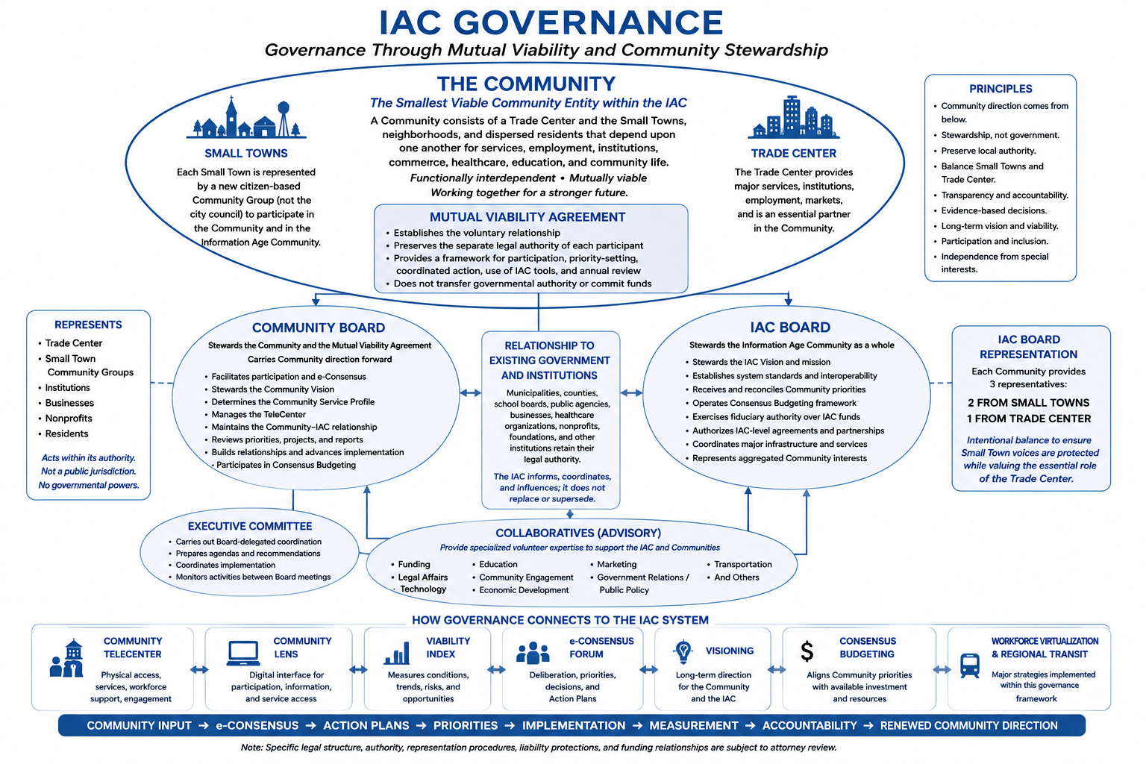
COMMUNITY DIRECTION → STEWARDSHIP → REPRESENTATION → ACCOUNTABILITY

I. THE COMMUNITY — THE SMALLEST VIABLE COMMUNITY ENTITY
Within the Information Age Community, the Community is the smallest viable Community entity. It is not a single municipality. It is the functionally interdependent relationship of a Trade Center and the Small Towns, neighborhoods, and dispersed residents that depend upon one another for services, employment, institutions, commerce, healthcare, education, social relationships, and Community life.
The Trade Center provides the principal concentration of services and institutions. The Small Towns retain their own identities, histories, governments, and local relationships while gaining access to capabilities they cannot efficiently sustain alone. In return, the Trade Center depends upon the surrounding population for workforce, customers, students, patients, volunteers, economic activity, and market strength.
The Community therefore becomes the first level within the IAC at which these interdependencies can be organized and stewarded as a viable whole. The relationship is one of Mutual Viability: strengthening the Trade Center strengthens the Small Towns, and strengthening the Small Towns strengthens the Trade Center.
Each participating municipality and institution retains its own legal authority and identity. The Community does not replace them; it adds an organized Community Sector structure through which shared conditions, priorities, opportunities, and long-term viability can be addressed together.
Preserve local identity and authority.
Organize shared Community interests.
Steward Mutual Viability.

II. GOVERNANCE AS COMMUNITY STEWARDSHIP
IAC Governance is a system of Community stewardship, not another layer of government. It provides the structure through which residents can become informed, establish priorities, develop Action Plans, coordinate resources, and influence the decisions that shape Community life while existing governments, institutions, and businesses retain their lawful authority.
The Community is the source of direction. Viability provides evidence. The Community Alliance strengthens understanding. Visioning defines long-term direction. e-Consensus provides the structured process through which participants deliberate, establish priorities, resolve differences, and develop Community decisions and Action Plans. Community Voice carries those documented conclusions outward.

III. THE MUTUAL VIABILITY AGREEMENT
The Mutual Viability Agreement (MVA) is the proposed voluntary framework that formalizes cooperation among the constituent parts of the Community while preserving their separate legal identities and authorities. It provides a structure for shared information, participation, Visioning, priority-setting, coordinated projects, use of IAC tools, and annual review.
A critical element now under legal review is that Small Town participation is intended to come from newly organized citizen-based Community Sector groups—not automatically from city councils. These groups would represent residents in the Mutual Viability relationship, help identify local needs and assets, participate in Visioning and e-Consensus, preserve local identity, and select or nominate representatives. They would not exercise municipal powers.
When an Action Plan requires public expenditure, regulation, land-use action, contracting, or another statutory function, the legally responsible governmental or institutional body acts through its own lawful process. The precise legal form, standing, membership, and agreement structure of these citizen groups remain subject to attorney review.

IV. THE COMMUNITY BOARD
Each Community establishes a Community Board to steward the relationship among its Trade Center, Small Towns, residents, institutions, and the larger IAC. The Community establishes direction; the Board facilitates, stewards, coordinates, and acts upon that direction.
1. Facilitates informed Community participation and e-Consensus.
2. Stewards the Community Vision and the Mutual Viability relationship.
3. Reviews Community priorities, Action Plans, projects, and progress.
4. Determines the Community Service Profile and local use of IAC resources.
5. Manages the Community TeleCenter and maintains the Community–IAC relationship.
6. Builds relationships with governments, businesses, schools, healthcare providers, nonprofits, funders, and other institutions.
7. Participates in Consensus Budgeting and helps move documented Community priorities toward implementation.
The Community Board is not a public jurisdiction and does not exercise taxing, regulatory, police, education, land-use, or other governmental powers unless separately and lawfully delegated.

V. THE IAC BOARD
The IAC Board provides stewardship for the Information Age Community as a whole. Its purpose is not to substitute regional judgment for Community judgment, but to protect the integrity of the shared system, maintain the IAC Vision, coordinate capabilities that benefit from scale, reconcile Community priorities, exercise fiduciary responsibilities, and represent the aggregated interests of participating Communities.
Each Community provides THREE representatives to the IAC Board
2 FROM THE SMALL TOWNS • 1 FROM THE TRADE CENTER
This structure intentionally protects the Small Town voice while recognizing the Trade Center as the Community service hub. It is designed to keep the IAC grounded in the Mutual Viability of the entire Community rather than allowing its largest center to dominate regional stewardship.
1. Stewards the IAC Vision, mission, and system integrity.
2. Establishes common standards and protects interoperability.
3. Receives and reconciles Community priorities without recreating them.
4. Oversees Consensus Budgeting and exercises fiduciary authority over IAC-controlled funds.
5. Authorizes major IAC agreements, partnerships, and shared capabilities.
6. Evaluates system-wide performance and represents aggregated Community interests externally.

VI. EXECUTIVE COMMITTEE AND COLLABORATIVES
The Executive Committee supports the IAC Board by preparing agendas, coordinating implementation, monitoring assigned activities, and carrying out other responsibilities delegated by the Board. It does not replace the Board or independently redefine Community priorities.
Collaboratives provide specialized volunteer professional capacity comparable to the departments available to large governments and corporations. They may include Funding, Legal Affairs, Technology, Education, Community Engagement, Economic Development, Marketing, Government Relations and Public Policy, Transportation, and other fields. Collaboratives advise and support the Board and participating Communities; they do not exercise independent governing authority.

VII. CONSENSUS GOVERNANCE, BUDGETING, AND ACCOUNTABILITY
e-Consensus is where Community deliberation is converted into documented priorities, decisions, and Action Plans. Boards do not recreate that Community judgment. They determine how the results can be carried forward within fiduciary, contractual, organizational, and legal authority. Independent governments, institutions, businesses, and funders retain responsibility for actions requiring their own approval.
Consensus Budgeting then connects documented priorities with the Annual Budgeting Conference and available public, private, philanthropic, institutional, nonprofit, and Community resources. The objective is broader than an IAC operating budget: it is to improve the alignment of total investment affecting the Community with documented Community priorities.
Accountability is continuous. Viability measures changing conditions; Visioning measures progress toward long-term direction; e-Consensus records preserve Community judgment; the Lens publishes priorities and results; Consensus Budgeting links priorities to investment; and Community Voice strengthens public and institutional accountability.

VIII. RELATIONSHIP TO EXISTING GOVERNMENT AND INSTITUTIONS
Municipalities continue to govern municipalities. School boards govern schools. Public agencies retain statutory responsibilities. Businesses and institutions retain their own governance and fiduciary authority. The IAC does not replace them.
What changes is the strength and organization of the Community Sector interacting with them. The IAC gives the Community Sector the information, representation, continuity, and documented Community Voice needed to participate meaningfully alongside the Public and Private Sectors.

IX. HOW GOVERNANCE CONNECTS TO THE IAC
1. Mutual Viability Agreement. defines the voluntary operating relationship underlying the Community.
2. Viability Index. provides evidence and accountability.
3. Community Alliance. strengthens the knowledge environment in which participation occurs.
4. e-Consensus Forum. develops Community decisions and Action Plans.
5. Visioning. provides enduring Community and IAC direction.
6. Community Lens. provides the digital interface for information, participation, transparency, and accountability.
7. TeleCenter. provides the physical and operating interface for implementation.
8. Collaboratives. provide specialized volunteer professional expertise.
9. Consensus Budgeting. aligns Community priorities with investment and resources.
10. Workforce Virtualization and Regional Transit. operate as major strategies within the stewardship framework.

GOVERNING DOCTRINE
The Community establishes direction.
The Community Board stewards that direction.
The IAC Board protects and coordinates the larger system.
Collaboratives provide expertise.
Existing institutions retain their lawful authority.
Mutual Viability binds the relationship together.

LEGAL STRUCTURE UNDER REVIEW
The precise legal form of the Small Town citizen groups, Community Boards, representation and selection procedures, MVA parties, fiduciary duties, liability provisions, voting authority, funding relationships, and related governance mechanics are currently under attorney review. This concept document defines the intended operating philosophy and relationships the legal structure should support.

