THE COMMUNITY LENS
The Digital Front Door to the Information Age Community
AT A GLANCE  PURPOSE  Organize everything the Community knows, offers, and does into one structured digital environment where residents, organizations, visitors, and partners can find, understand, access, and participate.  SIX CORE FUNCTIONS  TeleCenter Services • Engagement Applications • Community Entity Directory • Community Receptionist • View the Neighborhood • Profiles & Indicators.  THE DIFFERENCE  Instead of leaving the Community scattered across thousands of unrelated websites and search results, the Lens creates a structured Community view—using NAICS-based entity discovery, maps, profiles, indicators, and guided assistance.  TWO-WAY SYSTEM  Information, services, plans, and results flow outward; questions, ideas, concerns, volunteer offers, requests, and participation flow back into the Community and IAC. | 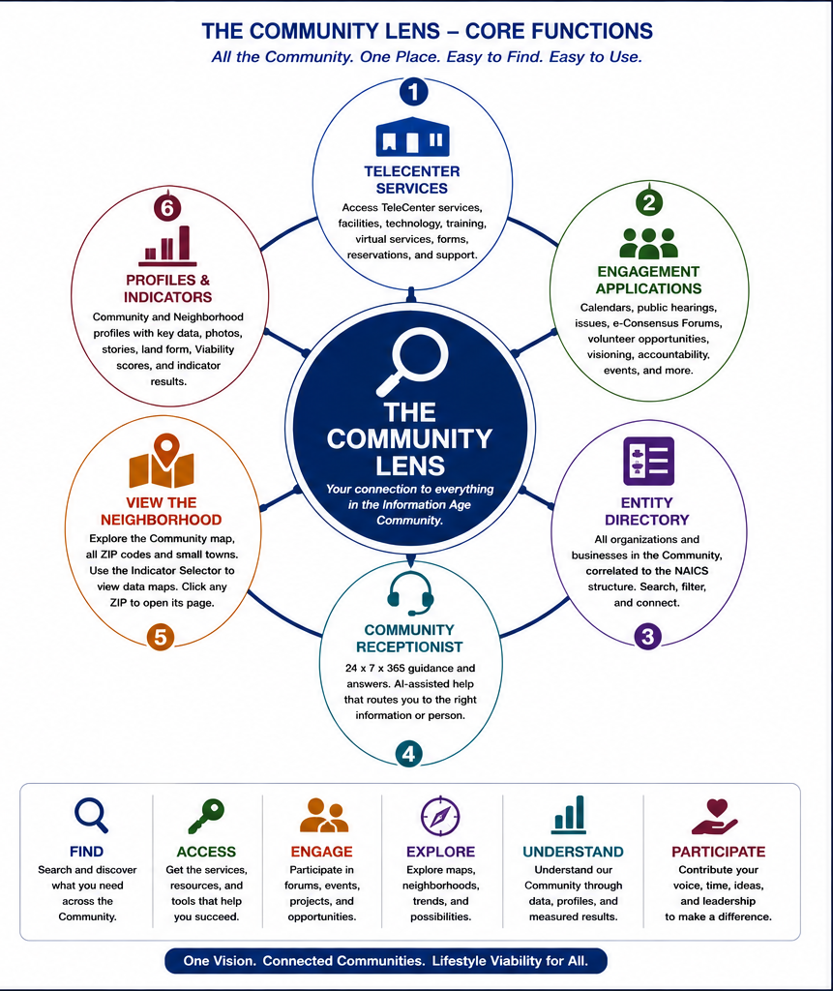
FIND • ACCESS • ENGAGE • EXPLORE • UNDERSTAND • PARTICIPATE

I. PURPOSE — A STRUCTURED DIGITAL FRONT DOOR
The Community Lens is the Community’s structured digital front door to the Information Age Community. It brings together information, services, applications, maps, profiles, engagement tools, and assistance in one place so residents, businesses, organizations, visitors, and prospective residents can quickly understand the Community and act within it.
The Internet normally presents a Community as thousands of disconnected websites, commercial search results, government pages, and institutional silos. The Lens reverses that fragmentation. It organizes the Community as a whole — the Trade Center, its Small Towns, its neighborhoods, its institutions, its services, and its opportunities — while preserving links back to the organizations that actually provide those services.
The Lens is therefore not intended to replace local websites. It is the organizing layer that makes the Community visible, searchable, understandable, and usable as a single entity.

II. SIX CORE FUNCTIONS
1. TeleCenter Services. Provides the digital menu to the Community TeleCenter: assistance, training, facilities, technology, forms, reservations, virtual services, equipment and resource access, business and career support, and other Community capabilities. The Lens is the online doorway; the TeleCenter is the physical and operating interface when human help, equipment, facilities, or implementation is needed.
2. Community Engagement Applications. Provides access to the applications through which people participate in Community life: calendars, public hearings, issues and concerns, e-Consensus Forums, Visioning, volunteerism, mentoring, events, contributions, recognition, accountability, project participation, budgeting, and other engagement activities. This turns the Lens from a publishing site into an active participation environment.
3. Community Entity Directory. Creates a structured directory of the organizations and websites within the Community. Businesses, employers, government, schools, healthcare providers, nonprofits, churches, recreation, services, and other entities are correlated to the NAICS structure and related functional tags so users can search by need rather than by knowing an organization’s name in advance. Results can return the entity name, location, website, map link, contact information, and related service information.
4. Community Receptionist. Provides a continuing human and AI-assisted guidance layer for people who do not know where to begin. The receptionist helps translate “What do I need?” into the correct service, organization, TeleCenter function, Community application, neighborhood resource, or outside referral. The original Portal concept envisioned this as a 24 x 7 x 365 Community capability; staffing and automation can evolve while the function remains constant.
5. View the Neighborhood. Provides the geographic interface to the Community. The map shows the Trade Center and every Small Town / ZIP-code neighborhood within the Community. Users can select an indicator to display ZIP-level values graphically, compare conditions across the Community, and click any ZIP to open that Neighborhood Profile. The map makes the functional Community visible in a way that municipal boundaries alone cannot.
6. Profiles and Indicators. Provides both the aggregate Community Profile and individual Neighborhood Profiles. These pages combine key demographic, economic, land-form, service, identity, history, and Viability information. Tables, charts, trends, maps, photographs, and Community stories allow the visitor to move from a broad Community condition to the detailed characteristics of a specific ZIP-code neighborhood.

III. THE COMMUNITY / NEIGHBORHOOD HIERARCHY
The Lens follows the IAC’s natural geography rather than forcing users to navigate through unrelated jurisdictions. The user can move in either direction:
1. IAC — the larger Information Age Community region.
2. Community — the smallest viable Community entity: the Trade Center together with its Small Towns and dispersed population.
3. Neighborhood — the ZIP-code level at which a Small Town, urban neighborhood, or other local area can be viewed in detail.
This drill-down / roll-up structure allows the same system to answer very different questions: “What services exist anywhere in my Community?” “How is my neighborhood doing?” “Which ZIPs have the strongest or weakest indicator?” or “How does this Community compare with the larger IAC?”

IV. WHAT PEOPLE CAN DO THROUGH THE LENS
1. Find. Search for services, organizations, programs, facilities, people, and information without needing to know which institution provides them.
2. Access. Reach TeleCenter services, training, forms, technology, facilities, reservations, virtual providers, and other support.
3. Engage. Join e-Consensus Forums, Visioning activities, hearings, events, volunteer efforts, mentoring, and other Community processes.
4. Explore. Use maps to see the Community and its neighborhoods, select indicators, compare ZIPs, and move directly to Neighborhood Profiles.
5. Understand. Review the Community Profile, Neighborhood Profiles, Viability results, trends, economic and demographic conditions, land form, Community stories, and other evidence.
6. Participate. Contribute ideas, concerns, time, talent, resources, referrals, and Community knowledge; follow projects, Action Plans, budgets, and results.

V. THE LENS AS A TWO-WAY SYSTEM
The Lens is not simply a website that publishes information. It is a two-way Community operating interface.
1. IAC / Community to the Resident. Data, maps, profiles, services, opportunities, meetings, Action Plans, results, Vision progress, Community stories, and assistance flow outward through the Lens.
2. Resident / Organization to the Community. Questions, ideas, concerns, volunteer offers, service requests, Forum participation, proposed resources, corrections, and Community knowledge flow back through the Lens.
This continual exchange strengthens the quality of the Community’s information and makes participation part of ordinary Community life rather than an occasional public meeting.

VI. THE LENS AS THE COMMUNITY’S PUBLIC FACE
The Lens serves people who already live in the Community, but it also presents the Community to people who may want to live, work, visit, invest, study, start a business, or build a relationship there. The Community Vision, identity, stories, profiles, services, institutions, economic opportunities, neighborhoods, and lifestyle characteristics therefore become part of a coherent public presentation.
This role is especially important for Small Towns. Instead of appearing on the Internet as isolated places with incomplete digital footprints, they become visible as distinct neighborhoods within a larger, viable Community that can offer the combined services and opportunities of the Trade Center and surrounding Small Towns.

VII. HOW THE COMMUNITY LENS CONNECTS TO THE IAC
TeleCenter. The Lens is the digital interface to TeleCenter services; the TeleCenter supplies the human, physical, technical, and implementation layer when digital access alone is insufficient.
Community Alliance. Alliance knowledge, outside resources, recommended materials, and Community learning opportunities can be distributed and requested through the Lens.
e-Consensus Forum. The Lens provides access to Forums, background material, registration, published results, Action Plans, and accountability tracking.
Visioning. The Community Vision is continuously visible through the Lens, while annual progress measures and Vision review results can be reported there.
Viability Index. The Lens presents Viability scores, indicator results, maps, trends, and profiles and provides the user-facing pathway into deeper analysis.
Governance. Community and IAC Boards can publish priorities, decisions, meeting information, budgets, progress, and accountability information through the Lens.
Collaboratives. Specialized knowledge, volunteer opportunities, technical resources, and project support developed by the Collaboratives can be accessed through the Lens.
Workforce Virtualization. Remote-work, employer, continuity, workforce, and supporting service information can be distributed to workers and employers through the Lens.
Regional Transit. Transit information, service relationships, mobility opportunities, and future deployment information can be linked directly to the neighborhoods and services they connect.
The Lens brings the IAC to the screen. The TeleCenter brings the IAC into the Community.

