THE IAC TELECENTER
The Community’s Physical and Operating Home
AT A GLANCE  PURPOSE  Turn Community priorities into coordinated, practical action through a locally managed physical and operating presence.  THE CORE IDEA  Virtualize what can be virtualized. Distribute what must remain physical. Coordinate both through the IAC network. Keep the Community in control of its own direction.  WHAT IT DOES  Connects residents to services, technology, training, facilities, volunteers, providers, equipment, and implementation support—while extending selected capabilities into Small Towns and neighborhoods.  WHY IT MATTERS  The Community Board establishes priorities and stewards the Community relationship. The TeleCenter gives those decisions an operating home and a practical way to mobilize people, providers, technology, and resources. | 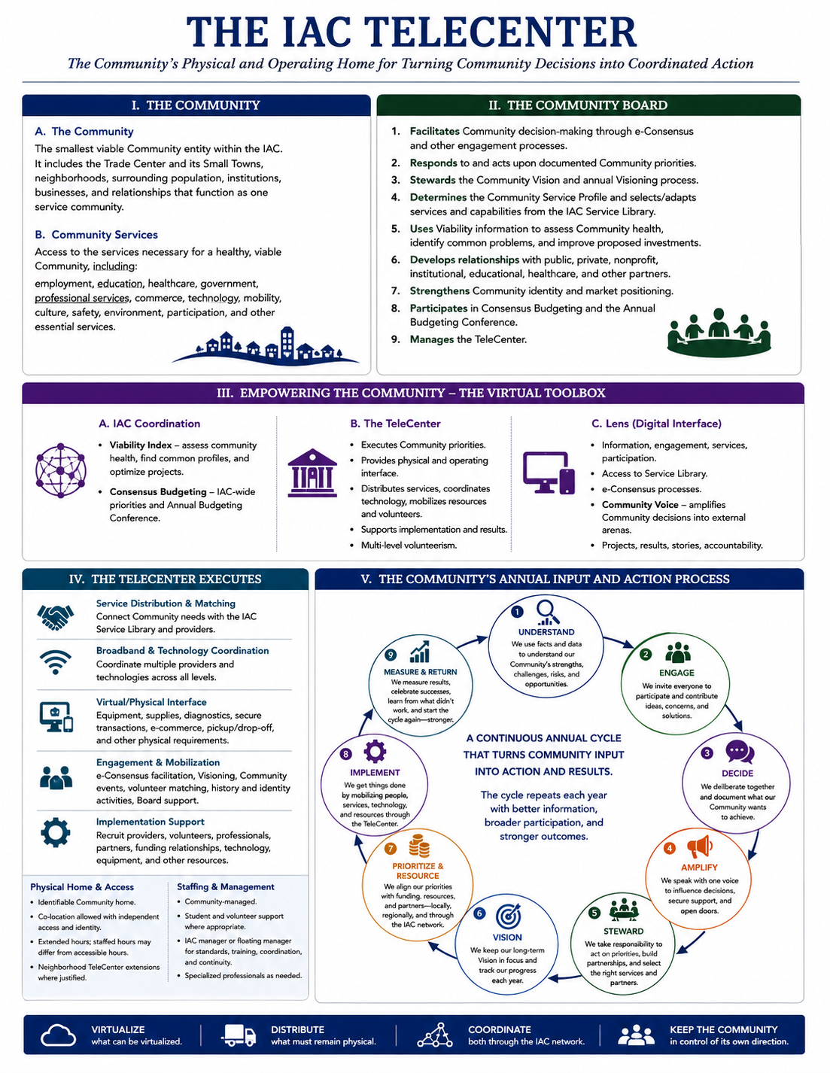
COMMUNITY PRIORITIES → LOCAL ACCESS → COORDINATED IMPLEMENTATION

I. THE COMMUNITY

A. The Community
The Community is the smallest viable Community entity within the Information Age Community. It is the scale at which residents can establish a shared Vision, evaluate Community conditions, determine service needs, express priorities, develop projects, coordinate resources, and act collectively.
Its parts retain their individual identities while participating in a larger relationship based upon mutual viability.
1. The Trade Center — Community Service Hub. The principal concentration of everyday services, institutions, employment, commerce, healthcare, education, government access, professional capability, and Community support. Its viability depends upon the population, workforce, customers, institutions, and market represented by the entire Community.
2. Small Towns — Distinct Community Neighborhoods. Small Towns retain their own history, identity, relationships, businesses, institutions, and Community life while gaining access to services and capabilities that cannot be efficiently sustained independently.
3. Dispersed Households and Rural Areas — Community Reach. Farms, cabins, rural residences, and other dispersed households remain part of the Community and gain access through home-first virtualization, broadband, mobility, delivery systems, and TeleCenter support.
4. Neighborhoods — Local Identity and Access. Neighborhoods represent the scale closest to residents and provide opportunities for extending selected services, engagement, volunteer activity, and Neighborhood TeleCenter capabilities when need or concentration justifies them.
5. Mutual Viability — The Governing Relationship. The Trade Center depends upon the surrounding Community for workforce, customers, students, patients, volunteers, economic activity, and institutional support. Small Towns and dispersed residents depend upon the Trade Center and wider IAC for services and capabilities they cannot efficiently sustain themselves. Strengthening one therefore strengthens the other.

B. Community Services
Community viability depends less upon whether every service is physically located in every town than upon whether every resident has reasonable access to the capabilities required for a healthy and attractive life.
The Community therefore develops a Community Service Profile that identifies what services are needed and the most effective level at which each should be delivered.
1. Home-Based and Virtual Services. Employment, education, healthcare consultations, professional services, government transactions, commerce, information, Community participation, and other capabilities should reach the home whenever practical, secure, affordable, and effective.
2. Distributed Community Services. Capabilities requiring some physical presence may be distributed through Small Towns, Neighborhood TeleCenters, partner facilities, mobile services, delivery systems, or other local access points.
3. Trade Center Services. Services requiring greater population, professional staffing, specialized equipment, facilities, or economies of scale may appropriately be concentrated in the Trade Center.
4. Higher-Level Services. Highly specialized capabilities may be accessed through Service Centers, other Communities, or the wider IAC and Global Service Center network.
5. The IAC Service Library. The IAC coordinates a growing library of providers, services, curricula, technology, equipment, expertise, programs, and other capabilities. The Community Board selects and adapts those that fit the Community Service Profile and identifies gaps the IAC should recruit or develop.
The objective is access to capability without unnecessary duplication of facilities or institutions.

II. THE COMMUNITY BOARD
The Community Board represents and stewards the interests of the entire Community—the Trade Center, Small Towns, neighborhoods, surrounding residents, institutions, businesses, and Community relationships.
The Community establishes its priorities. The Board facilitates the development of those decisions, responds to them, and acts upon them.
The Board does not supersede governmental, institutional, or private authority. Formal approvals remain with the organizations legally or organizationally responsible for them. The Board instead provides Community-wide stewardship across boundaries that no single jurisdiction or institution represents.

A. Representative Structure
The proposed Board structure is intentionally representative of the entire Community rather than only the Trade Center. Each Small Town would have one representative, while the Trade Center would have three representatives. This gives every constituent Small Town a direct place in Community stewardship while recognizing the Trade Center’s larger service, institutional, and population role. Final representation, selection, terms, eligibility, and fiduciary provisions remain subject to the governing documents and legal review.

B. Board Responsibilities
1. Facilitates Community Decision-Making. Supports informed participation, e-Consensus, Community discussion, issue resolution, and development of documented Community priorities, policies, and Action Plans.
2. Responds to Community Priorities. Moves documented priorities toward action by developing projects, relationships, partnerships, resources, and implementation strategies.
3. Stewards the Community Vision. Maintains the enduring Community Vision within the broader IAC Vision and coordinates the annual process used to measure progress toward it.
4. Determines the Community Service Profile. Identifies the services and capabilities the Community requires, determines the appropriate delivery level, selects and adapts resources from the IAC Service Library, and identifies unmet needs.
5. Uses Viability to Improve Decisions and Investments. Applies Community health information, comparative analysis, and project-review capabilities to strengthen proposals and increase Community benefit.
6. Builds Community Relationships. Develops working relationships among Small Towns, governments, employers, schools, healthcare providers, nonprofits, professional organizations, funders, service providers, and other partners.
7. Strengthens Community Identity and Market Position. Preserves and interprets the history, traditions, assets, institutions, economic heritage, stories, and characteristics that make the Community distinctive and works with the IAC to market it as a desirable place to live.
8. Participates in Consensus Budgeting. Reviews IAC-wide priorities, develops Community priorities, and participates in the Annual Budgeting Conference to help align investment and resources.
9. Manages the TeleCenter. Establishes operating priorities, service expectations, access requirements, partnerships, Neighborhood TeleCenter extensions, staffing arrangements, and performance expectations.
The Community establishes direction.
The Board facilitates, stewards, and acts upon it.

III. TOOLS THAT EMPOWER THE COMMUNITY
The IAC provides Communities with capabilities that would be difficult, inefficient, or costly to develop independently. These tools combine IAC-wide scale with Community-level choice and implementation.

A. IAC Coordination
The IAC coordinates functions that benefit from being developed across the larger network rather than recreated separately within every Community.

1. The Viability Index
The Viability Index provides three complementary capabilities.
1. Community Health Assessment. A broad system of indicators measures how comprehensively healthy the Community is and identifies trends, strengths, vulnerabilities, resilience, risks, opportunities, and progress.
2. Common-Profile Search. Searchable Community profiles identify Communities experiencing similar conditions or opportunities so that common problems can be addressed strategically across all affected Communities.
3. Project Review and Optimization. Six AI-supported analytical engines help examine proposed projects and investments, identify missing information, expand beneficiaries and stakeholders, recognize shared assets and partners, locate additional funding, test alternatives, reduce risk, and optimize Community return.
The objective is not simply to determine whether a proposed project is acceptable. It is to ask:
How can this investment produce the greatest possible benefit for the Community?
The Community Board drives the Community review while formal approvals remain with the governmental, institutional, or private organizations responsible for them.

2. Consensus Budgeting
Consensus Budgeting connects Community priorities with larger investment decisions.
IAC-wide information, Viability findings, emerging opportunities, and e-Consensus help identify potential priorities. Communities then review, modify, and prioritize those needs from their own perspective.
The results move to the Annual Budgeting Conference, where investments can be evaluated, combined, expanded, modified, coordinated, and aligned with public, private, philanthropic, institutional, nonprofit, and Community resources.
The purpose is not simply to develop an IAC budget. It is to improve the alignment of the total investment affecting the Community with documented Community priorities.

B. The TeleCenter
The IAC TeleCenter is the physical and operating home of the Community Board and the Community’s local implementation interface with the larger IAC network.
It is Community-managed and IAC-enabled.
The TeleCenter responds to priorities and needs identified through the Lens, e-Consensus, Community Voice, Visioning, Board activity, and everyday Community use. It is also catalytic—actively identifying gaps, matching needs with providers, recruiting new capabilities, organizing participation, and helping move Community priorities into implementation.
1. Service Distribution and Matching. The TeleCenter connects Community needs with the IAC Service Library and with providers, programs, curriculum, expertise, technology, equipment, and other capabilities available throughout the IAC network. The Community does not need to own or locally recreate every service it uses; the TeleCenter helps determine where the capability exists and how it can reach the resident or organization that needs it.
2. Broadband and Technology Coordination. Broadband is treated as a system extending from the full IAC through Service Centers, Communities, Small Towns, neighborhoods, large residential or commercial locations, and individual households. The IAC collaborates with multiple service providers and technologies to achieve the appropriate combination of coverage, performance, affordability, redundancy, resilience, and support. The TeleCenter provides the local coordination point for that system.
3. The Virtual/Physical Interface. The home is the preferred endpoint for services whenever practical. Virtual services, however, often retain physical requirements. The TeleCenter provides the intersection between the virtual provider and those residual needs, including equipment, supplies, specialized technology, secure transactions, diagnostics, testing, e-commerce interactions, pickup and returns, training materials, and other physical capabilities that cannot efficiently be placed in every home.
4. Community Facilitation. The TeleCenter supports Community Board activities, e-Consensus, Community Voice, Visioning, project development, meetings, training, Community events, family histories, local storytelling, historical activities, and other efforts that strengthen participation and Community identity.
5. Volunteer Mobilization. Volunteerism operates at multiple levels. Students, residents, retirees, professionals, businesses, organizations, mentors, and other participants can contribute to a single event, research project, Community history effort, mentoring activity, project team, Collaborative, continuing Community initiative, or IAC-wide effort. The TeleCenter helps translate willingness to contribute into productive participation.
6. Implementation Support. Once a Community priority has been established, the TeleCenter helps recruit and coordinate the providers, volunteers, students, professionals, institutions, businesses, technology, equipment, funding relationships, and other resources needed to implement it. The TeleCenter therefore does more than respond to service requests; it helps turn Community decisions into action.
7. Physical Home and Access. Every Community TeleCenter has an identifiable physical home. It may be purpose-built or co-located with another Community asset, but co-location must preserve the independence, security, identity, technology, storage, and access needed by TeleCenter functions. Operating access will commonly extend beyond conventional government or institutional hours. Staffed hours and accessible hours are not necessarily the same.
8. Neighborhood Extensions. Selected TeleCenter capabilities can extend into Small Towns, neighborhoods, residential concentrations, business campuses, commercial locations, or other sites where sufficient need exists. Neighborhood TeleCenters do not duplicate the full Community TeleCenter; they extend only the capabilities justified by their location and population.
9. Staffing and Management. The preferred operating model is lean and Community-based. Students and volunteers support appropriate functions wherever practical. An IAC manager or floating manager serving several Communities can maintain common standards, training, technology coordination, service quality, reporting, continuity, and operating effectiveness. Specialized professional functions remain with qualified providers.

C. The Community Lens
The Community Lens is the Community’s digital interface with the IAC.
The Lens and TeleCenter are designed as complementary parts of the same operating system.
The Lens brings the IAC to the screen.
The TeleCenter brings the IAC into the Community.
1. Information and Access. The Lens provides Community profiles, maps, service information, Viability findings, projects, events, Community stories, volunteer opportunities, and access to the Community Service Profile and IAC Service Library.
2. Engagement. Residents can use the Lens to participate, register, contribute, request assistance, volunteer, follow projects, review progress, and engage in Community activities.
3. e-Consensus and Community Voice. e-Consensus provides the structured process through which Community participants deliberate issues and develop documented Community judgments, priorities, policy positions, resolutions, and Action Plans. e-Consensus defines the content of Community Voice. Community Voice then amplifies those documented conclusions into governmental, political, institutional, business, funding, service-provider, and other arenas where they can influence decisions and action.
4. Multi-Level Volunteerism. The Lens makes Community needs and opportunities visible and enables people and organizations to identify how they wish to contribute. The TeleCenter then helps match that interest with actual Community work.
5. Digital/Physical Feedback. When Lens activity requires human assistance, facilitation, specialized technology, equipment, supplies, physical exchange, matching, or implementation, the TeleCenter provides the response. TeleCenter activity in turn feeds information back to the Lens—new services, projects, Community stories, volunteer opportunities, events, e-Consensus results, Vision progress, Community priorities, and measurable outcomes. The relationship is continuous rather than one-way.

IV. THE COMMUNITY’S ANNUAL INPUT AND ACTION PROCESS
The Community operates through a continuing annual cycle in which information becomes participation, participation becomes documented Community judgment, priorities become action, and measured results improve the next cycle.
The final public version of this section is intended to be presented primarily through a simple nine-part circular graphic centered on THE COMMUNITY.
Cycle Step | Community Function
1. UNDERSTAND | We use facts and data to understand our Community’s strengths, challenges, risks, and opportunities.
2. ENGAGE | We invite everyone to participate and contribute ideas, concerns, and solutions.
3. DECIDE | We deliberate together and document what our Community wants to achieve.
4. AMPLIFY | We speak with one Community Voice to influence decisions, secure support, and open doors.
5. STEWARD | We act upon Community priorities, build relationships, and coordinate the services and partners needed to move them forward.
6. VISION | We keep our long-term Community Vision in focus and measure our progress toward it each year.
7. PRIORITIZE & RESOURCE | We align Community priorities with funding, investment, resources, and partners through Consensus Budgeting and the Annual Budgeting Conference.
8. IMPLEMENT | We mobilize people, services, technology, providers, volunteers, and resources through the TeleCenter to turn priorities into action.
9. MEASURE & RETURN | We measure results, share what was learned, and return that knowledge to the Community to begin the next cycle stronger.
Center of the circle: THE COMMUNITY — Community Input → Community Decisions → Coordinated Action → Measurable Results.
The final arrow returns Measure & Return to Understand, emphasizing that the IAC is a recurring Community management process rather than a sequence that ends with implementation.

RESTORING LIFESTYLE VIABILITY
The Information Age Community gives individual Communities access to the advantages of scale without requiring them to surrender their identity or control of their own direction.
A Small Town can gain access to capabilities it could never sustain independently. A Trade Center can strengthen the broader market and population upon which its services depend. Rural households can participate in employment, education, healthcare, commerce, professional services, technology, and civic life without unnecessary geographic disadvantage.
The Community determines what it wants to become. The Community Board facilitates those decisions, stewards the resulting priorities, and acts upon them. The IAC supplies scale, information, services, relationships, analytical capability, and investment coordination. The Lens provides the digital interface. The TeleCenter provides the physical and operating capability that helps convert those resources into local results.
And the annual Community process measures whether those efforts are producing a healthier, stronger, more resilient, and more viable place to live.
Virtualize what can be virtualized.
Distribute what must remain physical.
Coordinate both through the IAC network.
Keep the Community in control of its own direction.
Explore the IAC: The TeleCenter | Community Alliance | Governance | Mobility & Access | Community Voice | Visioning | The Lens | Viability Index | Workforce Virtualization

