THE VIABILITY INDEX
Turning Community Data into Community Intelligence
AT A GLANCE  PURPOSE  Measure Community health, reveal change over time, find comparable places and shared conditions, and improve projects and investments before resources are committed.  ZIP PHILOSOPHY  Collect at the smallest practical level. Preserve the original ZIP observation. Aggregate upward when needed. Never allow higher-level averages to erase the condition of the smaller place.  FOUR APPLICATIONS  Community Wellness • Trending Data • Viability Calculator • Community Decision Support.  FIXED WEIGHTING  Indicators, Components, Topics, and Categories carry defined weights that remain constant unless deliberately changed through the controlled weighting process—preserving comparability across places and time. | 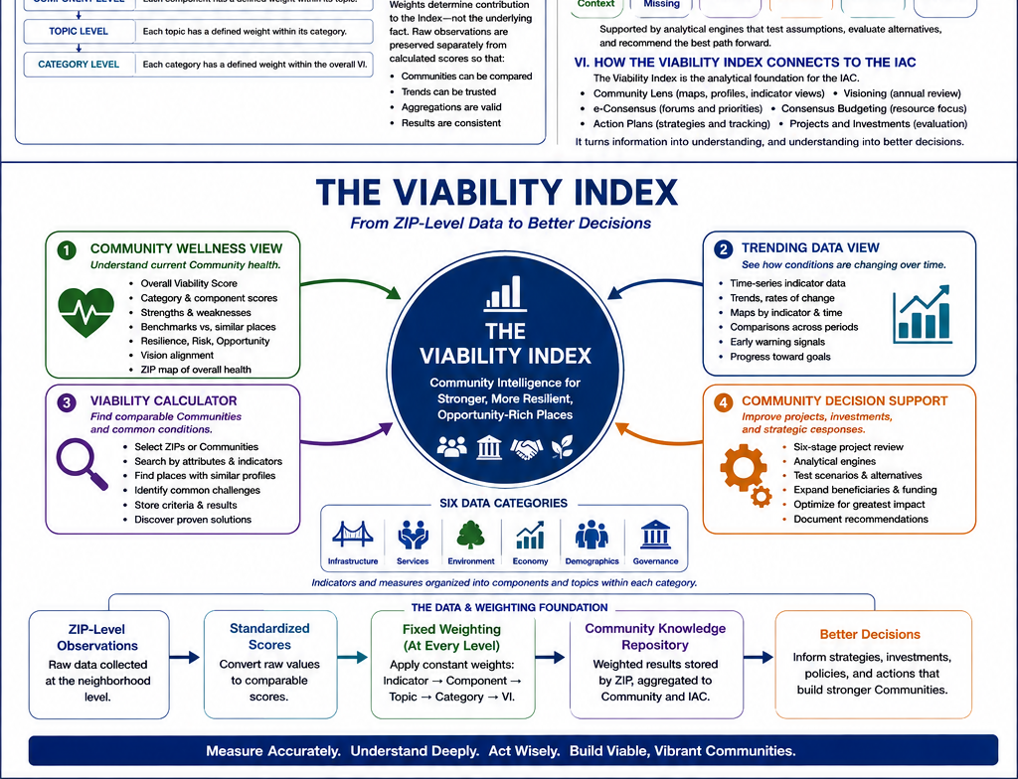
ZIP-LEVEL DATA → WEIGHTED COMMUNITY KNOWLEDGE → BETTER DECISIONS

The Viability Index is the IAC's evidence, measurement, and decision-support system. It begins with ZIP-level observations, preserves the condition of the individual neighborhood or Small Town, and builds upward into Community intelligence that can reveal health, trends, common conditions, and opportunities to improve projects and investments.

I. PURPOSE - FROM COMMUNITY DATA TO COMMUNITY INTELLIGENCE
The Viability Index was developed to understand the actual condition of Communities throughout the IAC and to avoid the distortions that occur when larger jurisdictions or centers dominate aggregated data.
It is not merely a score and it is not merely a list of indicators. It combines a Community Knowledge Repository, standardized scoring, fixed weighting, comparison and trend analysis, and a decision-support process that turns information into strategic response.
The score is a tool, not the destination. The purpose is to help Communities understand where they stand, how they are changing, what conditions they share with other places, and how investments can be structured to create the greatest total Community return.

II. THE ZIP PHILOSOPHY - PRESERVE THE NEIGHBORHOOD, UNDERSTAND THE WHOLE
ZIP codes are the basic geographic building blocks of IAC maps, profiles, data, and analysis. The principle is simple: collect at the smallest practical consistent level, preserve the original observation, and aggregate upward only when a broader view is required.
• ZIP-level data reveals differences among Small Towns and neighborhoods that can disappear inside county, metropolitan, or other large-area averages.
• The original ZIP observation remains available even when data are aggregated to the Community, larger service geography, or IAC level.
• Searchable geographic, political, economic, demographic, and other attributes make it possible to find Communities that are genuinely comparable rather than merely similar in population.
• The same ZIP foundation supports maps, Neighborhood Profiles, Community Profiles, trend analysis, benchmarking, and the Viability Calculator.
Collect at the smallest practical level. Preserve the original observation.
Aggregate upward when needed. Never allow aggregation to erase the condition of the smaller place.

III. THE COMMUNITY KNOWLEDGE REPOSITORY
The Viability Index is supported by a continuously developing Community Knowledge Repository. The current working structure contains six collected-data categories. Indicators hold the measurable observations; the higher levels organize, weight, interpret, and report them.
Infrastructure | Services | Environment | Economy | Demographics | Governance
Physical & virtual systems | Health, education, safety & support | Natural systems, hazards & land use | Jobs, income, costs & enterprise | Population & households | Engagement, trust & decision capacity
Working hierarchy: Category → Topic → Component → Indicator → Measure → Data Element → ZIP Observation → Source / Readiness → Interpretive Use.

IV. INDICATOR WEIGHTING - A CONSTANT VALUE AT EACH LEVEL
The Index uses a fixed weighting structure so that performance can be compared across places and across time. The data value may change as Community conditions change; the weight remains constant unless it is deliberately revised through the controlled weighting process.
Level | How the Weight Functions | Why It Remains Constant
Indicator | Each indicator has a defined relative weight within its Component. | Preserves the importance assigned to the measure.
Component | Each Component has a defined relative weight within its Topic. | Keeps rollups comparable among ZIPs and Communities.
Topic | Each Topic has a defined relative weight within its Category. | Prevents changing conditions from changing the rules.
Category | Each of the six Categories has a defined contribution to the overall Viability calculation. | Preserves year-to-year and place-to-place comparability.
Important distinction: raw observations are always retained separately. Weighting changes an item's contribution to the calculated Index; it does not alter the underlying fact.

V. THE FOUR VIABILITY APPLICATIONS
The Viability Index is expressed through four principal applications. Together they move the system from measurement to comparison, learning, and action.

1. COMMUNITY WELLNESS VIEW
How healthy is the Community?
Provides the current assessment of Community condition through the Viability Summary, category and component results, strengths and weaknesses, benchmarks, resilience, risk, opportunity, and Vision Alignment.

2. TRENDING DATA VIEW
How is the Community changing?
Uses historical and current observations to show direction and rate of change. Indicators can be mapped by ZIP, compared across periods, and used to identify emerging strengths, warnings, and opportunities.

3. VIABILITY CALCULATOR
Which Communities share similar conditions?
Allows users to select ZIPs or Communities, define search criteria, find comparable places, store the search criteria and results, identify common challenges or opportunities, and use successful responses in one place to inform others.

4. COMMUNITY DECISION SUPPORT
How can projects and investments be improved?
Applies the Community knowledge base and analytic engines to proposals, issues, opportunities, and concerns. The purpose is to broaden benefits, identify additional stakeholders and resources, compare scenarios, increase leverage, and optimize total Community return.

VI. THE VIABILITY SUMMARY
The Viability Summary sits above the six data categories. It is the highest-level interpretation of what the collected observations, weights, trends, comparisons, and Community Vision reveal.
• Standard VI Score - overall condition plus category and component scores, trends, and benchmarks.
• Resilience - the ability to absorb stress, maintain essential functions, recover, and adapt.
• Risk - structural weaknesses, vulnerabilities, fragility, hazards, and other potential threats.
• Opportunity - leverage points, shared investments, cross-category benefits, and possibilities for stronger outcomes.
• Vision Alignment - the relationship between current conditions, proposed investments, and the Community and IAC Visions.

VII. THE SIX-STAGE PROJECT REVIEW PROCESS
Community Decision Support follows a prescripted sequence supported by analytical engines. The process is not intended to slow or control a project; it is intended to reveal opportunities to improve it before resources are committed.
1. Setting the Context: Pull the known facts into context: indicator selection, ZIP retrieval, benchmarks, trends, maps, and identity.
2. Make Sure Nothing Is Missing: Identify information gaps, qualify sources, assign research responsibility, validate local facts, and assess confidence.
3. Aligning Priorities: Test the proposal against Community priorities, severity, cross-category impacts, weighting assumptions, and readiness.
4. Setting Scenarios: Identify additional beneficiaries, assets, shared resources, Mutual Viability opportunities, and critical mass.
5. Scenario Optimization: Compare options using impact, cost, difficulty, leverage, risk, ROI, and total Community return.
6. Project Approval: Turn the selected approach into a sequenced action package with funding alignment, dependencies, governance, and version control.

VIII. HOW THE VIABILITY INDEX CONNECTS TO THE IAC
Community Lens - publishes profiles, indicator maps, Neighborhood detail, trends, and selected Viability findings.
Visioning - provides the stable Community direction against which present conditions and investments can be evaluated.
e-Consensus Forum - helps residents and partners interpret evidence, establish priorities, and develop Action Plans.
Community Alliance - broadens the knowledge environment surrounding emerging issues and opportunities.
Consensus Budgeting - uses common-condition analysis and project optimization to align priorities with resources.
Community Boards and IAC Board - use the Index as evidence for stewardship and decision-making while retaining human judgment.
TeleCenter - supports local access, research, facilitation, implementation, and follow-through.
Workforce Virtualization and Regional Transit - can be evaluated as strategies through the same Community condition and project-review framework.

IX. DATA TO DECISIONS
ZIP-Level Observations → Standardized Scores → Fixed Weighting → Community Knowledge → Better Decisions

