COMMUNITY VISIONING
A Stable Direction for Community Evolution
PURPOSE  Create a shared, durable Community direction that reflects local identity while aligning with the larger IAC Vision.  THE VISION  The Vision is not rewritten every year to fit results. It establishes the enduring direction; annual reviews measure performance against it and adjust actions when progress falls short.  FIVE DIMENSIONS  Service • Fellowship • Communications • Leadership • Accountability. These dimensions translate Community culture and values into observable, measurable performance.  HOW IT WORKS  Community identity and aspirations define the Vision; metrics make it measurable; annual review identifies progress and gaps; recognition and revised Action Plans keep the Community moving toward the same long-term destination. | 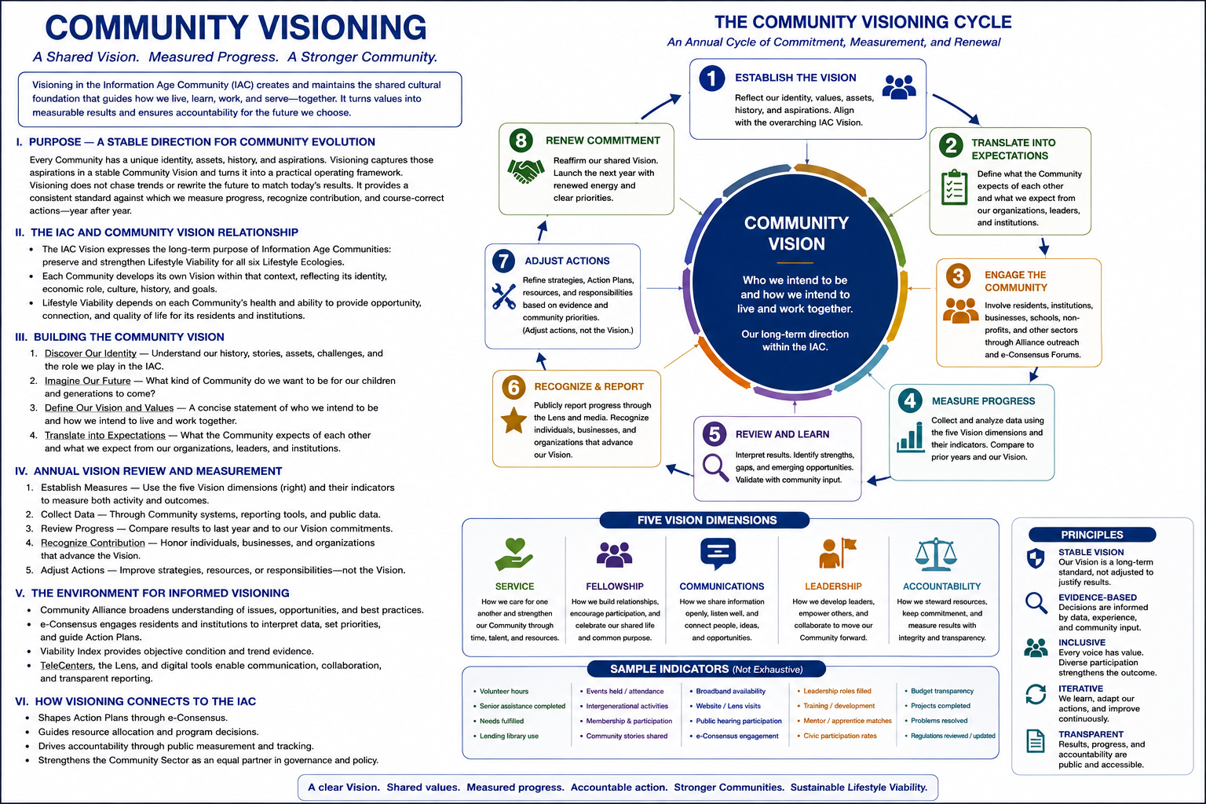
DEFINE THE VISION → MEASURE PROGRESS → ADJUST ACTIONS → RENEW COMMITMENT

I. PURPOSE — A STABLE DIRECTION FOR COMMUNITY EVOLUTION
Every Community has a distinctive identity, history, assets, culture, economic role, and aspirations. Visioning converts those characteristics into a shared long-term direction that can guide participation, institutional behavior, investment, and Community action.
The Vision is not a slogan and it is not rewritten every year to fit current results. It provides a stable reference point against which progress can be measured, contributions recognized, weaknesses exposed, and actions adjusted over time.
The objective is to create a Community culture in which otherwise independent residents, businesses, schools, churches, nonprofits, public institutions, and other organizations can understand how their individual roles contribute to the health and direction of the whole Community.

II. THE IAC AND COMMUNITY VISION RELATIONSHIP
The IAC establishes the broad global Vision and values framework. Each Community then develops its own Vision within that context, reflecting its unique identity and role within the larger IAC.
1. IAC Vision — Defines the shared long-term purpose of the Information Age Community and the principles that support Lifestyle Viability across its six Lifestyle Ecologies.
2. Community Vision — Defines how the Trade Center, Small Towns, residents, institutions, and organizations intend to contribute to that larger purpose while preserving their own identity and aspirations.
3. Measurable Community Culture — Translates Vision into expectations, behaviors, commitments, and measures that can be reviewed over time.

III. BUILDING THE COMMUNITY VISION
1. Discover Our Identity — Understand the Community’s history, stories, assets, challenges, traditions, economic role, relationships, and distinctive place within the IAC.
2. Imagine Our Future — Ask what kind of Community residents want to preserve and create for themselves, their children, and future generations.
3. Define the Vision and Values — State clearly who the Community intends to be and how residents and institutions intend to live and work together.
4. Translate Vision into Expectations — Define what residents can expect from the Community, what the Community expects from residents and institutions, and how organizations can connect their work to the broader Vision.

IV. THE FIVE VISION DIMENSIONS
The historical IAC Vision Tracking framework organizes Community culture and performance around five dimensions drawn from Rotary, Gallup, Gates, and Alcoholics Anonymous service and accountability principles. These sources provide a foundation rather than a rigid formula; the Community can adapt measures while preserving the dimensions and longitudinal continuity.
Vision Dimension | Meaning
Service | How the Community cares for one another and strengthens Community through time, talent, assistance, mentorship, and shared resources.
Fellowship | How the Community builds relationships, belonging, participation, celebration, referral, and common purpose.
Communications | How information, ideas, concerns, knowledge, and opportunities move openly and effectively through the Community.
Leadership | How the Community develops leaders, invites participation, connects roles to the Vision, and encourages people and institutions to contribute.
Accountability | How commitments, projects, institutions, public decisions, and Community results are measured, reported, reviewed, and improved.

V. ANNUAL VISION REVIEW AND MEASUREMENT
The Vision becomes meaningful only if it can be measured consistently. The annual Vision review therefore uses the same core Vision and dimensions to create a longitudinal record of Community behavior and progress.
1. Establish Measures — Select indicators and metrics within the five Vision dimensions. Measures may include both quantitative activity and qualitative assessment.
2. Collect Evidence — Use Community systems, institutional reporting, the Lens, e-Consensus participation, TeleCenter activity, public data, and other appropriate records.
3. Review Progress — Compare current results with prior years and with the commitments embodied in the Community Vision.
4. Recognize Contribution — Identify residents, businesses, schools, nonprofits, institutions, and organizations whose work advances the Vision.
5. Adjust Actions — Where results are weak, improve strategies, Action Plans, resources, responsibilities, or implementation. Adjust the actions—not the Vision merely to justify current results.
6. Renew Commitment — Publish the review, reaffirm the Vision, and begin the next annual cycle with renewed priorities and responsibilities.

VI. SAMPLE VISION METRICS
The historical Vision Tracking work anticipated metrics such as the following. The final controlled list should be developed as the system is implemented and tested.
• Service — volunteer requests and completions; time-and-talent contributions; lending-library use; mentoring, apprenticeships, internships, and training opportunities.
• Fellowship — events, attendance, intergenerational activity, recognition, referrals, Community stories, and participation in Community organizations.
• Communications — Lens use, broadband access, public-hearing participation, communication channels, content adequacy, and effectiveness of information flow.
• Leadership — Vision audits, civic participation, leadership roles, candidate participation, training, development, and engagement.
• Accountability — budgets, projects approved and completed, regulations reviewed, complaints resolved, institutional performance, public reporting, and follow-through on commitments.

VII. THE ENVIRONMENT FOR INFORMED VISIONING
Visioning is strengthened by the other IAC systems. The Community Alliance broadens understanding of ideas and possibilities. The Viability Index supplies objective evidence about Community conditions and trends. e-Consensus provides the structured environment for interpreting evidence, resolving differences, and developing Action Plans. The Lens, TeleCenter, schools, libraries, and other Community institutions help residents participate and see the results.
This creates a practical distinction: the Viability Index asks how healthy the Community is; Visioning asks whether the Community is becoming what it said it wanted to become.

IX. IDENTITY, VALUES, FIT, AND CULTURAL EVOLUTION
Visioning is the principal process through which a Community defines its values, clarifies its identity, and states the future it intends to pursue. Those statements are not created by the IAC for the Community. They emerge from the Community itself and provide the reference point for stewardship, measurement, marketing, and participation.
A clear identity also makes Community matching possible. Prospective residents, teleworkers, retirees, entrepreneurs, families, and employers should be able to understand what kind of place a Community is before deciding whether it may be a good fit. The IAC can provide common profile and matching tools, but the Community supplies the authentic values, Vision, story, and lived context.
Openness is fundamental. Newcomers should not merely consume Community services; they should be invited into civic life. Their experience, skills, relationships, and values may influence Community culture over time. Visioning provides continuity of direction while open participation allows culture to evolve without casually erasing the Community's identity.
• Know who you are.
• Strengthen what makes the Community distinctive.
• Tell the story honestly.
• Welcome participation and allow culture to evolve.
• Measure progress against the enduring Vision rather than rewriting the Vision to fit current results.

IX. HOW VISIONING CONNECTS TO THE IAC
• Community Alliance — expands the ideas, knowledge, examples, and future possibilities available to residents and institutions.
• Viability Index — provides objective condition and trend evidence that can inform interpretation of Vision progress.
• e-Consensus Forum — supports broad interpretation, course correction, priority-setting, and development of Action Plans when collective judgment is needed.
• Community Lens — publishes the Vision, metrics, annual results, opportunities for participation, and progress toward commitments.
• TeleCenter — provides physical access, facilitation, training, meetings, and implementation support.
• Community Board — stewards the Community Vision and the annual review process.
• IAC Board — stewards the overarching IAC Vision and maintains alignment across Communities.
• Consensus Budgeting — helps align resources and investment with priorities emerging from Visioning and Community decisions.
• Community Voice — carries documented Community expectations and accountability into external institutions and public policy discussions.

X. GOVERNING DOCTRINE
Know Who We Are.
Define Who We Intend To Become.
Measure Whether Our Actions Are Taking Us There.
Recognize Contribution And Expose Gaps.
Adjust Our Actions While Preserving A Stable Long-Term Vision.

