THE e-CONSENSUS FORUM™
Structured Community Deliberation
AT A GLANCE  PURPOSE  Convert broad individual knowledge, concerns, and ideas into documented Community judgment, priorities, and Action Plans.  DISTINCTIVE DESIGN  Anonymous individual responses, inclusive participation, one-person/one-vote evaluation, iterative open inquiry, complete documentation, and statistical participant profiling.  HOW IT WORKS  The Forum progressively moves from Issue to Strategy to Tactics to Stakeholders to Resources & Budget to Leadership and finally to an Action Plan—alternating open inquiry with grouping, evaluation, and voting.  WHY IT MATTERS  The process reduces domination by status or volume, makes the composition of participants visible for bias analysis, and preserves the path by which the Community reached its conclusion. | 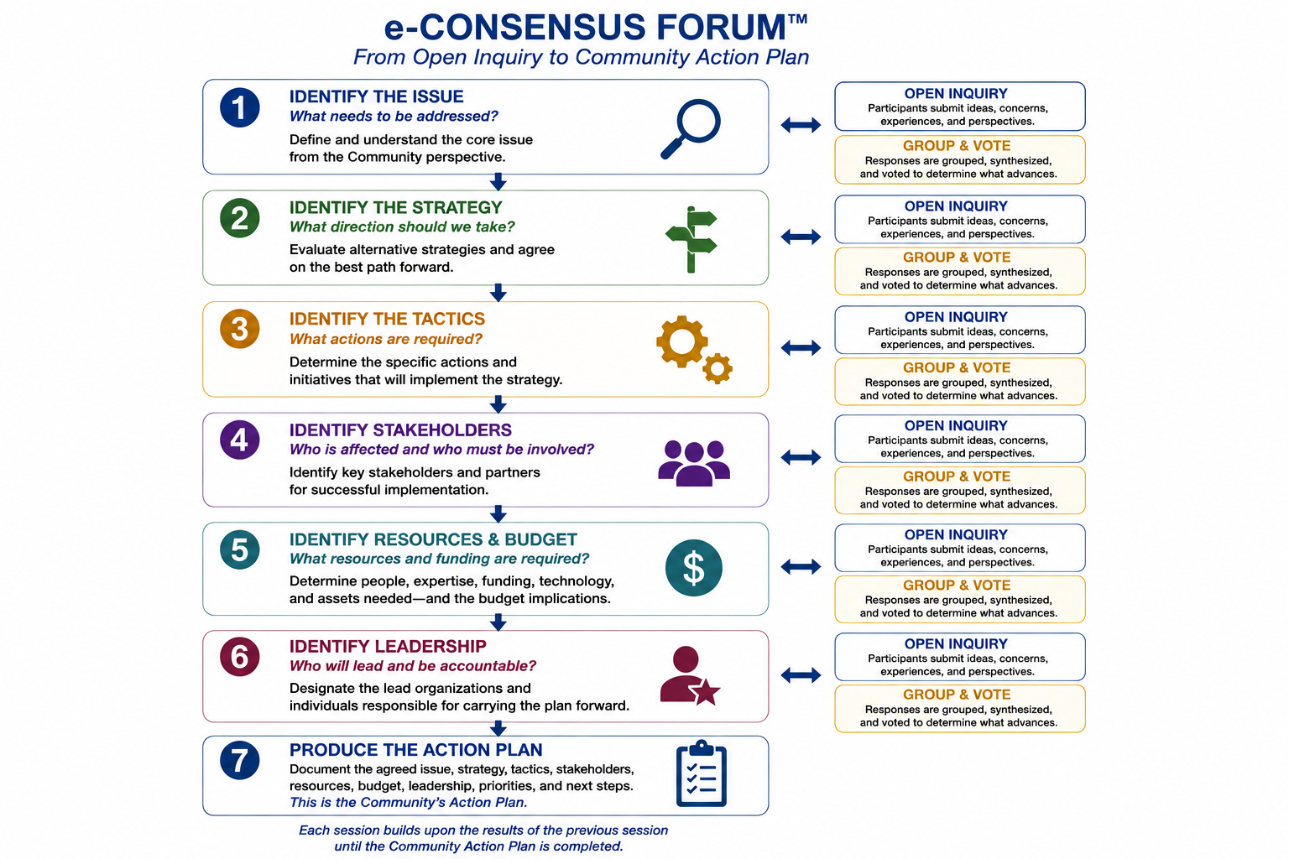
OPEN INQUIRY → COLLECTIVE JUDGMENT → ACTION PLAN → ACCOUNTABILITY

I. PURPOSE — BUILDING DOCUMENTED COMMUNITY JUDGMENT
The e-Consensus Forum is the IAC’s structured deliberation process for bringing a diverse cross-section of people together around a defined issue, developing shared Community judgment, publishing the result, and—when action is required—developing an Action Plan and tracking what happens next.
Its purpose is not simply to measure opinion. It is to convert broad individual knowledge, experience, concerns, and ideas into a disciplined sequence of Community priorities, strategies, implementation choices, leadership, resources, and accountability.
The Forum strengthens the Community Sector by giving residents an organized means to develop documented positions that can be understood by governments, institutions, businesses, service providers, funders, and other decision-makers.

II. THE FORUM’S DISTINCTIVE ATTRIBUTES
1. Anonymous. Individual comments and votes are confidential. Anonymity reduces hierarchy, peer pressure, meeting-room intimidation, and domination by the loudest or most powerful participant.
2. Inclusive. Every participant responds to each question. Quiet participants and less visible perspectives are therefore included rather than depending upon who chooses to speak.
3. Democratic. Each authorized participant has one vote. The process is designed around equal participant standing rather than organizational rank.
4. Focused. The alternating open-question, grouping, evaluation, and voting cycle progressively identifies what matters most and narrows the discussion toward resolution.
5. Documented. Every response, grouping, vote, session summary, and final conclusion can be retained. The nuances of the discussion are preserved rather than reduced to meeting highlights.
6. Iterative. Each session is built from what the participants produced in the previous session. The Forum therefore develops understanding progressively rather than asking for a final judgment at the outset.
7. Transparent in Composition. Individual answers remain anonymous, but the participating population is statistically described so the context and potential bias of the Forum result can be evaluated.

III. THE PARTICIPANT PROFILE — UNDERSTANDING WHO PRODUCED THE RESULT
Every consensus result is influenced, at least in part, by who participated. Focus groups, public meetings, surveys, and modern polls can all produce different results when the participant population changes. e-Consensus addresses that limitation directly through a one-time registration profile that is kept separate from anonymous Forum responses and votes.
Individual Response | Participant Population
Anonymous and confidential | Statistically described in aggregate so readers can understand who participated, evaluate representativeness, and identify potential sources of bias.
Depending upon the Forum, profile variables may include age range, geography, Lifestyle Ecology, employment sector, industry or occupation, organizational role, Community role, and other appropriate non-sensitive characteristics.
Because participant characteristics and Forum results are retained as structured data, the architecture also creates the potential to segment results by participant characteristics or compare separate Forums addressing the same issue. This can reveal where groups converge, where they differ, and whether an apparent consensus is strongly associated with the composition of the participants.
The purpose is not to invalidate a result because a group has a particular profile. It is to make the context of that result visible.

IV. HOW THE FORUM WORKS
The Forum operates through alternating cycles of open inquiry and structured evaluation. Participants first create the content; the system then groups and synthesizes that content; participants evaluate or vote on the resulting choices; and the next inquiry is constructed from what the group has produced.
1. Recruit and Register. A Forum is announced, participants are recruited, complete or confirm their profile, and register for the appropriate Forum or session.
2. Open Inquiry. Participants respond independently to open-ended questions, contributing ideas, concerns, experiences, and alternatives without being restricted to predetermined answers.
3. Group and Synthesize. Responses are organized into themes or alternatives so the full range of participant input can be reviewed.
4. Evaluate and Vote. Participants rank, allocate, evaluate, or vote on the grouped material to determine what advances.
5. Return the Results. Session transcripts, summaries, and results are distributed so participants can see what the group said and how the next session was formed.
6. Repeat. The next session uses the previous results as its starting point. The process continues until the Forum has sufficiently resolved its assigned question.
7. Document and Publish. The Forum produces a final report documenting the progression of the discussion, the results, the participant profile, and any resulting Community decision or Action Plan.

V. DEVELOPING THE ACTION PLAN
When the Forum is intended to move from discussion to action, its content progresses from a broad issue toward an implementable plan. The exact number of sessions can vary with the subject, but the current working sequence is:
1. Identify the Issue. What needs to be addressed?
2. Identify the Strategy. What direction should we take?
3. Identify the Tactics. What specific actions are required?
4. Identify the Stakeholders. Who is affected and who must be involved?
5. Identify Resources and Budget. What people, expertise, funding, technology, assets, and budget are required?
6. Identify Leadership. Who will lead and who will be accountable?
7. Produce the Action Plan. Document the issue, strategy, tactics, stakeholders, resources, budget, leadership, priorities, and next steps.
Policy positions currently use a 60 percent approval threshold; most other Forum decisions use a simple majority unless the Forum Plan establishes another approved rule. The governing principle is that the process and threshold are known before the decision is made.

VI. PUBLICATION, TRACKING, AND ACCOUNTABILITY
A Forum does not end when the vote closes. Its conclusions are published, assigned to the identified responsible actor or actors, and retained for follow-up. This creates an accountability loop that is largely absent from conventional meetings and opinion research.
1. Publish. Release the Forum report, participant profile, Community decision, and Action Plan through the Lens and other appropriate channels.
2. Amplify. Use Community Voice and appropriate media or stakeholder communications to carry documented conclusions outward.
3. Track. Record implementation commitments, responsible actors, milestones, and progress.
4. Compare. Compare actual performance with the Forum’s documented priorities, commitments, or policy positions.
5. Follow Up. Where progress is incomplete or conditions change, initiate additional sessions or a new Forum.

VII. WHERE e-CONSENSUS CAN BE USED
1. Public opinion research and issue exploration
2. Public policy development and accountability
3. IAC and Community implementation
4. Annual budgeting and capital allocation
5. Rapid Community problem solving
6. Cross-Community engagement around shared interests
7. Distributed Board and governance activity, both synchronous and asynchronous
8. Service-provider negotiation and service specification
9. Development of new product or service requirements
10. Visioning, project development, and other structured Community decisions

VIII. HOW e-CONSENSUS CONNECTS TO THE IAC
Viability Index. provides evidence about conditions, trends, risks, and opportunities and can identify issues requiring broader Community interpretation.
Community Alliance. broadens knowledge and understanding before and during deliberation.
Community Lens. provides digital access to Forums, background materials, results, Action Plans, and tracking information.
TeleCenter. provides physical access, assistance, facilitation, technology, and support for participants who need it.
Community Board. initiates or sponsors Community Forums and stewards resulting priorities and Action Plans.
IAC Board. can initiate IAC-wide Forums and acts upon results within its fiduciary and organizational authority.
Consensus Budgeting. uses structured deliberation to evaluate and prioritize investment needs.
Community Voice. amplifies documented Forum conclusions to governments, institutions, businesses, funders, service providers, and the broader public.
Collaboratives. provide specialized information, technical expertise, and implementation support when a Forum requires it.
The Alliance informs. e-Consensus deliberates. e-Consensus develops the Community decision and Action Plan.

